A
PROJECT REPORT
ON
PRAVA
College Academic Management System
Developed for
Women's College of Home Science and BCA, Loni
Submitted to
Savitribai Phule Pune University, Pune
Submitted by
Rutuja Ashok Khobare | Roll No. 30
Under the Guidance of
Surekha Kale
For the Academic Year
2026–2027
In Partial Fulfilment of the Course
B.Sc (Computer Applications)
DEPARTMENT OF THE COMPUTER APPLICATIONS

Loknete Dr. Balasaheb Vikhe Patil (Padma Bhushan Awardee)
Pravara Rural Education Society's
Women's College of Home Science and BCA, Loni
Tal- Rahata, Dist- Ahilyanagar, Pin-413713
A
PROJECT REPORT
ON
PRAVA
College Academic Management System
Submitted by
Rutuja Ashok Khobare | Roll No. 30
Submitted to the Department of Computer Applications
Under the Guidance of
Surekha Kale
In partial fulfilment of the requirements

For the degree of
B.Sc (Computer Applications)
Loknete Dr. Balasaheb Vikhe Patil (Padma Bhushan Awardee)
Pravara Rural Education Society's
Women's College of Home Science and BCA, Loni
Tal- Rahata, Dist- Ahilyanagar, Pin-413713
Academic Year 2026–2027
PROJECT SUBMISSION
Submitted by
Rutuja Ashok Khobare | Roll No. 30
Student of TY B.Sc (CA) – Third Year
B.Sc (Computer Applications)
I submit the group project
PRAVA
College Academic Management System
I, a student of TY B.Sc (CA), submit the group project entitled “PRAVA – College Academic Management System” for the academic year 2026–2027.
The project presents the design and implementation of an academic management portal for students, teaching staff and college administration. This report documents the application modules, database design, user interfaces and verification of the implemented system.
I have prepared this project as a group member under the guidance of Surekha Kale as part of the B.Sc (Computer Applications) project work at Savitribai Phule Pune University, Pune.
Place: ________________________ | Date: ________________________
________________________
Rutuja Ashok Khobare
Student signature | Roll No. 30
Loknete Dr. Balasaheb Vikhe Patil
(Padma Bhushan Awardee)
Pravara Rural Education Society's
Women's College of Home Science and BCA, Loni
CERTIFICATE
This is to certify that
Rutuja Ashok Khobare | Roll No. 30
a student of TY B.Sc (CA) – Third Year, has prepared and submitted
the group project
PRAVA
College Academic Management System
under the guidance of Surekha Kale, in partial fulfilment
of the requirements for the degree of
B.Sc (Computer Applications)
Savitribai Phule Pune University, Pune
Academic Year 2026–2027
________________________  Dr. Sanjay Vani  Head of Department | ________________________  External Examiner  Name and signature
________________________  Surekha Kale  Project Guide | ________________________  Dr. Anushree Rajendra Khaire  Principal
Place: __________________________  Date: __________________________ |  | College Seal
Women's College of Home Science and BCA, Loni
STUDENT DECLARATION
I, Rutuja Ashok Khobare (Roll No. 30), a student of TY B.Sc (CA) at Women's College of Home Science and BCA, Loni, declare that this report presents my work on the group project “PRAVA – College Academic Management System” for the academic year 2026–2027.
The report describes the design and implementation of the college academic portal, including student, staff and office workspaces, database records, academic workflows and access controls. It is submitted under the guidance of Surekha Kale as part of my B.Sc (Computer Applications) project work.
College information, university curriculum documents, open-source software and technical references are acknowledged in the bibliography. Generated local records illustrate academic workflows; they do not certify college results. Submitted student profiles are retained separately from these presentation records.
Class: TY B.Sc (CA) – Third Year
Project Type: Group Project
Academic Year: 2026–2027
Place: ________________________ | Date: ________________________
________________________
Rutuja Ashok Khobare
Student signature | Roll No. 30
Women's College of Home Science and BCA, Loni
ACKNOWLEDGEMENT
I thank my project guide, Surekha Kale, for guidance in the preparation of my TY B.Sc (CA) project report, PRAVA – College Academic Management System.
I express my gratitude to Dr. Sanjay Vani, Head of Department, and Dr. Anushree Rajendra Khaire, Principal, for the academic environment in which this project is presented. I also thank the teaching staff of Women's College of Home Science and BCA, Loni for supporting my learning.
The project gave me an opportunity to connect web development with a practical college workflow. Preparing separate student, staff and office workspaces helped me understand how interface design, validation, database relationships and access permissions work together.
I acknowledge the college website, university syllabus documents, open-source software and official technical documentation used during the development and documentation of the project. These resources helped me describe the academic context and implement the application.
I thank my family, friends and everyone who assisted me with project review and demonstration preparation.
With sincere thanks,
Rutuja Ashok Khobare | Roll No. 30
TY B.Sc (CA) – Academic Year 2026–2027

Technology Profile
PRAVA is a browser-based academic portal. A Python and Flask application manages accounts, validates academic operations and stores structured records in a relational database. The local presentation version uses SQLite and serves the website on the same computer.
Layer | Technology | Purpose
Presentation | HTML, CSS, JavaScript | Responsive public pages and role-specific workspaces
Templates | Jinja | Server-rendered pages with shared navigation
UI library | Bootstrap 5.3.3 and Icons 1.11.3 | Locally bundled layout and interface assets
Application | Python 3.11–3.13; Flask 3.0.3 | Routes, services and application configuration
Persistence | Flask-SQLAlchemy 3.1.1; SQLite | Models, relationships and local records
Authentication | Flask-Login 0.6.3; Werkzeug 3.0.3 | Sessions and password-hash verification
Forms | Flask-WTF 1.2.1 and WTForms 3.1.2 | Input validation and CSRF protection
Testing | Python unittest | Isolated automated functional and security checks
Delivery | GitHub and Windows launcher | Versioned source and repeatable local setup

The repository also contains PostgreSQL and optional external authentication configuration for future hosting. This report evaluates the working local-authentication installation. Package versions above describe the project requirements and bundled assets.

Abstract
PRAVA is a College Academic Management System for Women's College of Home Science and BCA, Loni. It connects public college information with student, staff and administrative workspaces. The project supports BCA and the Home Science specialisations in Food Science and Nutrition, and Textile Science and Designing, using a versioned 2024 NEP curriculum catalogue.
The website opens on Home. Its header contains Home, Academics, Contact and a Login dropdown. Student login continues through BCA or Home Science selection, while Staff and Office / Administration open their own forms. The authenticated account determines the displayed name, permissions and dashboard. Night mode is the default, with a Day mode option.
Students can submit a website sign-up request for Office approval. Separate Google Forms collect student and staff profile information into private response spreadsheets. Those responses require verification and conversion to the portal CSV templates; submitting a Google Form does not automatically create a PRAVA account.
Python, Flask, Jinja and SQLAlchemy implement the application, while a local SQLite database preserves users and academic records. The 22 model tables support profiles, teaching allocations, attendance, marks, materials, assignments, notices, curriculum sources, activities and review workflows. Password hashing, CSRF protection, role checks and record ownership restrict access.
The repository baseline is 4abb237 with local typography improvements. All 63 automated tests passed on 5 October 2026. This report documents the implementation, database, academic workspaces and setup. Final-year syllabus verification, official NEP grade calculations and account notifications remain future enhancements.
Keywords: academic management, Flask, SQLite, BCA, Home Science, NEP curriculum, role-based access.
INDEX

Project Title Page 2
Project Submission 3
Certificate 4
Student Declaration 5
Acknowledgement 6
Technology Profile 7
Abstract 8
1 Introduction Objectives and Scope 10
2 Requirements Analysis and Feasibility 11
3 System Architecture and Modules 12
4 Login Registration and Permissions 13
5 Database Design and ER Diagrams 15
6 Data Flow Diagrams 18
7 Data Dictionary 21
8 Academic Processing and Reports 26
9 Student and Staff Information Collection 27
10 Input and Output Screens 28
11 Testing and Verification 38
12 Security and Data Maintenance 40
13 Advantages Limitations and Future Work 41
14 Project Cost and Conclusion 42
15 Bibliography 43
Appendix Local Installation and Demonstration 45

1 Introduction Objectives and Scope
College academic records connect identities, programme enrolment, teaching allocations, attendance, assessments and learning resources. Students need access to their own progress; teachers need the records of assigned classes; and the Office needs consistent institutional data. PRAVA brings these responsibilities into one browser-based application.
Problem and proposed system
Keeping the same academic information in separate registers, files and messages can make retrieval slow and introduce duplicate entries. PRAVA addresses this design problem through shared relational records and server-side access rules. Public college content, pending registrations and verified academic profiles are maintained separately.
Objectives
• Provide clear public navigation and role-specific login with the correct account identity.
• Verify student registration and roster imports before activating academic accounts.
• Link student and staff work to the correct programme, curriculum, semester and subject.
• Manage attendance, marks, materials, assignments, notices, activities and reports.
• Provide source-linked syllabus information and a repeatable local demonstration setup.
Project scope
The catalogue covers BCA, B.Sc. Food Science and Nutrition, and B.Sc. Textile Science and Designing. FY, SY and TY navigation represents the three-year journey; detail is displayed according to the available source review. Office and Principal access use distinct administrative permissions. The local project demonstrates academic operations; fees, payroll, library circulation and university result certification are outside its current modules.

2 Requirements Analysis and Feasibility
The requirements come from the requested college workflows, the supplied report format, college and curriculum references, and source-code inspection. Google Forms support profile collection. Submitted records require Office review; the project does not claim measured adoption benefits or institutional-scale operation.
Requirement | Local demonstration setup
Hardware | 64-bit laptop or desktop; 4 GB RAM and 1 GB free space are planning recommendations, not measured minima.
Software | Python 3.11–3.13, a modern browser and the pinned requirements.txt dependencies.
Database and files | SQLite in instance/prava.sqlite3; learning files and profile uploads stored separately.
Connectivity | Internet for first setup and external sources. Bundled local pages render after setup without internet.
Quality | Readable Day/Night themes, validation feedback, persistent records, controlled access and auditable review.

Feasibility
Technical feasibility follows from the conventional browser, Flask and relational database architecture. SQLite supports local presentation without a separate database server. Operational feasibility depends on the Office verifying identities and allocating subjects before Staff enters records. Separate dashboards make these responsibilities visible.
An existing laptop and open-source dependencies support an economical local demonstration. Printing, binding and any later hosting remain separate costs. Data feasibility depends on official student identifiers, staff assignments and applicable batch documents. Missing academic results remain pending, while unresolved curriculum items retain review status.

3 System Architecture and Modules
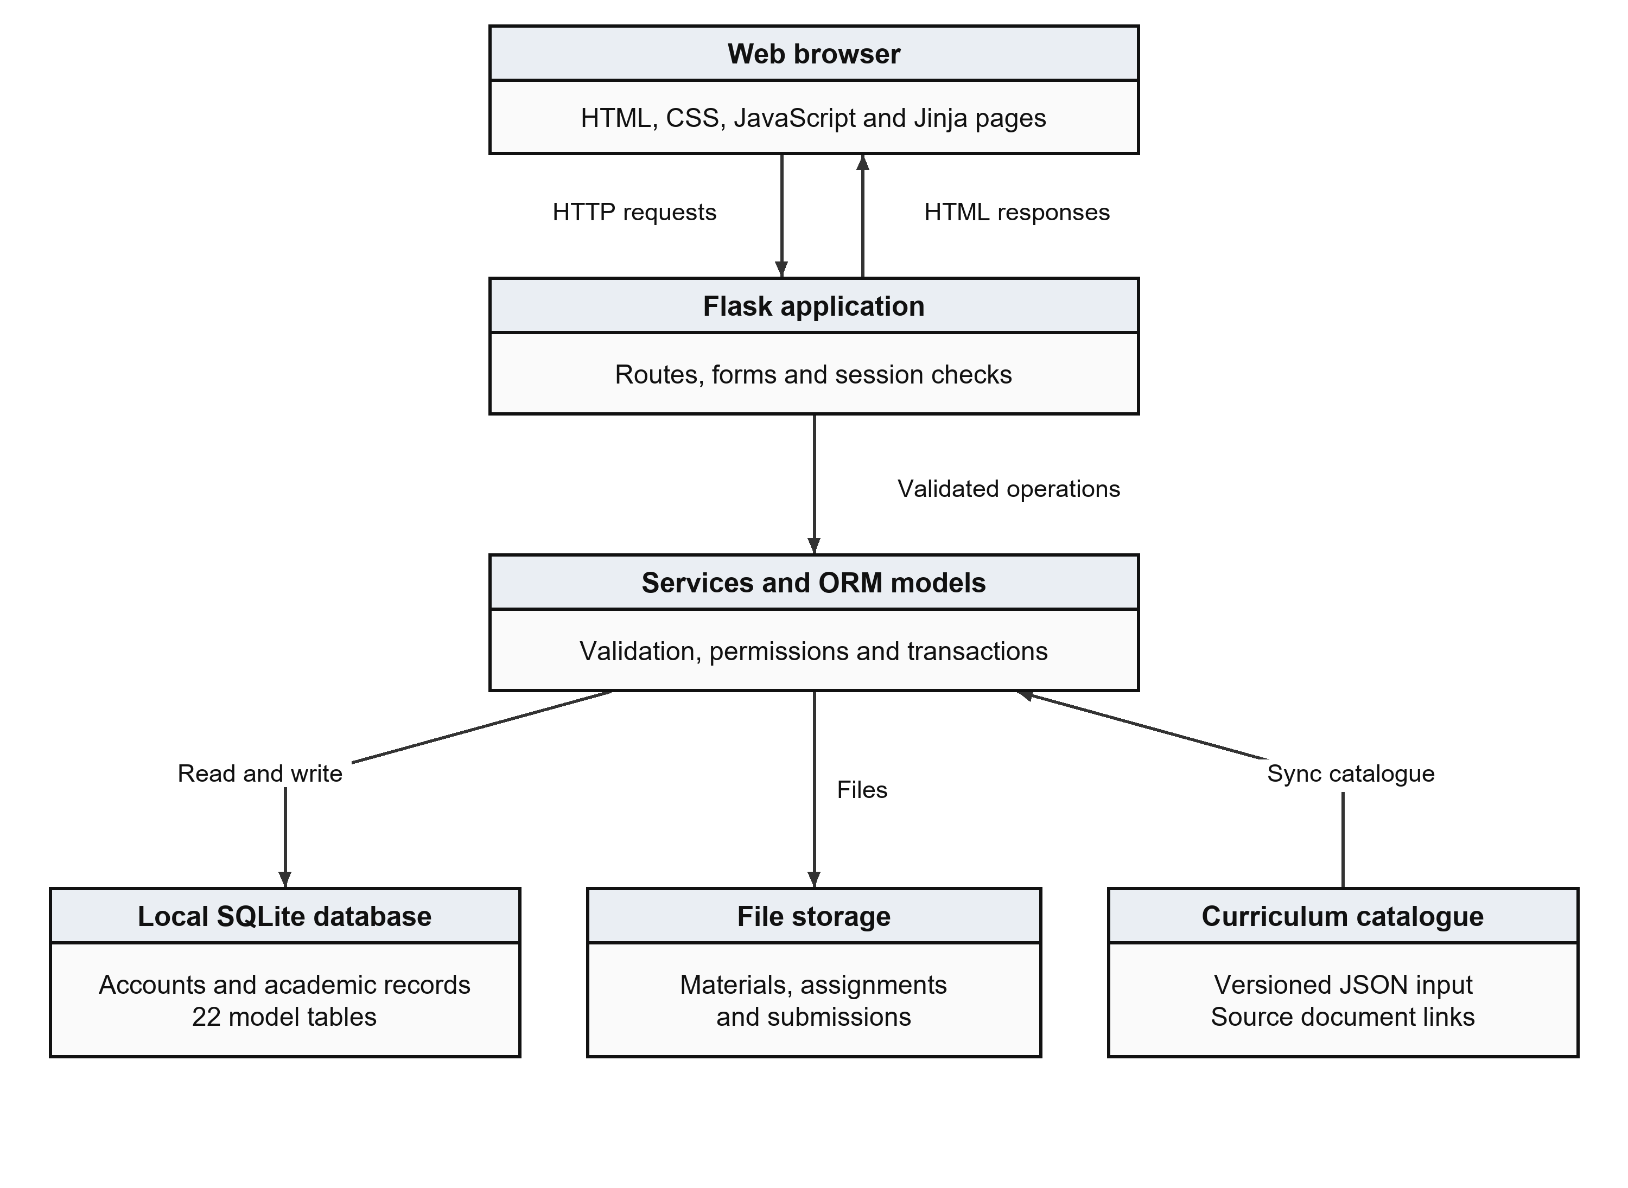
Figure 1 Browser application services and local storage
Flask routes receive requests, validate forms and check sessions and roles. Services perform academic operations through SQLAlchemy. Jinja renders HTML responses; uploaded files remain separate from their metadata. The curriculum JSON synchronises reference information into the database.
Module | Principal responsibility
Public and access | Home, college information, academics, contact, role login and student sign-up.
Student and Staff | Programme-based progress views; assigned-subject attendance, marks and learning resources.
Administration | Profiles, approvals, curriculum review, imports, notices, access scopes and exports.
Shared services | Database transactions, validation, activity records, upload checks and persistent setup.

4 Login Registration and Permissions
Entry point | Destination and rule
Home → Login dropdown | Student, Staff and Office / Administration appear immediately below Login.
Student → BCA / Home Science | Dedicated form validates credentials, active status, role and programme.
Staff | Staff credentials open the faculty workspace and assigned-subject tools.
Office / Administration | Administrative workspace follows Office, Principal or administrator scope.
Back Switch and Logout | Back uses defined internal pages. Switching requires new credentials. Logout uses protected POST.

Student sign-up and approval
Website sign-up captures identity, programme, semester, admission year and a password that is stored only as a hash. A valid request becomes Pending in student_registrations. Office approval rechecks duplicate identities and creates the user and student profile in one transaction. Rejection preserves the review decision without activating an account.
Permission boundaries
A student reads her own academic records. Staff works with explicitly assigned subjects and eligible students. Office manages authorised records and approvals. Principal scope is read-only for permitted oversight. Privileged account creation requires administrator scope. A failed account switch preserves the earlier authenticated identity; choosing a portal alone does not change the account.
Public student sign-up currently uses local password authentication. Optional external authentication requires additional provisioning work. Registration approval emails are not automated.
Use Case Diagram
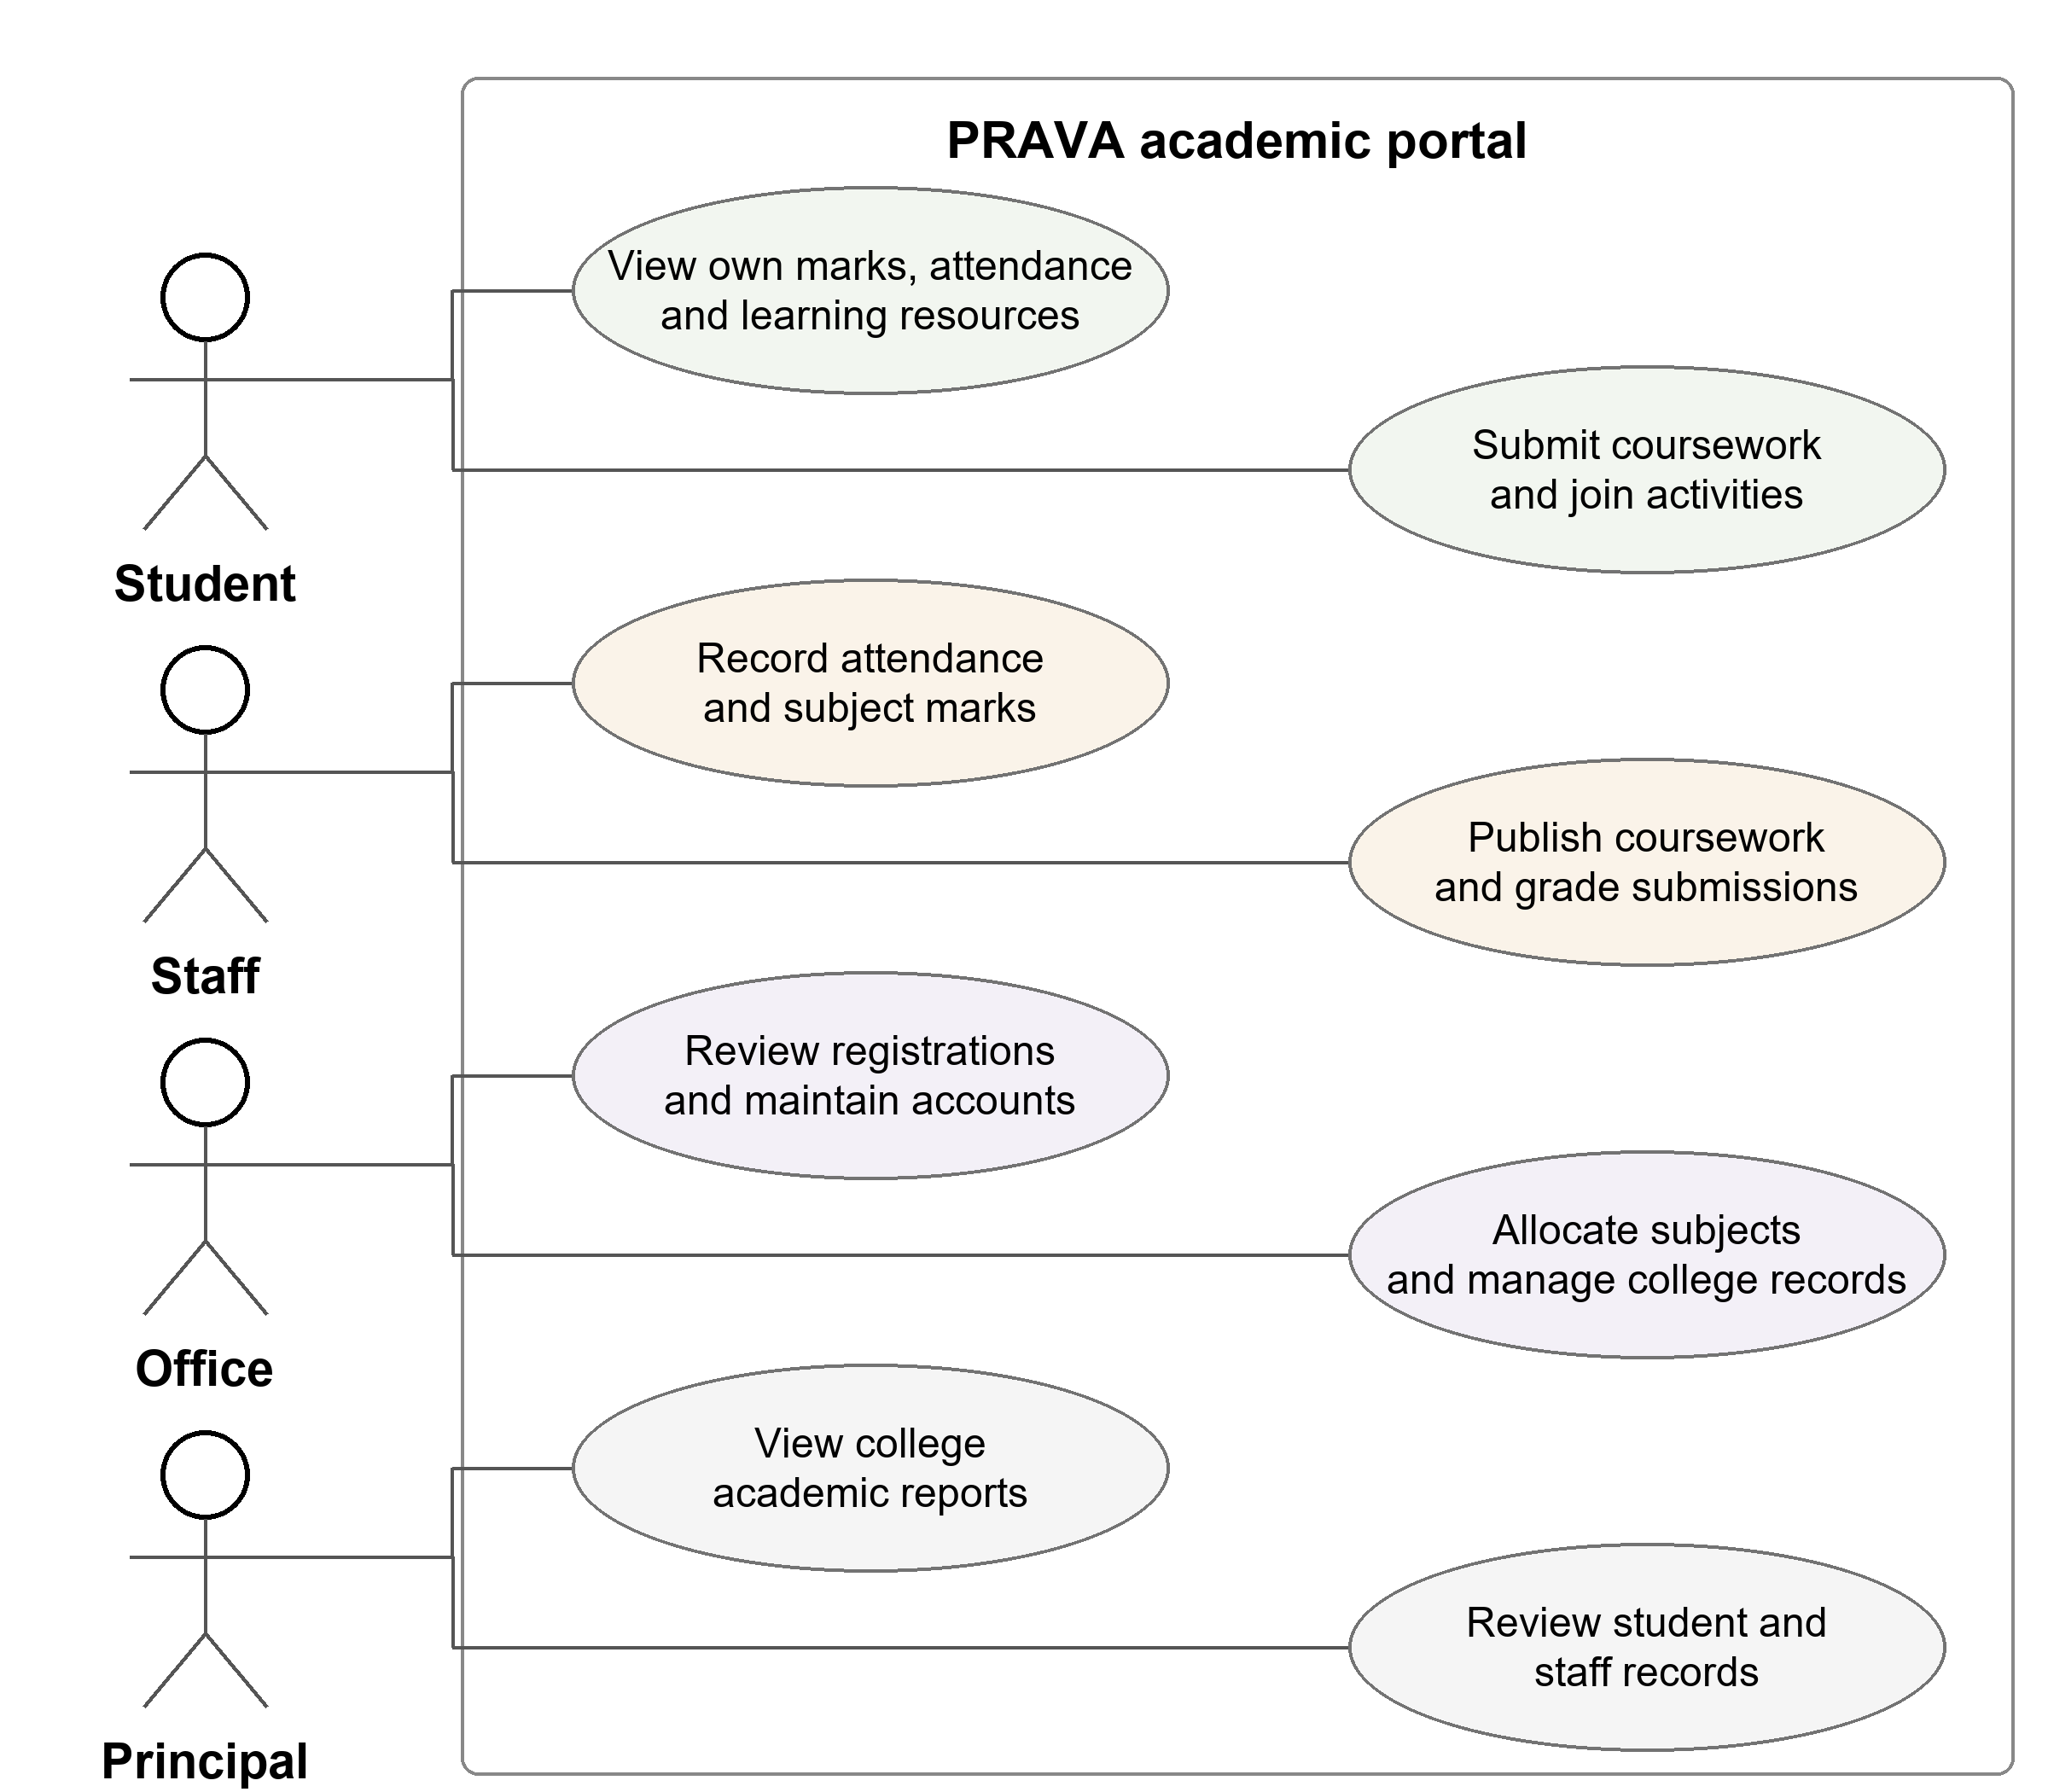
Figure 2 Primary actors and their academic operations
Student access is restricted to her own records. Staff operations depend on subject allocation. Office handles record maintenance and registration review; the Principal account provides read-only oversight.
Protected operations require an active authenticated account. A prospective student may submit a public sign-up request; Office approval is required before that account can access the student workspace.

5 Database Design and ER Diagrams
The implementation contains 22 model tables and 227 columns. PK denotes a primary key, FK a foreign key and UQ a uniqueness constraint. A 1-to-many relationship is implemented by a child foreign key; 1-to-0..1 describes an optional unique profile for a user.
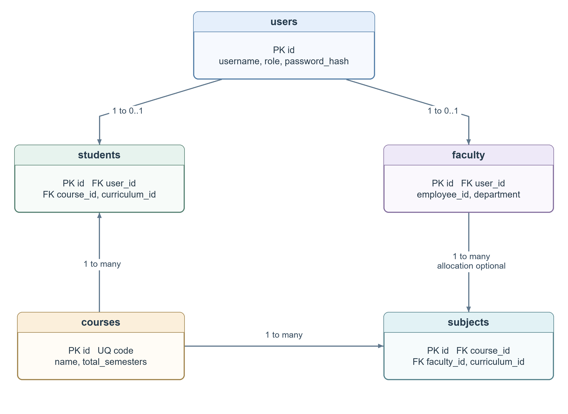
Figure 3 Accounts profiles courses and teaching subjects
users holds authentication identity; students and faculty hold role-specific profiles. Students belong to courses and curricula. subjects describes actual teaching allocations, including programme, semester and faculty. The separate curriculum catalogue provides source-reviewed reference entries.
The data dictionary follows SQLAlchemy declarations. Application validation and SQLite enforcement can differ. Password fields contain hashes; JSON text fields hold structured data. Foreign-key relationships are shown only where declared.
Academic and Learning Relationships
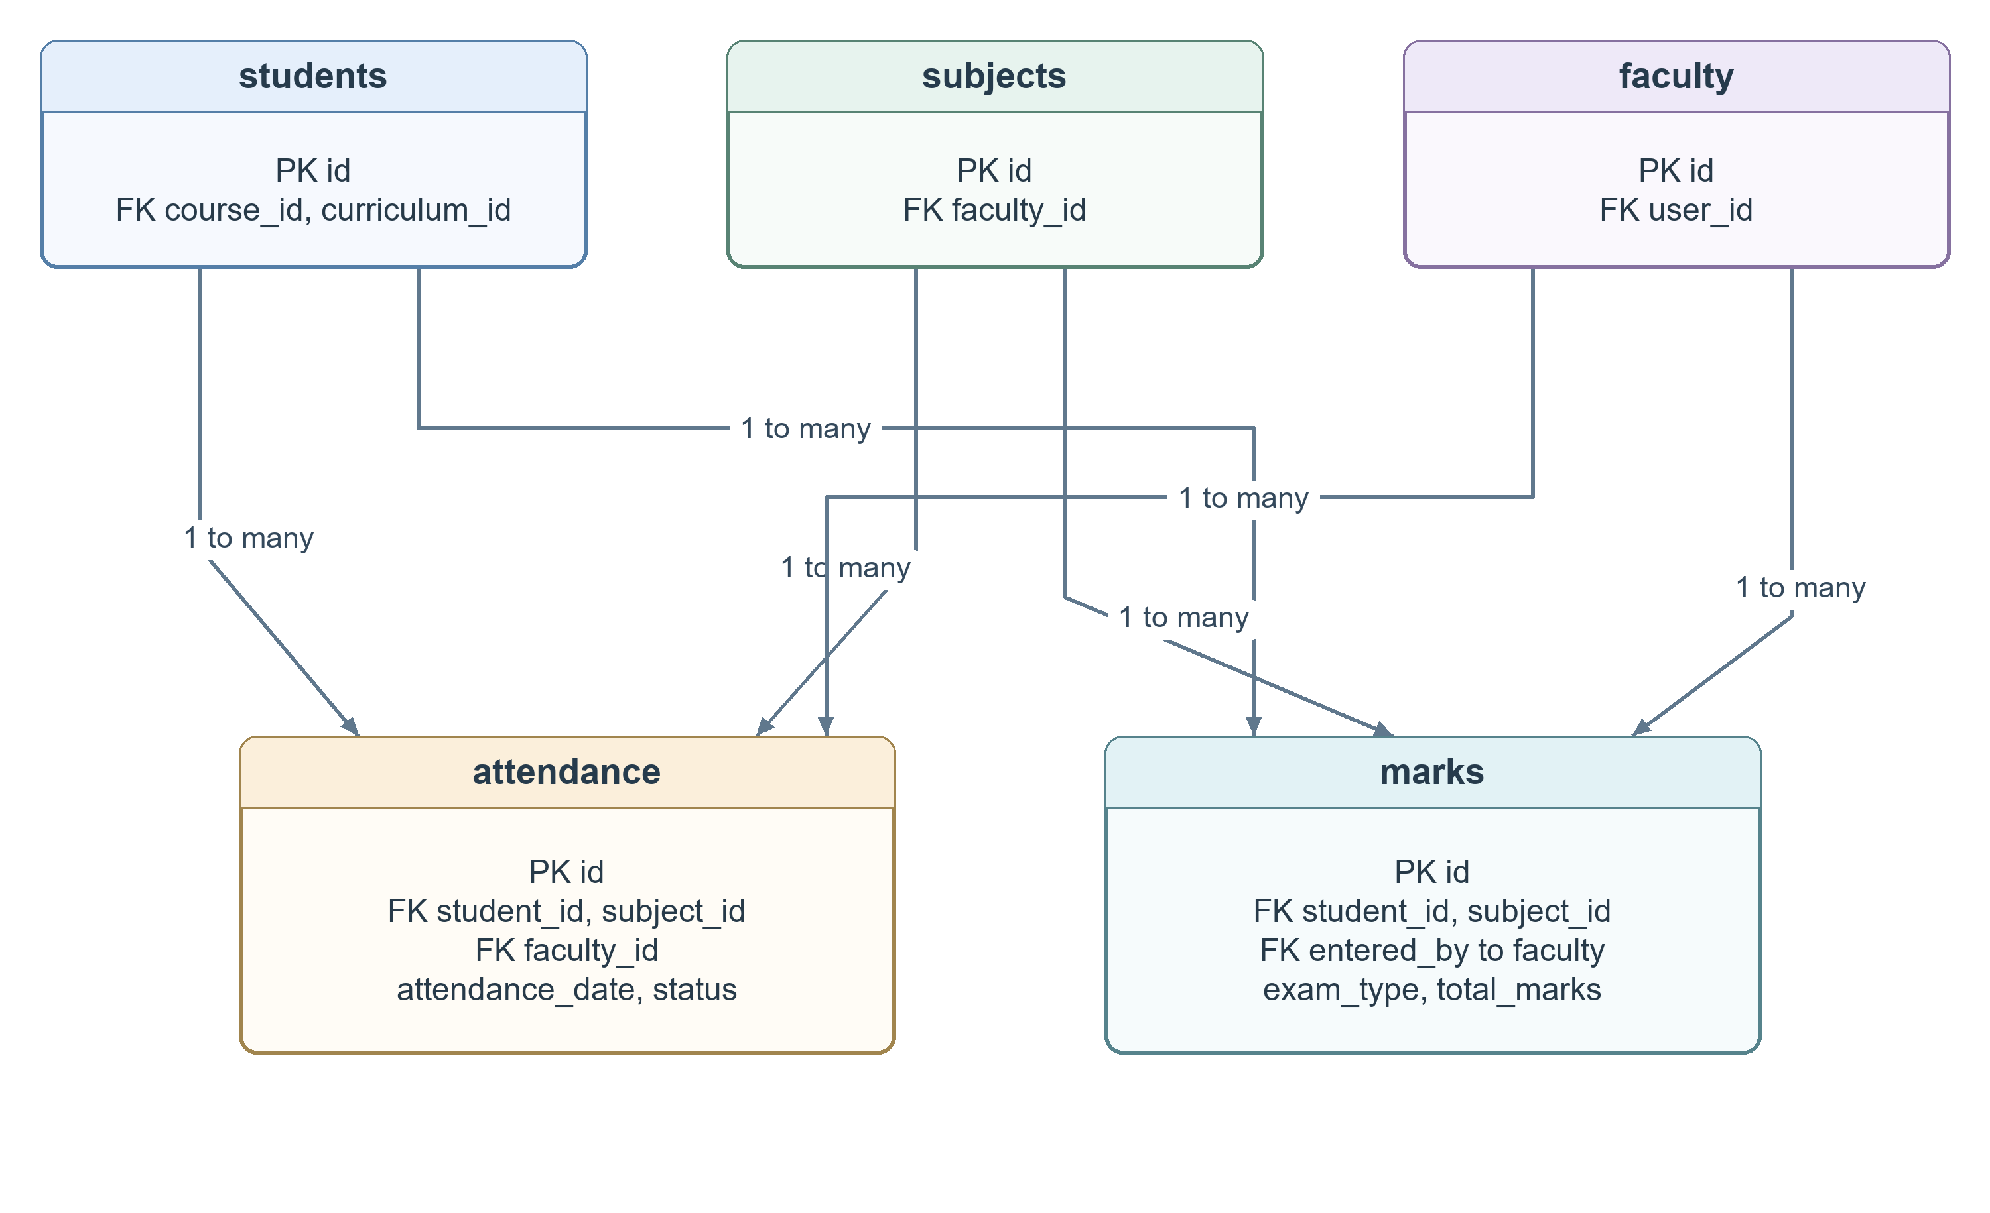
Figure 4 Student subject and faculty references in assessment
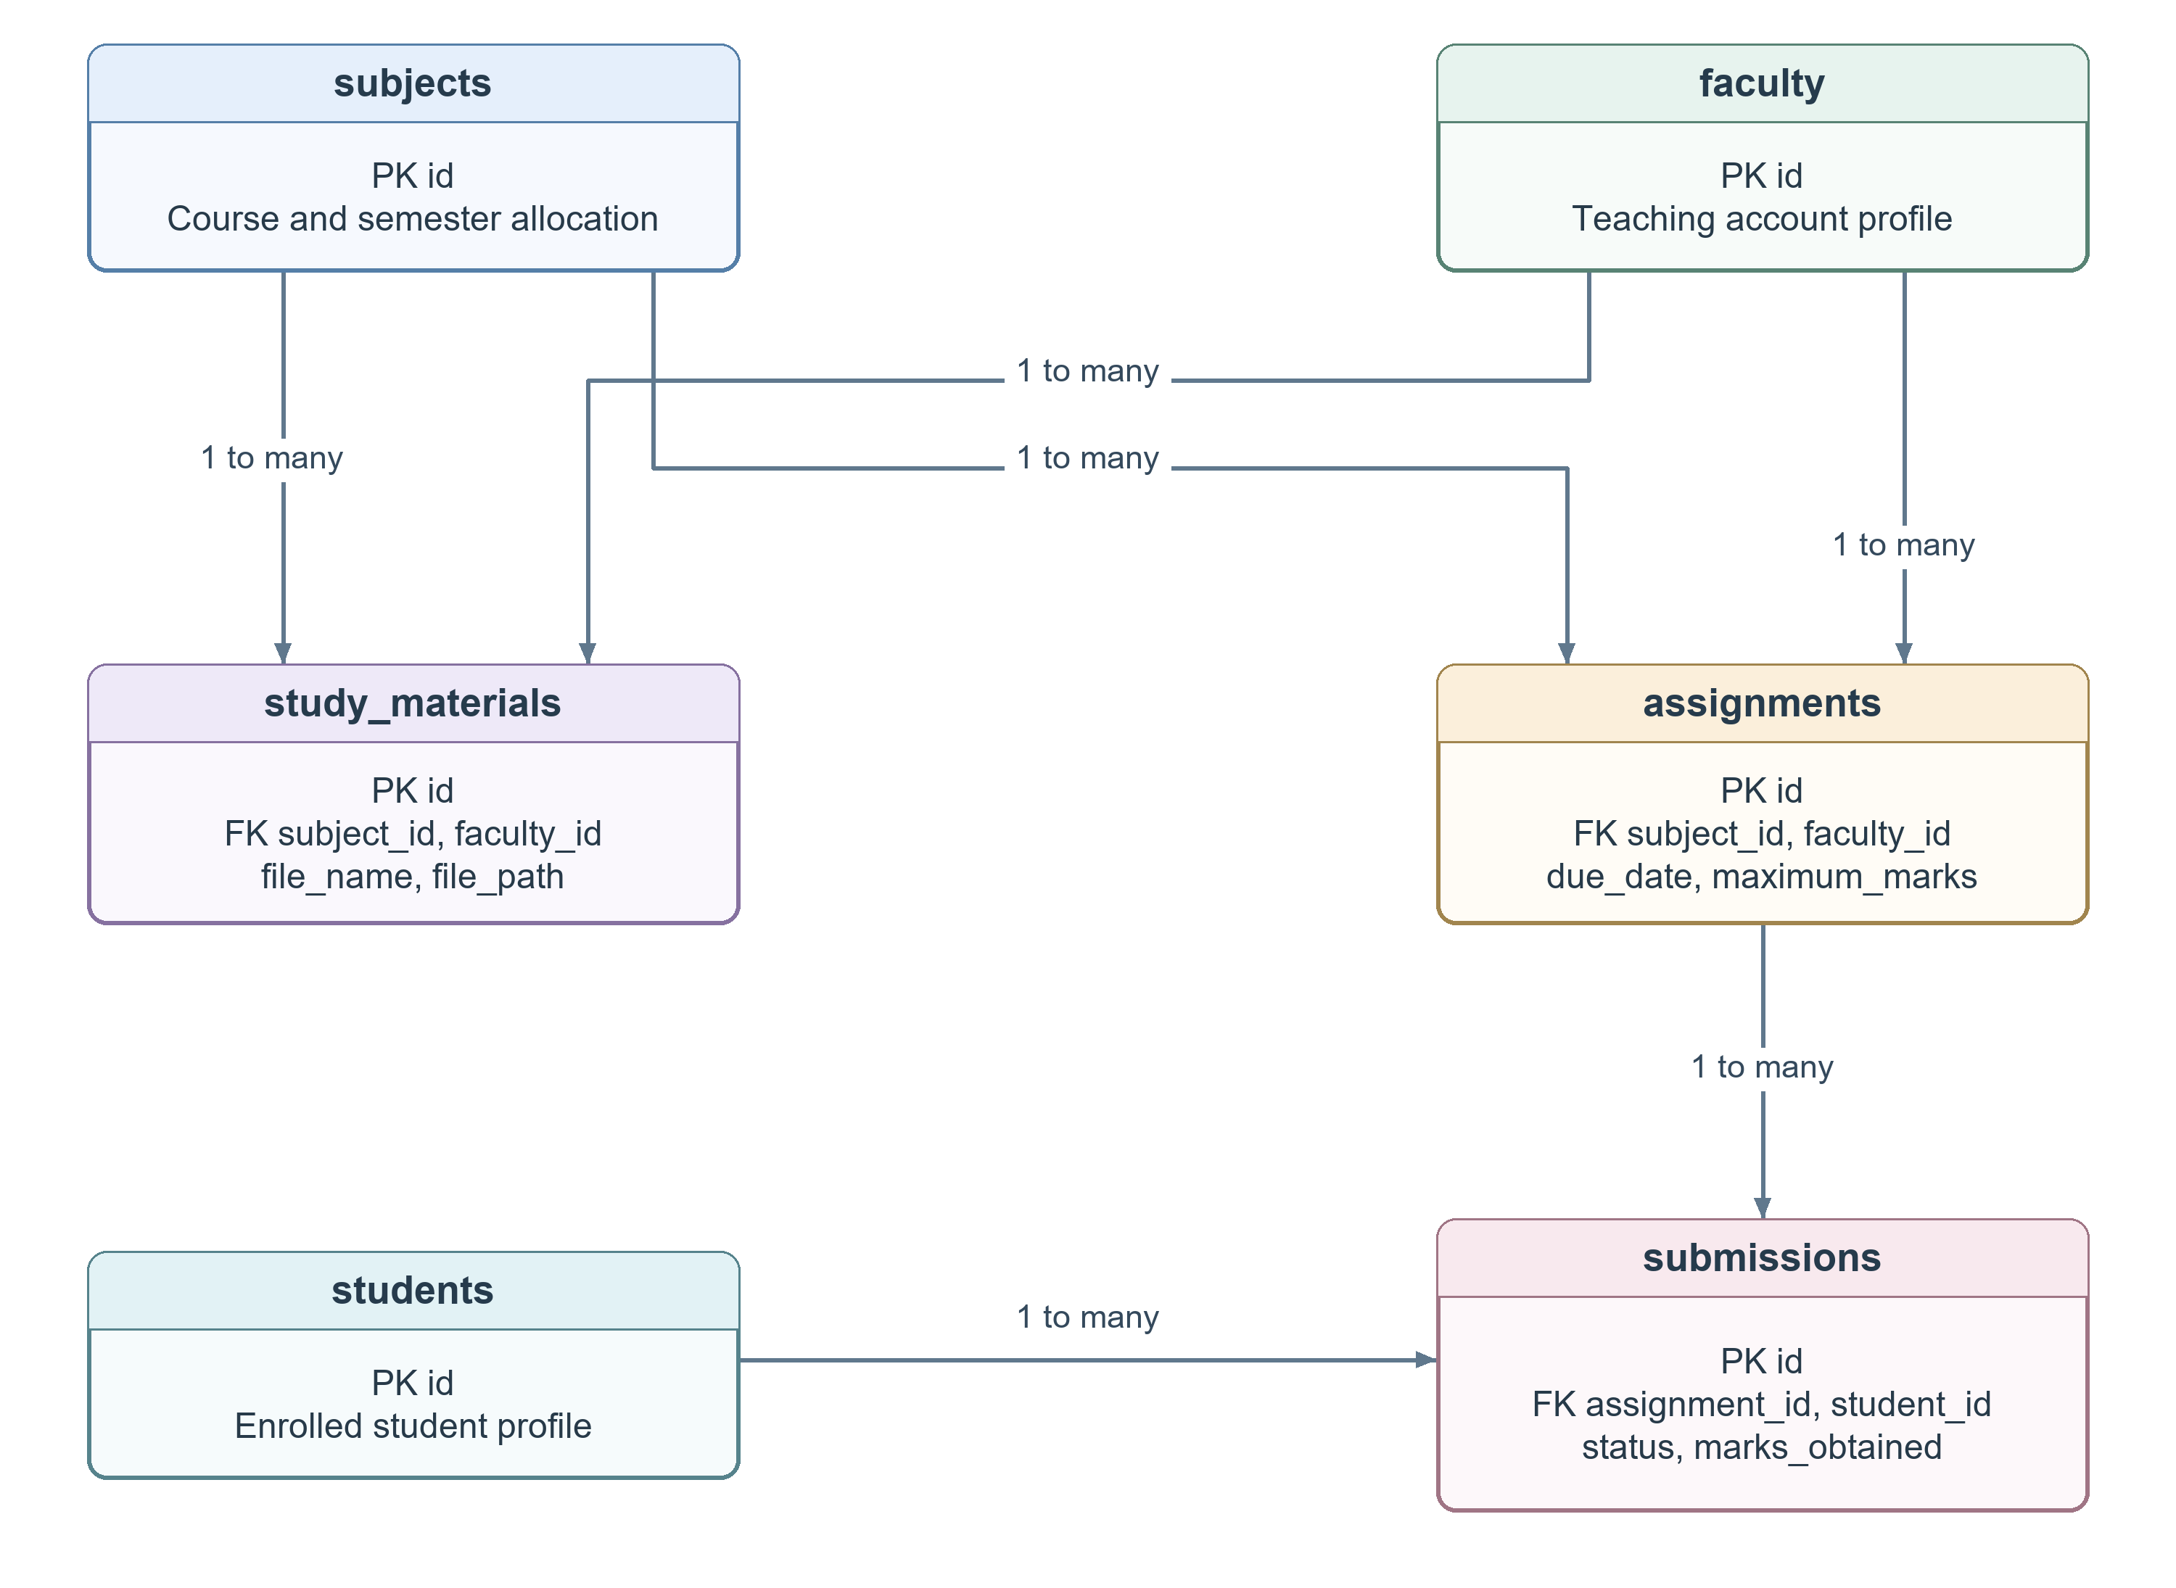
Figure 5 Learning materials assignments and submissions
Attendance is unique per student, subject and date; marks per student, subject and exam type. An assignment has at most one tracked submission per student. All academic operations also check the authorised subject relationship.
Curriculum and Participation Relationships
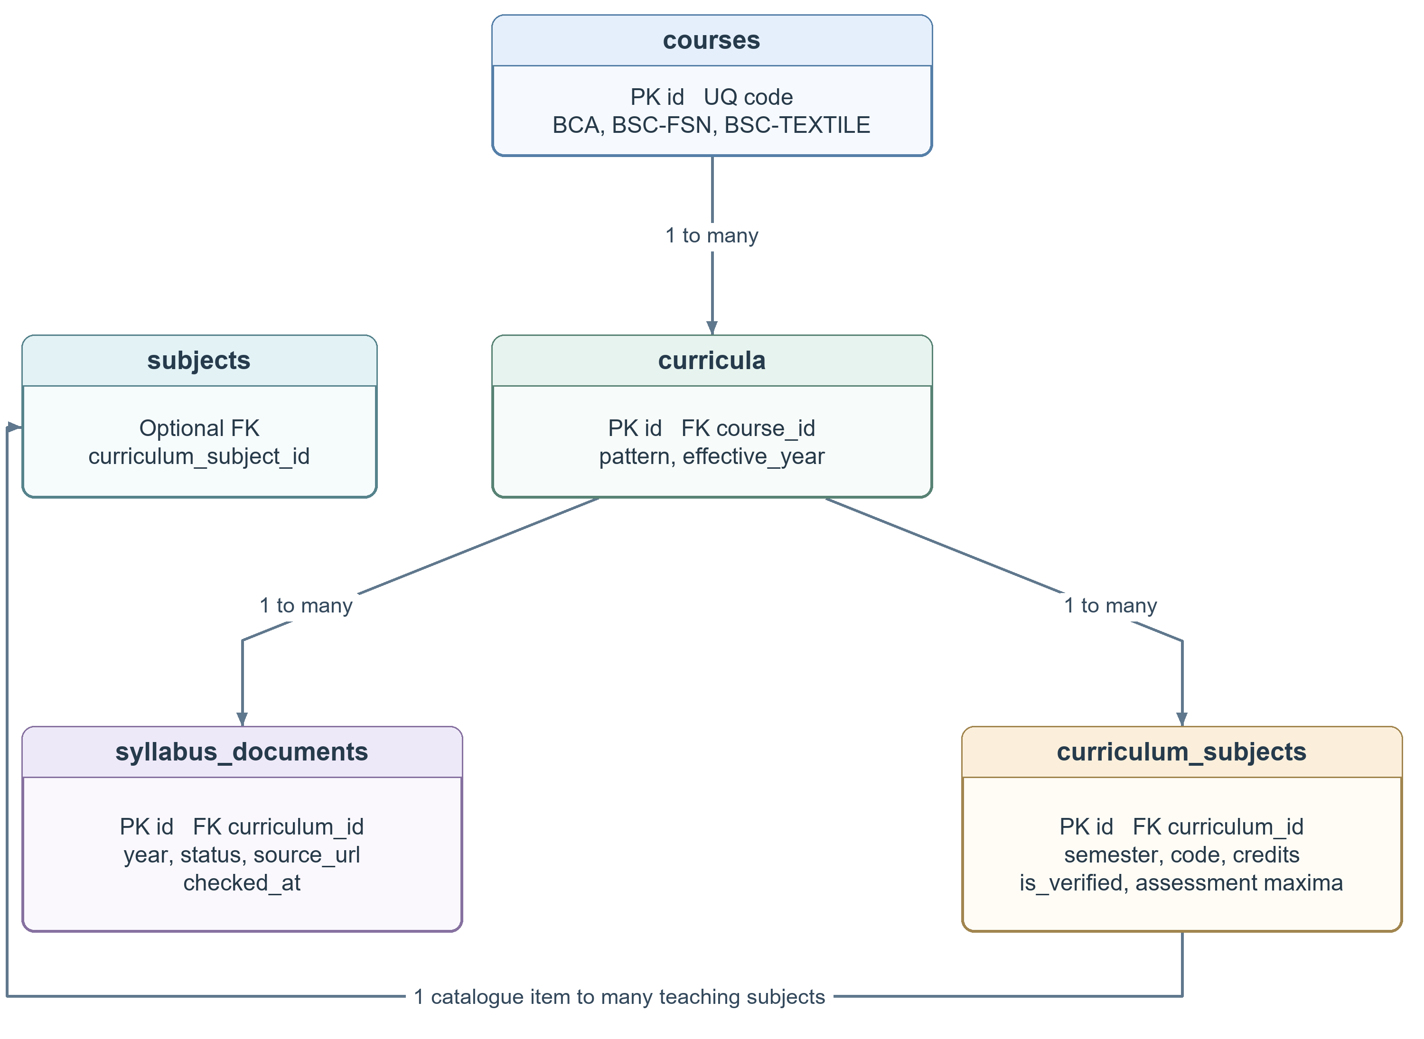
Figure 6 Versioned curriculum documents and catalogue subjects
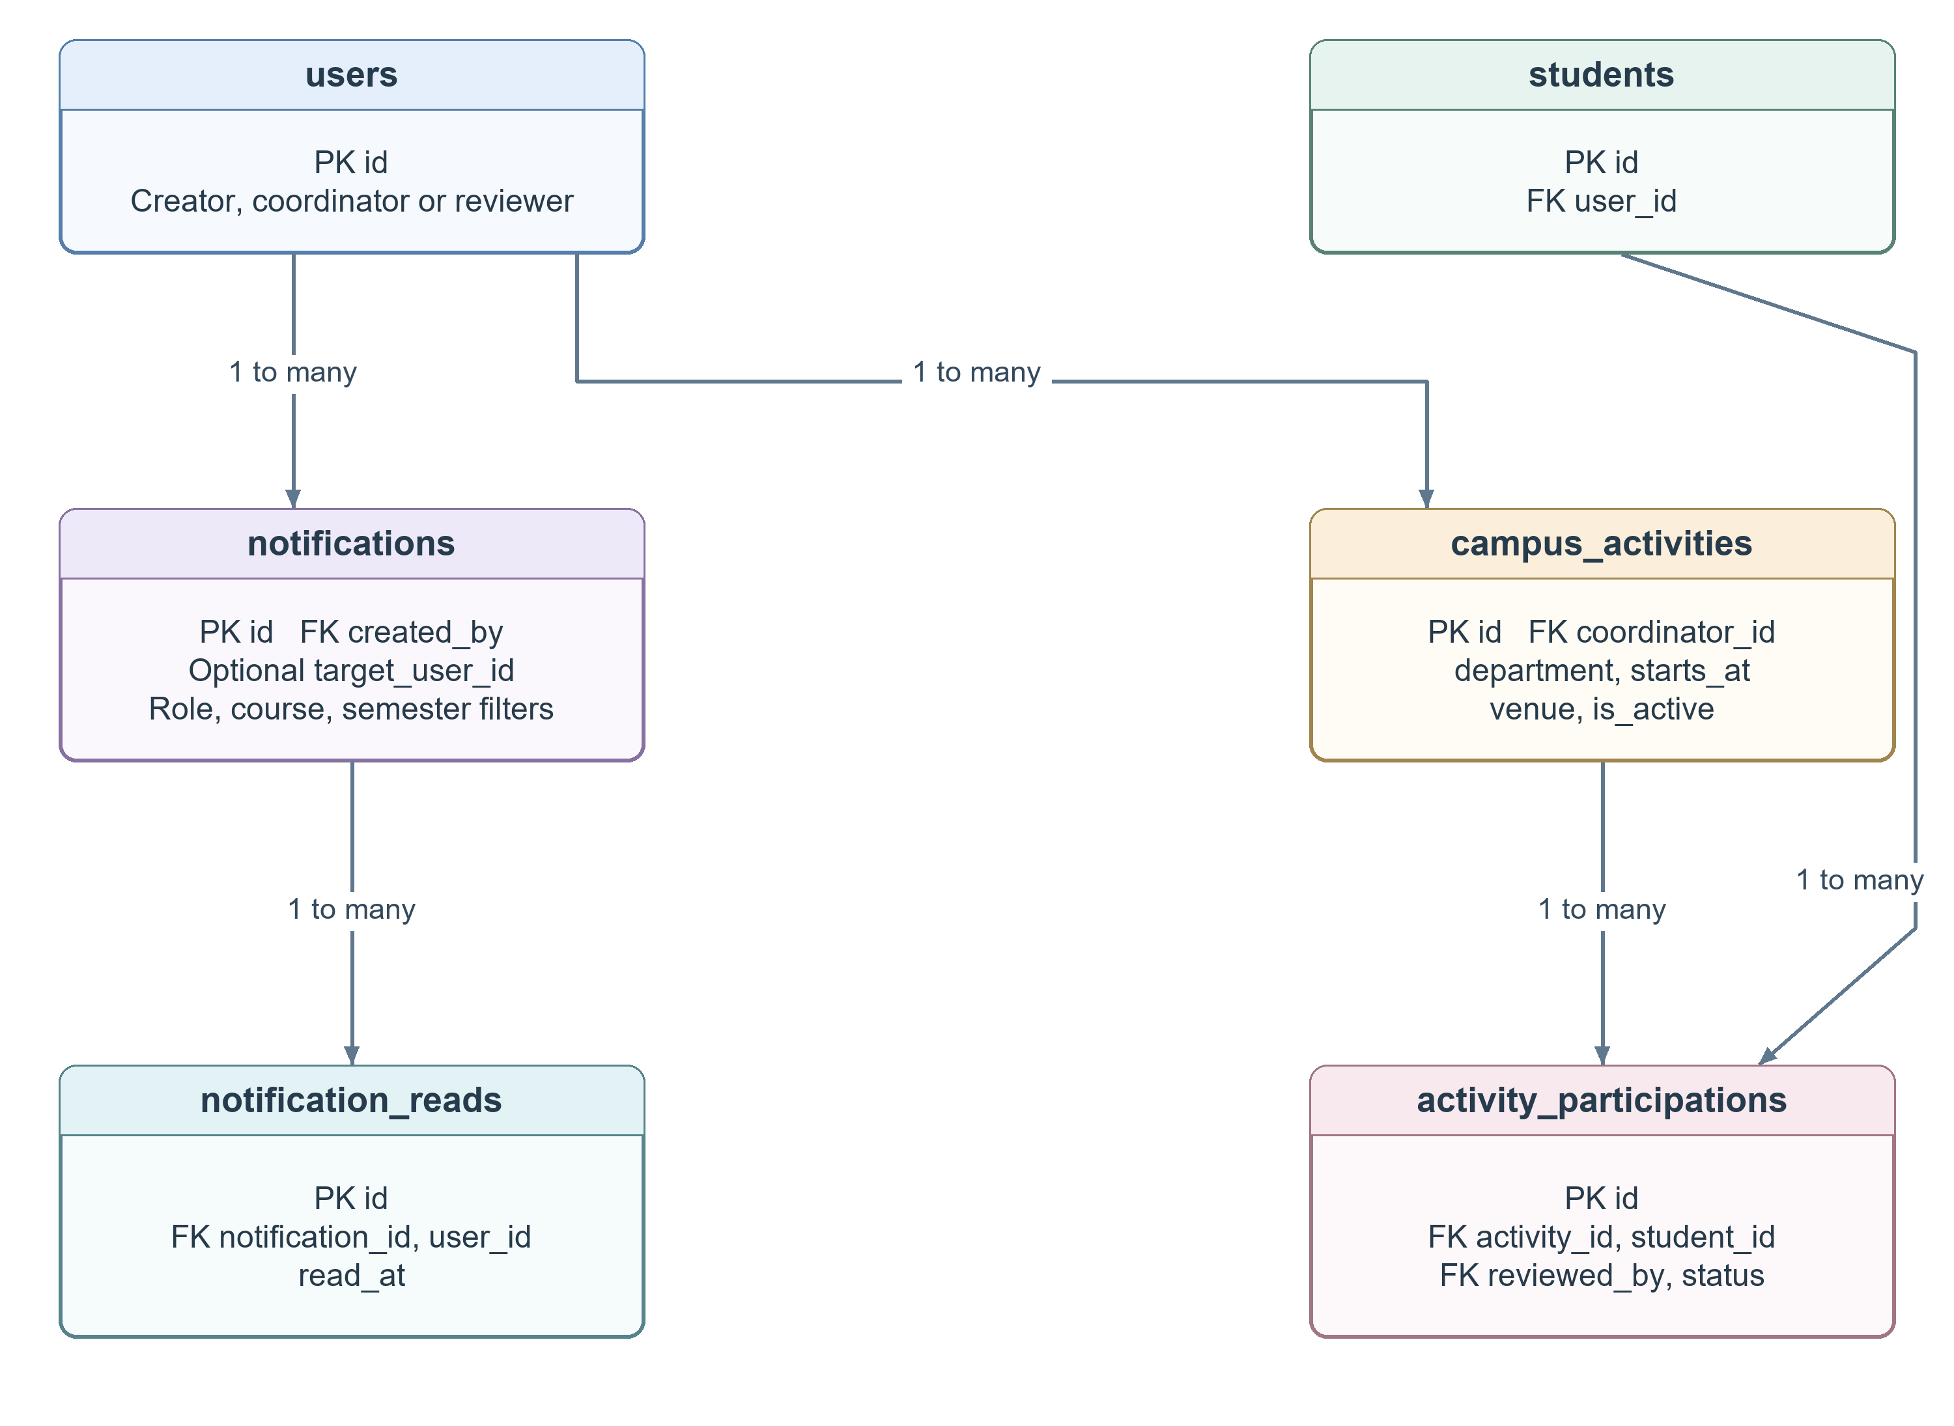
Figure 7 Notifications read receipts and activity participation
Source documents and catalogue subjects belong to a curriculum pattern. Activity participation links a student to an activity and its review. Contact inquiries and student-test snapshots are independent records; their models do not declare a student-account foreign key.

6 Data Flow Diagrams
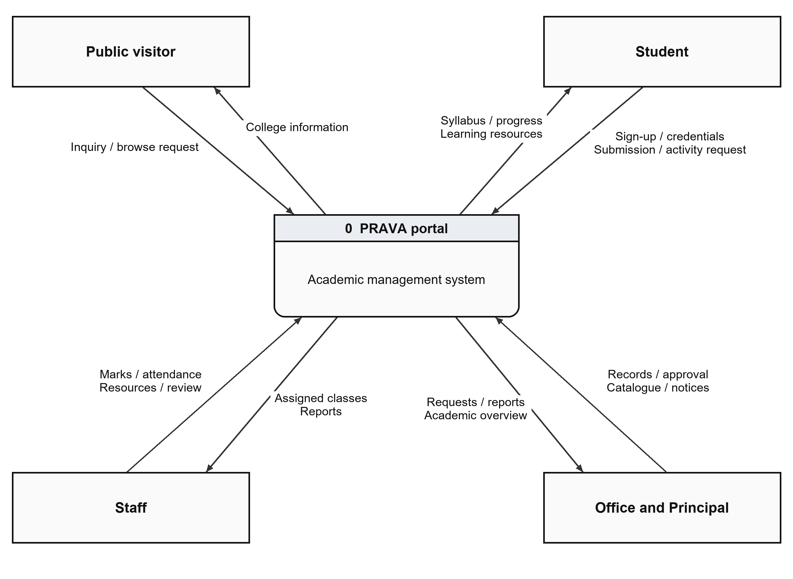
Figure 8 Context DFD for the PRAVA academic portal
The context diagram shows the system boundary. Visitors request public information and submit inquiries. Students supply registration and learning inputs and receive their academic views. Staff maintain assigned academic records. Office manages approvals and institutional records; Principal access provides permitted oversight.
Arrows identify information exchanged with the system. The database is internal to PRAVA and is expanded into logical stores at the next level. Google Forms collection is a separate preparatory intake process, followed by verified CSV import.
Level One Data Flow
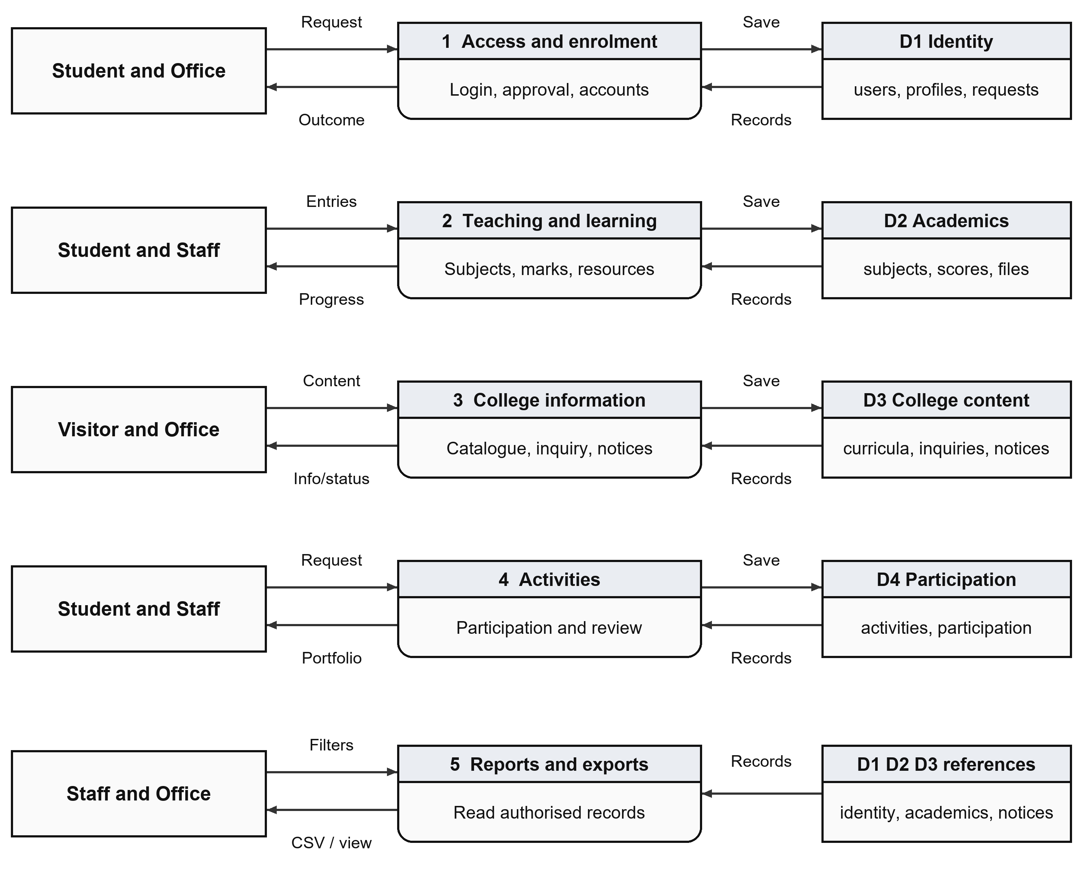
Figure 9 Level one decomposition and logical data stores
The five processes cover access and enrolment, teaching and learning, college information, activities, and reporting. D1–D4 group related tables in the same relational database. Reporting reads existing records within the current account scope and produces views or CSV files.
A report does not create a second independent academic total. The data stores are logical groups; the application maintains a shared schema with database keys and service-level validation.
Level Two Registration Review
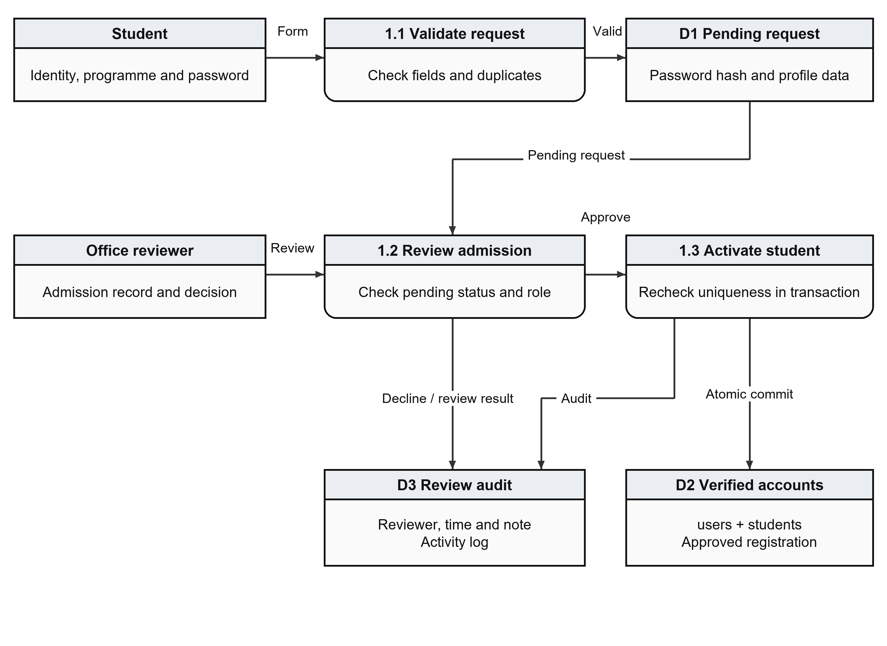
Figure 10 Student sign-up validation Office review and activation
A valid website sign-up creates a pending request after format and duplicate checks. An authorised Office user reviews the request. Approval repeats the uniqueness checks and creates a login identity and student profile atomically. A conflict rolls the operation back and returns review feedback.
The review records its decision, reviewer and time. Rejected requests remain reviewed. Approval permits the student to sign in with the chosen credentials; it does not automatically send an email or create subject allocations.
7 Data Dictionary
The schema contains 22 tables and 227 declared columns. This five-page summary lists every table and selected fields needed to explain the principal workflows. Repeated audit timestamps and secondary profile fields remain defined in the source models.
Table | Purpose
users | Login identity, role, scope and active status.
students | Student enrolment and programme profile.
faculty | Staff identity and professional profile.
courses | Degree programmes and semester count.
subjects | Teaching subjects and faculty allocation.
attendance | Date-wise student attendance.
marks | Subject assessments and component scores.
assignments | Faculty coursework and due dates.
submissions | Student work, marks and feedback.
study_materials | Uploaded learning-resource metadata.
student_registrations | Pending sign-ups and Office decisions.
curricula | Programme pattern and effective year.
curriculum_subjects | NEP catalogue subjects and assessment limits.
syllabus_documents | Year-wise source links and review status.
campus_activities | College activities and coordinators.
activity_participations | Student activity registration and review.
notifications | Targeted announcements and expiry.
notification_reads | Per-user notice read receipts.
contact_inquiries | Public contact messages and status.
record_imports | Staged CSV import payload and owner.
activity_logs | Recorded user actions and timestamps.
student_test_responses | Student test answers, score and feedback.
Notation: PK = primary key; FK = foreign key; UQ = unique. Each table has an id primary key. Field types and keys below follow the SQLAlchemy declarations; validation rules are described separately.
Identity and Enrolment
Table | Field | Type | Key / meaning
users | id | INTEGER | PK
users | username | VARCHAR(80) | UQ
users | full_name | VARCHAR(120) | Account holder name
users | email | VARCHAR(120) | UQ
users | password_hash | VARCHAR(255) | One-way password hash
users | role | VARCHAR(20) | student / faculty / admin
users | admin_scope | VARCHAR(30) | Administrator / office / principal scope
users | is_active | BOOLEAN | Controls account availability
students | id | INTEGER | PK
students | user_id | INTEGER | UQ; FK users.id
students | enrollment_number | VARCHAR(50) | UQ
students | course_id | INTEGER | FK courses.id
students | curriculum_id | INTEGER | FK curricula.id
students | semester | INTEGER | Current / assigned semester
students | admission_year | INTEGER | Year of admission
faculty | id | INTEGER | PK
faculty | user_id | INTEGER | UQ; FK users.id
faculty | employee_id | VARCHAR(50) | UQ
faculty | department | VARCHAR(120) | Teaching department
faculty | qualification | VARCHAR(120) | Recorded qualification
users stores shared authentication identity. A unique user_id connects each student or faculty profile to one account. Enrolment numbers and employee IDs identify the corresponding college records.
Teaching and Assessment
Table | Field | Type | Key / meaning
courses | id | INTEGER | PK
courses | code | VARCHAR(30) | UQ
courses | name | VARCHAR(120) | Display name
courses | total_semesters | INTEGER | Programme semester count
subjects | id | INTEGER | PK
subjects | code | VARCHAR(30) | Programme / subject code
subjects | course_id | INTEGER | FK courses.id
subjects | semester | INTEGER | Current / assigned semester
subjects | faculty_id | INTEGER | FK faculty.id
subjects | curriculum_subject_id | INTEGER | FK curriculum_subjects.id
attendance | id | INTEGER | PK
attendance | student_id | INTEGER | FK students.id
attendance | subject_id | INTEGER | FK subjects.id
attendance | attendance_date | DATE | Date of the class record
attendance | status | VARCHAR(20) | Workflow / attendance state
marks | id | INTEGER | PK
marks | student_id | INTEGER | FK students.id
marks | subject_id | INTEGER | FK subjects.id
marks | exam_type | VARCHAR(50) | Assessment label
marks | internal_marks | INTEGER | Internal component
marks | external_marks | INTEGER | External component
marks | total_marks | INTEGER | Internal + external total
Composite uniqueness: subjects (code, course_id, semester); attendance (student_id, subject_id, attendance_date); marks (student_id, subject_id, exam_type). Assessment services check eligibility and configured component limits.
Coursework and Registration
Table | Field | Type | Key / meaning
assignments | id | INTEGER | PK
assignments | subject_id | INTEGER | FK subjects.id
assignments | faculty_id | INTEGER | FK faculty.id
assignments | due_date | DATETIME | Submission deadline
assignments | maximum_marks | INTEGER | Maximum assignment score
submissions | id | INTEGER | PK
submissions | assignment_id | INTEGER | FK assignments.id
submissions | student_id | INTEGER | FK students.id
submissions | marks_obtained | INTEGER | Awarded assignment score
submissions | faculty_feedback | TEXT | Review comments
submissions | status | VARCHAR(30) | Workflow / attendance state
study_materials | id | INTEGER | PK
study_materials | subject_id | INTEGER | FK subjects.id
study_materials | file_path | VARCHAR(255) | Stored resource path
student_registrations | id | INTEGER | PK
student_registrations | enrollment_number | VARCHAR(50) | UQ
student_registrations | curriculum_id | INTEGER | FK curricula.id
student_registrations | status | VARCHAR(20) | Workflow / attendance state
student_registrations | reviewed_by | INTEGER | FK users.id
student_registrations | user_id | INTEGER | UQ; FK users.id
One submission is tracked per assignment and student. Registration review activates an approved account and links user_id; approval rechecks uniqueness. Uploaded-file paths identify controlled local storage, not a second academic database.
Curriculum and Activities
Table | Field | Type | Key / meaning
curricula | id | INTEGER | PK
curricula | course_id | INTEGER | FK courses.id
curricula | pattern | VARCHAR(80) | Curriculum pattern label
syllabus_documents | id | INTEGER | PK
syllabus_documents | curriculum_id | INTEGER | FK curricula.id
syllabus_documents | year | INTEGER | Programme year
syllabus_documents | source_url | VARCHAR(1000) | Reference document URL
syllabus_documents | status | VARCHAR(30) | Workflow / attendance state
curriculum_subjects | id | INTEGER | PK
curriculum_subjects | curriculum_id | INTEGER | FK curricula.id
curriculum_subjects | semester | INTEGER | Current / assigned semester
curriculum_subjects | code | VARCHAR(60) | Programme / subject code
curriculum_subjects | credits | NUMERIC(4, 1) | Published credit value
curriculum_subjects | is_verified | BOOLEAN | Catalogue verification flag
campus_activities | id | INTEGER | PK
campus_activities | title | VARCHAR(180) | Activity title
campus_activities | coordinator_id | INTEGER | FK users.id
activity_  participations | id | INTEGER | PK
activity_  participations | activity_id | INTEGER | FK campus_activities.id
activity_  participations | student_id | INTEGER | FK students.id
activity_  participations | status | VARCHAR(30) | Workflow / attendance state
activity_  participations | reviewed_by | INTEGER | FK users.id
Composite uniqueness: curriculum (course_id, pattern); syllabus document (curriculum_id, year); catalogue subject (curriculum_id, semester, code); participation (activity_id, student_id). Catalogue verification and activity review remain explicit recorded states.

8 Academic Processing and Reports
Subject allocation and attendance
Office creates teaching subjects for a course, curriculum and semester, then assigns the responsible faculty member. Staff receives the eligible cohort for that allocation. Attendance stores Present, Absent or Late per student and class date. The current report counts Present and Late as attended sessions.
Attendance percentage = attended records ÷ recorded sessions × 100. With no sessions, progress remains pending. The implemented 75 percent warning is an application threshold that requires college confirmation before formal use.
Marks and assignments
Internal and external marks must be non-negative and within configured maxima. NEP entry also requires a verified assessment link and matching component limits. The total is internal plus external marks; official NEP grade, SGPA and CGPA conversion is pending. Assignments store deadlines and maximum marks; submissions hold work, status and faculty feedback.
Report | Information produced
Students and Faculty | Identity, programme or department, contact and active status.
Attendance | Student, subject, date, status and recording faculty.
Marks | Configured scores, totals and existing generic threshold-based result.
Assignments | Assignment, subject, due date, maximum marks and submission count.
Notifications | Title, audience, creator, active status and timing.

CSV and print-friendly views support review of stored records. The generic pass/fail export uses the subject passing threshold; it is not an official university result calculation.

9 Student and Staff Information Collection
Separate English Google Forms collect Student and Staff profiles into private response spreadsheets. As of 5 October 2026, nine student responses represent eight distinct BCA profiles after duplicate review. The local portal contains 19 students: eight submitted profiles and 11 generated identities, including five newly added Home Science students and FY/SY BCA students. Eleven staff profiles have teaching allocations.
Form | Required information | Optional information
Student | Full name, email, college Enrollment/PRN, programme, class, semester, admission year and confirmation. | Mobile, date of birth, gender and address.
Staff | Full name, email, Employee ID, department, teaching subjects with programme/semester, and confirmation. | Qualification, mobile and joining date.

Verified entry into PRAVA
• Collect responses using the relevant link. Passwords are not collected in Google Forms.
• Office checks identifiers, email uniqueness, programme, semester and admission year against official records.
• Prepare the exact Student or Staff UTF-8 CSV template, assigning a unique username to each verified person.
• Validate the import preview, then save the records. Imported accounts remain inactive until individual passwords and activation are completed by Office.
• Enter optional profile fields and teaching allocations separately. Student website sign-up remains a separate approval workflow.
Programme codes: BCA, BSC-FSN and BSC-TEXTILE; pattern: 2024 NEP. The local dataset includes 135 teaching subjects. Generated attendance, marks and coursework are linked only to presentation identities. Submitted profile values are preserved as authorised; unresolved details remain subject to college verification.

10 Input and Output Screens
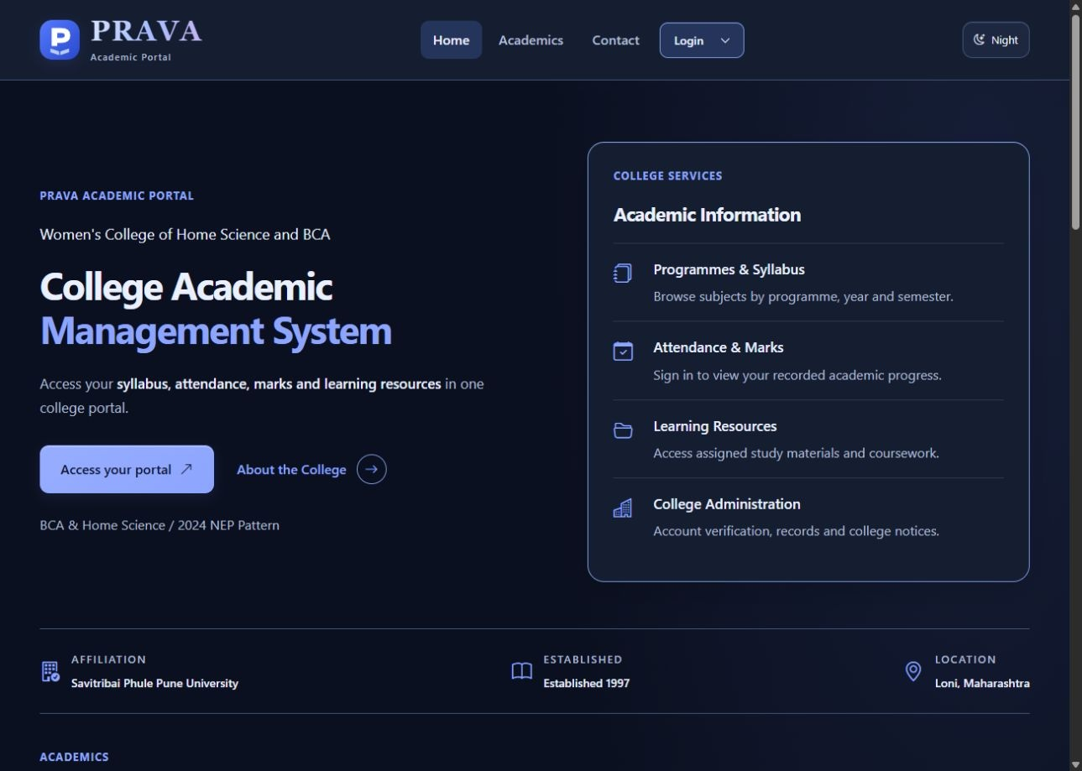
Figure 11 Current Home page in default Night mode
The header presents Home, Academics, Contact and Login. The revised heading identifies the College Academic Management System. Day mode is available from the theme control. The homepage presents academic services, programme information and college notices with functional headings.
Screenshots were refreshed on 5 October 2026 after the readability update. Named accounts display academic workflows. Generated academic entries illustrate local operation and are not official college results; the eight submitted BCA profiles retain their separate intake provenance.
Login Dropdown and Programme Selection
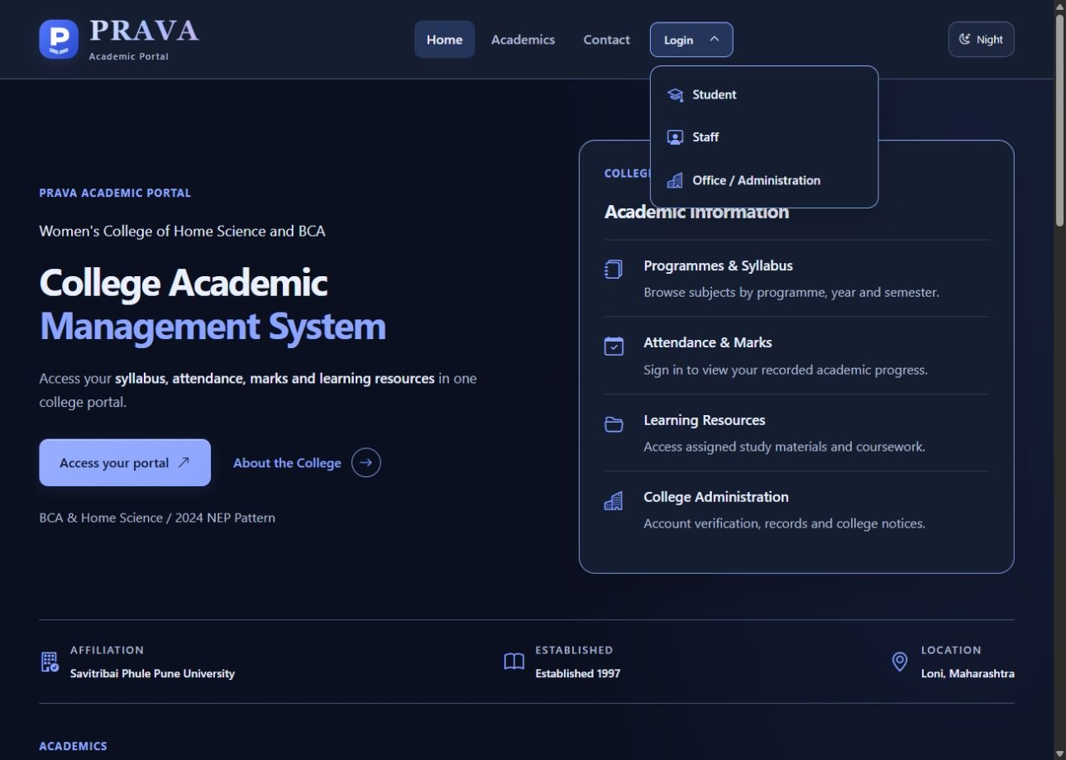
Figure 12 Login dropdown with Student Staff and Office options
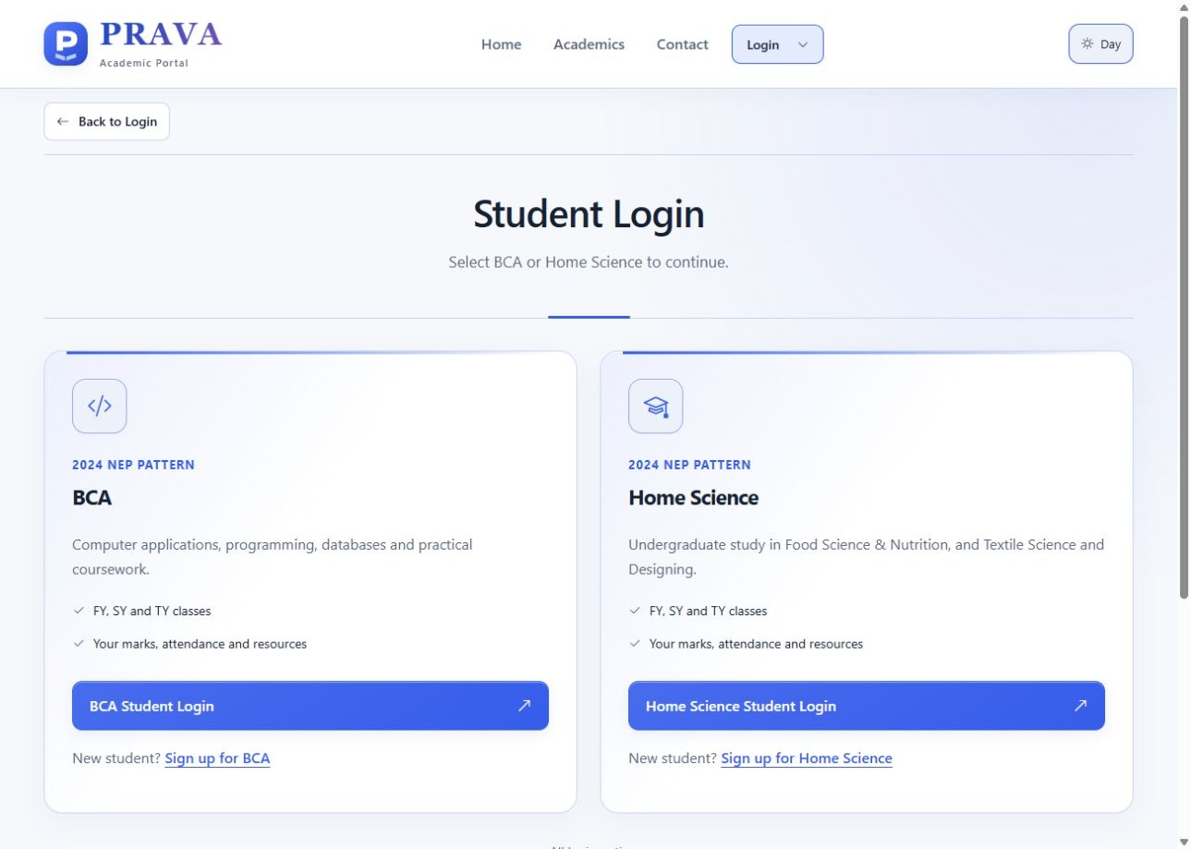
Figure 13 BCA and Home Science programme selection
Login opens a dropdown directly below the header control. Student continues to programme selection; the programme pages retain student sign-up links.
Student Login and Website Sign Up
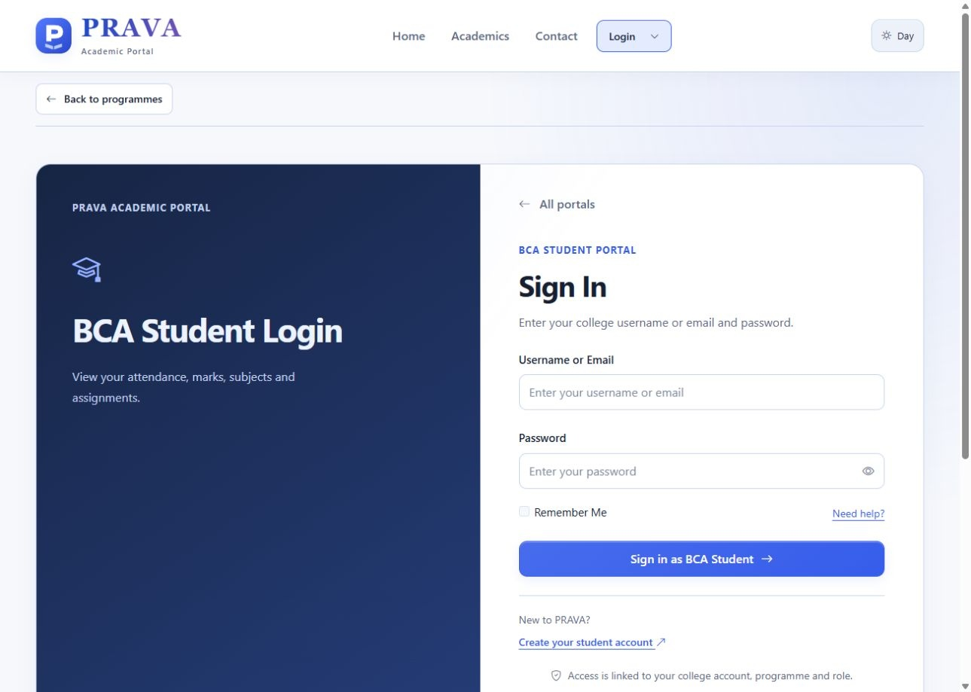
Figure 14 BCA student login form
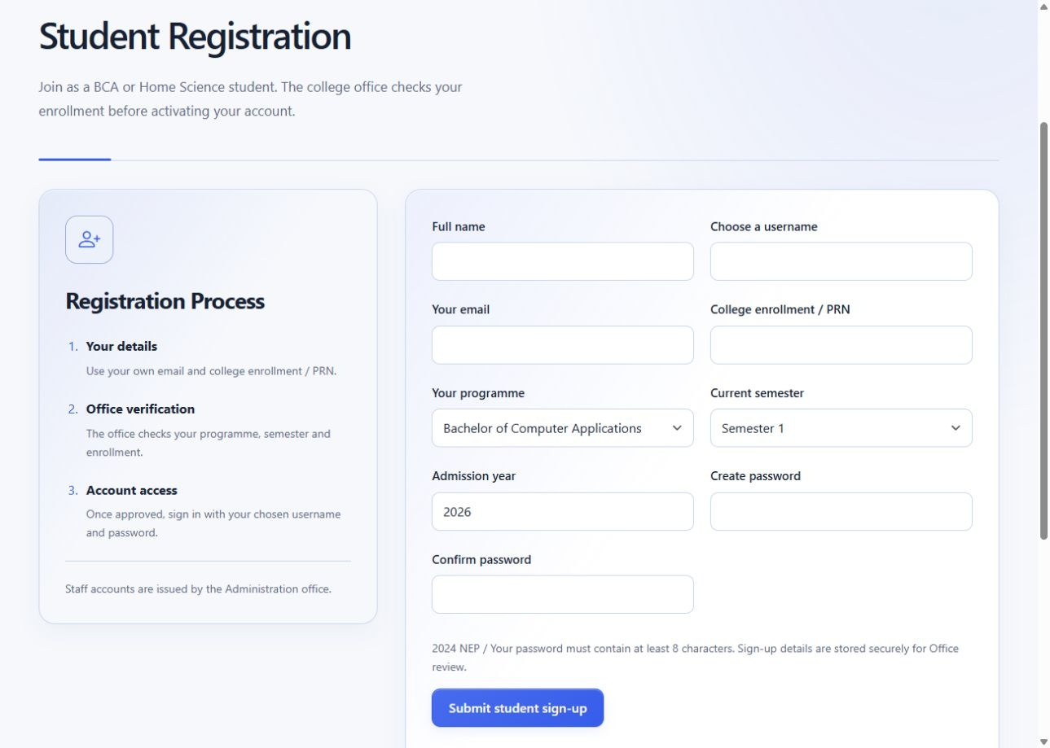
Figure 15 Student sign-up form awaiting Office verification
The role and programme are explicit on login. Website sign-up stores a pending request; successful submission alone does not grant active account access.
BCA Student Dashboard and Syllabus
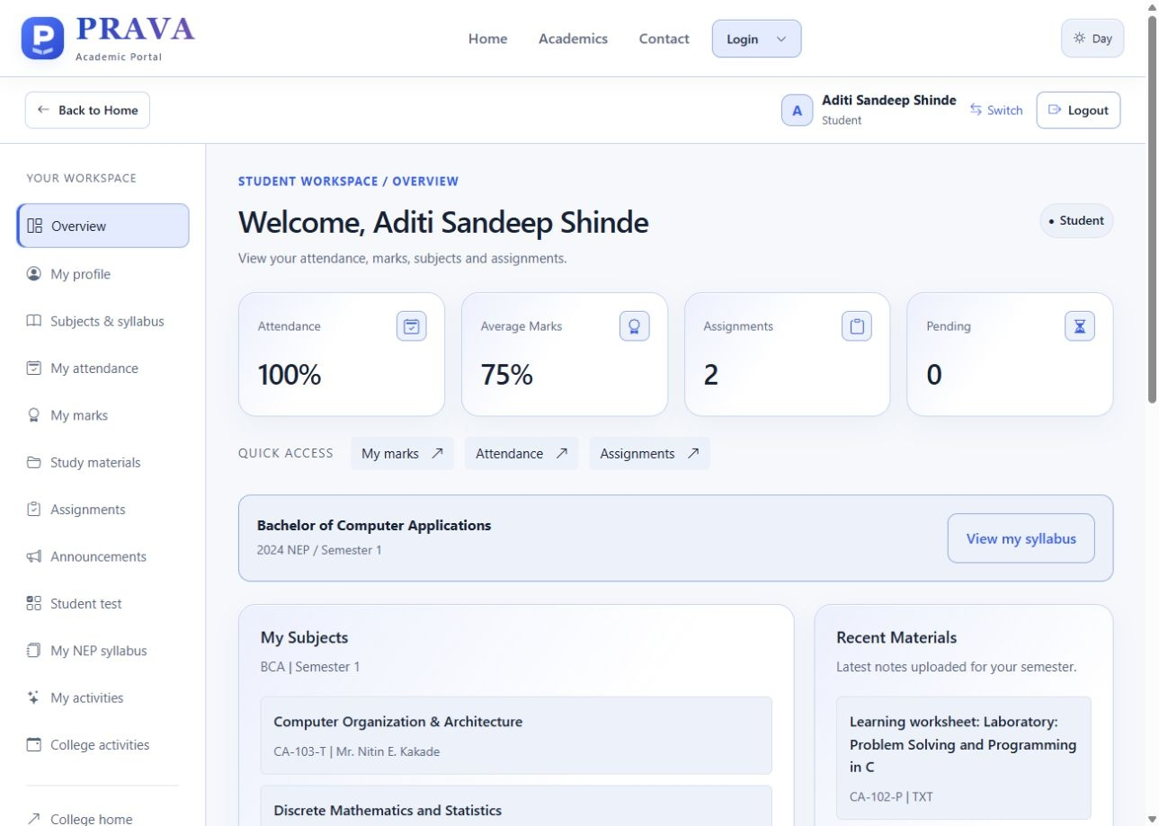
Figure 16 BCA student dashboard
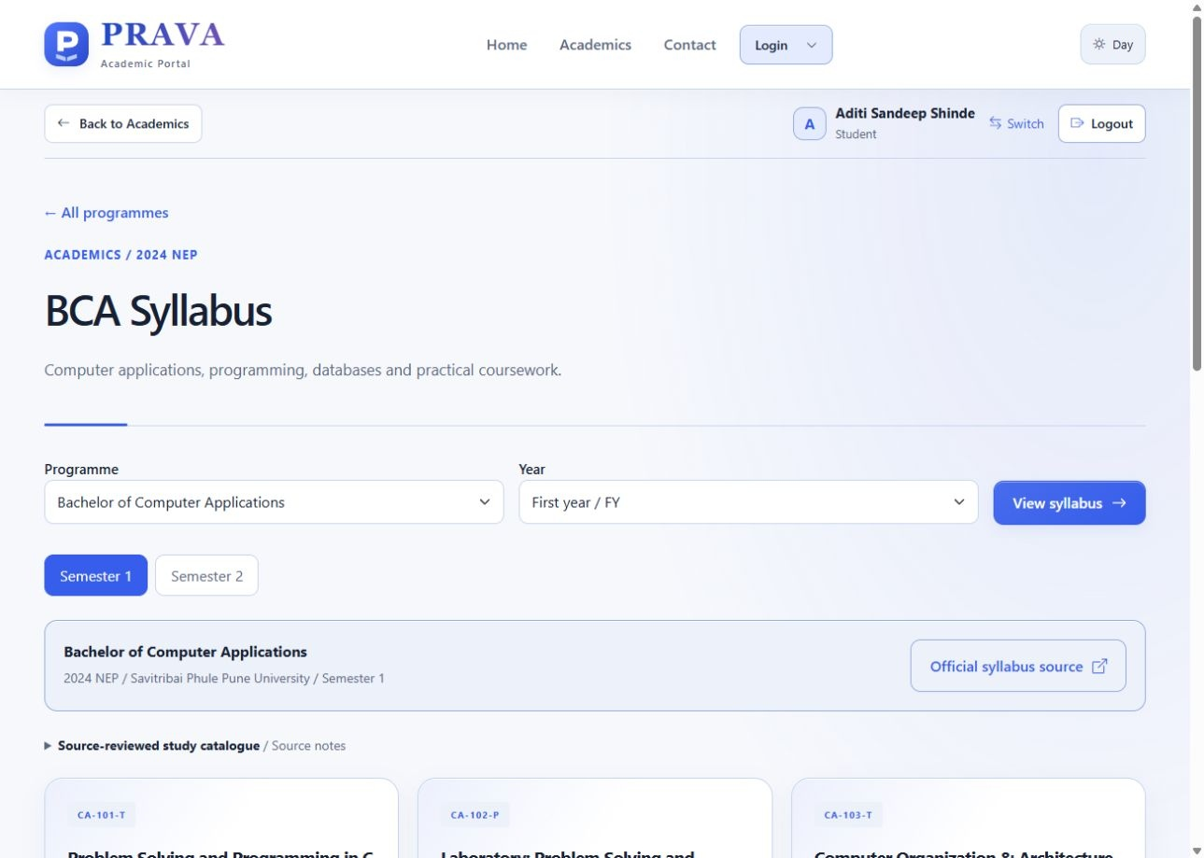
Figure 17 BCA NEP catalogue and official source link
Aditi Sandeep Shinde is the configured BCA presentation account. Its dashboard shows attendance, marks, coursework and allocated teaching subjects. The syllabus screen retains the source-linked NEP reference catalogue.
Home Science Dashboard and Syllabus
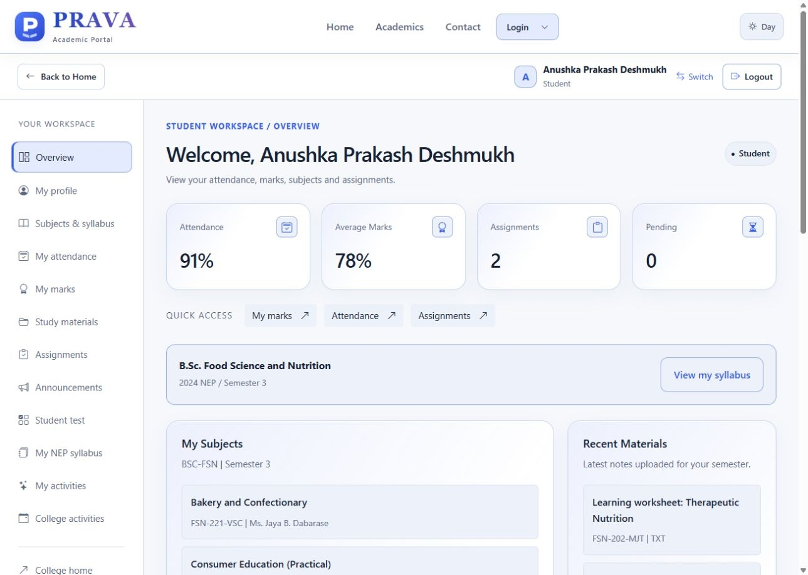
Figure 18 Home Science student dashboard
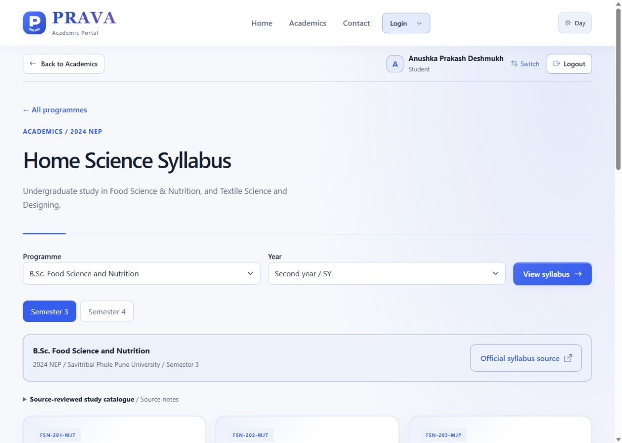
Figure 19 Home Science programme and semester catalogue
Anushka Prakash Deshmukh is configured for second-year Food Science and Nutrition. Home Science records also cover Textile Science and Designing, with FY, SY and TY students linked to their respective programmes.
Staff Dashboard and Attendance
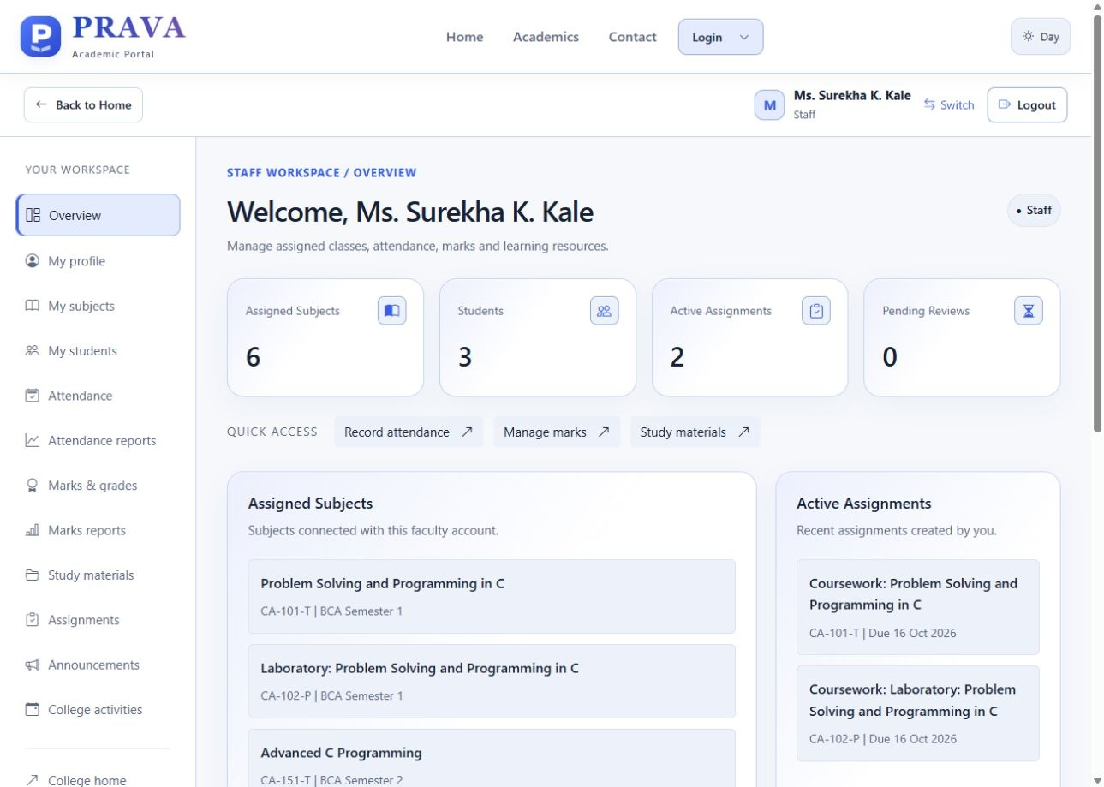
Figure 20 Staff dashboard with teaching summary
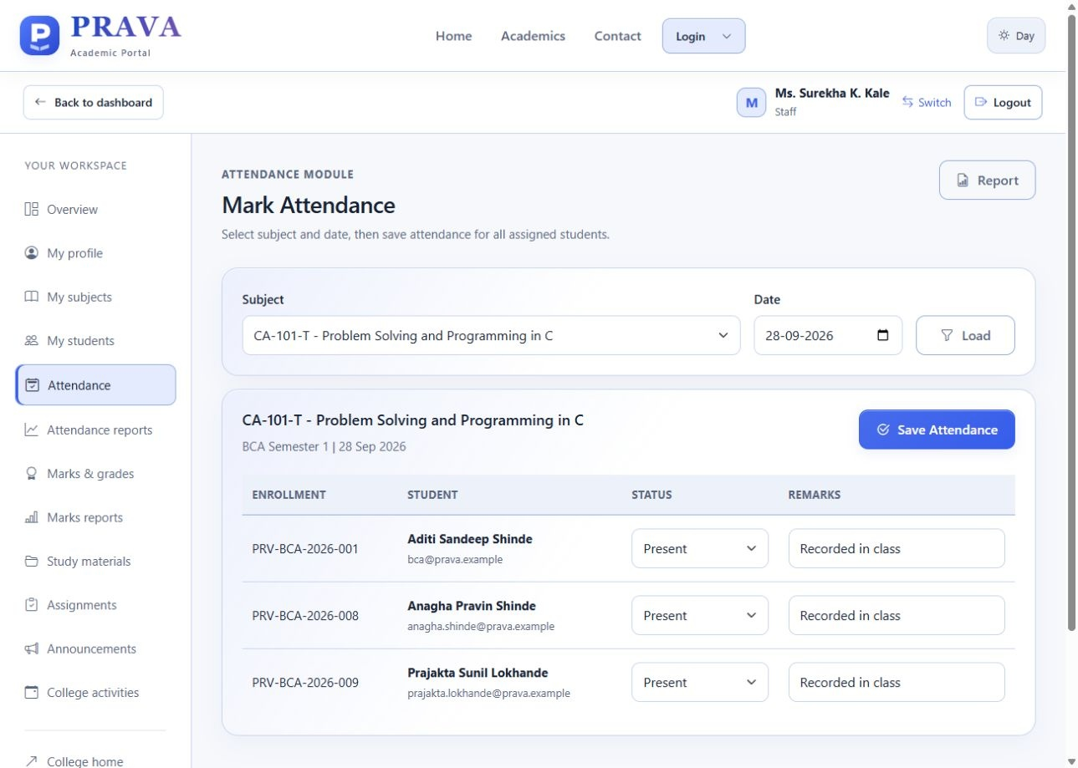
Figure 21 Attendance for an allocated teaching subject
Ms. Surekha K. Kale has six teaching allocations. The attendance screen loads the assigned BCA cohort and the selected class date. Academic entries and teaching allocations shown here are configured for the local project presentation.
Office Dashboard and Registration Review
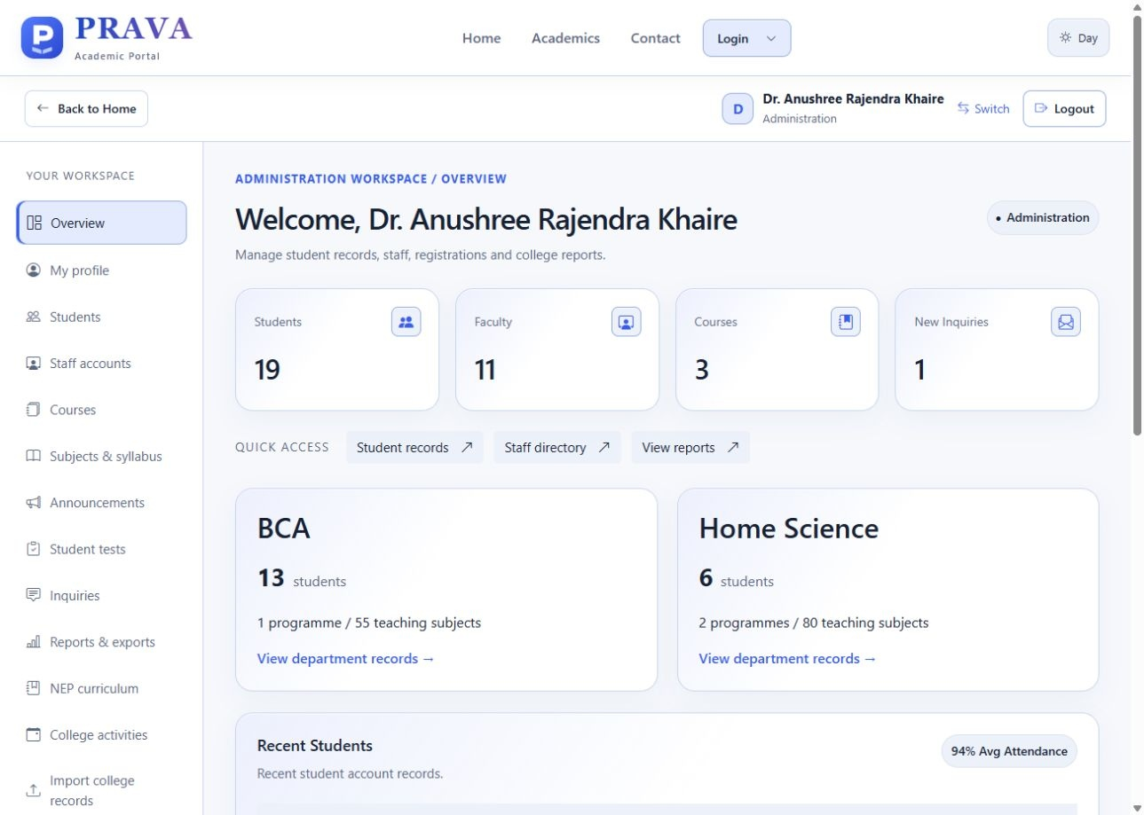
Figure 22 Office overview with BCA and Home Science departments
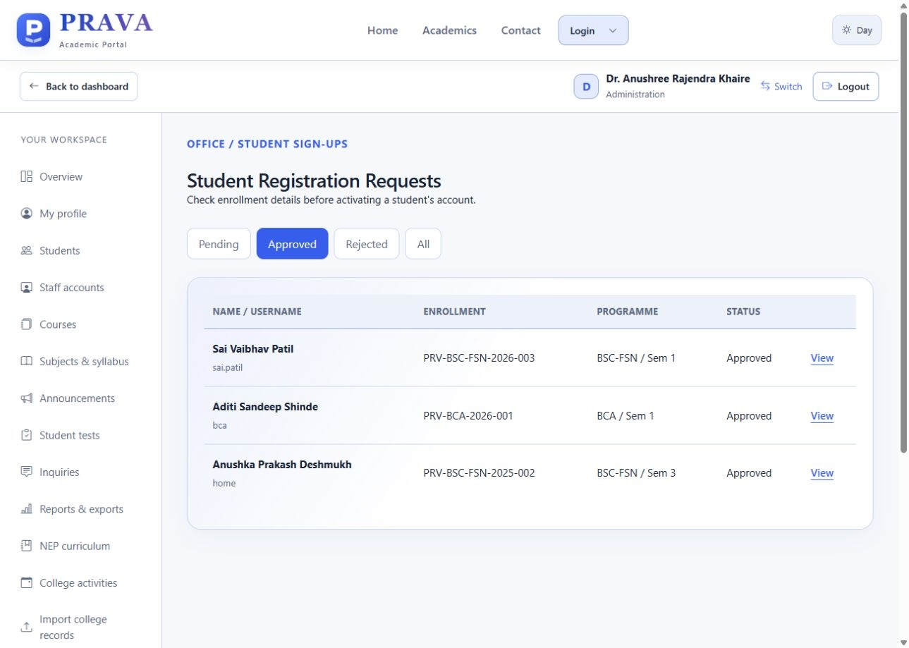
Figure 23 Office review queue for student sign-ups
The administration account displays Dr. Anushree Rajendra Khaire. The overview contains 19 student and 11 staff profiles, and the approved queue shows completed local registration records. Principal oversight also has a separate read-only account.
Roster Import and Report Outputs
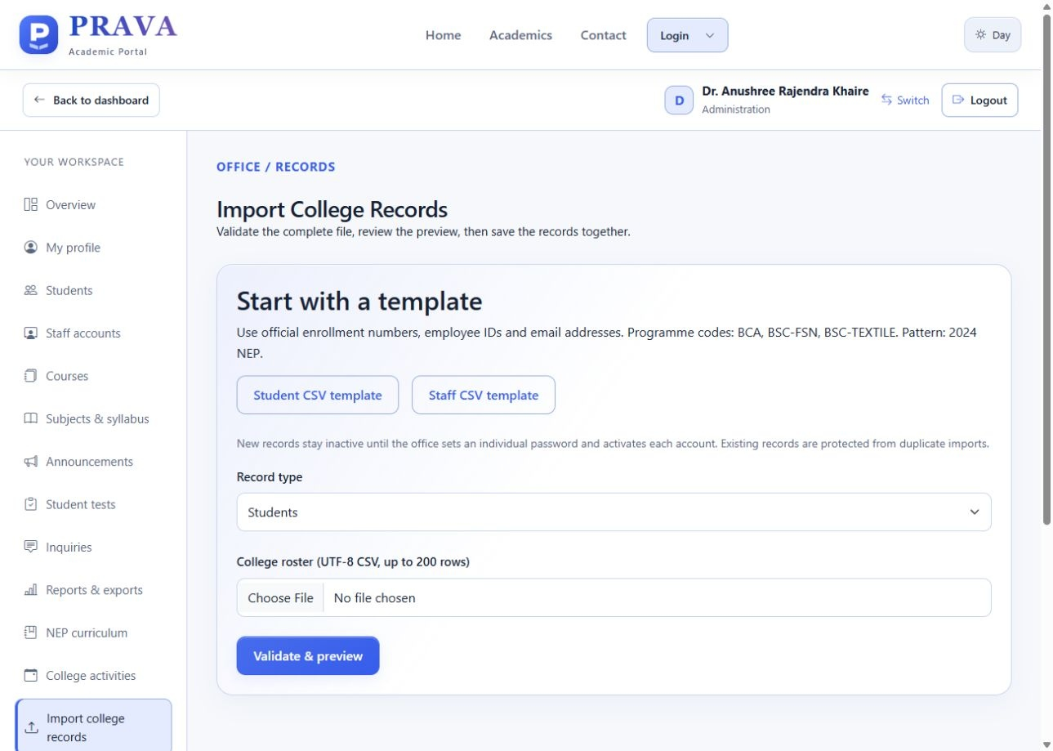
Figure 24 Separate Student and Staff CSV import templates
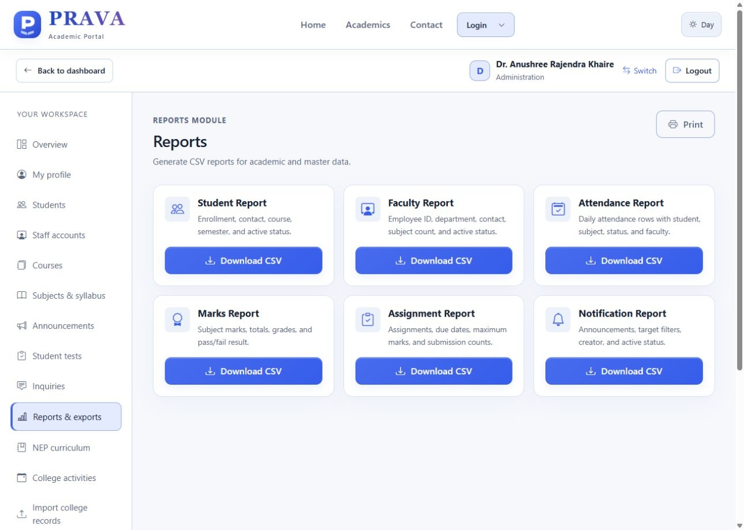
Figure 25 Administrative report and CSV export options
The import workflow validates a complete file before commit. Reports and exports use the stored records and applicable access scope.
Student Marks and Coursework
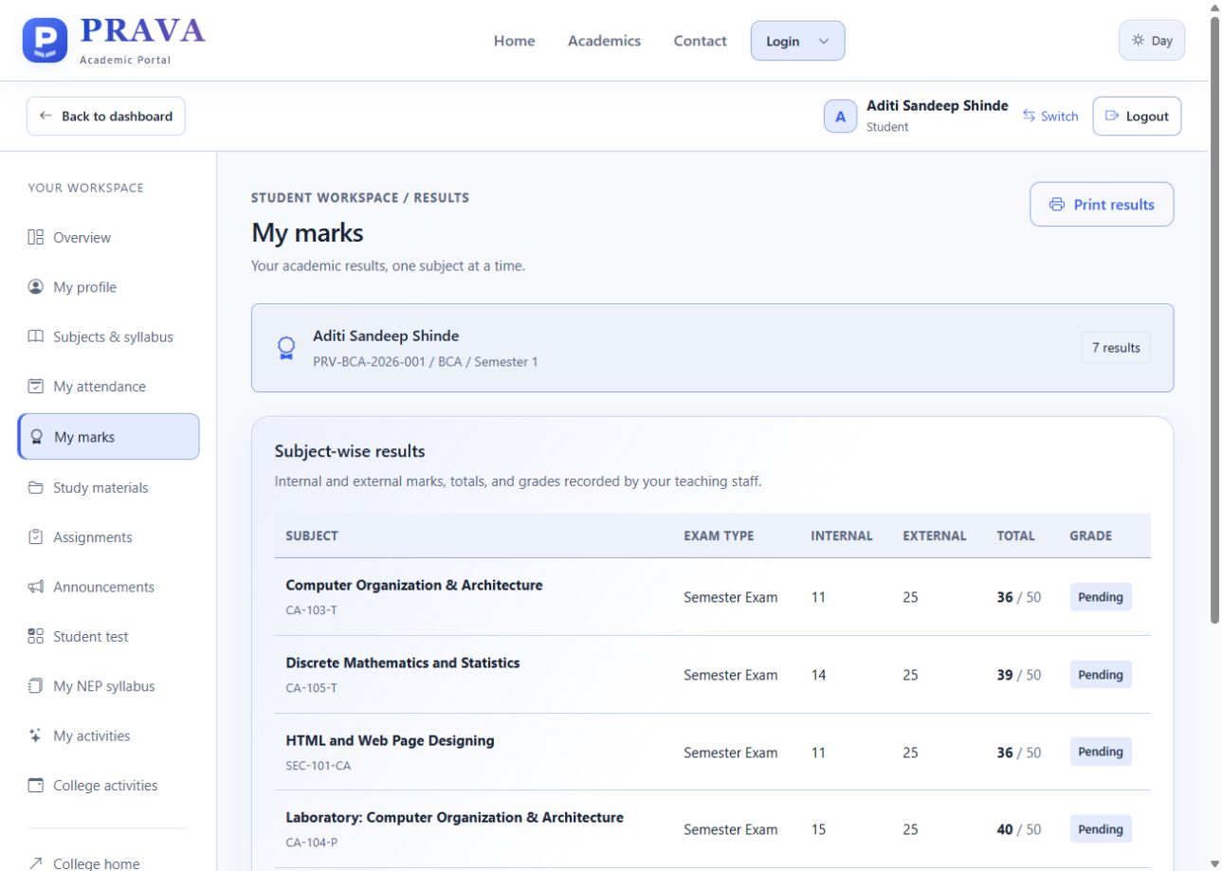
Figure 26 Student subject results with component marks
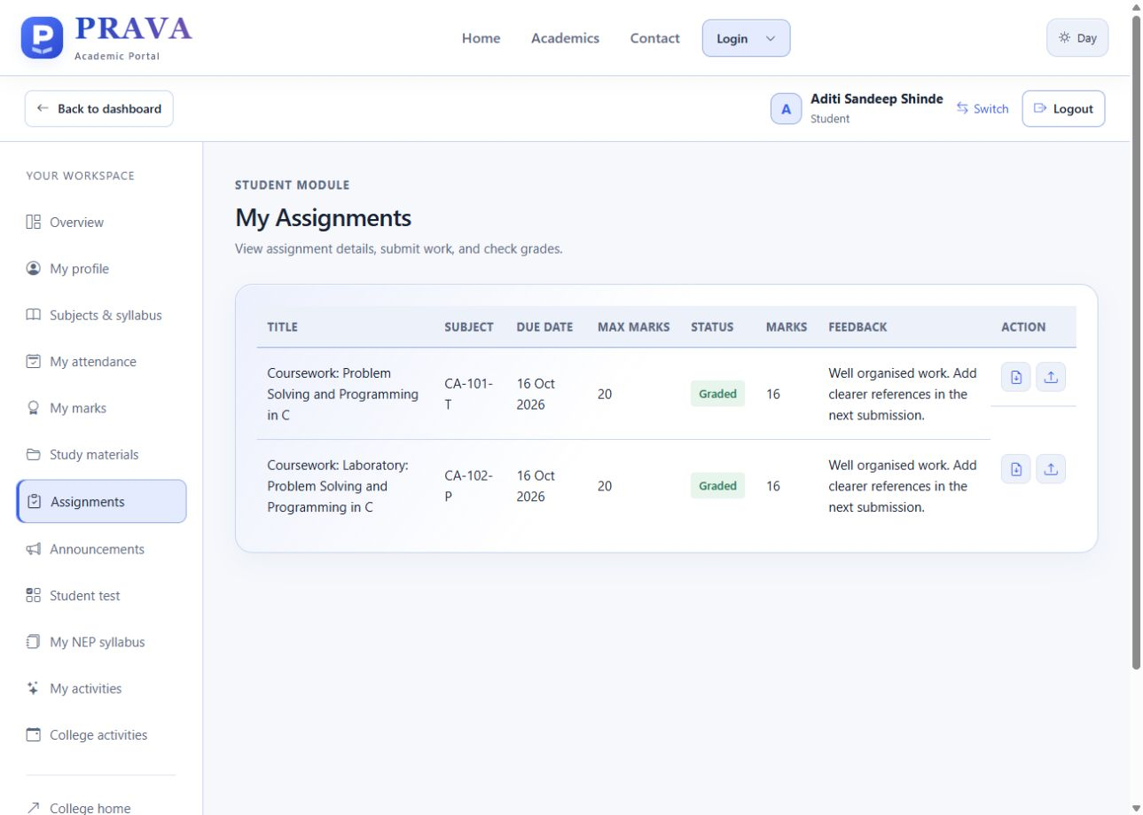
Figure 27 Submitted coursework with marks and faculty feedback
The student results page shows stored subject components and totals. Official NEP grade calculations remain pending. Coursework lists due dates, submission status, awarded marks and feedback for the signed-in student.
Staff Review and Grading
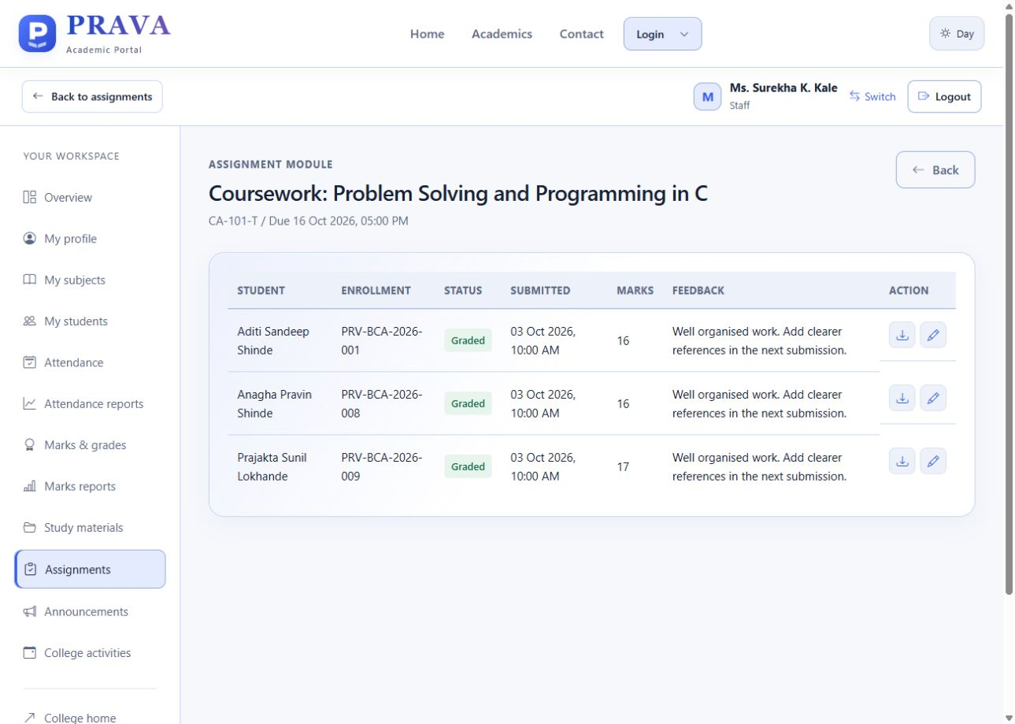
Figure 28 Faculty review of submissions for an allocated subject
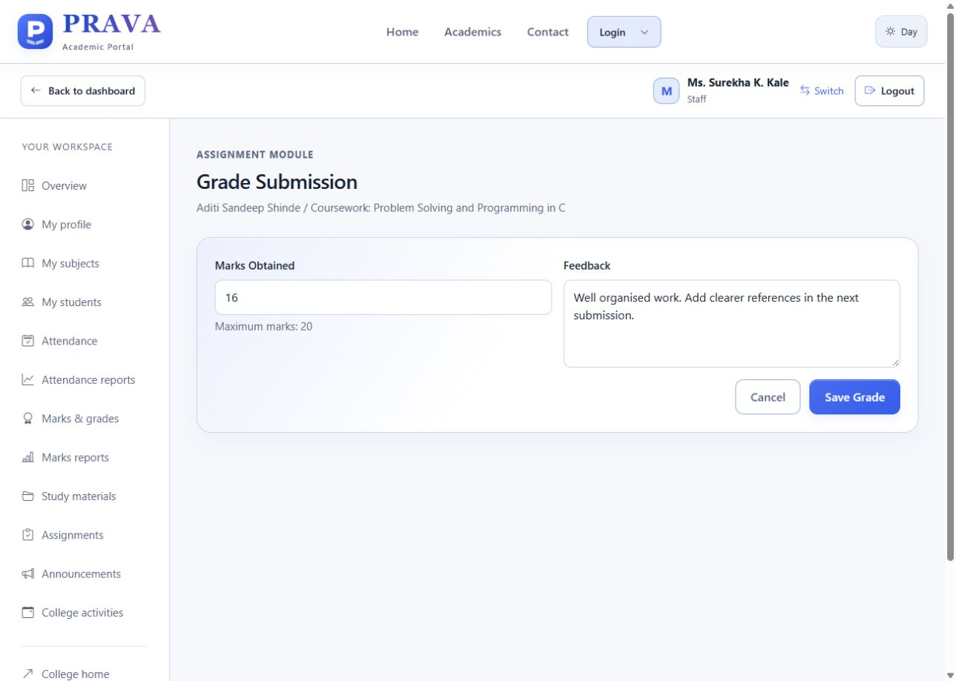
Figure 29 Assignment score and feedback entry
The assigned faculty member reviews the submitted file, awards a score within the assignment maximum, and records feedback. The displayed 16 out of 20 and review text are existing local presentation records.

11 Testing and Verification
All 63 automated tests passed on 5 October 2026 in 26.480 seconds using isolated fixtures. The run used repository baseline 4abb237 with local typography improvements. The controlled error-route test intentionally logs an exception while checking the friendly error response.
Test module | Tests | Result
college_upgrade | 15 | Passed
onboarding | 11 | Passed
phase14 | 12 | Passed
public_homepage | 20 | Passed
student_test | 5 | Passed
Total | 63 | Passed

Representative case | Expected and verified result
Login and switching | Role/programme checks; matching dashboard; failed switch preserves prior identity.
Registration and imports | Pending review; duplicate conflicts rejected; transaction rollback prevents partial accounts.
Permissions and security | Principal write restrictions; Staff subject ownership; CSRF and inactive account checks.
Academics and communication | NEP score bounds; curriculum publication status; notice audiences; activity ownership.
Public pages and student tests | Separate pages, valid contact storage, protected student tests and correct score handling.

Browser checks on 5 October 2026 confirmed all four main login flows and refreshed the report screenshots. Day and Night layouts were inspected at desktop and mobile widths. Key labels, form fields and table text use larger type; wide tables remain horizontally scrollable within their panels.
Input Validation Examples
The following examples explain implemented safeguards. They were checked through the isolated automated test suite on 5 October 2026; no invalid records were added to the working college database.
Login and programme checks
An incorrect password returns “Invalid username/email or password.” A BCA account cannot sign in through the Home Science portal. Inactive accounts are blocked, and an unsuccessful account switch preserves the previous valid identity.
Duplicate registration and import
Submitting the same student sign-up twice leaves one request. An existing enrollment / employee number is rejected by the CSV import preview. Approval and import commit repeat uniqueness checks, so a conflicting record prevents partial account creation.
Marks and assignment bounds
Validation example | Result
Internal maximum 15; enter 16 | Rejected: component exceeds its limit.
External maximum 35; enter 36 | Rejected: component exceeds its limit.
Assignment maximum 100; enter -1 or 101 | Rejected: negative or above-maximum score.
Student from a different academic cohort | Rejected: no eligible subject membership.
Verification evidence
test_phase14 covers login and assignment bounds; test_onboarding covers repeated sign-up and approval conflicts; test_college_upgrade covers NEP component limits, roster duplicates and curriculum ownership. All 63 tests passed in 26.480 seconds.

12 Security and Data Maintenance
Access and consistency
Passwords are stored as hashes. Protected routes check authentication, active status, roles and academic ownership. State-changing requests require CSRF tokens, including Logout. Imports and registration approval revalidate duplicates before commit. Unique keys and foreign keys complement service-level checks; selected actions are recorded in activity_logs.
Persistent storage and recovery
Location | Stored information
instance/prava.sqlite3 | Users, profiles, academic records, inquiries, review and activity data.
instance/.local-secret | Persistent local session secret.
instance/backups/ | Backups created by the launcher before detected schema upgrades.
app/static/uploads/ | Profile images, materials, assignments and submitted work.
Google response Sheets | Student and Staff intake responses; separate from the PRAVA database.

A complete backup preserves the database and required uploaded files. Stop the local server for a file-copy backup or use a consistent database backup procedure. Reopening the same installation retains its records. A newly extracted ZIP creates a separate installation, so populated folders should be preserved during updates.
Public deployment
The launcher binds to 127.0.0.1. Public hosting requires production settings, HTTPS, persistent database and file storage, private secrets, restricted administration and tested recovery. Local presentation credentials must be disabled for real operation. Repository publication delivers source code; it does not publish the local database or deploy a public service.

13 Advantages Limitations and Future Work
Advantages
• Public information and academic work are available through one consistent portal.
• Programme-aware student access and explicit Staff allocations keep records in the correct academic context.
• Office review, duplicate checks and transactional imports support controlled account creation.
• Source links, review labels, persistent local storage and CSV exports support demonstration and record review.
Current limitations
The catalogue has 131 entries: 123 source-reviewed public entries and eight drafts. Shared Home Science content appears under both specialisations. The BCA-linked source is titled B.Sc. Computer Applications; SY is marked draft. Twelve local Home Science TY practice topics support presentation without being labelled verified university syllabus. Detailed TY sources and some assessment details await confirmation.
Official NEP grade, SGPA/CGPA and individual elective enrolment are not implemented. The project does not automate email after Office approval. The Google Forms require review and manual conversion to import templates. The small local presentation dataset does not establish institutional capacity or full-semester operation.
Future enhancements
Priorities are approved batch-specific syllabus updates, elective registration, institution-validated grade calculations, controlled account recovery and registration notifications. Hosted operation should add verified backup restore, accessibility review and performance testing with representative data.

14 Project Cost and Conclusion
Illustrative cost estimate
The following is an academic planning example in INR, not recorded expenditure or logged effort. It assumes an existing laptop and connectivity. Team-hours are the combined effort of both members and are not multiplied by two again.
Planning item | Calculation | Value INR
Requirements and design | 40 hours × 100 | 4,000
Implementation | 70 hours × 100 | 7,000
Verification | 26 hours × 100 | 2,600
Documentation | 24 hours × 100 | 2,400
Total effort value | 160 hours × 100 | 16,000
Printing budget | Up to 45 pages × 3 × 2 copies | 270
Binding budget | 150 × 2 copies | 300
Local hosting fee | No paid hosting for local presentation | 0
Illustrative combined value | 16,000 + 270 + 300 | 16,570

Conclusion
PRAVA demonstrates a working college portal with clear role entry, programme-aware student access, Office-reviewed onboarding and academic tools. The relational design separates identity, teaching allocation, curriculum references and academic records. The current interface, 22-table schema, portable launcher and 63 passing tests support the implementation described in this report.
The project provides practical experience in web development, relational modelling, validation and software verification. Further work should complete approved academic rules and source review, then evaluate real operational data and hosting requirements.

15 Bibliography
Project implementation and technical references. The software versions are the repository requirements; curriculum references are preserved from the application source review.
1. PRAVA source repository
kvaishu0703/Prava_Edu. Baseline 4abb237 with local typography improvements; dataset, interface and 63 automated tests verified on 5 October 2026. README, models, services, templates and tests.
https://github.com/kvaishu0703/Prava_Edu
2. Python documentation
Python Software Foundation. Python 3.12 documentation.
https://docs.python.org/3.12/
3. Flask documentation
Pallets Projects. Application factories, configuration, blueprints and testing. Project dependency Flask 3.0.3.
https://flask.palletsprojects.com/en/stable/
4. SQLAlchemy ORM documentation
SQLAlchemy. Object relational mapping and model relationships.
https://docs.sqlalchemy.org/en/20/orm/
5. College information
Women's College of Home Science and BCA, Loni. Institutional information and academic references recorded by the project.
https://www.pravarahomesciencebca.in/
6. Google Forms setup
Google Apps Script Form service. Separate student/staff forms, validation, publishing and spreadsheet destinations; created 30 September 2026 and updated to English on 4 October 2026.
https://developers.google.com/apps-script/reference/forms/form
Curriculum Source References
7. SPPU FY B.Sc. Computer Applications syllabus linked by the college BCA department.
http://www.pravarahomesciencebca.in/documents/STUDENT%20CORNER/Syllabus/BCA/B.%20Sc.%20%28Computer%20Applications%29_14062024.pdf
8. SPPU SY B.Sc. Computer Applications draft hosted by Pratibha College.
https://pcccs.org.in/wp-content/uploads/2026/03/SY-B.Sc_.CA_.pdf
9. SPPU FY B.Sc. Home Science syllabus linked by the college.
http://www.pravarahomesciencebca.in/documents/STUDENT%20CORNER/Syllabus/Home%20Science/syllabus/B.Sc.%20%28Home%20Science%29_07062024.pdf
10. SPPU SY B.Sc. Home Science syllabus on the university circulars site.
http://collegecirculars.unipune.ac.in/sites/documents/Syllabus2025/S.Y.B.Sc.%20(Home%20Science)_25082025.pdf
The catalogue records its source-check date as 20 September 2026. Source title, pattern, effective year and review notes must be interpreted together. A college department label may differ from a university document title. Formal academic use requires confirmation that each document applies to the student batch.
The report preserves known source qualifications and current implementation status. It does not convert draft or incomplete syllabus content into a confirmed university scheme.

Appendix Local Installation and Demonstration
• Open https://github.com/kvaishu0703/Prava_Edu and choose Code → Download ZIP, then Extract All.
• Preserve any existing populated project folder. A new folder has its own local database.
• Install supported 64-bit Python; the README recommends 3.12 with Add Python to PATH.
• Open the inner folder containing START-PRAVA.cmd and double-click it. Internet is needed for first dependency setup.
• Keep the server window open. The browser opens http://127.0.0.1:5000/. Stop the server with Ctrl+C.
PowerShell: right-click the project folder → Open in Terminal. Run .\START-PRAVA.cmd. If port 5000 is busy, run .\START-PRAVA.cmd -Port 5001 and open http://127.0.0.1:5001/. The .\ prefix selects the file in the current folder.
Role | Login ID | Password
BCA student | bca | bca123
Home Science student | home | home123
Staff | staff | staff123
Office / Administration | office | office123

These credentials are for local presentation only. Verified college accounts use individual credentials. The local accounts are blocked when PRAVA_DEMO_MODE is disabled or production configuration is active.
Presentation order: Home and theme → Login dropdown → BCA and Home Science dashboards → Staff academic tools → Office review, import and reports. Use Logout or Switch account between roles. README.md contains the setup and maintenance instructions.

