E



**HO CHI MINH CITY UNIVERSITY OF TECHNOLOGY**

# FACULTY OF COMPUTER SCIENCE AND ENGINEERING



**SOFTWARE ENGINEERING**

# REPORT 4: MODULE INTERFACE, CLASS DIAGRAM, SEQUENCE DIAGRAM, ACTIVITY DIAGRAM/STATE-CHART DIAGRAM, DESIGN PATTERN, WORKING DEMONSTRATION

Lecturer: Dr. Bui Hoai Thang

## Project topic:

**SCARMS – Smart Campus System**

## Class: CC02

## Nguyen Ngo Chi Khang

1752275

Email: [khang.nguyenngochi@hcmut.edu.vn](mailto:khang.nguyenngochi@hcmut.edu.vn)

1. **MODULE INTERFACES: programming interfaces used among modules**

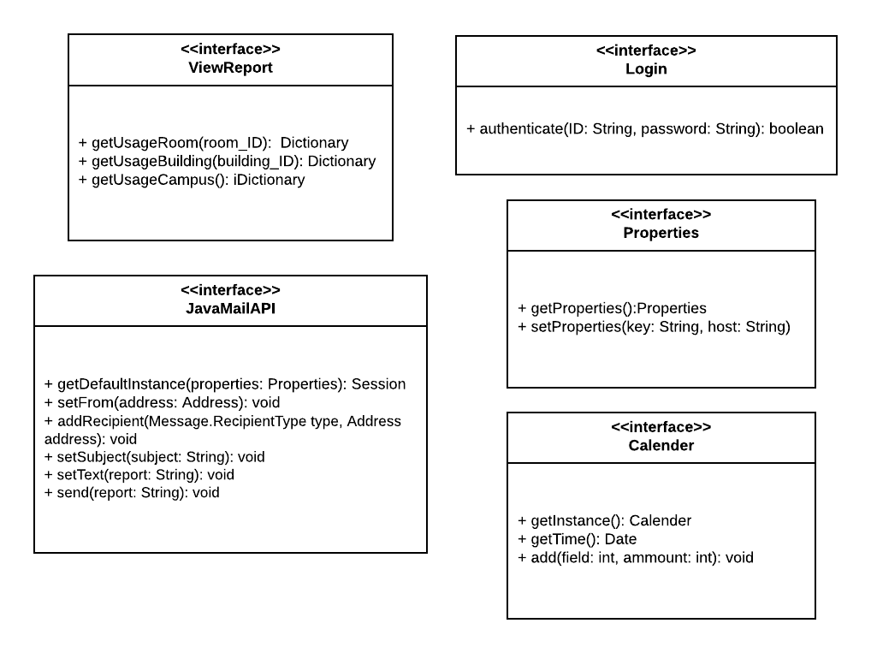

* Interface is model element that defines sets of operations and other classes implement it. Therefore, I use API, services like ViewReport or Login as interface.

1. **CLASS DIAGRAM:**

* I show class diagram that is about viewing report and system sends monthly report automatically to Admin and Board of Rectors.

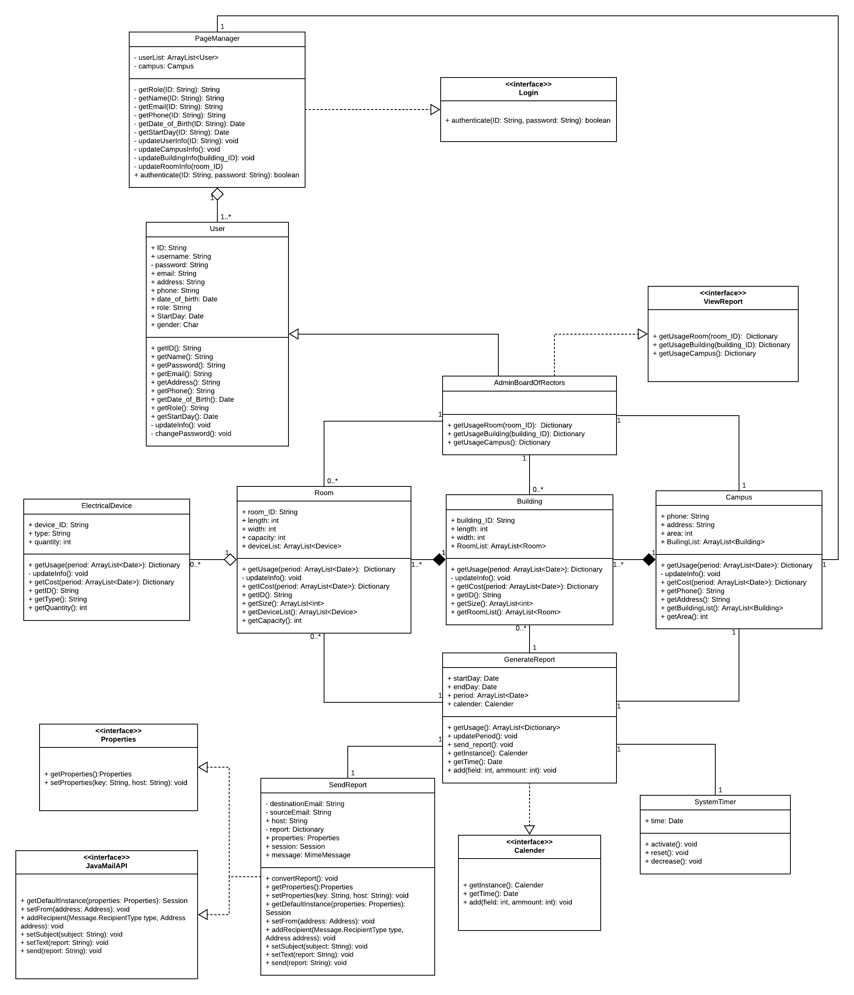

1. **METHOD DESCRIPTIONS:**

* Class: PageManager

|  |  |  |  |
| --- | --- | --- | --- |
| Method name | Input | Output | Description |
| getRole | ID of user | Role of that user | Page admin can manage all users by getting their roles because there are many roles in system and different roles can have rights to do different actions |
| getName | Name of user | Page admin can manage users |
| getEmail | Email of user |
| getPhone | Phone of user |
| getDate_of_Birth | Date of birth |
| getStartDay | The date user register to system |
| updateUserInfo | None | Update User roles, not passwords |
| updateCampusInfo | None | None | Update information of campus object like phone, address, area, building list (may change through time) |
| updateBuilding | ID of building | None | Update information, array of rooms, … |
| updateRoom | ID of room | None | Update information, array of electrical devices in this room |

* Class: User

getID(), getName(), getPassword(), getEmail(), getAddress(), getPhone()

getDate_of_Birth(), getRole(), getStartDay() are used for user being able to access their information, also update their information like username, password, … with updateInfo() and changePassword() (private)

* Class: Campus, Building, Room, ElectricalDevice

|  |  |  |  |
| --- | --- | --- | --- |
| Method name | Input | Output | Description |
| getUsage | Period of time that is array of 2 elements: start day and end day of this period | Dictionary of usage because each element of dictionary contains key and value that key is day, value is number of consumed hour (I use dictionary because it has same structure with json file which can be read with any programming language) | Get dictionary of consumed hour |
| updateInfo | None | None | Update usage, information of element |
| getCost | Period of time that is array of 2 elements: start day and end day of this period | Dictionary of cost that key is day, value is cost of usage | Get cost in format of dictionary |

We also have some more methods: getID(), getSize(), getRoomList(), getBuidingList(), getDeviceList(), getCapacity(), getPhone(), getAddress() are used for getting basic information of corresponding elements.

* Class: SystemTimer

|  |  |  |  |
| --- | --- | --- | --- |
| Method name | Input | Output | Descriptiom |
| activate | None | None | Activate GenerateReport class every month |
| reset | After one month, reset time to start time |
| decrease | Count time by decrease to zero |

* Class: GenerateReport

|  |  |  |  |
| --- | --- | --- | --- |
| Method name | Input | Output | Description |
| getUsage | None | Many Dictionaries are: Dictionaries Usage of Campus, of Rooms, of Buidings  (one dict for one element) | Get list of element usage |
| updatePeriod | None | After sending, it updates its time based variable calender |
| send_report | None | Calls API to send report to destination email |

* Class: SendReport

|  |  |  |  |
| --- | --- | --- | --- |
| Class method | Input | Output | Description |
| converReport | None | None | Convert list of dictionaries of usage to tables, text or json file for easy sending and understanding |

* Class: AdminBoardOfRectors, SendReport implements methods of Interface so I do not put interfaces’ functions to those class, but I understand that it calls API, or implements functions of Interface
* Interface: Login

|  |  |  |  |
| --- | --- | --- | --- |
| Method name | Input | Output | Description |
| authenticate | ID, password of user | result | Account exists or not |

* Interface: ViewReport

|  |  |  |  |
| --- | --- | --- | --- |
| Method name | Input | Output | Description |
| GetUsageRoom | ID of room | Dictionary of Usage of room | Provide function for getting the dictionary of usage of given ID room |
| getUsageBuiding | ID of building | Dictionary of Usage of building | Provide function for getting the dictionary of usage of given ID buiding |
| getUsageCampus | None | Dictionary of Usage of Whole Campus | Provide function for getting the dictionary of usage of the whole campus |

* Interface: JavaMailAPI

|  |  |  |  |
| --- | --- | --- | --- |
| Method name | Input | Output | Description |
| getDefaultInstance | Properties:  System properties | Session | Return default session |
| setFrom | Address object | None | Set header field |
| addRecipient | Recipient Type object, Address object | None | Add the given addresses to the recipient type |
| setSubject | Subject of message in String | None | Set subject ò message |
| setText | Report | None | Set the text as the message content using text/plain MIME type |
| send | Report | None | Send the message to the given adresses |

* Interface: Properties

|  |  |  |  |
| --- | --- | --- | --- |
| Method name | Input | Output | Description |
| getProperties | None | Properties of system | Get properties of system |
| setProperties | String key and String of host declared in SendReport | None | Set properties of system (host, destination email, …) |

* Interface: Calendar

|  |  |  |  |
| --- | --- | --- | --- |
| Method name | Input | Output | Description |
| getInstance | None | Variable of Calendar type | Like declare variable of Calendar type |
| getTime | None | Date | Get current date |
| add | 2 parameters: day/month/year and number added | None | Used for updating function |

** All classes implement interfaces that calls all methods of those interfaces. I have just explained all methods of interfaces, so I do not explain again in classes.

** Explain for some attributes:

* startDay: the starting day of period
* endDay: the ending day of period
* calender: variable which is used for updating period because days of months are different
* properties, session are variables of corresponding types for sending message to target email

1. **ACTIVITY DIAGRAMS:**

* Activity diagram for sending monthly report (first one) and viewing report at any time (second diagram) in details

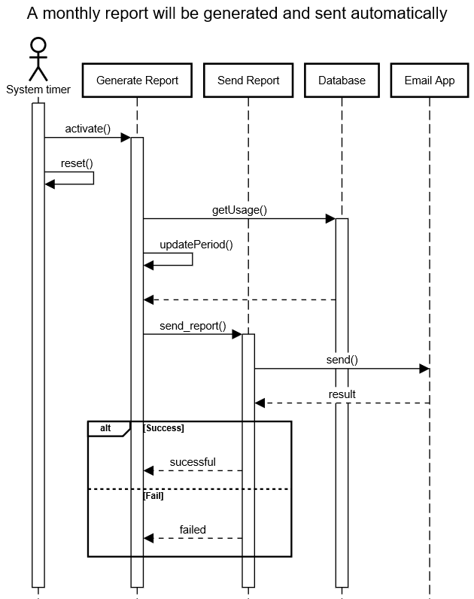

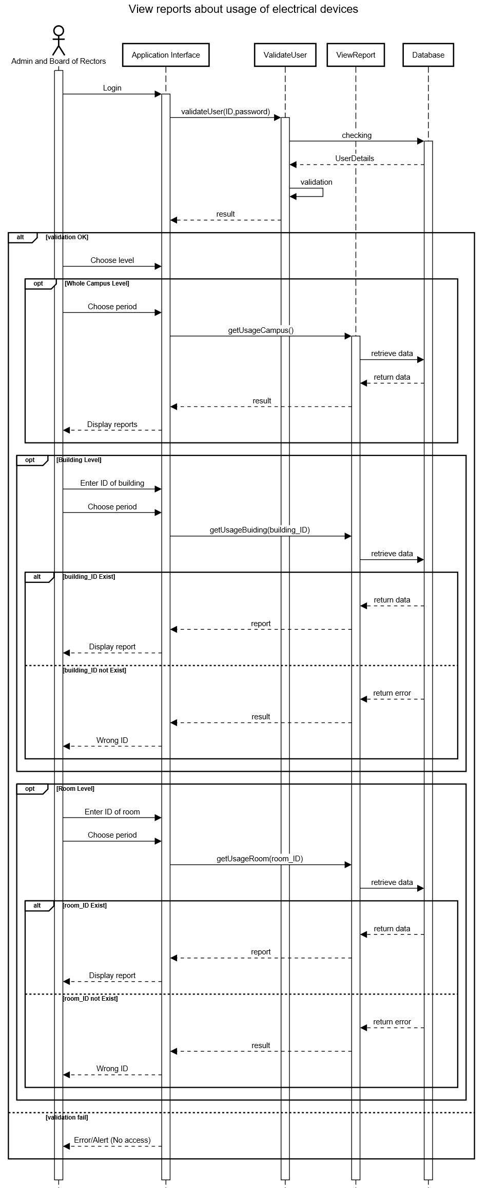

* The details of calling methods are displayed clearly in diagrams

1. **DESIGN PATTERNS:**

* I use Iterator which is the pattern for getting a way to access the elements of collection object in sequential manner without any need to know its underlying representation. Iterator may be applied for list of user, list of rooms, buildings for easier managing because Iterator has many advantages like: method name are simple and easy to use, it support both READ and REMOVE operations, …
* I can use Façade design pattern for Board/Admin of Rectors being easy to get usage of rooms, buildings by having an external communication layer over an existing system. Façade hides the internal complexity that shows simple on the outside.
* Also, there are many different design patterns link: Adapter, Singleton, … may be also applied to our whole system.

1. **WORKING DEMONSTRATION:**

* For login:

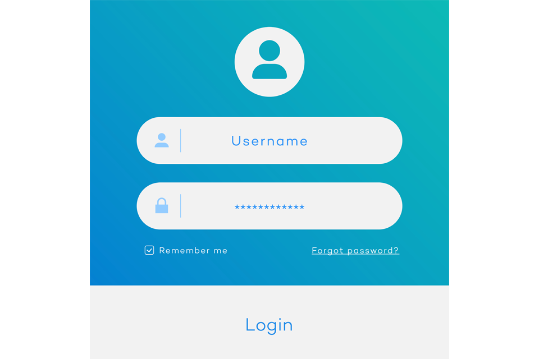

Firstly, we may have login page like that when accessing to system

Secondly, if the account is invalid, it raises error, and if not I will come to main page where viewing report

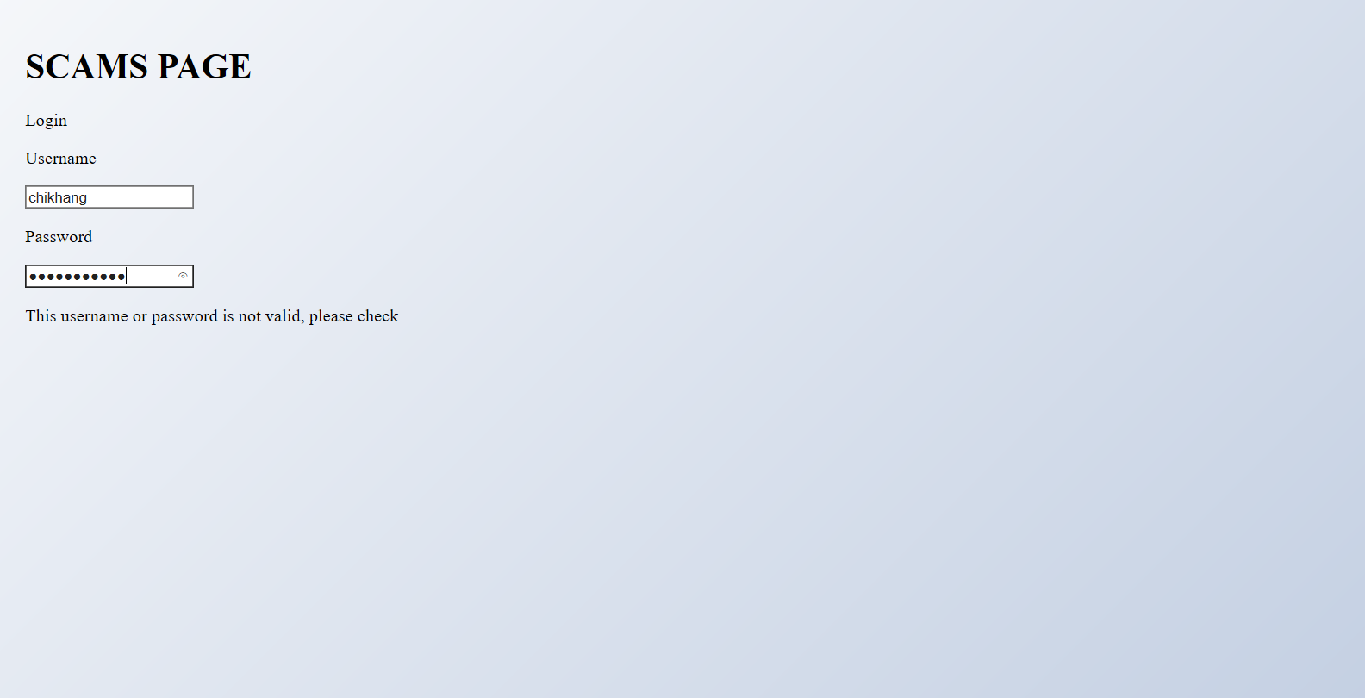

* Main page: Choose level of viewing

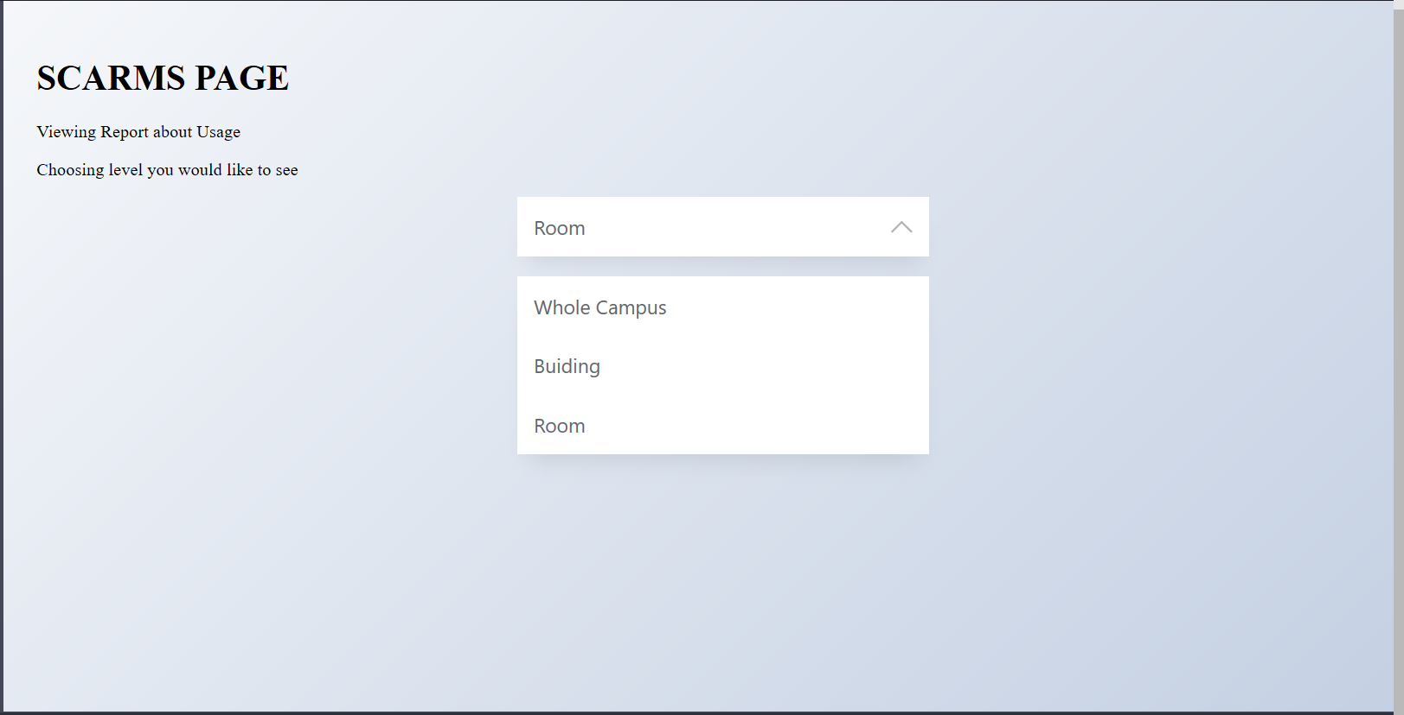

* After selecting Whole Campus level: It come to Whole Campus page (different page with selection page). In this page, user picks period of time viewing report like that

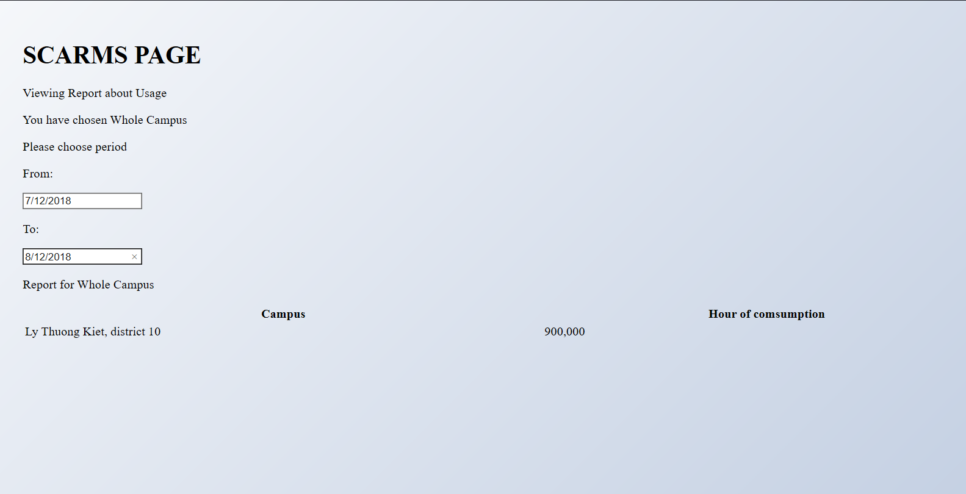

* If user choose Room or Building level, there will one more step entering ID and checking this ID whether is valid or not

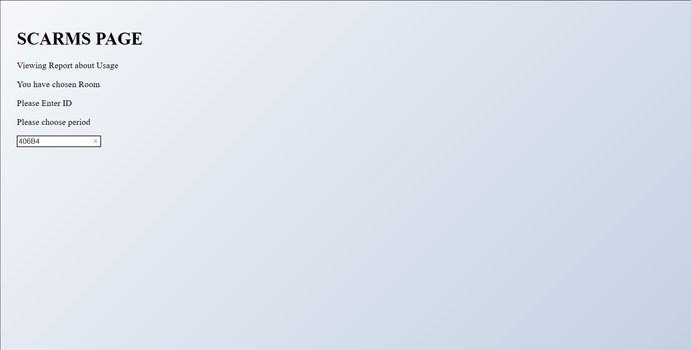

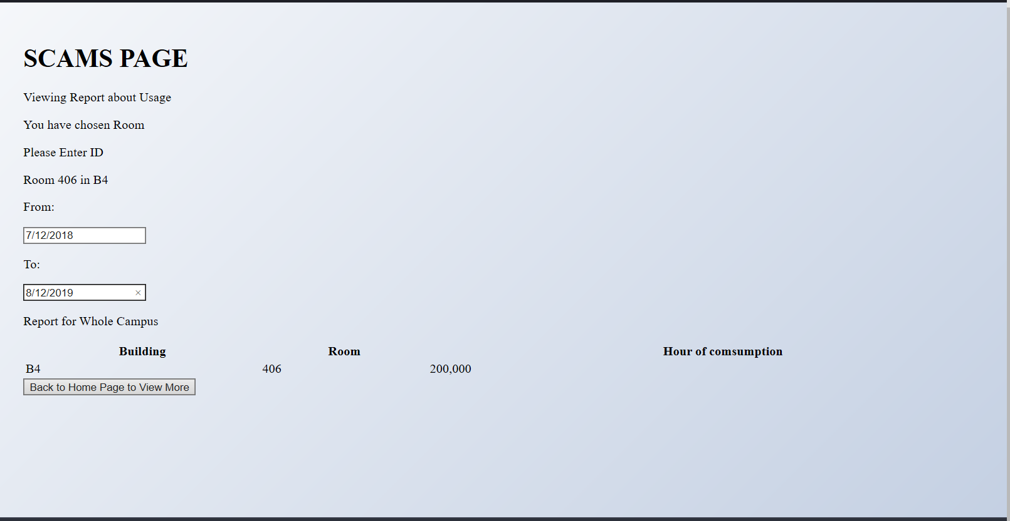

With wrong ID:

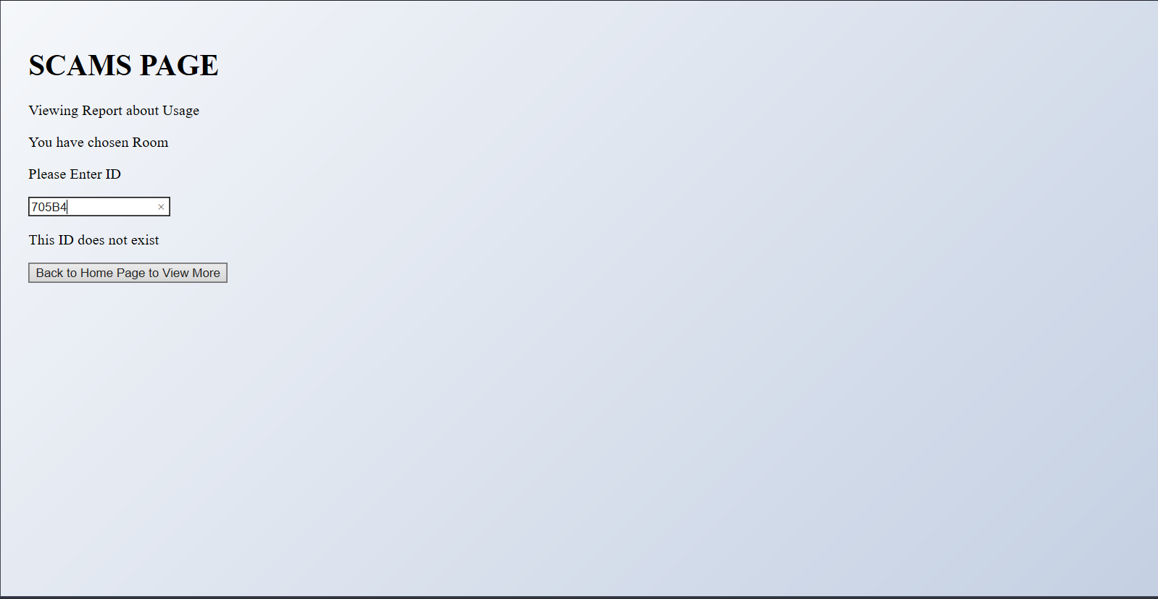

**There is little bit wrong in names of title and it misses some functions, but it is all about main functions of my system that can prove my class diagram to be able to work.

**Thank you so much**

**THE END**