Introduction

This analysis attempts to extract key operational insights from historical Jira data to support day-to-day MeerKAT telescope operations. The dataset provides a comprehensive overview of operational activities across multiple engineering and science projects, with a primary focus on the Science Data Processing (SDP), MeerKAT Time frequency Reference (MTFR), Correlator BeamFormer (CBF) and Condition And Monitoring (CAM) subsystems. Spanning a period from early 2019 to mid-2026, the data tracks 5,083 total issues, reflecting a mature project lifecycle characterized by a high volume of completed work and established workflows.

The data highlights the scale of the MeerKAT operational environment, which involves 13 active projects and 14 distinct issue types, ranging from standard Tasks and Stories to critical Defects and Bugs. While the majority of issues are currently in terminal states like Done or Closed, active development is evidenced by a persistent backlog and ongoing work in progress. This long-term dataset serves as a benchmark for understanding system stability, as seen in the high prevalence of Medium-priority issues compared to Urgent emergency fixes.

Executive summary
- Project Distribution: The majority of the workload is concentrated in the SDP Production Release 1 project, which accounts for over 60% of all issues (3,139 issues). Other significant projects include CAM (589 issues) and standard SDP(480 issues).
- Workflow Status: Most issues have reached a terminal state, with Done (3,116) and Closed (446) being the most frequent statuses. However, there is a notable Backlog of 434 issues and 182 issues currently In Progress, indicating ongoing development and maintenance activity.
- Priority and Urgency: The vast majority of issues are classified as Medium priority (4,227). High and Urgent priority issues combined make up about 13% of the total (684 issues), suggesting a stable system where most tasks are routine rather than emergency fixes.
- Creation Trends: Issue creation peaked significantly between mid-2021 and mid-2022, with several months seeing over 140 new issues. Since 2023, the rate of new issue creation has generally slowed, though there was a recent spike in early 2026.

Summary Statistics

Metric | Value
Total Issues | 5,083
Active Projects | 13
Primary Project | SDP Production Release 1
Most Common Status | Done
Primary Priority | Medium
Issue Types | 14 (e.g., Task, Defect, Story, Bug)

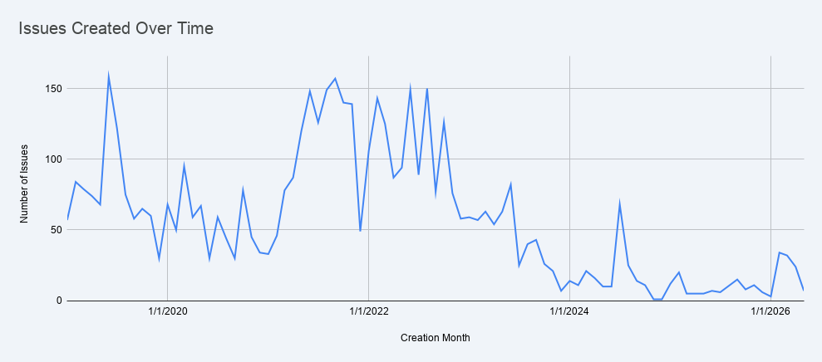
Figure 1: This figure shows a time series of issues across projects as reported. This line chart tracks the monthly trend of issue creation from January 2019 through May 2026. The data shows significant peaks in activity during mid-2019 (reaching 158 issues in June) and a sustained high-volume period throughout 2021 and 2022, where monthly counts frequently exceeded 140. Following 2022, there is a noticeable downward trend in new issue creation, with occasional minor spikes in 2024 and early 2026.

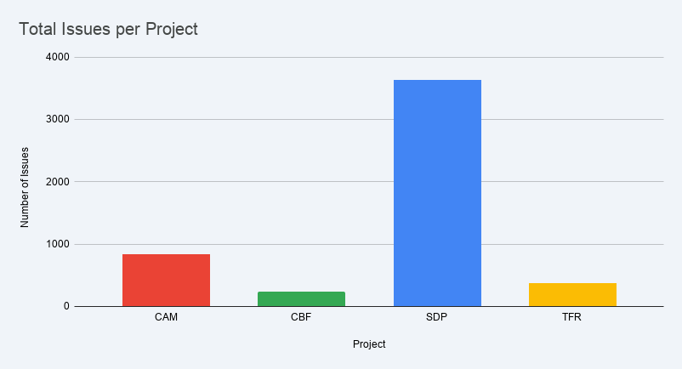
Figure 2: The bar plot above shows the total number of issues per project, this offers a high-level summary of total issues grouped by major project categories. The SDP category has the highest total with 3,637 issues, significantly outnumbering CAM (837), TFR(379), and CBF (230). This view highlights the primary areas of operational focus within the Jira data.

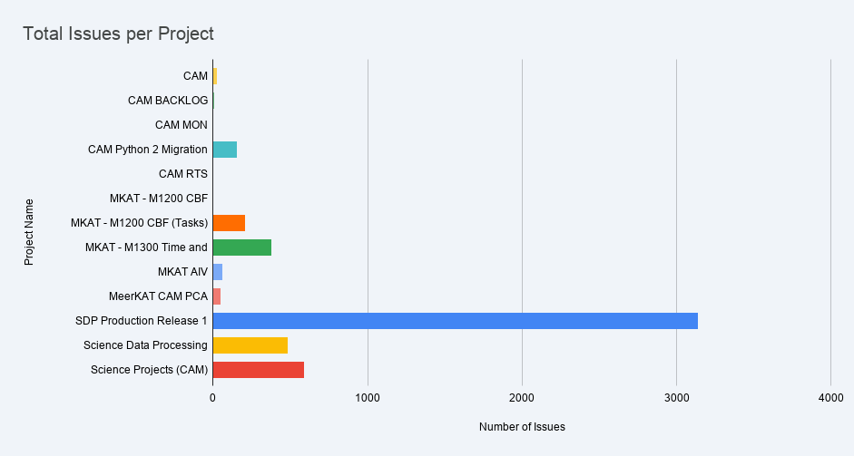

Figure 3: The figure shows the total number of reported issues for all 13 project names. This bar chart illustrates the total volume of issues recorded across various specific projects. SDP Production Release 1 stands out with the highest volume at 3,139 issues, followed by Science Projects (CAM) with 589 and SDP with 480. In contrast, projects like CAM MON, CAM RTS, and MKAT - M1200 CBF (Management)have the lowest activity, each recording only a single issue.

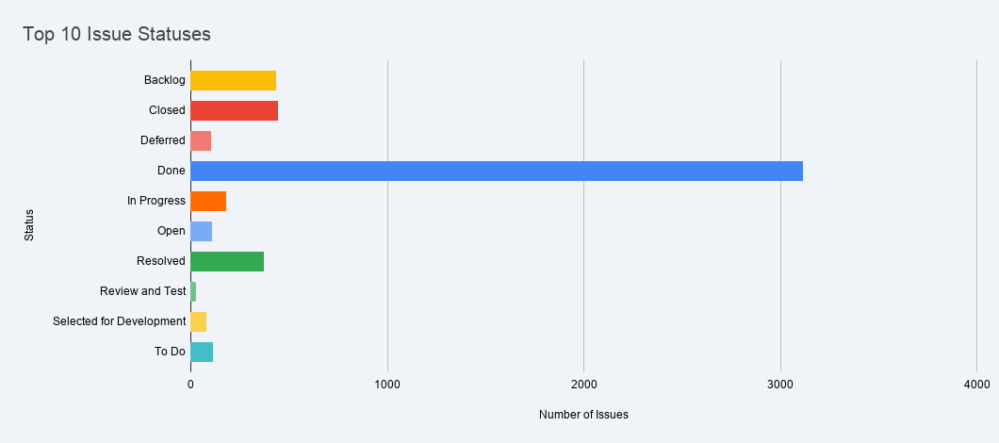
Figure 4: The figure shows top 10 issue statuses for all projects combined, this bar ranks the most frequent statuses assigned to issues. The vast majority of issues are in the Done status (3,116), indicating a high completion rate. Other common statuses include Closed (446), Backlog(434), and Resolved (373). Active statuses like In Progress (182) and To Do (113) represent a smaller fraction of the total issue count.

