A Project Report
On
DUPLICATE PROJECT CHECKER
Submitted To
RAJIV GANDHI UNIVERSITY OF KNOWLEDGE AND
TECHNOLOGIES RK VALLEY
in
partial fulfilment of the requirement for the award of the Degree of
BACHELOR OF TECHNOLOGY IN COMPUTER SCIENCE & ENGINEERING
Submitted by
CHEPPALI KALYANI (R190388)
Under the Guidance of
Mrs G. SWAPNA
DEPARTMENT OF COMPUTER SCIENCE AND ENGINEERING

RAJIV GANDHI UNIVERSITY OF KNOWLEDGE
TECHNOLOGIES



RAJIV GANDHI UNIVERSITY OF KNOWLEDGE TECHNOLOGIES

R.K. Valley, YSR Kadapa (District) - 516330



CERTIFICATE OF PROJECT COMPLETION

This is to certify that the project work titled “PROJECT DUPLICATE CHECKER” is a entitled Project work submitted by CHEPPALI KALYANI - R190388 in the department of COMPUTER SCIENCE AND ENGINEERING in partial fulfilment of requirements for the award of degree of Bachelor of Technology in Computer Science and Engineering for the year 2024-2025 carried out the work under the supervision.

Signature of Project Guide Head of Department (CSE)
G. SWAPNA CH. Ratna Kumari
Assistant Professor, Assistant Professor,
MTech MTech (UOH), (PHD)

Signature of External Guide :
RAJIV GANDHI UNIVERSITY OF KNOWLEDGE
TECHNOLOGIES


(A.P.Government Act 18 of 2008)
RGUKT-RK Valley Vempalli, Kadapa, Andhrapradesh-516330.

DECLARATION

I’m CHEPPALI KALYANI (R190388) hereby declare that the project report entitled “PROJECT MANAGEMENT” done under guidance of G.SWAPNA is submitted in partial fulfillment for the degree of Bachelor of Technology in Computer Science and Engineering during the academic session JULY 2024 – NOVEMBER 2024 at RGUKT-RK Valley. We also declare that this project is a result of our own effort and has not been copied or imitated from any source. Citations from any websites are mentioned in the references. To the best of my knowledge, the results embodied in this dissertation work have not been submitted to any university or institute for the award of any degree or diploma.

ACKNOWLEDGMENT

I would like to express my deep sense of gratitude and respect to all those people who guided, inspired, and helped me crown all my efforts with success. I wish to express my gratitude to Mrs G.SWAPNA for her valuable guidance at all stages of the study, advice, constructive suggestions, supportive attitude, and continuous encouragement, without which it would not have been possible to complete this project.
I would also like to extend my deepest gratitude and reverence to the Head of the Department of Computer Science and Engineering CH. RATNA KUMARI for their constant support and encouragement.
I would like to extend my sincere gratitude to Mr. R. Sreenivasulu sir, whose invaluable assistance in collecting data was instrumental in the completion of this project. His guidance and support were greatly appreciated, and I am thankful for his contribution to the success of this endeavor.
I express my sincere thanks to all other faculty members of the CSE Department for extending their helping hands and valuable suggestions when needed. Finally, my heartfelt thanks to my parents for giving me all I ever needed to be a successful student and individual. Because of their hard work and dedication, I have had opportunities beyond my wildest dreams.
With My Sincere Records
CHEPPALI KALYANI
R190388

TABLE OF CONTENTS
S.NO | INDEX | PAGE NUMBER
1 | Abstract | 6
2 | List Of Figures | 7
3 | List Of Tables | 7
4 | Introduction:  - Problem statement  - Motivation  - Contribution  - Existing Systems | 8-12
5 | Literature Review | 13-14
6 | Modules:  - Duplicate Checker  - Database Management  - User friendly interface | 15-26
7 | Source Code & Snapshots | 27-32
8 | Result and Discussion | 33-36
9 | Conclusion and Future  Enhancement | 37-39
10 | Reference | 40

ABSTRACT
The Project Management System for duplicate project checking aims to streamline the management and monitoring of student projects, ensuring that no two projects are duplicated across the university. The system utilizes Python and Flask for backend development, enabling users to search and compare project titles across the student database. This system also features a comprehensive interface using HTML, CSS, and JavaScript, providing users with a seamless experience for project title search and duplicate identification.
The backend logic of the system is designed to detect project duplication by comparing student project titles and cross-referencing them with relevant student data, including name, ID number, section, and faculty guide. Through the user-friendly interface, students and faculty can quickly search for project titles, view results of potential duplicate projects, and access detailed information regarding students and their respective guides.
The system has been designed with an emphasis on user experience, making it easy for both students and faculty to interact with the platform. Currently, progress includes the development of a search function for project titles, the design of the user interface, and integration with the student database for accurate and efficient duplicate checks. The system is continually being enhanced to incorporate additional features, such as the ability to view guides and manage projects effectively, ultimately helping to prevent project duplication and streamline the project management process for the university.

2.LIST OF FIGURES
Figure No | Title | Page Number
Figure1 | Routes1 | 27
Figure2 | Routes2 | 27
Figure3 | Routes3 | 28
Figure4 | Routes4 | 28
Figure5 | Home page | 29
Figure6 | Student_login page | 29
Figure7 | Faculty_login page | 29
Figure8 | Index page | 30
Figure9 | Guides page | 30
Figure10 | Faculty _ profile page | 31
Figure11 | Students page | 31
Figure12 | Students_profile | 32
Figure13 | Project Duplicate | 32

3 . List of Tables

S.NO | TITLE | PAGE NO
1 | Literature Review | 14

4.Introduction
Project management plays a crucial role in organizing, executing, and tracking various projects, particularly in academic settings. The "Project Duplicate Checker" is an innovative system designed to assist university staff and students in identifying duplicate project titles, ensuring that no two students work on the same project. This system facilitates a more streamlined and efficient approach to managing student projects, thereby avoiding unnecessary duplication of effort and promoting originality.
Traditionally, project duplication was identified manually by faculty members, which was not only time-consuming but also prone to human error. With the increasing number of students and projects in academic institutions, the need for an automated and efficient solution has become essential. By utilizing web technologies and backend systems, this Project Duplicate Checker enables faculty to easily manage projects and track potential duplications.
4.1 Problem Statement:
In educational institutions, project duplication often occurs when multiple students choose the same project, leading to redundant work and confusion among both students and faculty. This issue is compounded by the difficulty in tracking and managing large numbers of projects. The traditional methods of checking for duplicate projects rely on manual inspection, which is not scalable and can lead to delays in project approvals. The "Project Duplicate Checker" aims to solve this problem by providing an automated system that allows faculty and students to efficiently check for duplicate projects based on project titles and other relevant details.
By implementing a web-based platform, the system enables students to search for their project titles and quickly identify any potential duplicates. This approach minimizes the administrative burden on faculty, allowing them to focus on more critical aspects of project guidance and assessment.
4.2 Motivation:
The motivation behind the development of the "Project Duplicate Checker" lies in the increasing need to maintain order and clarity in managing academic projects. With a growing number of students, the likelihood of project duplication increases, and handling such instances manually becomes impractical.
This system aims to improve efficiency by automating the process of checking for duplicate projects, thus saving time for both faculty and students. The tool also ensures that students select original projects, which fosters creativity and innovation. By providing a platform where students can easily search and check project titles, the system reduces unnecessary work, promotes academic integrity, and ensures that project titles are unique.
4.3 Contribution:
The "Project Duplicate Checker" contributes to academic project management by offering several key benefits. Additionally, the system integrates a search function that allows students to check if their project has already been taken before submitting their final project proposal. This ensures originality and helps in reducing redundancy, promoting a more efficient workflow within the academic environment. This functionality significantly reduces the workload for faculty, allowing them to approve or reject projects with minimal effort.
Furthermore, the backend of the system, powered by Python and integrated with a database, ensures accurate and real-time updates of project statuses, supporting data-driven decisions. The platform also prioritizes user experience by featuring a simple and intuitive interface. This design caters to both students and faculty, providing a smooth and user-friendly experience. By streamlining the project submission and approval process, the "Project Duplicate Checker" enhances the overall management of academic projects, fostering an environment of originality and efficiency.
4.4 Existing Systems:
Many institutions still rely on traditional methods of project management, including manual checks and administrative oversight, which are prone to errors and delays. Some universities have implemented basic software systems for project management, but they are often limited in functionality and cannot automatically detect duplicate projects based on detailed comparisons of project titles or other key information.
While some online platforms allow students to submit their project titles, most systems do not include robust checking mechanisms for duplication or provide faculty with a comprehensive way to manage project titles across a large student body.
4.5 Limitations of Existing Systems:
Many existing systems rely on manual checks to identify duplicate projects, which can be time-consuming and error-prone. This manual process often leads to inefficiencies and increases the likelihood of overlooking duplicate entries. Additionally, most systems do not fully integrate with student databases, which would allow for more efficient checks against project titles and student information. This lack of integration hampers the ability to streamline the project approval process and maintain accurate records.
Moreover, existing systems face scalability issues as they are not designed to handle the growing number of students and projects, leading to delays and inefficiencies. These scalability challenges can hinder the overall effectiveness of project management within academic institutions. Furthermore, many systems are not designed with an intuitive user interface, making them difficult for students and faculty to navigate. This poor user experience can result in frustration and decreased productivity, as users struggle to interact with the system effectively.
4.6 Proposed System:
The "Project Duplicate Checker" aims to address these challenges by providing a comprehensive, user-friendly, and automated system for checking duplicate project titles. The system incorporates modern technologies such as Flask for backend development, integrated with a student database for real-time updates and accurate results.
1.6.1 Features of the Proposed System:
User Authentication and Authorization: Secure registration and login for both students and faculty ensure that only authorized users can access the system.
Duplicate Detection : Advanced algorithms compare project titles and check for duplicates in real-time, enhancing the efficiency of the system.
Database Integration: The system integrates with an existing student database, providing accurate and up-to-date information regarding students, their projects, and faculty guides.
4.6.2 Benefits of the Proposed System:
- Efficiency: Automated duplicate checks reduce manual workload for faculty and ensure students select unique projects.
- Accuracy: Real-time database integration ensures the system detects even the smallest variations in project titles.
- Scalability: The system can handle a growing number of students and projects without sacrificing performance.
- User Experience: The simple, easy-to-use interface ensures accessibility for both students and faculty.

5. Literature Review
Efficient management of project duplication detection is crucial for maintaining academic integrity and encouraging originality among students. Traditionally, supervisors have relied on manual methods and personal knowledge to identify duplicate projects. These methods are often slow, prone to errors, and limited by the expertise available, leading to delayed interventions and unintentional approvals of plagiarized projects. As the educational sector faces increasing challenges, there has been a gradual shift towards digital solutions to enhance project management and support supervisors more effectively.
Basic online systems have emerged as initial improvements over manual processes. These systems provide platforms for supervisors to check project titles and abstracts against existing databases to identify potential duplicates. However, these applications often lack advanced features such as real-time updates, comprehensive project databases, and tailored recommendations, leading to potential oversight and suboptimal project management practices. Despite these limitations, basic online systems have helped reduce some of the burden associated with manual duplication checks and have provided supervisors with quicker access to information.
However, basic online systems often fall short in providing comprehensive project information and tailored recommendations. They may lack real-time updates on project submissions and advanced comparison capabilities, which are critical for accurate and timely intervention. This limitation can result in missed duplicates and ineffective management practices, ultimately impacting the quality of student projects and academic standards.
Despite these shortcomings, basic online systems have played a crucial role in alleviating some of the burden associated with manual project duplication checks. They have empowered supervisors with quicker access to information, enabling them to make more informed decisions about project approvals. This accessibility is particularly beneficial in institutions with large student populations where manual checking is impractical.
In conclusion, while basic online systems represent a significant step towards digitizing academic project management, there remains considerable potential for further innovation. By addressing current limitations and harnessing cutting-edge technologies, digital solutions have the capacity to transform project duplication detection into a more efficient, proactive, and sustainable endeavor, ensuring academic integrity for future generations.
Year | Authors | Method | Outcome | Drawback
2011 | M. Abubakar et al. | Web-based supervision management system prototype | Includes user profile, project monitoring, and appointment setting modules | Dependency on large datasets, performance variability across datasets
2013 | A. Abdulkareem et al. | University portal for managing undergraduate projects using ASP.NET and Microsoft SQL Server | Automates supervisor allocation, manages project processes | Complex implementation, limited duplication detection
2015 | C. Leung et al. | Final year project management system for IT programs using project management tools | Helps track project progress, provides supervisor tools | Limited to group projects, lacks comprehensive duplication detection
2017 | Jumoke Soyemi, Folasade O. Isinkaye | Web-based student project duplication detection using HTML, JavaScript, CSS, and PHP | Prevents project duplication, encourages originality, provides a centralized database for supervisors | Requires manual input, lacks real-time updates.
6. MODULES
6.1:Project Search and Duplicate Checking Module
The Project Search and Duplicate Checking module is designed to ensure that no two students submit identical or highly similar project titles. This functionality is vital for maintaining the academic integrity of the institution by promoting originality and preventing plagiarism in student projects. This module allows users to search for existing projects and identify any duplicates, providing details about the students and guides associated with these projects.
Key Functionalities
- Project Search Interface: A user-friendly interface where users can input the title of a project or related keywords to search for existing projects in the database.
- Duplicate Checking Mechanism: An algorithm that processes the search input, compares it with existing project titles, and identifies potential duplicates.
- Result Display: A feature that displays search results, including detailed information about matching projects, such as student names, ID numbers, sections, email IDs, project titles, and guide names.
- User Feedback: Notifications and messages to inform the user about the search status, including whether duplicates were found or if no matching projects exist.
Functional Workflow:
- User Input: The user inputs a project title or keywords into the search bar on the project checker interface.
- Search Execution: The input is sent to the server, where it is processed and compared against the database of existing project titles.
- Duplicate Identification: The system identifies any projects with titles that match or closely resemble the input.
- Result Compilation: The results are compiled, including relevant details about each matching project.
- Result Presentation: The compiled results are displayed on the user interface, allowing the user to review them.
- User Notification: If no matches are found, the user is notified that there are no existing projects with the provided title.
Project Search Interface:
The project search interface is designed to be intuitive and easy to use, providing a seamless user experience. Key elements include:
- Search Bar: A central feature where users can type in the project title or keywords.
- Search Button: A button to initiate the search process.
- Results Section: A dedicated area where the search results are displayed.
Duplicate Checking Mechanism
- Input Processing: The input project title is processed to standardize the format, removing any unnecessary spaces or special characters.
- Database Query: The processed input is used to query the database, searching for titles that contain the input keywords or closely match the input title.
- Similarity Assessment: The system assesses the similarity between the input title and existing titles using text comparison algorithms. This can include exact matches, partial matches, and fuzzy matching techniques.
- Result Filtering: Only those projects that meet a certain similarity threshold are included in the final results.
Result Display:
The result display section is designed to present the search results clearly and comprehensively. Key features include:
- Table Format: Results are displayed in a tabular format for easy comparison and readability.
- Project Details: Each result includes the project title, student name, ID number, section, email ID, and guide name.
User Feedback
User feedback mechanisms are crucial for ensuring a positive user experience. These include:
- Success Messages: Informing the user when the search is complete and results are displayed.
- No Results Notification: Alerting the user if no matching projects are found.
Database Integration
Effective database integration is essential for the successful implementation of the Project Search and Duplicate Checking module. This involves:
- Database Schema Design: The database schema is designed to efficiently store and retrieve project-related data. Key tables include students_data (storing student and project information) and guide (storing guide information and their associated students).
- Efficient Querying: The database queries are optimized for quick retrieval of data, even with large datasets. This ensures that the search process is fast and responsive.
- Data Integrity: Ensuring data integrity through validation checks and maintaining consistent data formats in the database.
User Interaction and Experience:
The Project Search and Duplicate Checking module is designed with the user experience in mind. Key considerations include:
- Ease of Use: The interface is designed to be straightforward, requiring minimal input from the user and providing clear instructions and feedback.
- Speed and Efficiency: The search process is optimized for speed, ensuring that users receive quick responses to their queries.
- Clear Results: The results are presented in a clear and organized manner, making it easy for users to understand and act upon the information provided.
- Accessibility: The interface is accessible to users with varying levels of technical expertise, ensuring that all students and faculty can use the system effectively.

6.2 Database Management
The Database Management module is a cornerstone of the Project Management System, ensuring efficient, reliable, and secure management of data. By leveraging SQLAlchemy and adhering to best practices for database interactions, this module facilitates smooth and robust handling of student, project, and guide information. It plays a critical role in maintaining the integrity and security of the data, thereby supporting the overall functionality and success of the application.
Through its comprehensive implementation of key functionalities, this module not only streamlines data management but also enhances the user experience by providing intuitive and efficient ways to interact with the system. Whether it's logging in as a student, checking project uniqueness, or viewing detailed profiles, the Database Management module ensures that all these operations are performed seamlessly, contributing to the overall effectiveness of the Project Management System.
The Database Management module is a fundamental component of the Project Management System, responsible for handling all interactions with the underlying database. This module uses SQLAlchemy, a powerful SQL toolkit and Object-Relational Mapping (ORM) library for Python, to facilitate seamless communication between the Flask web application and the MySQL database. The primary objective of this module is to manage and manipulate the data efficiently, ensuring data integrity and security.
Database Configuration
The configuration of the database is essential to establish a connection between the Flask application and the MySQL database. This involves setting up the database URI and other necessary configurations. The database URI includes the database type, username, password, host, and the database name. Additionally, a secret key is configured for securing session data and other sensitive information within the application. SQLAlchemy is then initialized with these configurations, allowing it to handle the database operations effectively.
Data Models
In this module, data models are defined to represent the database tables within the application. These models are created using SQLAlchemy classes, where each class corresponds to a table in the database. The attributes of these classes represent the columns of the respective tables. This abstraction allows for an object-oriented approach to database interactions, making it easier to work with the data in Python.
The primary data models include:
- Students_data: This model represents the students' information, including attributes like student name, ID number, section name, email ID, project title, and the associated guide ID.
- guide: This model represents the guides' information, containing attributes like guide name and faculty ID.
Query Execution
The module executes various SQL queries to interact with the database. These queries are executed using the SQLAlchemy text function for complex operations that are not easily achievable with ORM methods. This flexibility allows for efficient data retrieval and manipulation. For standard operations, ORM-based queries are used, providing a more Pythonic and readable approach.

Key Functionalities Implemented
- Student Login: The module handles student login by validating the ID number and SSC details against the database. If the credentials match, the student is redirected to the main page; otherwise, an error message is displayed.
- Guide Information: The module retrieves and displays information about the guides, including their names and images. It also provides functionality to list students working under a specific guide.
- Project Checker: This feature allows users to search for projects by title. The system retrieves and displays the details of students who have worked on similar projects, along with their guide information. This functionality helps in identifying duplicate projects and ensures that each project is unique.
- Student Profile: The module provides functionality to view detailed profiles of students, including their project titles and guide information. This helps in tracking the progress and contributions of each student. The student profile also includes contact information and section details.
Student Login and Authentication
The student login functionality is a critical aspect of the Database Management module. It ensures that only authenticated students can access their profiles and project details. The login process involves:
- Capturing the student's ID number and SSC details through a form.
- Executing a query to validate these credentials against the records in the students_data table..
Guide Information and Management
The guide information functionality is designed to provide detailed information about the faculty members guiding various projects. This includes:
- Retrieving guide details such as name and image from the guide table.
- Displaying a list of guides on the guide.html page.
- Providing a detailed view of students working under a specific guide, including their names, ID numbers, email IDs, and project titles.
Project Checker
The project checker is a crucial feature for ensuring the uniqueness of projects within the system. It allows users to:
- Search for projects by entering a project title.
- Execute a query to find matching projects in the students_data table.
- Display the details of students who have worked on similar projects, including their guide information.
- Provide feedback if no matching projects are found, ensuring that users are aware of the uniqueness of their project.
Student Profile
The student profile functionality provides a comprehensive view of a student's academic and project details. It includes:
- Retrieving student details such as name, ID number, section, email ID, and project titles from the students_data table.
- Joining this information with the guide table to display the guide's name associated with the student's projects.
- Displaying the detailed student profile on the profstudent.html page, allowing easy access to all relevant information.
6.3 User-Friendly Interface
The User-Friendly Interface module of the Project Management System is designed to provide users with an intuitive and seamless experience. This module includes various HTML pages, each serving a specific purpose and ensuring that users can navigate the system easily. The pages are crafted with a focus on usability, accessibility, and aesthetic appeal to enhance user satisfaction and efficiency.
Home Page (home.html)
The home page is the central hub of the Project Management System, welcoming users and providing easy access to different sections of the application. Key features include:
- Navigation Bar: A consistent top navigation bar with links to the home page, guide and project checker. This ensures users can easily find their way around the application.
- Introduction Section: A brief introduction or welcome message explaining the purpose of the system and its key features.
- Quick Links: Direct links to the most frequently accessed sections, such as student login and project checker, to enhance navigation efficiency.
- Search Bar: An integrated search bar for quick access to information within the application.

Student Login Page (student.html)
The student login page allows students to securely log into the system. Key components include:
- Login Form: A simple form with fields for ID number and SSC details, ensuring a straightforward login process.
- Error Handling: Visual cues and messages to inform users of incorrect inputs or failed login attempts.
- Submit Button: A prominently placed submit button to complete the login process.
Guide Information Page (guide.html)
The guide information page lists all available guides, providing detailed information about each one. Features include:
- Guide List: A comprehensive list of guides with their names and images, making it easy to identify and select a guide.
- Profile Links: Links to detailed profiles of each guide, providing additional information such as contact details and areas of expertise.
Students Under Guide Page (students.html)
This page displays students working under a specific guide. Key features include:
- Student List: A list of students associated with the selected guide, displaying their names, ID numbers, email IDs, and project titles.
- Profile Links: Links to individual student profiles for more detailed information.
- Navigation Links: Easy navigation back to the guide information page or other relevant sections.
Project Checker Page (project_checker.html)
The project checker page is designed to verify the uniqueness of project titles. Features include:
- Search Form: A form where users can enter a project title to search for existing projects with similar titles.
- Results Display: Clear and organized display of search results, showing details of matching projects and their respective guides.
- Feedback Messages: Informative messages indicating whether matching projects were found or not.
Student Profile Page (profstudent.html)
The student profile page provides a detailed view of a student's information, including:
- Profile Details: Displaying student details such as name, ID number, section, email ID, and guide name.
- Project Information: Listing the student's project titles and other relevant academic information.
- Navigation Links: Easy navigation to related pages, such as the main student list and specific project details.
Faculty Profile Page (profile.html)
The faculty profile page provides detailed information about a specific faculty member. Key components include:
- Faculty Details: Displaying details such as name, department, contact information, and areas of expertise.
- Student List: A list of students currently being guided by the faculty member, including their project titles.
Faculty Login Page (faculty_login.html)
The faculty login page is tailored for faculty members to access their specific functionalities. Features include:
- Login Form: A form with fields for faculty credentials.
- Error Handling: Visual cues and messages for incorrect login attempts.
Logout Page (home.html)
The logout functionality ensures users can securely exit the system. Features include:
- Redirect to Home Page: Automatic redirection to the home page after logout.

7. Source Code & Snapshots
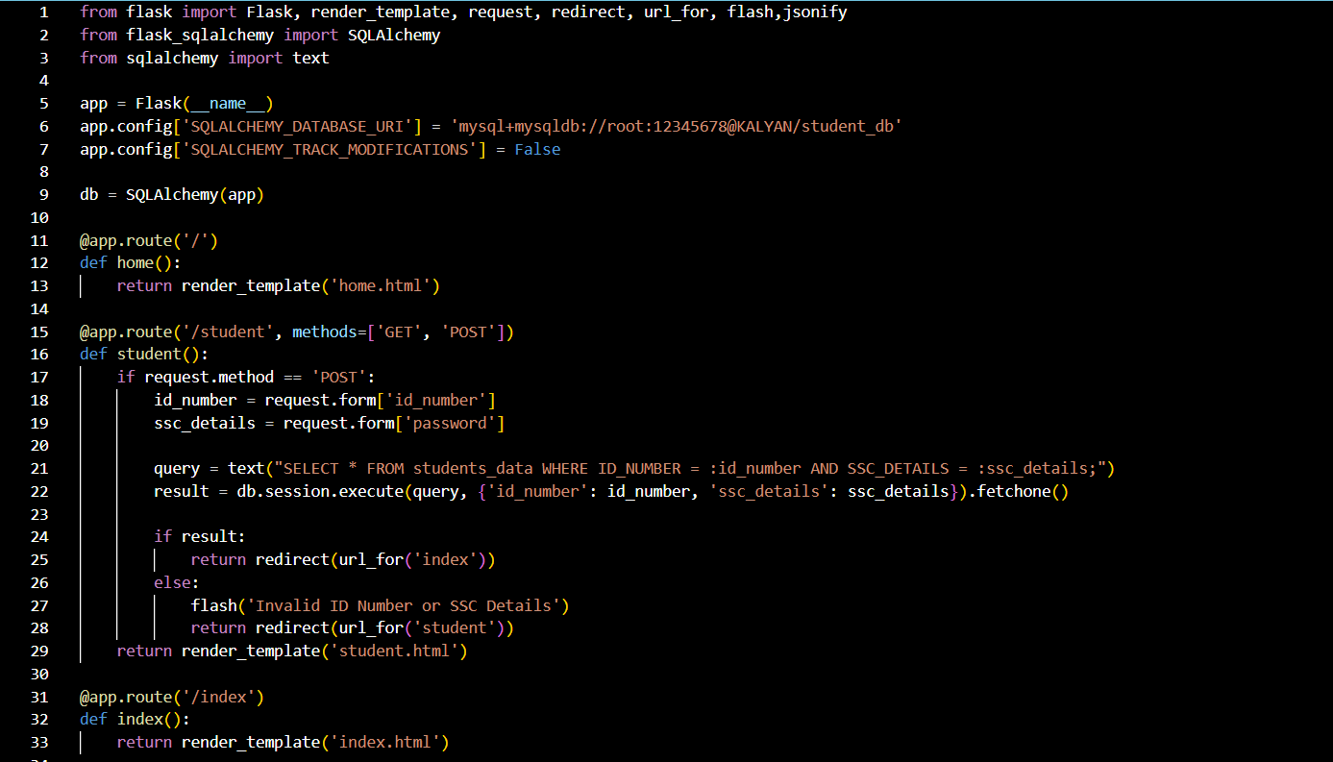
Figure 1: Routes1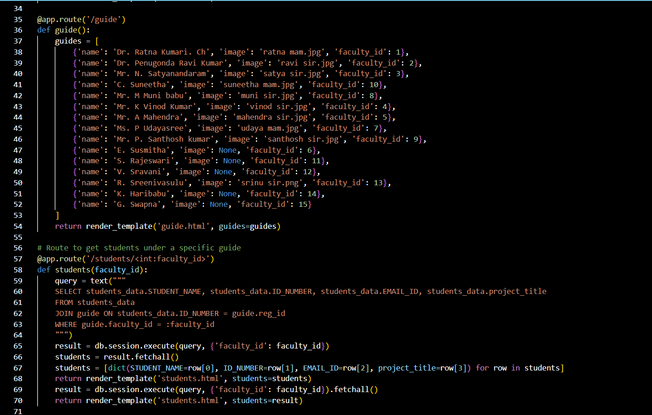
Figure 2:Routes2
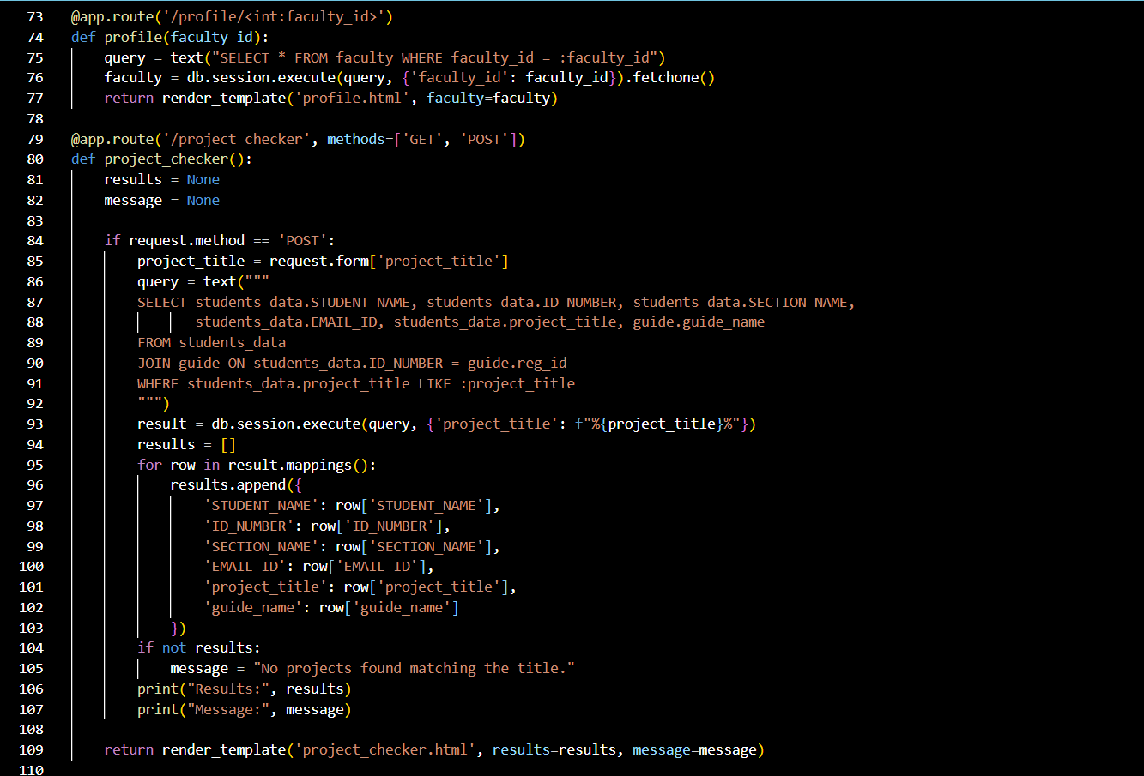
Figure 3: Routes3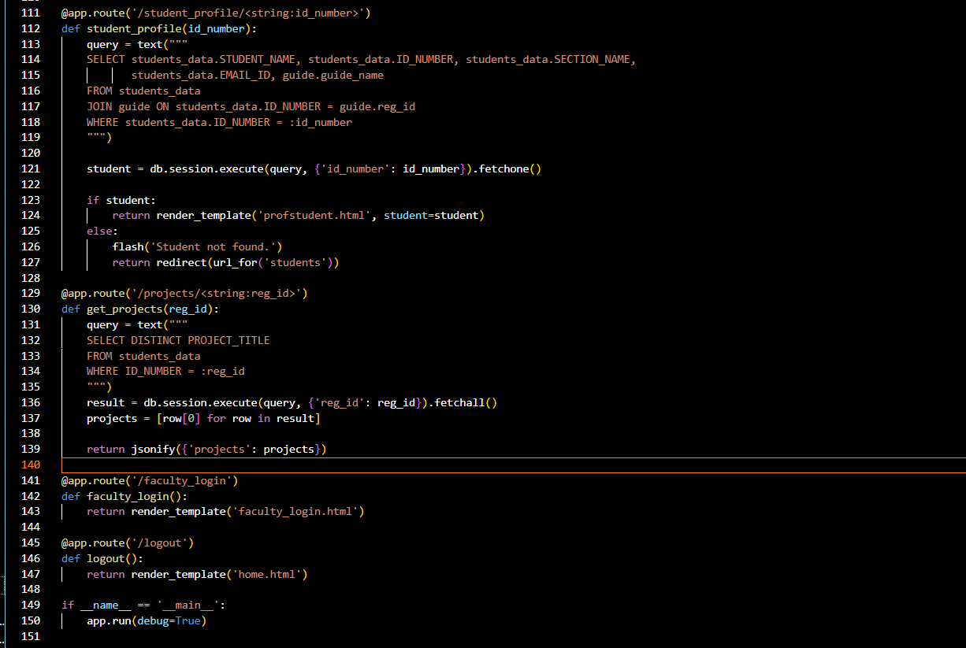
Figure 4:Routes4
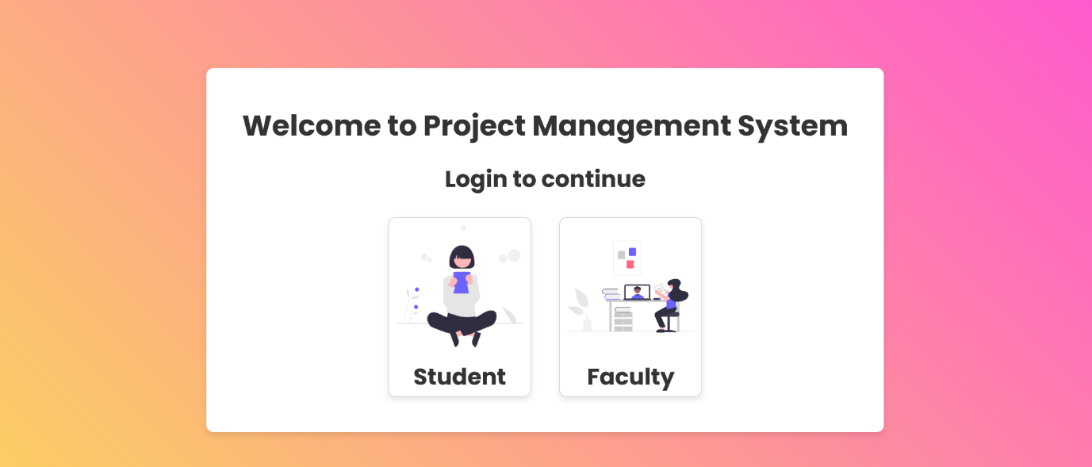
Figure 5: Home Page
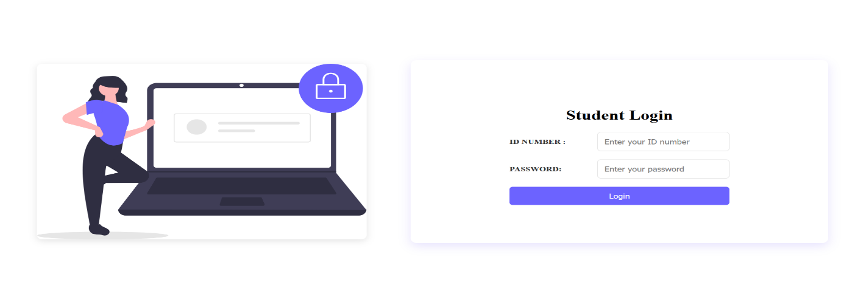
Figure 6:Student_login page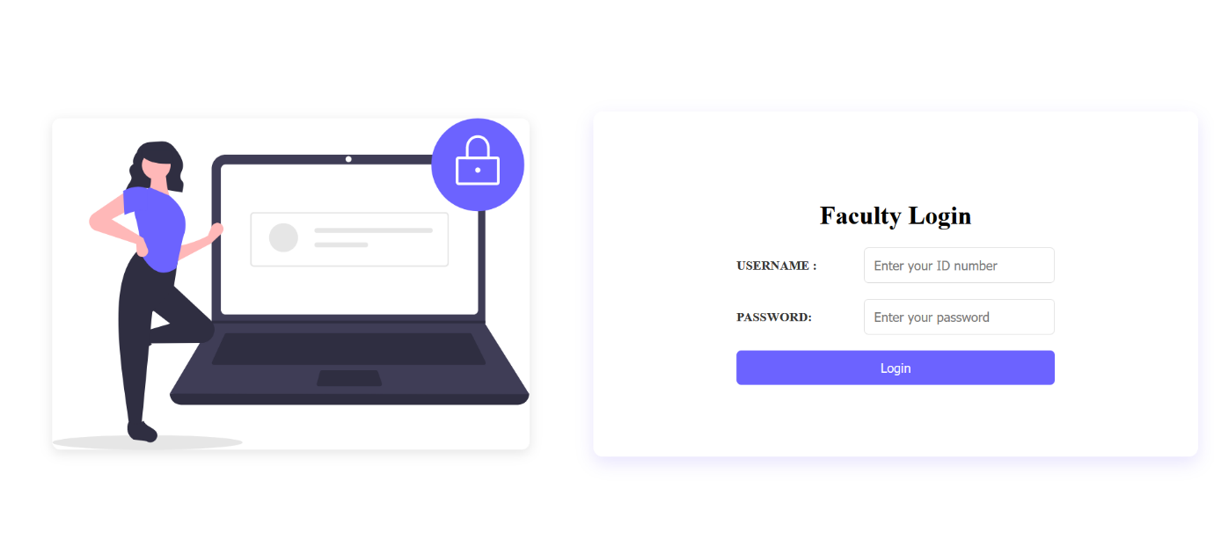
Figure 7:Faculty_login page
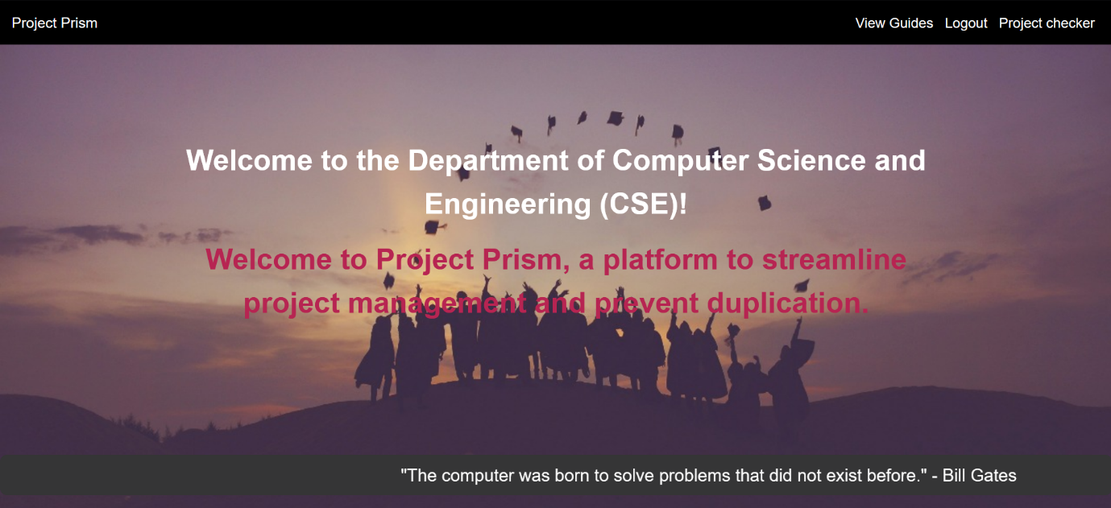
Figure 8 : Index page
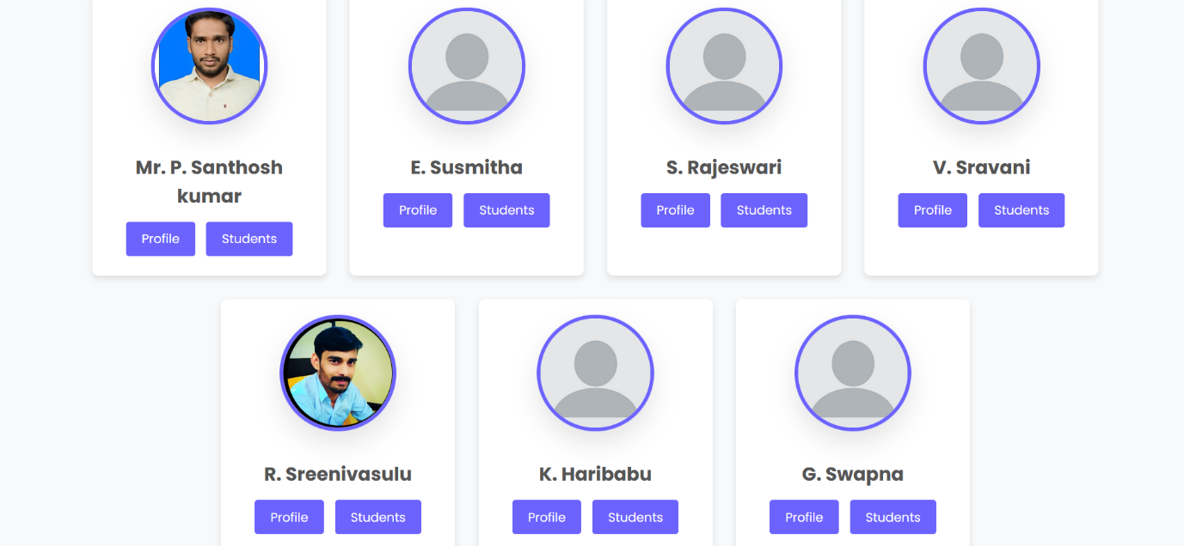
Figure 9 : Guides page

Figure 10 : Faculty _ profile page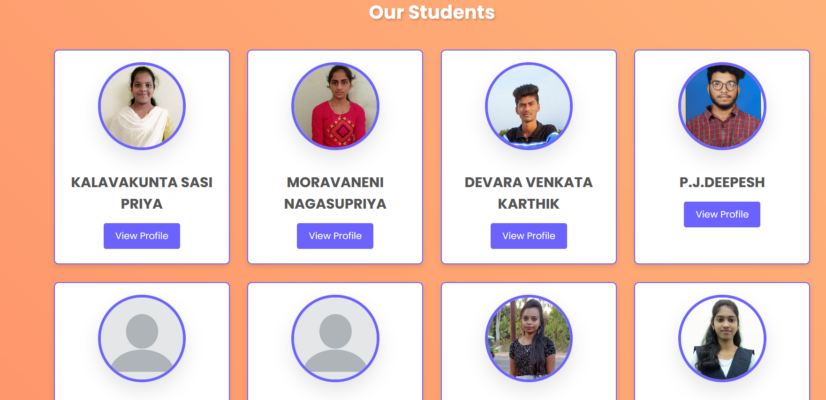
Figure 11: Students page
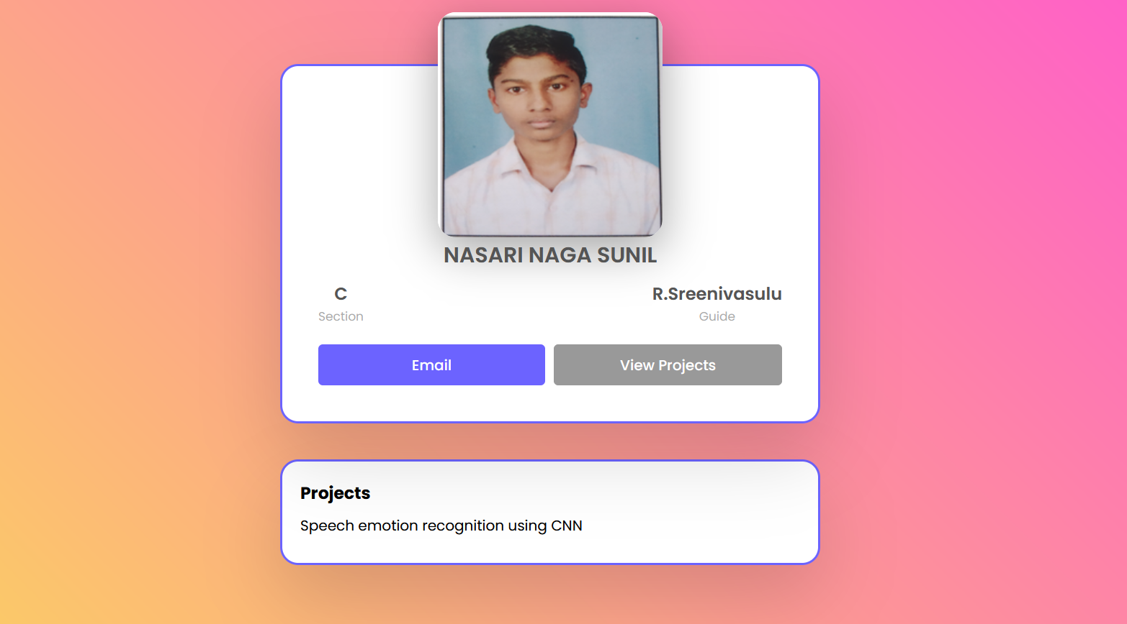
Figure 12:Student _profile
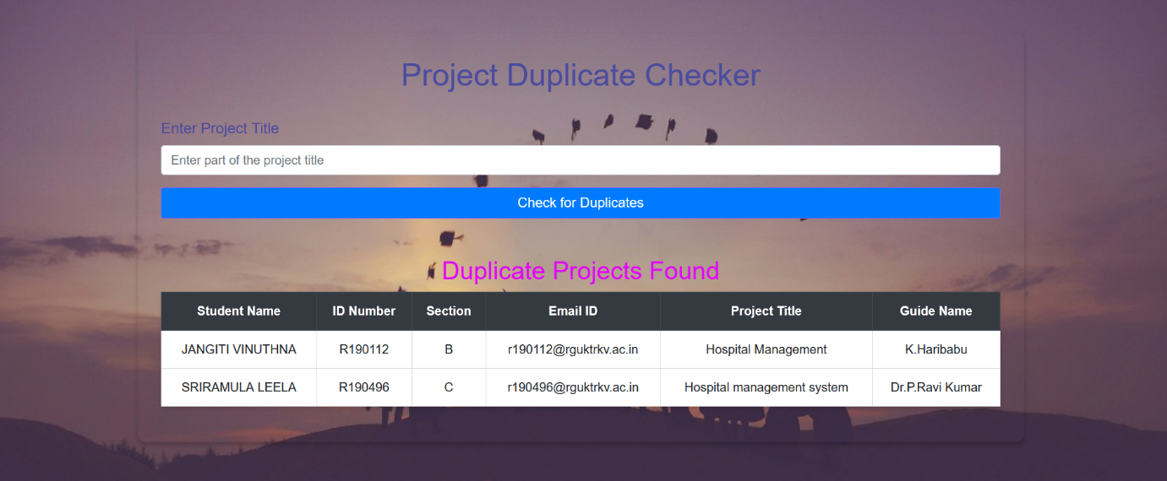
Figure 13:Project checking page

8. Result and Discussion :
Successful Implementation of the Project Management System
The Project Management System, specifically the duplicate project checker, was successfully implemented and tested. The key results from this implementation are summarized below:
- Database Integration:
  - The system uses a MySQL database to store and manage information about students, faculty, projects, and guides.
  - The database schema includes tables such as students_data, guide, and faculty, ensuring structured and efficient data management.
- User Authentication:
  - The student login functionality was tested and verified. Students can log in using their ID number and SSC details.
  - Similarly, separate login pages faculty members were tested and confirmed to be functional.
- Guide Information:
  - The guide.html page displays a list of guides with their names and images.
  - Each guide's profile is accessible, providing detailed information about their expertise and the students they are supervising.

- Students Under Guide:
  - The system displays a list of students working under a specific guide on the students.html page.
  - This includes detailed information such as student names, ID numbers, email addresses, and project titles.
- Project Checker:
  - The project_checker.html page allows users to search for existing projects by title.
  - Search results display detailed information about matching projects, including the names of students, their ID numbers, sections, email addresses, project titles, and guide names.
  - A clear message is provided if no matching projects are found.
- Individual Student Profiles:
  - Detailed profiles for individual students are available on the profstudent.html page.
  - Each profile includes comprehensive information such as the student’s name, ID number, section, email address, and the guide overseeing their project.
- Faculty Profiles:
  - Detailed profiles for faculty members are provided on the profile.html page.
  - Each profile includes the faculty member's name, department, contact information, and areas of expertise, as well as a list of students they guide.
Discussion
The implementation of the Project Management System, particularly the duplicate project checker, addresses several key objectives and demonstrates significant achievements:
Efficient Data Management
The system efficiently manages student, faculty, and project data using a structured MySQL database. The integration of SQLAlchemy for database interactions ensures that data queries are secure, efficient, and easy to manage. By organizing the data into well-defined tables, the system ensures data integrity and accessibility, which is crucial for the accurate and timely retrieval of information.
Enhanced User Experience
The user interface was designed with a focus on simplicity and usability. Each HTML page is tailored to meet the specific needs of its users, whether they are students, faculty, or administrators. The use of clear navigation links, informative messages, and a consistent layout contributes to a positive user experience. The ability to quickly access information about guides, students, and projects enhances the overall functionality of the system.
Robust Authentication and Security
Security is a critical aspect of any management system. The implementation of secure login mechanisms ensures that only authorized users can access sensitive information. By using unique ID numbers and secure credentials, the system protects against unauthorized access and ensures that data remains confidential.
Effective Duplicate Project Checking
The core functionality of the system, the duplicate project checker, effectively addresses the problem of duplicate project submissions. By allowing users to search for existing projects by title and providing detailed information about matching projects, the system helps to prevent redundancy and encourages originality in project work. This functionality is particularly valuable for faculty members and administrators who need to oversee numerous projects and ensure academic integrity.
Detailed Profiles and Information Access
Providing detailed profiles for students, guides, and faculty members adds significant value to the system. Users can access comprehensive information, making it easier to manage and track project progress. For example, faculty members can quickly view all students under their supervision, while students can see detailed information about their projects and guides.
Scalability and Future Enhancements
The system is designed to be scalable, allowing for future enhancements and additions. As the needs of the institution evolve, additional features can be integrated into the system. For example, features such as automated notifications, progress tracking, and enhanced search capabilities could further improve the system's functionality.

19.Conclusion and Future Enhancement
Conclusion :
The Project Management System, specifically the duplicate project checker, has successfully achieved its primary objectives. It effectively manages student and project data, ensures secure authentication, and offers a user-friendly interface. This implementation addresses the critical need to prevent duplicate project submissions, thereby promoting originality and academic integrity within the institution. The system's key features, such as detailed student and faculty profiles, efficient database management, and robust search functionalities, contribute significantly to its overall effectiveness.
Efficient database management is achieved through the use of MySQL and SQLAlchemy, which ensure that information is stored and retrieved securely and efficiently. The structured database schema supports seamless data interactions, enhancing the system's reliability. Robust authentication mechanisms provide secure login functionality for students, faculty, and HODs, ensuring that only authorized users can access sensitive information. This maintains the integrity and confidentiality of the data.
The user-friendly interface is intuitive and easy to navigate, enhancing the user experience by allowing users to access information quickly and efficiently. Consistent styling and clear navigation links contribute to the system's overall usability. The core functionality of the duplicate project checker is effectively implemented, allowing users to search for existing projects by title and receive detailed information about matching projects. This feature helps prevent redundancy and encourages innovation in project work.
The system also provides comprehensive profiles for students, guides, and faculty members, facilitating better management and tracking of project progress. Overall, the Project Management System successfully meets its goals and provides a valuable tool for managing and overseeing academic projects.
Future Enhancements
While the Project Management System has achieved its initial objectives, several potential enhancements could further improve its functionality and user experience. Implementing automated notifications for project deadlines, updates, and important announcements could enhance communication between students, faculty, and administrators. This feature would ensure that all stakeholders are kept informed in a timely manner.
Adding features to track the progress of projects and generate detailed reports could provide valuable insights for both students and faculty. This could include milestone tracking, progress updates, and performance analytics. Improving the search functionality to include advanced filters and sorting options would make it easier for users to find specific projects or information. This could include searching by keywords, guide names, or project categories.
Developing a mobile-friendly version of the system or a dedicated mobile app would allow users to access the system on-the-go, increasing accessibility and convenience. Integrating collaboration tools such as discussion forums, file sharing, and group messaging could facilitate better communication and collaboration among project teams and their guides.
Integrating the Project Management System with other academic or administrative systems used by the institution could streamline data sharing and improve overall efficiency. This could include integration with learning management systems (LMS), student information systems (SIS), and library databases.
Implementing a mechanism for users to provide feedback on the system's functionality and usability would help identify areas for improvement. Regular updates and enhancements based on user feedback would ensure that the system continues to meet the evolving needs of its users.
By incorporating these enhancements, the Project Management System can further improve its value and effectiveness, providing a comprehensive tool for managing academic projects and promoting innovation and originality within the institution.

10.References
- https://www.researchgate.net/publication/312523925_A_web-based_final_year_Students_Project_Duplication_Detection_System
- https://www.rguktrkv.ac.in/index.php

