**Open Loop:**

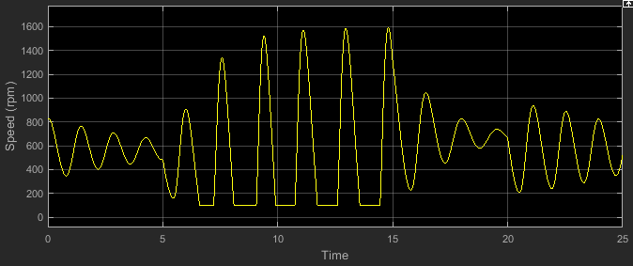

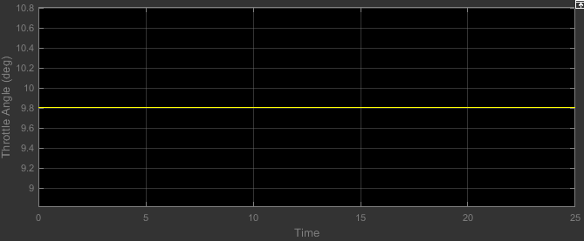

**Closed Loop (HandTuning)**

KP = 0.01;

TI = 1;

KI = 0.001;

Td = 1;

Kd = 1;

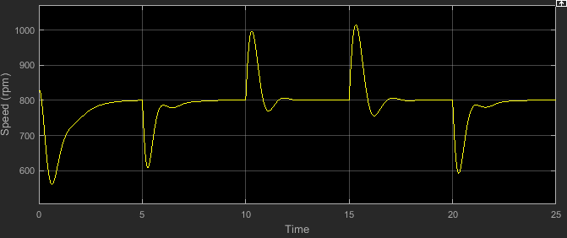

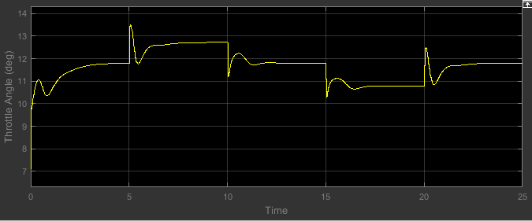

The below one is assumed to be stable one

KP = 0.5;

TI = 1;

KI = 0.005;

Td = 1;

Kd = 4;

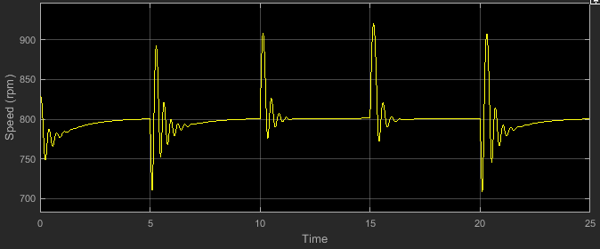

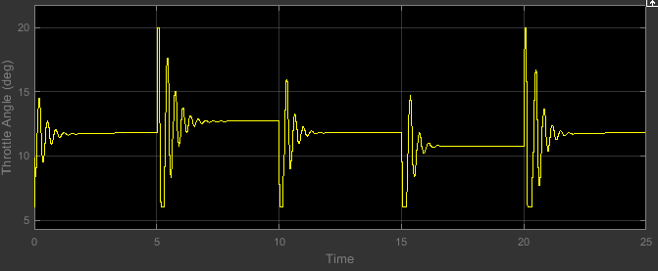

**Changing kd values only**

KP = 0.5;

TI = 1;

KI = 0.005;

Td = 1;

Kd = 3

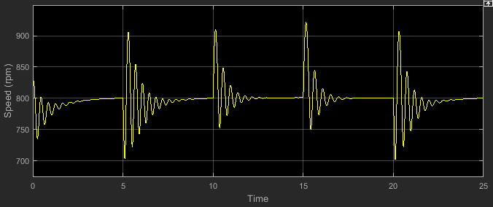

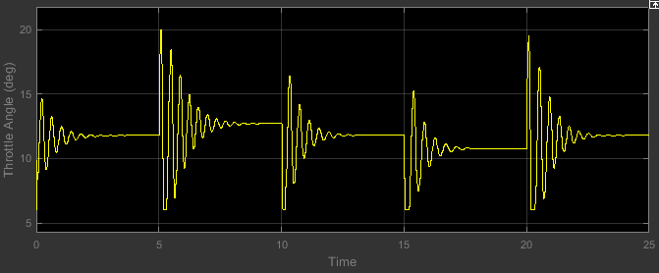

KP = 0.5;

TI = 1;

KI = 0.005;

Td = 1;

Kd = 4.7

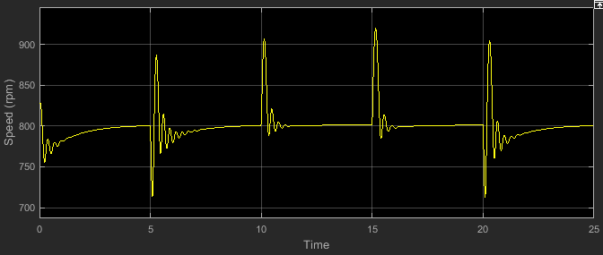

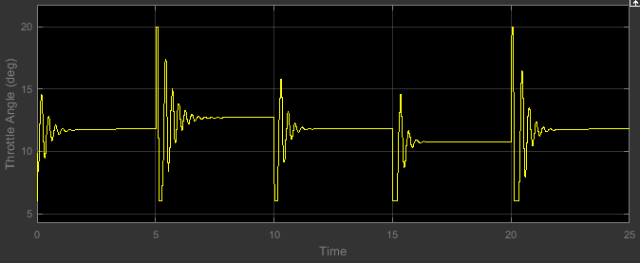

**Changing KI values only**

KP = 0.5;

TI = 1;

KI = 0.013;

Td = 1;

Kd = 4

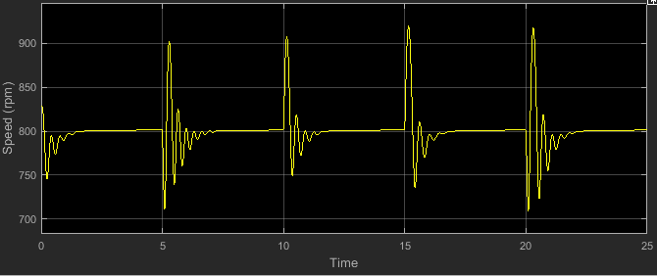

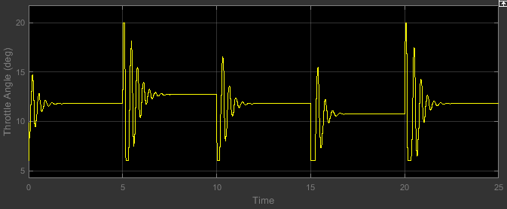

KP = 0.5;

TI = 1;

KI = 0.0004;

Td = 1;

Kd = 4

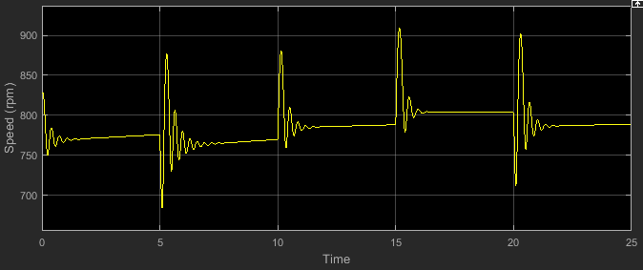

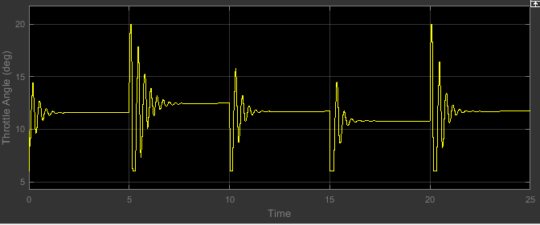

**Changing KP values**

KP = 0.17;

TI = 1;

KI = 0.005;

Td = 1;

Kd = 4

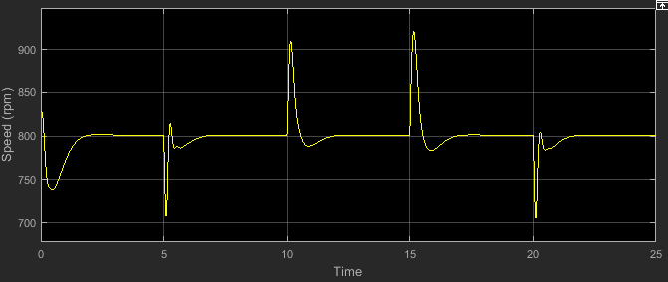

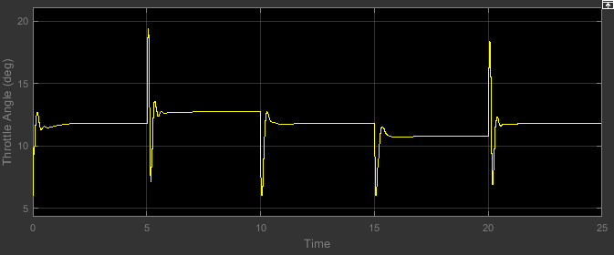

KP = 0.8;

TI = 1;

KI = 0.005;

Td = 1;

Kd = 4

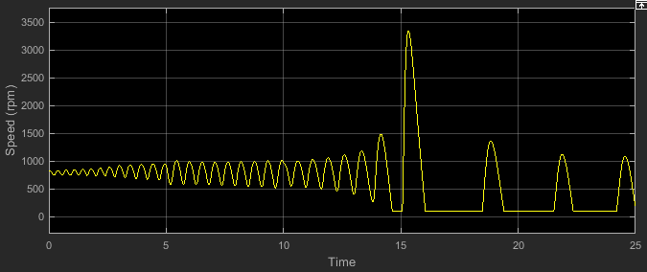

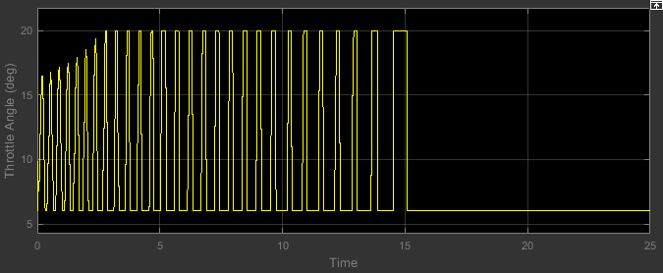

**Fmincon**

The below is the Best one

x0 =

0.0100 0.0010 2.0000

>> x

x =

0.2430 0.0115 2.0000

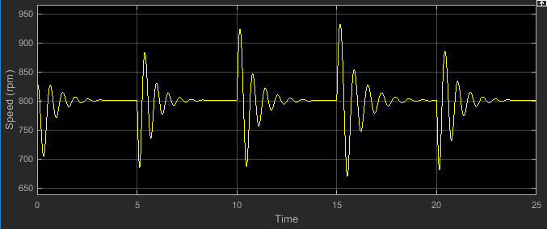

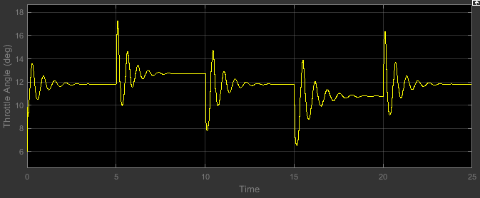

**Changing only Kd values**

x0 =

0.0100 0.0010 1.5000

>> x

x =

0.2504 0.0063 1.4331

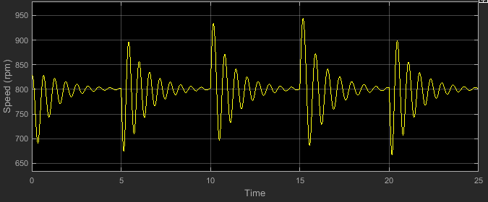

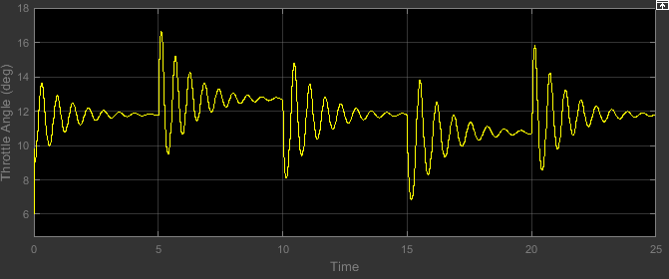

x0 =

0.0100 0.0010 5.0000

>> x

x =

0.2430 0.0115 2.0000

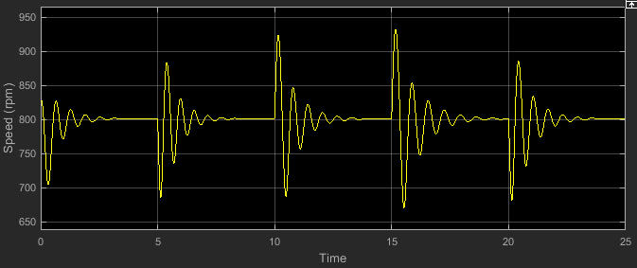

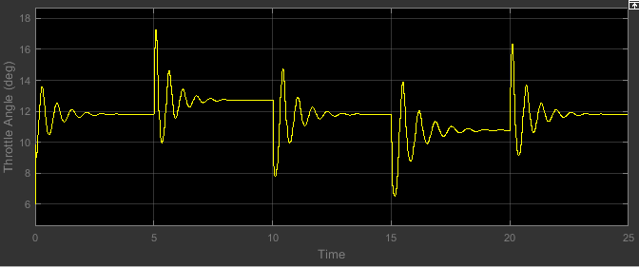

(Best)

x0 =

0.0100 0.0010 1.0000

>> x

x =

0.0108 0.0018 0.9996

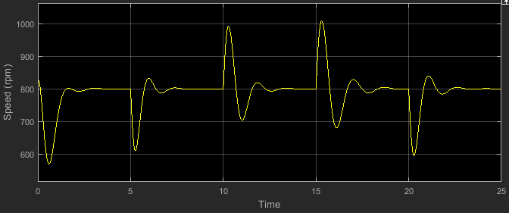

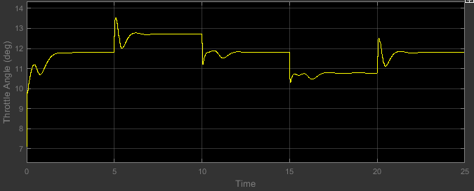

**Changing only KI values**

x0 =

0.0100 0.0090 2.0000

>> x

x =

0.1026 0.0036 1.3932

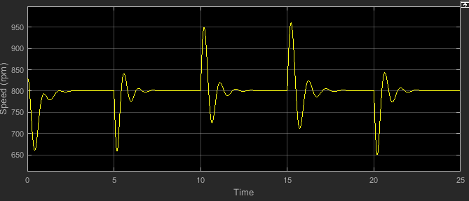

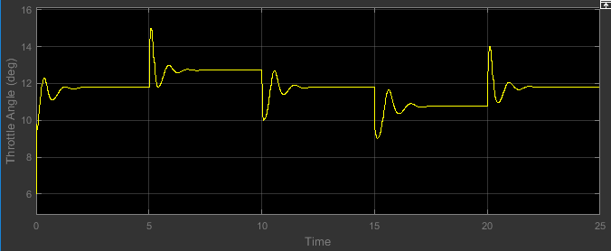

x0 =

0.0100 0.0005 2.0000

>> x

x =

0.0146 0.0052 1.9953

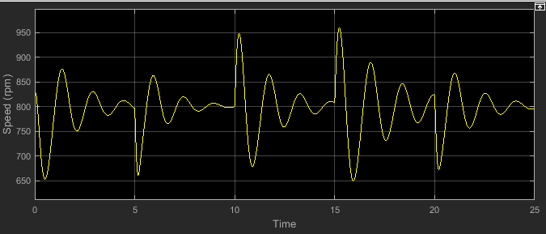

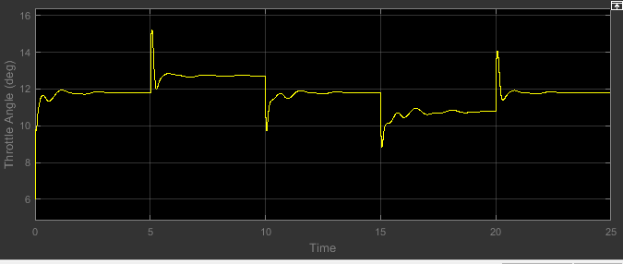

**Changing only KP values**

x0 =

0.0900 0.0010 2.0000

>> x

x =

0.0991 0.0105 1.9905

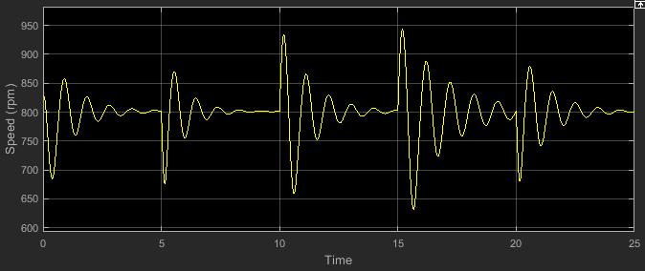

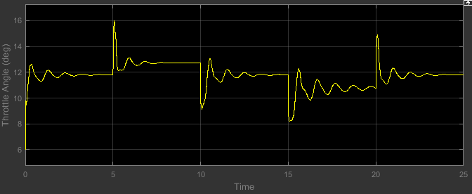

x0 =

0.0020 0.0010 2.0000

>> x

x =

0.0043 0.0033 2.0000

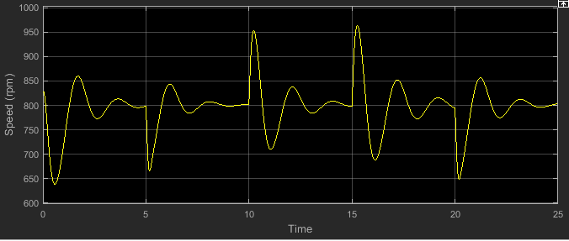

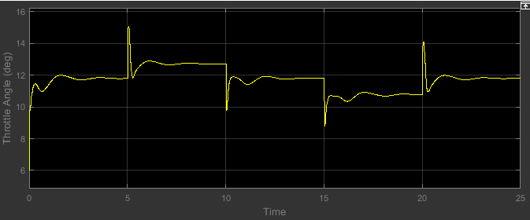

(Stable point)

x0 =

0.5000 0.0050 4.0000

>> x

x =

0.5002 0.0053 1.9997

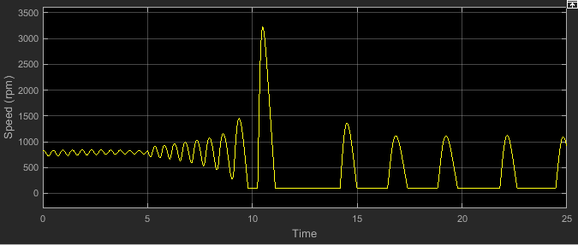

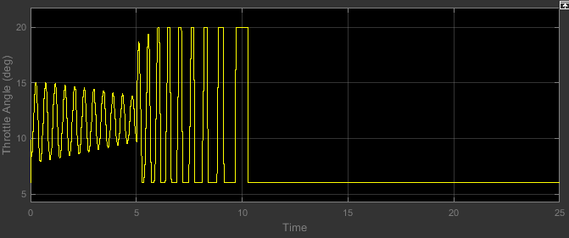

The below one is also fmincon with initial values (1,1,1) if you don’t want in report you can ignore it.

Note: After this check the Norm and error^2 and tolerance for fmincon as well

x =

0 2 0

>> x0

x0 =

1 1 1

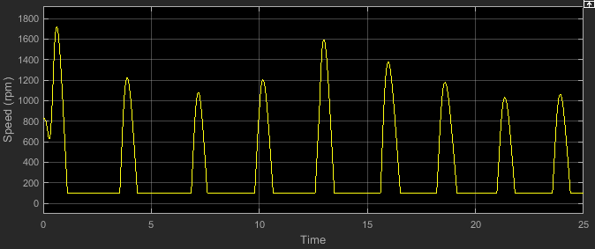

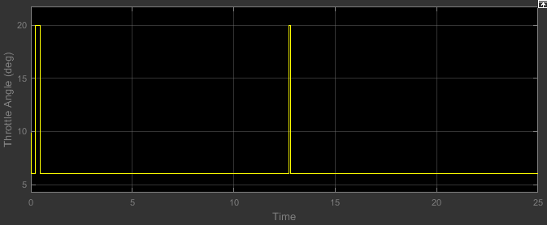

**Norm squared speed (fmincon)**

x0 =

0.0100 0.0010 2.0000

>> x

x =

0.0146 0.0057 2.0000

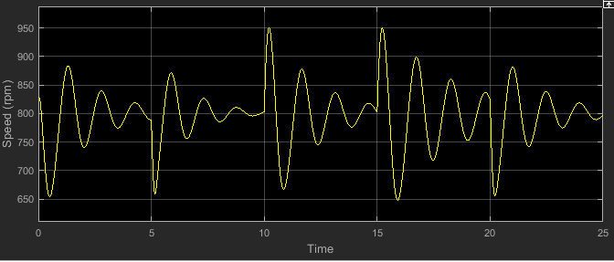

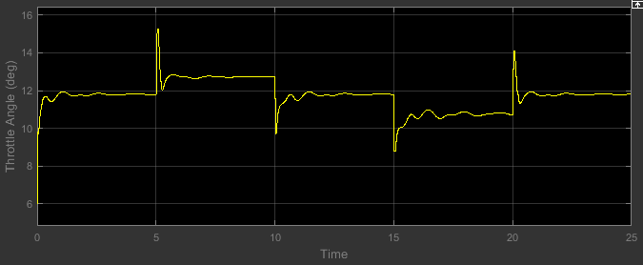

**T(error)^2**

x0 =

0.0100 0.0010 2.0000

>> x

x =

0.1585 0.0013 2.0000

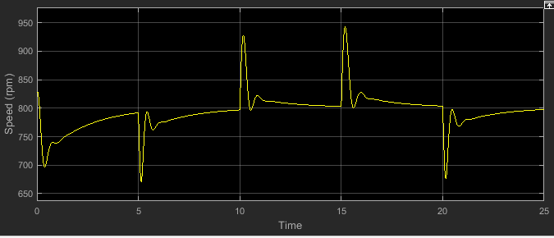

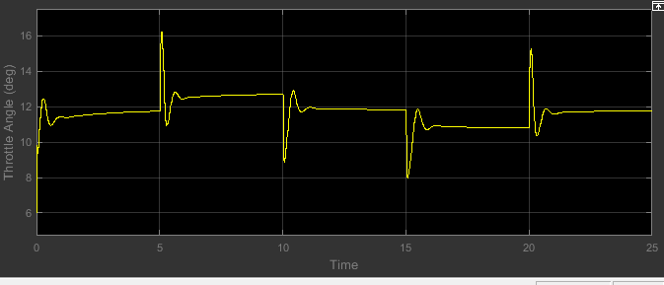

**With Tolerance e^-10**

x0 =

0.0100 0.0010 2.0000

>> x

x =

0.1640 0.0055 2.0000

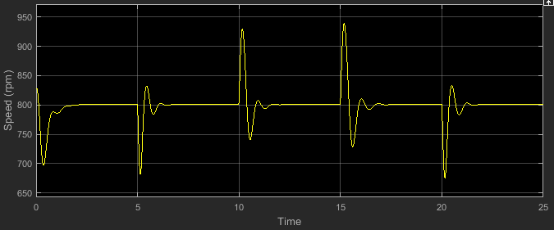

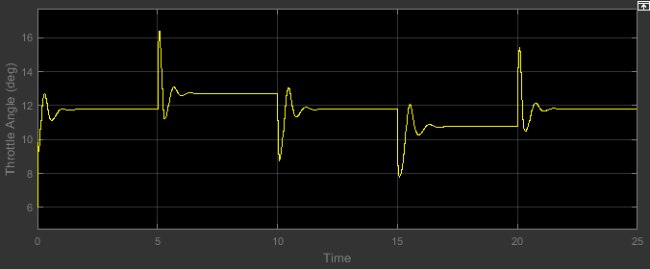

**Fminsearch**

As far fminsearch is concerned whatever the x0 values are the final x values are arriving almost same.

x0 =

0.0800 0.0010 2.0000

>> x

x =

0.2399 0.0095 3.5980

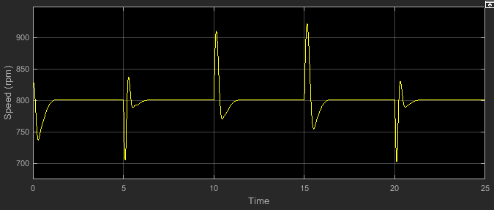

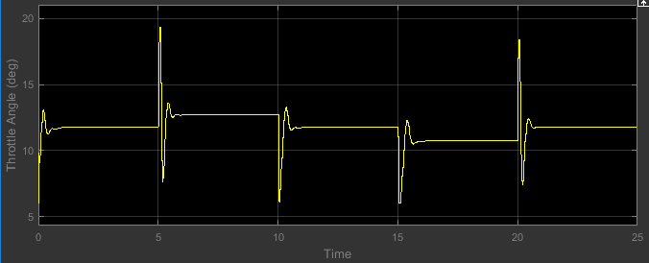

x0 =

0.1000 0.0090 5.0000

>> x

x =

0.2393 0.0095 3.5958

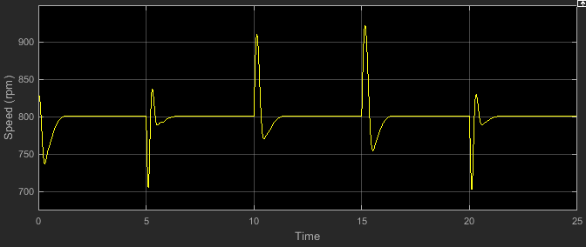

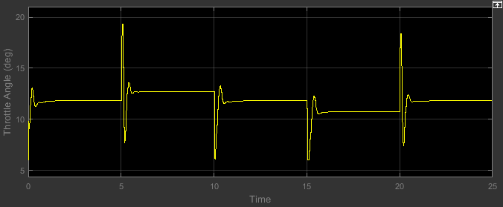

x0 =

0.0100 0.0010 2.0000

>> x

x =

0.2394 0.0095 3.5971

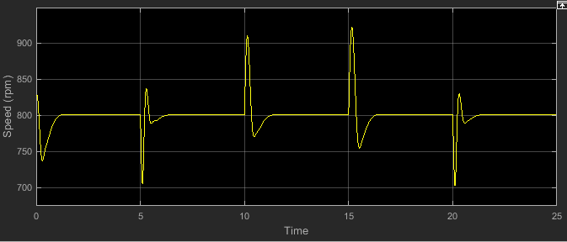

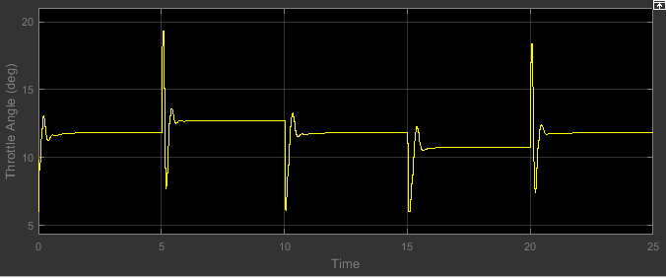

**Fminunc (Quasi Newton Algorithm)**

x0 =

0.0100 0.0010 2.0000

>> x

x =

0.0114 0.0017 2.0000

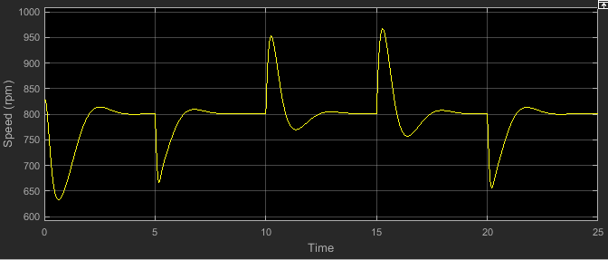

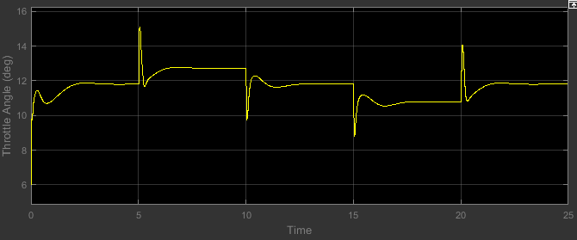

x0 =

0.0800 0.0010 2.0000

>> x

x =

0.1198 0.0060 1.9846

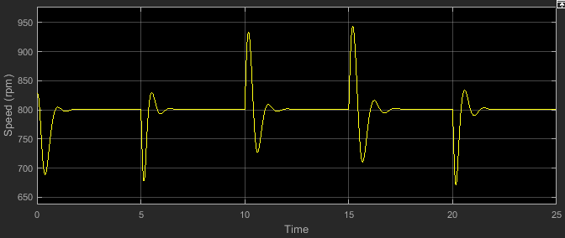

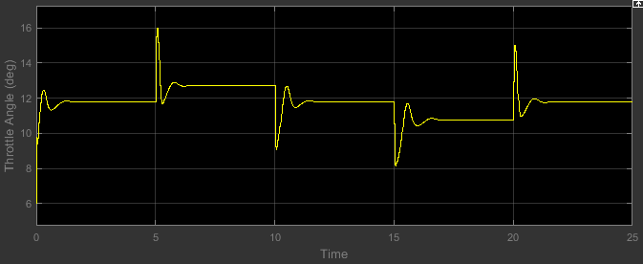

x0 =

0.1000 0.0090 5.0000

>> x

x =

0.1054 0.0084 5.0010

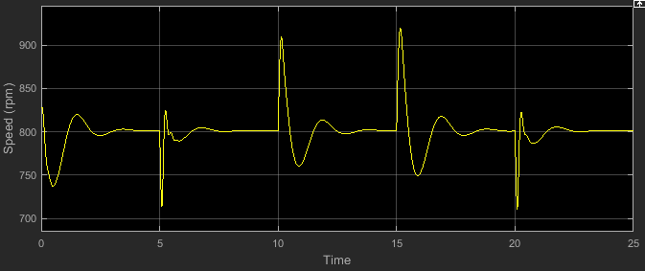

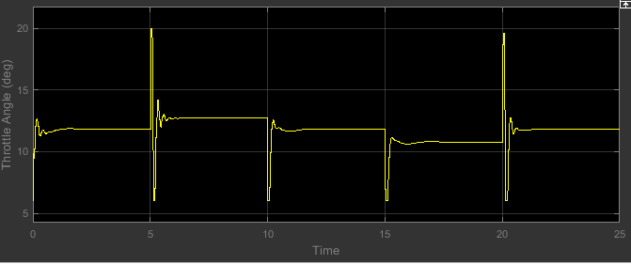

x0 =

0.0100 0.0010 3.0000

>> x

x =

0.0100 0.0024 3.0000

