# Magnetometer Calibration Guide

The following guide shows how one calibrates the magnetomter for the AR Drone 2.0. This guide assumes

1. You’ve installed the support package
2. Tested out external mode and everything works fine

**NOTE: the magnetometer is currently not used for the free flight hovering demo, you could potentially ignore this entire guide.**

**What are we calibrating?**

The magnetometer provides 3-axis information of the Earth’s magnetic field projected onto the sensor’s axes.

If one were to rotate the magnetometer and do a three dimensional plot of all three sensor readings (mx, my,mz) you will get something like this

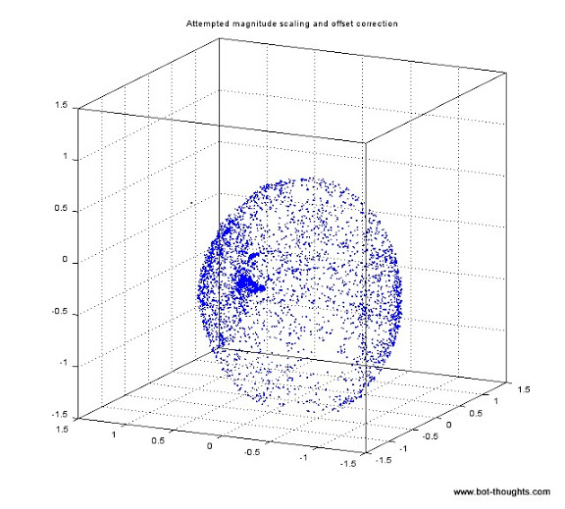

Something ellipsoid in nature. Instead of a perfect sphere, due to slight magnetic interference and sensor properties, this will re-shape the response of the sensor. To re-form the data correctly, we need to determine scaling and offset parameters to divide and multiply the magnetometer vector by to bring it back to a unit circle.

IMPORTANT NOTE:

The magnetometer provides 3-axes of information, thus, we are also going to measure a Z-component even if the sensors XY plane are parallel to the Earth’s ground. Depending on where you are on the Earth, the inclination (or , **magnetic inclination**) of this vector in the Z-direction will vary.

<http://www.ngdc.noaa.gov/geomag-web/?id=declinationFormId>

Consult with this website to see which way it will point along the Z-axis