Supplementary materials for:

Good me Bad me:

Prioritization of Good-Self in Perceptual Decision-Making
Chuan-Peng Hu *
Department of Psychology, Tsinghua University, 100084 Beijing, China,
German Resilience Center, 55131 Mainz, Germany,
Yuxuan Lan
School of Life Science, Tsinghua University, 10084 Beijing, China
C. Neil Macrae
School of Psychology, University of Aberdeen, Aberdeen, Scotland
Jie Sui
Department of Psychology, University of Aberdeen, Aberdeen, Scotland

* Correspondence: C-P. Hu, hcp4715@gmail.com

Table of Contents
Supplementary Material 1: Pilot study 1
Supplementary Material 2: Details of the main study 12
Supplementary Material 3: Comparing Bad-other with Good-self 23

Supplementary Material 1: Pilot study
Method
This experiment was pre-registered at: https://osf.io/324up/. All scripts in Matlab and stimuli are available at https://osf.io/4zvkm/. There were several deviations from the original plan, see the Deviations from pre-registration section.
Participants. Thirty-five college students (14 females, age: 21.65 ± 2.03) from Tsinghua University were recruited via an advertisement on the campus and compensated for ￥60 (~ $ 8.7) per hour. All participants were right-handed and had normal or corrected-to-normal visual acuity. Informed consent was obtained from participants prior to the experiment and the protocol was reviewed and approved by the Ethics Committee at the Department of Psychology, Tsinghua University.
This sample size for the matching task was computed using G*Power 3.1.9.2. Based on prior work yielding a medium effect size (self vs. other, Cohen’s d_{z} = 0.6), a power analysis revealed a requirement of at least 32 participants to replicate the similar effect size with α = .05 and desired power = 0.9.
Data from six participants were excluded from data analysis, four of them due to a procedural error during data collection, and two because of chance levels of performance in the matching task. Thus, data from 29 participants (13 females, age: 21.55 $±$ 1.99 years) were included in the analysis.
Stimuli and tasks. The data was collected using the same setting as described in the main text, with several differences:
(1), In the shape categorization task, the shapes were presented 200 ms, instead of 100 ms in the main experiment, and the feedback stimuli were happy or sad figurative faces (see Figure S1).
(2), There were three different type of blocks in the categorization task in the pilot study. Besides the categorizations of “self vs. other” and “good vs. bad”, participants also categorized the shapes based on whether the shape was important to them, i.e., “important vs not-important”. To customize the standard for importance, at the beginning of the categorization task, participants were asked to judge the importance of each of four shapes, and they were told to categorize the shape based on this standard in the importance categorization block.
(3). Trials number in this pilot experiments is different from the main experiment. There were 60 experimental trials per condition in total (match/mismatch × self/other × good/bad: match good self, match bad self, match good other, match bad other, mismatch good self, mismatch bad self, mismatch good other, mismatch bad other). For the categorization tasks, there were 72 trials per condition in total (three criteria for categorization: self, valence, importance, each with 4 different shapes).
(3), The questionnaire for individual differences were different from the main experiment.
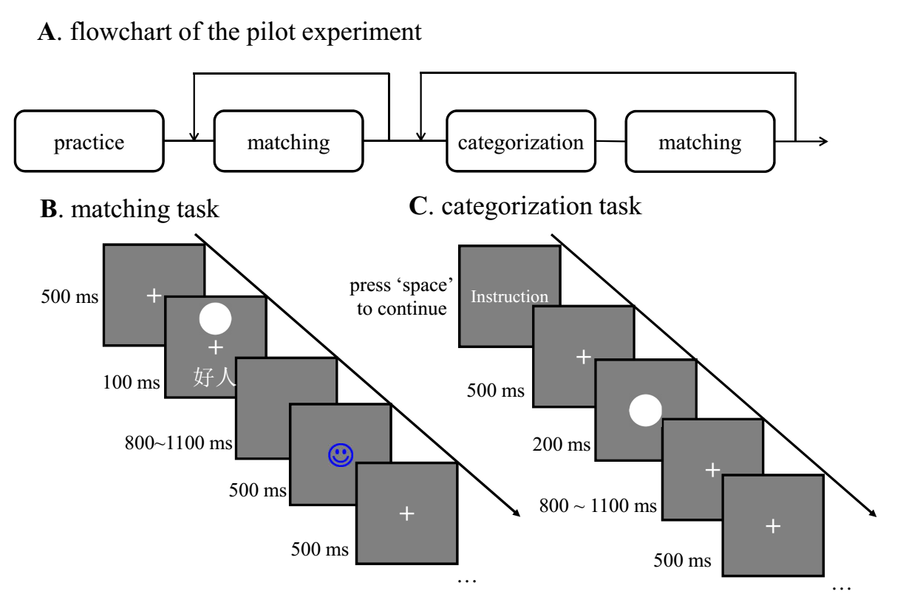
Figure S1. Examples of the stimuli and trials in the matching task and shape categorization tasks in Experiment 1. (A) The flowchart of Experiment 1. (B) A trial from the matching task. (C) A trial from the shape categorization task.

Experimental Design and Data Analyses. The behavioral data were analyzed in the same way as described in the main experiment, with two notes. First, the additional importance blocks in pilot study resulted in unbalanced number of trials, and therefore excluded from the analysis. And therefore, we didn’t include this categorization task in our main experiment. Second, the modeling part is different from the main experiment. In the pilot study, we registered both ex-Gaussian analysis and DDM, but DDM analyses was not reported, see below.
Modelling. In our pre-registration, we planned to model the data using ex-Gaussian and drift diffusion model (DDM). The DDM analysis were not reported (see Deviation from the Pre-registration below).
We fitted ex-Gaussian model with reaction times data of those correct trials (Heathcote, Brown, & Mewhort, 2002), as in our pre-registration (https://osf.io/srmp6/). The ex-Gaussian function characterizes the distribution of reaction times (RTs) as being made up of two distinct distributions ---- a Gaussian distribution and an exponential distribution. The mean and standard deviation of the Gaussian distribution are represented by the parameters mu (μ) and sigma (σ) respectively; the exponential distribution is represented by a single parameter, tau (τ), which reflects both the mean and the standard deviation. Previous studies have shown that variables can exert opposite effects on parameters of the Gaussian and the exponential component and that these changes can thus be hidden in analyses based only on mean RT data (e.g., (Heathcote, Popiel, & Mewhort, 1991; Spieler, Balota, & Faust, 1996))
We used the ‘timefit’ function in the ‘retimes’ package (Massidda, 2013), the R programming language (R Core Team, 2018), for ex-Gaussian analysis. The ‘timefit’ function use maximum likelihood method to estimate the parameter for reaction times distribution using ex-Gaussian probability distribution. Bootstrap method (re-sampled for 2 000 times) was used to obtain a stable result. We fitted the RT data (corrected trials with longer than 200ms) for each condition of each participant. Then, as in our main experiment, we removed the conditions with less then 50% accurate trials (i.e., 36 trials). The results reported here include 27 participants.
Deviations from pre-registration. As mentioned above, we excluded the importance categorization blocks because the unbalanced number of stimuli and responses across participants.
The criterion for excluding participants was slightly different from pre-registration. To maximize data usage, we used chance level performance (50% accuracy) as the criterion to exclude participants. This criterion was different from that (60% accuracy) in the pre-registration. Additional analysis with 60% overall accuracy as the exclusion criterion showed a similar pattern as those with 50% accuracy, although there were four more participants removed from data analysis.
All the ANOVAs, ex-Gaussian modeling, and DDM model were registered. For the ANOVAs, it is possible to calculate the 95% confidence intervals for the effect size (e.g., eta squared), we did not report that because we are more interested in the differences between different conditions as revealed by t-test. Given that all our raw data are open, interested readers can easily calculate the 95% confidence intervals of eta squared.
We did not specify about the simple effect analyses in our pre-registration however, we analyzed simple effect (planned contrast) based on previous research and our previous experiments, which consistently found the interaction between Self-relevance × Valence (see our open notebook: https://osf.io/nukwz/). More specifically, we are interested in testing the interaction between self-reference effect and valence effect, and tested four contrasts: Good-self vs Bad-self, Good-other vs. Bad-other, Good-self vs. Good-other, and Bad-self vs. Bad-other. The first two comparison reveals the valence effect at both self and other conditions, while the latter two comparison reveals the self-relevance effect on positive and negative conditions. The other two possible combination (Good-self vs. Bad-other, Good-other vs. Bad-self) was not informative for our purpose, we nevertheless tested the Good-self vs. Bad-other to address the concern from reviewer of previous version of this manuscript (version 1: https://psyarxiv.com/9fczh), and reported the results in the supplementary materials.
As suggested by reviewer of previous version of this manuscript and Wagenmakers et al. (2018), the number of models in Bayes factor analyses increased in the ANOVA analysis, it’s better also assess the results from Bayesian model averaging (Etz & Wagenmakers, 2017), which retain model selection uncertainty by averaging the conclusions from each candidate model, weighted by that model’s posterior plausibility. We reported the Bayes factor of Bayesian model averaging, which is indexed by BF_{incl}.
For the modeling part, we only reported the results of ex-Gaussian in the supplementary materials and did not report the DDM results. The omission of DDM results was partly because repeated measures ANOVA on RT did not provide evidence for the interaction. Nevertheless, the script for DDM analysis is available on our OSF project page.

Results
All the raw data (in csv format), summary results (in JASP format), and related R scripts are available at https://osf.io/4zvkm/.
Perceptual-matching task
ANOVAs. The repeated-measures ANOVAs on RTs showed strong evidence for the main effect of Valence (Good vs. Bad), F(1, 28) = 38.126, p < 0.001, ω² = 0.181, BF₁₀ = 1.326e + 6, BF_{incl} = 1.1e+6. But no clear evidence for the main effect of self-relevance effect F(1, 28) = 0.078, p = 0.782, ω² < 0.0001, BF = 0.198, BF_{incl} = 0.349. Only very weak evidence for the interaction between Self-relevance × Valence in the perceptual matching task, F(1, 28) = 3.939, p = 0.057, ω² = 0.0161, BF = 1.41, BF_{incl} = 0.99. The planned exploratory contrasts showed that there were faster responses to the Good-self than Bad-self association in the perceptual matching task (mean ± std: 655 ± 85 ms vs. 744 $±$ 70 ms), t(28) = -5.669, p < .001, Cohen's $d_{z}$ = -1.053, 95% CI [-1.503 -0.591], BF₁₀ = 4443, as well as faster responses to the Good-other than Gad-other association (mean ± std: 678 ± 93 ms vs. 725 $±$ 76 ms), t(28) = -3.164, p = .0037, Cohen's $d_{z}$ = -0.587, 95% CI [-0.978 -0.188], BF₁₀ = 10.6 (see Figure S2 A). These effects were robust across different priors (see Figure S3, upper panels). There was no evidence for differences for other two interested contrasts, i.e., Good-self vs Good-other or Bad-self vs. Bad-other.
There were strong evidence for the main effect of Valence (Good vs. Bad) on d prime, F(1, 28) = 10.74, p = 0.0028, ω² = 0.0324, BF₁₀ = 11.1, BF_{incl} = 8.44. But no evidence for the main effect of Self-relevance, F(1, 28) = 0.813, p = 0.375, ω² < 0.0001, BF₁₀ = 0.284, BF_{incl} = 0.297; or for the interaction between Self-relevance × Valence, F(1, 28) = 1.89, p = 0.18, ω² = 0.0033, BF₁₀ = 0.59, BF_{incl} = 0.197. Planned exploratory contrast analyses showed that d prime was larger in the Good-self compared to the Bad-self in the perceptual matching task (mean ± std: 1.749 ± 0.936 vs. 1.233 ± 1), t(28) = 3.26, p = 0.0029, Cohen's d = 0.606, 95% CI[0.204 0.998], BF₁₀ = 13.1. This effect is robust across different priors (see Figure S3, lower panel). There was no evidence for differences for other interested contrasts, i.e., Good-other vs., Bad-other, Good-self vs Good-other or Bad-self vs. Bad-other.
Shape-categorization task.
ANOVAs. The three-way repeated-measures ANOVAs on RTs showed weak evidence for the interaction between Self-relevance × Valence in the categorization task: F(1, 28) = 3.553, p = 0.0699, ω² = 0.006, BF₁₀ = 1.34, BF_{incl} = 1.69, but no clear evidence for the main effect of Valence, Self-relevance, task type, or for other two-way interactions, or the three-way interactions. Planned exploratory contrast analyses, in which we collapsed data from two different tasks (Valence-based categorization and Identity-based categorization), showed that responses to the Good-self were faster than Bad-self conditions (mean ± std: 513 ± 52 vs. 535 ± 58), t(28) = -3, p = 0.0056, Cohen's d = -0.558, 95% CI[-0.946 -0.162], BF₁₀ = 7.5, but no evidence for the difference between other contrasts of interest (see Figure S2 B, Figure S4).
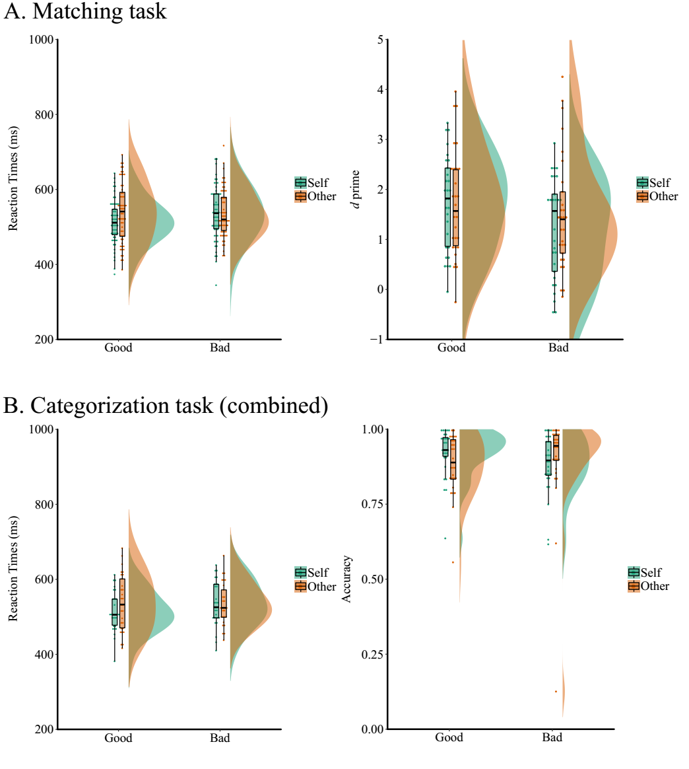
Figure S2 Reaction times (RT) and accuracy as a function of self-relevance and moral valence in Experiment 1. A. RTs and d prime in the matching task. B. RTs and accuracy data in the categorization task (combined both the identity-based and valence-based categorization).

Figure S3 Robustness check for Bayes factor from t-test as a function of prior. Upper Left: good-self vs. bad-self on RTs; Upper Right: good-other vs. bad-other on RTs; Lower: good-self vs. bad-self on d prime.

The three-way repeated measure ANOVA on accuracy data in the categorization task found weak evidence for the interaction between Self-relevance × Valence, F(1, 28) = 4.043, p = 0.0541, ω² = 0.0109, BF₁₀ = 2.29, BF_{incl} = 2, but no evidence for other main effects or interactions. Planned exploratory contrasts, after collapsing data from different tasks, revealed more accurate responses for the Good-self than the Bad-self conditions (mean ± std: 0.923 ± 0.08 vs. 0.884 ± 0.098), t(28) = 3.591, p = 0.0012, Cohen's d = 0.667, 95% CI[0.259 1.065], BF₁₀ = 27.6. Also, the Good-self conditions were more accurate than the Good-other conditions (mean ± std: 0.923 ± 0.08 vs. 0.883 ± 0.097), t(28) = 3.43, p = 0.0019, Cohen's d = 0.637, 95% CI[0.233 1.033], BF₁₀ = 19.2 (Figure S2 B, Figure S4), but no evidence for differences between other contrasts of interest.

Figure S4 Bayes factor from t-test in categorization task as a function of prior. Upper-left: good-self vs. bad-self on RTs; Upper-right: good-self vs. bad-self on ACC; Lower: good-self vs. good-other on ACC.
Ex-Gaussian results. The exGaussian modeling decompose the RT data into three parameters: mu, sigma and tau. For the parameter mu, classic 2 × 2 × 2 rmANOVA and Bayesian rmANOVA revealed no evidence for all effects of mu (ps > 0.02, BF₁₀ [0.174 0.98]). Neither evidence for any effects on the parameter tau.
For the parameter sigma, we found the following results, there was strong evidence for the interaction between Self-relevance and Valence, F(1, 26) = 7.24, p = 0.012, ω² = 0.0585, BF₁₀ = 41,8. All the other effects are not supported by the data (ps > 0.0512, BF₁₀ [0.2 1]). To analyze the interaction, we combined the data from different tasks, and conducted a 2 × 2 ANOVA. The results revealed strong evidence for the interaction between Self-relevance and Valence, F(1, 26) = 7.24, p = 0.0123, ω² = 0.0585, BF₁₀ = 36.7, while no evidence for neither main effect of Self-relevance [F(1, 26) = 3.22, p = 0.084, ω² = 0.011, BF₁₀ = 0.477] nor the main effect of Valence [F(1, 26) = 0.11, p = 0.743, ω² < 0.001, BF₁₀ = 0.215]. Simple effect found that for the Self condition, good-self (0.0574 ± 0.016) was smaller than bad-self (0.0697 ± 0.0231) condition: t(26) = -2.91, p_{adj} = 0.0288, Cohen’s d = -0.561, 95% CI [-0.963 -0.149], BF₁₀ = 6.13; while no evidence for the differences between good-other (0.0737 ± 0.033) and bad-other (0.0632 ± 0.0182), t(26) = 1.83, p_{adj} = 0.317, Cohen’s d = 0.352, 95% CI [-0.041 0.737], BF₁₀ = 0.869. Also, good-self is smaller than good-other, t(26) = -2.845, p_{adj} = 0.034, Cohen’s d = -0.548, 95% CI[-0.948 -0.138], BF₁₀ = 5.3, but no evidence showed differences between bad self and bad other, t(26) = 1.52, p_{adj} = 0.5636, Cohen’s d = 0.292, 95%[-0.096 0.675], BF₁₀ = 0.566. (see Figure S5).

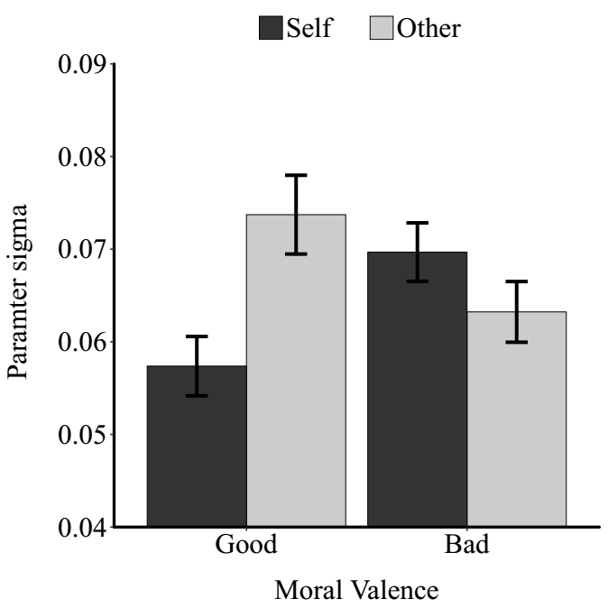
Figure S5. Mean values of parameter sigma as a function of the identity and valence of stimuli in categorization task (combined both identity- and valence-based categorization).
Cross-task analysis results. See Table S1 for all the correlations.

Supplementary Material 2: Details of the main study
Supplementary method.
Details of rmANOVAs. We tested the self-prioritization effect and the valence effect using 2 (self-relevance: self vs stranger) by 2 (valence: good vs. bad) repeated-measures analyses of variance (rmANOVAs) on response time (RT) of matched trials and d prime. For the shape-categorization task, one more within-subject variable (Task type: identity-based vs. valence-based) were added in the rmANOVAs on RT and accuracy data. Only correct trials were included in the RT analyses. We also conducted planned one-tailed t-tests. Specifically, we interested in four contrasts: Good-self vs Bad-self, Good-other vs. Bad-other, Good-self vs. Good-other, and Bad-self vs. Bad-other. The first two comparisons reveal the valence effect at both self and other conditions, while the latter two comparison reveals the self-relevance effect on positive and negative conditions. The effect sizes of the repeated measures ANOVAs (omega-squared, ω²) and t-tests (Cohen’s d) were reported, with the 95% confidence intervals of Cohen’s d. Note that the Cohen’ d estimated by JASP is the Cohen’ d_{z} (for different indices of Cohen’s d, see Lakens (2013)).
Bayes Factors were calculated by using the default prior in JASP 0.10.0.0 (Hu, Kong, Wagenmakers, Ly, & Peng, 2018; Wagenmakers et al., 2018). That is, for the repeated measure ANOVA, the distribution of fixed effect is Cauchy distribution with a scale parameter γ = 0.5, prior for random effect is Cauchy distribution with γ = 1, and prior for covariates is Cauchy distribution with γ = 0.354; for the t-test, we used a Cauchy distribution with scale parameter γ = 0.707. Criteria for interpreting BF was based on Jeffreys (Jeffreys, 1961; Wagenmakers et al., 2018), i.e., 0 < BF10 < 3 means anecdote evidence, 3 < BF10 < 6 means weak evidence, 6 < BF < 10 means moderate evidence, BF > 10 means strong evidence, and BF > 100 means overwhelming evidence. For the Bayesian rmANOVAs analysis, we also reported the results from Bayesian model averaging (indexed by BF_{incl}) (Etz & Wagenmakers, 2017), which retain model selection uncertainty by averaging the conclusions from each candidate model, weighted by that model’s posterior plausibility.
Details of Cross-Task Analyses. Correlational analyses between the perceptual-matching and shape-categorization tasks were conducted to test the generalization of the self-prioritization and positivity effects. We analyzed both the pilot study and the confirm study separately as well as combined them together. Recent simulation showed that correlation might be unstable if the sample size is small, therefore the result from combined data should be more reliable than separated data.
Details of Diffusion Modelling. The diffusion process is characterized by different parameters. The drift rate (v) estimates the rate of information acquisition, thus is used as a measure of perceptual processing during decision-making. A single start value (z) is estimated between the thresholds, such that that z = 0.5 means no bias (i.e., the starting point is located at the mid-point between two response thresholds), z > 0.5 means there is a bias toward the response that coded as 1 in each task. All non-decisional processes (e.g., stimulus encoding, response execution) are measured by the parameter t₀.
In the reponse coded approach, the top and lower boundary is defined based on the response required for the presented stimulus. For the perceptual-matching task, matching trials were coded as 1 while non-matching trials were coded as 0. For the valence-based categorization task, positive stimuli (good-self, good-other) were coded as 1 and negative stimuli were coded as 0. For the identity-based categorization tasks, self-relevant stimuli (good-self, bad-self) were coded as 1 while other-relevant stimuli (good-other, bad-other) were coded as 0.
All model parameters were estimated using four Markov Chain Monte-Carlo (MCMC) chains of 10,000 samples, each with 1000 burn-in samples to allow the chain to converge (see our online open scripts). The four chains were used to calculate the Gelman–Rubin convergence statistic for all model parameters. This statistic was close to 1, indicating that 10,000 samples were sufficient for MCMC chains to converge (Wiecki, Sofer, & Frank, 2013). Each HDDM parameter for each participant and each condition was modeled to be distributed according to a normal (or truncated normal, depending on the bounds of parameter intervals) distribution centered around the group mean with group variance.
To select the best fitting model, we conducted a model comparison with additional models in which the parameters v and z were free to vary, using the Deviance Information Criterion (DIC) and posterior prediction check (PPC). DIC is a widely-used index for model comparison of hierarchical models. Typically, lower DIC values favor models with the highest likelihood and least degrees of freedom. However, DIC should not be the only criteria in deciding which model is best (see, http://ski.clps.brown.edu/hddm_docs/howto.html#perform-model-comparison). Hence, we also computed the minimum square error (MSE) of PPC to indicate the differences between the data generated by the model and the original data. The smaller the MSE of PPC, the better the model fit.
Bayesian model comparisons showed that the best fitting model required the three-parameter model (see Table S4), consistent with the findings in prior research (Golubickis, Falben, Cunningham, & Macrae, 2018; Golubickis et al., 2017). We then extracted the parameters for each condition and tested the Bayesian hypothesis by analyzing the posterior probability density of the parameters across the conditions.
Details of questionnaires. Participants completed a series of questionnaires; including: justice sensitivity scale, intuition reflective survey, disgust sensitivity, personality scale, trait self-esteem, locus of control, free will and determinism scale, moral identity, moral self-image. These questionnaire data were collected for revising the free will and determinism scale (see (Liu, Wang, Sui, Peng, & Hu, 2019)), which is not related the current research purpose. The personal distance, more identity, and moral self-image data were collected for the same purpose as described above for pilot study, and did not analyzed for the same reason.
Deviation from pre-registration. The stopping rule in our registration was a bit ambiguous, we’ve written two rules: “interaction between self-relevance and valence or t-test of good-self > good-other on RT data”. Retrospectively, however, both criteria can help us arrived the similar sample size.
We pre-registered all ANOVAs, post-hoc comparison, and DDM. However, the 95% confidence intervals of one-tailed t-test included -∞ or ∞ as one of the boundaries, we used the Cohen’s d and its confidence intervals estimated from two-tailed t-test instead, while kept the p-values from one-tailed t-tests. Also, we reported the robustness analysis for Bayesian t-test in supplementary materials, these analyses were conducted based on reviewers’ comment on previous version of this manuscript (version 1: https://psyarxiv.com/9fczh). As for the simple effect analysis, we follow the same rationale as in pilot study.
For the cross-task correlation analysis, we also combined pilot and confirm study together to get a more robust estimation (see Table S1, Table S2 in supplementary materials).
In HDDM, the top and lower boundary can be defined in two ways: either based on accuracy (i.e., the top boundary is coded as correct response and the lower boundary is coded as an error response) or presented stimulus (i.e., the top boundary is coded as stimuli the require one response and the lower boundary is coded as the stimuli require the other response). In our registration, we didn’t specify which way we would use but the script written at that time used the default, i.e., the accuracy coded. We changed to the stimulus coded approach as one author (CNM) pointed out that it’s hard to interpret the results from accuracy-based modeling, a reason similar to Frank, Krypotos, & Wiecki stated in (Boehm et al., 2018). However, both response-based and accuracy-based modelling gave similar results and their scripts are all available on our OSF page.

Supplementary results.
Robustness check of Bayesian t-tests. Below are the results from robustness check for Bayesian t-test. Figure S6, robustness check for Bayesian t-tests for matching task; Figure S7, robustness check for Bayesian t-tests for categorization tasks.
Figure S6 Robustness check for Bayes factor from t-test in matching task as a function of priors. Top-left: good-self vs. bad-self on RTs; Top-right: good-self vs. good-other on RT; Lower left: good-self vs. bad-self on d prime; lower right good-self vs. good-other on d prime.
Figure S7 Robustness check for Bayes factor from t-test in categorization task as a function of priors. Top lest: good-self vs. bad-self on RTs; Top-right: good-self vs. good-other on RT; Lower left: good-self vs. bad-self on ACC; lower right good-self vs. good-other on ACC.
Cross-task analysis. See Table S1 for the results of cross-task analysis correlation analysis from the confirm study, and Table S2 for the results of cross-task correlational analysis estimated by combining data from two studies.
Table S1. Correlation of self-effect and valence effect across tasks (pilot study: n = 29; confirmative study: n = 41).
Contrast | Task 1 | Task 2 | pilot study  (r, 95%CI, BF₁₀) |  | confirmative study  (r, 95%CI, BF₁₀)
 |  |  | d prime-ACC | RT | d prime-ACC | RT
good-self v. good other | Matching | Valance-based | .462, [.116 .709], 4.82 | .756, [.539 .879], 10163 | -.205, [-.482 .109], 0.09 | .518, [.297 1], 128.7
 | Matching | Id-based | .542, [.219 .758], 18.7 | .661, [.389 .827], 327.4 | -.131, [-.421 .184], 0.11 | .493, [.266 1], 68.6
bad-self v. bad other* | Matching | Valance-based | -.118, [-.464 .260], 0.28 | -.131, [-.475 .248], 0.29 | -.055, [-.356 .257], 0.21 | .25, [-.065 .516], 0.63
 | Matching | Id-based | -.098, [-.448 .278], 0.26 | .297, [-.078 .599], 0.74 | -.145, [-.433 .17], 0.29 | .23, [-.083, .503], 0.54
good-self v. bad-self | Matching | Valance-based | .104, [-.273 .454], 0.27 | .152, [-.227 .491], 0.32 | .242, [-.71 .51], 1.11 | .183, [-.082 1], 0.64
 | Matching | Id-based | .038, [-.333 .399], 0.24 | .501, [.164 .733], 8.84 | -.06, [.0361 .252], 0.15 | .433, [.194 1], 18.41
good-other v. bad-other* | Matching | Valance-based | .317, [-.056 .612], 0.88 | .327, [-.44 .619], 0.96 | -.06, [-.361 .252], 0.21 | .22, [-.098 .491], 0.47
 | Matching | Id-based | .221, [-.159 .543], 0.43 | .363, [-.005 .644], 1.37 | .09, [-.228 -.383], 0.22 | .45, [.166 .666], 13.2
* these two correlation analyses were not presented in the pre-registration. matching task = matching judgment task; valence-based task = valence-based categorization task; id-based task = identity-based categorization task.

Table S2 Cross-task correlation for the self-prioritization effect and positivity effect (combined data from two experiments).
Contrast | Task 1 | Task 2 | d prime-ACC  (r, 95%CI, BF₁₀) * | RT  (r, 95%CI, BF₁₀)
good-self v. bad-self | matching | valance-based | .194, [-.043 .410], 0.53 | .164, [-.074 .384], 0.164
 | matching | id-based | .051, [-.186 .282], 0.16 | .454, [.245 .623], 306.7
good-other v. bad-other | matching | valance-based | 0.129, [-.109 .354] 0.26 | .273, [.041 .477], 1.94
 | matching | id-based | 0.138, [-.099 .362] 0.28 | .398, [.179 .578], 44
good-self v. good-other | matching | valance-based | .271, [.038 .476], 1.86 | .621, [.452 .747], 1.5e+6
 | matching | id-based | .326, [.099 .521], 6.2 | .575, [.394 .714], 8.8e+4
bad-self v. bad-other | matching | valance-based | -.082, [-.311 .156] 0.19 | .067, [-.171 .297], 0.17
 | matching | id-based | -.117, [-.343 .121] 0.24 | .268, [.035 .473], 1.74
* matching task = the perceptual matching task; valence-based task = the valence-based categorization task; id-based task = the identity-based categorization task. r = correlation coefficient; 95%CI = the 95% confidence intervals of the correlation coefficient; BF₁₀ = the Bayes factor results of hypothesis testing of the correlation (H₀: no correlation; H₁: there are correlation).
Supplementary results from DDM analyses. See Table S3 for the results of model comparison in both matching task and categorization tasks. See Figure S8 for the drift rate of non-matching trials. See Table S4 for the detailed results of planned contrast on drift rate (v) and non-decision time (t₀).
Table S3. The values of Deviance Information Criterion (DIC) and MSE for model comparison in the formal study.
Model | Free to vary | Matching task |  | Valence-based categorization |  | Identity-based categorization
 |  | DIC | MSE | DIC | MSE | DIC | MSE
1 | v, t, z | -2329.8 | 0.146 | -13855.3 | 0.221 | -13752.5 | 0.218
2 | v, z |  |  | -12507.6 | 0.227 | -12284.5 | 0.224
Note. v = drift rate, a = decision boundary, z = initial bias, and t = non-decision time. The model with bold font is the best fitted model.

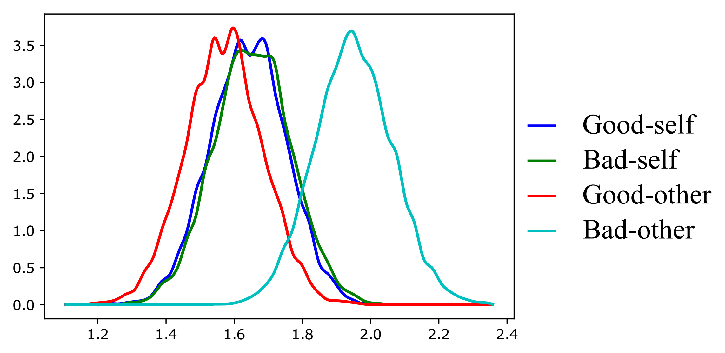
Figure S8. drift rate (v) of mismatched trials in the matching task.

Table S4. Comparisons of the group-average posterior distribution of initial bias (z) and non-decision time (t) in replication study.
 |  | Good self > Bad self | Good other > Bad other | Good self > Good other | Bad self > Bad other
v | Matching task | 1 | 0.534 | 1 | 0.123
 | Valence-based task | 0.9944 | 0.136 | 0.9936 | 0.12
 | Identity-based task | 0.9957 | 0.017 | 0.9961 | 0.019
t | Matching task | 0.203 | 0.017 | 0.932 | 0.567
 | Valence-based task | 0.303 | 0.085 | 0.315 | 0.085
 | Identity-based task | 0.915 | 0.06 | 0.992 | 0.335
* matching task = matching judgment task; valence-based task = valence-based categorization task; id-based task = identity-based categorization task. Note, we only reported matched trials for the matching task. The mis-matched trials’ results can easily be obtained by our open results.

Supplementary Material 3: Comparing Bad-other with Good-self
Reviewer 3 of our previous version of the manuscript (version 1: https://psyarxiv.com/9fczh) raised the question that bad-other was also processed efficiently, and therefore the observed effect may reflect a congruency effect: “congruent (Good-self and Bad-other) relative to associations that are incongruent (Bad-self and Good-other)”.
This possibility can be excluded if Bad-other was processed less efficiently than Good-other and Good-self. Here we reported the Good-other vs. Bad-other and the Good-self vs. Bad-other. We found that the Good-self and Good-other conditions were faster than Bad-other condition across both tasks and both experiments. The d prime and accuracy data also showed similar pattern, but less robust. Detailed results are shown below:
Pilot study, matching task: the RT data, there was strong evidence showed that Good-self was faster than Bad-other: t(28) = -5.43, p < 0.001, Cohen's d = -1.008, 95% CI[-1.451 -0.553], BF₁₀ = 2445. Also, Good-other was faster than Bad-other, t(28) = -3.16, p = 0.0037, Cohen's d = -0.587, 95% CI[-0.978 -0.188], BF₁₀ = 10.6.
The d prime data did not show evidence for differences between Good-self and Bad-other, t(28) = 1.51, p = 0.142, Cohen's d = 0.28, 95% CI[-0.093 0.649], BF₁₀ = 0.55, neither for the differences between Good-other and bad-other, t(28) = 1.27, p = 0.214, Cohen's d = 0.236, 95% CI[-0.135 0.603], BF₁₀ = 0.41
Pilot study, categorization task: We used data collapsed across identity-based and valence-based categorization task. the RT data, moderate evidence showed Good-self was faster than Bad-other: t(28) = -3.08, p = 0.0047, Cohen's d = -0.57, 95% CI[-0.96 -0.174], BF₁₀ = 8.75, but no evidence for the difference between Good-other and Bad-other, t(28) = 0.323, p = 0.749, Cohen's d = 0.06, 95% CI[-0.305 0.424], BF₁₀ = 0.21
The accuracy data, no evidence for difference between Good-self and Bad-other, t(28) = 1.18, p = 0.247, Cohen's d = 0.22, 95% CI[-0.151 0.586], BF₁₀ = 0.37, or for difference between Good-other and Bad-other, t(28) = -0.47, p = 0.642, Cohen's d = -0.087, 95% CI[-0.451 0.278], BF₁₀ = 0.22.
Confirm study, matching task: the RT data, there was strong evidence showed that Good-self was faster than Bad-other: t(41) = -5.972, p < 0.001, Cohen's d = -0.922, 95% CI[-1.28 -0.556], BF₁₀ = 67779. Also, there was moderate evidence that Good-other was faster than Bad-other: t(41) = -2.38, p = 0.011, Cohen's d = -0.37, 95% CI[-0.677 -0.052], BF₁₀ = 4
The d prime data did not show evidence for differences between Good-self and Bad-other, t(41) = 1.81, p = 0.039, Cohen's d = 0.28, 95% CI[-0.03 0.587], BF₁₀ = 1.42, neither evidence for Good-other and Bad-other, t(41) = -1.17, p = 0.248, Cohen's d = -0.181, 95% CI[-0.485 0.125], BF₁₀ = 0.0827
Confirm study, categorization task: We used data collapsed across identity-based and valence-based categorization task. the RT data, moderate evidence showed Good-self was faster than the Bad-other: t(41) = -7.59, p < 0.001, Cohen's d = -1.187, 95% CI[-1.583 -0.781], BF₁₀ = 8.49e+6, but no evidence showed that there was difference between Good-other and Bad-other: t(41) = 0.285, p = 0.777, Cohen's d = 0.045, 95% CI[-0.262 0.350], BF₁₀ = 0.137.
The accuracy data, no evidence for the difference between Good-self and Bad-other, t(41) = 2.19, p = 0.034, Cohen's d = 0.343, 95% CI[0.025 0.656], BF₁₀ = 2.83, or between Good-other and Bad-other, t(41) = -1.96, p = 0.057, Cohen's d = -0.306, 95% CI[-0.618 0.008], BF₁₀ = 0.061.
Reference
Boehm, U., Annis, J., Frank, M. J., Hawkins, G. E., Heathcote, A., Kellen, D., . . . Wagenmakers, E.-J. (2018). Estimating across-trial variability parameters of the Diffusion Decision Model: Expert advice and recommendations. Journal of Mathematical Psychology, 87, 46-75.
Etz, A., & Wagenmakers, E.-J. (2017). J. B. S. Haldane’s Contribution to the Bayes Factor Hypothesis Test. Statistical Science, 32(2), 313–329.
Golubickis, M., Falben, J. K., Cunningham, W. A., & Macrae, C. N. (2018). Exploring the self-ownership effect: Separating stimulus and response biases. Journal of Experimental Psychology: Learning, Memory, and Cognition, 44(2), 295-306.
Golubickis, M., Falben, J. K., Sahraie, A., Visokomogilski, A., Cunningham, W. A., Sui, J., & Macrae, C. N. (2017). Self-prioritization and perceptual matching: The effects of temporal construal. Memory & Cognition, 45(7), 1223-1239.
Heathcote, A., Brown, S., & Mewhort, D. J. K. (2002). Quantile maximum likelihood estimation of response time distributions. Psychonomic Bulletin & Review, 9(2), 394-401.
Heathcote, A., Popiel, S. J., & Mewhort, D. J. (1991). Analysis of response time distributions: An example using the Stroop task. Psychological Bulletin, 109(2), 340-347.
Hu, C.-P. (2017). The Priority of Moral Self in Cognitive Process. (PhD), Tsinghua University, Beijing. Retrieved from http://www.chinaxiv.org/abs/201909.00137
Hu, C.-P., Kong, X.-Z., Wagenmakers, E.-J., Ly, A., & Peng, K. (2018). Bayes Factor and Its Implementation in JASP: A Practical Primer (in Chinese). Advances in Psychological Science, 26(6), 951-965.
Jeffreys, H. (1961). Theory of probability (3 ed.). Oxford, UK: Oxford University Press.
Lakens, D. (2013). Calculating and reporting effect sizes to facilitate cumulative science: a practical primer for t-tests and ANOVAs. Frontiers in Psychology, 4, 863.
Liu, Q.-L., Wang, F., Sui, J., Peng, K., & Hu, C.-P. (2019). The Reliability and Validity of Chinese Version of Free Will and Determinism Plus Scale: PsyArxiv.
Massidda, D. (2013). Retimes: Reaction time analysis. Retrieved from https://cran.r-project.org/web/packages/retimes/index.html
R Core Team. (2018). R: A language and environment for statistical computing. R Foundation for Statistical Computing. Vienna , Austria. Retrieved from https://www.R-project.org/
Spieler, D. H., Balota, D. A., & Faust, M. E. (1996). Stroop performance in healthy younger and older adults and in individuals with dementia of the Alzheimer's type. Journal of Experimental Psychology: Human Perception and Performance, 22(2), 461-479.
Wagenmakers, E.-J., Love, J., Marsman, M., Jamil, T., Ly, A., Verhagen, J., . . . Morey, R. D. (2018). Bayesian Inference for Psychology. Part II: Example Applications with JASP. Psychonomic Bulletin & Review, 25(1), 58-76.
Wiecki, T. V., Sofer, I., & Frank, M. J. (2013). HDDM: Hierarchical Bayesian estimation of the Drift-Diffusion Model in Python. Frontiers in Neuroinformatics, 7.

This effect size is based on a series of experiments in the unpublished data (Hu, 2017), also see our open notebook on the updated version of those results: https://osf.io/nukwz/.
see the blog by Guillaume A. Rousselet: https://garstats.wordpress.com/2018/06/01/smallncorr/.

