**1. Project Overview and Functionalities**

The project is a creation of a Fitness Tracker application written in Python – ‘fitnesstracker.py’. It aims to provide users with an integrated platform to manage their fitness activities, diet, and goals. The primary functionalities include:

- User Management: Register and login functionalities for managing multiple users.

- Workout and Diet Tracking: Users can log detailed workouts and diet plans.

- Goal Setting and Monitoring: Users can set fitness goals, deadlines, and track achievements.

- Social Interaction: Allows interaction between users for motivational purposes.

- Reminder System: Users can set reminders for activities and goals.

This project is essential because it supports individuals aiming to achieve fitness goals by providing a comprehensive system to track and motivate their progress.

**2. Cloning the Project**

What It Means: Cloning refers to copying the entire contents of a Git repository, allowing us to have a local version of the project.

Goal: The main goal of cloning the repository is to obtain the project's files on the local machine for development or testing.

Implementation:

- The command `!git clone https://github.com/kondalreddycs567-hub/kondalreddycs567lastproject.git` was used. This initiates a clone from the specified GitHub repository to a designated folder named `kondalreddycs567lastproject`.

Result: The cloning process successfully created a local copy of the project, allowing for further code inspection, testing, and development. We have extracted the ‘fitnesstracker.py’ and ‘testcases.py’ files successfully.

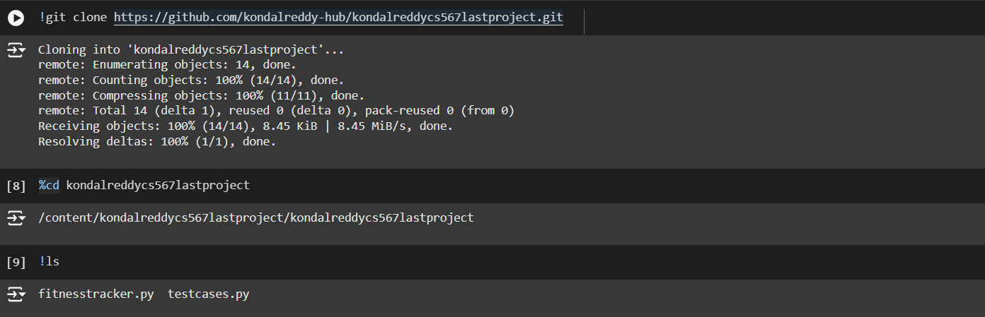

**3. Source Code Analysis using `cloc`**

What It Means: `cloc` (Count Lines of Code) is a utility that counts the number of lines in software projects and categorizes them into comments, blank, and code lines.

Goal: To quantify the size and scope of the codebase, which is useful for evaluating complexity and maintenance efforts.

Implementation:

- The command `!cloc fitnesstracker.py testcases.py` was executed to count lines in the specified Python files.

Result: The analysis showed:

- Python: 2 files containing a total of 71 blank lines, 3 comment lines, and 371 lines of code.

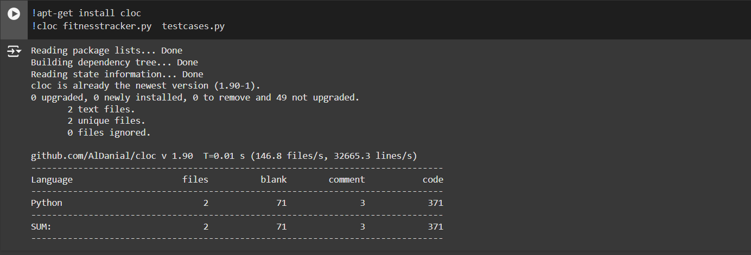

**4. Unit Testing with `unittest`**

What It Means: Unit testing involves validating individual parts of the code (units) to ensure each part behaves as expected.

Goal: To verify the correct functionality of different components in the Fitness Tracker application.

Implementation:

- Employing Python's `unittest` framework to execute defined test cases in `testcases.py`.

Result: 14 tests executed successfully. Here are five specific tests conducted:

1. User Registration: Confirms users can register with unique usernames.

2. Login User: Validates successful login using correct credentials.

3. Invalid Login: Ensures error messages display for incorrect login credentials.

4. Add Detailed Workout: Tests adding a new workout session for a user.

5. Set Goal Deadline: Checks if users can set deadlines for their fitness goals.

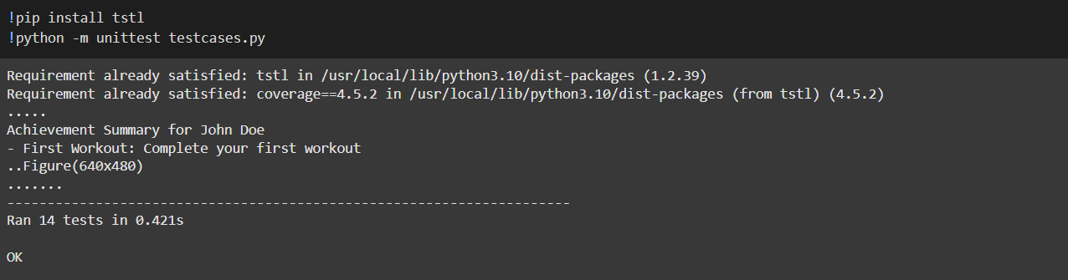

**5. Code Coverage Analysis**

What It Means: Code coverage measures how much of the code is executed during testing, highlighting areas not covered by tests.

Goal: To assess the thoroughness of the test suite and identify untested parts of the code.

Implementation:

- Executed with commands `!coverage run testcases.py` and `!coverage report -m` to produce a coverage report.

Result:

- The `fitnesstracker.py` file had a coverage of 47%, indicating potential areas for additional test coverage.

- The `testcases.py` achieved a high coverage of 97%, suggesting that the tests themselves were well-covered.

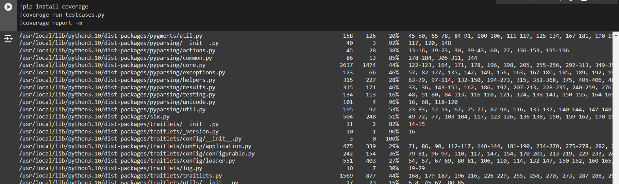

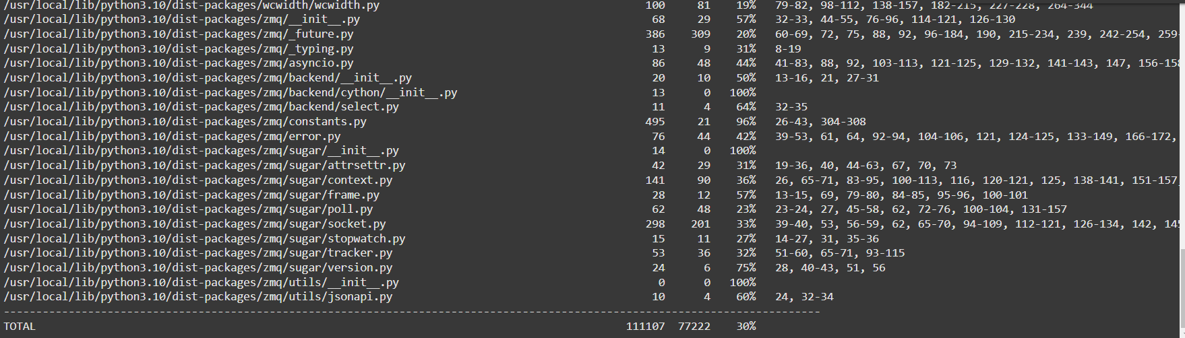

**6. Mutation Testing**

What It Means: Mutation testing involves introducing small changes (mutants) to the source code to evaluate the effectiveness of test cases in detecting defects.

Goal: To ensure the robustness and fault-detecting capabilities of the test suite.

Implementation:

- Executed with `!pip install mutpy` followed by `!mut.py --target fitnesstracker.py --unit-test testcases.py --runner 'unittest' --coverage`.

Result:

- A mutation score of 57.5% was achieved, with 23 mutants killed and 17 surviving. This indicates that while the tests are generally effective, there’s room for improvement in detecting all introduced mutations.

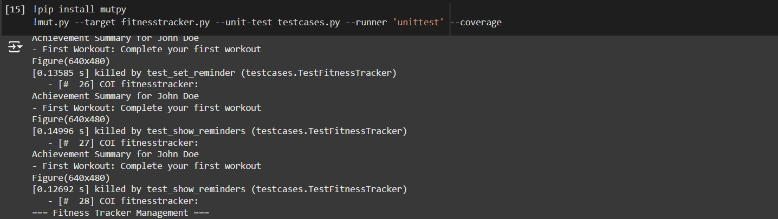

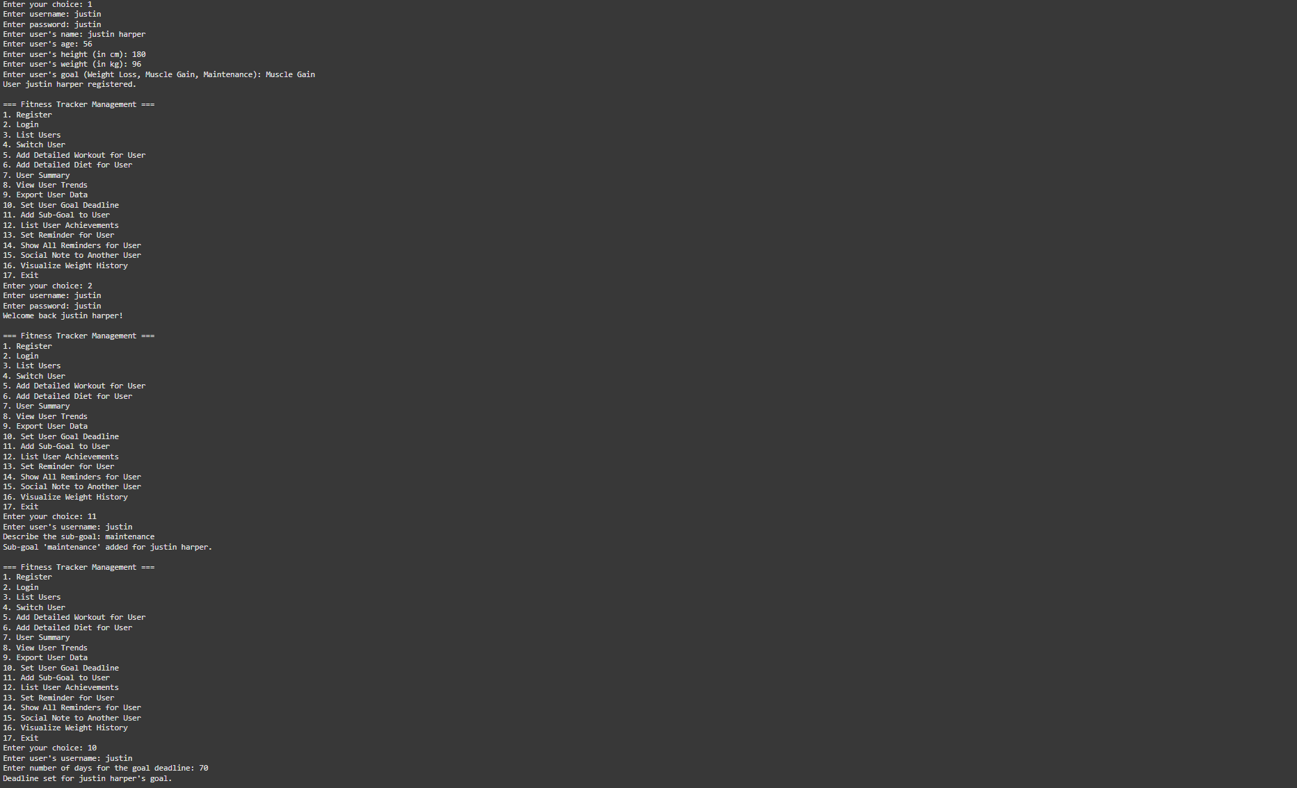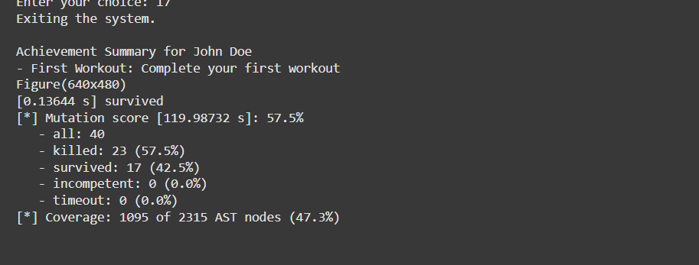

**7. Improvements & Missed Functionalities**

1. Interactive User Interface: We can implement a graphical interface to enhance user interaction.

2. Advanced Analytics: We can provide in-depth analysis and visualization of workouts and dietary habits.

3. Real-time Activity Integration: Allow to sync with wearable devices for real-time data tracking.

4. Comprehensive Social Features: Can expand social interactions with community challenges and leaderboards.

8. Conclusion

In summary, My Fitness Tracker project is a well-designed application that facilitates comprehensive tracking of fitness-related activities. However, the project reveals several enhancement opportunities through code coverage (47%) and potential undetected mutations (57.5% mutation score), indicating areas where additional testing could be beneficial. Through cloning, the project can be studied and modified locally, and utilizing tools like `cloc`, `unittest`, `coverage`, and `mut.py` provides valuable insights into the code structure, testing rigor, and potential growth areas. The integration of additional functionalities will further elevate the user experience and robustness of the application.