1. validation1.html
   1. First Name validation: Check to see if name accepts only alphabets and number

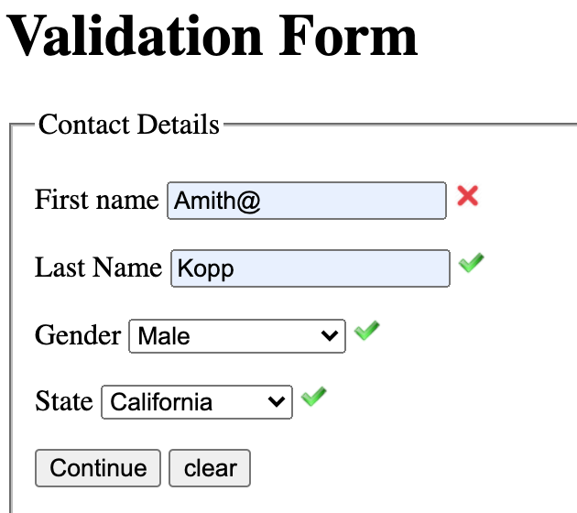

* 1. Last Name validation: Check to see if name accepts only alphabets and number

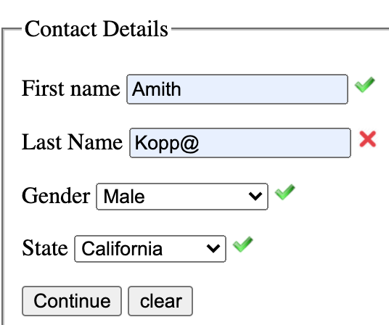

The first name and last name were checked by seeing if the characters in the input string are either letters or numbers.

* 1. Gender validation: ensures the user selects a option within the dropdown

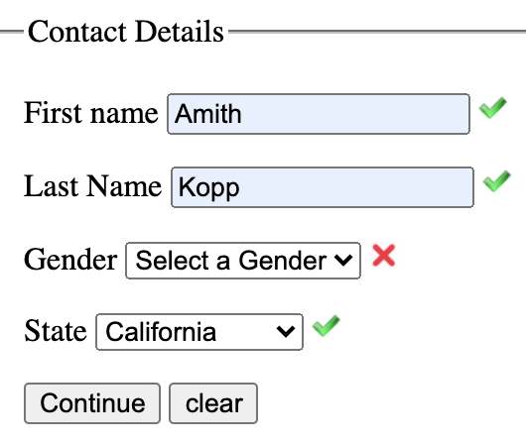

* 1. State Validation: ensures the user selects a option within the dropdown

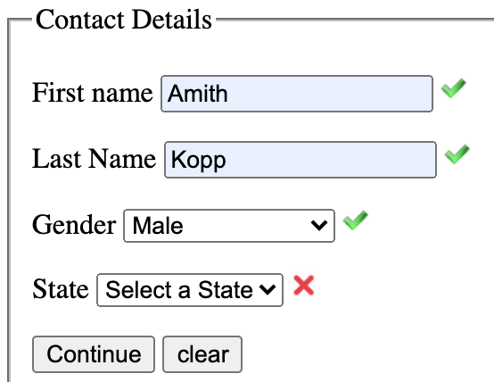

For checking the validation of gender or state, the code checked if the user selected an option other than Select( the default value) and if so, accept the input.

Once the user enters all valid entries, the form will move to validation2.html page through the window.location.replace function.

1. validation2.html
   1. Generic page layout: Contains all the attributes and displays an example format in the text box.

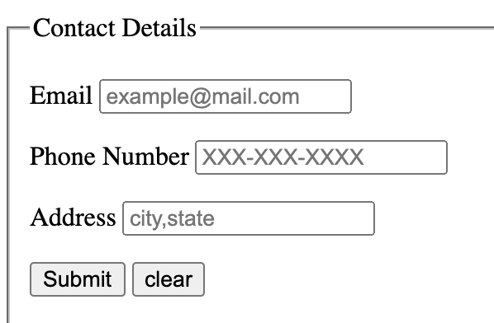

* 1. Email validation: checks if the user has entered a email in the valid format

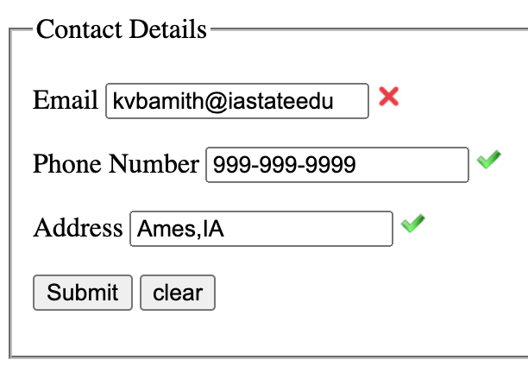

Email is validated by checking it the user has entered in the following format: [xxx@xxx.xxx](mailto:xxx@xxx.xxx), where x can be either a letter or a number. This validation is done by trying to split the input string into 3 pieces( string before the @ symbol, the string before the . symbol and finally whatever is left).

* 1. Phone number validation: checks if the user has entered a phone number in the valid format

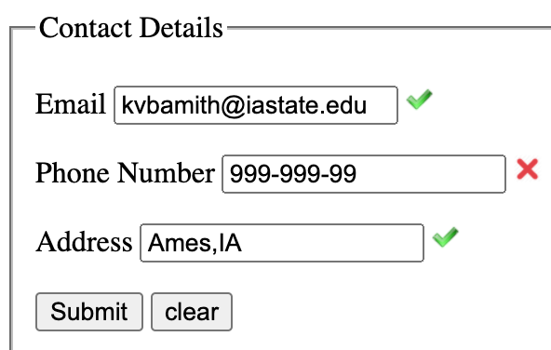

The phone number is validated by checking to see if the number is either the format xxx-xxx-xxxx or xxxxxxxxxx where x is only a number and there a total of 10 numbers.

* 1. Address validation: checks if the user entered the location in the right format

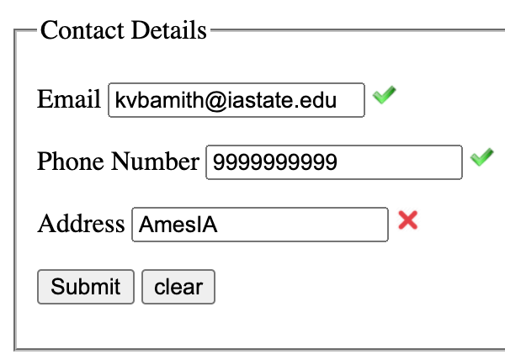

The address is checked by trying to split the input string by a comma.

The clear button in both pages can be used to clear all the users inputs to start over.