1. Showing the data in a table:

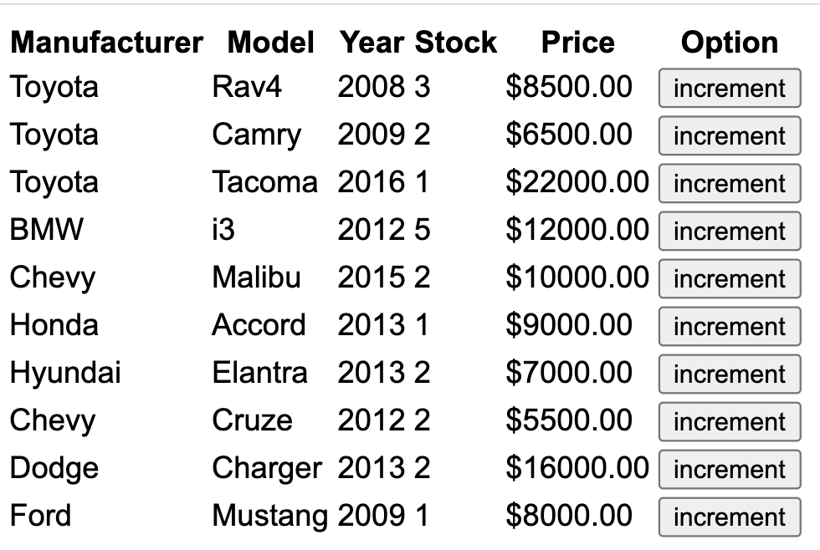

I implemented this part by creating a table in my react app. The headers were created in my JavaScript implementation in render, and the data was read from the data table “cars” using the map function and added to the table in html. The last column was a column for a button to increment the stock value for the corresponding car.

1. Incrementing the stock value of a car:

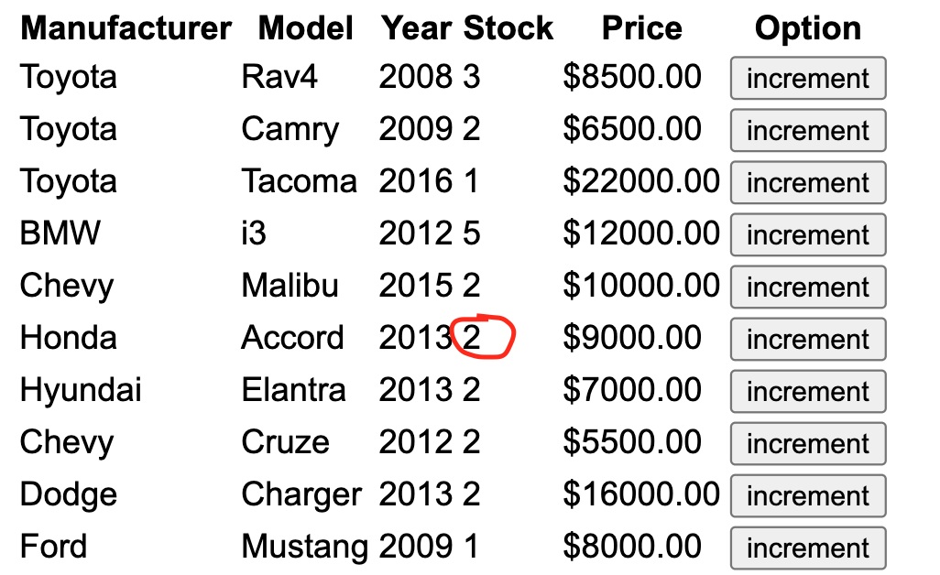

If you compare the picture in part 1) to the one right above, you can see that the stock value is increased, which happened as a result of pressing the increment button in that row. This was implemented by calling onClick function that retrieves the current stock value in the data for that row, increases it by 1 and updates the new value into the data for that row.

1. Sorting in ascending/descending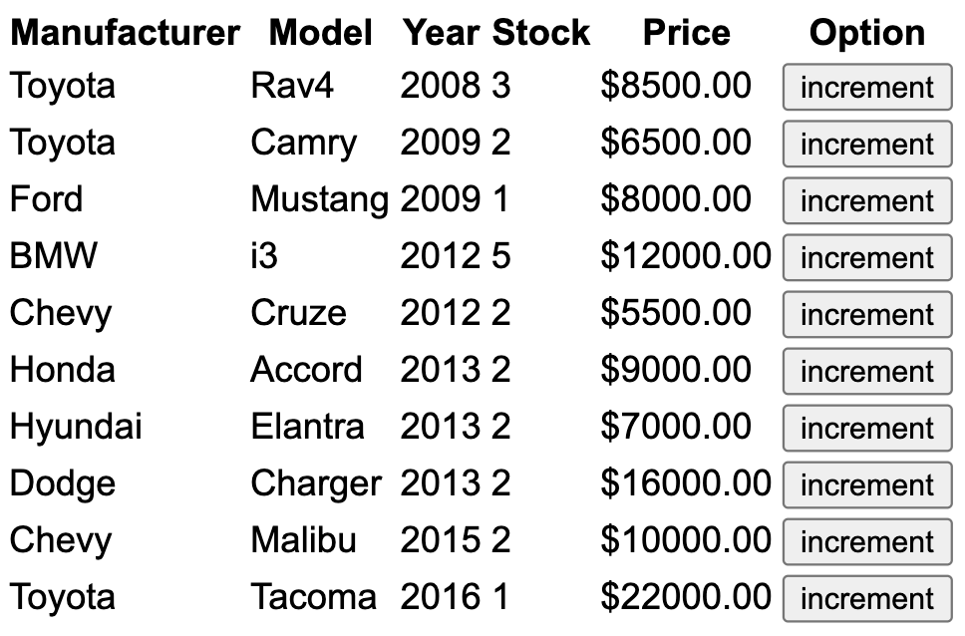

When the “Year” column header is clicked, it sorts the list by year in ascending order. I implemented this by using the onclick functionality to point to function that calls the sort method for a list. This sort method is sent a function that sorts the table by year from earliest to latest.

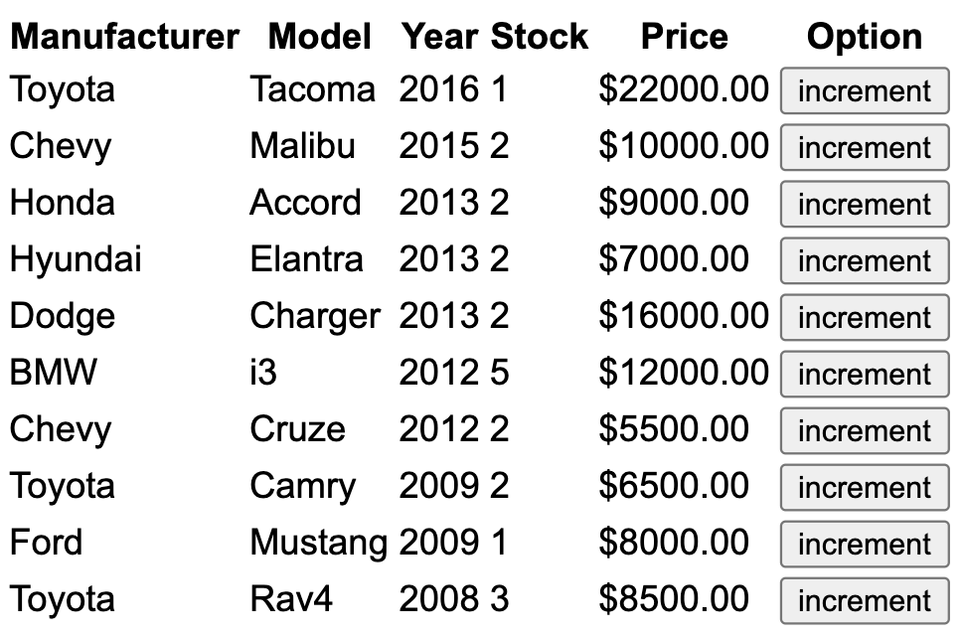

When the “Year” header is pressed again it sorts it in descending order and keeps switching between ascending/descending based on how many times you click. This functionality was incorporated by creating a global Boolean that records whether it is currently in ascending state or descending and swaps every time the button is clicked.