My humble
Submission to Vivkananda College

P.K. Manoj Kumar

CONTENTS

S.NO | NAME OF THE TITLE | PAGE NO
1 | COMPANY PROFILE
2 | INTRODUCTION
3 | MODULAR DESCRIPTION
4 | SYSTEM REQUIREMENTS  - Software requirements  4.1 Minimum Hardware Requirements  4.2 SYSTEM ANALYSIS  4.3 SYSTEM DESIGN
5 | SYSTEM TESTING AND IMPLEMENTATION  - SYSTEM TESTING  5.1 SYSTEM IMPLEMENTATION
6 | ABOUT THE SOFTWARE  - SOFTWARE ARCHITECTURE  - JAVA  - JAVASCRIPT  - HTML  - SERVLETS  - JDBC
7 | DATA FLOW DIAGRAM
8 | DATABASE DESIGN
9 | SOURCE CODE
10 | SCREEN LAYOUTS
11 | CONCLUSION
12 | BIBLIOGRAPHY

HIDUSTAN SOFTWARE LIMITED

COMPANY PROFILE

Hindustan software limited established in 1995, has been actively involved in development of customized software for various clients since its inception and also has its presence strongly felt in the areas of Training & consulting. Market Leadership through customer satisfaction, a commitment to excellence & high growth rate, these have characterized HSL in its rapid climb in Information Technology Industry.

DEVELOPMENT

Our software development team strives to develop innovative software that meets customer needs. A team of developers with exclusive educational background and excellent computing skills exert their maximum efforts and endeavor to satisfy the specialized requirement of our esteemed clients. Our expertise and vast exposure qualifies us in developing software’s in Information systems, Web Based Applications, Internet Solution, Web page Design and Hosting. Our team consists of expertise in Java, VC++, VB, Oracle and all Internet Application Development Tools.

TRAINING

Hindustan has trained more than 1000 professionals so far in the area of JAVA and VC++. All the students have launched in a very good career path both in India & abroad. The curriculum matches latest trends and make the students to compete in the IT industry.

SKILLSET AVAILABLE

C, C++, VC++, JAVA, ASP, XML, JSP, EJB-Web Logic, VISUAL BASIC -MS-ACCESS, RMI, COM, CORBA, SCRIPTS, EMBEDDED SYSTEM, ETC.,

CONSULTING

The training division gives us an opportunity to meet variety of candidates with various skill sets. Our database consists of details regarding more than 1000 professionals. So we are fit to assist all sort of IT Human resource consultancies and IT companies in India and abroad.
Excellence through “TEAM WORK” The Philosophy of Total Quality Management is inculcated in every HSL employee through intensive training programs. Our investment on a highly skilled and motivated manpower constitutes towards establishing HSL as a truly quality conscious company, continually striving to bring the finest solutions to the discerning customers.

INTRODUCTION

CYBER CREDIT CARD SYSTEM

This Credit Card Banking (CCB) allows the user to use his credit card to purchase the products. This project will validate the credit card number, security number, and expiry date, discount products. After the validation of the credit card, the amount for the purchasing products will be deducted from his bank account.
The way of people buying the variety of things, using credit card changed the pattern of purchasing the products. Previously, if the user wants to purchase something, he has to carry the money to all the places.
CCB gives all the information related to the credit cards and additional features of their credit cards, which makes the customer or user wisely, to decide which credit card has to be selected.
This project has a powerful utility that enables users to know for the details of particular credit card in a very simple and efficient manner the option is limited to these categories of credit cards. Hence minimizing the time taken to know for the details of credit card is in the user’s choice.

CREDIT CARD PAYMENT PROCESSING

1. Consumer inserts his credit card
2. E Business processes credit card
PRINCIPAL BANK
4. Principal bank sends request to card issuing bank
CARD ISSUING BANK
5. Card issuing bank accepts (or declines) sent back to Principal Bank
6. Request from principal bank to Merchant
3. Credit card information sent to principal bank
7. Products to Customer
MERCHANT

BRIEF DETAILS OF DIAGRAM

1. Customer pays for online purchase by credit card.
2. E business processes credit card using payment processing software.
3. Credit card information sent to principal bank holding merchant account.
4. Principal bank sends request to card issuing bank.
5. Card issuing bank accepts or declines and sends transaction back to
Principal bank
6. Principal bank sends transaction back to merchant.
7. Merchant fulfilled the order and consumer received the products.

MODULAR DESCRIPTION

Credit Card Banking (CCB) has the following modules namely:

- SignUp Module
- Accounts Module
- Login Module
- Card Module

Signup Module:

The SignUp Module is used in Personal Information details.If you collect all the inputs when you press the submit button in the main page and checked it the database. Your details are store for SignUp module.

Accounts Module:

The Accounts Module is used to enter the accounts details with checked in Accounts number and amount. It is collected for the database access.

Login Module:

The Login Module is used in existing and new user details. If you enter user name and password then log is in correct for the option to proceed.

Card Module:

The Card Module deals with Card Selection, Card Validation and Limit Validation.

SYSTEM REQUIREMENTS

SYSTEM REQUIREMENTS

WORKING ENVIRONMENT

Windows 98

Software Requirements:

Web Server - JavaWebServer2.0
Front end - HTML
Script - JavaScript
Middle Tier - Servlets2.0
Back end - MS ACCESS

Minimum Hardware Requirements:

Processor - Intel inside Pentium-II
Hard Disk - 20GB
RAM - 128MB SDRAM
CD Drive - 52x Samsung
Floppy drive - 1.44 MB Sony

SYSTEM ANALYSIS

Introduction to System Analysis

System analysis is a process of gathering interpreting facts, diagnosing problems, and using facts to improve the system. The objective of the system analysis is to understand the important facts of current system by studying it in detail. To accomplish this objective the following have to be done.

- Learn the details of the system as well as procedures currently in practice.

- Develop insight into future demands of the organization on its growth, hike in Competition, evolving new financial structures, introduction of new technology, and changes in the customer needs.

- Documentation details of the current system for discussion and review by others.

- Evaluate effectiveness and efficiency of the current system and procedure taking into account the impact of anticipating future demands.

- Recommend any revisions and enhancements to the current system, indicating how they are justified. If appropriate, an entire new system may be purposed.

- Document the new system features at a level of details that allows others to understand its components and manage the new system developed.

SYSTEM DESIGN

The design of a system produces the details that state how a system meet the requirements identified during system analysis. System specialists often refer to this stage as logical design, in contrast to the process of developing program software, which is referred to as physical design.

Data Flow Diagrams have been used in the design of the system. Data Flow Diagram is a graphical tool used to describe and analyze the movement of data. The transformation of data from input to output, through processes may be described logically using these Data Flow Diagrams.

The DFD shown to the user must represent only the major functions being performed by the system. This is called Top Level DFD. If this process is complex enough, it can be broken further into different levels. This process can be continued till the process is simple. This is called the leveling of DFD’s.

SYSTEM TESTING

Theoretically, a new designed system should have all the pieces in working order, but in reality, each piece works independently. Now is the time to put all pieces into one system and test it to determine whether it meets the user’s requirements. The purpose of the system is to consider all the likely variations to which it will be subjected and then push the system to its limits. It is tedious but necessary step in system development. One needs to be familiar with the following basic terms.

- UNIT TESTING: is testing changes made in an existing or a new program.
- SEQUENTIAL OR SERIES TESTING: is checking the logic of one or more programs in the candidate system, where the output of one program will affect the processing done by another program.
- SYSTEM TESTING: is executing a program to check logic changes made in it and with the intention of finding errors making the program fail.
- ACCEPTANCE TESTING: is running the system with live data by the actual user of the system.

Testing is vital to the success of the system. System testing makes a logical assumption that if all the parts of the system are correct, the goal will be successfully achieved. In adequate testing or no-testing leads to errors that may not appear until months later. Another reason for system testing is its utility as a user-oriented vehicle before implementation. The best program and the user have communication barriers due to different backgrounds. The system tester (designer, programmer, or user) who has developed some computer mastery can bridge this barrier.

- Unit Testing:

This focuses on the smallest unit of software design. The module using the details design description as a guide; important control paths are tested to uncover errors within the boundary of the module.

Unit test consideration:

The module interface id tested to ensure that information properly flows into and out of the program unit under test. The local data structures are examined to ensure that the data stored temporarily maintains it integrity during all steps in an algorithm execution. Boundary conditions are tested to ensure that the module operates properly at boundaries established to limit or restrict processing. The test of data flow across a module interface is required before any other test. If data do not enter and exit properly, all other tests are moot.

Unit Procedure:

- Unit test is normally considered adjunct to the coding style.
- After source level code has been developed, reviewed and verified for correct syntax, unit test case design begins. Each test case should be coupled with a set of expected results.
- Normally, a driver is a “main program” that accepts test case data, passes such data to the module to be tested and prints the relevant results. Stubs serve to replace modules that are subroutines called by the module to be tested. A Stub or ‘dummy stub program’ uses the subroutine module’s interface to do minimal data manipulation and returns.

Unit testing is simplified when a module with high cohesion is designed. When a module addresses only one function, the number of test cases is reduced and errors can be more easily predicted and uncovered.

(ii) Integration Testing:

Integration is a systematic technique for constructing the program structure, while at the same time conducting tests to uncover errors associated with interfacing. The objective is to make unit-tested modules and build a program structure that has been dictated by design. Incremental integration is the program that is the program that is constructed and tested in small segments where errors are easier to isolate and correct.

Top down Integration:

Top-down integration is an incremental approach to the construction of program structure. Modules are integrated by moving downward through the control hierarchy, beginning with the main control module. Module subroutine to the main control module is incorporated into the structure either in a depth-first manner is engaged for this system. Breadth-first incorporates all modules directly subroutine at each level, moving across the structure horizontally.

The integration process is performed in a series of five steps:

- The main control module is used as a test driver and stubs are substituted for all modules directly subroutine to the main control module.
- Depending on the integration approach selected (depth or breadth first) subroutine stub are replaced one at a time with actual modules.
- Tests are conducted as each module is integrated.
- On the completion of each set of test, another stub is replaced with the real module.
- Registration testing is conducted to ensure that new errors have not been introduced.

(iii) Validation testing:

At the end of integration testing, the system is completely assembled as a package with interfacing errors corrected after which a final series of software tests namely validation testing begins. Validation succeeds when the software functions in a manner that can be reasonably expected by the user.

Criteria:

Software validation is achieved through black box tests that demonstrates conformity with requirements.

(iv) System Testing:

System testing is actually a series of different tests whose primary purpose is to fully exercise the computer-based system. Although each test has a different purpose, all work should verify that all system elements have been properly integrated and perform allocated functions. Being the most important test, the performance test is covered briefly below:

- Performance Testing: For real-time systems, software that provides required function but does not conform to performance requirement is unacceptable. Performance testing is designed to test the run-time performance of software within the context of an integrated system. Performance testing occurs throughout all steps in the testing process. Even at the unit level, the performance of an individual module may be accessed as tests are conducted. However, it is not until all system elements are fully integrated that the true performance of a system can be ascertained.

Debugging:

Debugging is not testing not occurs as a consequence of testing, that is when a test case uncovers an error, debugging is the process that results in the removal of the error.

Normally three categories for debugging approaches are proposed:

- Brute force
- Back-tracking
- Cause-elimination

- Brute force:

This is the most common and least efficient method for isolating the cost of a software error. Brute-force debugging method is usually applied when all else fails. Using a “let the computer finding the error” philosophy, memory-dumps are taken, runtime traces are invoked and the program is loaded with WRITE (in this case message box) statements. In the information that is produced, a clue is found leading to the cause of the error.

- Back-tracking:

This is fairly common debugging approach that can be used successfully in small programs. Beginning at the site where a symptom has been uncovered, the source code is traced backwards (manually) until the site of the cost is found.
- Cause-Elimination:

This approach is manifested by induction/deduction and introduces the concept of ‘binary partition’. A ‘cause hypothesis’ is devised and the error related data are used to prove or disprove the hypothesis. Alternatively, a list of all possible causes is developed, and tests are conducted to eliminate each. If initial tests indicate that a particular cause hypothesis shows promise, that data are refined in an attempt to isolate the path.

Each of the debugging approaches can be supplemented with debugging tools. A wide variety of debugging compilers, dynamic debugging aids (tracers), automatic test case generators, memory dumps and cross-reference maps can be applied. However, tools are not a substitute for careful evaluation, based on a complete software design document and clear source code.

SYSTEM IMPLEMENTATION

After proper testing and validation, the question arises whether the system can be implemented or not. Implementation includes all those activities that take place to convert from the old system to the new. The new system may be totally new, replacing an existing module or automated system, or it may be major modification to an existing system. In either case proper implementation is essential to provide a reliable to provide a reliable system to meet organization requirements.

All planing has now, be completed and the transformation to a fully operational system can commence. The first job will be writing, debugging documenting of all computer programs and their integration into a total system. The master and transaction files are decided, and this general processing of the system is established. Programming is complete when the programs conformed to the detailed specification.

When the system is ready for implementation, emphasis switches to communicate with the finance department staff. Open discussion with the staff is important form the beginning of the project. Staff can be expected to the concerned about the effect of the automation on their jobs and the fear of redundancy or loss of status must be allayed immediately. During the implementation phase it is important that all staff concerned be apprised of the objectives of overall operation of the system. They will need shinning on how computerization will change their duties and need to understand how their role relates to the system as a whole. An organization-training program is advisable; this can include demonstrations, newsletters, seminars etc.

The department should allocate a member of staff, who understands the system and the equipment, and should be made responsible for the smooth operation of the system. An administrator should coordinate the users to the system.

Users should be informed about new aspects of the system that will, affect them. The features of the system explained with the adequate documentation. New services such as security, on-line application from the back-ups must be advertise on the staff when the time is ripe.

Existing documents such as employee loan details should be entered into the new system. Since these files are very large, conversion of these may continue long after the system based on current files has been implemented. Hence we need to assign responsibility for each activity.

The system may come into full operation via number of possible routes. Complete change over at one point time is conceptually the most tidy. But this approach requires careful planning and coordination, particularly during the changeover. A phased approach, possible implementing the system of the section relating to one operation or procedure first and processing to more novel or complex subsystems in the fullness of time. These likely to be less traumatic. A phased approach gives the staff time to adjust to the new system. But depends on being able to split the system, without reliance on it. Thus approach is sensible when the consequences of failure are disastrous, but will require extra staff time. The fourth angle, is pilot operation permits any problems to be tackled on a smaller scale operation. Pilot operation generally means the implementation of the complete system, but at one location or branch only.

ABOUT THE SOFTWARE

SOFTWARE ARCHITECTURE

The following diagram illustrates the links between various components involved in this system:

CLIENT SERVER
HTML AND JAVASCRIPT
JAVA

SEVLETS

DATABASE

In the following sections the salient features of each of their components are discussed:

- Java
- JavaScript
- HTML
- Servlets
- JDBC

JAVA

WHAT IS JAVA?

Java ha two things: a programming language and a platform.
Java is a high-level programming language that is all of the following

Simple Architecture-neutral
Object-oriented Portable
Distributed High-performance
Interpreted multithreaded
Robust Dynamic
Secure

Java is also unusual in that each Java program is both compiled and interpreted. With a compile you translate a Java program into an intermediate language called Java bytecodes the platform-independent code instruction is passed and run on the computer.

Compilation happens just once; interpretation occurs each time the program is executed. The figure illustrates how this works.

Java Program
Compilers
Interpreter
My Program

You can think of Java byte codes as the machine code instructions for the Java Virtual Machine (Java VM). Every Java interpreter, whether it’s a Java development tool or a Web browser that can run Java applets, is an implementation of the Java VM. The Java VM can also be implemented in hardware.

Java byte codes help make “write once, run anywhere” possible. You can compile your Java program into byte codes on my platform that has a Java compiler. The byte codes can then be run any implementation of the Java VM. For example, the same Java program can run Windows NT, Solaris, and Macintosh.

JAVA PLATFORM

A platform is the hardware of software environment in which a program runs. The Java platform differs from most other platforms in that it’s a software only platform that runs on the top of other, hardware-based platform. Most other platforms are described as a combination of hardware and operating system.

The Java platform has two components:

- The Java Virtual Machine (Java VM)
- The Java Application Programming Interface (Java API)

You’ve already been introduced to the Java VM. It’s the base for the Java platform and is ported onto various hardware-based platforms.

The Java API is a large collection of ready-made software components that provide many useful capabilities, such as graphical user interface (GUI) widgets.

The Java API is grouped into libraries (package) of related components. The next sections, what can Java do? Highlights each area of functionally provided by the package in the Java API.

The following figure depicts a Java program, such as an application or applet, that’s running on the Java platform. A special kind of application known as a server serves and supports clients on a network. Examples of the servers include Web Servers, proxy servers, mail servers, print servers, and boot servers. Another specialized program is a Servlet. Servlets are similar to applets in that they are runtime extensions of the application. Instead of working in browsers, though, servlets run with in Java Web Servers, configuring of tailoring the server.

How does the Java API support all of these kinds of programs? With packages of software components that provide a wide range of functionality. The API is the API included in every full implementation of the platform.

The core API gives you the following features:

- The Essentials: Objects, Strings, threads, numbers, input and output, datastructures, system properties, date and time, and so on.
- Applets: The set of conventions used by Java applets.
- Networking: URL’s TCP and UDP sockets and IP addresses.
- Internationalization: Help for writing programs that can be localized for users.

Worldwide programs can automatically adapt to specific locates and be displayed in the appropriate language.

JAVA PROGRAM

- Java API
- Java Virtual Machine
- Java Program
- Hard Ware

API and Virtual Machine insulates the Java program from hardware dependencies. As a platform-independent environment, Java can be a bit slower than native code. However, smart compilers, well-tuned interpreters, and Just-in-time-byte-code compilers can bring Java’s performance close to the native code without threatening portability.

WHAT CAN JAVA DO?

However, Java is not just for writing cut, entertaining applets for the World Wide Web (WWW). Java is a general purpose, high-level programming language and a powerful software platform. Using the fineries Java API,you can write many types of programs.

The most common types of program are probably applets and application, where a Java application is a standalone program that runs directly on the Java platform.
Security:

Both low-level and high-level, including electronic signatures, public/private key management, accesses control, and certificate.

JAVASCRIPT OVERVIEW

INTRODUCTION

JavaScript is an interpreted, object-based scripting language. Although it has fewer capabilities that full-fledged object-oriented like C++ and Java, JavaScript is more than sufficiently powerful for its intended purposes. JavaScript is not a cut-down version of any other language; it is not a simplification of anything. It is, however, limited. You cannot write standalone application in it, and it has little capability for reading or writing files. Moreover, JavaScript script can run only in the presence of an interpreter, either in a web server or a web browser.

JavaScript is loosely typed language. That means you do not have to declare that data types of variables explicitly.

It is scripting language used to develop Internet applications mostly for client side validations. It has the features of windows, frames, buttons, forms, images, list boxes, applets and so on.

MAIN FETURES:

Most of the browsers support JavaScript. It has all the functionalities of a high level language. It supports OOPS.

JAVASCRIPT IN VB SCRIPT:

Microsoft Visual Basic Scripting Edition, the newest member of the Visual Basic family of programming languages, brings active scripting to a wide variety of environments, including web client scripting to a wide variety of environments, including web client scripting in Microsoft Internet Explorer and Web server scripting in Microsoft Internet Information Server.

VBScript talks with host applications using ActiveX scripting. With ActiveX scripting, browsers and host applications do not require special integration code for each scripting component. ActiveX scripting enables a host to compile scripts, obtain and call entry points, and manage the namespace available to the developer.

HYPERTEXT MARKUP LANGUAGE (HTML)

INTRODUCTION

HTML is a major language of the Internet’s World Wide Web. Web sites and web pages are written in HTML. HTML files are plain-text files so they can be edited on any type of Computer IBM, Mac, UNIX, Intel etc. The World Wide Web is a collection of linked documents or pages on millions of computers spread over the entire internet. HTML which defines their appearance and layout and more importantly creates the links to other documents.

A set of instructions embedded in a document is called MarkUp Language. These instructions describe what the document text means and how it should look in a display. The language also tells you how to make a document with other document on your local system, the World Wide Web and other Internet resources such as FTP.

Brief History of HTML:

HTML was originally developed by time Berners lee which at CERN, and popularized by the mosaic browser developed at NCASA. During of the course of the 1990’s it has blossomed with the explosive growth of the Web. During this time, HTML has been extended in a number of ways. The Web depends on Web page authors and vendors sharing the same conversions for HTML. This has motivated the join work on specifications for HTML. HTML 2.0 was developed under the aegis of the Internet Engineering Task Force (IETF) to codify common practice in late 1994. HTML has been developed with the version that all manner of devices should be able to use information on the Web. Computers with high or low and bandwidth.

Document Structure Elements:

HTML documents are composed of four parts:

- A HTML document begins with a line declaring which version of HTML is being used to create the document.
- A HTML document that describes the documents as a HTML document.
- A declarative header section which is enclosed in the <HEAD> element
- The main body of the document which contains the actual document content. The body can be contained within either the <BODY> elements.

The “head” section is opened and closed by <HEAD> and </HEAD> tags. Information about the document such as the title, indexing information and ownership. The “body” section is opened and closed by <BODY> and </BODY> tags. The text and images of the document itself to be displayed by the Web browser.

Model HTML document:

<HTML>
<HEAD>
<TITLE>
<SAMPLE HTML Document>
</TITLE>
</HEAD>
<BODY>……………………………….</BODY>
</HTML>

SERVLETS OVERVIEW

INTRODUCTION

Servlets extend the request-response-oriented servers, such as Java-enabled Web servers. For example, a servlet can retrieve data from an HTML form and applying the business logic used to update Product database.

Client System

HTTP Server
Servlet

Product Database

Applets used in browsers. Similarly Servlets for server.

The servlet API assumes nothing about the server’s environment or protocol. So Servlet can be embedded in many different servers.

Uses of Other Servlets:

There are many applications for servlets:

- A Servlet can handle multiple requests concurrently, it allows servlets to support systems and concurrently requests.
- Servlets can be used to balance load among several servers that mirror the same content, and to partition a single logical service over several servers, thus servlets can forward requests.
Web Servers:

A Web server receives the request it then springs into action. Depending on the type of request, the webserver might look for a web page or it might execute program on the server, usually, as discussed earlier, CGI script or an advanced server-side program.

The Servlet API:

The two packages contains the code to build the servlets: javax.servlet and javax.servlet.http

The javax.servlet package:

The javax.servlet package contains a number of interfaces and classes that establish the framework in which servlets operate. The ServletRequest and ServletResponse are also very important.

- The ServletRequest interface is used to read data from a client request.
- The ServletResponse interface is used to write data to a client response.

The Servlet Interface:

All servlets must implement the Servlet interface. Generic Servlet must implements the Servlet and Servletconfig interface. HttpServlet extends GenericServlet. It is commonly used to servlets that receives and process HTTP requests.

GenericServlets
ServletConfig
Servlet
HttpServlet

The ServletRequest Interface:

The ServletRequest interface is implemented by the server. It enables to obtain about a client request:
- The parameter of the names passed by the client, and the names of the remote host that made the request.
- Servlets use to get data from clients that use application protocols such as the HTTP POST and PUT methods in an InputStream such as ServletInputStream.
- The HttpServletRequest interface contains methods for accessing HTTP-specific header information.

The ServletResponse Interface:

The ServletResponce interface is implemented by the server. It enables to obtain about a client response:

- It allows the servlet to set the content length.
- Servlet can send the reply data which writer through n output stream such as ServletOutputStream.
- The HttpResponse interface contains allow the servlet to manipulate HTTP-specific header information.

Hypertext Transfer Protocol (HTTP):

The Hypertext Transfer Protocol (HTTP) is used an application-level protocol for distributed, collaborative, hypermedia information systems. A feature of HTTP is the typing and negotiation of data representation, allowing systems to be built independently of the data being transferred. The HTTP protocol is a request/response protocol.

The javax.servlet.http Package:

The javax.servlet.http package contains several interfaces and classes that are commonly used by servlet developers.

Http Request and Responses:

The Http Requests and Responses contains in two arguments:

- An HttpServletRequest is used to enables servlets to read data from an HTTP request.
- An HttpServletResponse is used to enables servlets to write data to an HTTP response.

HttpServletRequest Object:

An HttpServletRequest Object provides to access the data from the client:

- The getParameter method returns the value of a named parameter and similarly the getParameterValues method returns an array of values for the named parameter.
- The getReader method returns the BufferedReader to use to read the data.
- The getInputStream method returns the ServletInputStream to use to read the data.

HttpServletResponse Objects:

An HttpServletResponse object provides the HTTP method. To access the data from the user:

- The getWriter method returns a Writer.
- The getOutputStream method returns the ServletOutputStream.

HTTP Header Data:

The HTTP header data means to access Writer or OutputStream. For example, the GET and POST for HTTP requests to which the service method includes:

- The handling for GET requests returns to doGet, Conditional GET and HEAD requests.
- The handling for POST requests returns to doPost.
- The handling for PUT requests returns to doPut.
- The handling for DELETE requests returns to doDelete.

Servlets Features:

Servlets are efficient when compared to any other server-side programs. They allow persistence of data to be maintained. More important is the fact they are portable, robust security features.

Servlets Better than CGI:

Servlets offer advantages over CGI in the areas of performance, portability and security. Each of these advantages will be discussed in turn:

- Performance is perhaps the most visible difference between servlets and CGI. Since most servlets run in the same process space as the server and are loaded only once, they are able to respond much more quickly and efficiently to client requests. In contrast, CGI must create a new process to service each new request. The overhead involved with creating a new process incurs a significant performance penality. Unlike servlets, CGI cannot share a single database connection across multiple requests.
- Portability is another strong advantage for servlets. Unlike many CGI applications, servlets can be run on different servers and platforms without modifications. This characteristic can be extremely important when building enterprise-wide distributed applications.
- Servlets are much more secure than CGI. Though CGI scripts can be written in Java, they are often written in more error-prone language such as C, since C programs can inadvertently or maliciously access invalid memory locations, CGI programs are less secure. Of course, these restrictions can be lifted according to the security policies set by the Java Security Manager.

Life Cycle of Servlet:

Each Servlet has the same life cycle:

- Sever loads and initializes the servlets calls the init () method.
- The sever handles zero or more client requests calls the service () method.
- The server removes the servlets calls the destroy () method.

(Some servers do this step only when they shutdown Destroy ())

Server

Server
Servlet code

Server

Servlet code
Servlet code
Client
Client
Handle
Client Request

Initialization Parameters of Servlets:

Initialize the servlet before client requests are handled and before the servlet is destroyed. The servlet runs the init method. The servlet calls the init method when the server loads the servlet, and similarly will not call the init method again unless the server is reloading the servlet. After initialization, the servlet able to handle client requests. Initialization can be accessed in two ways:

- The init method declared by the servlet interface receives ServletConfig object as its argument. This object provides methods that enable you to read the initialization parameters.
- The getServletConfig method declared by the servlet interface returns a ServletConfig object.

Destroying Servlets:

Destroys the servlet runs the servlet’s destroy method. The method is run once; similarly the server will not run the destroy method, when the server calls the destroy method, another thread might be running a service request. Servlets run until the server destroys them.

Communication of Servlets:

To communicate servlets sometimes need to access network resources. HTML pages, objects shared among servlets at the same server and other servlets:

- The Request Despatcher Object with other Server Resources (JSDK 2.1) such as other servlets with HTML pages and so on.
- The resource is an object in the JAVA programming language such as Sharing Resources Among Servlets (JSDK2.1).
- The other servlet’s servlet object and calling its public such as Calling Servlet from Servlets (JSDK2.0).

Utilities For Running Servlets:

The JSDK2.0 has a utility called Servletrunner. If you can test it with the utility included in the JSDK, while JSDK2.1 comes with a small utility server.

Properties of Servlets:

The servlet requires initialization parameters, if you set this data before starting the JSDK process that runs your servlet.

JAVA DATABASE CONNECTIVITY (JDBC)

JDBC AND ODBC IN JAVA:

Most popular and widely accepted database connectivity called Open Database Connectivity (ODBC) is used to access the relational databases. It offers the ability to connect to almost all the databases on almost all platforms. Java applications can also use this ODBC to communicate with a database. Then we need JDBC why? There are several reasons:

- ODBC API was completely written in C language and it makes an extensive use of pointers. Calls from Java to native C code have a number of drawbacks in the security, implementation, robustness and automatic portability of applications.
- ODBC is hard to learn. It mixes simple and advanced features together, and it has complex options even for simple queries.
- ODBC drivers must be installed on client’s machine.

Architecture of JDBC:

JDBC Architecture contains three layers:

JDBC Application
JDBC Drivers
JDBC Drivers

- Application Layer: Java program wants to get a connection to a database. It needs the information from the database to display on the screen or to modify the existing data or to insert the data into the table.
- Driver Manager: The layer is the backbone of the JDBC architecture. When it receives a connection-request form.
- The JDBC Application Layer: It tries to find the appropriate driver by iterating through all the available drivers, which are currently registered with Device Manager. After finding out the right driver it connects the application to appropriate database.
- JDBC Driver layers: This layer accepts the SQL calls from the application and converts them into native calls to the database and vice-versa. A JDBC Driver is responsible for ensuring that an application has consistent and uniform m access to any database.

When a request received by the application, the JDBC driver passes the request to the ODBC driver, the ODBC driver communicates with the database and sends the request and gets the results. The results will be passed to the JDBC driver and in turn to the application. So, the JDBC driver has no knowledge about the actual database, it knows how to pass the application request o the ODBC and get the results from the ODBC.

The JDBC and ODBC interact with each other, how? The reason is both the JDBC API and ODBC are built on an interface called “Call Level Interface” (CLI). Because of this reason the JDBC driver translates the request to an ODBC call. The ODBC then converts the request again and presents it to the database. The results of the request are then fed back through the same channel in reverse.

Structured Query Language (SQL):

SQL (Pronounced Sequel) is the programming language that defines and manipulates the database. SQL databases are relational databases; this means simply the data is store in a set of simple relations. A database can have one or more table. You can define and manipulate data in a table with SQL commands. You use the data definition language (DDL) commands to creating and altering databases and tables.

You can update, delete or retrieve data in a table with data manipulation commands (DML). DML commands include commands to alter and fetch data.

The most common SQL commands include commands is the SELECT command, which allows you to retrieve data from the database.

In addition to SQL commands, the oracle server has a procedural language called PL/SQL. PL/SQL enables the programmer to program SQL statement. It allows you to control the flow of a SQL program, to use variables, and to write error-handling procedures

DATAFLOW DIAGRAM

Level 0:

Validate user & Credit card for home appliances
Reports
Password
User-id

Level 1:

User
Login
Sign up
Validating Account Number and Card Number
Accounts
Card
Selection
New credit card with password
(Security number) is issued
Card
Validation
Validating Card Type and Bank Name
A

Limit
Validation
A
Validating Card Number and the Purchased Amount is deducted from the Limitation amount
Cash statement Report is provided to the user

DATABASE DESIGN

SignUp Table:

Field Name | Data Type
Name | Text
Password | Memo
Sex | Memo
Address | Memo
Pin | Number
City | Memo
Landmark | Memo
Emailid | Memo
Resph | Number
Offph | Number
Proff | Text
Income | Number

Account Table:

Field Name | Data Type
Accountno | Number
Amount | Number

Card Table:

Field Name | Data Type
Cardno | Number
Sno | Number
Cardname | Memo
Cardtype | Number
Bankname | Memo

Nbserver Table:

Field Name | Data Type
Accountno | Number
Holdername | Memo
Address | Memo
Phno | Number
Bankname | Memo
Amount | Number

SOURCE CODE
PROGRAM DESCRIPTION

Program  No | Program Name | Program Description
1 | Accounts In Java | This program is used for entering the Account details corresponding to the Account number and the amounts. It is mainly collected for the database access
2 | Sign In Java | This program helps to get the Personnel Information Details (i.e.) getting the information of Customer’s name, his password, sex, contact address etc.
3 | Login In Java | Selects the name and password from the stored details of the database using SQL query.
4 | Login1 Java | Login program provides access to the database for an authenticate User. It gets the correct user and password and pave the way to access.
5 | Credit in Java | It used for getting the Credit Card Name, Card Type and Name of the Bank in which the user having an account.
6 | Balance In Java | Balance Transfer from old account to new account.
7 | Card Selection In Java | It affords the details of the selected Card contains Holder Name, Date of Selection, Card No, Security No, Bank Name, Card Limit.
8 | Card Validation In Java | Helps the user to check the validation of the Card. It gets Card No, and Security No.
9 | Limit In Java | Credit Limit is checked after finishing the purchase.
10 | Limit Validation In Java | Allows the user to pick a purchase product if the Card limit is with in Purchase Limit. Otherwise it displays the error messages.
11 | Selection Option In Java | Let the option to proceed further, immediately after login. Any one of the following options can be selected: Card Selection, Card Validation, Statement, Balance Transfer, and Mail.
12 | Mail In Java | Any feedback like Card Missing can be send thro’ E-mail by the user.
13 | Statement | Displays all the details about the Card. Card No, has to be given as Input.

1. Accounts in Java:

import java.io.*;
import javax.servlet.http.*;
import javax.servlet.*;
public class accounts extends HttpServlet
{
public void doGet(HttpServletRequest request,HttpServletResponse response)
throws ServletException,IOException
{
response.setContentType("text/html");
PrintWriter out=response.getWriter();
out.println("<body bgcolor='#fbfbf1'>");
out.println("<br><img align=left src='d:/student/madhav/project/rose.gif'>");
out.println("<center>");
out.println("<big>WELCOME ACCOUNTS DETAILS OPTIONS </big>");
out.println("<br><br>");
out.println("<a href='http://localhost:8080/servlet/newaccounts'>NEWACCOUNT CREATION</a>");
out.println("<br><br>");
out.println("<a href='http://localhost:8080/servlet/oldaccount'>OLDACCOUNT DEATILS</a><br>");
out.println("<br><img align=right src='d:/student/madhav/project/rose.gif'>");
out.println("</body>");
out.println("</form>");
out.println("</html>");
}
}

2. Sign in Java:

import java.io.*;
import javax.servlet.http.*;
import javax.servlet.*;
public class sign extends HttpServlet
{
public void init(ServletConfig c) throws ServletException
{
super.init(c);
}
public void doGet(HttpServletRequest request,HttpServletResponse response)
throws ServletException,IOException
{
response.setContentType("text/html");
PrintWriter out=response.getWriter();
out.println("<html>");
out.println("<head><title>NEW USER FORM</title>");
out.println("<SCRIPT LANGUAGE='JavaScript'>");
out.println("<!--");
out.println("function validate()");
out.println("{");
out.println("var name,pass,i,addr,email,resphone,offphone,pinno,city,income,land,proff,at=0,dot=0");
out.println("name=document.newform.cname.value");
out.println("pass=document.newform.pass.value");
out.println("addr=document.newform.add.value");
out.println("pinno=document.newform.pin1.value");
out.println("city=document.newform.city.value");
out.println("land=document.newform.land.value");
out.println("email=document.newform.email.value");
out.println("resphone=document.newform.res.value");
out.println("offphone=document.newform.off.value");
out.println("proff=document.newform.proff.value");
out.println("income=document.newform.cnum.value");
out.println("document.newform.cname.focus();");
out.println("if(name==0){");
out.println("alert('ENTER YOUR NAME')");
out.println("}");
out.println("else if(!isNaN(parseInt(name))){");
out.println("alert('ENTER YOUR NAME CORRECTLY')");
out.println("}");

out.println("if(pass==0){");
out.println("alert('PLEASE ENTER THE PASSWORD ')");
out.println("}");

out.println("if(addr==0){");
out.println("alert('PLEASE ENTER YOUR ADDRESS')");
out.println("}");

out.println("if(pinno==0){");
out.println("alert('PLEASE ENTER THE PIN ')");
out.println("}");

out.println("if(pinno.length>6){");
out.println("alert('PLEASE ENTER PIN NUMBER LESS THAN 6 DIGITS')");
out.println("}");

out.println("if(city==0){");
out.println("alert('PLEASE SELECT YOUR CITY')");
out.println("}");

out.println("if(land==0){");
out.println("alert('PLEASE ENTER YOUR LANDMARK ')");
out.println("}");

out.println("if(email==0)");
out.println("{");
out.println("alert('PLEASE ENTER YOUR EMAILID')");
out.println("}");
out.println("else {");
out.println("for(i=0;i<=email.length;i++){");
out.println("if(email.charAt(i)=='@'){");
out.println("at++");
out.println("}");
out.println("if(email.charAt(i)=='.'){");
out.println("dot++");
out.println("}");
out.println("}");
out.println("if(at!=1){");
out.println("alert('ENTER A VALID EMAILID')");
out.println("}");
out.println("else if(dot<1 || dot>2){");
out.println("alert('ENTER A VALID EMAILID')");
out.println("}}");

out.println("if((resphone==0) & (offphone==0)){");
out.println("alert('PLEASE ENTER ATLEAST ONE PHONE NUMBER')");
out.println("}");

out.println("else{");
out.println("if(isNaN(resphone)){");
out.println("alert('ENTER YOUR PHONE NO. CORRECTLY')");
out.println("}");

out.println("if(isNaN(offphone)){");
out.println("alert('ENTER YOUR PHONE NO. CORRECTLY')");
out.println("}}");

out.println("if(resphone.length>11){");
out.println("alert('ENTER YOUR RES PHONE LESS THAN 11 DIGITS')");
out.println("}");

out.println("if(offphone.length>11){");
out.println("alert('ENTER YOUR OFF PHONE LESS THAN 11 DIGITS')");
out.println("}");

out.println("if(income==0){");
out.println("alert('PLEASE ENTER YOUR INCOME')");
out.println("}");

out.println("else if(isNaN(income)){");
out.println("alert('ENTER YOUR INCOME IN NUMBERS')");
out.println("}");
out.println("}");
out.println("-->");
out.println("</SCRIPT>");
out.println("</head>");

out.println("<body bgcolor=#fbfbf1>");
out.println("<TABLE cellSpacing=0 cellPadding=0 width='100%' bgColor=fmgkfg border=0><TBODY>");
out.println("<TR bgColor=hdhsfg>");
out.println("<TD bgColor=gold><font size=6 color=black><center><marquee behavior=alternate>SIGN UP PAGE</center></font> </maquee>");
out.println("</TD></TR></TBODY></TABLE>");
out.println("<HR SIZE='3' COLOR='red'>");
out.println("<TABLE cellSpacing=0 cellPadding=0 width='100%' bgColor=#nfdj454 border=0><TBODY>");
out.println("<TR bgColor=846584>");
out.println("<TD bgColor=black><FONT face=Arial color=red size=4><B><marquee>Applicant's Personal Details</B></FONT></marquee>");
out.println("<br>");
out.println("</TD></TR></TBODY></TABLE>");
out.println("</FONT></TD></TR></center></TBODY></TABLE>");
out.println("<HR SIZE='3' COLOR='red'>");
out.println("<form name='newform' action='http://localhost:8080/servlet/postsignup'>");
out.println("<TABLE cellSpacing=0 cellPadding=0 width='100%' bgColor=red border=0><TBODY>");
out.println("<TR bgColor=red>");
out.println("<TD bgColor=#fbfbf1><FONT face=Arial color=blue size=4><B>Applicant's Personal Details :</B></FONT>");
out.println("</TD></TR></font></TBODY></TABLE>");
out.println("<TABLE cellSpacing=0 cellPadding=0 width='100%' bgColor=#fbfbf1 border=0><TBODY>");
out.println("<TR>");
out.println("<TD width='25%' rowSpan=2><FONT face=Arial size=2>Customer Name</FONT></TD>");
out.println("<TD Align=left colspan=3><FONT face=Arial size=2><INPUT type=textbox name='cname' size='25'></FONT></TD><br>");
out.println("</TR></TBODY></TABLE>");
out.println("<TABLE cellSpacing=0 cellPadding=0 width='100%' bgColor=#fbfbf1 border=0><TBODY>");
out.println("<TR><TD width='25%' rowSpan=2><FONT face=Arial size=2>Password</FONT></TD>");
out.println("<TD Align=left colspan=3><FONT face=Arial size=2><INPUT type=password name='pass' size='20'>");
out.println("</TD></TBODY></table>");
out.println("<TABLE cellSpacing=0 cellPadding=0 width='100%' bgColor=#fbfbf1 border=0><TBODY>");
out.println("<TR>");
out.println("<TD width='25%' rowSpan=2><FONT face=Arial size=2>Sex ");
out.println("<TD Align=top rowSpan=2><FONT face=Arial size=2>");
out.println("<input type='radio' maxLength=25 name='cma' value='m' checked>MALE<INPUT TYPE='RADIO' MAXLENGTH=25 NAME='cma' VALUE='f'>FEMALE<BR></FONT>");
out.println("</TD></TBODY></table>");
out.println("<TABLE cellSpacing=0 cellPadding=0 width='100%' bgColor=#fbfbf1 border=0><TBODY>");
out.println("<TR bgColor=#fbfbf1><TD bgColor=#fbfbf1><FONT face=Arial color=blue size=2><B>Applicant's Mailing Address :</B></FONT>");
out.println("<TR bgColor=#fbfbf1>");
out.println("<TD width='25%'><FONT face=Arial size=2>Contact Address </FONT></TD>");
out.println("<TD width='25%'><FONT face=Arial size=2>Pincode </FONT></TD>");
out.println("<TD width='25%' height=2><FONT face=Arial size=2>City</FONT> </TD>");
out.println("<TD width='25%' height=2><FONT face=Arial size=2>Landmarks</FONT>");
out.println("</TD></TR>");
out.println("<TR bgColor=#fbfbf1><TD width='25%' height=2><FONT face=Arial size=2><input type=textbox name='add' size='20'></FONT> </TD>");
out.println("<TD width='25%' height=2><FONT face=Arial size=2><INPUT type=textbox name='pin1' size='6'></FONT> </TD>");
out.println("<TD width='25%' height=2><SELECT size=1 name='city'>");
out.println("<OPTION value=Select Option selected>--Select City--</OPTION> ");
out.println("<OPTION value=Ahmedabad>Ahmedabad</OPTION>");
out.println("<OPTION value=Aurangabad>Aurangabad</OPTION>");
out.println("<OPTION value=Bangalore>Bangalore</OPTION>");
out.println("<OPTION value=Baroda>Baroda</OPTION>");
out.println("<OPTION value=Calcutta>Calcutta</OPTION> ");
out.println("<OPTION value=Chandigadh>Chandigadh</OPTION>");
out.println("<OPTION value=Chennai>Chennai</OPTION>");
out.println("<OPTION value=Delhi>Delhi</OPTION>");
out.println("<OPTION value=Goa>Goa</OPTION>");
out.println(" <OPTION value=Hyderabad>Hyderabad</OPTION> ");
out.println("<OPTION value=Jaipur>Jaipur</OPTION> ");
out.println("<OPTION value=Ludhiyana>Ludhiyana</OPTION>");
out.println("<OPTION value=Mangalore>Mangalore</OPTION>");
out.println("<OPTION value=Mumbai>Mumbai</OPTION> ");
out.println("<OPTION value=Nagpur>Nagpur</OPTION>");
out.println("<OPTION value=Nasik>Nasik</OPTION>");
out.println("<OPTION value=Others>others</OPTION>");
out.println("</SELECT> </TD>");
out.println("<TD width='25%' height=2><FONT face=Arial size=2><INPUT type=textbox name='land' size='20'></FONT>");
out.println("</TD></TR></TBODY></TABLE>");
out.println("<TABLE cellSpacing=0 cellPadding=0 width='100%' bgColor=#fbfbf1 border=0>");
out.println("<TBODY>");
out.println("<TR bgColor=#fbfbf1><TD width='25%' height=4><FONT face=Arial size=2>E-Mail Address</FONT></TD>");
out.println("<TD height=4><FONT face=Arial size=1>&nbsp;</FONT><FONT face=Arial size=1></FONT> </TD></TR>");
out.println("<TR bgColor=#fbfbf1><TD width='25%' height=2><FONT face=Arial size=2><INPUT type=textbox name='email' size='20'></FONT> </TD>");
out.println("<TD vAlign=top height=2><FONT face=Arial size=2>&nbsp;</FONT>");
out.println("</TD></TR></TBODY></TABLE>");
out.println("<TABLE cellSpacing=0 cellPadding=0 width='100%' bgColor=#fbfbf1 border=0><TBODY>");
out.println("<TR bgColor=#fbfbf1>");
out.println("<TD bgColor=#fbfbf1><FONT face=Arial color=blue size=2><B>Applicant's Telephone :</B></FONT>");
out.println("</TD></TR></TBODY></TABLE>");
out.println("<TABLE cellSpacing=0 cellPadding=0 width='100%' bgColor=#fbfbf1 border=0><TBODY>");
out.println("<TR bgColor=#fbfbf1>");
out.println("<TD width='25%' height=4><FONT face=Arial size=2>Residence</FONT></TD>");
out.println("<TD width='26%' height=4><FONT face=Arial size=2>Office</FONT></TD>");
out.println("<TD height=4><FONT face=Arial size=1>&nbsp;</FONT><FONT face=Arial size=1></FONT> </TD></TR>");
out.println("<TR bgColor=#fbfbf1>");
out.println("<TD width='25%' height=2><FONT face=Arial size=2><INPUT type=textbox name='res' size='8'></FONT> </TD>");
out.println("<TD width='26%' height=2><FONT face=Arial size=2><INPUT type=textbox name='off' size='8'></FONT> </TD>");
out.println("<TD vAlign=top height=2><FONT face=Arial size=2>&nbsp;</FONT>");
out.println("</TD></TR></TBODY></TABLE>");
out.println("<TABLE cellSpacing=0 cellPadding=0 width='100%' bgColor=#fbfbf1 border=0><TBODY>");
out.println("<TR><TD width='25%' rowSpan=2><FONT face=Arialsize=2>Profession</FONT></TD>");
out.println("<TD Align=left colspan=3><SELECT size=1 name='proff'>");
out.println("<OPTION value='Select Option' selected>Select Option</OPTION>");
out.println("<OPTION value=CA>CA</OPTION>");
out.println("<OPTION value=Consultant>Consultant</OPTION>");
out.println("<OPTION value=Teacher>Teacher</OPTION>");
out.println("<OPTION value=Doctor>Doctor</OPTION>");
out.println("<OPTION value=Engineer>Engineer</OPTION>");
out.println("<OPTION value=Banker>Banker</OPTION>");
out.println("<OPTION value=Journalist>Journalist</OPTION>");
out.println("<OPTION value=Lawyer>Lawyer</OPTION>");
out.println("<OPTION value=Trader>Trader</OPTION>");
out.println("<OPTION value=Student>Student</OPTION>");
out.println("<OPTION value=Others>Others</OPTION>");
out.println("</SELECT> </TD>");
out.println("</TR></TBODY></TABLE>");
out.println("<TABLE cellSpacing=0 cellPadding=0 width='100%' bgColor=#fbfbf1 border=0><TBODY>");
out.println("<TR bgColor=#fbfbf1>");
out.println("<TD bgColor=#fbfbf1><FONT face=Arial color=blue size=2><B>Applicant's income Details :</B></FONT> ");
out.println("</TD></TR></TBODY></TABLE>");
out.println("<TABLE cellSpacing=0 cellPadding=0 width='100%' bgColor=#fbfbf1 border=0><TBODY>");
out.println("<TR bgColor=#fbfbf1>");
out.println("<TD width='25%' height=4><FONT face=Arial size=2>Income</FONT></TD>");
out.println("<TR bgColor=#fbfbf1>");
out.println("<TD width='26%' height=2><FONT face=Arial size=2><INPUT type=textbox name='cnum' size='20'></FONT></TD>");
out.println("<TD vAlign=top height=2><FONT face=Arial size=2>&nbsp;</FONT> ");
out.println("</TD></TR></TBODY></TABLE>");
out.println("<center><br>");
out.println("<input type=submit value='Submit' onmouseup=validate()>");
out.println("<input type=reset value='Reset'>");
out.println("</center><br>");
out.println("</form>");
out.println("</body>");
out.println("</html>");
}
public void destroy()
{
}
}

3. Login Java:
import java.io.*;
import javax.servlet.*;
import javax.servlet.http.*;
import java.sql.*;
public class Login extends HttpServlet
{
PrintWriter pw;
Connection con;
Statement st;
ResultSet r;
HttpSession hs;
String s1,s2,s3,s4,s33,s44;
String send1="http://localhost:8080/servlet/selectoption1";
String send2="http://localhost:8080/servlet/invalid11";
public void doGet(HttpServletRequest request,HttpServletResponse response)
throws ServletException,IOException
{
try
{
Class.forName("sun.jdbc.odbc.JdbcOdbcDriver");
con=DriverManager.getConnection("jdbc:odbc:bm");
st=con.createStatement();
response.setContentType("text/html");
pw=response.getWriter();
}
catch (Exception e)
{
pw.println("DSN ERROR"+e);
}
try
{
HttpSession hs=request.getSession(true);
s3=request.getParameter("cname");
hs.putValue("name",s3);
s4=request.getParameter("pass");
ResultSet r=st.executeQuery("select name,password from signup");
while(r.next())
{
String s1=r.getString(1);
String s2=r.getString(2);
if (s3.equals (s1) && s4.equals (s2))
{
response.sendRedirect(send1);
}
}
ResultSet p=st.executeQuery("select subname,password from subhold");
s33=request.getParameter("cname");
hs.putValue("name",s33);
s44=request.getParameter("pass");
while(p.next())
{
String s11=p.getString(1);
String s22=p.getString(2);
if (s33.equals (s11) && s44.equals (s22))
{
response.sendRedirect(send1);
}
}
response.sendRedirect(send2);

}
catch(Exception e)
{
pw.println(e);
}
}
}

4.Login1 Java:

import java.io.*;
import javax.servlet.http.*;
import javax.servlet.*;
public class Login1 extends HttpServlet
{
public void doGet(HttpServletRequest request,HttpServletResponse response)
throws ServletException,IOException
{
response.setContentType("text/html");
PrintWriter out=response.getWriter();
out.println("<html><head><title>Login Form</title>");
out.println("<SCRIPT LANGUAGE='JavaScript'>");
out.println("<!--");
out.println("function validate()");
out.println("{");
out.println("var name,pass");
out.println("name=document.form1.cname.value");
out.println("pass=document.form1.pass.value");

out.println("if(name==0){");
out.println("alert('ENTER YOUR NAME')");
out.println("}");

out.println("else if(!isNaN(parseInt(name))){");
out.println("alert('ENTER YOUR NAME CORRECTLY')");
out.println("}");

out.println("if(pass==0){");
out.println("alert('PLEASE ENTER THE PASSWORD ')");
out.println("}");
out.println("}");

out.println("-->");
out.println("</SCRIPT>");
out.println("</head>");

out.println("<body bgcolor='silver' text=red>");
out.println("<form name='form1' action=http://localhost:8080/servlet/Login>");
out.println("<br><br><br><br>");
out.println("<TITTLE><CENTER><b><h2>LOGIN FORM</CENTER></TITTLE></font></b></h2>");
out.println("<PRE><PRE><PRE><PRE><PRE><CENTER><br><br><br>");
out.println("<font size=5>LOGIN NAME <INPUT TYPE=TEXT NAME='cname' SIZE=15>");
out.println("<BR>");
out.println(" PASSWORD &nbsp; <INPUT TYPE=PASSWORD NAME='pass' SIZE=15><BR>");
out.println("</font>");
out.println("<INPUT TYPE='SUBMIT' VALUE='SUBMIT' onmouseup=validate()>");
out.println("<br><br<br>");
out.println("</CENTER>");
out.println("</body>");
out.println("</form>");
out.println("</html>");
}
}

5. Credit in Java:

import java.io.*;
import javax.servlet.http.*;
import javax.servlet.*;
public class credit extends HttpServlet
{
public void doGet(HttpServletRequest request,HttpServletResponse response)
throws ServletException,IOException
{
response.setContentType("text/html");
PrintWriter out=response.getWriter();
out.println("<html><head><title>Card Selection</title>");
out.println("</head>");
out.println("<BODY bgcolor='silver'>");
out.println("<form name='form1' action=http://localhost:8080/servlet/cardselection>");
out.println("<br><br><br>");
out.println("<div align='center'>");
out.println("<table border='2' width='46%'>");
out.println("<tr>");
out.println("<td width='62%' height='28'>");
out.println("<img src='d:/student/madhav/project/visalogo1.jpg'>");
out.println("<img src='d:/student/madhav/project/masterlogo.jpg'>");
out.println("</td>");
out.println("</tr>");
out.println("</table>");
out.println("<table border='2' width='60%'>");
out.println("<tr>");
out.println("<td width='74%' height='28'>");
out.println("<div align='center'>");
out.println("<p><font size='6' color='#660066'><b><marquee behavior='alternate'> Card Selection</marquee></b></font></p>");
out.println("<p>&nbsp;</p>");
out.println("</td>");
out.println("<table border='2' width='60%'>");
out.println("<tr>");
out.println("<td width='54%' height='28'>");
out.println("<div align='right'><b>Credit Card Name:");
out.println("</td></B></div>");
out.println("<td width='46%' height='28'>");
out.println("<input type='radio' name='name' value='VISA' checked>VISA");
out.println("<input type='radio' name='name' value='MASTERCARD'>MASTER CARD</td>");
out.println("</tr>");
out.println("<tr>");
out.println("<td width='54%' height='28'>");
out.println("<div align='right'><b>Credit Card Type:");
out.println("</td></B></div>");
out.println("<td width='46%' height='28'>");
out.println("<input type='radio' name='type' value='75000' checked>SILVER");
out.println("<input type='radio' name='type' value='95000'>GOLD");
out.println("<input type='radio' name='type' value='100000'>PLATINUM");
out.println("</b>");
out.println("</td>");
out.println("</tr>");
out.println("<tr>");
out.println("<td width='54%' height='28'>");
out.println("<div align='right'><b>Bank Name: </b></div>");
out.println("</td>");
out.println("<td width='46%' height='28'>");
out.println("<select name='day'>");
out.println("<option value='SBI'>SBI</option>");
out.println("<option value='ICICI'>ICICI</option>");
out.println("<option value='KVB'>KVB</option>");
out.println("</table><br><br>");
out.println("<input type=submit value='Submit'>");
out.println("</div>");
out.println("</form>");
out.println("</BODY>");
out.println("</HTML>");
}
}

6. Balance in Java:

import java.io.*;
import javax.servlet.http.*;
import javax.servlet.*;
public class balance extends HttpServlet
{
public void doGet(HttpServletRequest request,HttpServletResponse response)
throws ServletException,IOException
{
response.setContentType("text/html");
PrintWriter out=response.getWriter();
out.println("<html><head><title>Balance Transfer</title>");
out.println("<SCRIPT LANGUAGE='JavaScript'>");
out.println("<!--");

out.println("function validate()");
out.println("{");
out.println("var accno,shopaccno,puramt");
out.println("accno=document.form1.crno.value");
out.println("shopaccno=document.form1.nno.value");
out.println("puramt=document.form1.amt.value");

out.println("if(accno==0){");
out.println("alert('ENTER YOUR ACCOUNT NUMBER')");
out.println("}");

out.println("else if(isNaN(parseInt(accno))){");
out.println("alert('ENTER YOUR ACOUNT NUMBER CORRECTLY')");
out.println("}");

out.println("if(shopaccno==0){");
out.println("alert('PLEASE ENTER THE SHOP ACCOUNT NUMBER')");
out.println("}");

out.println("else if(isNaN(parseInt(shopaccno))){");
out.println("alert('ENTER SHOP ACOUNT NUMBER CORRECTLY')");
out.println("}");

out.println("if(puramt==0){");
out.println("alert('PLEASE ENTER PURCHASING AMOUNT')");
out.println("}");

out.println("else if(isNaN(parseInt(puramt))){");
out.println("alert('ENTER PURCHASING AMOUNT CORRECTLY')");
out.println("}");
out.println("}");

out.println("-->");
out.println("</SCRIPT>");
out.println("</head>");

out.println("<BODY bgcolor='#fbfbf1'>");
out.println("<form name='form1' action=http://localhost:8080/servlet/balance1>");
out.println("<br>");
out.println("<div align='center'>");
out.println("<p><font size='6' color='black'><marquee behavior='alternate'><b>BALANCE TRANSFER DETAILS</b></marquee></font></p>");
out.println("<img align=left src='d:/student/madhav/project/redline.gif'>");
out.println("<p>&nbsp;</p>");
out.println("<table border='2' width='60%' height='30%'>");
out.println("<br><br>");
out.println("<tr>");
out.println("<td width='44%' height='28'>");
out.println("<div align='right'><b>Customer Card Number: </b></div>");
out.println("</td>");
out.println("<td width='46%' height='28'>");
out.println("<input type='text' name='crno' size=20>");
out.println("</td>");
out.println("<tr>");
out.println("<td width='54%' height='28'> ");
out.println("<div align='right'><b>Shop Account No: </b></div>");
out.println("</td>");
out.println("<td width='46%' height='28'> ");
out.println("<input type='text' name='nno' size=20>");
out.println("</td>");
out.println("<tr>");
out.println("<td width='54%' height='28'>");
out.println("<div align='right'><b>Amount Transfer: </b></div>");
out.println("<td width='46%' height='28'> ");
out.println("<input type='text' name='amt' size=20>");
out.println("</td>");
out.println("</tr>");
out.println("</table>");
out.println("<p>");
out.println("<input type=submit name=b1 value='Submit' onmouseup=validate()>");
out.println("</p>");
out.println("</div>");
out.println("</form>");
out.println("<p>&nbsp;</p></BODY>");
out.println("</HTML>");
}
}

7. Card Selection in Java:

import java.io.*;
import javax.servlet.*;
import javax.servlet.http.*;
import java.sql.*;
import java.util.Date;
public class cardselection extends HttpServlet
{
PrintWriter pw;
Connection con;
Statement st,st1;
String s1,s2,s3,s4,s5,s6,s11;
int sn,sn1,cn,cn1;
HttpSession hs;
ResultSet rs;
public void doGet(HttpServletRequest request,HttpServletResponse response)
throws ServletException,IOException
{
try
{
Class.forName("sun.jdbc.odbc.JdbcOdbcDriver");
con=DriverManager.getConnection("jdbc:odbc:bm");
st=con.createStatement();
}
catch(Exception e)
{
pw.println("DSN ERROR"+e);
}
try
{
response.setContentType("text/html");
PrintWriter out=response.getWriter();
hs=request.getSession(true);
String nname=(String)hs.getValue("name");
rs=st.executeQuery("select max(cardno),max(sno) from card");
while(rs.next())
{
s1=rs.getString(1);
s2=rs.getString(2);
}
cn=Integer.parseInt(s1);
cn1=cn+1;
sn=Integer.parseInt(s2);
sn1=sn+1;
Date date=new Date();
s3=request.getParameter("name");
s4=request.getParameter("type");
s5=request.getParameter("day");
st.executeUpdate("insert into card values('"+cn1+"','"+sn1+"','"+s3+"','"+s4+"','"+s5+"')");
out.println("<BODY bgcolor='#fbfbf1'>");
out.println("<br><br>");
out.println("<div align='center'>");
out.println("<hr>");
out.println("<font size='6' color='red'><marquee behavior='alternate'>SELECTION DETAILS</marquee>");
out.println("<hr>");
out.println("<table border=2 color='blue'><tr><th>HOLDER NAME</th><th>CARD NUMBER</th><th>SECURITY NUMBER</th><th>CARD TYPE AMOUNT</th>");
out.println("<tr>");
out.println("<td>"+nname+"</td>");
out.println("<td>"+cn1+"</td>");
out.println("<td>"+sn1+"</td>");
out.println("<td>"+s4+"</td>");
out.println("</tr>");
out.println("</font>");
out.println("</div>");
out.println("</body>");
out.println("</table>");
out.println("<br><br>");
out.println("YOUR CARD PICKUP DATE:");
out.println(date);
out.println("<br><br>");
out.println("<a href='http://localhost:8080/servlet/valid'>CARD VALIDATION</a>");
out.println("<br><br>");
out.println("<a href='http://localhost:8080/servlet/limit'>PURCHASE LIMIT</a>");
out.println("<br><br>");
out.println("<a href='http://localhost:8080/servlet/state'>STATEMENT</a>");
out.close();
}
catch(Exception e)
{
System.out.println(e);
}
}
}

8. Card Validation in Java:

import java.io.*;
import javax.servlet.*;
import javax.servlet.http.*;
import java.sql.*;
public class cardvalid extends HttpServlet
{
PrintWriter pw;
Connection con;
Statement st;
ResultSet r;
String s1,s2,s3,s4;
String send1="http://localhost:8080/servlet/limit";
String send2="http://localhost:8080/servlet/invalid1";
public void doGet(HttpServletRequest request,HttpServletResponse response)
throws ServletException,IOException
{
try
{
Class.forName("sun.jdbc.odbc.JdbcOdbcDriver");
con=DriverManager.getConnection("jdbc:odbc:bm");
st=con.createStatement();
response.setContentType("text/html");
pw=response.getWriter();
}
catch (Exception e)
{
pw.println("DSN ERROR"+e);
}
try
{
s3=request.getParameter("cno");
s4=request.getParameter("sno");
ResultSet r=st.executeQuery("select cardno,sno from card");
while(r.next())
{
String s1=r.getString(1);
String s2=r.getString(2);
if (s3.equals (s1) && s4.equals (s2))
{
response.sendRedirect(send1);
}
}
response.sendRedirect(send2);
}
catch(Exception e)
{
pw.println(e);
}
}
}

9. Limit in Java:

import java.io.*;
import javax.servlet.http.*;
import javax.servlet.*;
public class limit extends HttpServlet
{
public void doGet(HttpServletRequest request,HttpServletResponse response)
throws ServletException,IOException
{
response.setContentType("text/html");
PrintWriter out=response.getWriter();
out.println("<html><head><title>Amount Validation</title>");
out.println("<SCRIPT LANGUAGE='JavaScript'>");
out.println("<!--");

out.println("function validate()");
out.println("{");
out.println("var cardno,puramt");
out.println("cardno=document.form1.cno.value");
out.println("puramt=document.form1.amt.value");

out.println("if(cardno==0){");
out.println("alert('ENTER YOUR CARD NUMBER')");
out.println("}");

out.println("else if(isNaN(parseInt(cardno))){");
out.println("alert('ENTER YOUR CARD NUMBER CORRECTLY')");
out.println("}");

out.println("if(puramt==0){");
out.println("alert('PLEASE ENTER THE PURCHASING AMOUNT ')");
out.println("}");
out.println("}");

out.println("-->");
out.println("</SCRIPT>");
out.println("</head>");

out.println("<BODY bgcolor='#fbfbf1'>");
out.println("<form name='form1' action='http://localhost:8080/servlet/limitvalidation'>");
out.println("<p><font size='6' color='98677'><b><marquee behavior='alternate'> Amount Validation</marquee>");
out.println("</font>");
out.println("<img align=left src='d:/student/madhav/project/redline.gif'>");
out.println("<br><br>");
out.println("<div align='center'>");
out.println("<tr>");
out.println("<td width='54%' height='28'>");
out.println("<td width='46%' height='28'>");
out.println("Card No: &nbsp;&nbsp;&nbsp;&nbsp;&nbsp;&nbsp;&nbsp;&nbsp;&nbsp;&nbsp;&nbsp;&nbsp; <input type=text name='cno'>");
out.println("</table><br><br>");
out.println("</td>");
out.println("<tr>");
out.println("<td width='54%' height='28'>");
out.println("<td width='46%' height='28'>");
out.println("Purchase Amount: <input type=text name='amt'>");
out.println("</table><br><br>");
out.println("<input type=submit value='Submit'onmouseup=validate()>");
}
}

10. Limit Validation in Java:

import java.io.*;
import javax.servlet.*;
import javax.servlet.http.*;
import java.sql.*;
public class limitvalidation extends HttpServlet
{
PrintWriter pw;
Connection con;
Statement st;
ResultSet r;
int c1,c2,c3,c4,check;
String s1,s2,s3,s4;
public void doGet(HttpServletRequest request,HttpServletResponse response)
throws ServletException,IOException
{
try
{
Class.forName("sun.jdbc.odbc.JdbcOdbcDriver");
con=DriverManager.getConnection("jdbc:odbc:bm");
st=con.createStatement();
response.setContentType("text/html");
pw=response.getWriter();
}
catch (Exception e)
{
pw.println("DSN ERROR"+e);
}
try
{
s3=request.getParameter("cno");
int c3=Integer.parseInt(s3);
s4=request.getParameter("amt");
int c4=Integer.parseInt(s4);
ResultSet r=st.executeQuery("select cardno,cardtype from card");
while(r.next())
{
int s1=r.getInt("cardno");
int s2=r.getInt("cardtype");
if(c3==s1 && s2<c4)
{
pw.println("<html><head><title>Limit Validation</title></head><body bgcolor='#fbfbf1'>");
pw.println("<center>YOUR CREDIT LIMIT EXCEED YOU CAN'T PROCEED<br><br>");
pw.println("<a href='http://localhost:8080/servlet/limit'>Previous</a></center>");
pw.println("</body></html>");
check=1;
break;
}
else
check=0;
}
if(check==0)
{
pw.println("<html><head><title>Limit Validation</title></head>");
pw.println("<body bgcolor='#fbfbf1'>");

pw.println("<center>");
pw.println("CARD LIMIT IS WITH IN PURCHAING LIMIT");
pw.println("<br>");
pw.println("YOU TO PICK ALL THE PURCHASING PRODUCTS");
pw.println("<br>");
pw.println("<a href='http://localhost:8080/servlet/mail1'>MAIL</a>");
pw.println("</center>");
pw.println("</body>");
pw.println("</html>");
}
}
catch(Exception e)
{
pw.println(e);
}
}
}

11. Selection option in Java:

import java.io.*;
import javax.servlet.http.*;
import javax.servlet.*;
public class selectoption extends HttpServlet
{
public void doGet(HttpServletRequest request,HttpServletResponse response)
throws ServletException,IOException
{
response.setContentType("text/html");
PrintWriter out=response.getWriter();
out.println("<html<head><title>Select Option</title></head>");
out.println("<body bgcolor='#fbfbf1'>");
out.println("<form name='form1' method='Get'>");
out.println("<img align=left src='d:/student/madhav/project/rose.gif'>");
out.println("<center>");
out.println("<big>WELCOME TO CYBERCASH</big>");
out.println("<br><br>");
out.println("<a href='http://localhost:8080/servlet/credit'>CARD SELECTION</a>");
out.println("<br><br>");
out.println("<a href='http://localhost:8080/servlet/valid'>CARD VALIDATION</a>");
out.println("<br><br>");
out.println("<a href='http://localhost:8080/servlet/state'>STATEMENT</a>");
out.println("<br><br>");
out.println("&nbsp;&nbsp;&nbsp;&nbsp;&nbsp;&nbsp;&nbsp;&nbsp;&nbsp;&nbsp;&nbsp;&nbsp;&nbsp;&nbsp;&nbsp;&nbsp;&nbsp;&nbsp;&nbsp;&nbsp;&nbsp;&nbsp;");
out.println("<a href='http://localhost:8080/servlet/balance'>BALANCE TRANSFER</a>");
out.println("<br><br>");
out.println("&nbsp;&nbsp;&nbsp;&nbsp;&nbsp;&nbsp;&nbsp;&nbsp;&nbsp;&nbsp;&nbsp;&nbsp;&nbsp;&nbsp;&nbsp;&nbsp;&nbsp;&nbsp;");
out.println("<a href='http://localhost:8080/servlet/mail1'>MAIL</a>");
out.println("<img align=right src='d:/student/madhav/project/rose.gif'>");
out.println("</form>");
out.println("</body>");
out.println("</html>");
}
}

12. Mail in Java:

import java.io.*;
import javax.servlet.*;
import javax.servlet.http.*;
import java.sql.*;
import java.util.Date;
public class mail extends HttpServlet
{
PrintWriter pw;
Connection con;
Statement st,st1;
String s1,s2,s3,s4,s5,s6,s11;
int sn,sn1,cn,cn1;
ResultSet rs;
public void doGet(HttpServletRequest request,HttpServletResponse response)
throws ServletException,IOException
{
response.setContentType("text/html");
PrintWriter out=response.getWriter();
out.println("<BODY bgcolor='#fbfbf1'>");
out.println("<br><br>");
out.println("<div align='center'>");
out.println("<hr>");
out.println("u r mail send to<font color='#FF0000'>WWW.CREDITCARD.COM</font><br><br>");
out.println("<a href='http://localhost:8080/servlet/selectoption'>Selection</a>");
out.println("</body>");
out.println("</table>");
out.println("<br><br>");
out.close();
}
}

13. Statement in Java:

import java.io.*;
import javax.servlet.*;
import javax.servlet.http.*;
import java.sql.*;
import java.util.Date;
import java.util.Date;
public class statement extends HttpServlet
{
PrintWriter out;
Connection con;
Statement st;
String s1,s3,s5,nname;
int c1,s2,s4;
HttpSession hs;
ResultSet rs;
public void doGet(HttpServletRequest request,HttpServletResponse response)
throws ServletException,IOException
{
try
{
Class.forName("sun.jdbc.odbc.JdbcOdbcDriver");
con=DriverManager.getConnection("jdbc:odbc:bm");
st=con.createStatement();
}
catch(Exception e)
{
out.println("DSN ERROR"+e);
}
try
{
response.setContentType("text/html");
PrintWriter out=response.getWriter();
hs=request.getSession(true);
String nname=(String)hs.getValue("name");
s1=request.getParameter("cno");
c1=Integer.parseInt(s1);
rs=st.executeQuery("select cardno,cardname,cardtype,bankname from card");
Date date=new Date();
int temp=0;
while(rs.next())
{
s2=rs.getInt("cardno");
s3=rs.getString("cardname");
s4=rs.getInt("cardtype");
s5=rs.getString("bankname");
if (c1==s2)
{
out.println("<body bgcolor='#fbfbf1'>");
out.println("<center>");
out.println("<TABLE WIDTH='440' HEIGHT='250' BGCOLOR='yellow '>");
out.println("<TR>");
out.println("<TD WIDTH='440' HEIGHT='250' BGCOLOR='iceblue'>");
out.println("<font color='red'><Big><marquee>SATEMENT DETAILS</Big></marquee></font><hr>");
out.println("<br>");
out.println("The Statement Date: "+date+"");
out.println("<br>");
out.println("The Card Holder Name:"+nname+"");
out.println("<br>");
out.println("The Card NO: "+c1+"");
out.println("<br>");
out.println("The cardname: "+s3+"");
out.println("<br>");
out.println("The cardLimit: "+s4+"");
out.println("<br>");
out.println("The bankname: "+s5+"");
out.println("</TD>");
out.println("</TR>");
out.println("</TABLE><br><br>");
out.println("<a href='http://localhost:8080/servlet/selectoption'>SELECTION</a>");
temp=temp+1;
}

}
if (temp==0)
{
out.println("<body bgcolor=#fbfbf1>");
out.println("<center><b>The Card no is incorrect");
out.println("<a href='http://localhost:8080/servlet/state'>Previous</a></b></center>");
out.println("</body>");
}
}
catch(Exception e)
{
out.println(e);
}
}
}

SCREEN LAYOUTS

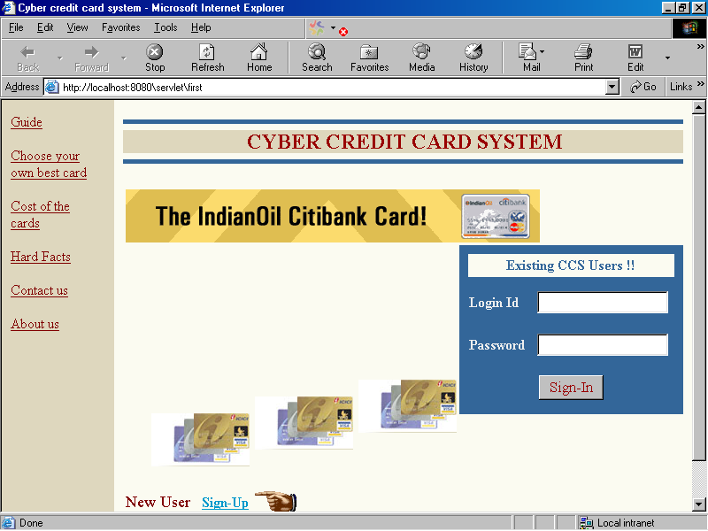

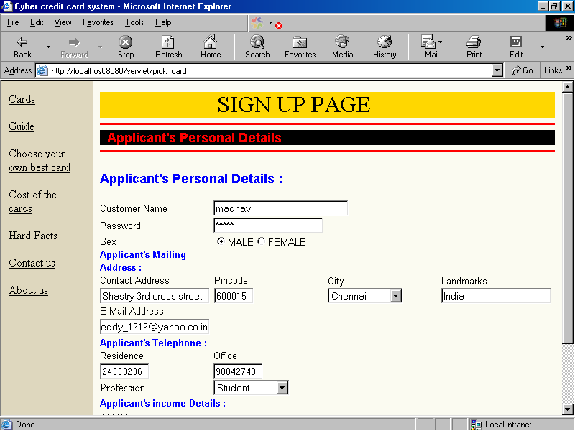

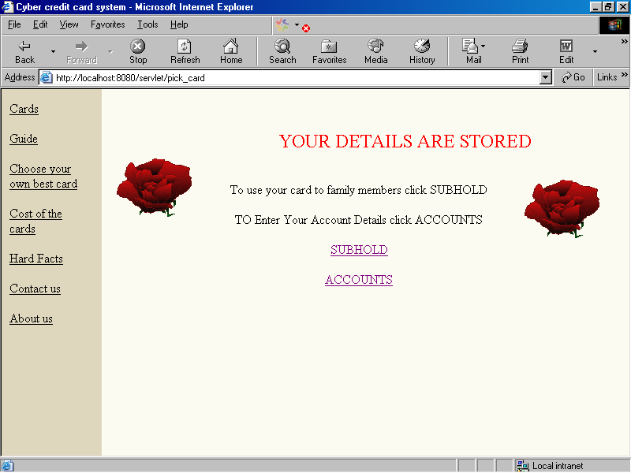

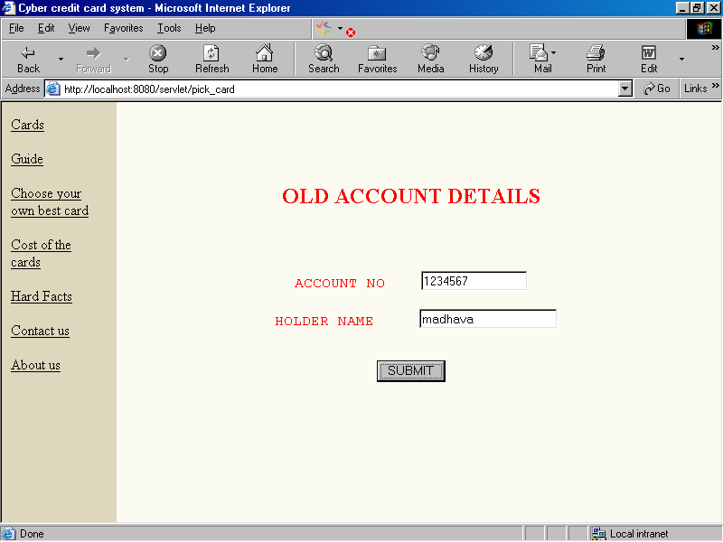

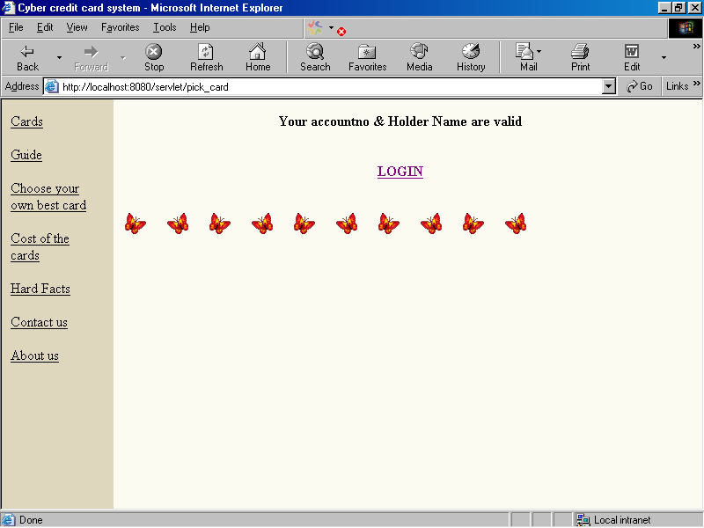

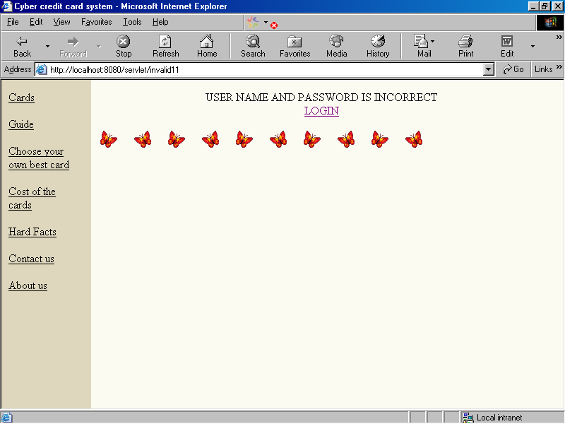

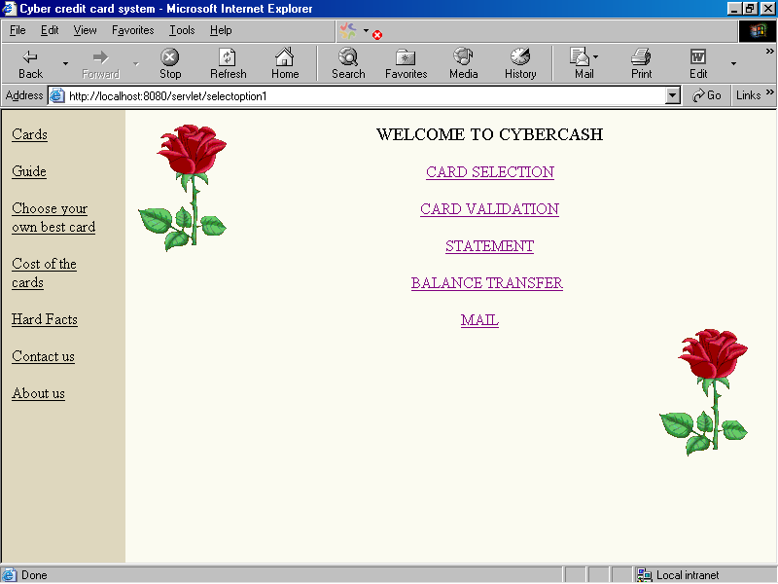

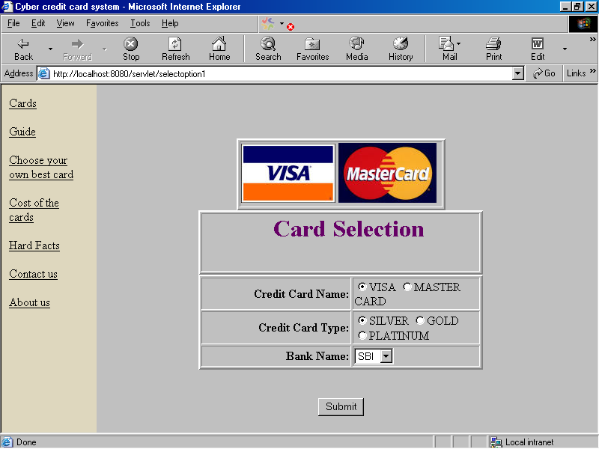

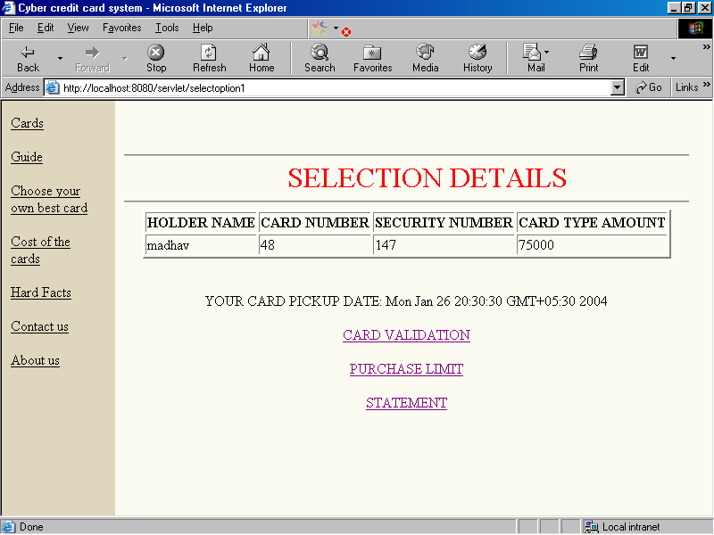

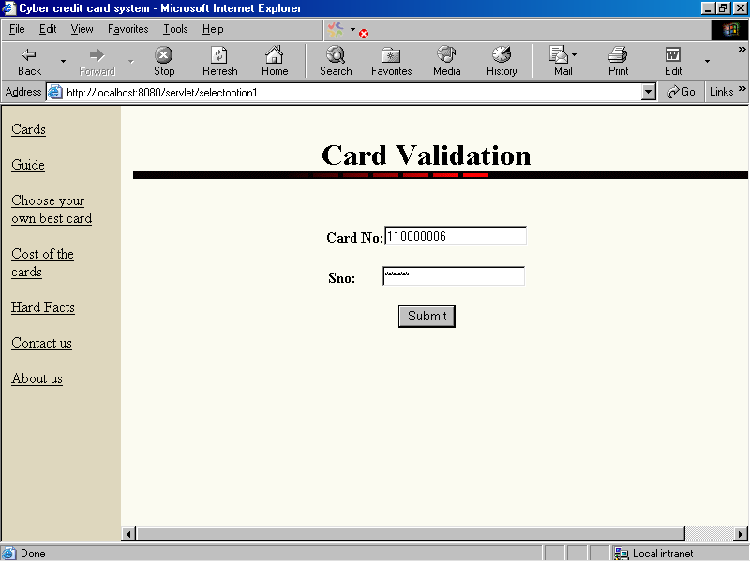

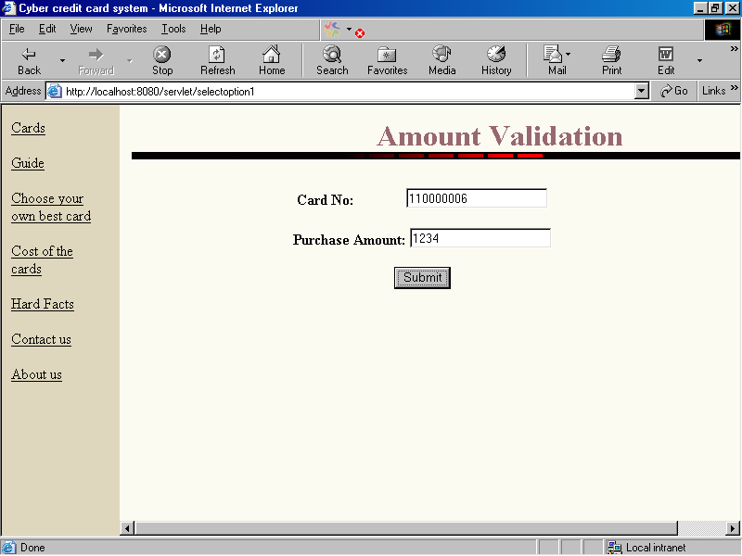

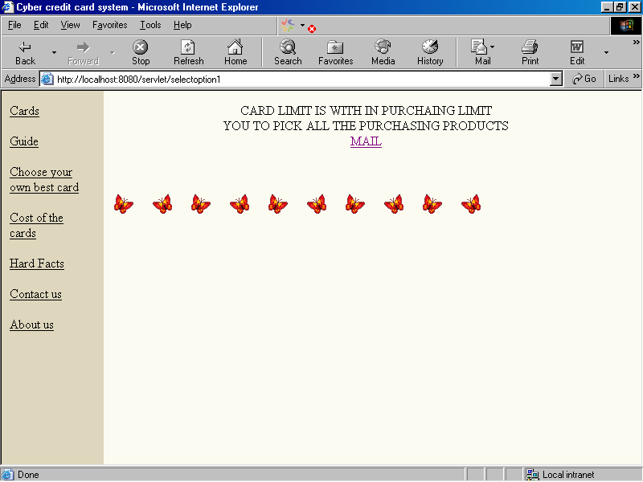

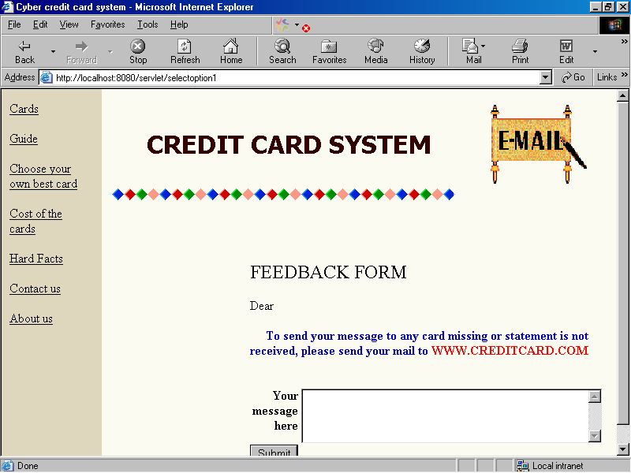

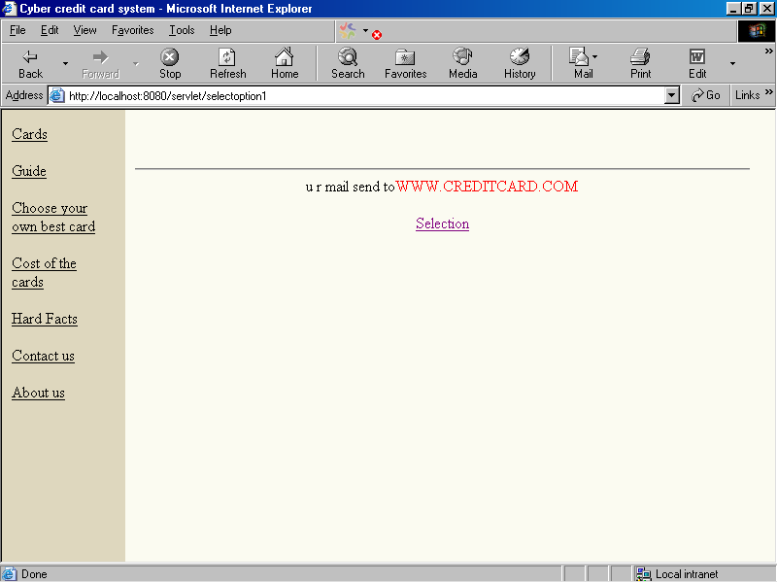

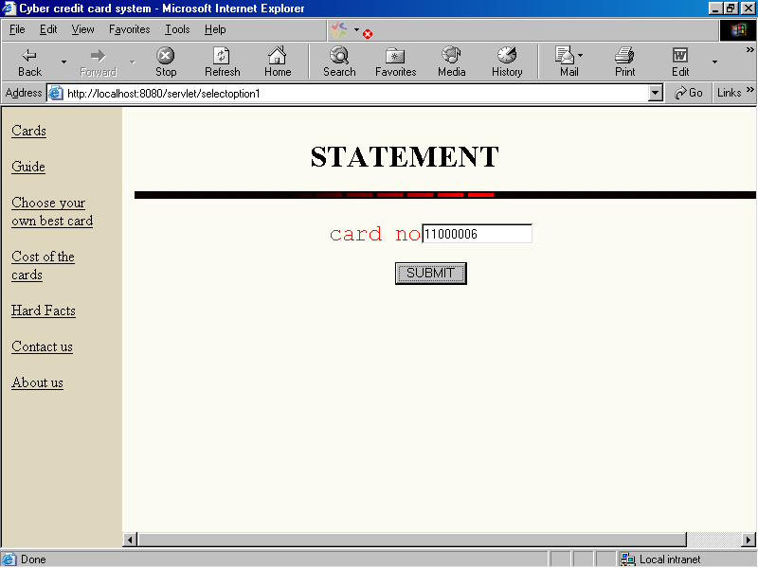

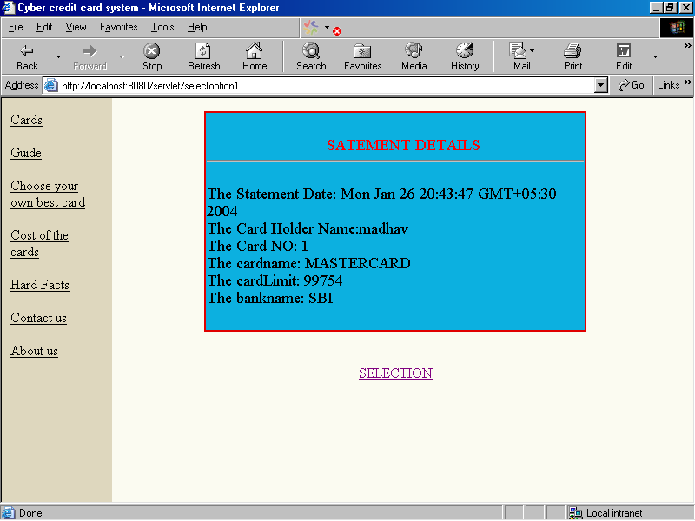

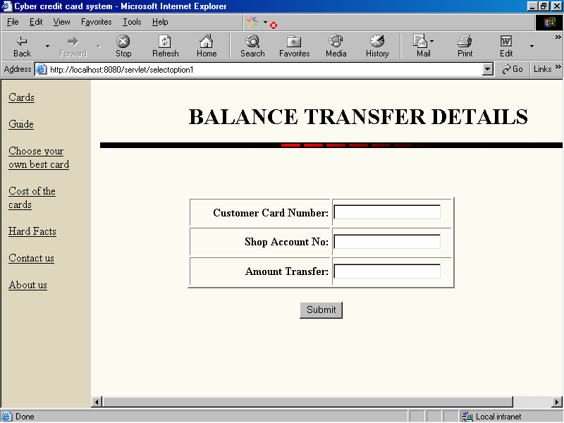

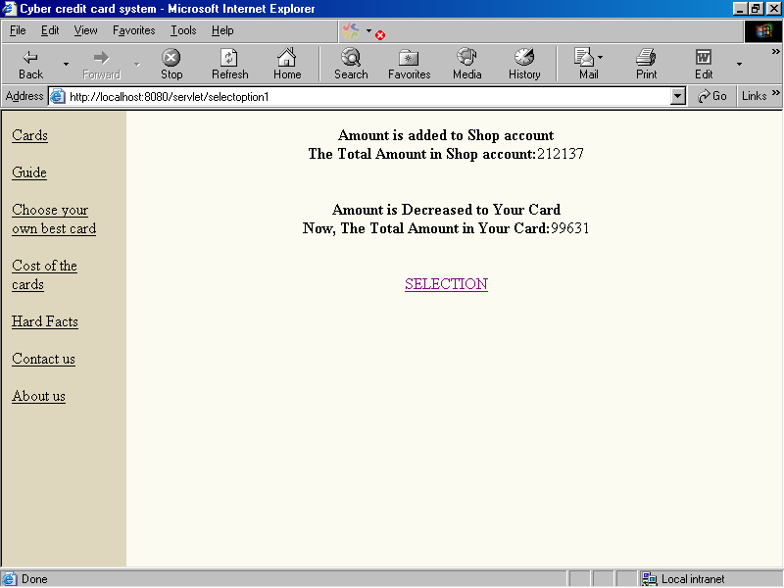

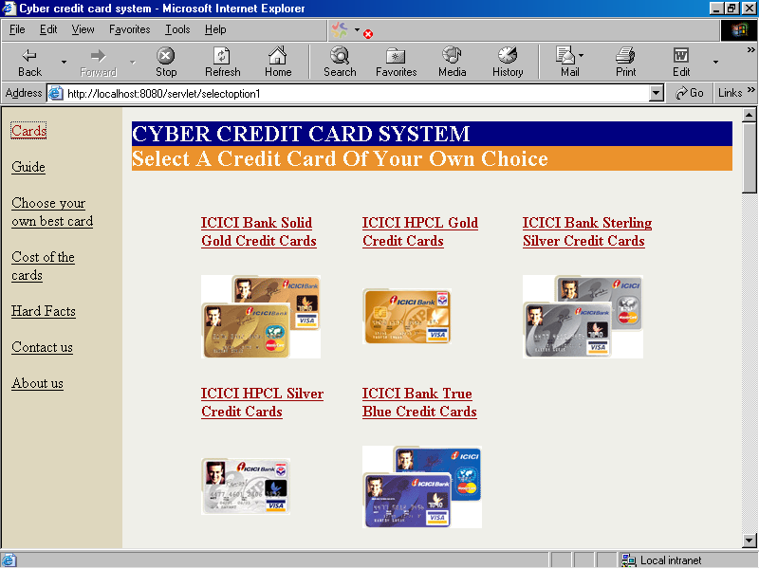

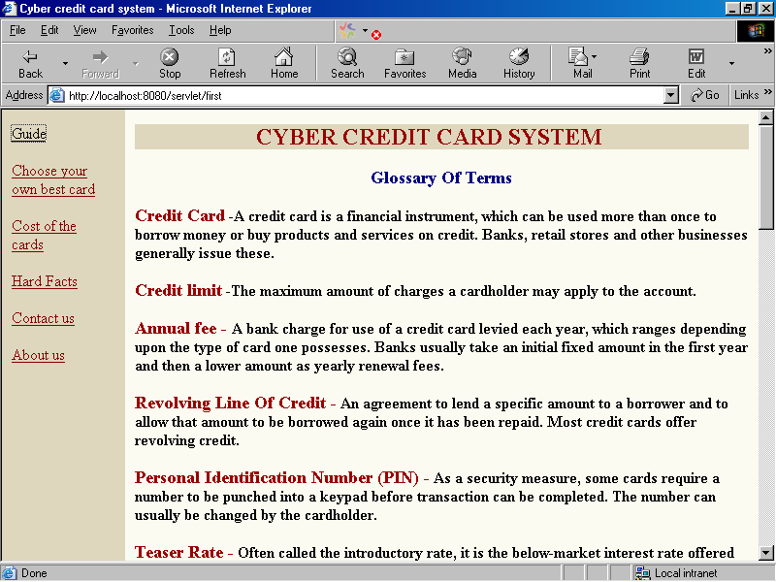

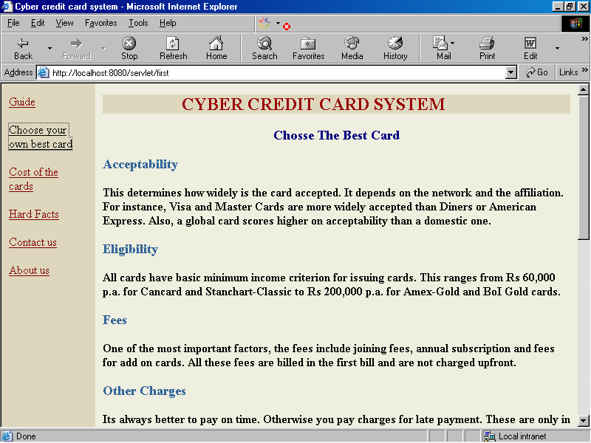

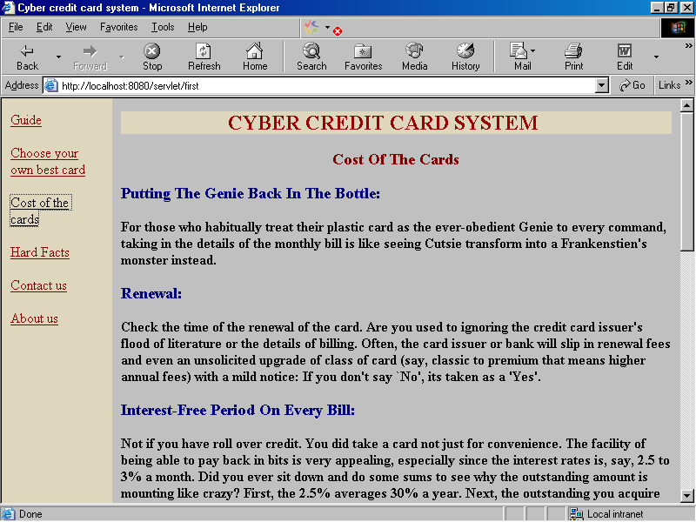

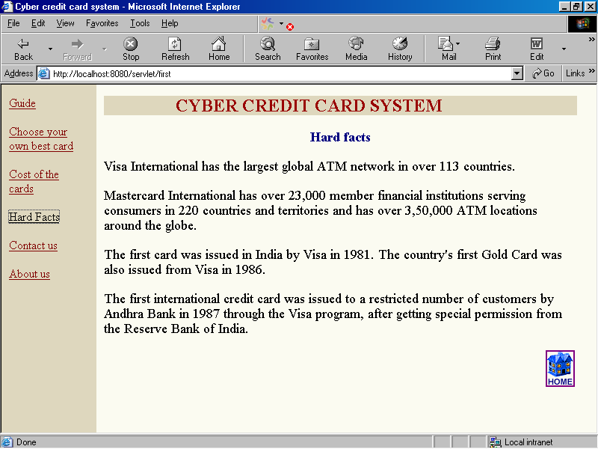

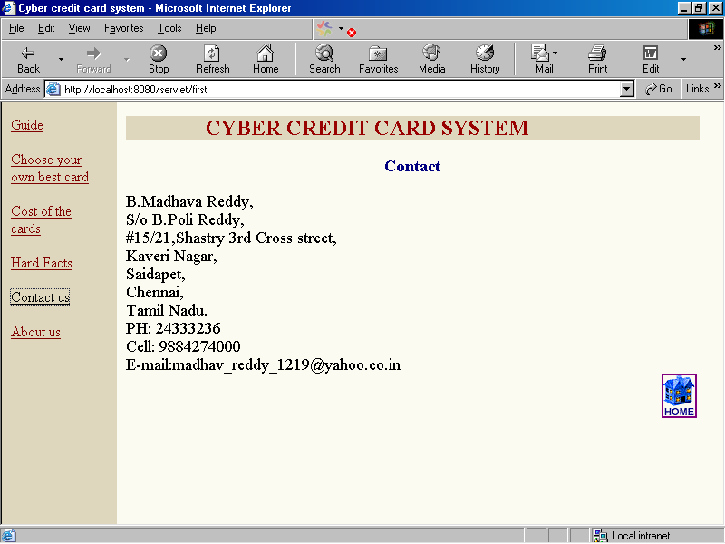

CONCLUSION

Previously the user has to carry the money to all the places, to purchase products in the market. By introducing this credit card system the user can insert the card in the concerned bank, holding account and can purchase the products directly from the merchant without paying cash. This amount for the purchasing products will be deducted from his bank account. This system will develop GLOBAL TRADING.

Implementing encryption and decryption for the effective security protection can enhance this project further. This project provides some security for the accessing of the credit card.

BIBLIOGRAPHY

1. JAVA2 The Complete Reference - Herbert Schildt

2. An Introduction to HTML - J.Arnold

3. Mastering JavaScript - James Jaworski

4. HTML 3.2 UNLEASED - John December and

Mark Ginsburg

5. JAVA handbook - TATA InfoTech

6. Credit Card Banking - P.C. Nanda

