KT Markdown Viewer
User Manual
A fast, native Markdown viewer for Windows and Linux
Kveldstid AS
kveldstid.com
github.com/hansos/MdViewer
Document version 1.0 · Applies to the current build

Contents

1. About this manual
KT Markdown Viewer (KT MD Viewer) is a desktop application for reading Markdown documents. It is a viewer, not an editor: it opens your files, renders them, and gets out of the way. Nothing you open is changed unless you explicitly enable the one optional writing feature described in section 8.4.
This manual describes the application as it is built today. Features that are planned but not yet present are listed separately in section 13 so that you always know what to expect from the version in your hands.

1.1 Who this manual is for
Anyone who reads Markdown files: developers reading a repository’s documentation, technical writers reviewing drafts, and anyone who keeps notes in plain text. No prior knowledge of Markdown syntax is required to use the viewer, although section 9 summarises the syntax it understands.

1.2 Conventions used
- Ctrl+O — keys you press. A plus sign means hold the keys together.
- Explorer — a named part of the application window or a control you click.
- settings.json — a file or path on disk.
On Linux, every shortcut in this manual works exactly as written. The application does not remap keys per platform.

2. Installing and starting

2.1 System requirements
Item | Requirement
Operating system | Windows 10 version 1809 or later (x64 / ARM64), or a current desktop Linux distribution
Runtime | .NET 10 — included in the self-contained and MSIX builds; required separately only for framework-dependent builds
Display | Any resolution; the window scales with the system DPI setting
Disk space | Under 200 MB for the application, plus a small cache for rendered diagrams
Network | Not required. The application works entirely offline.

2.2 Installing on Windows
Install the MSIX package by double-clicking it and following the prompts. The installer registers KT MD Viewer as a handler for the Markdown file extensions .md, .markdown, .mdown and .mkd, so double-clicking a Markdown file in File Explorer opens it in the viewer.
S C R E E N S H O T P L A C E H O L D E R
Figure 1. The Windows installation prompt
Capture the MSIX installer dialog showing the application name, publisher and the Install button.

2.3 Installing on Linux
Unpack the release archive to a directory of your choice and run the mdviewer executable. If your desktop environment uses the freedesktop standard, copying the supplied .desktop file into ~/.local/share/applications makes the viewer appear in your application menu and available as a handler for Markdown files.

2.4 Starting the application
Start KT MD Viewer the same way you start any other application on your system, or start it from a terminal and pass files to open:
mdviewer README.md docs/SPECIFICATION.md
Each path given on the command line opens in its own tab, and the folder containing the first file becomes the workspace shown in the Explorer panel. Relative paths are resolved against the directory you ran the command from.
Command-line option | Effect
<file> … | Opens each file in its own tab and sets the workspace to the first file’s folder
--no-restore | Starts with an empty window instead of reopening the previous session, for this launch only

3. The first look
When you start KT MD Viewer for the first time, no document is open and the start page fills the window. It offers the three ways in — open a file, open a folder, or use quick open — and, once you have read something, a list of your most recent documents.
S C R E E N S H O T P L A C E H O L D E R
Figure 2. The start page on first launch
Capture the whole window with no document open: the title, the “Nothing opened yet” message, and the three action buttons at the bottom.

Once a document is open, the window is divided into five areas. Learn these names; the rest of the manual uses them.
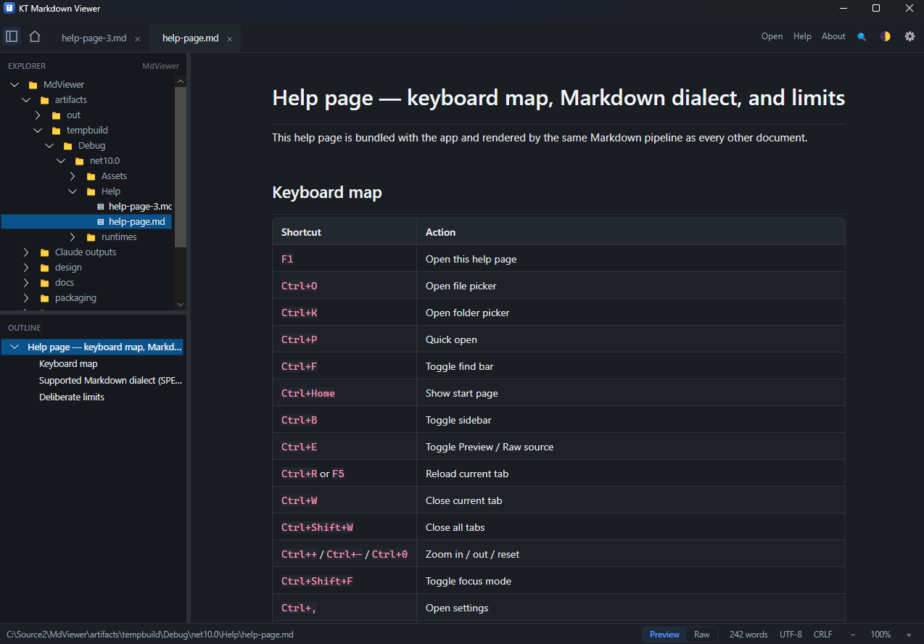

Area | What it is for
Tab strip (top) | One tab per open document, plus the sidebar toggle and the Home button that returns to the start page
Toolbar (top right) | Open, Help, About, Find, theme switch and Settings
Sidebar (left) | Explorer above, Outline below, separated by a draggable divider
Document pane (centre) | The rendered document, or its raw source — whichever view the tab is in
Status bar (bottom) | The file path, the Preview / Raw switch, word count, encoding, line endings and zoom

4. Opening documents
There are six ways to open a document. They all end in the same place: a new tab, with the document rendered and its headings listed in the Outline.

4.1 Open a single file
- Press Ctrl+O, or click Open in the toolbar, or click Open file… on the start page.
- Choose one or more files in the file picker. Markdown extensions are pre-selected in the filter, but any text file can be opened.
- Each file you selected opens in its own tab.
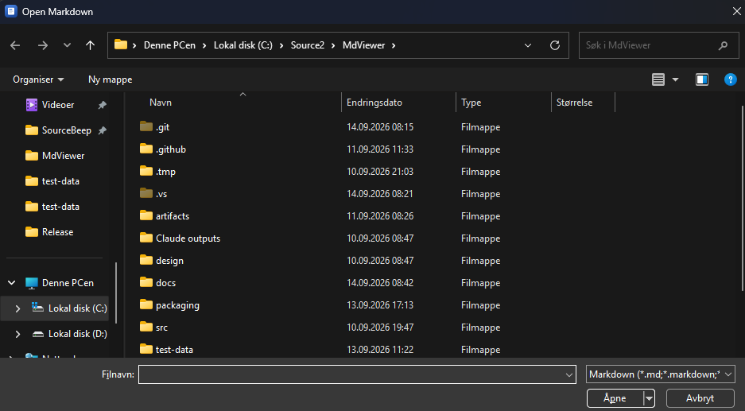

4.2 Open a folder as a workspace
Press Ctrl+K, or click Open folder…. The folder becomes the workspace: its contents appear in the Explorer panel of the sidebar and are indexed so that quick open can find them. Opening a folder does not open any document — it only gives you something to browse.
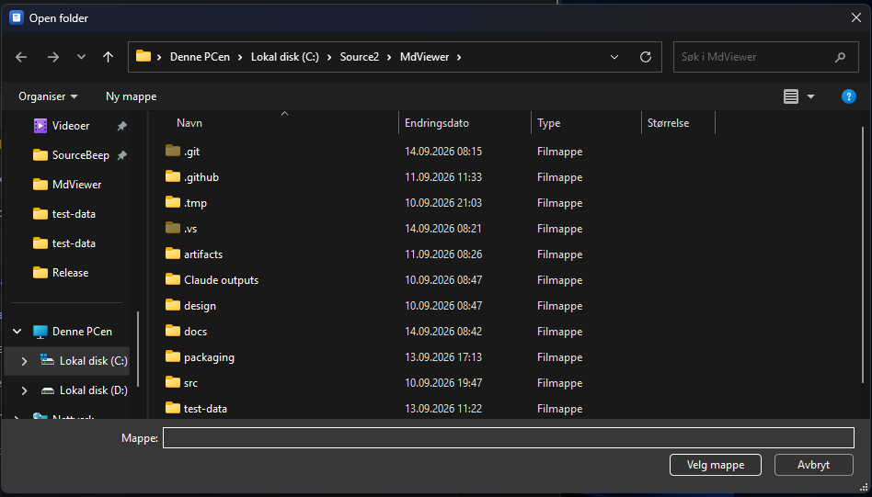

4.3 Quick open
Press Ctrl+P to open the quick-open palette. Before you type anything it lists your recent documents, each marked with a RECENT badge. As soon as you start typing, it searches the whole workspace by fuzzy filename match — you do not have to type the letters next to each other, so spmd finds docs/SPECIFICATION.md.
Key | Action in quick open
↑ / ↓ | Move through the results
Enter | Open the selected result
Esc | Close the palette without opening anything
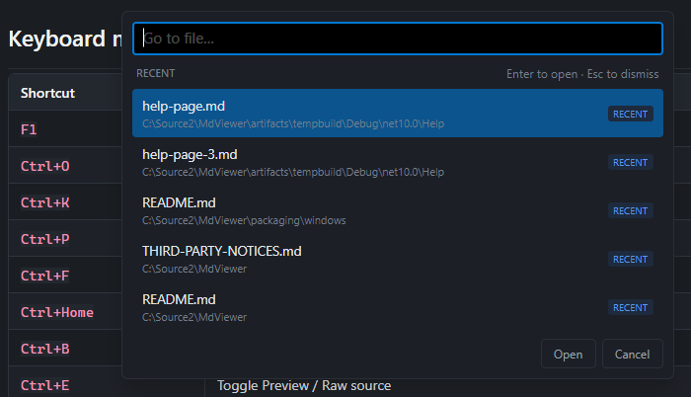

4.4 The Explorer tree
A single click on a file in the Explorer opens it in its own tab. Clicking a file that is already open simply moves you to its tab — nothing is closed behind your back. Folders expand when clicked, and their contents are read only at that moment, so even a very large workspace opens instantly.
Right-click in the tree for two commands: open the selected file in your configured external editor, and a toggle that hides folder branches containing no Markdown files, which is the fastest way to make a source repository readable.
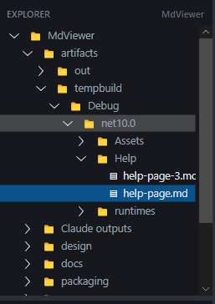

4.5 Drag and drop
Drag files from your file manager onto the window and they open as tabs. Drag a folder onto the window and it becomes the workspace.

4.6 From the file manager
On Windows, Markdown files are associated with KT MD Viewer during installation, so double-clicking a .md file opens it. If the application is already running, the file is added as a tab in the existing window rather than starting a second copy.

4.7 Recent documents
The start page lists the five most recently opened documents, newest first, with a Show all button for the rest of the history. Press Ctrl+Home or click the Home button in the tab strip to return to the start page at any time; press Esc or click Back to document to return to what you were reading.
An entry whose file has been moved or deleted is shown as unavailable rather than quietly disappearing from the list, so you can see that the file has gone instead of wondering where it went.
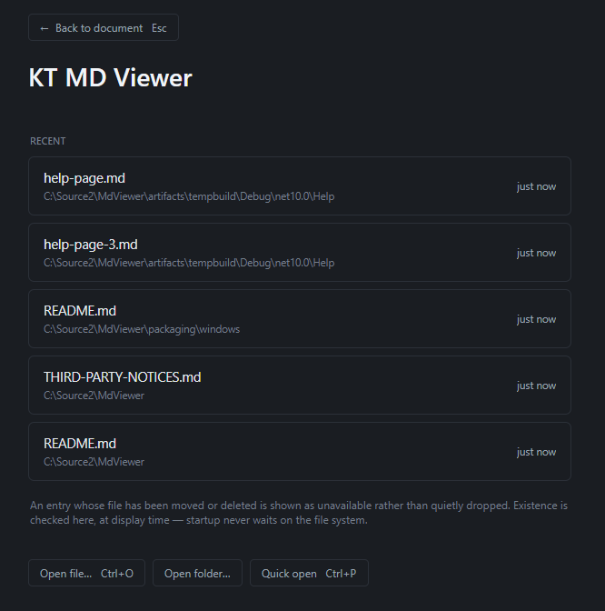

5. Working with tabs
Every document you open gets its own tab, and every tab keeps its own state: its scroll position, its zoom level, its view mode, and its outline. Switching tabs puts you back exactly where you left off.
Action | How
Switch tab | Click it in the tab strip
Close a tab | Click the × on the tab, or press Ctrl+W
Close every tab | Ctrl+Shift+W — leaves the start page showing
See the full path | Hover the tab; the tooltip shows the complete path
Scroll the strip | The strip scrolls sideways when there are more tabs than fit

A small coloured dot on the left of a tab title means the file has changed on disk since it was loaded. Section 7.4 explains what the viewer does about that.
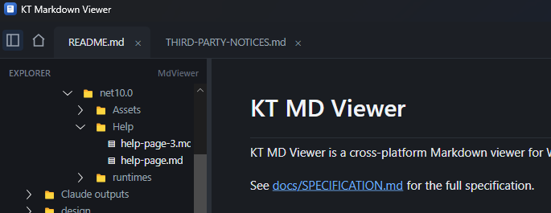

6. Reading a document

6.1 Preview and raw source
Each tab shows one of two views of the same file. Preview is the rendered document and is the default for every tab you open. Raw is the Markdown source as it is written on disk, in a monospace font with a fixed line-number gutter down the left. Switch between them with Ctrl+E or the segmented control in the status bar.
Your reading position carries across the switch. Both views know where you are in the underlying text, so flipping to the source of the paragraph you are reading puts you at that paragraph, not back at the top of the file.
Raw view is read-only
The raw view shows the source so that you can read it and copy from it. It is not an editor and never writes to your file. To edit a document, open it in your own editor — see section 11.3.

S C R E E N S H O T P L A C E H O L D E R
Figure 10. Preview and raw view of the same document
Capture two screenshots of the same passage — one in Preview, one in Raw with the line-number gutter visible — and place them side by side.

6.2 Moving around
Key | Action
↑ / ↓ | Scroll one line up or down
Page Up / Page Down | Scroll one screen up or down
Home / End | Jump to the start or the end of the document
Alt+← | Return from a footnote to where you were reading

6.3 The Outline
The lower half of the sidebar lists the document’s headings as a tree that mirrors their nesting. Click a heading to scroll straight to it. As you scroll, the outline highlights the heading you are currently under, so you always know your place in a long document. Documents with no headings show a short message rather than an empty panel.
S C R E E N S H O T P L A C E H O L D E R
Figure 11. The Outline panel
Capture the sidebar with the Outline showing a nested heading tree, with the heading currently on screen highlighted.

6.4 Zoom
Zoom is per tab, so you can enlarge a dense specification without affecting the document in the next tab. Press Ctrl++ and Ctrl+- to change it, Ctrl+0 to return to 100%, or use the −, percentage and + buttons at the right of the status bar. Clicking the percentage also resets it.

6.5 Focus mode
Press Ctrl+Shift+F to hide the chrome and leave only the text. Press it again, or Esc, to bring everything back.
S C R E E N S H O T P L A C E H O L D E R
Figure 12. Focus mode
Capture the same document in normal view and in focus mode, so the difference in visible chrome is obvious.

6.6 The status bar
The status bar reports what the viewer knows about the document in front of you:
Indicator | Meaning
Path | The full path of the document, or a status message when the viewer has something to tell you
Preview / Raw | Which view the tab is in — click to switch
Word count | Words in the document
Encoding | The text encoding the file was detected as — see section 7.3
Line endings | CRLF or LF, as found in the file
Zoom | The current zoom level for this tab

S C R E E N S H O T P L A C E H O L D E R
Figure 13. The status bar
Capture the status bar at full width, close-cropped, so every indicator is legible.

7. Searching, encodings and changes on disk

7.1 Find in document
Press Ctrl+F or click the magnifier in the toolbar to open the find bar. It appears over the top right of the document without pushing the text around. Type, and matches are highlighted as you go, with a running count of how many there are and which one you are on.
Control | Action
Enter / F3 | Go to the next match
Shift+Enter / Shift+F3 | Go to the previous match
Aa | Match case
ab | Whole word only
.* | Treat the query as a regular expression
Esc | Close the find bar

Find state belongs to the tab, so each document remembers its own query and options while it stays open.
S C R E E N S H O T P L A C E H O L D E R
Figure 14. The find bar
Capture the find bar open over a document with a query typed, the match counter showing something like “3 of 17”, and highlighted matches visible in the text below.

7.2 Reloading
Press Ctrl+R or F5 to read the current document from disk again. Your place is kept: the viewer notes which part of the text you were reading and returns you there after the reload, even if the document changed above you.

7.3 Text encodings
The viewer works out the encoding of each file it opens, in this order: a byte-order mark if the file has one; then a check of whether the content is valid UTF-8; and finally the system default — the ANSI code page on Windows, UTF-8 on Linux. The result is shown in the status bar, so a file that renders with strange characters tells you immediately what it was read as.

7.4 Files that change while you read them
Open documents are watched for changes on disk, which is what you want when you are reading generated documentation or a file someone else is editing. When a watched file changes, the tab shows a coloured dot and the document is refreshed with your reading position preserved. If you prefer the viewer not to watch files at all, turn off file watching in Settings.
If a document cannot be read — it was deleted, or you lack permission — the tab stays open and explains what happened, with a Try again button rather than closing itself.
S C R E E N S H O T P L A C E H O L D E R
Figure 15. A document that could not be opened
Capture the error state in the document pane, showing the message and the Try again button.

8. Appearance and settings

8.1 Themes
The theme button in the toolbar cycles through three settings: System (follow your desktop’s light or dark preference), Light and Dark. A small label appears beside the button to confirm which one you selected. Switching theme repaints the document immediately; nothing is re-read or re-parsed, so it is instant even in a long file.
S C R E E N S H O T P L A C E H O L D E R
Figure 16. The same document in light and dark theme
Capture the same passage twice, once in each theme, and place the two images side by side.

8.2 Opening Settings
Press Ctrl+, or click the gear in the toolbar. Settings fill the document pane rather than opening a separate window; press Esc or click Close to return to your document. Changes take effect as you make them and are saved automatically.
S C R E E N S H O T P L A C E H O L D E R
Figure 17. The Settings page
Capture the Settings page scrolled to the top, showing the Appearance, Panels and Typography sections.

8.3 What you can change
Section | Settings
Appearance | Theme: System, Light or Dark
Panels | Show or hide the Explorer, the Outline and the status bar
Typography | Body font and size, monospace font and size, line height, content width, or use the full window width
Rendering | Smart punctuation; allow ticking task-list checkboxes
Raw view | Show line numbers; show front matter
Files | The external editor to use for the “open in editor” commands
File watching | Watch open files for external changes
Startup | Reopen the previously used folder when the application starts

Reading is easier in a narrow column, which is why the content width is limited by default rather than stretching across a wide monitor. If you prefer full width, the Typography section has a checkbox for it.

8.4 Ticking task lists
Markdown task lists render as real checkboxes. They are read-only until you turn on Allow ticking task list checkboxes in Settings. With that setting on, clicking a checkbox rewrites the corresponding [ ] or [x] marker in the file on disk. This is the only way the application ever writes to a document you opened, and it is off by default.
S C R E E N S H O T P L A C E H O L D E R
Figure 18. A task list
Capture a rendered task list with a mix of ticked and unticked items.

8.5 The sidebar
Press Ctrl+B or click the toggle at the left of the tab strip to show and hide the sidebar. Drag the divider between Explorer and Outline to give one of them more room, and drag the edge of the sidebar itself to make it wider or narrower. Both positions are remembered.

8.6 Where your settings are kept
Settings and session state are stored as JSON in your user profile — nothing is written to the folders you browse, and nothing leaves your machine.
Platform | Location
Windows | %APPDATA%\MdViewer\
Linux | $XDG_CONFIG_HOME/mdviewer/ (usually ~/.config/mdviewer/)

8.7 Picking up where you left off
When you close the application, your open tabs, their order, the active tab, each tab’s reading position, view mode and zoom, the window size and position, the sidebar layout and the workspace are all saved. They come back the next time you start. A file that no longer exists is skipped without comment. To start clean for one launch, use --no-restore on the command line.

9. What the viewer renders
KT MD Viewer renders CommonMark plus a deliberate set of extensions. Everything listed here works out of the box; nothing has to be enabled.

9.1 Text and structure
Feature | Written as | Notes
Headings | # to ###### | Feed the Outline and can be linked to with #anchor
Emphasis | *italic*, **bold** | Plus ~~strikethrough~~, ==mark==, ++insert++, ~sub~, ^sup^
Lists | -, *, 1. | Nested to any depth
Task lists | - [ ] and - [x] | Rendered as checkboxes; see section 8.4
Block quotes | > | Nested quotes supported
Definition lists | Term, then : definition
Abbreviations | *[HTML]: HyperText… | Shown with the expansion on hover
Footnotes | [^1] | Alt+← returns you to where you were reading
Front matter | YAML between --- lines | Shown as document metadata; can be hidden in Settings
Emoji | :smile: and :) | Replaced with the Unicode character
Figures | ^^^ … ^^^ caption | An image or block with a caption beneath it

S C R E E N S H O T P L A C E H O L D E R
Figure 19. Rendered text features
Capture a passage that shows headings, emphasis, a nested list, a block quote and a footnote reference together.

9.2 Tables
Both pipe tables and grid tables are rendered, with per-column alignment. Columns size themselves to their content. When a table is too wide for the window, it scrolls sideways inside its own frame — the page itself never scrolls sideways — and the header row stays visible while the body passes under it.
S C R E E N S H O T P L A C E H O L D E R
Figure 20. A wide table
Capture a table wide enough to scroll horizontally, showing the sticky header row and the scroll edge.

9.3 Code blocks
Fenced code blocks are syntax-highlighted, using the language named after the opening fence. The language is shown in the corner of the block, and a copy button copies the original source rather than the highlighted text. A language the viewer does not recognise is rendered as plain monospace text rather than as an error.
S C R E E N S H O T P L A C E H O L D E R
Figure 21. A code block
Capture a highlighted code block showing the language label and the copy button in the top-right corner.

9.4 Callouts
Custom containers (:::note, :::warning and similar) and GitHub-style alerts (> [!NOTE], > [!WARNING]) are rendered as coloured callout boxes.
S C R E E N S H O T P L A C E H O L D E R
Figure 22. Callouts
Capture three or four callout boxes of different kinds stacked together, so their colours can be compared.

9.5 Diagrams
Mermaid diagrams in a ```mermaid block are rendered directly by the application. There is nothing to install: no Node.js, no external command-line tool and no browser engine. The diagram is drawn to match the active theme, so it stays readable in both light and dark. A diagram whose source has an error shows the error in place rather than breaking the document around it.
S C R E E N S H O T P L A C E H O L D E R
Figure 23. A rendered Mermaid diagram
Capture a flowchart or sequence diagram rendered in the document, ideally in both themes.

9.6 Mathematics
Inline maths between single dollar signs and display maths between double dollar signs are typeset as formulas.
S C R E E N S H O T P L A C E H O L D E R
Figure 24. Typeset mathematics
Capture a passage containing both an inline formula and a display formula.

9.7 Images
Images stored next to your document load from disk and are scaled down to fit the reading column, never blown up past their natural size. Images hosted on the web are a different matter — see section 10.2.

10. Links, privacy and safety

10.1 How links behave
Link | What happens when you click it
#anchor | Scrolls to that heading in the current document
another-file.md | Opens that document in a new tab
another-file.md#anchor | Opens the document and scrolls to the heading
https:// or http:// | Opens in your system web browser
mailto: | Opens your system mail application
Other schemes | Blocked, with a short explanation

10.2 Remote images are not fetched
An image hosted on the web is not downloaded when you open a document. Opening a file you were sent should not tell anyone that you opened it, and an image URL is enough to report exactly that. Instead, the image shows as a placeholder with its alternative text, and you can allow the document to load its images if you want to see them.
S C R E E N S H O T P L A C E H O L D E R
Figure 25. A remote image placeholder
Capture a document containing a remote image, showing the placeholder with its alt text and the control that loads the images.

10.3 HTML is shown, not executed
Markdown allows raw HTML, and a viewer that executed it would be a small web browser with all the risks that implies. KT MD Viewer does not do that. A short list of harmless formatting tags — line breaks, bold, italic, code, keyboard keys, highlighting, subscript, superscript, underline and strikethrough — is interpreted as formatting. Everything else is shown as dimmed, escaped text so you can see exactly what the document contains without any of it running.

10.4 Nothing leaves your machine
The application makes no network connections of its own. It does not check for updates in the background, send telemetry, or transmit anything about the documents you open. Your recent-documents list and your settings stay in your user profile on your own machine.

11. Help and other commands

11.1 The built-in help page
Press F1 or click Help in the toolbar. The help page opens as a tab like any other document — it is a Markdown file, rendered by the same engine — and gives a condensed keyboard map and a summary of the supported syntax.

11.2 About
Click About in the toolbar for the version number, the publisher, and links to the project’s website, its source repository, the licence and the third-party notices.
S C R E E N S H O T P L A C E H O L D E R
Figure 26. The About page
Capture the About page showing the product name, version number and the links.

11.3 Opening a document in your own editor
KT MD Viewer does not edit files, but it will hand one to a program that does. Set the path to your editor in the Files section of Settings, then right-click a file in the Explorer, or right-click inside the document pane, and choose the “open in editor” command. Your editor opens the file; the viewer notices when you save and refreshes the tab.
S C R E E N S H O T P L A C E H O L D E R
Figure 27. Choosing an external editor in Settings
Capture the Files section of the Settings page with an editor path filled in and the Browse button visible.

12. Keyboard reference
Every shortcut in the application, in one place.

12.1 Files and tabs
Key | Action
Ctrl+O | Open file
Ctrl+K | Open folder as workspace
Ctrl+P | Quick open
Ctrl+W | Close the current tab
Ctrl+Shift+W | Close all tabs
Ctrl+R or F5 | Reload the current document
Ctrl+Home | Show the start page

12.2 Reading
Key | Action
Ctrl+E | Switch between Preview and Raw source
↑ / ↓ | Scroll one line
Page Up / Page Down | Scroll one screen
Home / End | Go to the start or end of the document
Alt+← | Return from a footnote
Ctrl++ / Ctrl+- / Ctrl+0 | Zoom in, out, reset

12.3 Finding
Key | Action
Ctrl+F | Open or close the find bar
Enter or F3 | Next match
Shift+Enter or Shift+F3 | Previous match

12.4 Window and application
Key | Action
Ctrl+B | Show or hide the sidebar
Ctrl+Shift+F | Focus mode
Ctrl+, | Settings
F1 | Help page
Esc | Close whatever overlay is open — find bar, quick open, settings, start page

13. Known limits and what is coming
These boundaries are deliberate, and knowing about them saves you looking for a setting that is not there.

13.1 By design
- The viewer does not edit documents. Ticking a task-list checkbox, when you enable it, is the single exception.
- Raw HTML is shown as text rather than rendered, and remote images are not fetched until you allow them. Both are explained in section 10.

13.2 Planned for later versions
Feature | Status
Selecting text across several paragraphs, and copying it back as Markdown | Planned
Side-by-side source and preview with synchronised scrolling | Planned for version 2
Dragging a tab out into its own window | Not planned for version 1

14. Troubleshooting
Symptom | What to do
The text is full of strange characters | Check the encoding shown in the status bar. The file is probably in a legacy encoding the automatic detection could not identify.
A table runs off the side of the window | That is expected for a very wide table — scroll it sideways inside its own frame. The page itself never scrolls sideways.
An image does not appear | If it is hosted on the web, allow the document to load remote images (section 10.2). If it is a local file, check that the path in the document is correct relative to the document itself.
A code block is not coloured | The language after the opening fence is missing or not recognised. The block still renders, just without colour.
A diagram shows an error instead of a picture | The Mermaid source has a syntax error. The message names the problem.
Quick open finds nothing | No folder is open. Open a folder (Ctrl+K) so that there is a workspace to search.
The sidebar toggle does nothing | Both the Explorer and the Outline are switched off in Settings, so there is nothing for the sidebar to show.
My tabs did not come back | The application was started with --no-restore, or the files have been moved or deleted since.

15. Licence and credits
KT Markdown Viewer is published by Kveldstid AS and released under the MIT Licence. The source is available at github.com/hansos/MdViewer, and the licences of the third-party components shipped with the application are listed in the THIRD-PARTY-NOTICES file in that repository and reachable from the About page.
The application is built on Avalonia UI, with Markdig for parsing, TextMateSharp for syntax highlighting, Mermaider for diagrams and CSharpMath for typesetting mathematics.
© Kveldstid AS

