**Conduit Project**

**E2E Automation Draft**

**Krishnaveni Vempati**

Contents

**Project Summary:** 3

**E2E test execution report:** 4

**Test files:** 5

**Test files are in the following path** 5

- **angular-ngrx-nx-realworld-example-app\apps\conduite2e\src\integration** 5

**Test Support files are in the following path** 5

- **angular-ngrx-nx-realworld-example-app\apps\conduite2e\src\support** 5

**E2E test Issues:** 6

**Project Summary:**

Summary of Conduit GUI E2E automation using Cypress Tool.

1. Without logging in check for the list for public feeds and navigation on the page.
   * How to validate, any database is there or anywhere the feeds are stored?
   * Automation is Done for Nav part, which is on the top right hand upper corner
   * covered Sign In, Sign Up Links
2. Check for tags on the right side of the page
   * Automation is done for all the available tags
   * Duplicate tags are there - Bug
   * In appropriate tag is there - Bug
3. New user sign-up
   * Automation is done
   * Covered both Positive, Negative and Clear fields parts are done
4. Existing user login, address both successful and unsuccessful login
   * Automation is done
   * Covered both Positive and Negative cases
5. After successful login, check for the additional navigation available that wasn’t there before the login
   * Automation is done by checking or validating the links and banner after successful login
6. User changing their settings and saving it
   * Tried all the possibilities to get the Settings link work after login , but finally figured out that the **name** of the links for Settings, Editor for Post feed, Profile are missing after login and so, once that is fixed, it can easily automatable

1. Adding a comment to a post
   * Even this link doesn't work because of the same reason described in 6, name of the link is missing but it can be easily automatable once that name of the link is fixed.

**E2E test execution report:**

Overall Result screen shot of my test automation execution using Cypress tool:

* Total test cases : 44
* Pass: 42
* Fail: 2
  + Failed because of the link name missing which can be automatable after the code is fixed. Please see the below screenshot-2

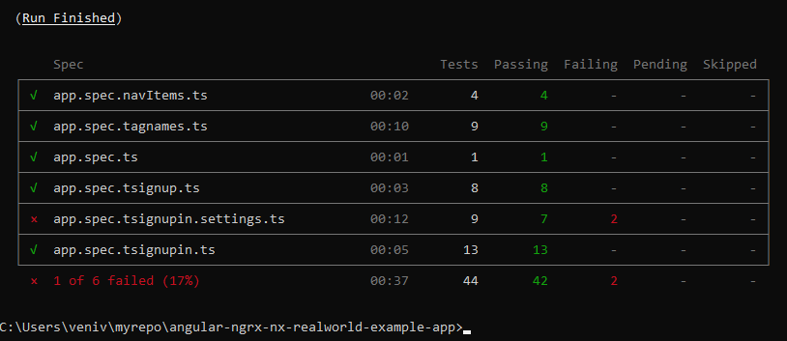

Screenshot-1: Automation Summary

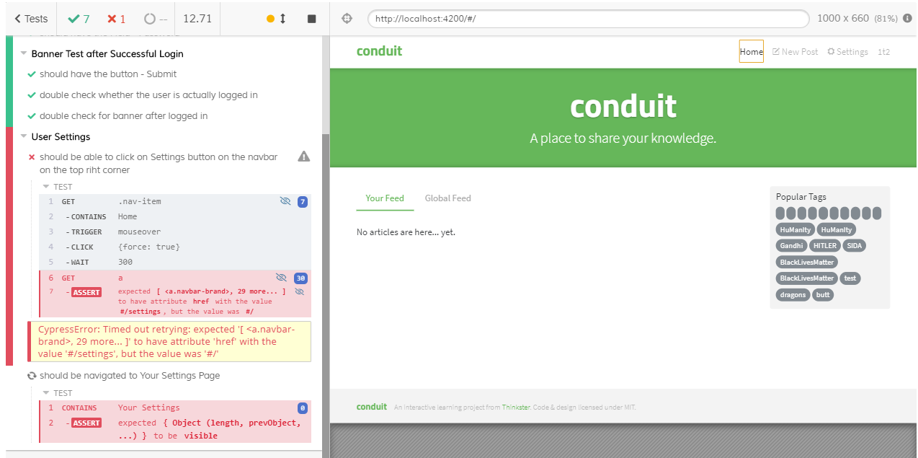

Screenshot 2: Failure case

**Test files:**

**Test files are in the following path**

* **angular-ngrx-nx-realworld-example-app\apps\conduite2e\src\integration**

1. app.spec.ts
   * Validates the Initial Launch Page
2. app.spec.navItems.ts

* Validates the Navigation bar items on the top right corner before login (Sign In, Sign Up)

1. app.spec.tagnames.ts
   * Validates the Tag Names before login
2. app.spec.tsignup.ts
   * Validates the Sign up page for the fields and buttons
3. app.spec.tsignupin.ts
   * Validates both positive and negative scenarios of the Sign In and Sign up
4. app.spec.tsignupin.settings.ts
   * Validates Settings dialog and page after successful login

**Test Support files are in the following path**

* **angular-ngrx-nx-realworld-example-app\apps\conduite2e\src\support**

1. app.po.ts
   * Holds the constants

**E2E test Issues:**

**Issue-1:** Please see the details in the below screenshot.

* Missing link names after logging in. Please compare below screenshots taken before login and after login.
  + Screenshot-3: Before login
  + Screenshot-4: After login

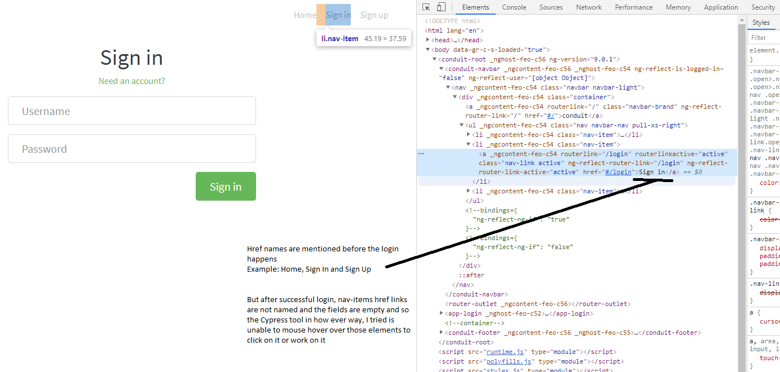

Screenshot-3

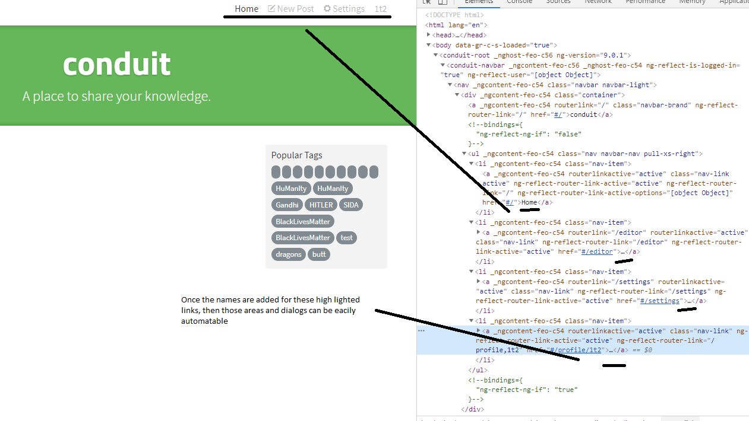

Screenshot-4: Missing link names after login

**Issue-2:** Duplicate tags and inappropriate tag names. Please see the below screenshot for more details

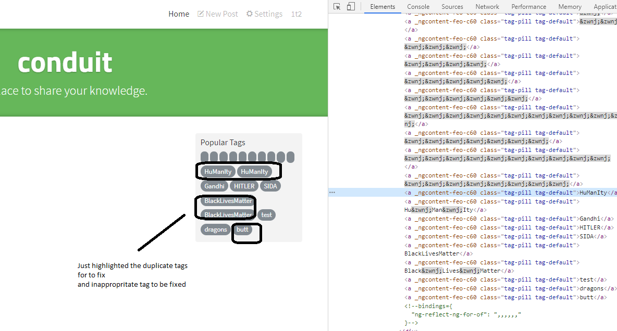

Screenshot-5: Duplicate tags and inappropriate tag names