How to transfer a file from SGEMS to ArcMap

In SGEMS, export the data as a gslib file. The cells must be square not rectangular and there must be an even number of cells in the x direction. The header is removed and then a new header is added:

Coarse Grid Fine Grid

|  |  |  |  |
| --- | --- | --- | --- |
| |  |  | | --- | --- | | NCOLS 70  NROWS 105  XLLCENTER 566000  YLLCENTER 5248500  CELLSIZE 500  NODATA_VALUE -9966699 | NCOLS 700  NROWS 1050  XLLCENTER 566000  YLLCENTER 5248500  CELLSIZE 50  NODATA_VALUE -9966699 | |  |

The data needs to be sorted in the reverse order, so I add a column next to the data from 1 to n. Then sort on this with expanded in descending order.

The data then need to be transposed in order to remove the carrier return and make the data space delimited rather than tab delimited. Use TSE Pro to do this, just choose Wrap from the File menu, save the file as a .txt and then open in word doc, add the new header, save and do the following.

Use the ascii to raster command in Arc to import the data.

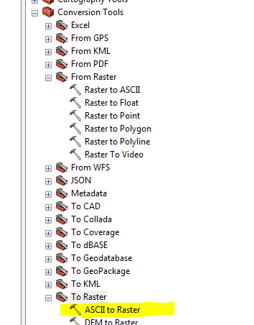

Then use the mirror tool to reflect the data about a y-axis located in the center of the raster. This is why there must be an equal number of cells in the x-direction.

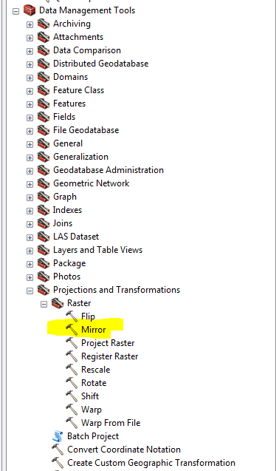

Now to crop the raster to the polygons. I needed to use the Aggregate Polygon tool to create a single polygon.

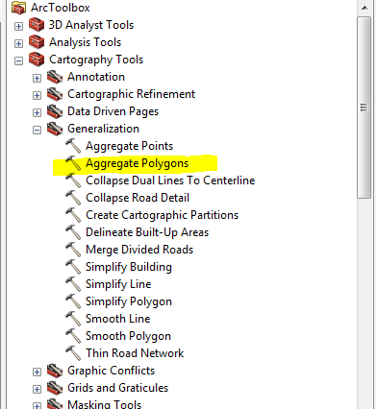

I need to use the Extract by Mask tool (the clip tool inside Raster-> Raster Processing-> Clip tool didn’t work for whatever reason).

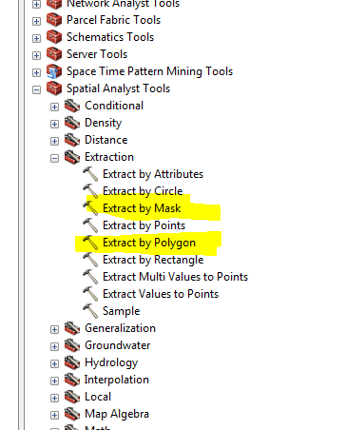

A bandpass filter was applied to smooth the kriged result.

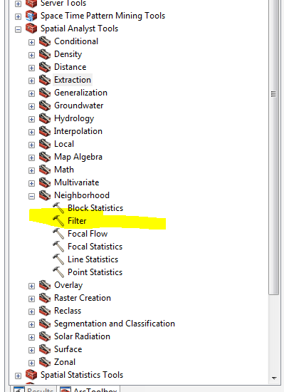

Mark and Deb think it would be best to take the many polygons and turn them into both a single polygon and polyline. The polygon can be used to clip the data.

Use Aggregate Polygons Tool.

Right now, because I am using such coarse data, I will need to resample my grid and split each cell into ~5 cells 100 m wide and 100m tall since my current cell size is 500x500.

To evaluate the data on one side of the polygons and not the other, I need to use the polyline and digitize the rest of a box on the top left side and then remove these values.