|  |
| --- |
| KUNAL VICHAVE |

AI Developer

Phone - +91 7387961727   
Email - kunalvichave258@gmail.com   
LinkedIn - www.linkedin.com/in/kunal-vichave/   
GitHub - www.github.com/kvichave

|  |
| --- |
| CAREER SUMMARY: |

|  |
| --- |
| I am a final-year Computer Science and Engineering student specializing in Artificial Intelligence. With a |

solid foundation in machine learning and data science, I have actively contributed to hands-on projects, refining my programming skills and collaborating effectively. Eager to apply my knowledge to real-world challenges, I am positioned for a dynamic career in the evolving field of artificial intelligence.

|  |
| --- |
| EDUCATION: |

|  |
| --- |
| **BTech - Computer Science and Engineering with (Artificial** |

**Intelligence and Machine learning)**

University of Mumbai

Place - Kopar Khairane (Navi Mumbai)

2022 - pursuing (Expected- 2025)

Average GPA -8

**(GitHub)**

Mumbai University

Place - Dombivli

(GitHub)

Percentage 85.54

|  |  |
| --- | --- |
| PROJECTS |  |
| **Pre-Post World News API** | **[(GitHub)](http://prepost.neuralberg.com/)** |

A web application which provides news all around the world with wide range of categories.

Successfully created API service of the news based on categories. From this project I have learned and enhanced skills to use Flask , Beautiful Soup, Jinja, Tailwind CSS, JavaScript

**DocBerg**  **[(GitHub)](https://github.com/kvichave/DocBerg)**

Created a web application which provides services related to documents such as - Resume Analyzer with suggestions, Document conversion, Image text extraction. From this project I have learned and enhanced skills to use Tensorflow, NLP, OCR, Flask, Tailwind CSS, Javascript

**Revving UP**  **[(GitHub)](https://github.com/kvichave/Revving-Up)**

Created a web application clone of Cardekho, which provides services such as - Multiple car selections, BHP and Torque comparison Graphs, Ratings-Reviews, Features comparison , 3D model, etc. From this project I have learned and enhanced skills in Features Extraction , Data cleaning, Plotly, Ajax-JavaScript, Tailwind CSS.

**(GitHub)**  **[(GitHub)](https://github.com/kvichave/SocioFy)**

A web application for creators to watch their Instagram page, derive post’s comments sentiment analysis and statistics. In this project I have worked on API’s (Facebook Graph API), Django framework, Social Authentication, Sentiment Analysis, Tensorflow, Plotly for dynamic plots

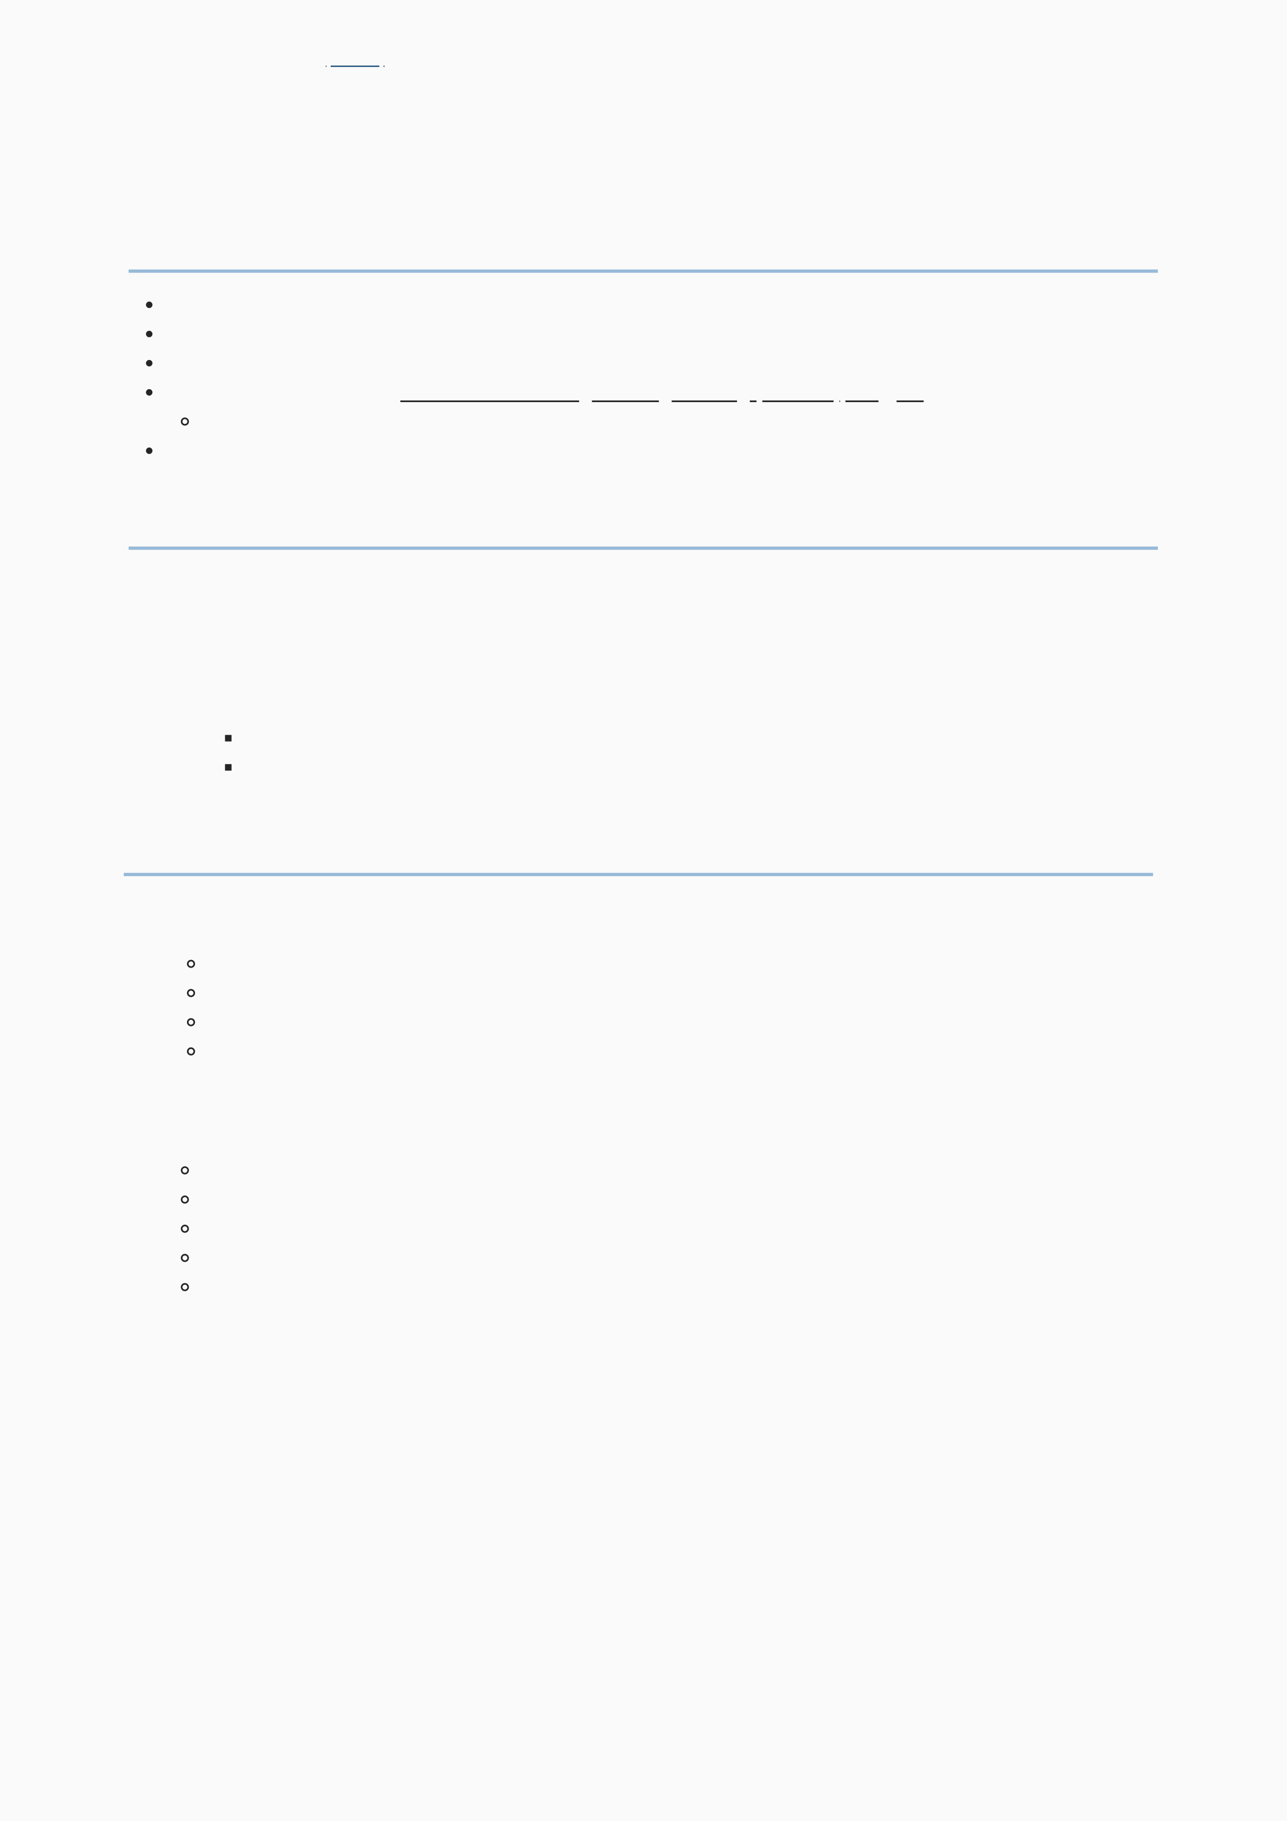

**Teamwork [Problem solving](https://github.com/kvichave/AInterview)**

Creativity

PARTICIPATON

Python (Tensorflow, Pandas, Numpy)   
Scikit-learn (for data preprocessing ,model building,and evaluation)   
Logithon - Softlink Global Pvt. Ltd.

ML Quest Hackathon - [Python - ( Django, Flask, Matplotlib, Seaborn, Plotl](https://unstop.com/c/g-h-raisoni-college-of-engineering-ghrce-nagpur-1163813)y , TensorFlow, Pandas, Numpy, BeautifulSoup )   
JavaScript - ( Ajax, JQuery, Vanilla Javascript, React, React Native )

CSS - ( Tailwind, BootStrap )

1. **SQL - ( MySQL, SqLite )**

Intelligence and Machine learning Internship  
 Remote  
 Project - Home Value Prediction  
 Integrity

SIH- Smart India Hackathon

**HackOverflow 2.O - National level hackathon (Pillai)**

Python - ( Django, Flask, Matplotlib, Seaborn, Plotly, TensorFlow, Pandas, Numpy, BeautifulSoup ) (GitHub)   
CSS - ( Tailwind, BootStrap )   
SQL - ( MySQL, SqLite )

**Logithon - Softlink Global Pvt. Ltd.**

ML Quest Hackathon - G. H. Raisoni College of Engineering (GHRCE), Nagpur   
Achieved 3rd Rank   
HackCelestial - National Level Hackathon (Pillai Tech Alegria)   
Problem solving   
YBI Foundation (Internship)