User Guide

**Requirements:**

1. Computer with a Java virtual machine installed
2. A mouse and a keyboard

**Note:** no other external software or libraries are required, as they are included in the libs folder within the game folder. Or if the game is run from the executable *.jar file all the dependencies are already included in this *.jar file.

**Description of the program:**

At program launch the user is presented with a menu, consisting of 3 options: “Start”, “Records” and “Settings”. By pressing “Start”, the user launches the game. The game itself is of type “Block Breaker”, to some known as “breakout”.

The game is pretty simple. The player is presented with a set of blocks, some lives, a pad and ball(s). The main objective of the game is to destroy the blocks, without losing all lives. The blocks are stationary, while the pad and ball(s) are not. When the game starts, the balls are deployed with time intervals between their appearance and with random initial horizontal speeds. The ball(s) bounces of the walls, blocks and the pad. Player controls the pad only, by using the mouse and uses it to direct the ball(s) towards the blocks and tries to avoid the balls reaching the ground. Blocks can be destroyed by hitting them with the ball, some of them require more than one hit. When a ball hits the ground the pad gets shorter. When the pad shrinks completely a life is lost and the pad gets reset to 100% of its initial width. When all the blocks in a level are destroyed the game progresses to the next level, with two extra rows and columns of blocks, and one extra ball. The game ends if all the lives are lost, or if the user decides to exit the game by pressing “esc”. At the end of the game the user can enter his/her name to be saved in the score database. By pressing “Records”, the user opens the records panel, where 5 best results and corresponding players’ names, taken from the database, are displayed in ascending order. By pressing “Settings”, the user can select the difficulty of the game.

**Step-by-step instructions:**

**How to launch the program and open the main menu:**

1. Locate the BlockBreakerApp class and run the main() method. Note parameters required.  
   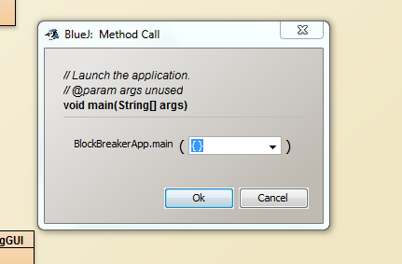

Figure 1 launching the program

1. Once the main() method is run, the program’s main menu will be opened.  
   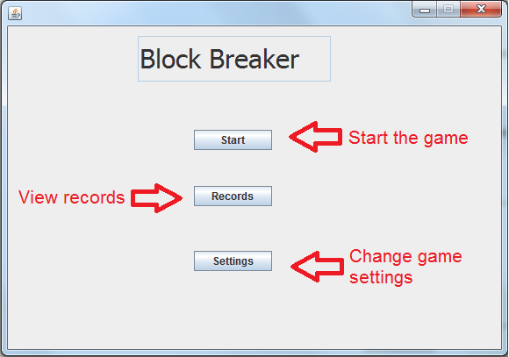

Figure 2 Main menu

1. It has 3 options as seen in the picture above: “Start”, “Records” and “Settings”.
2. To exit the program, just press the default window exit button, usually a cross in either the right or left top corner of the window.

**How to start the game:**

1. Launch the program as described in the instruction above
2. In the main menu select the 1st option “Start” and wait a few seconds. The game window will open and the game will start straight away.  
   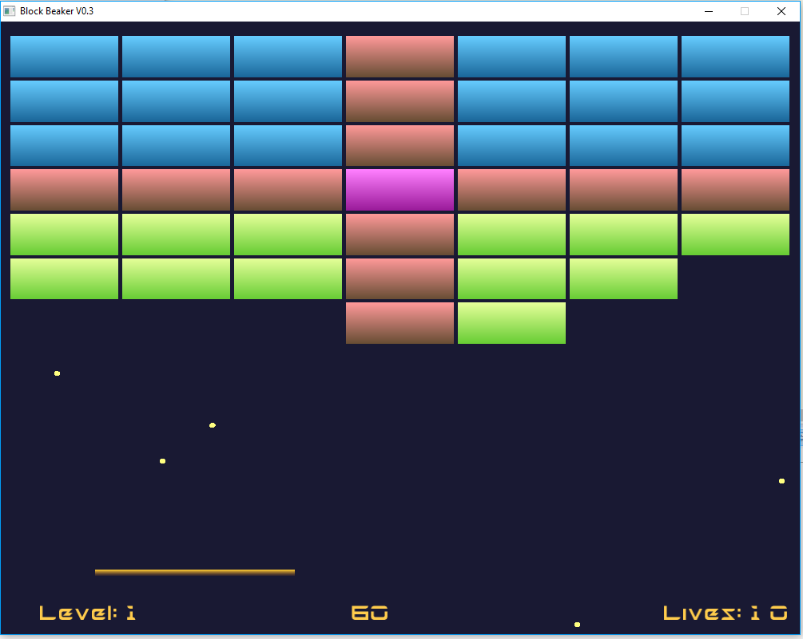

Figure 3 The game

1. Use the mouse to navigate and press “esc” to exit the game.
2. Score and lives are displayed on the bottom of the screen.
3. The game is finished, when you run out of lives.
4. After the game has finished, you will be presented with a field to enter your name to appear in the scoreboard. Please enter the name *without*spaces. Once you entered your name and clicked “Confirm” or pressed “Enter”, your score and name will be saved in a text file on your local drive. After that you will be returned to the main menu.  
   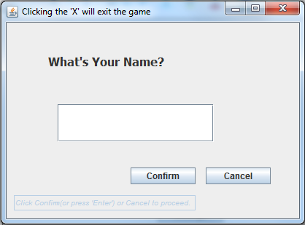

Figure 4 Asking for the name

**How to view the scoreboard:**

1. Locate and select the 2nd option “Records” in the main menu, which you are presented with after launching the program.
2. A scoreboard with 5 best scores and corresponding players’ names in ascending order will open.  
   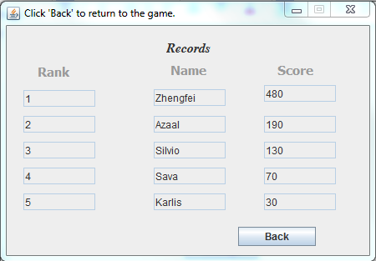

Figure 5 Scoreboard

1. Press “back” to return to the main menu.

**How to change the difficulty:**

1. Locate and select the 3rd option “Settings” in the main menu, which you are presented with after launching the program.  
   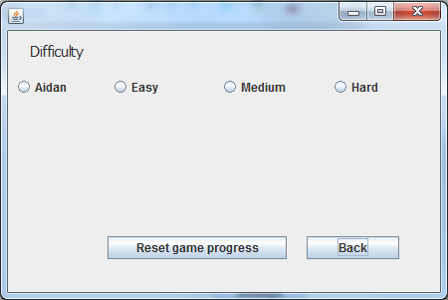

Figure 6 Settings panel

1. There are a few options, with each of them setting the velocity of the ball(s) to a particular value. Although we as developers tried to make the game as balanced as possible, it might take you a few tries to determine, which difficulty you are most comfortable with.
2. Press “Reset game progress” to reset game progress, i.e. delete all the scores.
3. Press “back” to return to the main menu.