ENGINEERINGCOLLEGE DEPARTMENT MANAGEMENT SYSTEM
PROJECT DOCUMENTATION
Software Engineering Domain
Django Web Application
Academic Year 2026-2027
This report is prepared according to the supplied DOCUMENT format, using 12 pt Times New Roman body text and chapter-wise organization.

TABLE OF CONTENTS

Chapter 1: Introduction
Chapter 2: System Analysis
Chapter 3: Design Representation
Chapter 4: Implementation
Chapter 5: Testing
Chapter 6: Results
Chapter 7: Conclusion
Chapter 8: Future Enhancements
Chapter 9: Bibliography

Chapter-I
INTRODUCTION

1.1 OBJECTIVE
The objective of the EngineeringCollege Department Management System is to provide a centralized web platform for maintaining department academic records, faculty profiles, student profiles, certificates, generated PDFs, syllabus information, exam-branch utilities, and gallery resources. The system is designed as a Django-based information system that reduces manual paperwork and improves the availability, consistency, and retrievability of department data.
The system supports separate administrative, faculty, and student workflows. It stores structured academic data in relational database models, maintains uploaded department documents, and generates profile PDFs that can be previewed, downloaded, merged with supporting documents, and protected with passwords where required.

1.2 PROBLEM STATEMENT
Engineering departments commonly maintain faculty records, student details, certificates, research data, FDP records, project titles, and academic documents in separate files or spreadsheets. This separation creates duplication, inconsistent updates, slow retrieval, and difficulty in preparing reports for audits, academic review, and student/faculty verification. A web-based system is required to manage these records through a consistent interface and produce useful outputs such as searchable lists, profile PDFs, certificate bundles, and academic dashboards.

1.3 EXISTING SYSTEM
In the existing manual or semi-manual approach, faculty and student details are recorded in paper forms, local spreadsheets, and independent folders. Certificates and photos are often stored separately from the main record. Preparing a complete profile report requires manually locating files, validating the latest version, and arranging them into a document.

1.3.1 DRAWBACKS
Repeated data entry across forms and spreadsheets.
No single source of truth for student and faculty records.
Time-consuming generation of profile reports and certificate bundles.
Difficult retrieval of records during inspections or academic reviews.
Inconsistent naming and storage of uploaded documents.
Limited audit visibility for profile updates and PDF generation activity.

1.4 PROPOSED SYSTEM
The proposed system is a Django web application that centralizes department information and exposes role-specific workflows through admin, faculty, and student dashboards. Data is represented through Django models such as Faculty, Student, Certificate, ResearchPublication, StudentResearchPublication, FDP, BTechProject, Subject, FacultyProfile, and FacultyLog. The application uses forms and templates for data entry, PostgreSQL-compatible database storage, and PDF libraries for report generation.
The project also includes a structured Software Engineering submission folder containing documentation, UML diagrams, test cases, database notes, PPT assets, and video material, making the project suitable for academic evaluation and future maintenance.

1.4.1 ADVANTAGES
Centralized department data management.
Role-aware access for admin, faculty, and student users.
Automatic profile PDF generation and document merge support.
Searchable and exportable faculty/student information.
Structured academic pages for syllabus, gallery, and exam-branch work.
Organized project folder with documentation, database notes, UML diagrams, test cases, PPT, and video script.

Chapter-II
SYSTEM ANALYSIS

2.1 LITERATURE SURVEY
Department management systems are a practical application of database-backed web engineering. Modern academic institutions need software that combines structured records, document storage, reporting, and role-based interfaces. Web frameworks such as Django are suitable for this requirement because they provide an object-relational mapper, form handling, authentication support, template rendering, middleware, and deployment-friendly configuration.
The reviewed approach in this project follows the Model-View-Template pattern. Models define durable entities such as Faculty and Student. Views implement workflows such as login, add/edit profile, PDF generation, syllabus access, gallery display, and exam-branch pages. Templates present pages for dashboards, profile forms, galleries, syllabus pages, and PDF layouts. This separation supports maintainability and makes the system easier to test.
Reference Area | Observation | Use in Proposed System
Django MVT Architecture | Separates data, business logic, and presentation. | Used through models.py, views.py, forms.py, templates, and urls.py.
Relational Database Design | Structured tables enforce consistency and relationships. | Used for faculty, student, certificate, research, FDP, subject, and log records.
PDF Reporting | Academic reports often require printable profile documents. | ReportLab, pypdf, PyMuPDF, and template-based generation support PDF outputs.
Role-Based Workflows | Academic systems need different operations for admin, faculty, and students. | Separate dashboard routes and session checks guide users to the correct workflow.
Table 2.1: Literature Survey Summary

2.2 REQUIREMENTS SPECIFICATION
The following hardware and software requirements are used to implement and run the proposed system.

2.2.1 HARDWARE REQUIREMENTS
Hardware | Requirement
Processor | Intel Core i5 or above
RAM | 8 GB minimum
Hard Disk | 1 TB recommended, with sufficient media storage
Client Device | Desktop, laptop, or Android WebView client
Table 2.2: Hardware Requirements

2.2.2 SOFTWARE REQUIREMENTS
Software | Requirement
Operating System | Windows 10/11 or Linux server environment
Backend | Python 3.10+, Django
Frontend | HTML5, CSS3, JavaScript, responsive Django templates
Database | PostgreSQL for deployment; SQLite may be used for isolated local development/testing
PDF Tools | ReportLab, pypdf, PyMuPDF, Pillow, optional pdfkit/wkhtmltopdf
Deployment | Render-compatible Django deployment with WhiteNoise static serving
Design Tools | PlantUML, StarUML-compatible UML notation, Microsoft Word
Table 2.3: Software Requirements

2.3 MODULE ANALYSIS
Module | Description
Authentication and Session Management | Admin login, student login, Google login option, logout, and role-aware redirection.
Admin Dashboard | Central dashboard for maintaining department records, viewing summary data, and navigating faculty/student operations.
Faculty Management | Faculty profile registration, editing, academic qualifications, professional data, research publications, FDP/workshop records, subject handling, and profile PDF generation.
Student Management | Student profile registration, academic details, certificates, research publication proof, student dashboard access, and generated student profile PDFs.
Certificate and PDF Management | Profile PDF creation, PDF preview/download, certificate attachment, and document merge support for faculty and student records.
Exam Branch and Syllabus | Academic utility pages for syllabus access, lesson-plan downloads, attendance/report views, and exam-branch operations.
Gallery | Department gallery pages for academic and event-related media presentation.
Project Domain Documentation | Software Engineering project folder containing report, UML diagrams, test cases, database notes, PPT assets, and video material.
Table 2.4: Module Description

2.4 FEASIBILITY STUDY
Technical feasibility is strong because the project uses mature technologies: Django, Python PDF libraries, relational database models, and standard HTML/CSS/JavaScript templates. Operational feasibility is also strong because the workflows map directly to department activities such as registering students, updating faculty profiles, uploading certificates, viewing syllabus pages, maintaining gallery resources, and generating profile reports. Economic feasibility is practical because open-source tools form the core stack.

Chapter-III
DESIGN REPRESENTATION

3.1 UML DESCRIPTION
The system design is represented using UML diagrams grouped by admin, student, and faculty modules. These diagrams cover class structure, entity relationships, use cases, sequence flows, activity flows, collaboration, state transitions, and deployment. The diagrams are maintained in the project folder as PlantUML source files and generated PNG images.
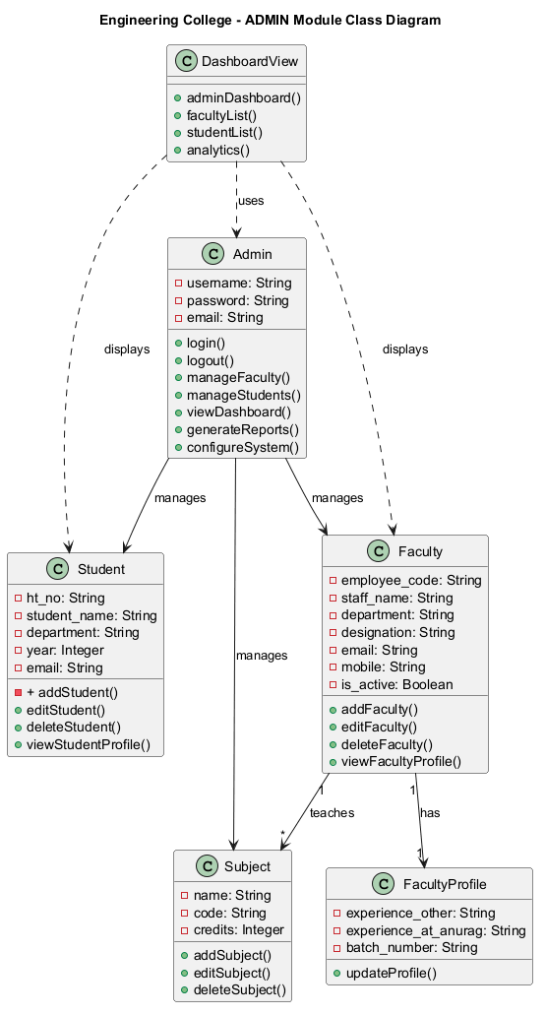
Figure 3.1: Admin Class Diagram

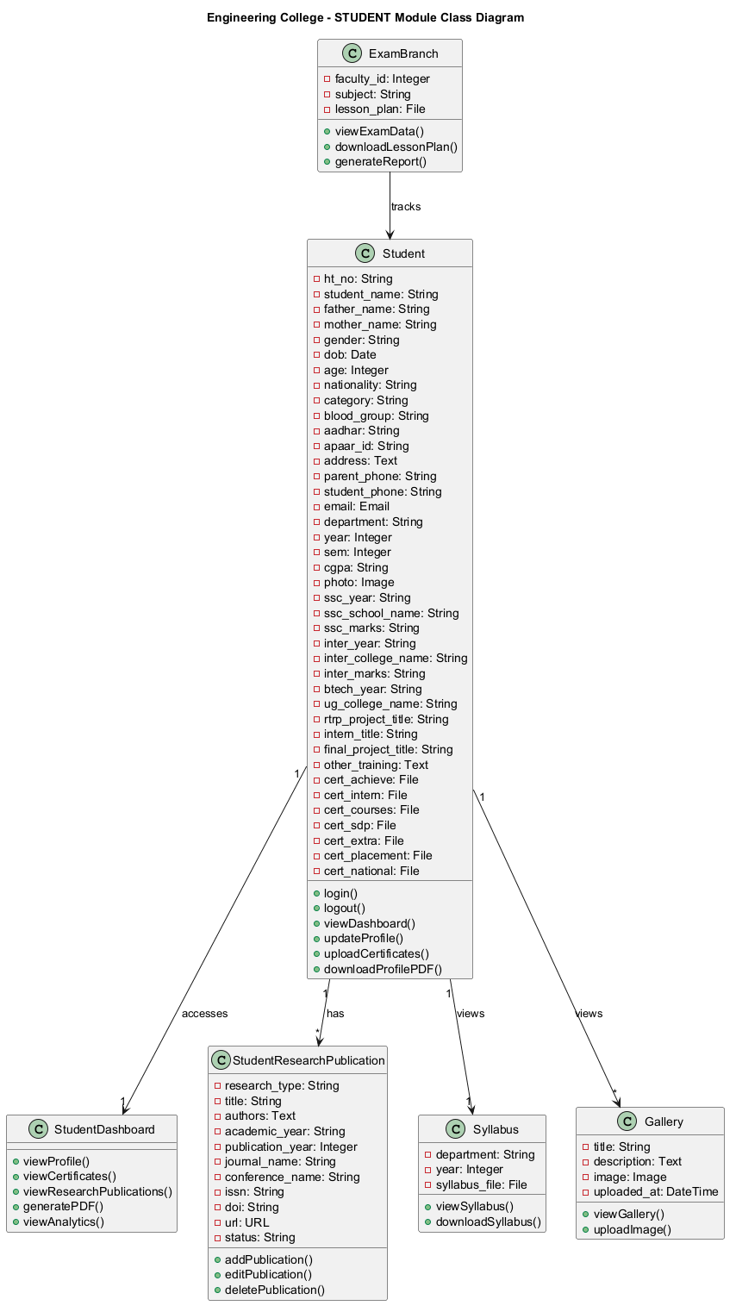
Figure 3.2: Student Class Diagram

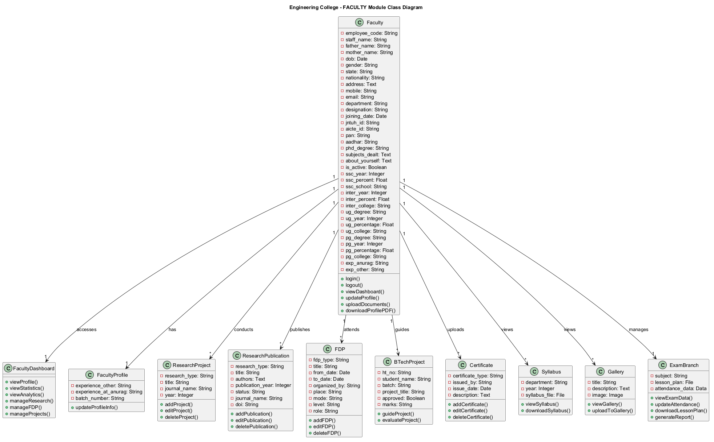
Figure 3.3: Faculty Class Diagram

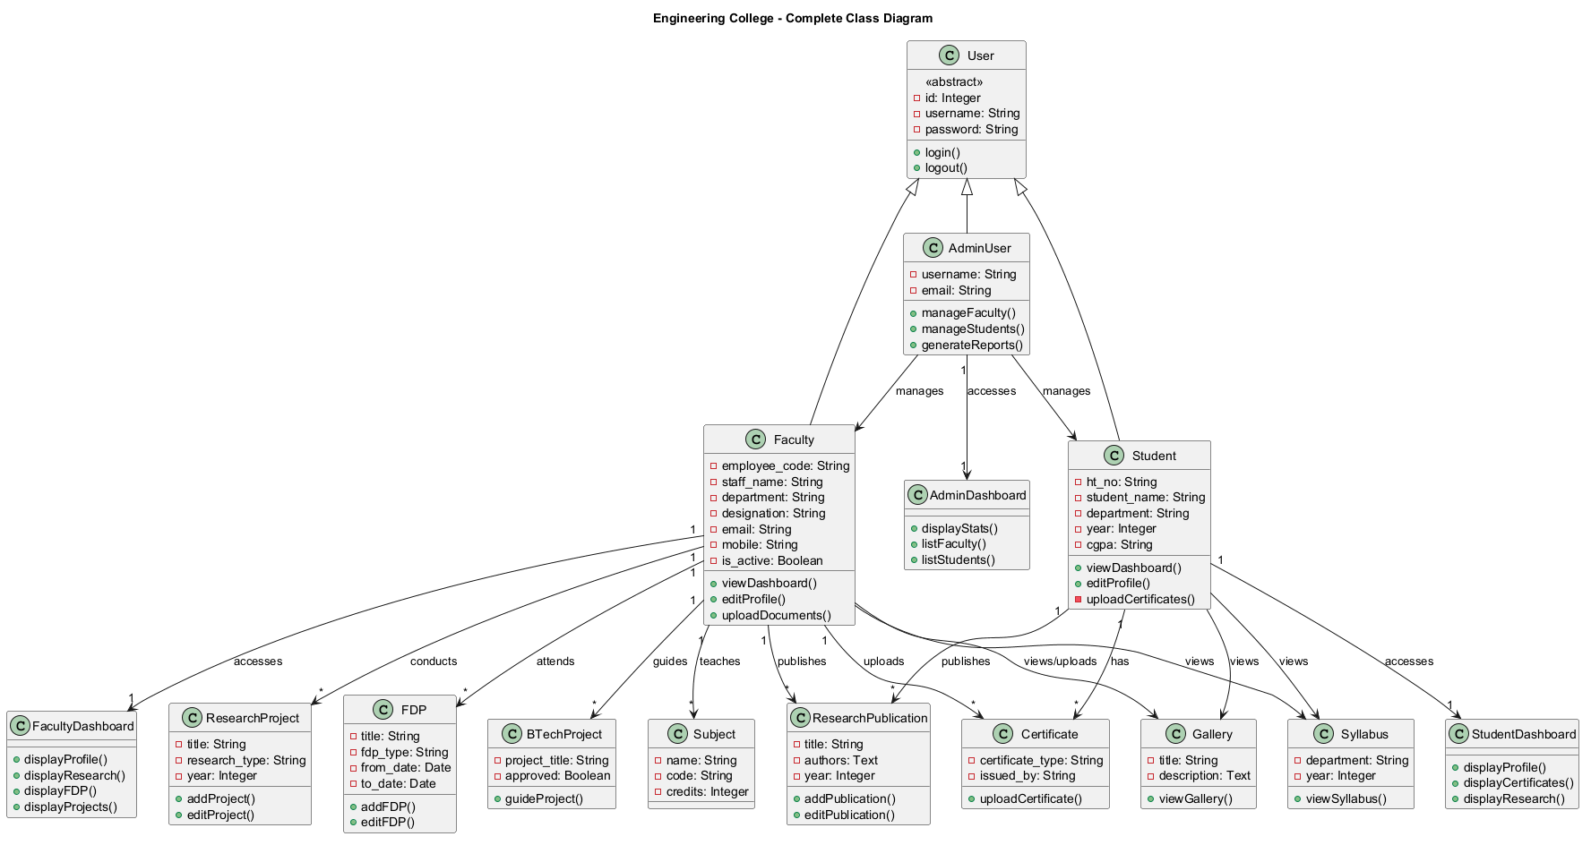
Figure 3.4: Complete Class Diagram

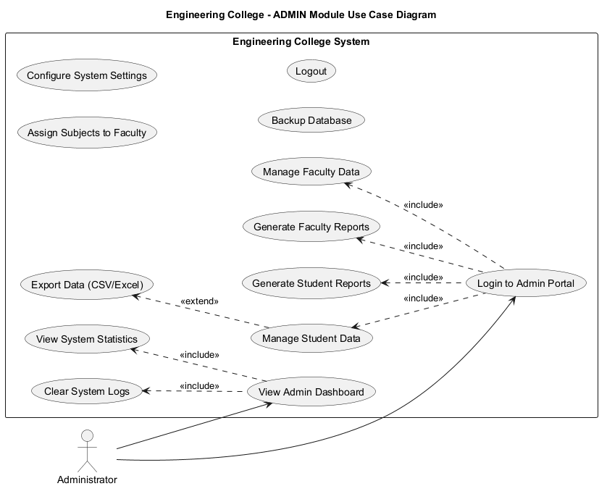
Figure 3.5: Admin Use Case Diagram

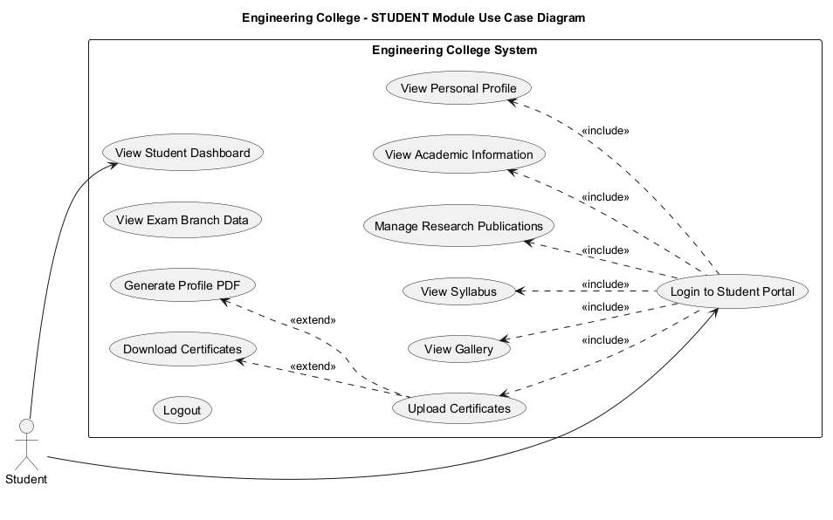
Figure 3.6: Student Use Case Diagram

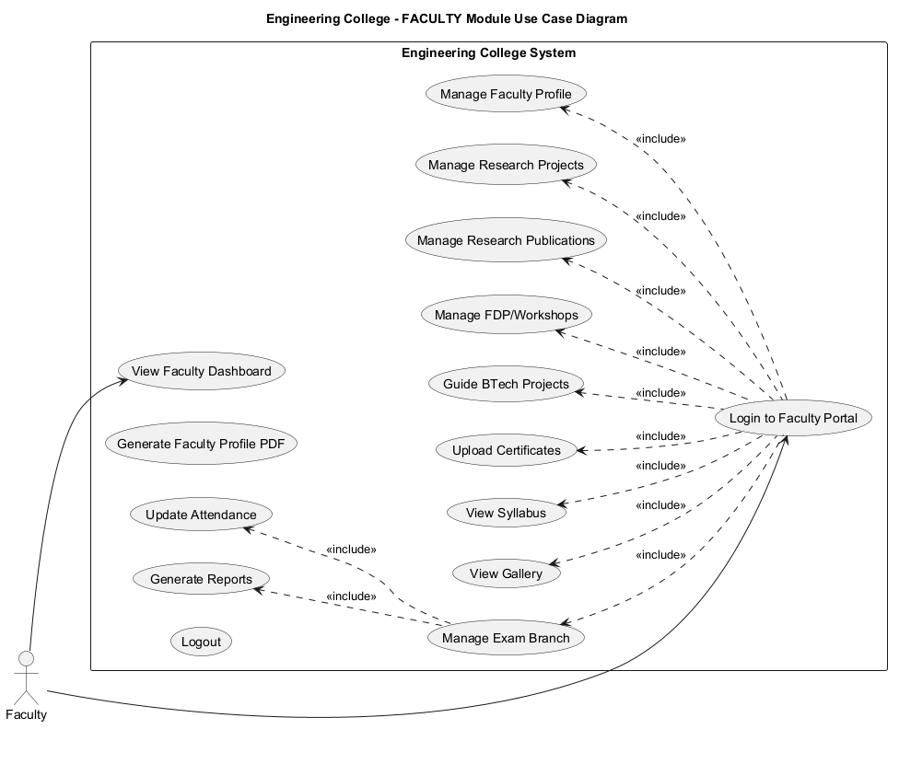
Figure 3.7: Faculty Use Case Diagram

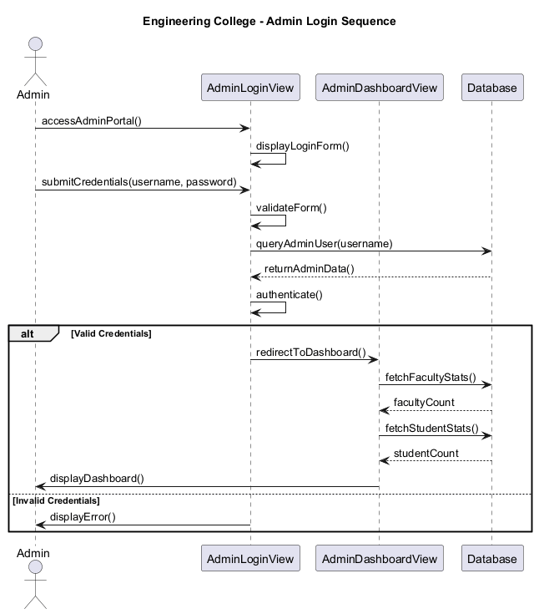
Figure 3.8: Admin Login Sequence Diagram

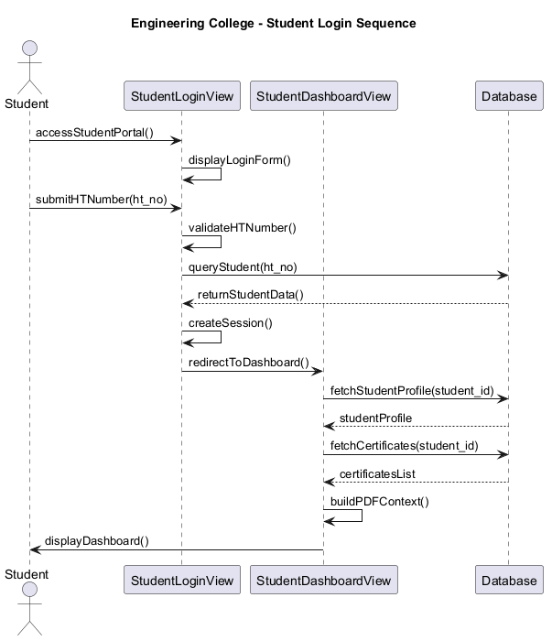
Figure 3.9: Student Login Sequence Diagram

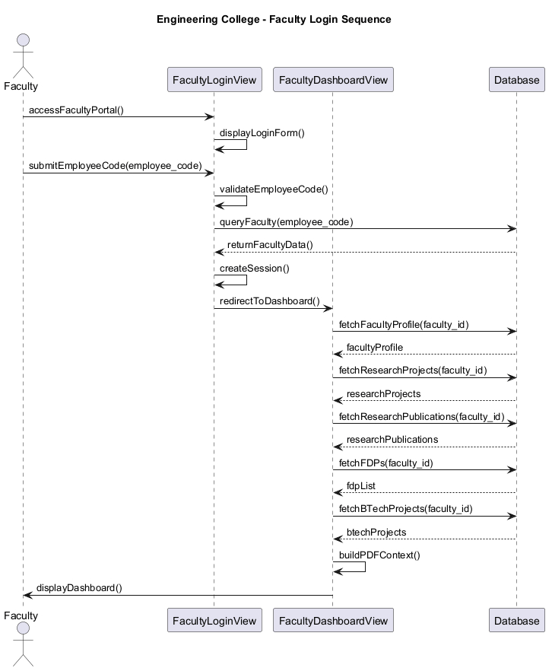
Figure 3.10: Faculty Login Sequence Diagram

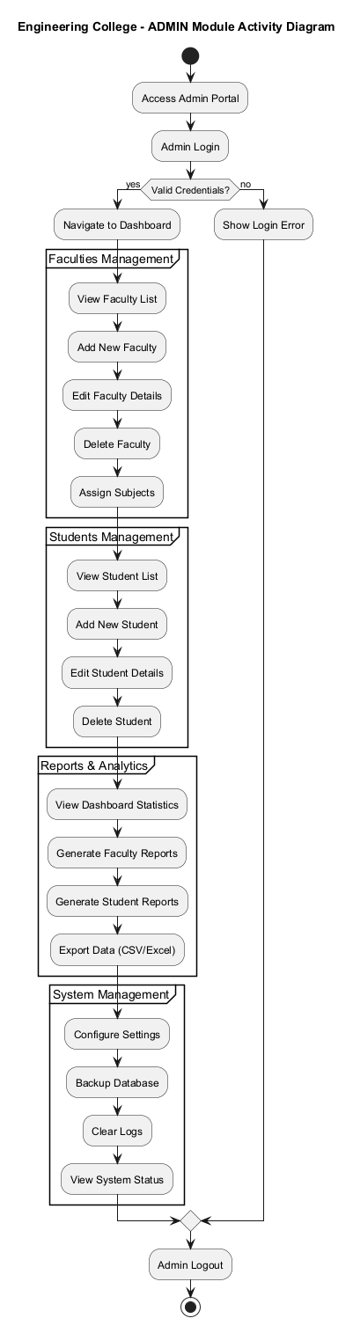
Figure 3.11: Admin Activity Diagram

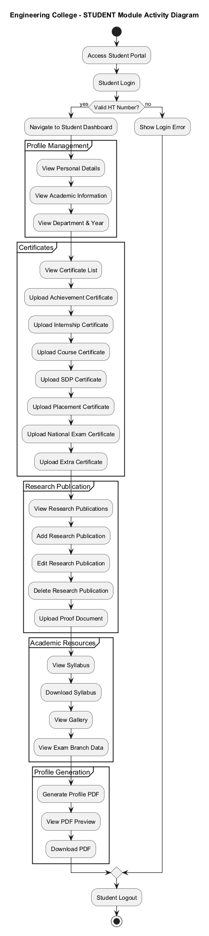
Figure 3.12: Student Activity Diagram

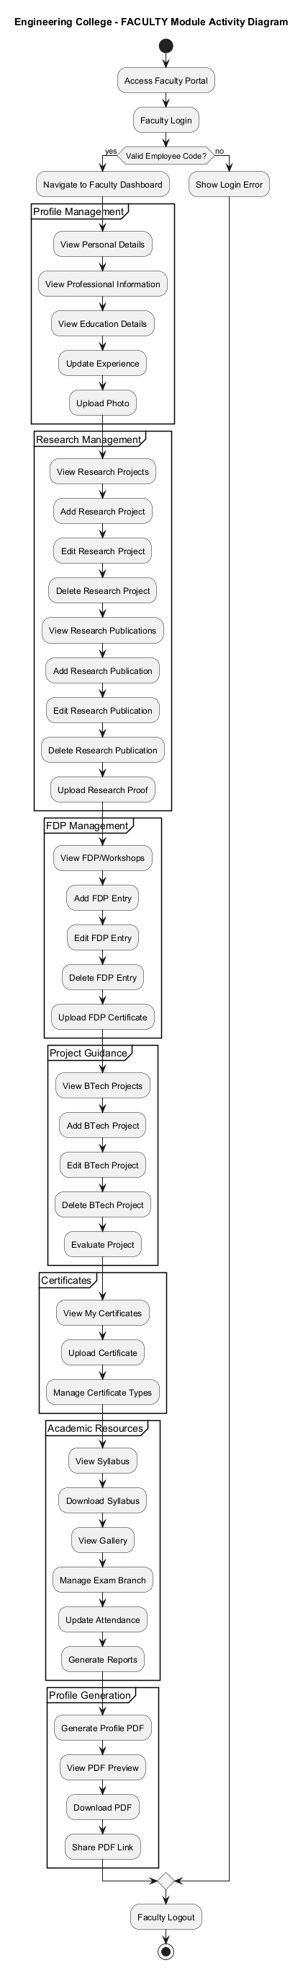
Figure 3.13: Faculty Activity Diagram

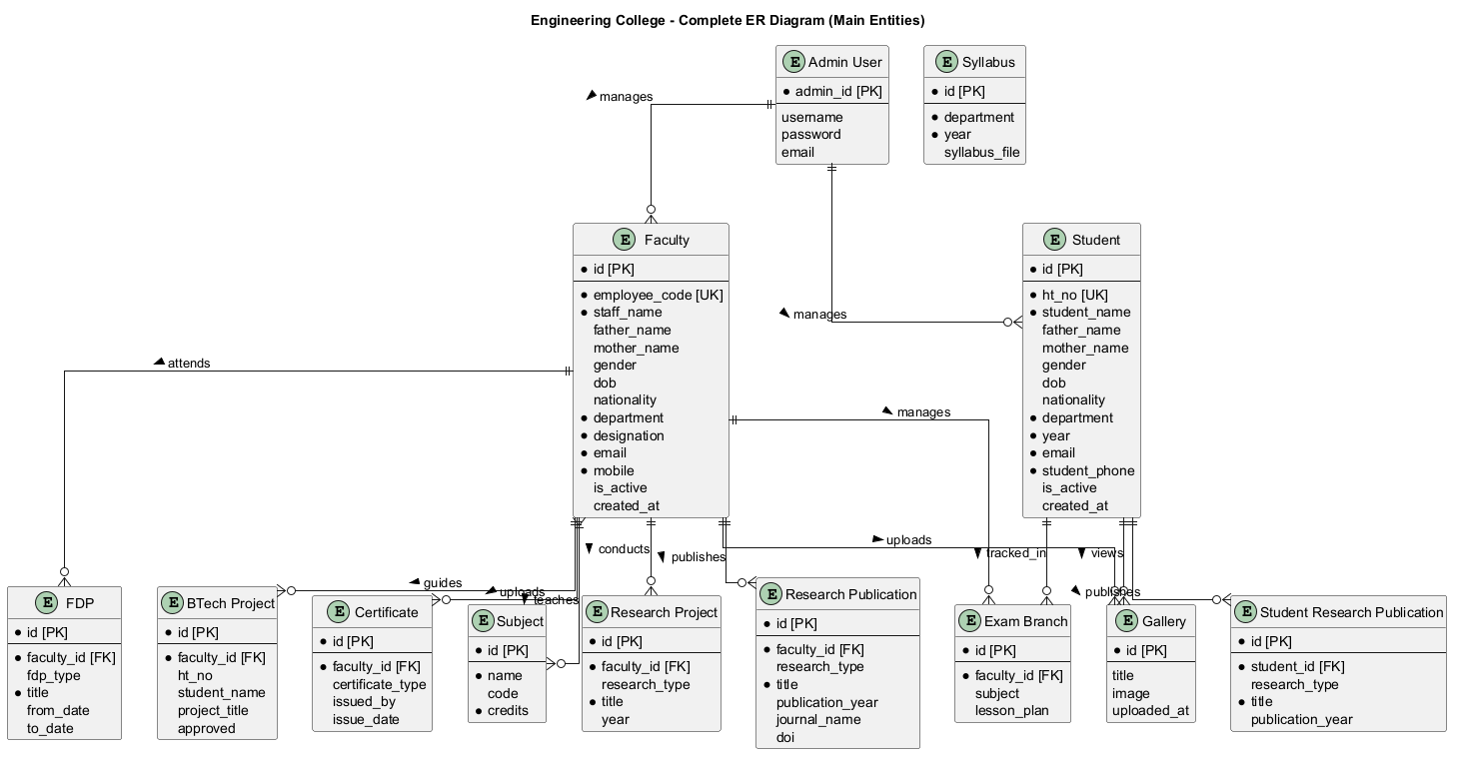
Figure 3.14: Complete ER Diagram

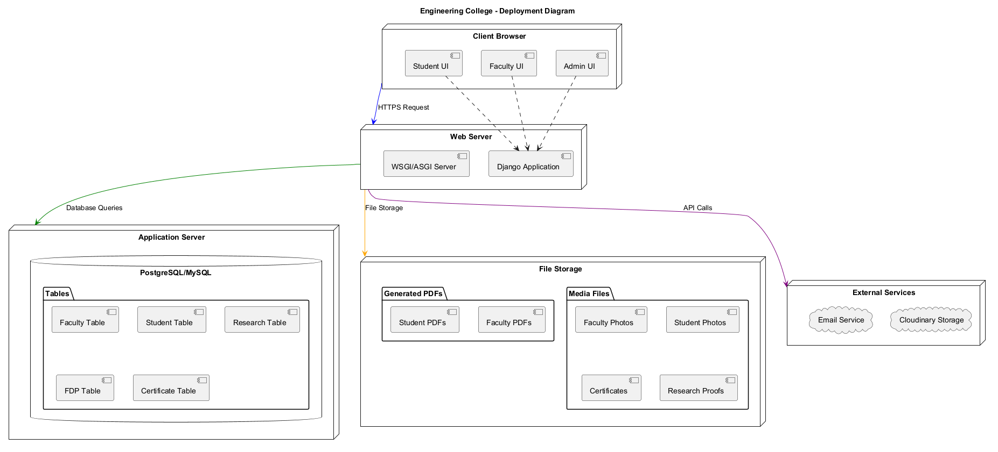
Figure 3.15: Deployment Diagram

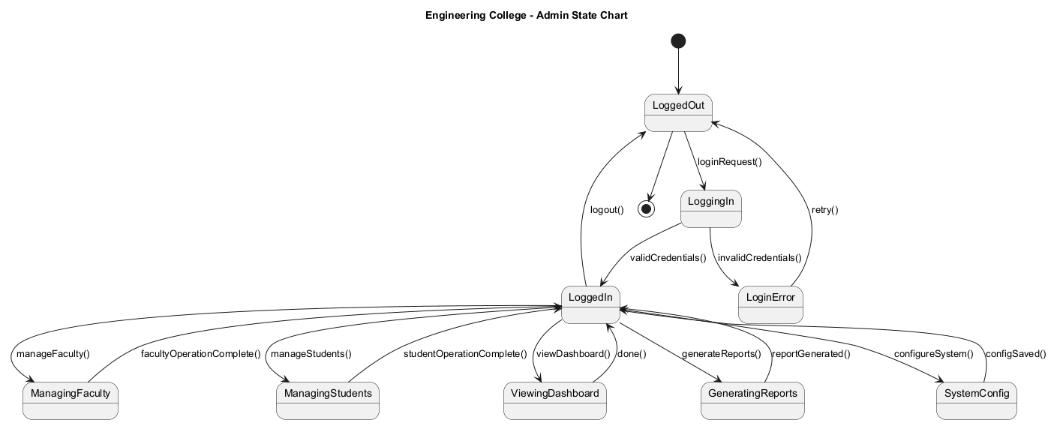
Figure 3.16: Admin State Chart

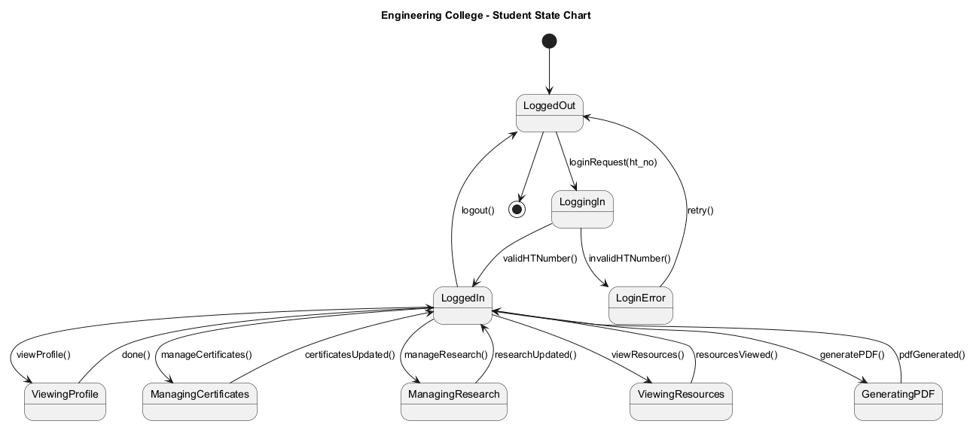
Figure 3.17: Student State Chart

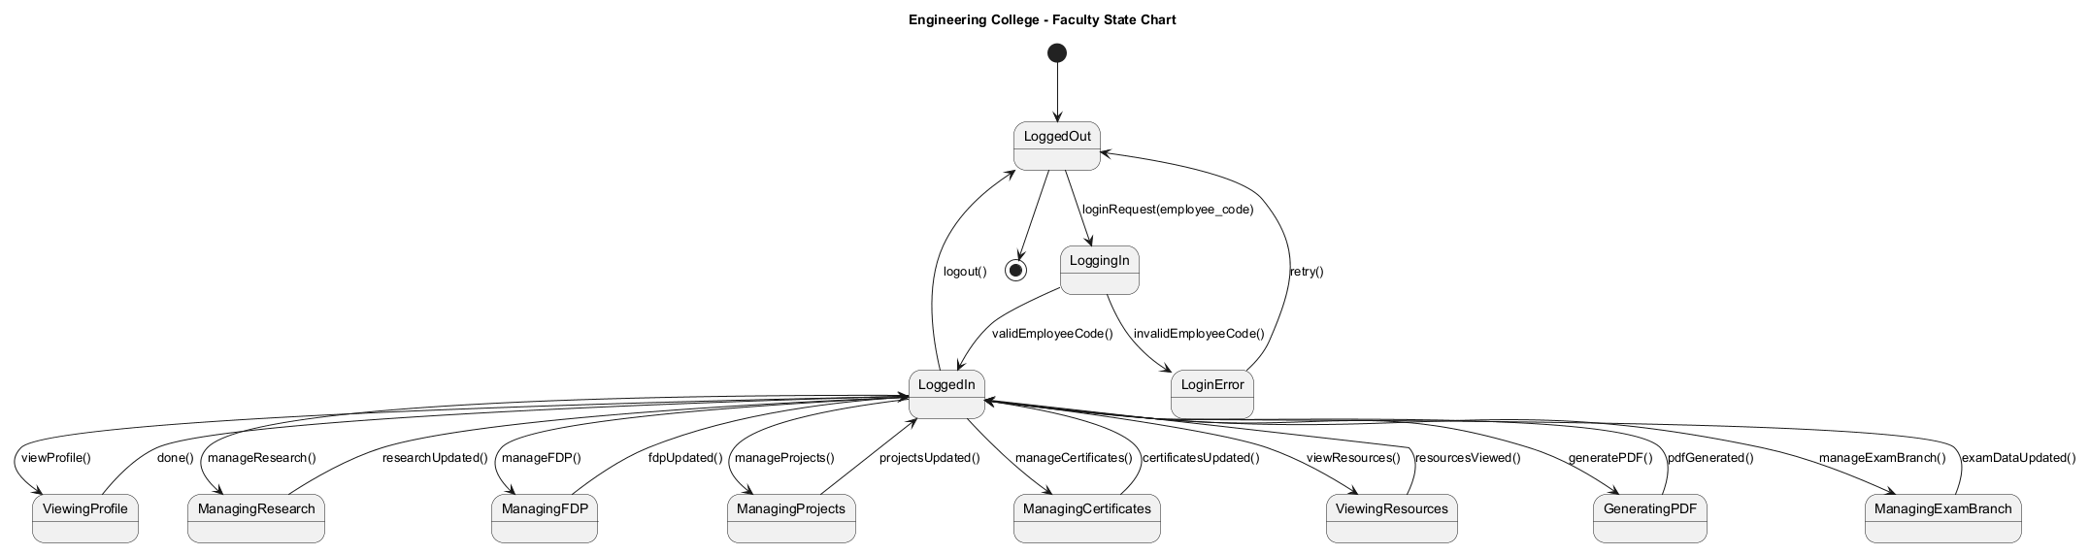
Figure 3.18: Faculty State Chart

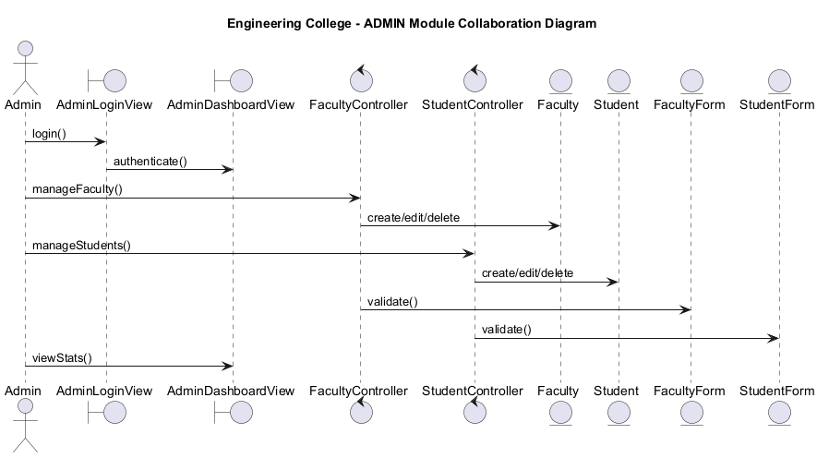
Figure 3.19: Admin Collaboration Diagram

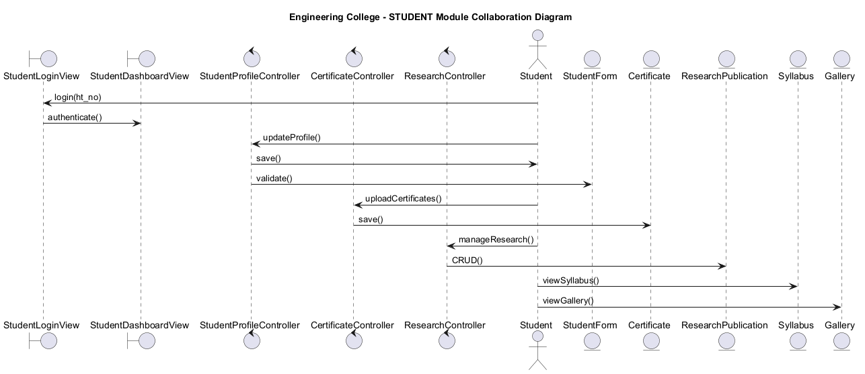
Figure 3.20: Student Collaboration Diagram

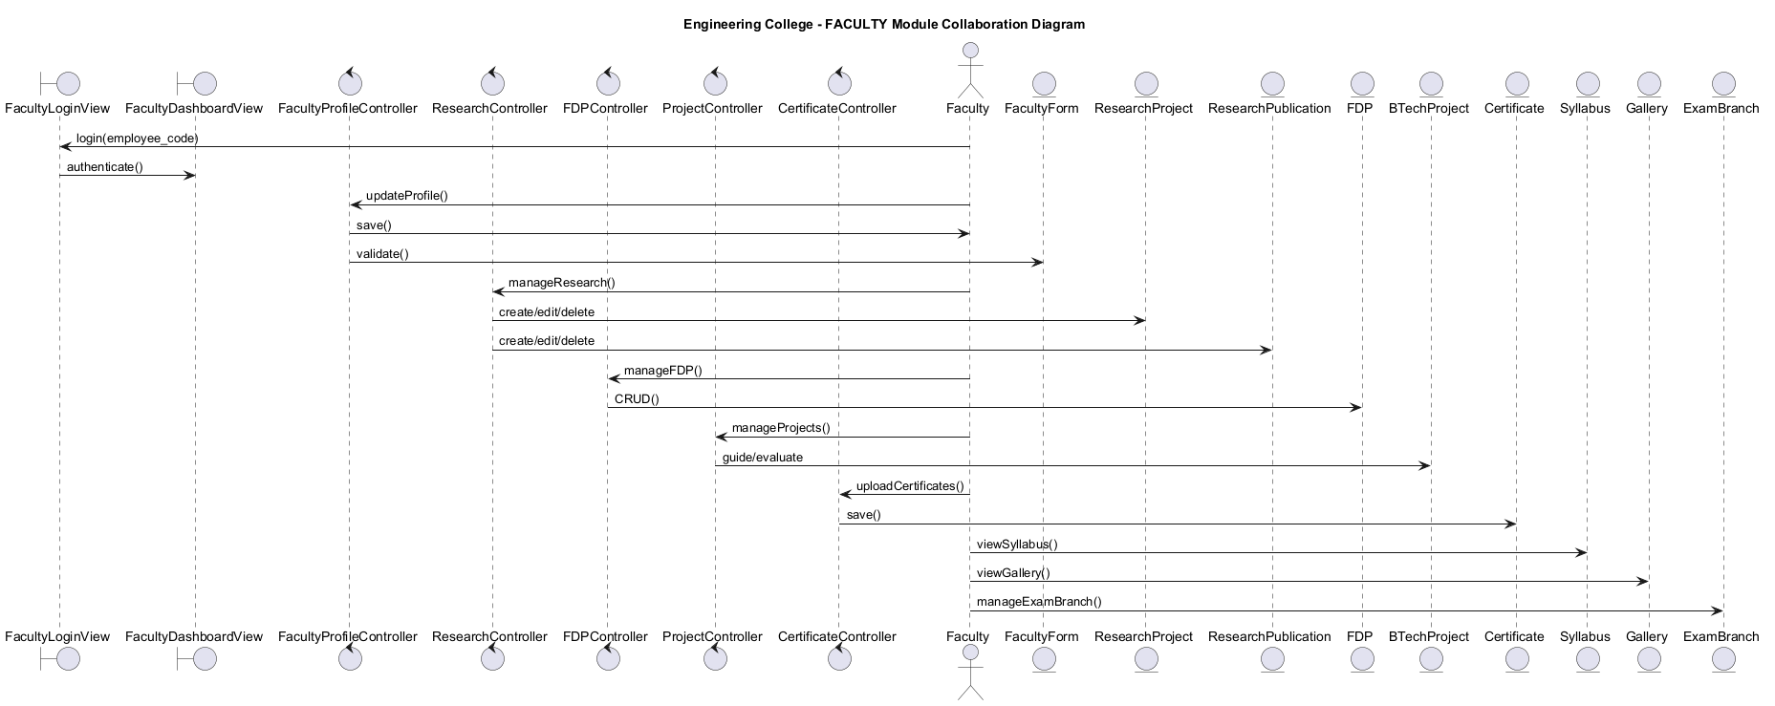
Figure 3.21: Faculty Collaboration Diagram

Chapter-IV
IMPLEMENTATION

4.1 TECHNOLOGIES

4.1.1 HTML
HTML templates are used to render login pages, dashboards, faculty pages, student pages, gallery, syllabus screens, and PDF layouts. Django template inheritance supports reusable base layouts and consistent page structure.

4.1.2 CSS
CSS files under the static and dashboard static folders style student and faculty experiences. The UI uses responsive layouts, dashboard panels, form styling, and printable PDF page styling.

4.1.3 JAVA SCRIPT
JavaScript is used for dynamic interactions such as form helpers, dashboard behavior, and client-side user interface updates.

4.1.4 PYTHON AND DJANGO
Python implements the server-side application logic. Django provides URL routing, model definitions, form validation, session handling, template rendering, middleware, authentication, and database migrations.

4.1.5 DATABASE AND FILE HANDLING
The system stores structured records through Django models and database migrations. Uploaded photos, certificates, and generated PDFs are connected to the corresponding faculty or student record through file fields and URL fields.

4.2 SAMPLE CODE
# dashboard/models.py - simplified model examples
class Faculty(models.Model):
staff_name = models.CharField(max_length=255)
employee_code = models.CharField(max_length=50, unique=True)
department = models.CharField(max_length=100, blank=True, null=True)
designation = models.CharField(max_length=100, blank=True, null=True)
photo = models.ImageField(upload_to='faculty_photos/', blank=True, null=True)
pdf_document = models.FileField(upload_to='faculty_pdfs/', blank=True, null=True)
class Student(models.Model):
ht_no = models.CharField(max_length=50, unique=True)
student_name = models.CharField(max_length=255)
department = models.CharField(max_length=100, blank=True, null=True)
photo = models.ImageField(upload_to='student_photos/', blank=True, null=True)
pdf_generated = models.BooleanField(default=False)
# engineeringcollege/urls.py - project routing
urlpatterns = [
path('health/', health_check, name='health_check'),
path('admin/', admin.site.urls),
path('', include('dashboard.urls')),
]
# dashboard/urls.py - examples of department routes
path('faculty/add/', views.add_faculty, name='add_faculty')
path('student/<int:student_id>/', views.student_detail, name='student_detail')
path('student/pdf/<int:student_id>/', views.generate_student_pdf_view, name='generate_student_pdf')
path('syllabus/', views.syllabus_view, name='syllabus')
path('gallery/', views.gallery, name='gallery')

4.3 DATABASE DESIGN
Major database tables are generated from Django models. Important entities include Faculty, Student, Certificate, FacultyLog, ResearchPublication, StudentResearchPublication, FDP, BTechProject, Subject, and FacultyProfile. Relationships include one-to-one faculty profiles, faculty-to-certificate, faculty-to-research, faculty-to-FDP, student-to-publication, and many-to-many faculty-subject assignment.
Entity | Purpose
Faculty | Stores personal, professional, educational, document, research, and PDF information for faculty members.
Student | Stores hall ticket number, personal details, academic details, certificate slots, research proofs, and generated PDF references.
Certificate | Stores faculty certificate records and uploaded certificate files.
ResearchPublication | Stores faculty research output with publication metadata and proof document.
StudentResearchPublication | Stores student research output and proof document details.
FDP | Stores faculty development program, workshop, seminar, conference, and training records.
BTechProject | Stores student project guidance data connected with faculty records.
FacultyLog | Stores action history for important faculty/student operations.
Table 4.1: Database Entity Summary

Chapter-V
TESTING

5.1 TEST LEVELS
Testing is performed at multiple levels to verify the correctness of individual functions, interaction between modules, form validation, URL routing, PDF creation, and system readiness.

5.1.1 UNIT TESTING
Unit testing verifies isolated logic such as PDF asset resolution, URL generation, form cleaning, and model behavior.

5.1.2 INTEGRATION TESTING
Integration testing verifies that views, templates, models, sessions, and files work together as expected.

5.1.3 VALIDATION TESTING
Validation testing ensures that forms accept valid faculty/student data and reject oversized or invalid input where model limits require it.

5.1.4 SYSTEM TESTING
System testing validates end-to-end workflows such as login, dashboard access, student creation, faculty creation, PDF generation, gallery access, and syllabus access.

5.2 TEST CASES
Test Case Name | Inputs | Expected Output | Actual Output | Result
TC-01 Django System Check | Run manage.py check | No system check issues | No system check issues | Pass
TC-02 Database Migration | Run manage.py migrate | All migrations apply | Migrations complete | Pass
TC-03 Server Start | Run manage.py runserver | Server starts on localhost | Server starts at local URL | Pass
TC-04 Dashboard Page | Open root URL | Dashboard or login page loads | Page loads with Engineering College content | Pass
TC-05 Student Add | Submit student form | Student saved and redirected to list | Student directory shows submitted student | Pass
TC-06 Faculty PDF | Generate faculty PDF | PDF response and saved document | Application returns PDF content | Pass
TC-07 Student PDF | Generate student PDF | PDF response and generated status updated | Student PDF output is produced | Pass
TC-08 Gallery Page | Open gallery URL | Gallery content loads | Gallery page displays department media | Pass
TC-09 Syllabus Page | Open syllabus URL | Syllabus page loads | Syllabus screen is visible | Pass
Table 5.1: System Test Cases

Chapter-VI
RESULTS

The implementation produces dashboard pages, student and faculty management pages, generated PDFs, gallery output, syllabus output, and academic utility pages. The following screenshots show the visible results already stored with the project submission assets.
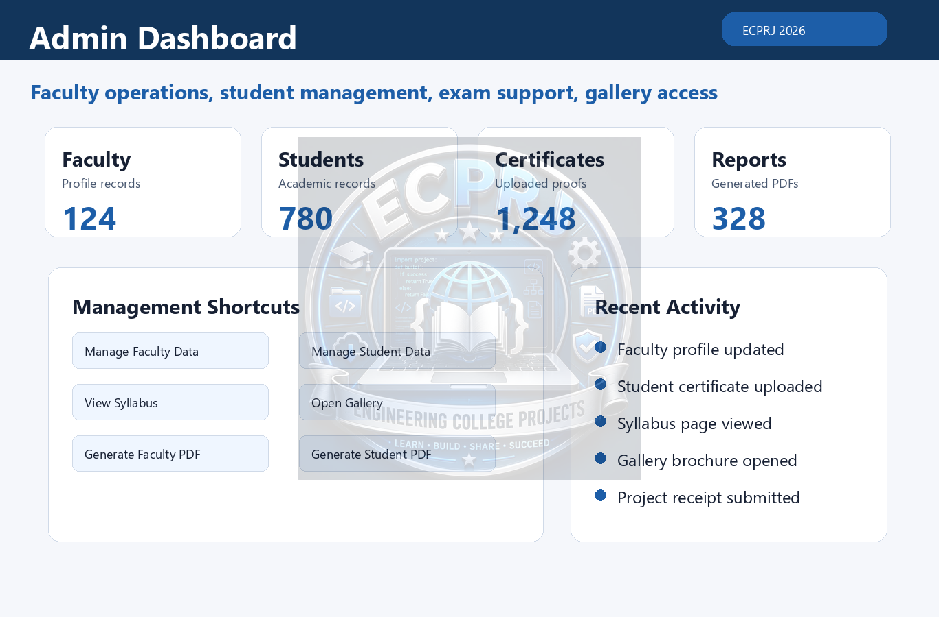
Figure 6.1: Admin Dashboard Result

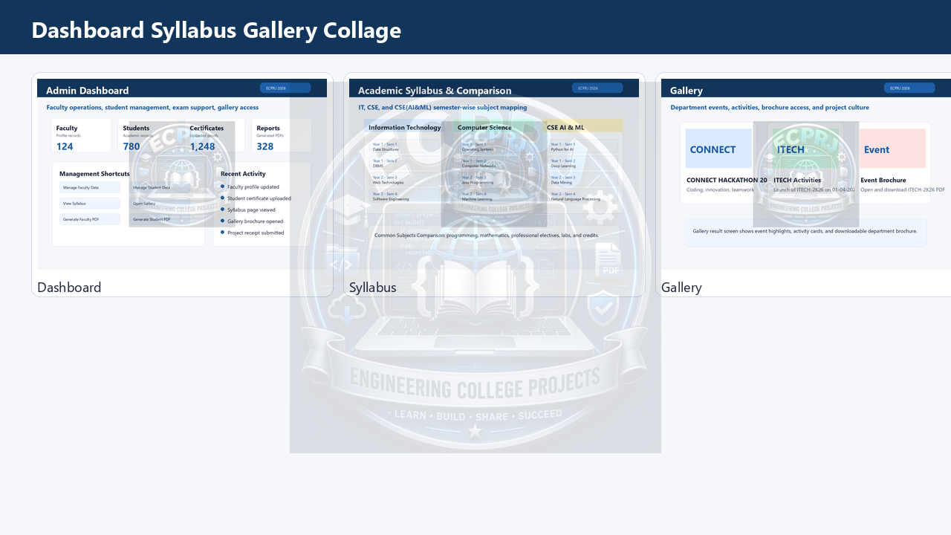
Figure 6.2: Dashboard, Syllabus, and Gallery Result

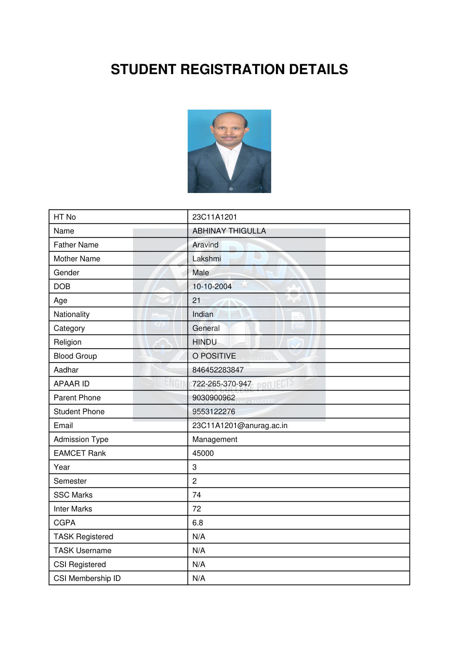
Figure 6.3: Student PDF First Page

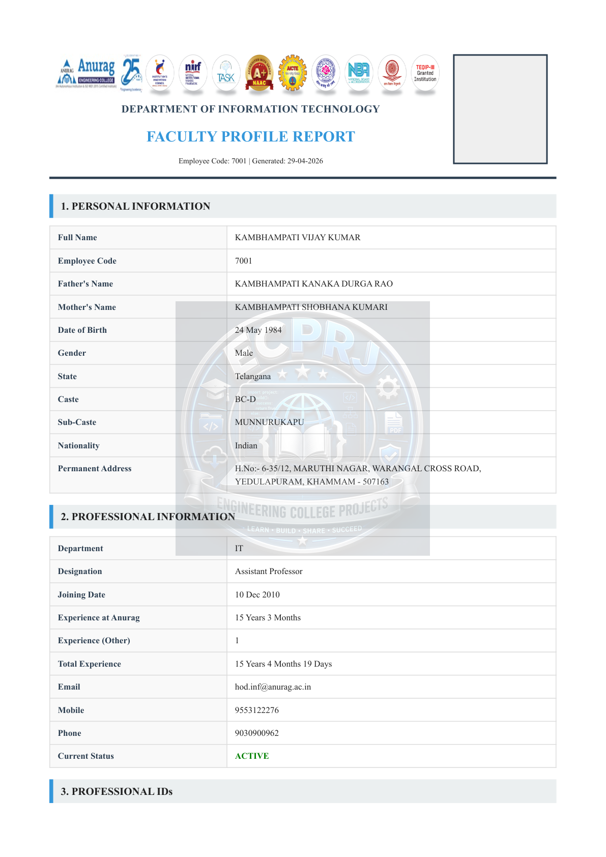
Figure 6.4: Faculty PDF First Page

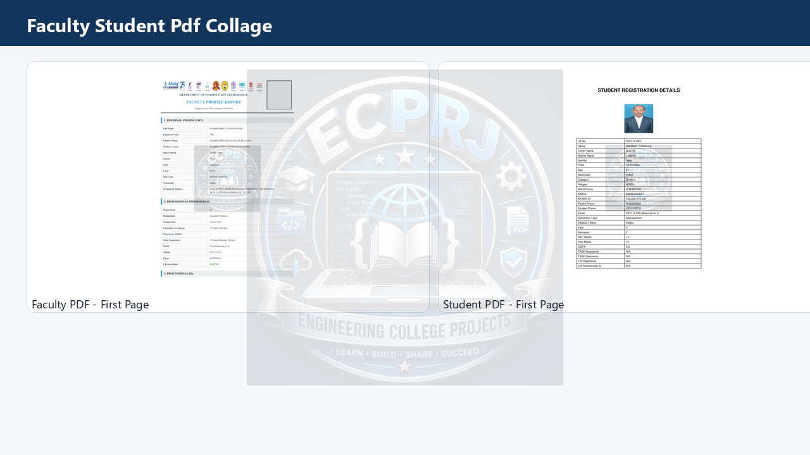
Figure 6.5: Faculty and Student PDF Output

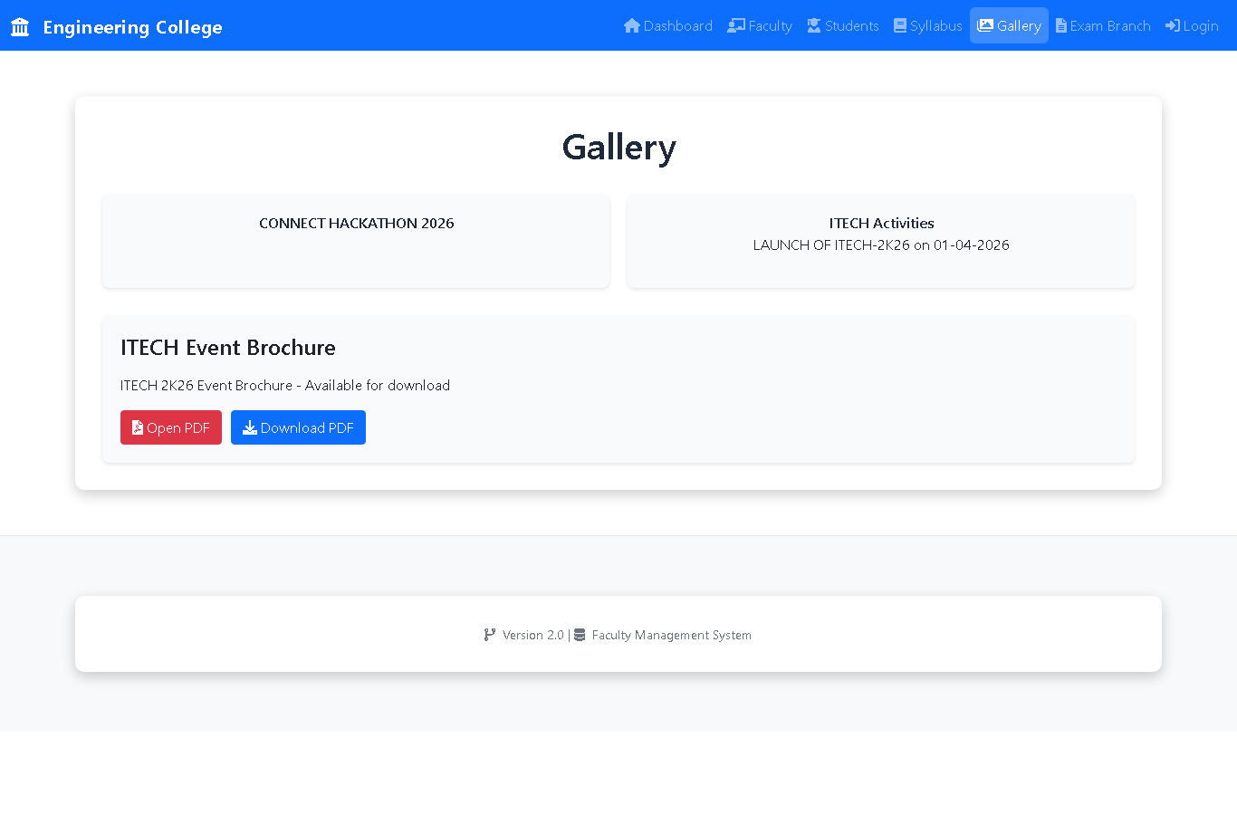
Figure 6.6: Gallery Screen

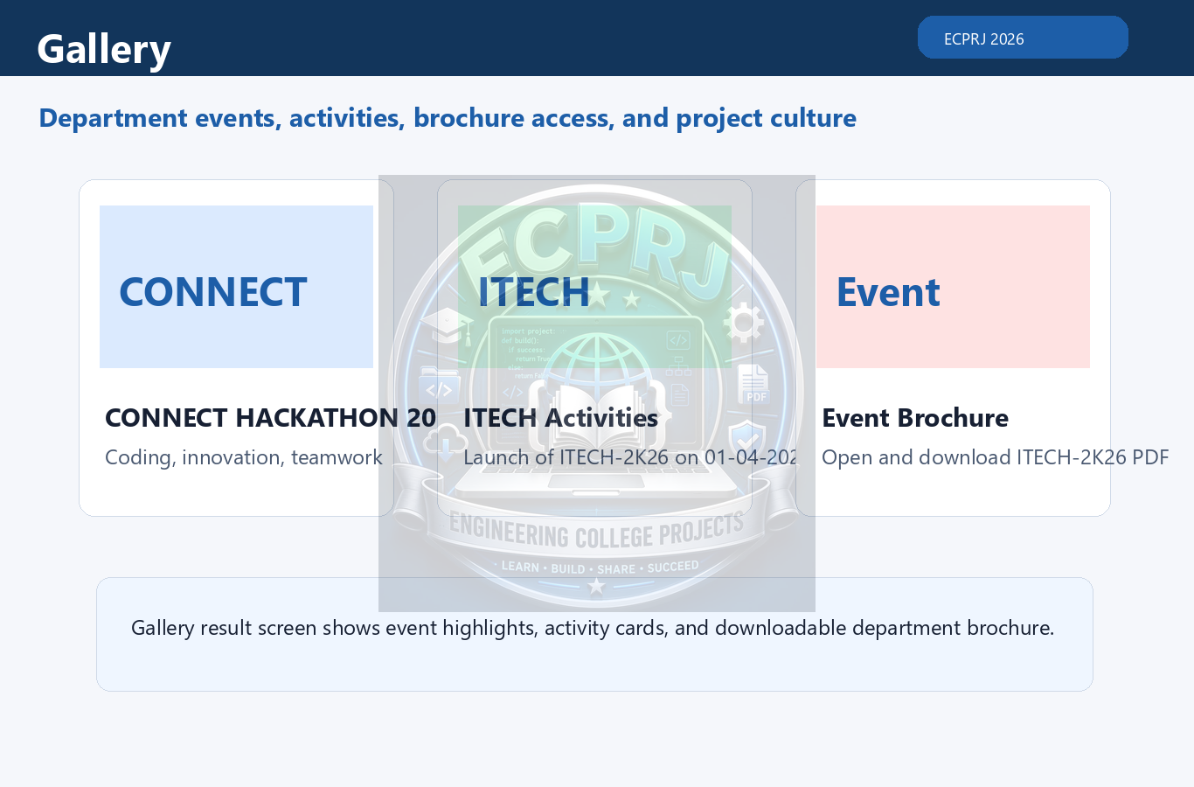
Figure 6.7: Gallery Result

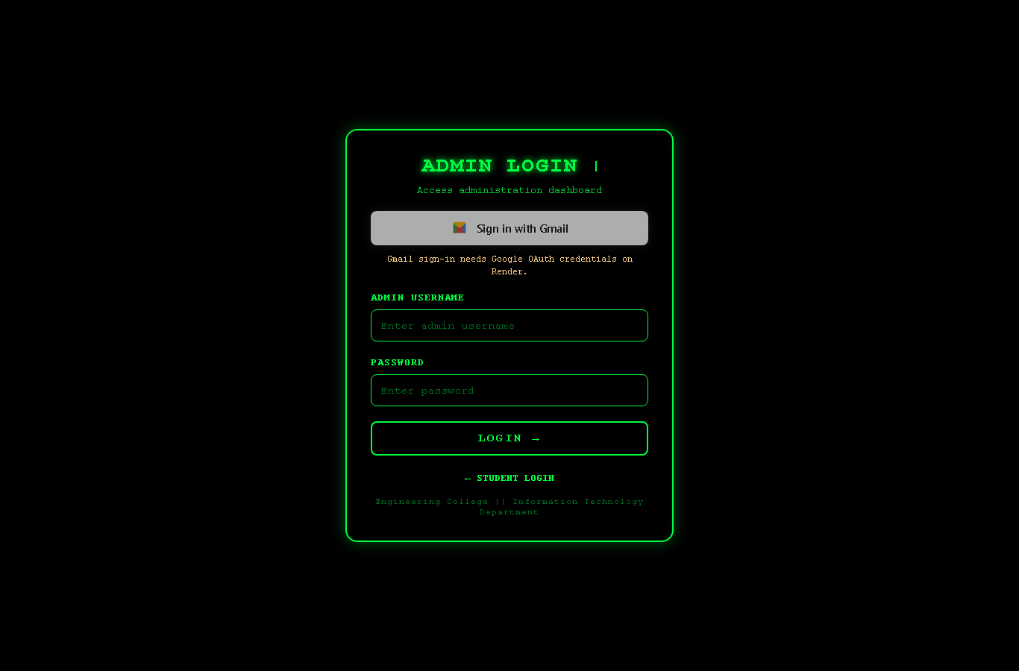
Figure 6.8: Syllabus Screen

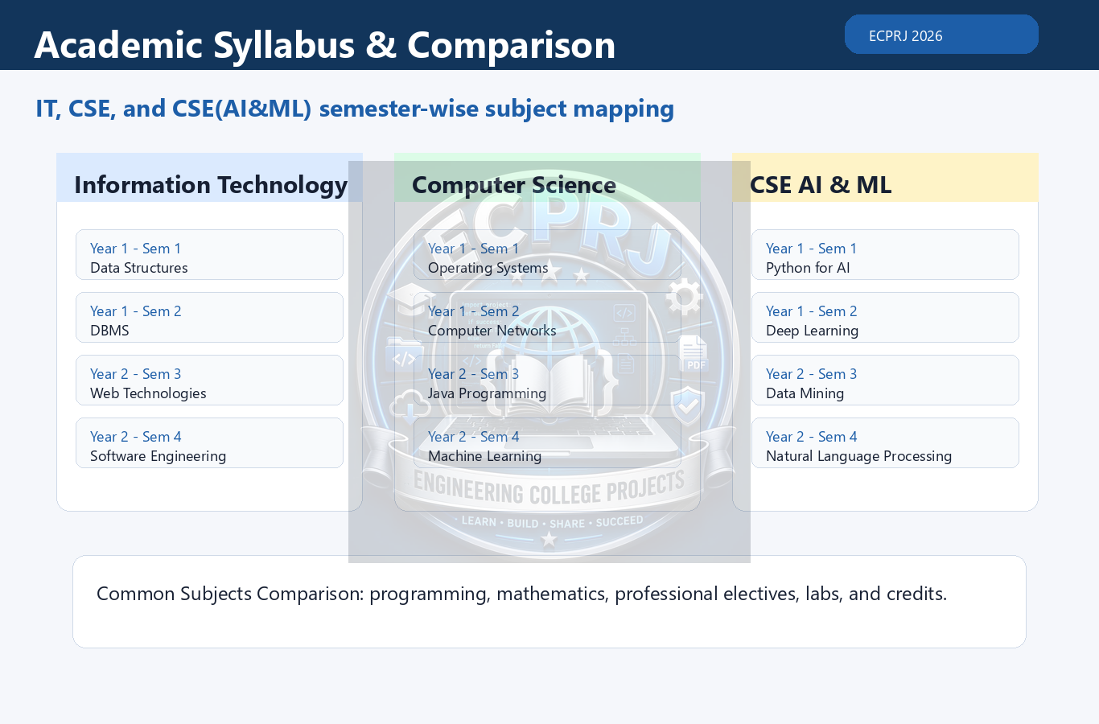
Figure 6.9: Syllabus Result

Chapter-VII
CONCLUSION

The EngineeringCollege Department Management System successfully demonstrates a software engineering solution for managing department academic information through a centralized Django application. It reduces manual record handling by combining faculty, student, certificate, research, PDF, syllabus, gallery, and exam-branch workflows in one system. The use of Django models, forms, templates, and migrations gives the project a maintainable structure, while relational database storage and PDF-generation tools make it suitable for real-world department usage. The project documentation, UML diagrams, test cases, database notes, PPT assets, and video material further support academic submission and future extension.

Chapter-VIII
FUTURE ENHANCEMENTS

Future enhancements can include finer role-based permissions, stronger API endpoints for the Android client, automated analytics dashboards, background jobs for large PDF generation, richer audit logs, improved search and filtering, expanded exam-branch automation, automatic backup scheduling, and a complete REST API for integration with mobile apps or institutional ERP systems. Notification services and advanced report builders can also be added without changing the core Django architecture.

BIBLIOGRAPHY

BOOKS
Django for Professionals - William S. Vincent - WelcomeToCode Publishing
Software Engineering - Ian Sommerville - Pearson Education
Database System Concepts - Silberschatz, Korth, and Sudarshan - McGraw Hill

WEBSITES
https://docs.djangoproject.com/
https://www.python.org/doc/
https://www.postgresql.org/docs/
https://docs.render.com/
https://plantuml.com/

