Main Site Redesign – PPD Maps

Functional Requirements

## PPD Search Results Page: “Browse by Risk Factor” / “Keyword Search” (NEW)

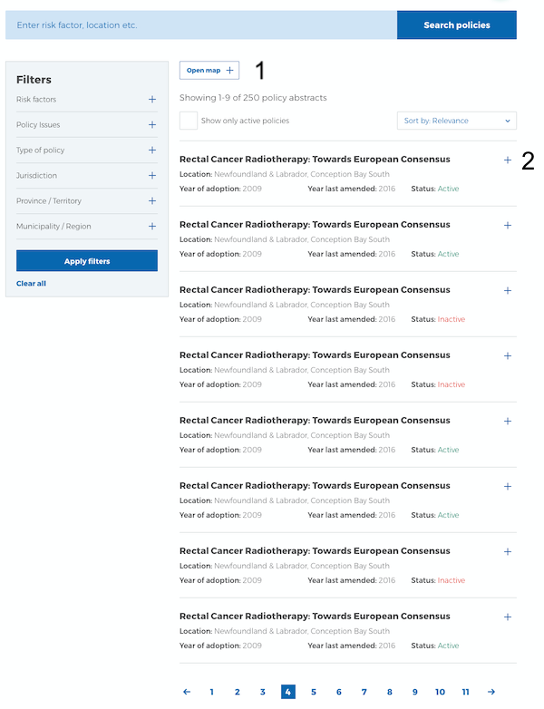

|  |  |  |  |
| --- | --- | --- | --- |
| Ref # | Action | Results/Details | CMS Notes |
| PPDR1.0 | User clicks on button “Open map +” call to action | The button text changes to “Close map x”  A map appears on the top of the list of policy abstracts, and displays circles of numbers. See PPD Search Results Page: “Browse by Location” section. | By default, the map is hidden and the call to action button text is “Open map +” |

## PPD Search Results Page: “Browse by Location” (NEW)

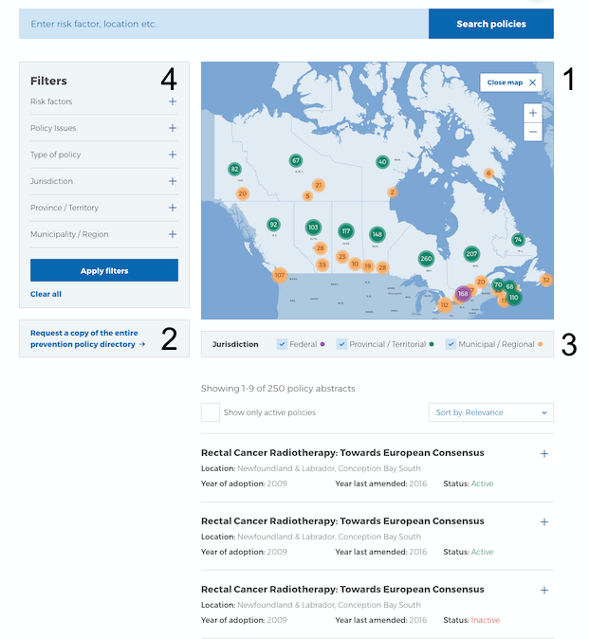

|  |  |  |
| --- | --- | --- |
| Ref # | Action | Results/Details |
| PPDL1.0 & PPDL3.0 | User lands on the page from the previous action of clicking “Browse by Location” option | The map is visibly displayed above the list of policy abstracts.  By default, the map displays policy abstracts at the “Federal” and “Provincial / Territorial” levels.  By default, the Jurisdiction “Federal” and “Provincial / Territorial” options are checked.  The map displays circles with these attributes:   * Colours: represent the different checked Jurisdiction level(s) * Numbers: represent the quantity of policy abstracts at the checked Jurisdiction level(s) and checked Filter item(s)   The visuals in the map are determined by:   * Selected filter items in the “Filter” section on the left (PPDL4.0) * Selected options in the Jurisdiction bar below the map (PPDL3.0)   The Policy Abstracts list is displayed below the map and reflects the visuals in the map on a 1:1 ratio. |
| PPDL1.1 | User clicks on button “Close map x” call to action | The text on the button changes to “Open map +”.  The map and the Jurisdiction bar are hidden. |
| PPDL1.2 | User clicks on button “Open map +” call to action | The text on the button changes to “Close map x”.  The map and the Jurisdiction bar become visible. |
| PPDL1.3 | User clicks on the “+” zoom magnification bar on top right of the map | The map zooms in, and the visuals of the circles adjust based on the zoom magnification.  The list of policy abstracts below the map stays the same as the Filters on the left and the associated Jurisdiction horizontal bar remain unchanged.  For more technical info of the zoom-in range, please refer to this page: https://www.mapbox.com/help/adjust-tileset-zoom-extent/ |
| PPDL1.4 | User clicks on the “-“ zoom magnification bar on top right of the map | The map zooms out, and the visuals of the circles adjust based on the zoom magnification. The list of policy abstracts below the map stays the same as the Filters on the left and the associated Jurisdiction horizontal bar remain unchanged.  For more technical info of the zoom-in range, please refer to this page: https://www.mapbox.com/help/adjust-tileset-zoom-extent/ |
| PPDL2.0 | User clicks on the call to action button “Request a copy of the entire PPD 🡪” | User is directed to a different page within CPAC Main Site. See “Request PPD Export” page |
| PPDL3.1 | User selects 1 or more Jurisdiction level options | The map & list display policy abstracts that are tagged with the selected Jurisdiction level(s) & Filters. |
| PPDL3.2 | User selects zero Jurisdiction level options | The map & list do not display any policy abstracts, regardless of Filter(s) selected.  Each policy abstract has a Jurisdiction level attached to it. |
| PPDL4.0 | User first lands on the page from a previous action | All Filters are collapsed. See section Database Search Results Page, item DBS2.0.  By default, no Filters is selected. |
| PPDL4.1 | User selects a Filter item | The map & list display policy abstracts based on Filter item(s) and Jurisdiction level(s) selected. |

## PPD Search Results Page: “Browse by Location” (Federal, Provincial, Municipal) (NEW)

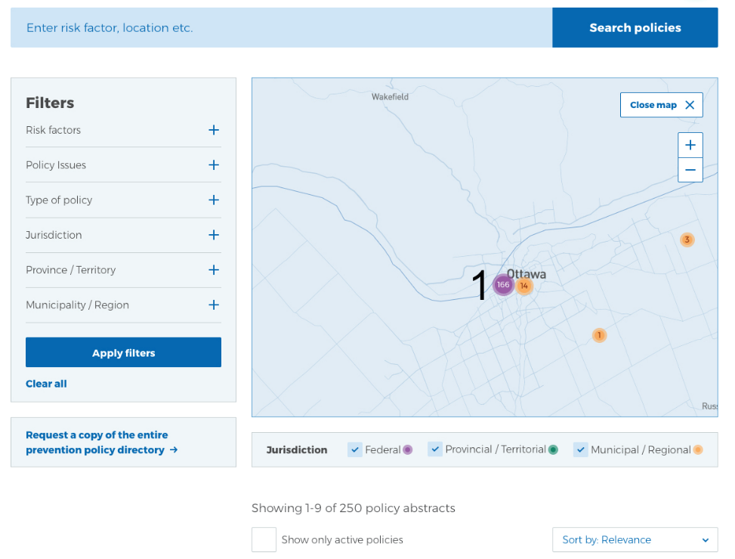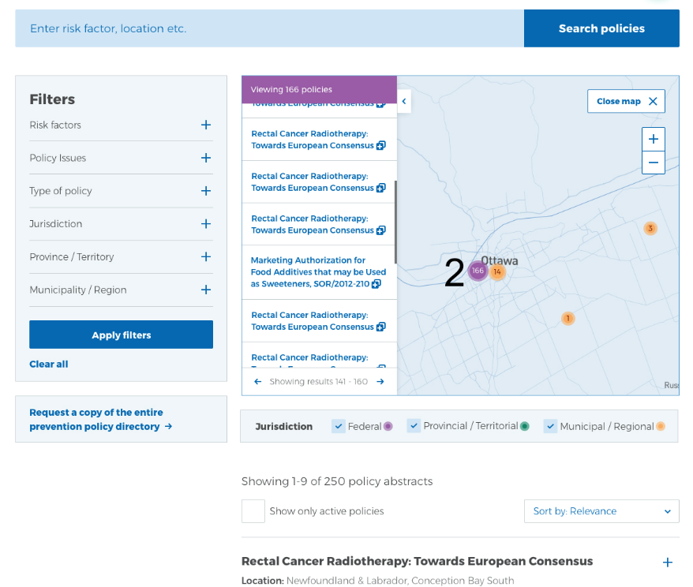

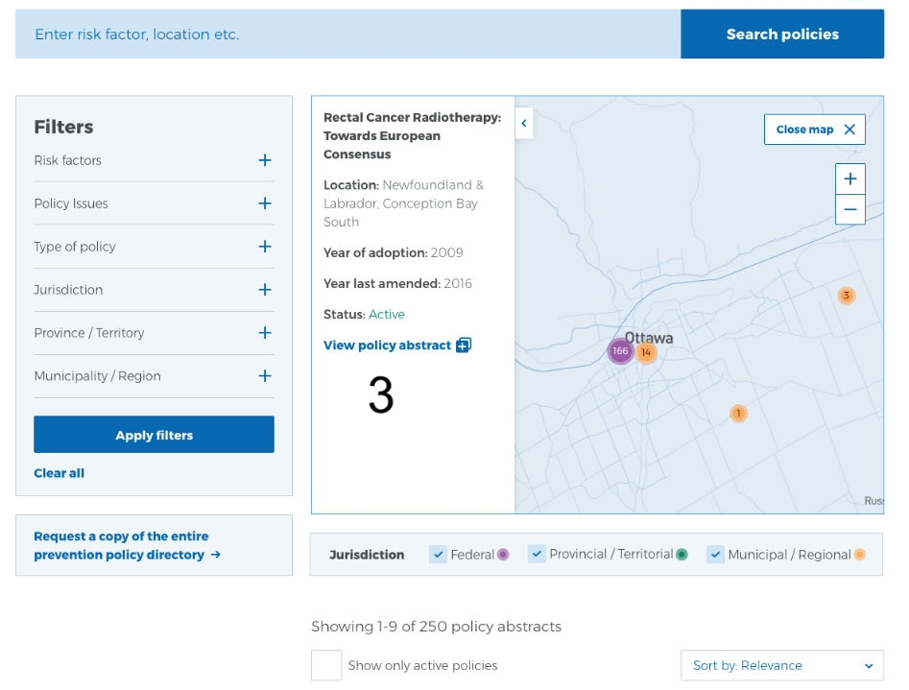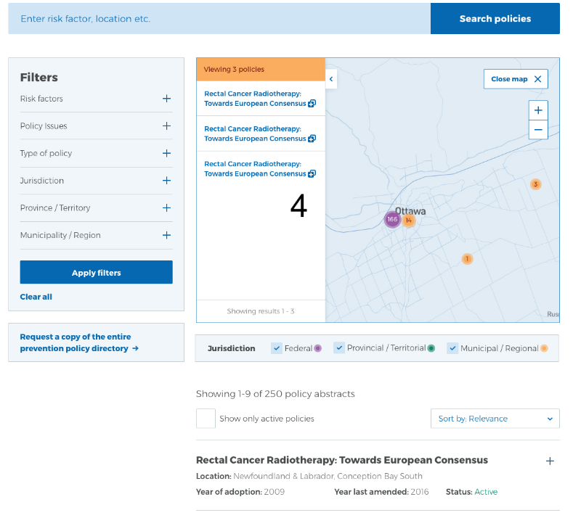

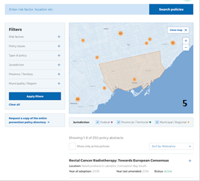

|  |  |  |
| --- | --- | --- |
| Ref # | Action | Results/Details |
| PPDF1.0 | User clicks on the “+” zoom magnification to zoom into a circle | The map gets zoomed into the detailed level.  If there is more than one circle in the location (for example a Federal purple circle and an Ottawa Municipal orange circle) The Federal purple circle is offset to the left of the Ottawa Municipal orange circle. |
| PPDF2.0 | User clicks on a circle that shows a quantity of more than 1 abstract | A drawer slides out to the left of the map. It has these elements:   * A page that displays a list of 20 policy abstracts per page. Each policy abstract is displayed with clickable titles. * A scroll bar to allow user to scroll up and down the list of 20 policy abstracts on one page. * A pagination bar at the bottom of the drawer that allows user to page “left”/previous and page “right”/forward. * A label on the top of the drawer that lists the total policies. * A drawer “knob”, that when clicked, closes the drawer   The drawer list of policy abstracts is a subset of the list of policy abstracts at the bottom of the page. There are no changes/impacts to the list of policy abstracts below the map.  This behaviour is the same for Federal, Provincial and Municipal policies. |
| PPDF2.1 | User clicks on a policy abstract title from the list | A new browser tab opens up within CPAC Main site that displays more details of that policy abstract. See “Database Landing From Share” section. |
| PPDF3.0 | User clicks on a circle that represents **one** policy abstract | A drawer slides out to the left of the map. It has these elements:   * A drawer “knob”, that when clicked, closes the drawer * A high-level summary of the (one) policy abstract   + Policy abstract **Title**   + **Location**   + **Year of Adoption**   + **Year last Amended**   + **Status**: [Active / Inactive]   + A clickable link “**View policy abstract**”   This behaviour is the same for Federal, Provincial and Municipal policies. |
| PPDF3.1 | User clicks on the “View policy abstract” link | A new browser tab opens up within CPAC Mainsite that displays more details of that policy abstract. See “Database Landing From Share” section. |
| PPDF4.0 | User clicks on a circle that shows quantity of < 20 policy abstracts | A drawer slides out to the left of the map. It has the same elements as PPDF2.0, except there is no scroll bar and no a pagination bar.  The drawer list of policy abstracts is a subset of the list of policy abstracts at the bottom of the page. There are no changes/impacts to the list of policy abstracts below the map. |
| PPDF4.1 | User clicks on the “View policy abstract” link | A new browser tab opens up within CPAC Main site that displays more details of that policy abstract. See “Database Landing From Share” section. |
| PPDM5.0 | User mouse-hovers over a circle. | The map displays the associated Regional boundary of the circle. |