**Final Configuration Documentation For FindAGrave**

1. **Configuration For CI process in Jenkins for Feature Branch**
   1. Configuration for API
      1. Initial Build
      2. CI process under Container
   2. Configuration for Frontend
      1. Initial Build
      2. CI process under Container
2. **Configuration For CI process in Jenkins for Release Branch**
   1. Configuration for API
      1. Initial Build
      2. CI process under Container
   2. Configuration for Frontend
      1. Initial Build
      2. CI process under Container
3. **Configuration For CI process in Jenkins for Master Branch**
   1. Configuration for API
      1. Initial Build
      2. CI process under Container
   2. Configuration for Frontend
      1. Initial Build
      2. CI process under Container
4. **Configuration For CD process in Jenkins for Release Branch**
   1. Configuration for API
   2. Configuration for Frontend
5. **Rollback configuration**
6. **Saving Environment Configuration**
7. Configuration For CI process in Jenkins for Feature Branch
   1. Configuration for API
      1. Initial Build

**Job name- FindAGrave_Docker-CI-Initial-Build-ForFeatureBranch**

# Getting source from SCM.

# Restricting slave as same machine.

# 

Build will be trigger at every push in feature branch.

In execute shell we are copying package.json to /var/lib/Jenkins/jobs/docker_image_backend

This folder already contains Dockerfile .

“npm install “ will download all dependencies and add it into the image.

After that docker command will build and push the image to docker repository.

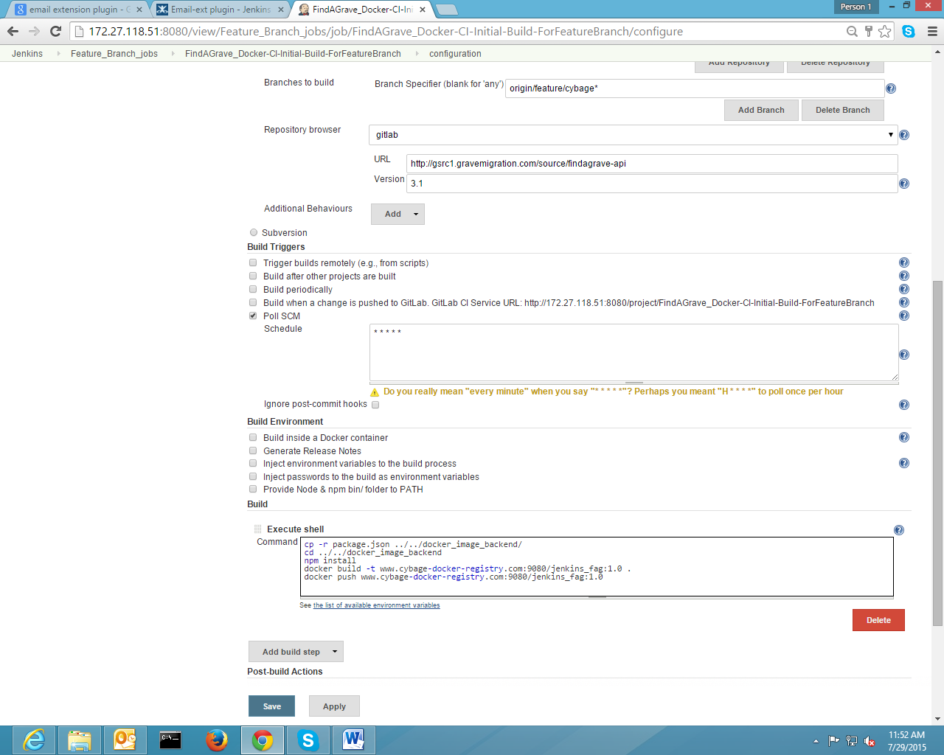

docker_image_backend contains Dockerfie, Tools and package.json

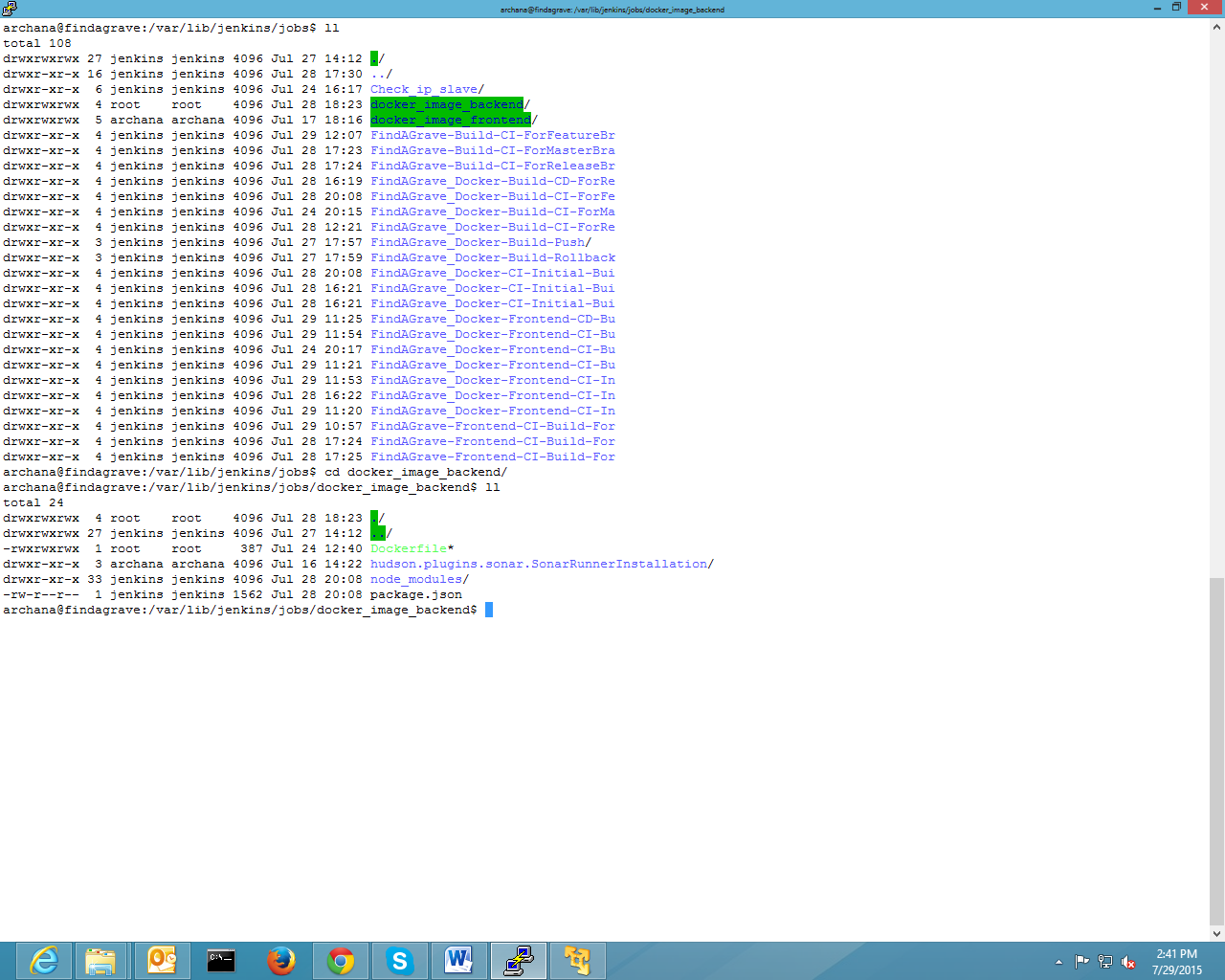

Now, automatically It will trigger to next job i.e FindAGrave_Docker-Build-CI-ForFeatureBranch

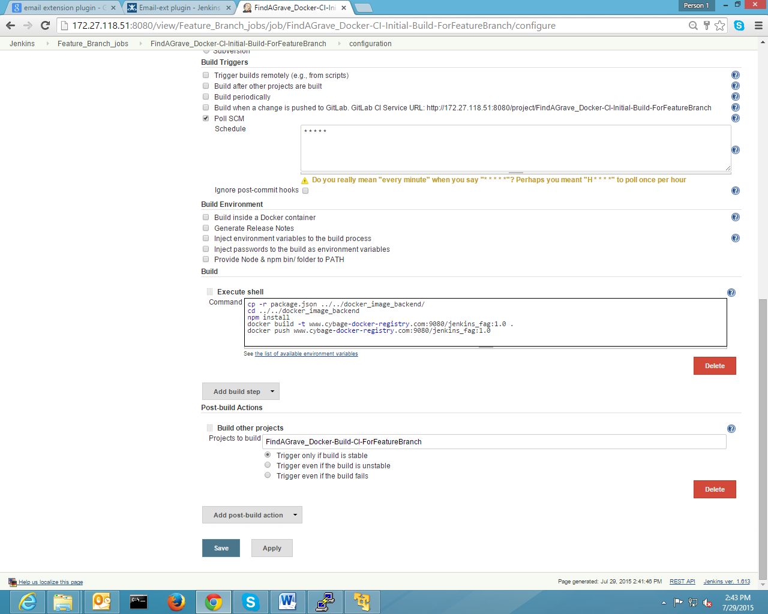

* + 1. CI process under Container

Job Name- FindAGrave_Docker-Build-CI-ForFeatureBranch

Restricted to run on master machine

Checkout latest codes from gitlab.

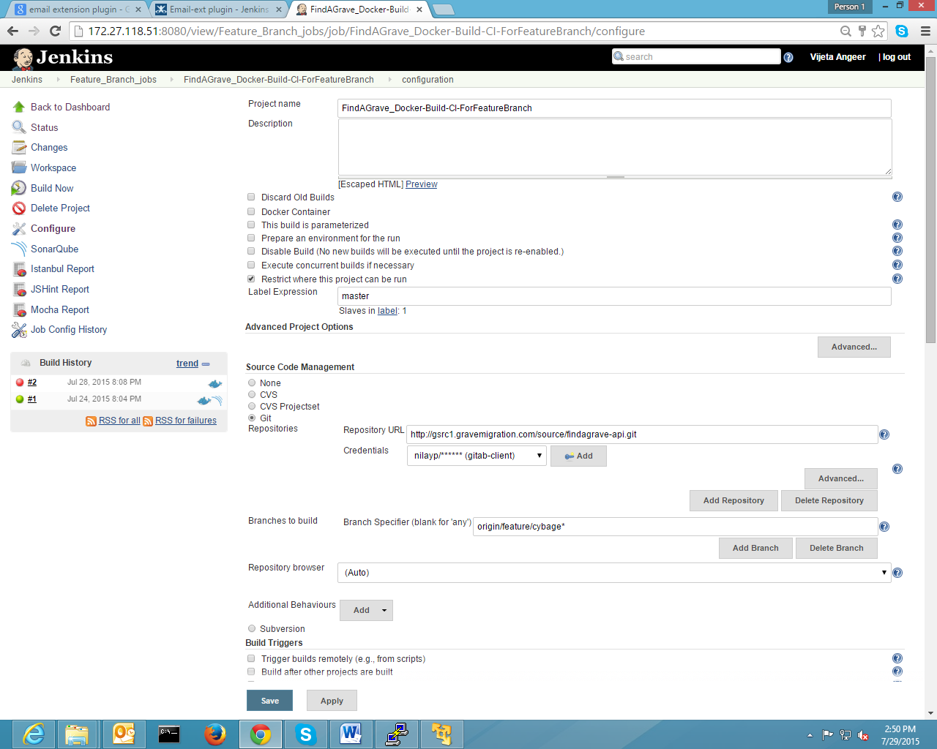

Checked Build inside a Docker Container then it will run whole CI process under container

In execute shell CI process is written

Sonarqube setting

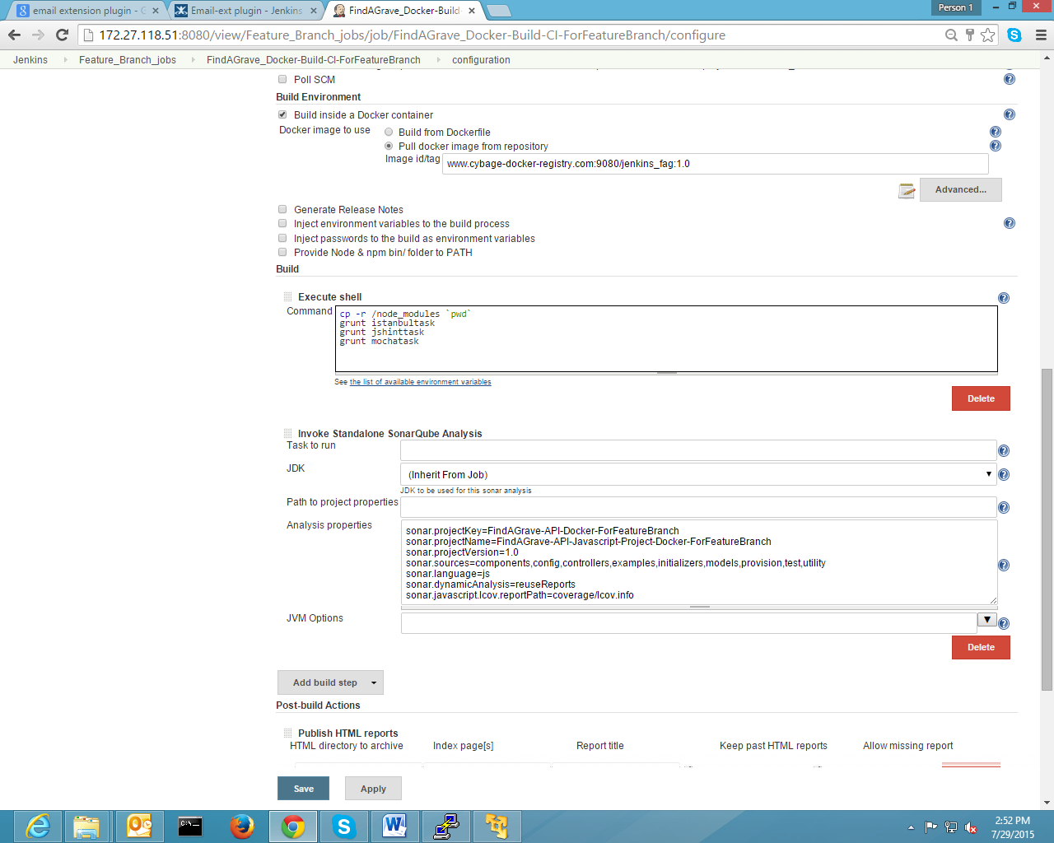

Html pages render on Jenkins to show different reports.

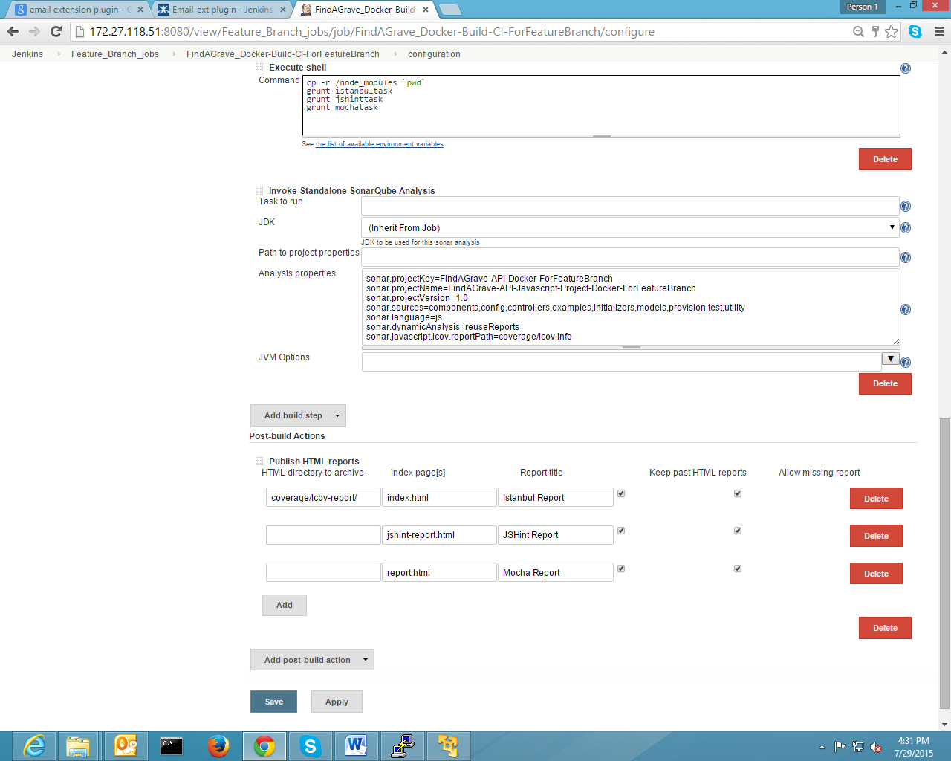

* 1. Configuration for frontend
     1. Initial Build

Job name- FindAGrave_Docker-Frontend-CI-InitialBuild-ForFeatureBranch

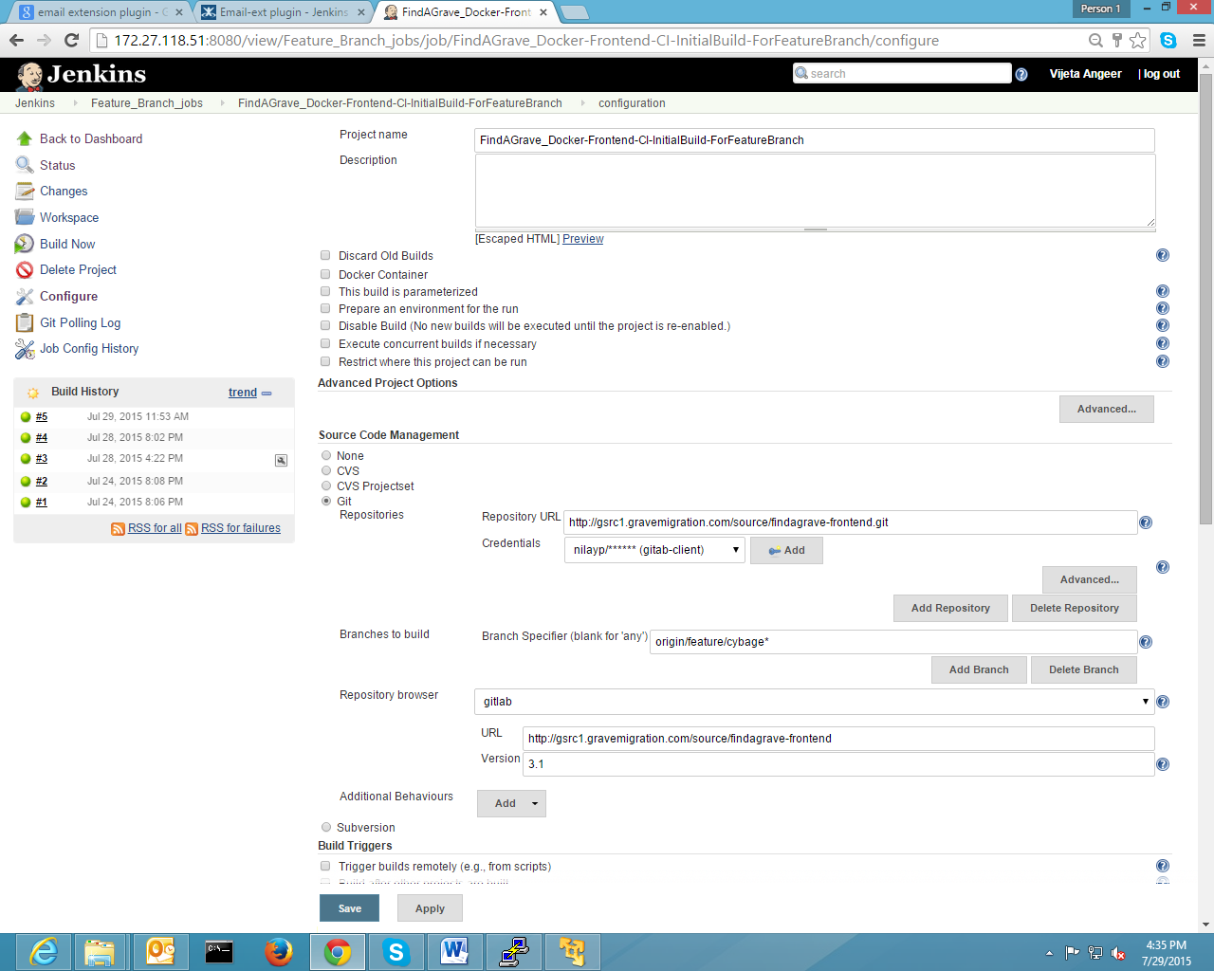

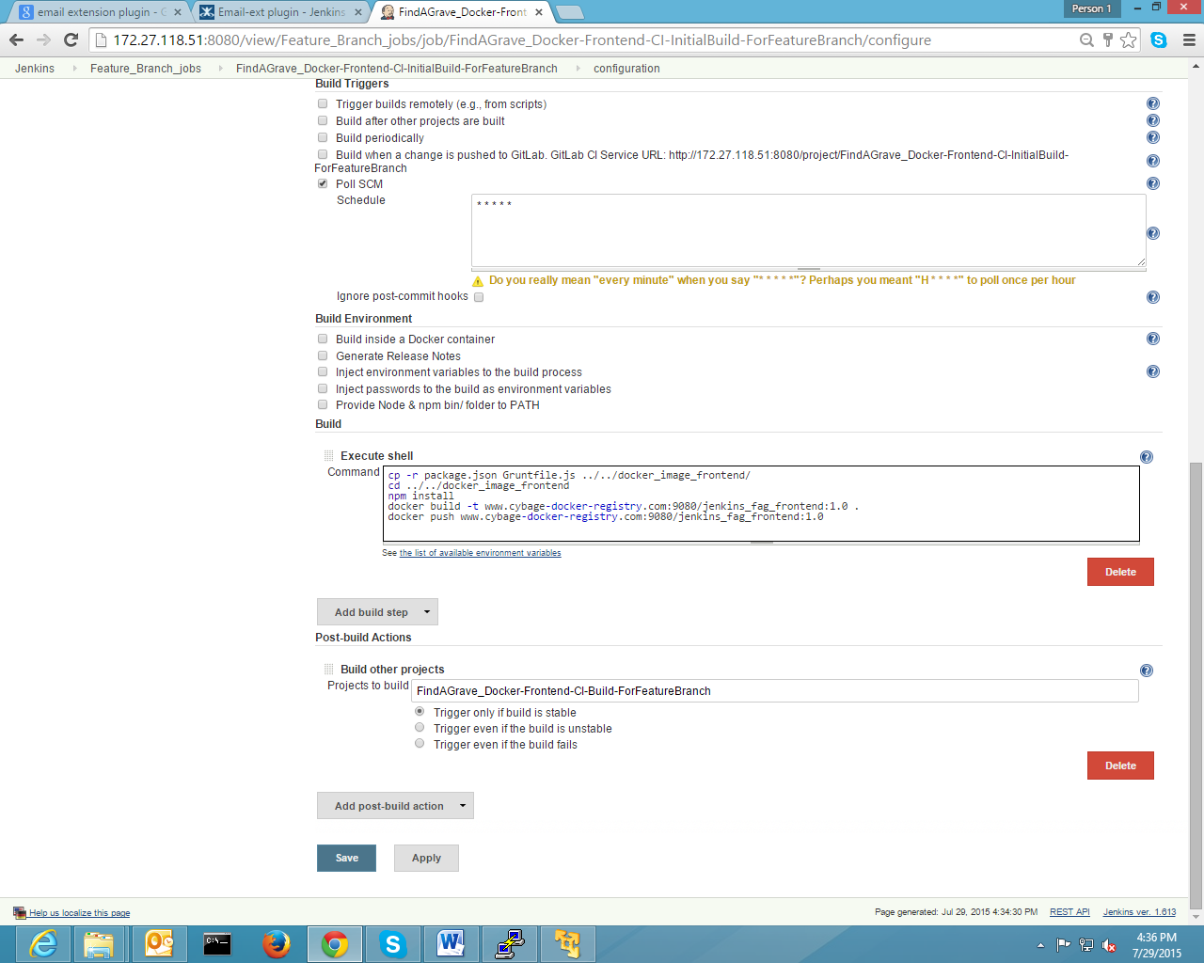



* + 1. CI process under container

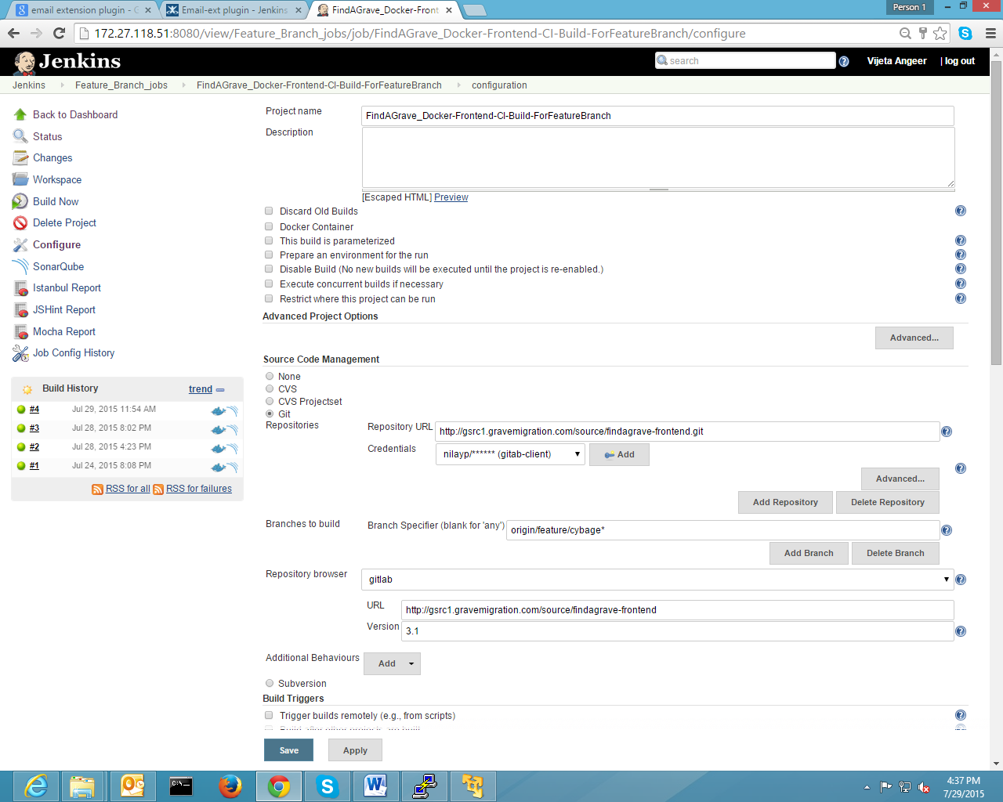

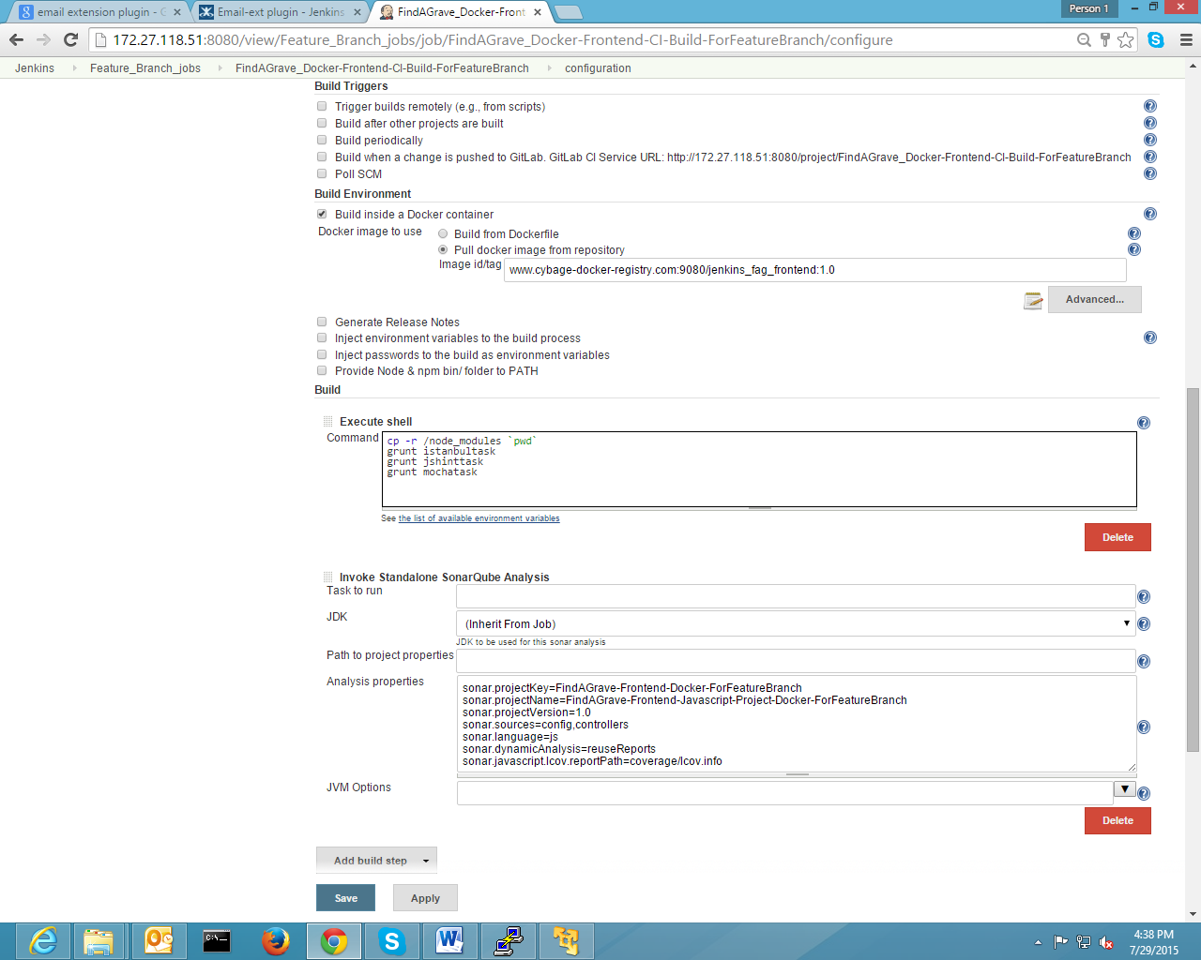

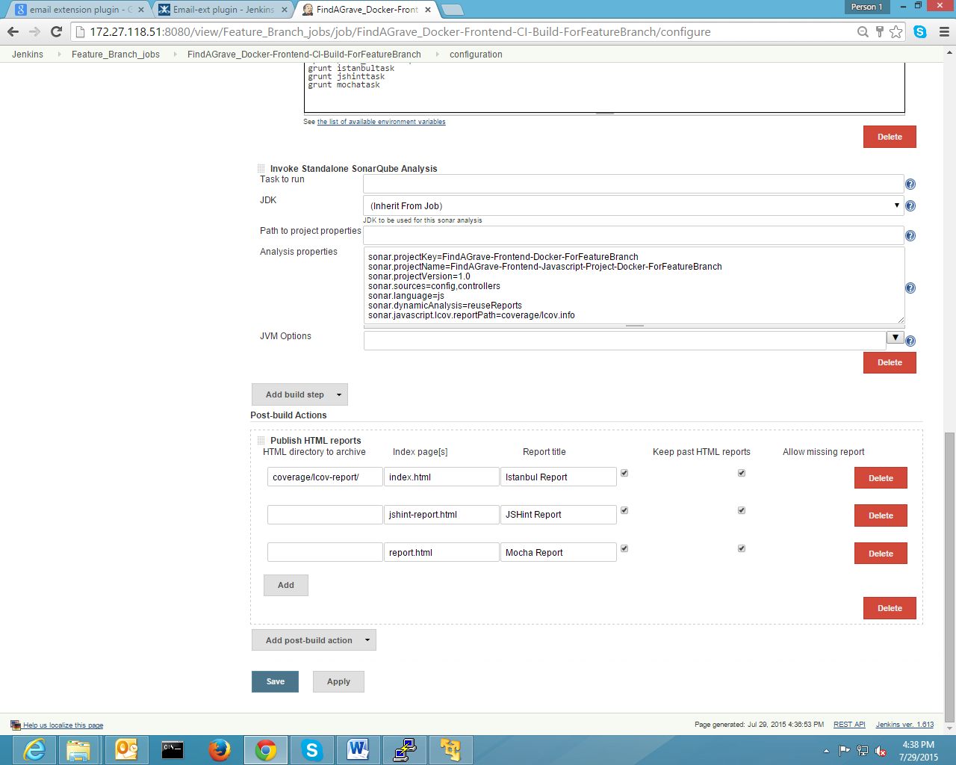

1. Configuration For CI process in Jenkins for Release Branch
   1. Configuration for API
      1. Initial Build

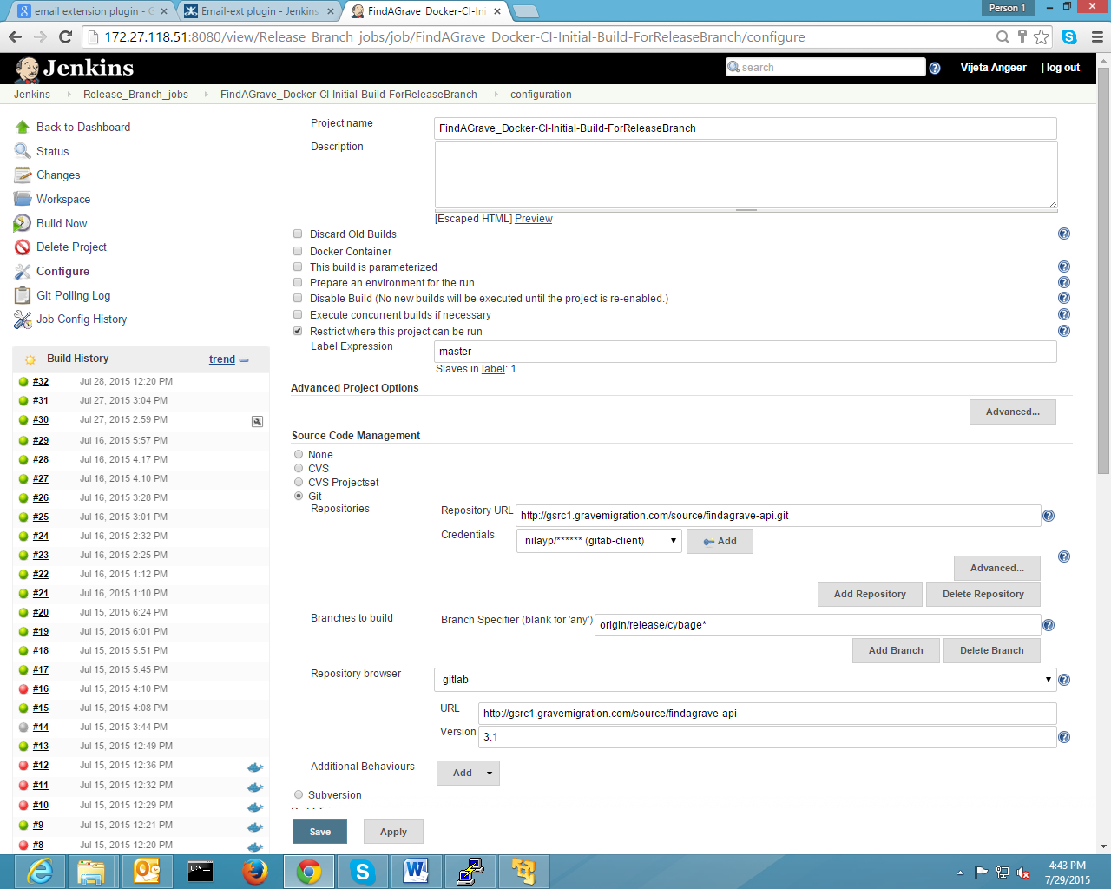

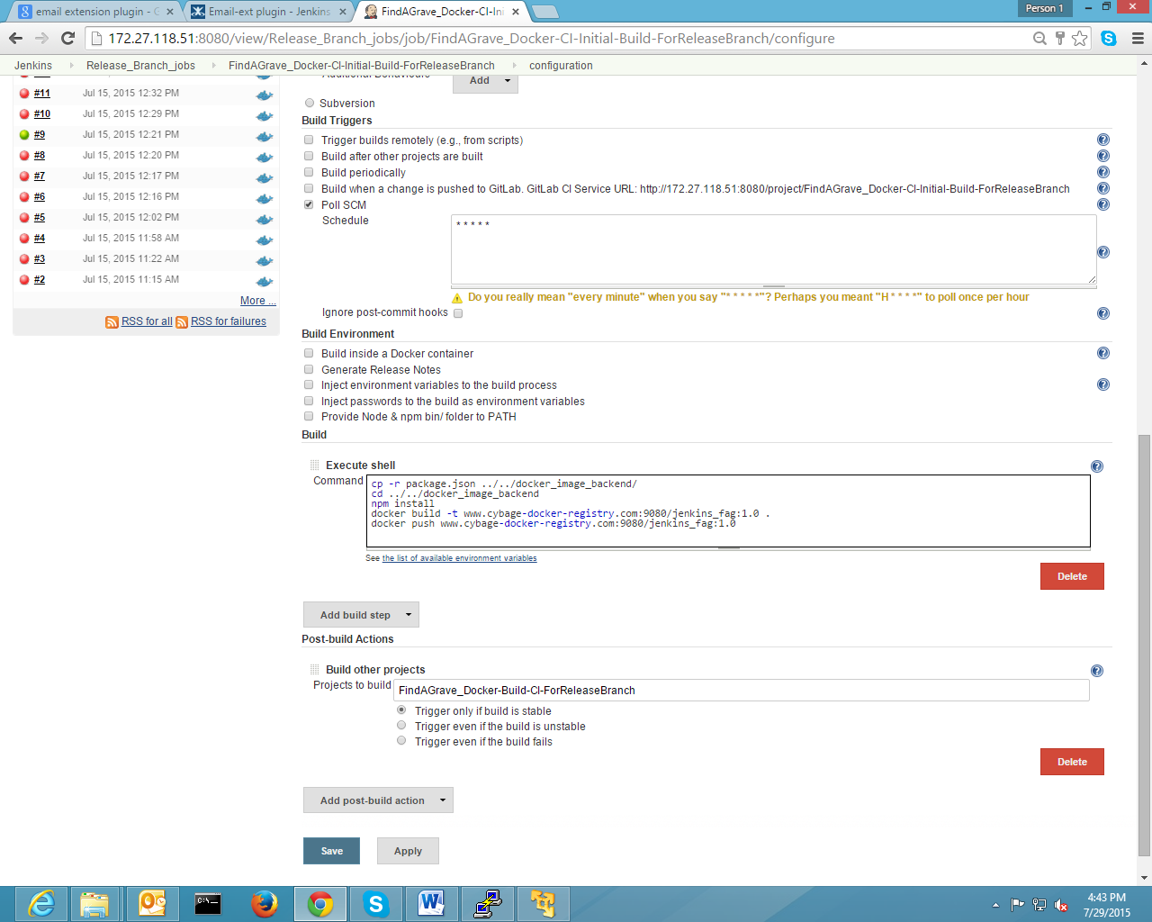



* + 1. CI process under Container

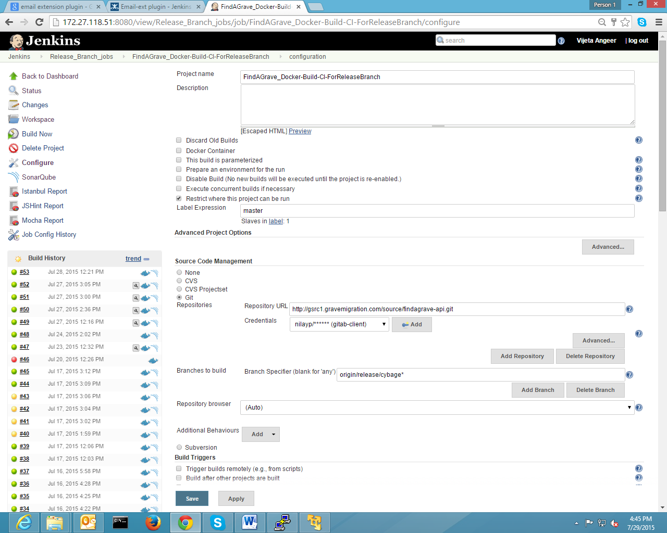

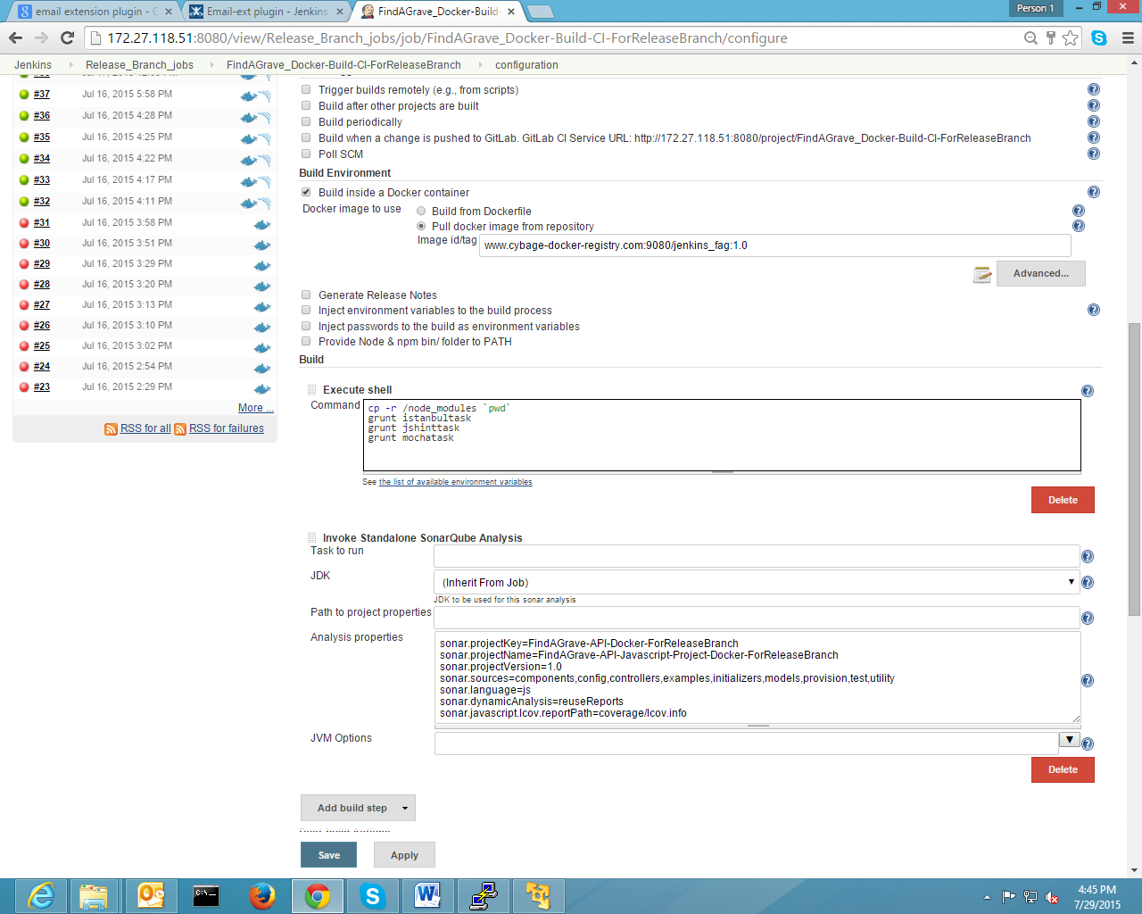

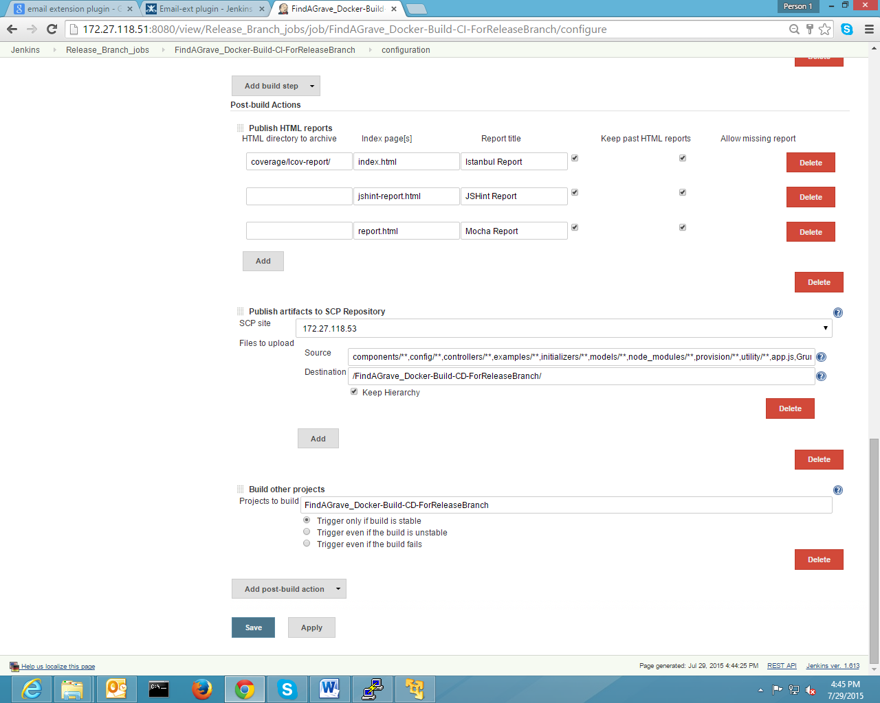

* 1. Configuration for frontend
     1. Initial Build
     2. CI process under Container