1. We are using Jenkins and in Jenkins we are build our CI under docker container with specified environment.

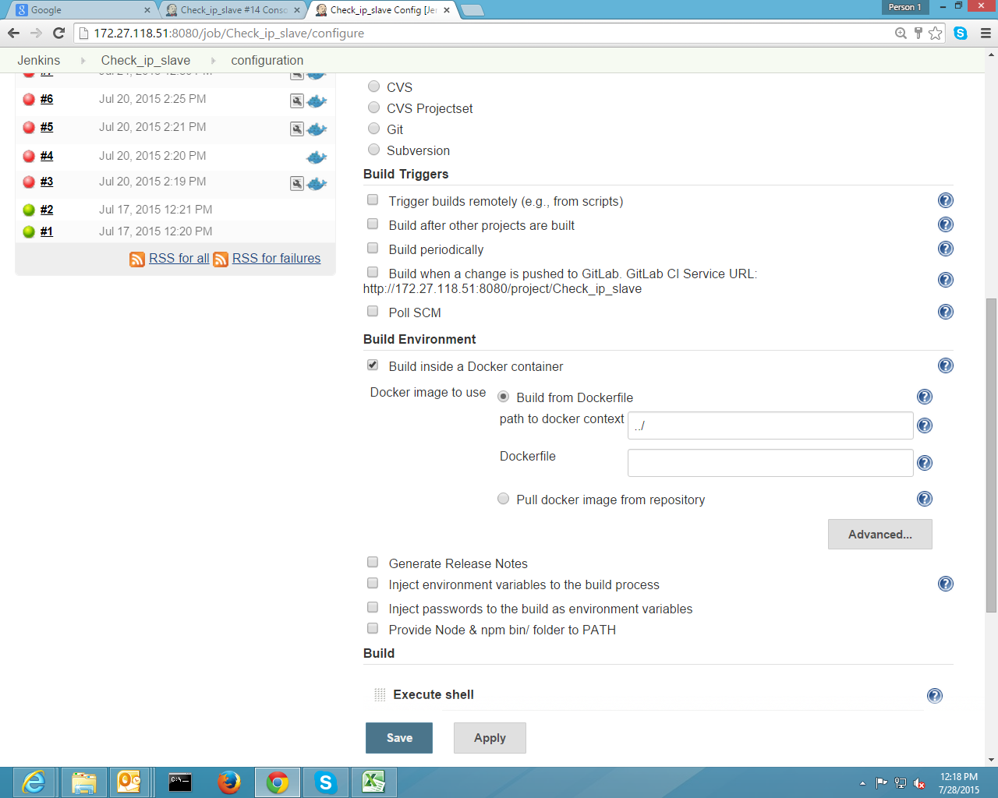

1. We are running “npm install” under execute shell.

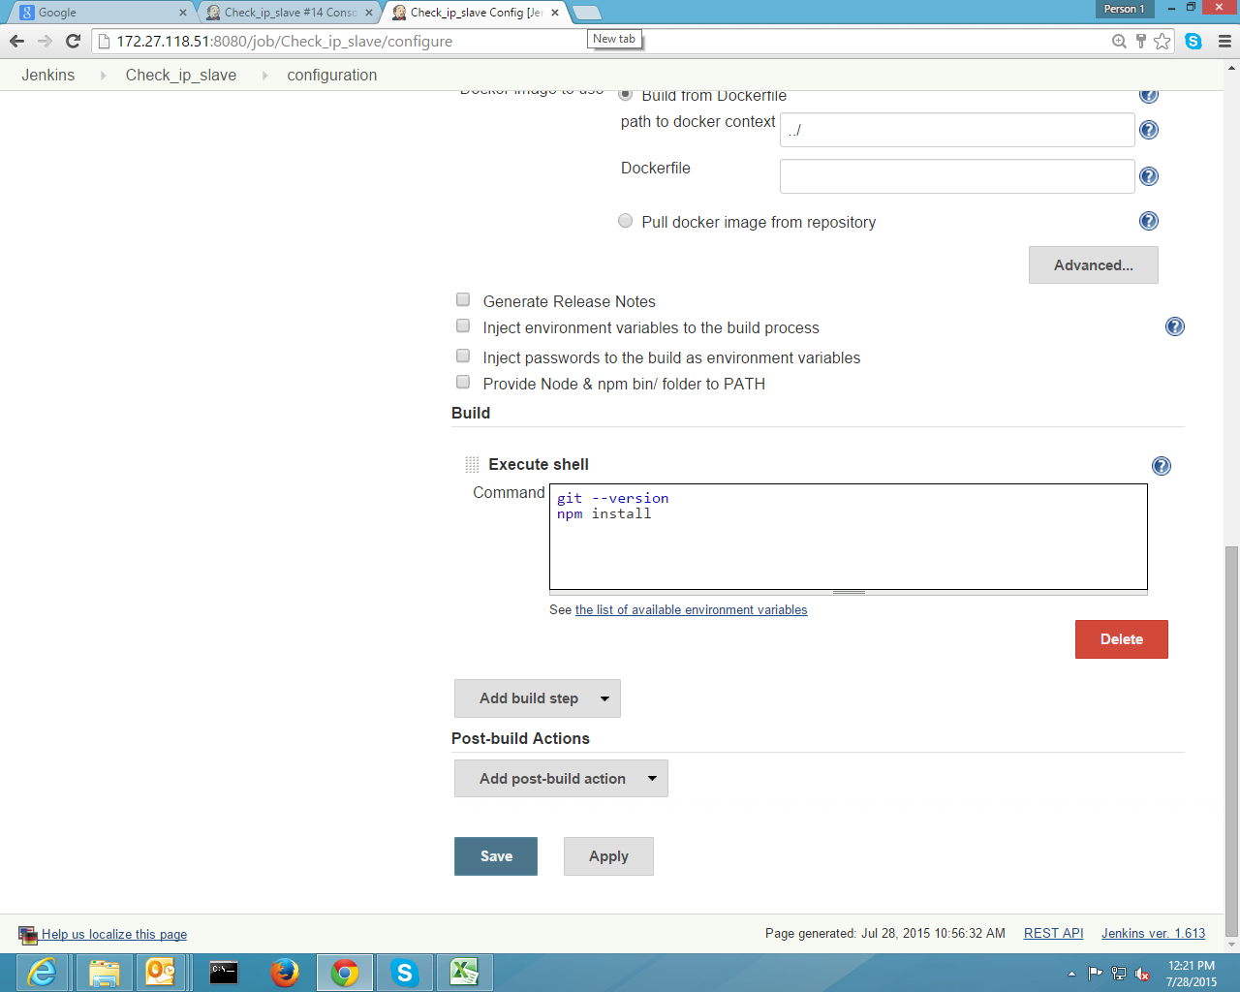

1. Npm install calls “Package.json” in which dependencies are listed ,in this some dependencies are cloning from their gitlab, which giving error during cloning .

It is working fine when all dependencies are download from npm repository.(NOTE:- When we are running “npm install” in the running container not from Jenkins

then it is getting downloaded)

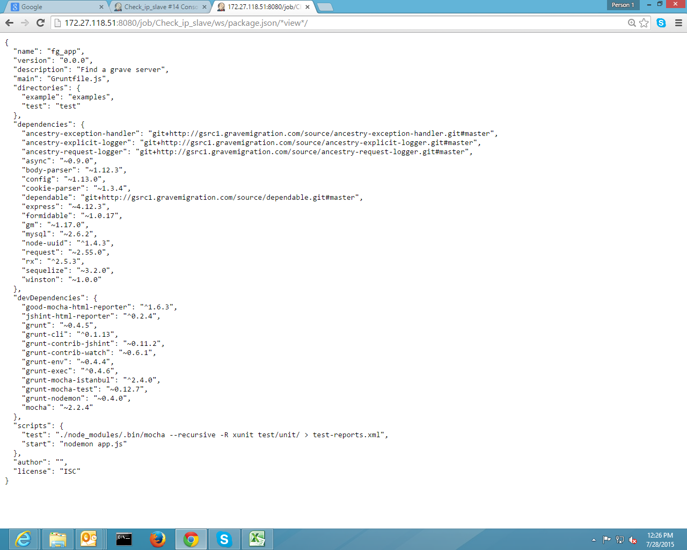

1. Error description in Jenkins during “npm install”

