**PROBLEM:**

**To Run your Selenium Test using CI server there might be compatibility issues so the test cases fail.**

**The reason behind the failure is the display output which is not set for the browser to launch in.**

**SOLUTION:**

**Xvfb performs all graphical operations in memory without showing any screen output. To run your tests using a browser that's loaded on your CI Server you will need to configure your tests to launch the browser virtually (e.g., using something like Xvfb).**

# Step 2 :- INSTALLATION

**To install Xvfb follow the below steps:**

**UBUNTU**

**apt-get install Xvfb Firefox**

**CENTOS**

**yum install Xvfb Firefox**

**XVFB**

* **Start Xvfb on a specific display port and background the process**

**Xvfb :99 &**

* **Tell the terminal session to use the display port**

**export DISPLAY=:99**

# Step 3:- EXECUTION OF SELENIUM SCRIPTS

**Execute the Selenium scripts**

**The Test cases should get executed headless**

# Step 4:- Xvfb Plugin for JENKINS

**Install the Xvfb Plugin in Jenkins**

**Global Configuration Jenkins**

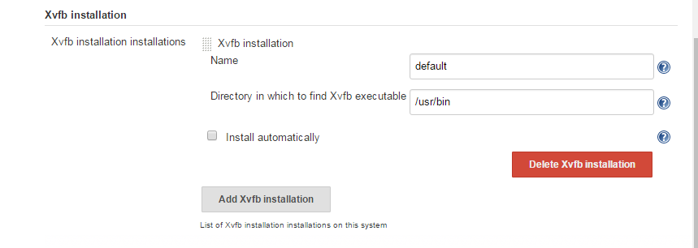

**Xvfb will reflect under the Build Environment**

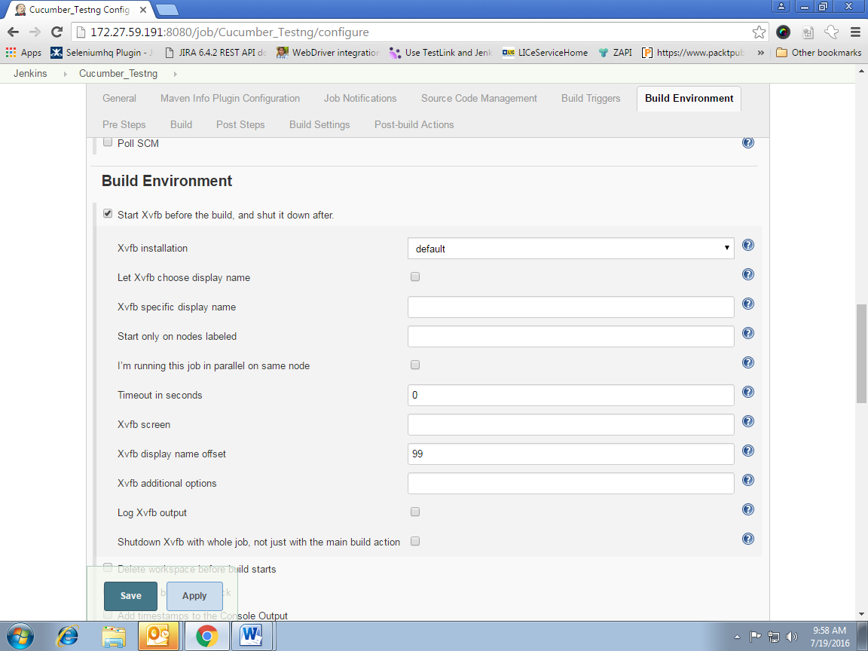

**Once the Jenkins job is triggered Xvfb will start and stop after the job is completed.**