**ROLLBACK**

ROLLBACK: - Rollback is completely manual process in this scenario. Rollback is to be done once the QA Tester manually checks and confirms the committed changes are unstable or have some issue. If the committed changes are stable the QA Tester pushes it into the registry. Registry is a repository for the pushed committed images. Once the QA tester triggers the rollback process the previous deployed images should be replaced with latest pushed committed image. Thus for the roll back process we require latest pushed image having the source code as well as environment.

The Rollback process involves three steps:

1. Removing the deployed containers on the QA server.
2. Pulling the latest pushed committed image from the registry.
3. Redeploying the pulled image to the QA server.

Here is the following configuration required for the Jenkins job:

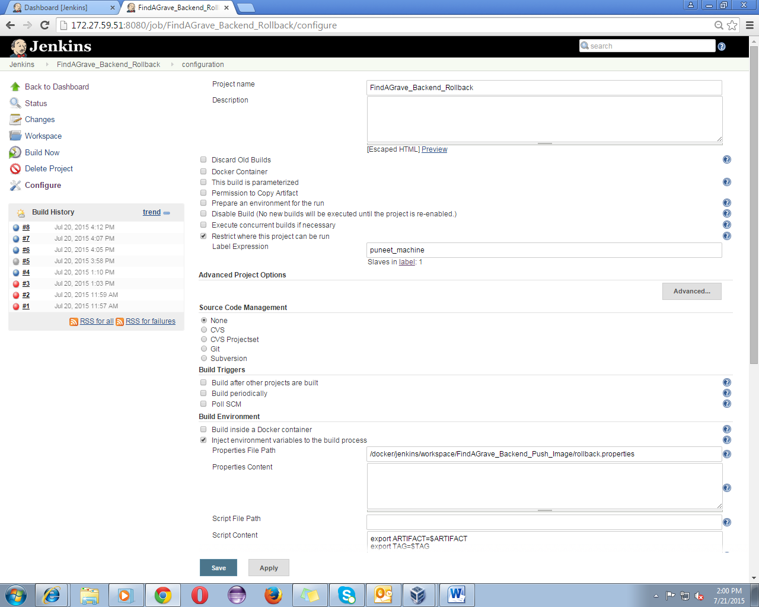

For rollback we require the latest pushed image which will be recognized by its repo:tag i.e. image name. This image name will be injected as environment variable into the build process. In Jenkins we have Envinject plugin which provides this functionality, we are required to provide the path of the properties file and Jenkins will automatically make it available into the build process.

The Build process starts with an execute shell and the first step will be verifying whether any container is running or not if yes then remove it or else need not to do anything.

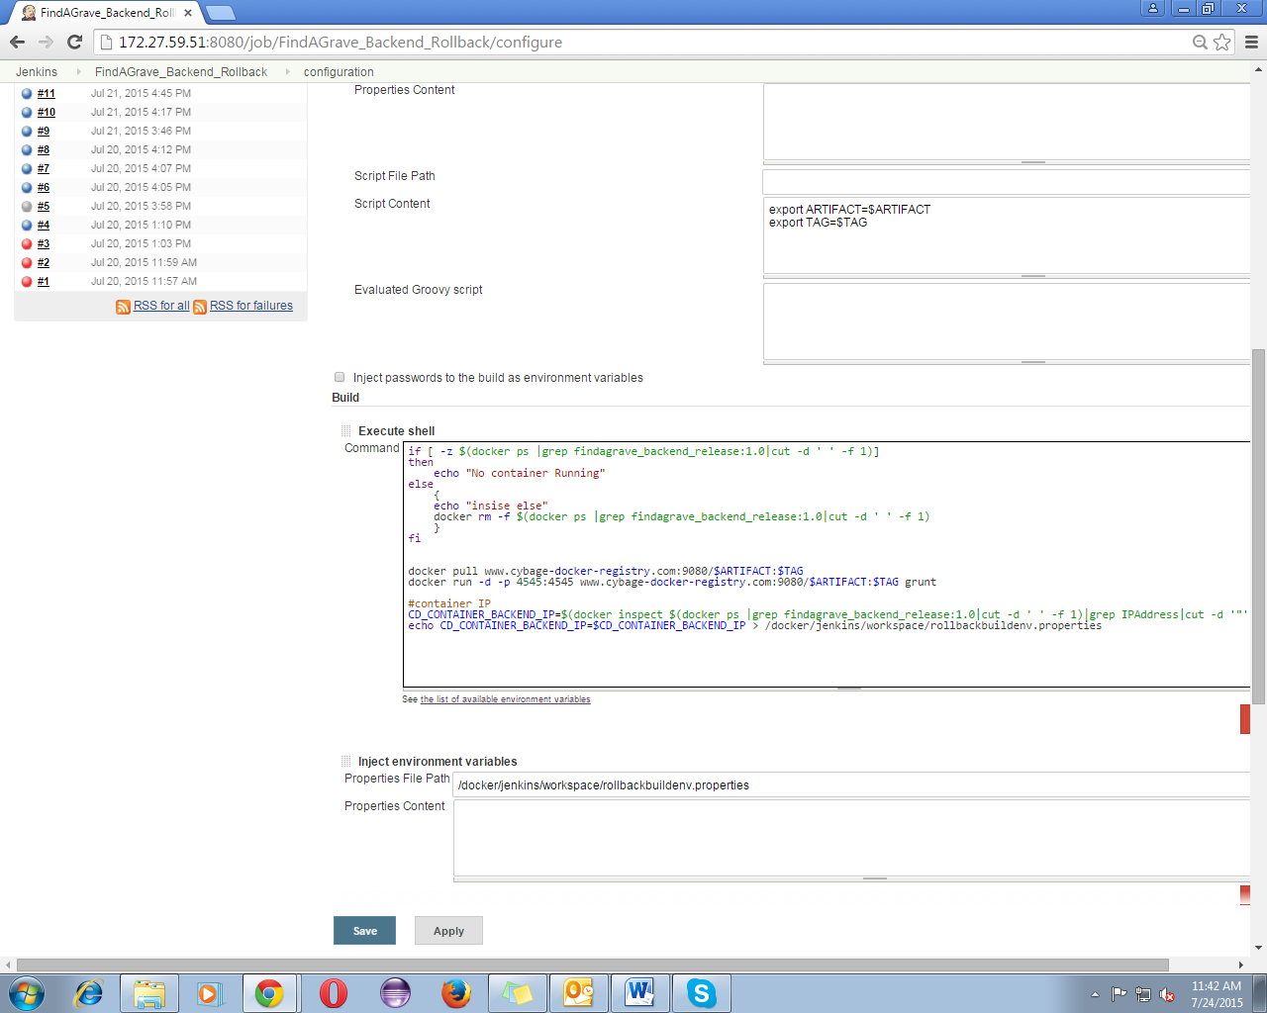

After removing the running containers , we can start with second step i.e. pulling the latest pushed image and running it onto the QA server . Docker pull command is used to pull the latest pushed image and docker run command is used to run the containers.

Once the redeploying of the container on QA server is complete, we need to send an email to the QA which will contain the IP and port of the running containers. For this again we need to retrieve IP of the running container and set it into the environment variables so the IP can be retrieved into the mail configuration .

The mail configuration required into the Jenkins job is as follows.

Jenkins has several email plugins which have these properties .Mostly we will be using Extended email plugin which has several different features which can be configured as desired. For Jenkins to send mail SMTP need to be configured on the machine on which Jenkins is installed . For this wee had raised an IS ticket and they will configure SMTP on the machine .

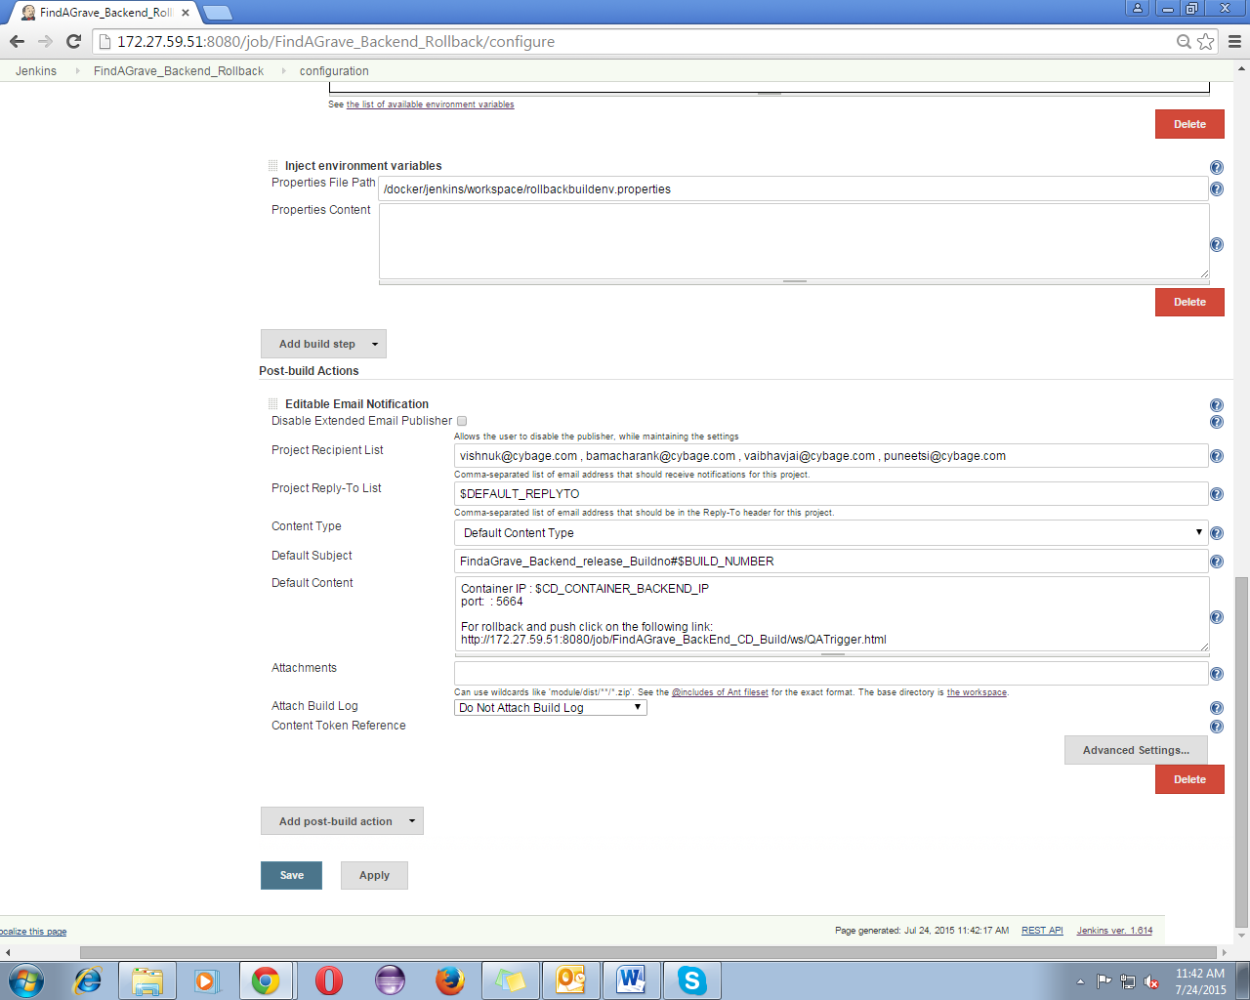

On the successful completion of the job the QA server will have the rolled back environment and code .

Since the rollback was manual hence with this the rollback will be complete.