**Docker Jenkins For CI**

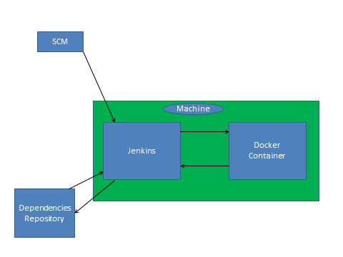

**CI Process with Docker container—**

1. Jenkins and Docker will always on same machine for CI process.
2. Whenever someone push the code in SCM it will automatically trigger in Jenkins and build process will get started.
3. Jenkins will checkin all the changes from SCM.
4. Jenkins will download all the dependencies from Repositories.
5. Jenkins started building Docker image.
6. Jenkins started running Docker container with defined environment.
7. Now all the build process run under Docker container like-
8. Code compilation
9. Unit test running
10. Code coverage
11. Static code analysis
12. Artifacting etc.
13. Docker container will forward all the reports to Jenkins.
14. Jenkins display all the reports generated during CI process.
15. Jenkins will automatically remove the Docker container.

**Jenkins Docker Setup**

1. Install Docker on same machine where is Jenkins.
2. Change the setting of docker file which is under /etc/default/

cd /etc/default/

vim docker

add:-

DOCKER_OPTS="-H tcp://0.0.0.0:4243 -H unix:///var/run/docker.sock"

1. Change in host file

cd /etc/

vim hosts

add:-

172.27.59.8 [www.cybage-docker-registry.com](http://www.cybage-docker-registry.com)

1. Add .dockercfg file in jenkins user home

Like:- If you are using Jenkins then add in to /var/lib/Jenkins/

EX- {

"https://artprod.company.com": {

"auth": "YWRtaW46QVAyMjN6blJTVnNNRlNBMTIzRUUyaVJuQnBi",

"email": "vijetaa@cybage.com"

},

"https://www.cybage-docker-registry.com:9080": {

"auth": "bWFuanVsczptYW5qdWxz",

"email": "manjuls@cybage.com"

},

"www.cybage-docker-registry.com:9080": {

"auth": "bWFuanVsczptYW5qdWxz",

"email": "manjuls@cybage.com"

},

"http://www.cybage-docker-registry.com:9080": {

"auth": "bWFuanVsczptYW5qdWxz",

"email": "manjuls"

}

1. Jenkins setup

Download plugin [CloudBees Docker Custom Build Environment Plugin](https://wiki.jenkins-ci.org/display/JENKINS/CloudBees+Docker+Custom+Build+Environment+Plugin) in Jenkins.

No setup in global level.

1. Setup at job level.
2. Choose Build inside a docker Container at job level.
3. Give the path of your docker file in “PATH TO DOCKERFILE”.(if it is in current directory then put “.”)
4. Do not add any docker file name in Dockerfile (Keep blank)
5. Click on Advance
6. In docker server url put your server url
7. No need to add server credential and docker registry credentials.

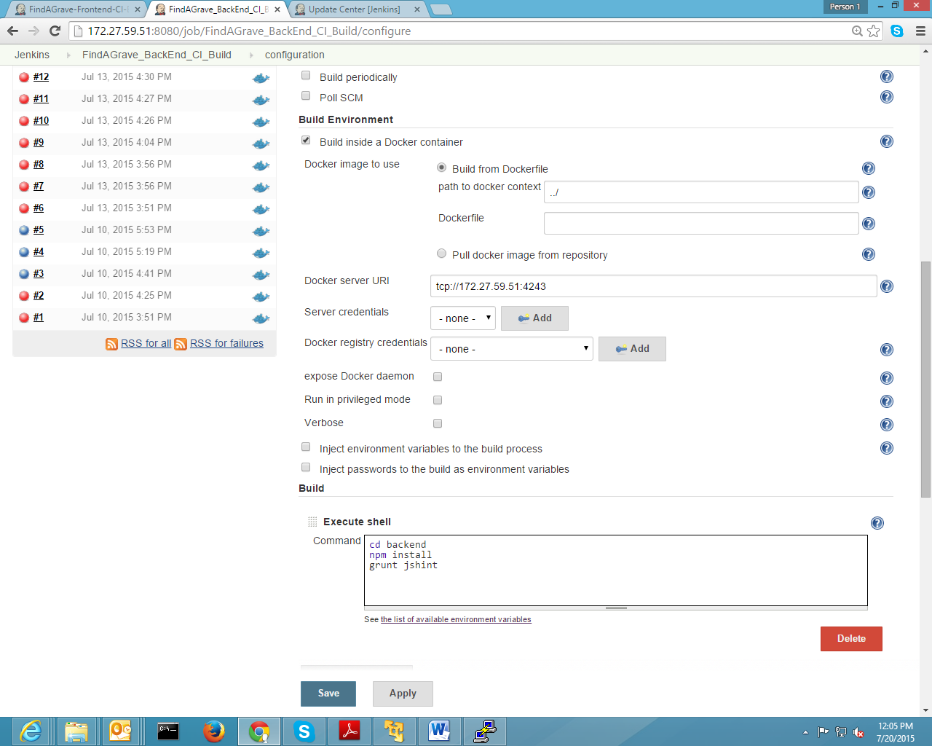

1. Docker file:-

FROM www.cybage-docker-registry.com:9080/jenkins_node_slave:1.1  
RUN apt-get update && apt-get install wget gcc g++ make npm -y   
RUN mkdir /src  
#WORKDIR /src  
RUN cd /src  
RUN wget <http://nodejs.org/dist/v0.12.0/node-v0.12.0.tar.gz>   
RUN tar xvf node-v0.12.0.tar.gz && cd node-v* && ./configure && make && make install   
RUN npm install -g grunt-cli   
RUN chmod 777 /tmp -R  
 VOLUME ["/tmp/"]

1. FROM www.cybage-docker-registry.com:9080/jenkins_node_slave:1.1

It will download the desired image on your local system.

1. RUN apt-get update && apt-get install wget gcc g++ make npm –y

It will install all the updated dependencies in the image.

1. RUN wget <http://nodejs.org/dist/v0.12.0/node-v0.12.0.tar.gz>   
   RUN tar xvf node-v0.12.0.tar.gz && cd node-v* && ./configure && make && make install   
   RUN npm install -g grunt-cli   
    These commands will install node and grunt-cli in the image.
2. RUN chmod 777 /tmp -R  
    VOLUME ["/tmp/"]

If you are getting such problem then add it in to Dckerfile

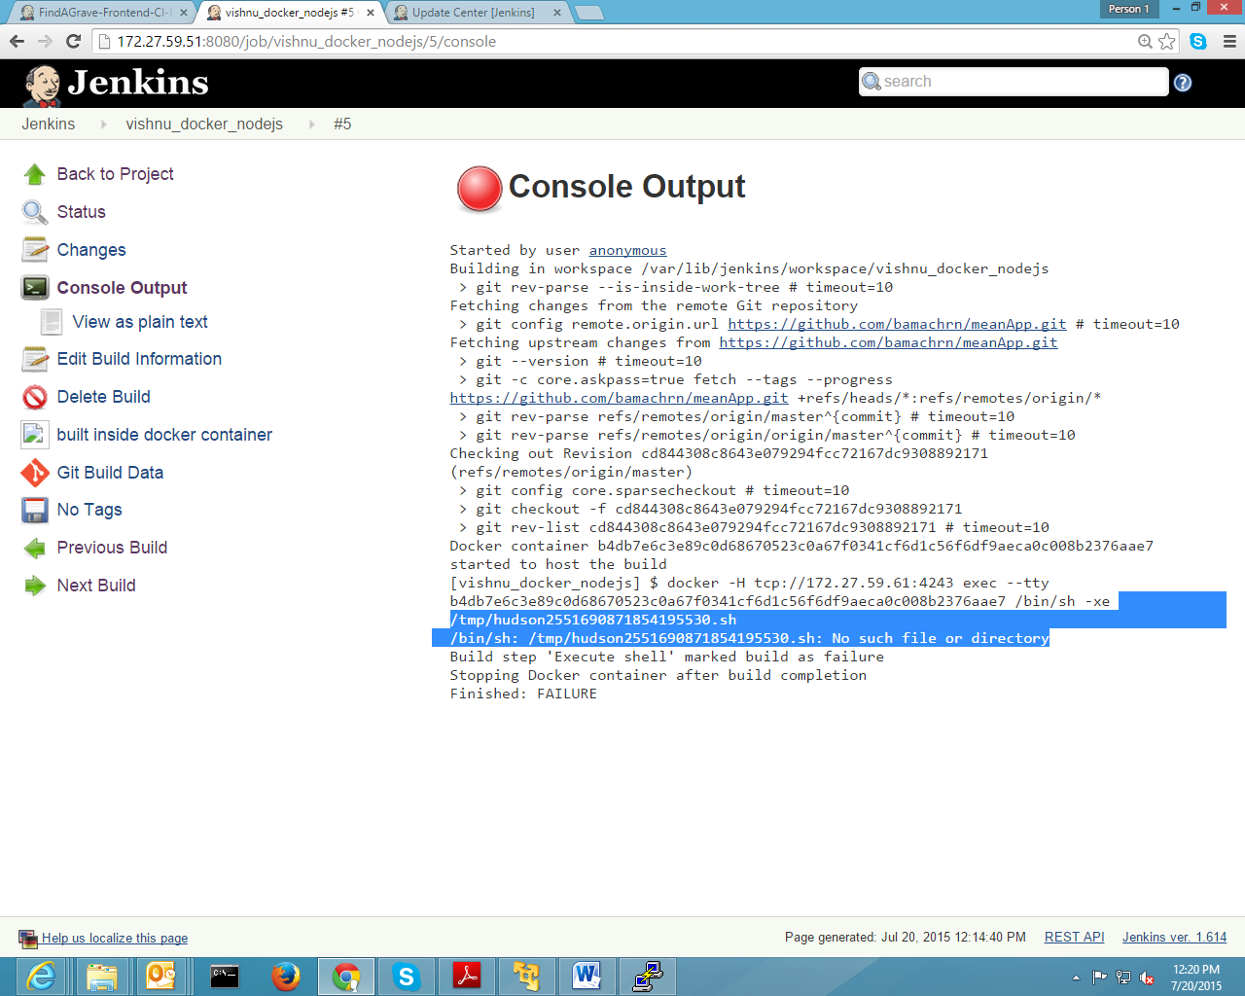

1. Getting Problem during running CI process of Node.
2. If you are getting error during “npm install” in container as /var/lib/Jenkins/.npm Error

Then add this in your dockerfile

RUN mkdir -p /var/lib/jenkins && chmod 777 /var/lib/jenkins -R  
VOLUME ["/var/lib/jenkins"]

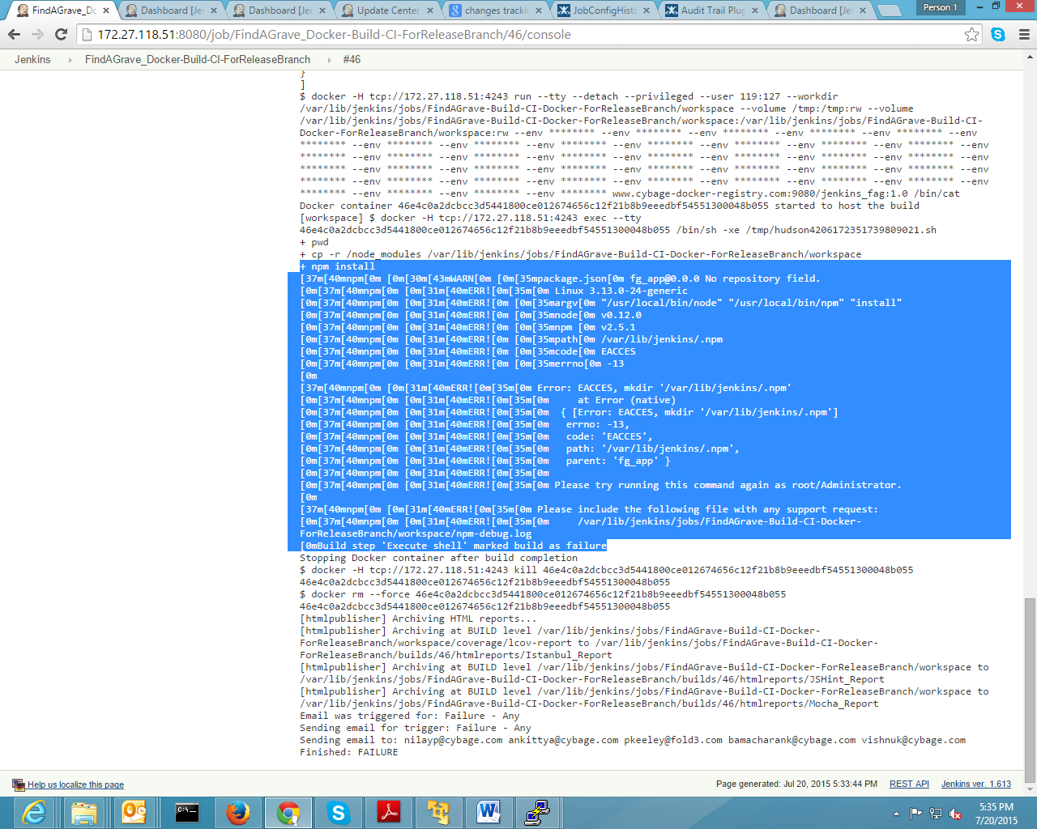

1. Problem and solution for running sonar-runner under docker-container
2. If you are getting problem while running sonar-runner under container then add this in Dockerfile.

RUN mkdir -p /var/lib/jenkins/tools/ && chmod 777 /var/lib/jenkins/tools/

WORKDIR /var/lib/jenkins/tools

ADD hudson.plugins.sonar.SonarRunnerInstallation hudson.plugins.sonar.SonarRunnerInstallation

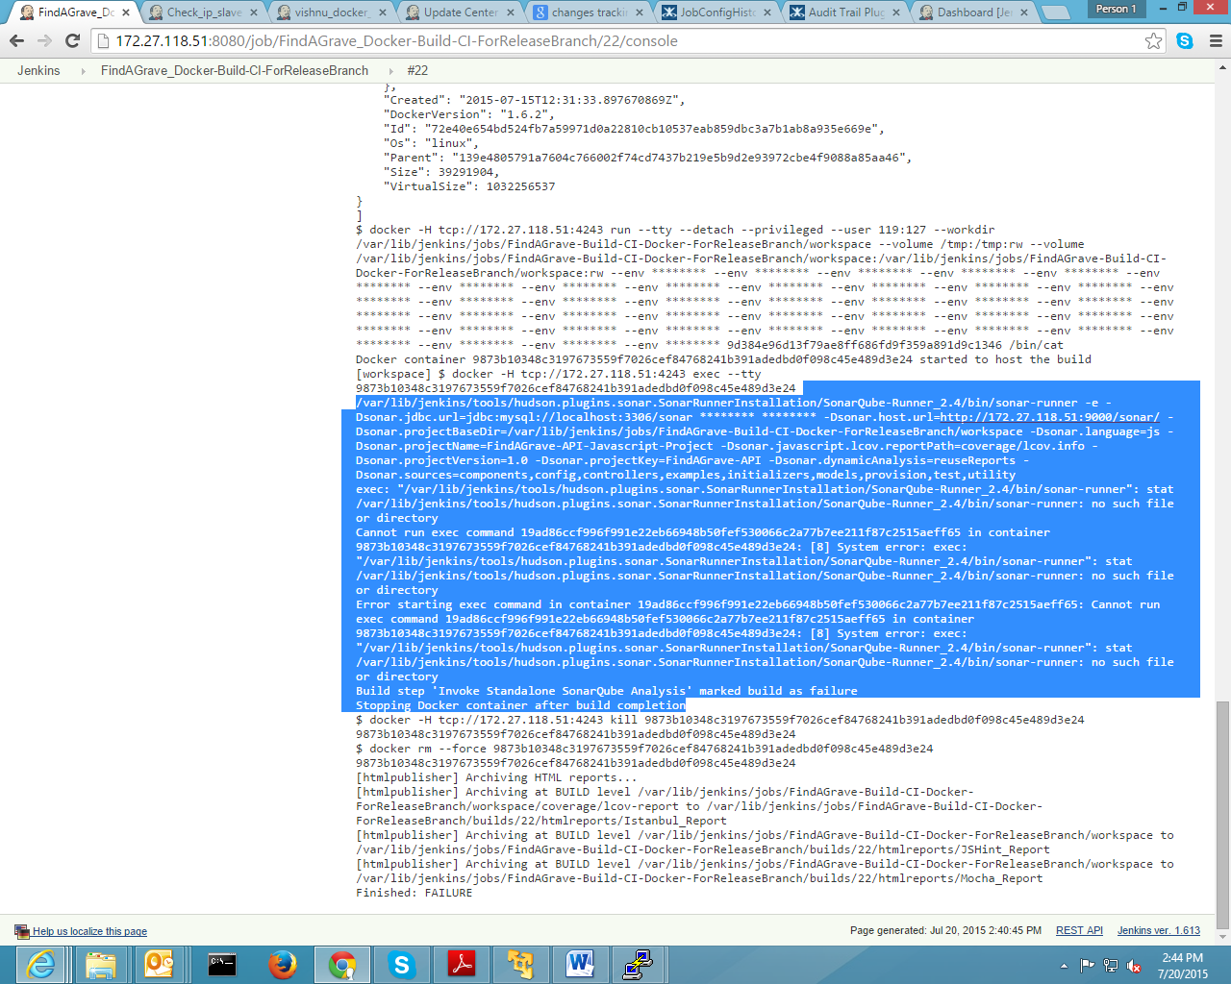

1. If you are getting time mismatch problem while running sonar-runner under container then add this into docker file.

RUN echo "Asia/Kolkata" > /etc/timezone && dpkg-reconfigure --frontend noninteractive tzdata

