**Docker Setup in machine**

1. Change the setting of docker file which is under /etc/default/

cd /etc/default/

vim docker

add:-

DOCKER_OPTS="-H tcp://0.0.0.0:4243 -H unix:///var/run/docker.sock"

1. Setup in Jenkins
2. First install Docker plugin and Cloudbees docker custom build environment plugin in Jenkins.
3. Configure Jenkins global level

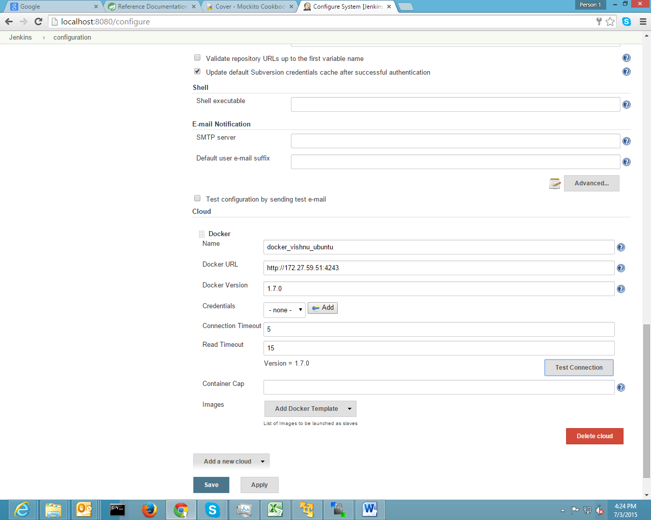

1. In global setting give name and put the url of your docker containing machine and docker port, before ip put http.
2. In docker version put version of docker same as your docker containing machine.
3. Add credential of docker containing machine
4. Test the connection