Ping Utility Analysis

# 1. Ping Basics

The ping utility is a network diagnostic tool that checks the reachability of a host on an Internet Protocol (IP) network. It helps determine if a specific IP address or domain name is accessible and how long it takes for packets to travel to the destination and back. Basic Syntax:

*ping [options] <hostname or IP address>*

Examples:

ping www.google.com

ping 127.0.0.1 (this is local server)

# 2. Ping Output Analysis

Running the Ping Command:  
ping outlook.com



1. The output shows that 4 packets were sent to the IP address 142.250.194.78 (which is associated with google.com).

2. The time=66 ms shows the round-trip time for each packet.

3. The summary at the end shows that all packets were received (0.0% packet loss), meaning the connection to the website is healthy.

Local Host Analysis:  
ping 127.0.0.1

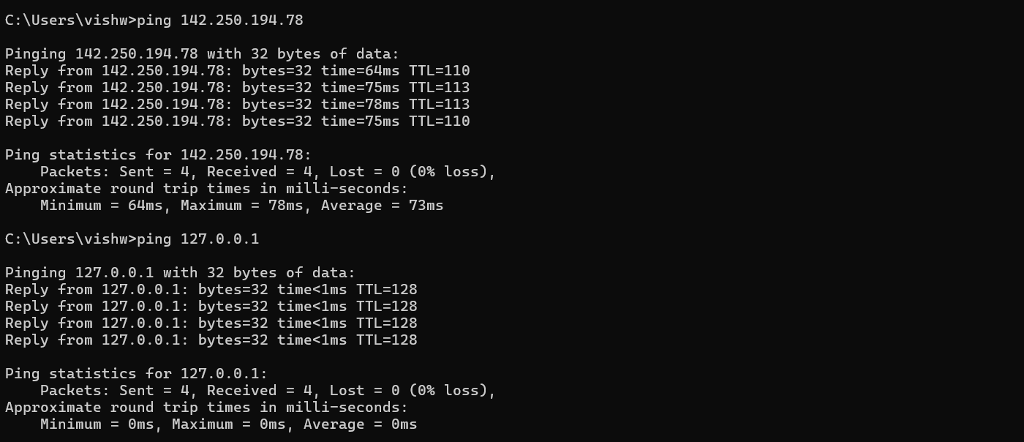

1. The output shows that the local machine responded to all the packets.

2. The round-trip times are extremely low (<1ms), indicating a very fast response since the packets don’t need to travel through a network.

# 3. Ping Options

- -c (count): Specifies the number of packets to send.

For Windows: **-n**: Specifies the number of echo requests to send.

Command: ping -n 5 google.com

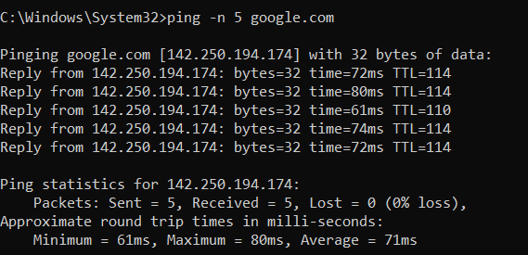

**Explanation**: This command sends exactly 5 ping requests to google.com and then stops. The output will include statistics based on these 5 packets.

In windows we use -l instead of -s   
Example: ping -l 1000  [google.com](http://www.google.com)

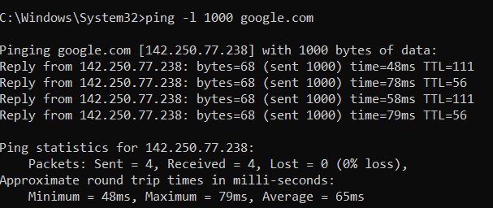

**Explanation**: This command sends ping requests to google.com with each packet carrying 1000 bytes of data. This can help in testing how the network handles larger packets.

- -t (ttl): Specifies the Time to Live for the packets.

In windows we use -i instead of -t   
Example: ping -i 5 [www.google.com](http://www.google.com)

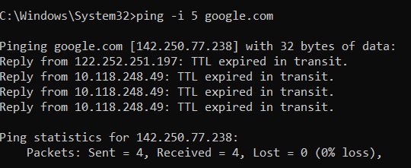

**Explanation**: This command sets the TTL of the ping packets to 5. If the packets have to pass through more than 5 routers to reach google.com, they will be discarded before reaching the destination. This is useful for tracing the number of hops to a destination or controlling the range of your ping tests.

- -w (deadline): Specifies a timeout, in seconds, before ping exits.

This command is same in both linux and windows.  
Example: ping -w 2000 [www.google.com](http://www.google.com)

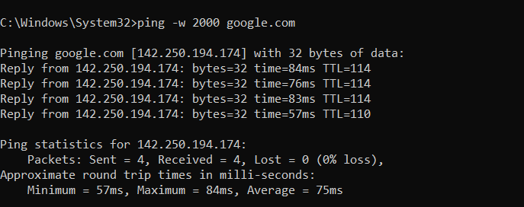

**Explanation**: This command will wait up to 2 seconds for each ping reply from google.com. If no response is received within 2 seconds, the ping is counted as lost. This can be useful in networks with high latency or where you want to limit how long ping waits for a response.

# 4. Troubleshooting with Ping

**Step 1: Basic Connectivity Check**

* **Command**: ping remote-server.com
* **Purpose**: This initial ping test checks whether the workstation can reach the remote server. If the ping command returns replies, it means that basic IP connectivity exists between the workstation and the server.

**Possible Outcomes**:

* **Reply from remote-server.com**: Indicates that the server is reachable, and basic connectivity is established.
* **Request timed out**: Indicates that the server is not reachable. This could be due to the server being down, a network issue, or a firewall blocking ICMP traffic.

**Step 2: Check for Intermittent Connectivity or Packet Loss**

* **Command**: ping -n 100 remote-server.com
* **Purpose**: Sending multiple pings (e.g., 100) allows you to observe if there is any packet loss or intermittent connectivity issues. Packet loss might indicate network congestion, faulty hardware, or configuration issues.

**Possible Outcomes**:

* **No packet loss**: Indicates stable connectivity.
* **Packet loss observed**: Points to possible network issues such as congestion, faulty cables, or network hardware issues.

**Step 3: Measure Network Latency (Round-Trip Time)**

* **Command**: ping -n 10 remote-server.com
* **Purpose**: Measuring the round-trip time (RTT) helps diagnose latency issues. High RTT values may indicate network congestion, a slow link, or an overloaded server.

**Possible Outcomes**:

* **Low and consistent RTT (e.g., <100ms)**: Indicates normal network performance.
* **High RTT (e.g., >200ms) or fluctuating times**: Could indicate network congestion, a slow link, or server performance issues.

**Step 4: Check the Path to the Server**

* **Command**: ping -i 2 remote-server.com
* **Purpose**: By setting a low TTL value (e.g., 2), you can determine how far the packet can travel before the TTL expires. This can help identify at which hop the issue might be occurring.

**Possible Outcomes**:

* **TTL expired at a specific hop**: The issue could be related to a specific router or network segment.
* **TTL reaches the destination**: Indicates the path is generally functioning as expected.

**Step 5: Test Larger Packet Sizes**

* **Command**: ping -l 1500 remote-server.com
* **Purpose**: Sending larger packets can help identify issues with MTU (Maximum Transmission Unit) settings on the network. If large packets are dropped or fragmented, it could point to issues with MTU size mismatches.

**Possible Outcomes**:

* **Larger packets are successful**: Indicates no issues with MTU settings.
* **Larger packets fail or are fragmented**: Suggests a possible MTU mismatch or misconfiguration in the network.

**Step 6: Use Extended Timeout for Slow Networks**

* **Command**: ping -w 5000 remote-server.com
* **Purpose**: Extending the timeout period allows you to accommodate slower networks where replies might take longer to return. This can help differentiate between network slowness and a complete loss of connectivity.

**Possible Outcomes**:

* **Replies received within extended time**: Indicates slow network performance.
* **Timeouts even with extended time**: Points to potential network failure or severe congestion.

**Summary of Tools and Options**

* **Basic Connectivity**: ping remote-server.com
* **Packet Loss**: ping -n 100 remote-server.com
* **Network Latency**: ping -n 10 remote-server.com
* **Path Verification**: ping -i 2 remote-server.com
* **MTU Issues**: ping -l 1500 remote-server.com
* **Extended Timeout**: ping -w 5000 remote-server.com