**Lab 04: Assignment: Ping Utility Analysis**

**Task 1: Tracert Basics**

**Purpose of Tracert Utility:** Tracert (or traceroute) is a network diagnostic tool used to trace the path that packets take from the source to the destination. It shows each hop (router) the packets pass through and the time it takes to reach each one. This helps in identifying network issues, such as delays or unreachable destinations

Syntax: tracert [options] <destination>

Trace route to a website: tracert [www.google.com](http://www.google.com)

Trace route to a local host: tracert 127.0.0.1

**Task 2: Tracert Output Analysis**

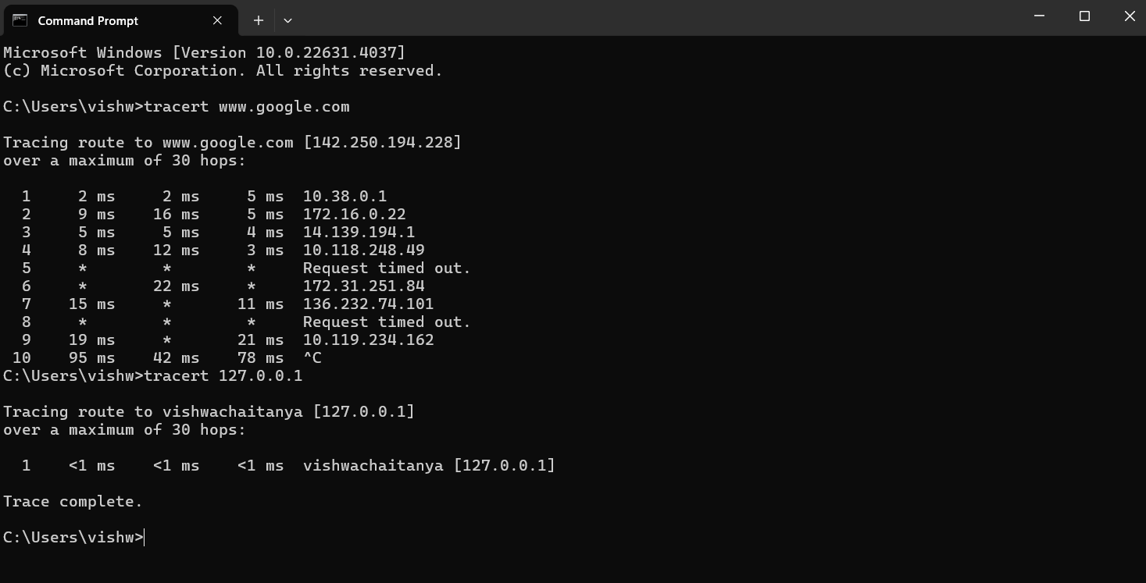

**Output Analysis:**

* **Hop Number:** The sequential number of the hop.
* **RTT (Round-Trip Time):** The time in milliseconds it takes for the packet to reach the hop and return.
* **IP Address:** The IP address of the router at that hop.
* **Significance:** This output shows the path and time taken at each hop. It helps in identifying the network's route and pinpointing where delays or issues may occur.
* **Analysis:** This trace is direct since 127.0.0.1 is the loopback address, meaning the trace stays within the local machine.

**3. Tracert Options:**

**-d (Do not resolve hostnames):**

* Skips resolving IP addresses to hostnames for faster output**.**

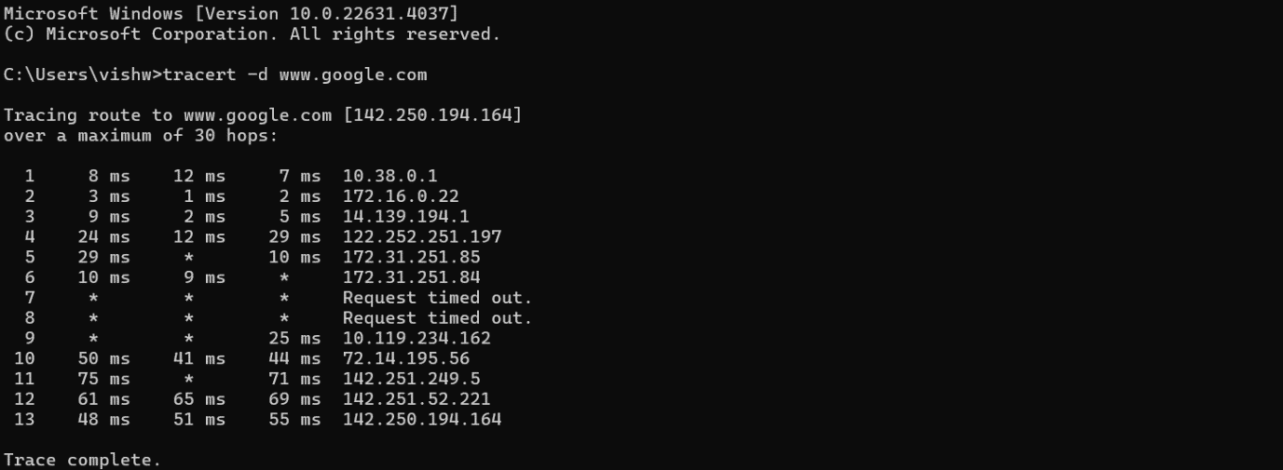

**-h (Maximum number of hops):**

* Sets the maximum number of hops before giving up.

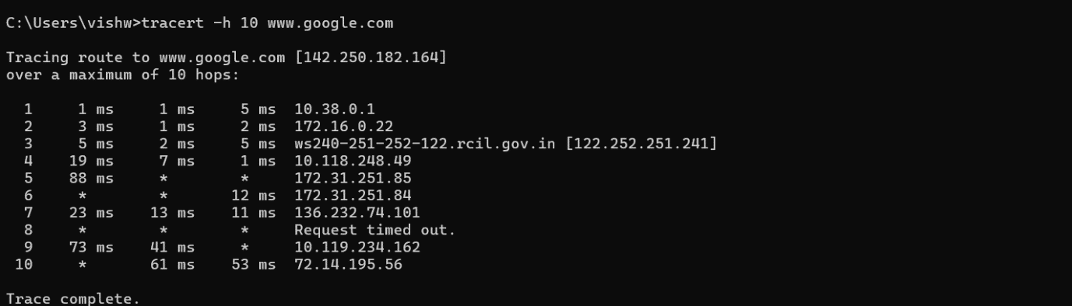

**-w (Timeout in milliseconds):**

* Sets the timeout for each reply.

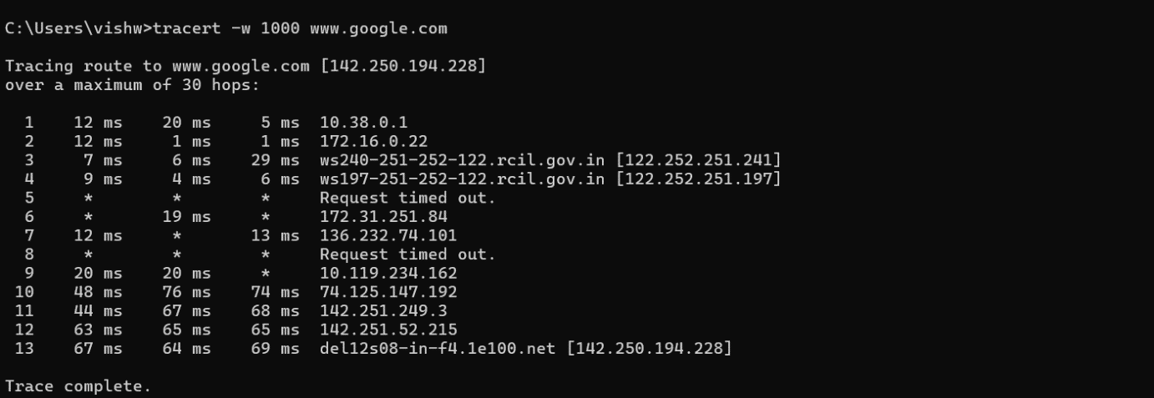

**Task 4: Troubleshooting with Tracert**

If users experience slow connectivity to a website, tracert can be used to diagnose where the delay occurs.

**Command:** tracert -h 20 -w 2000 www.slowwebsite.com

* **Diagnosis:**
  + Identify the hop where delays begin.
  + Check for high RTT values or "*" indicating timeouts.
  + This indicates the point in the network causing the delay.

**Task 5: Conclusion**

Tracert is a valuable tool for diagnosing network issues, showing the path and time taken for packets to reach their destination.

**Limitations:**

* Firewalls may block ICMP packets used by tracert.
* Some hops may not respond, leading to incomplete traces.