SQL practice

On the website <https://www.sql-practice.com/>, using the database available there, I perform the following queries:

1. display all information about patients:

SELECT * FROM patients;

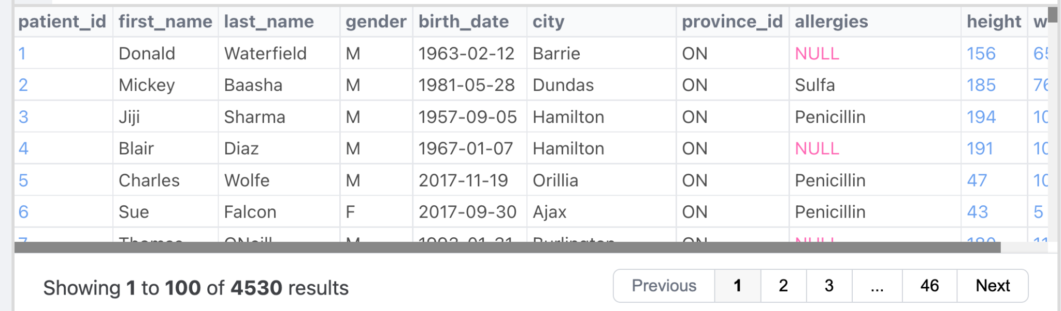

1. Print the minimum and maximum weights in the data set:

SELECT

(SELECT MIN(weight) FROM patients) AS min_weight,

(SELECT MAX(weight) FROM patients) AS max_weight;

1. Print the name, surname and weight of the patient with the highest weight. Only one line should be displayed for the result:

SELECT first_name, last_name, weight

FROM patients

WHERE weight = (SELECT MAX(weight) FROM patients)

LIMIT 1;



1. Print the patient ID, weight, height and birthday of the 5 patients with the lowest weight in the dataset:

SELECT patient_id, weight, height, birth_date

FROM patients

order by weight

LIMIT 5;

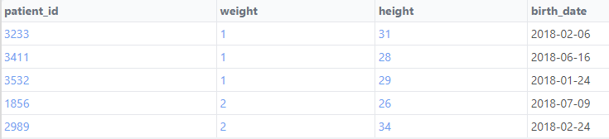

1. I add to the previous result the number of years the patient was alive, rounded to 2 decimal places, at the time of his/her visit to the clinic (admission_date from the admissions table).

I noticed that the age at the time of admission is negative. Either it is a bug in the data or the specifics of the data, for example, a pregnant woman came to the clinic - we will not know.

SELECT p.patient_id, p.weight, p.height, p.birth_date,

ROUND((JULIANDAY(a.admission_date) - JULIANDAY(p.birth_date)) / 365.25, 2) AS age_at_admission

FROM (

SELECT patient_id, weight, height, birth_date

FROM patients

ORDER BY weight

LIMIT 5

) as sub

JOIN patients p ON p.patient_id = sub.patient_id

INNER JOIN admissions a ON a.patient_id = p.patient_id;

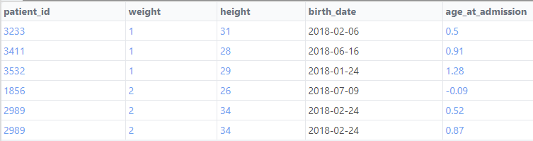

1. I print the TOP 5 diagnoses in the database by the number of cases of appointments with them. I named the column with the number of cases with the diagnosis count_cases:

SELECT diagnosis, COUNT(1) as count_cases

FROM admissions

GROUP BY diagnosis

ORDER BY count_cases DESC

LIMIT 5;

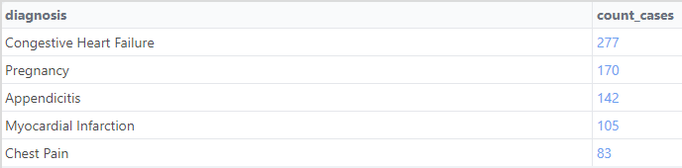

1. I display all the information from the admissions table for the last patient in the database (identified by admission_date) with the most frequent diagnosis:

SELECT a.*

FROM admissions a

JOIN (

SELECT diagnosis

FROM admissions

GROUP BY diagnosis

ORDER BY COUNT(*) DESC

LIMIT 1

) AS most_common_diagnosis

ON a.diagnosis = most_common_diagnosis.diagnosis

WHERE a.admission_date = (

SELECT MAX(admission_date)

FROM admissions

WHERE diagnosis = most_common_diagnosis.diagnosis

);



1. I have created a query to find a list of first names, last names and allergies of patients from Hamilton who have allergies (i.e. the value allergies is not empty):

SELECT first_name, last_name, allergies

FROM patients

WHERE city = 'Hamilton' AND allergies IS NOT NULL;

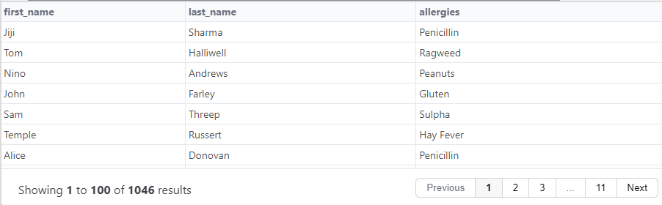

1. Each appointment costs $50 for patients without insurance and $10 for patients with insurance. All patients with a paired patient ID have insurance.

We will code each patient as "Yes" if they have insurance and "No" if they do not, and call this column has_insurance. Aggregate the data by has_insurance and add the total cost of admissions for each has_insurance group.

SELECT

CASE WHEN MOD(patient_id, 2) = 0 THEN 'Yes' ELSE 'No' END AS has_insurance,

SUM(CASE WHEN MOD(patient_id, 2) = 0 THEN 10 ELSE 50 END) AS cost_after_insurance

FROM admissions

GROUP BY has_insurance;

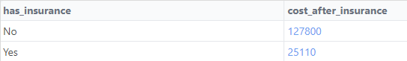

1. Print the unique names of the patients that begin and end with "s", along with the number of such patients. The number of name bearers is sorted in descending order:

SELECT first_name, COUNT(*) AS name_count

FROM patients

WHERE first_name like 'S%s'

GROUP BY first_name

ORDER BY name_count DESC;

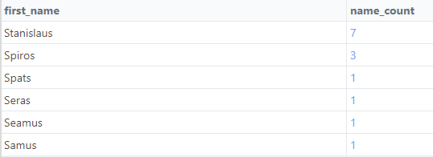

1. Print the number of male patients and female patients by province (province_name) so that the number of men is in one column and the number of women is in the other. I sorted the data in descending order of the number of men and filtered the data so that only those provinces with more than 20 patients (men and women in total) were included in the sample.

SELECT province_name,

SUM(CASE WHEN gender == 'M' THEN 1 ELSE 0 END) AS male_count,

SUM(CASE WHEN gender == 'F' THEN 1 ELSE 0 END) AS female_count

FROM patients p JOIN province_names pn ON p.province_id=pn.province_id

GROUP BY province_name

HAVING SUM(1) > 20

ORDER BY male_count DESC;

