PROJECT DOCUMENTATION
CAMPUS SKILL EXCHANGE & HELP MANAGEMENT SYSTEM
(SkillBridge)

A Full-Stack CRUD-Based Web Application

Submitted By: JANANI VEERASAMY
Department: Information Technology
Year: 2nd Year
Application: SkillBridge – Campus Skill Exchange & Help Management System

Prepared according to the supplied Standard Operating Procedure (SOP)

PROJECT DOCUMENTATION DECLARATION
This document presents the design, development, database structure, CRUD implementation, validation, testing, user interface, and demonstration details of the Campus Skill Exchange & Help Management System (SkillBridge). The content is prepared from the supplied project source folder, project documentation files, and the screenshots provided for the working application.
The report follows the structure and requirements of the supplied CRUD-based web application SOP. Where the project uses Supabase directly through its JavaScript client rather than a separate Django or Spring Boot server, the report describes the implemented architecture as it exists in the project instead of replacing it with a different backend design.

TABLE OF CONTENTS
1. Project Overview
2. Problem Statement
3. Objectives
4. Scope of the Project
5. Requirements Analysis
6. Technology Stack
7. System Architecture
8. Modules and Functional Description
9. Database Design
10. API and Data Operation Documentation
11. CRUD Implementation
12. Validation and Security
13. Frontend–Backend Integration
14. User Interface Demonstration
15. Testing Procedure and Results
16. Installation and Execution
17. Challenges and Solutions
18. Future Enhancements
19. Project Submission Checklist
20. Learning Outcomes
21. Completion Criteria
22. Conclusion

1. PROJECT OVERVIEW
Project Title: Campus Skill Exchange & Help Management System (SkillBridge).
SkillBridge is a peer-to-peer skill exchange platform designed for college students. The system allows students to publish skills they can teach, discover skills offered by other students, create help requests, update request status, and interact through a structured help-exchange workflow. The project also includes profile management, feedback, search and filtering, role-based administration, and database-level security.
The supplied project identifies React, TypeScript, Tailwind CSS and Vite for the frontend, React Router DOM for navigation, Lucide React for icons, and Supabase for PostgreSQL database services, authentication and Row Level Security. The project source is organized into reusable components, authentication/context modules, student and admin pages, service-layer functions, types, utilities and database migrations.
The working screenshots demonstrate the student-facing interface, including login, dashboard, About page, Browse Skills, My Skills, Add Skill, My Requests, request status update, request deletion confirmation, request editing, and request details.
1.1 Project Purpose
The purpose of SkillBridge is to provide a structured digital environment where students can exchange knowledge within a campus community. It connects students who have a skill to students who need help, while providing CRUD operations and controlled access to user-owned records.
1.2 Key Features
- Email/password registration, login and logout.
- Student and Admin role-based access.
- Add, view, edit and delete skills.
- Create, view, edit and delete help requests.
- Request status management: Open, In Progress, Completed and Cancelled.
- Offer-help workflow for open requests.
- Feedback after completed help requests using a 1–5 rating and comment.
- Search and filtering for skills and help requests.
- Student profile viewing and editing.
- Admin dashboard and moderation functions.
- Responsive and user-friendly interface with loading, empty, error and confirmation states.
2. PROBLEM STATEMENT
College students frequently need help with subjects, tools, or skills but may struggle to identify peers who can assist them. Traditional academic support systems can be limited in availability and scope. At the same time, many students possess useful technical, academic or creative skills but do not have a dedicated platform through which they can offer those skills to their peers.
SkillBridge addresses this gap by providing a peer-to-peer skill exchange platform. Students can offer skills they know, create help requests when assistance is required, browse and search available skills, receive rule-based matching with potential helpers, and provide feedback after help is completed.
The system therefore combines skill discovery and help-request management in one application, supported by authentication, database constraints, row-level security and administrative moderation.
3. OBJECTIVES
- Enable secure user registration and authentication with Student/Admin roles.
- Implement complete CRUD operations for skills.
- Implement complete CRUD operations for help requests.
- Provide search and filter functionality for skills and help requests.
- Implement rule-based skill matching between requests and skill providers.
- Provide a feedback mechanism after help completion.
- Provide an admin dashboard for platform monitoring and content moderation.
- Ensure responsive design across desktop, tablet and mobile devices.
- Implement client-side and server/database-side validation.
- Provide meaningful error handling and user-friendly messages.
4. SCOPE OF THE PROJECT
- Frontend user-interface development using React and TypeScript.
- Student authentication and protected application routes.
- Skill management and skill discovery.
- Help-request creation and lifecycle management.
- Rule-based skill matching.
- Feedback management after completed requests.
- Profile management.
- Administrative user/content management.
- Database design using PostgreSQL through Supabase.
- Validation, RLS policies, testing and documentation.
5. REQUIREMENTS ANALYSIS
5.1 Functional Requirements
ID | Requirement | Description
FR01 | User Registration | Register using full name, email, password, department, year, college and bio.
FR02 | Authentication | Login and logout using email and password.
FR03 | Role Management | Support Student and Admin roles.
FR04 | Skill CRUD | Add, read, update and delete skills.
FR05 | Request CRUD | Create, read, update and delete help requests.
FR06 | Status Management | Move requests through Open, In Progress, Completed or Cancelled.
FR07 | Offer Help | Allow a student to offer help on an open request.
FR08 | Feedback | Submit 1–5 star feedback and a comment after completion.
FR09 | Profile | View and edit permitted profile fields.
FR10 | Dashboard | Display activity statistics and recent items.
FR11 | Admin Management | Manage users, skills, requests and feedback.
FR12 | Search & Filter | Search/filter skills and requests using supported fields.
FR13 | Skill Matching | Show students who can help based on skill name/category.

5.2 Non-Functional Requirements
Category | Requirement
Security | Supabase Auth, Row Level Security, owner-scoped policies and admin controls.
Performance | Indexes are defined for frequently queried skill, request and feedback columns.
Responsiveness | Interface is intended to work across desktop, tablet and mobile screen sizes.
Accessibility | Labels, readable contrast and keyboard-friendly controls are included.
Usability | Loading, empty and error states, toast notifications and delete confirmations are provided.

6. TECHNOLOGY STACK
Layer | Technology | Purpose
Frontend | React 18.3.1 | Component-based user interface
Language | TypeScript 5.5.3 | Typed frontend development
Build Tool | Vite 5.4.2 | Development server and production build
Styling | Tailwind CSS 3.4.1 | Responsive UI styling
Routing | React Router DOM 7.18.3 | Application navigation
Icons | Lucide React 0.446.0 | Interface icons
Backend / Database | Supabase / PostgreSQL | Database and backend services
Authentication | Supabase Auth | Email/password authentication
Security | Supabase Row Level Security | Database-level access control

The supplied SOP lists Django/Django REST Framework or Spring Boot as backend options. The actual SkillBridge project instead uses Supabase as the backend/database service through the Supabase JavaScript SDK. This report documents the actual implementation present in the supplied project.
The project package configuration also includes ESLint, TypeScript tooling, PostCSS and Autoprefixer. The application can be run through the Vite development server using the npm scripts supplied in package.json.
7. SYSTEM ARCHITECTURE
SkillBridge follows a client-service-backend architecture. React pages form the presentation layer. The service layer in src/services/ contains the application’s data-access functions. The Supabase JavaScript client communicates with Supabase Auth and the PostgreSQL database. Row Level Security policies enforce access at the database layer.
PUBLIC UI | STUDENT UI | ADMIN UI
Landing / About / Login / Register | Dashboard / Skills / Requests / Profile | Admin Dashboard / Users / Skills / Requests / Feedback
React + TypeScript + Tailwind CSS + React Router | Service Layer (src/services/) | Supabase JS Client
Supabase Auth | PostgreSQL Database | Row Level Security Policies
Security Definer Functions: is_admin(), offer_help(), handle_new_user()

7.1 Authentication Flow
- User registers through the Supabase Auth sign-up function with profile metadata.
- The database trigger creates the corresponding profile record.
- User logs in through email/password authentication.
- The frontend obtains the authenticated session and profile information.
- The application determines whether the user has Student or Admin access.
- Protected routes and database RLS policies enforce access restrictions.
7.2 Data Flow
- User performs an action in the React interface.
- The relevant service function in src/services/ is called.
- The Supabase JavaScript client sends the database/authentication request.
- PostgreSQL processes the operation and RLS policies verify authorization.
- The service returns data or an error.
- The React interface updates the visible state and displays a success/error message.
8. MODULES AND FUNCTIONAL DESCRIPTION
Module | Description
8.1 Public Module | Landing, About, Login and Register pages introduce the platform and provide entry into the authenticated application.
8.2 Authentication Module | Provides email/password registration, login, logout, protected routes and role identification.
8.3 Student Dashboard | Displays skill count, active requests, completed work, pending activity, quick actions and recent items.
8.4 Skill Management Module | Students add, read, edit and delete skills, with fields for name, category, level, description, experience, availability and preferred mode.
8.5 Browse Skills Module | Students discover skills offered by other students and use search/filter functionality.
8.6 Help Request Module | Students create help requests with title, required skill, category, description, priority, preferred mode and deadline.
8.7 Request Tracking Module | Students view requests, edit details, update status and delete requests with confirmation.
8.8 Skill Matching Module | The system applies rule-based matching using skill name and category to identify students who can help.
8.9 Feedback Module | Completed requests can receive a 1–5 rating and a comment subject to validation and uniqueness rules.
8.10 Profile Module | Students can view profile information and edit permitted non-role fields.
8.11 Admin Module | Administrators can view statistics and manage users, skills, requests and feedback.
8.12 Shared UI / State Module | Reusable components provide badges, dialogs, loading states, error states, navigation, protected routes, toasts and rating controls.

9. DATABASE DESIGN
The database design supplied with the project uses PostgreSQL through Supabase. Four principal application tables are documented: profiles, skills, help_requests and feedback. The profiles table extends the authenticated user with student-specific information.
Table | Important Columns | Constraints / Purpose
profiles | id, full_name, email, department, year, college, bio, role, is_active, created_at, updated_at | PK id; email UNIQUE; role CHECK; required profile fields
skills | id, user_id, skill_name, category, skill_level, description, experience, availability, preferred_mode, created_at, updated_at | PK id; user_id FK; checks for level, availability and mode
help_requests | id, user_id, title, skill_needed, category, description, priority, preferred_mode, deadline, status, provider_id, created_at, updated_at | PK id; requester/provider FKs; checks for priority, mode and status
feedback | id, request_id, provider_id, requester_id, rating, comment, created_at | PK id; FKs; rating 1–5; comment length check; request/requester UNIQUE

9.1 Entity Relationship Description
Entity A | Relationship | Entity B
auth.users | 1 : 1 | profiles
profiles | 1 : N | skills
profiles | 1 : N | help_requests (requester)
profiles | 1 : N | help_requests (provider, optional)
help_requests | 1 : 1 | feedback
profiles | 1 : N | feedback (provider)
profiles | 1 : N | feedback (requester)

9.2 Database Indexes
- idx_skills_user_id
- idx_skills_category
- idx_skills_skill_name
- idx_help_requests_user_id
- idx_help_requests_category
- idx_help_requests_status
- idx_feedback_request_id
- idx_feedback_provider_id
10. API AND DATA OPERATION DOCUMENTATION
The application does not expose a separate custom REST controller layer such as Django REST Framework or Spring Boot. Instead, all application data operations use the Supabase JavaScript client through the service layer in src/services/. The supplied API documentation records authentication calls, table operations and the offer_help RPC function.
Area | Operation | Purpose
Authentication | signUp() | Register a user and attach profile metadata.
Authentication | signInWithPassword() | Authenticate an existing user.
Authentication | signOut() | End the current session.
Skills | SELECT | List skills with search/filter options.
Skills | INSERT | Create a new skill.
Skills | SELECT by ID | Retrieve one skill with provider information.
Skills | UPDATE | Update an owned skill.
Skills | DELETE | Delete an owned/admin-managed skill.
Help Requests | SELECT | List requests with filters.
Help Requests | INSERT | Create a help request.
Help Requests | UPDATE | Update request details or status.
Help Requests | DELETE | Delete an owned/admin-managed request.
Help Requests | RPC offer_help() | Offer help on an open request.
Feedback | INSERT | Submit feedback after completion.
Feedback | SELECT | Check/view feedback.
Feedback | DELETE | Admin-only feedback deletion.

10.1 Typical Result / Error Categories
Code | Meaning
200 | Successful read/update operation
201 | Successful creation (conceptual API result category)
400 | Validation error
401 | Unauthenticated access
403 | Forbidden / ownership or role restriction
404 | Requested record not found
500 | Server-side or service error

11. CRUD IMPLEMENTATION
11.1 Skills CRUD
Operation | Page | Data | Control
CREATE | /my-skills/new | skill_name, category, skill_level, description, experience, availability, preferred_mode | Required name/category/level; owner RLS
READ | /my-skills, /browse-skills, /skills/:id | Current user's skills or searchable skills | Read access according to application/RLS rules
UPDATE | /my-skills/:id/edit | Skill fields | Only owner can update
DELETE | Delete control + confirmation | Skill ID | Owner or admin; confirmation required

11.2 Help Requests CRUD
Operation | Page | Data | Control
CREATE | /help-requests/new | title, skill_needed, category, description, priority, preferred_mode, deadline | Owner-scoped create
READ | /help-requests, /my-requests, /requests/:id | Request list/details | Search/filter supported
UPDATE | /requests/:id/edit + status control | Request details/status | Owner-scoped update
DELETE | Delete control + confirmation | Request ID | Owner or admin

11.3 Feedback CRUD
- CREATE: Submit feedback only after the request is completed.
- READ: Feedback is displayed on request details after submission; administrators can view feedback.
- DELETE: Feedback deletion is restricted to administrators.
12. VALIDATION AND SECURITY
12.1 Validation Rules
- Required fields must not be empty.
- Email values must follow a valid email format.
- Passwords must satisfy the application's minimum length rule.
- Password confirmation must match during registration.
- Skill levels must use the supported Beginner, Intermediate or Advanced values.
- Priority must use Low, Medium or High.
- Request status must use Open, In Progress, Completed or Cancelled.
- Feedback rating must be between 1 and 5.
- Feedback comment must meet the minimum documented length.
- Duplicate feedback for the same request/requester pair is prevented by a unique constraint.
12.2 Security Controls
- Passwords are handled through Supabase Auth rather than stored as plain application data.
- Row Level Security is enabled on application tables.
- Owner-scoped policies restrict users to their own protected create/update operations.
- Admin operations use the documented is_admin() SECURITY DEFINER function.
- The offer_help() SECURITY DEFINER function supports the offer-help workflow.
- Environment variables are used for Supabase configuration.
- The supplied project documentation recommends avoiding hard-coded secrets and credentials.
13. FRONTEND–BACKEND INTEGRATION
The React frontend communicates with Supabase through the @supabase/supabase-js client. The project keeps data-access operations in a service layer, which separates UI components from direct database calls.
- User interacts with a React page or form.
- The page calls a service function.
- The service function uses the Supabase client to query or modify data.
- Supabase Auth/RLS validates the request and PostgreSQL performs the data operation.
- The returned result is handled by the React component.
- Toast notifications, empty states, loading states or error states communicate the result to the user.
14. USER INTERFACE DEMONSTRATION
The following screenshots were supplied from the running SkillBridge application. They are included as evidence of the implemented interface and workflow. The screenshots are mapped to the relevant modules and CRUD actions.
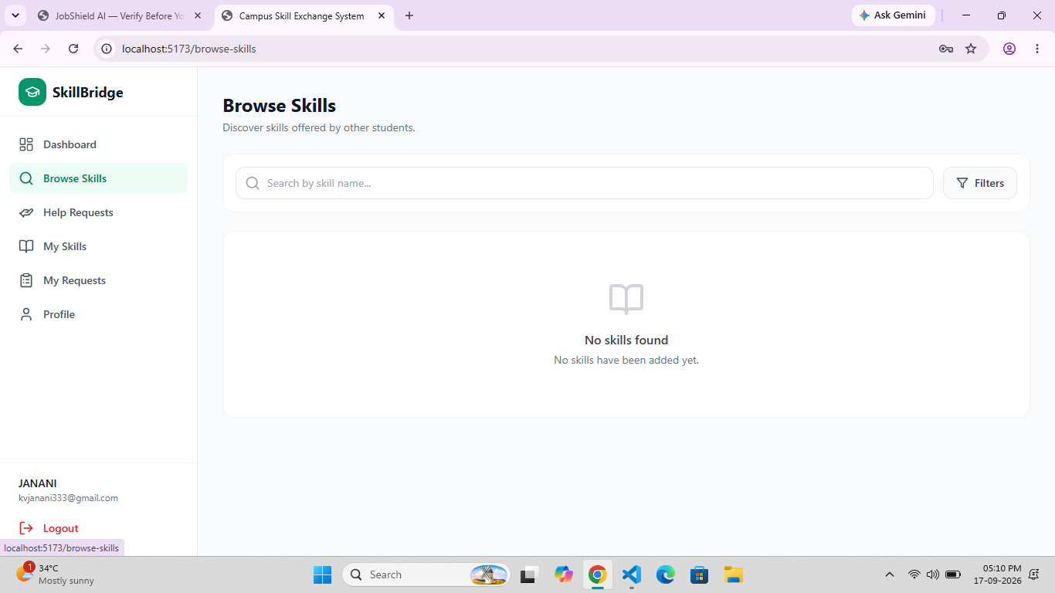
Figure 1. Browse Skills page showing the empty-state message.
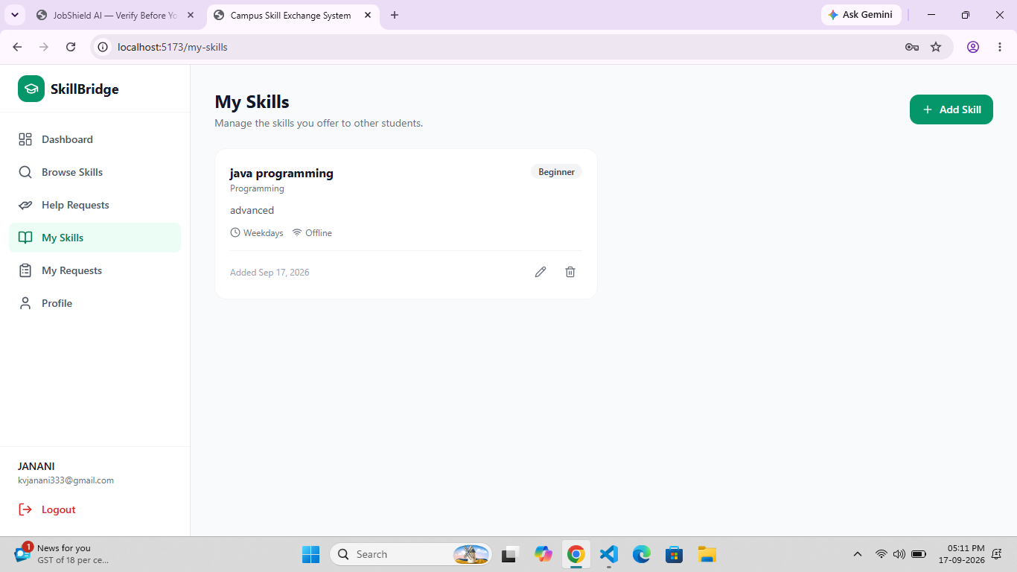
Figure 2. My Skills page showing a skill offered by the student.
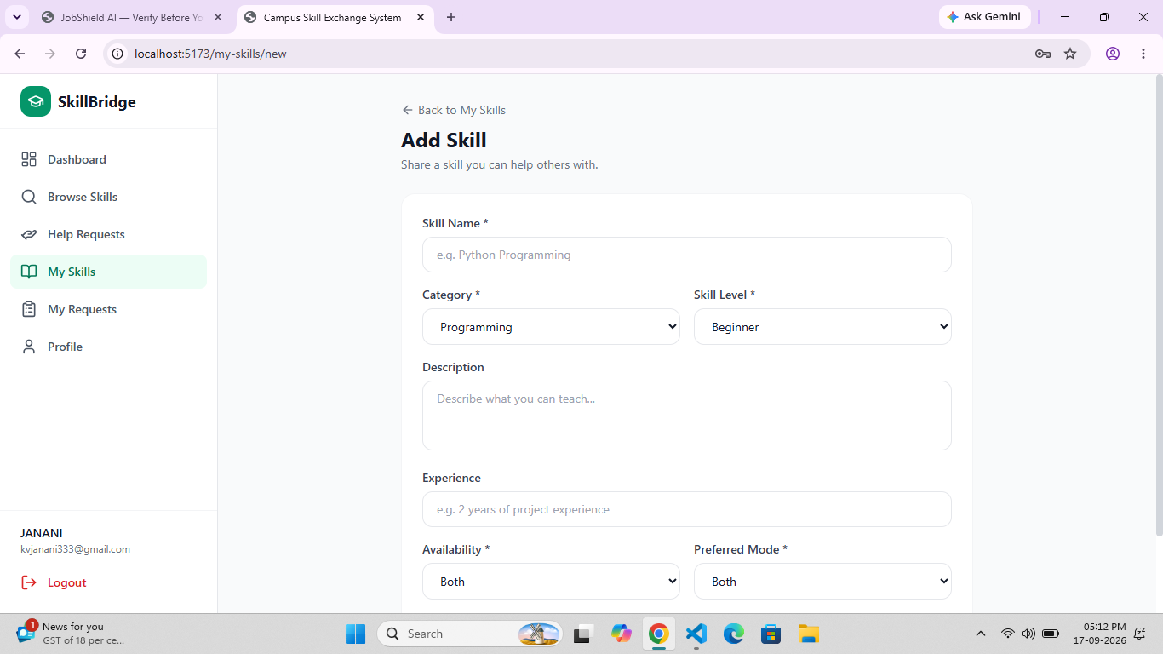
Figure 3. Add Skill form with skill, category, level, description, experience, availability and preferred mode fields.

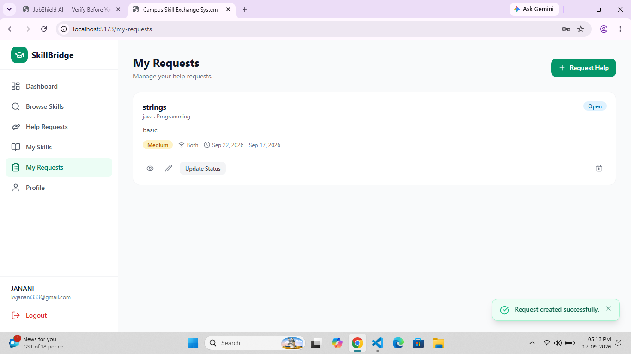
Figure 4. My Requests page showing a created help request.
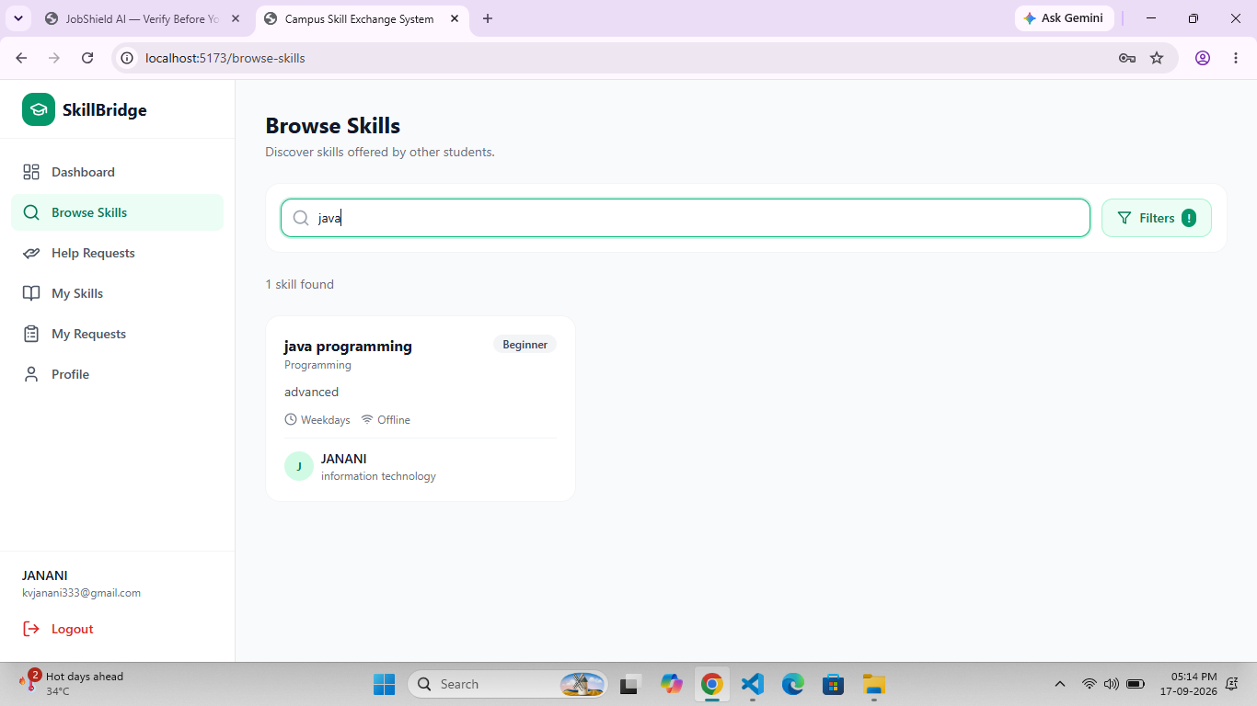
Figure 5. Browse Skills search and filter functionality.
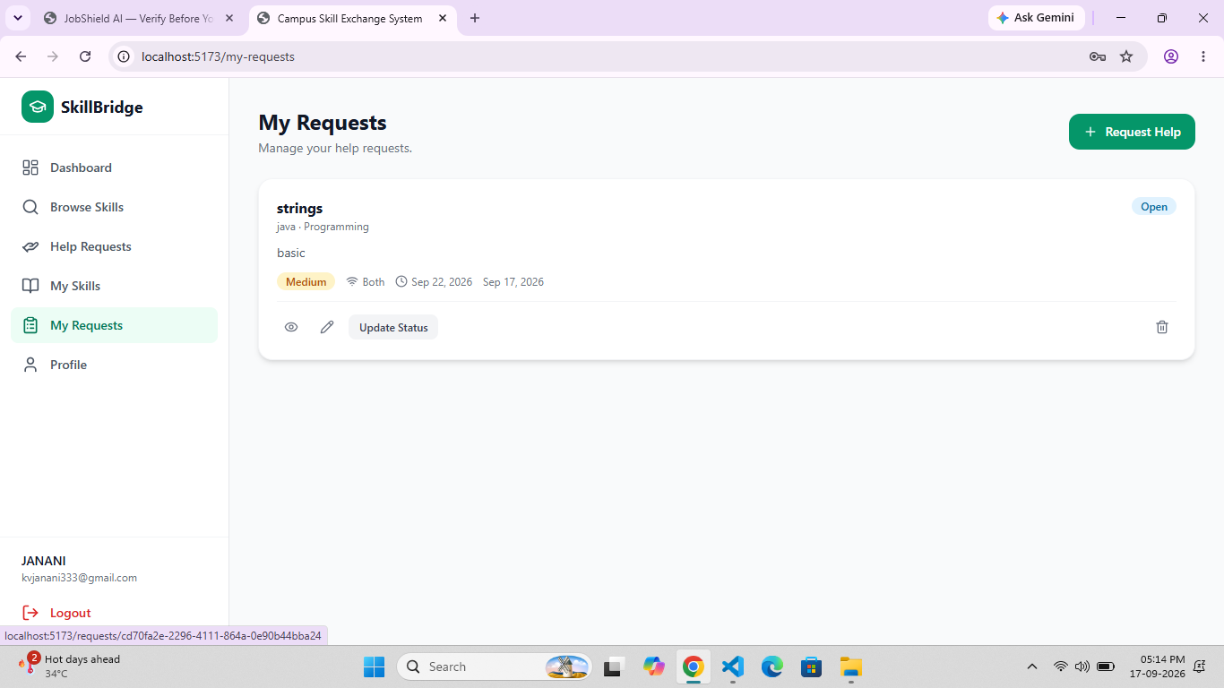
Figure 6. My Requests page after creating a help request.

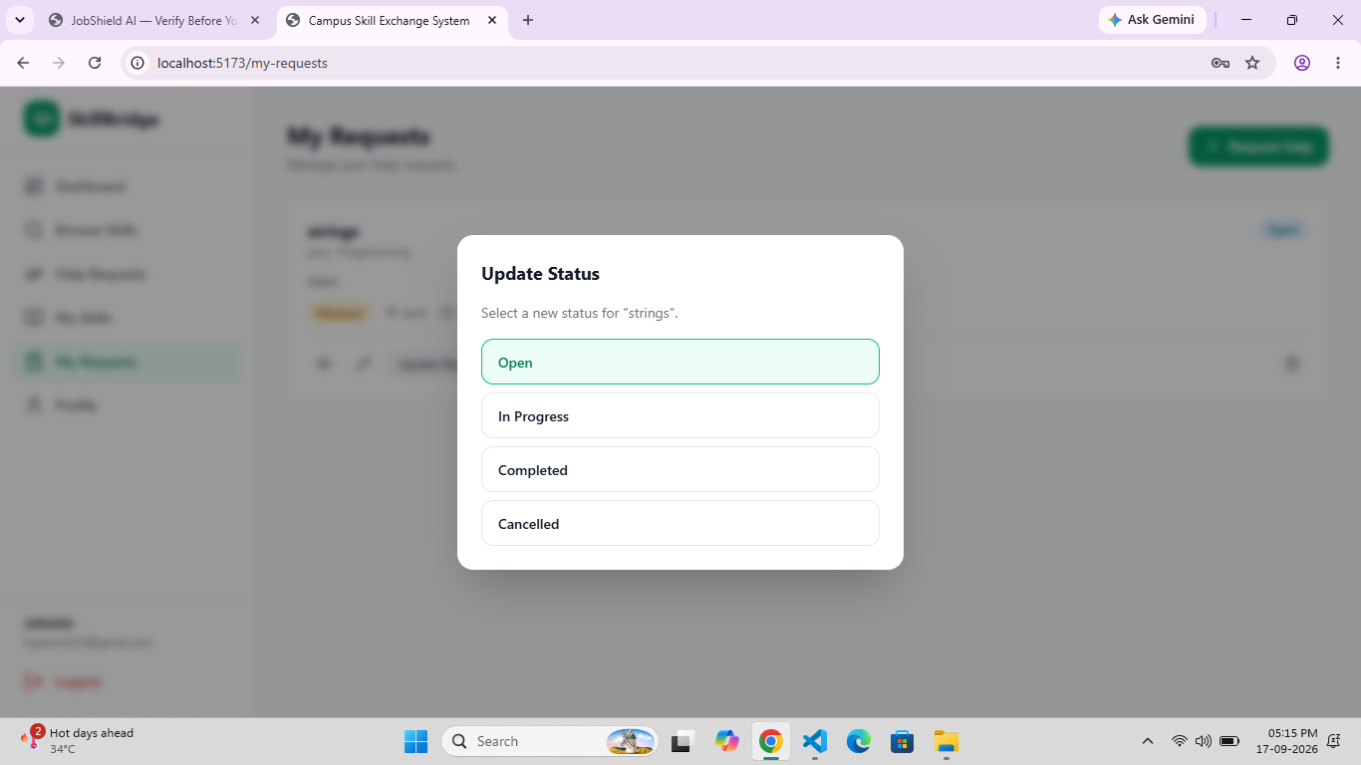
Figure 7. Update Status dialog for a help request.
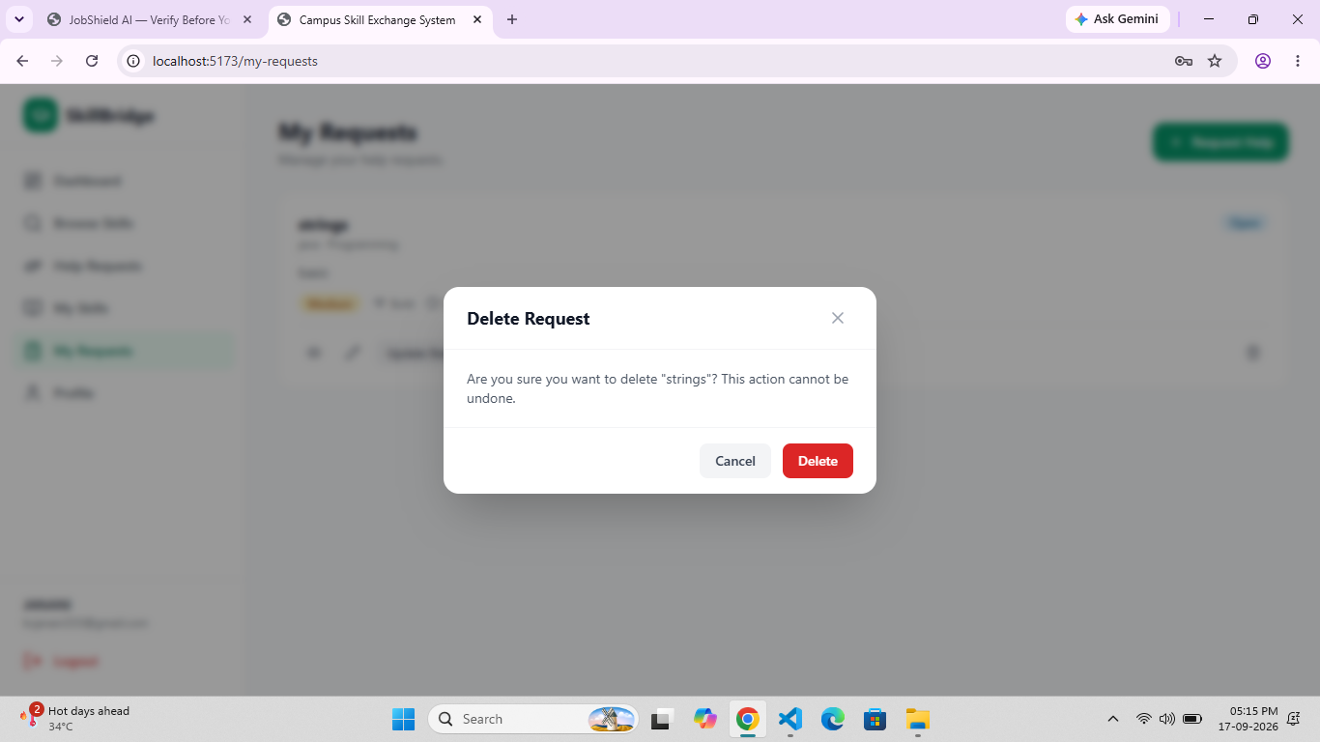
Figure 8. Delete Request confirmation dialog.
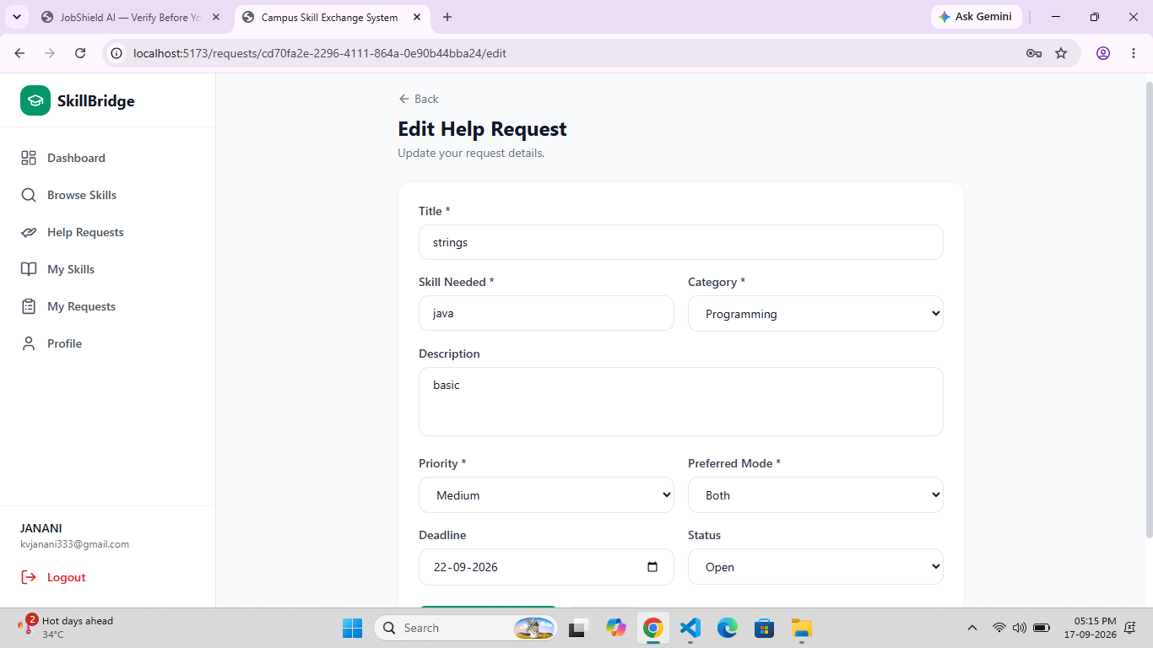
Figure 9. Edit Help Request form.

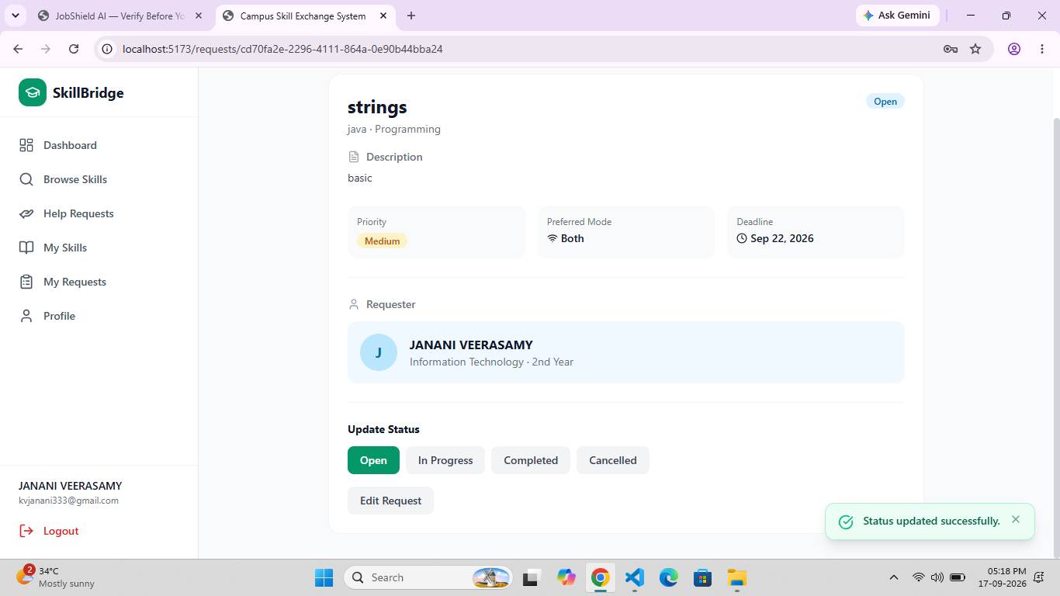
Figure 10. Help Request Details page showing status and requester information.
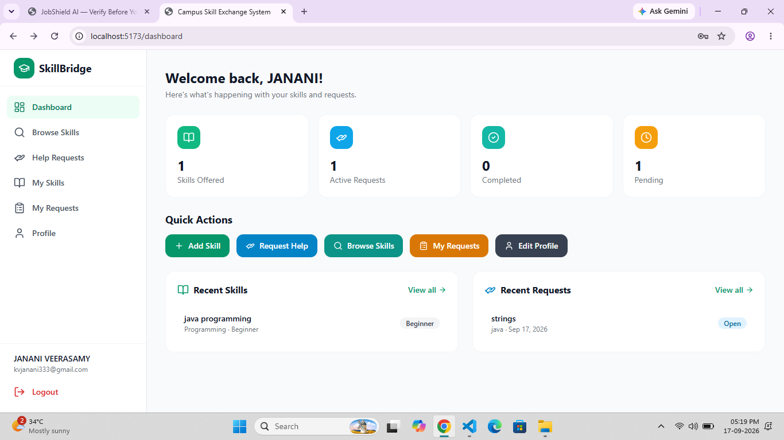
Figure 11. Student Dashboard with statistics, quick actions, recent skills and recent requests.

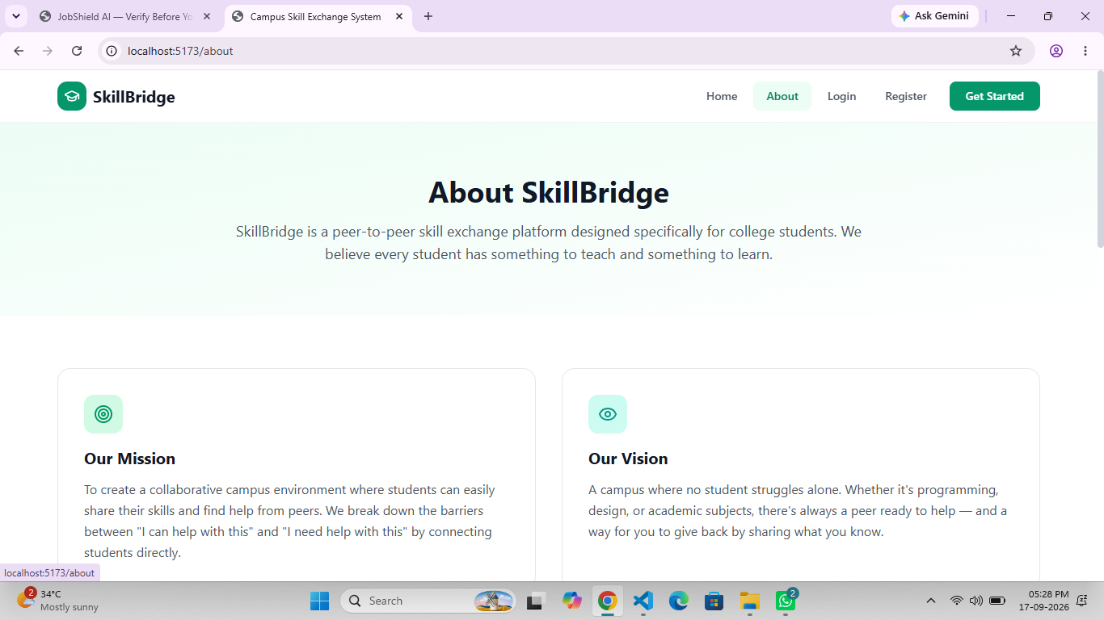
Figure 12. About SkillBridge page showing the mission and vision.
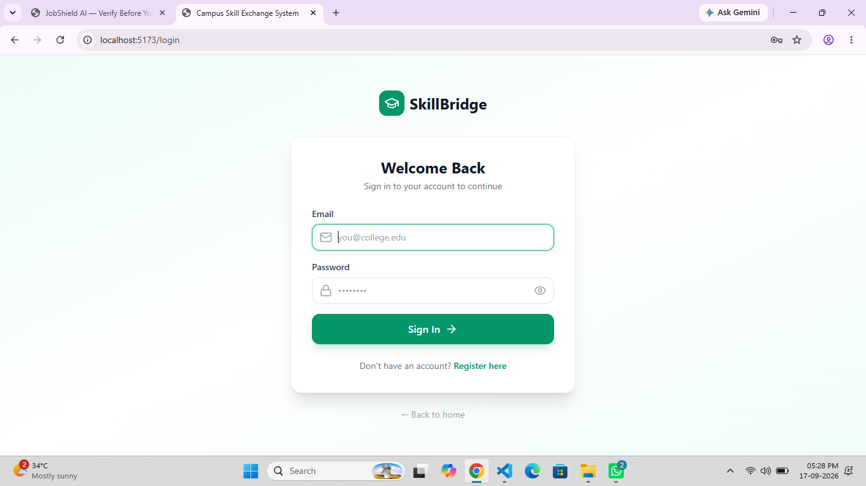
Figure 13. SkillBridge Login page.
15. TESTING PROCEDURE AND RESULTS
The supplied project includes a testing document covering registration, login, skills CRUD, help requests CRUD, feedback, admin functions, search/filter and skill matching. The documented test cases below are reproduced as the project’s stated testing evidence.
15.1 Registration Tests
Test Case | Expected / Observed Result | Result
Valid registration | Account created and redirected to login | Pass
Empty required fields | Validation message displayed | Pass
Invalid email | Valid email message displayed | Pass
Duplicate email | Already registered message displayed | Pass
Password below minimum | Minimum-length message displayed | Pass
Password mismatch | Mismatch message displayed | Pass

15.2 Login Tests
Test Case | Expected / Observed Result | Result
Correct credentials | Login success and dashboard redirect | Pass
Wrong password | Invalid credentials message | Pass
Unknown email | Invalid credentials message | Pass
Empty fields | Required-field message | Pass

15.3 Skills CRUD Tests
Test Case | Expected / Observed Result | Result
Create valid skill | Skill added successfully | Pass
Empty skill name | Validation message | Pass
Read My Skills | Only current user's skills shown | Pass
Read Browse Skills | Skills shown with filters | Pass
Update own skill | Updated successfully | Pass
Delete own skill | Confirmation then deletion | Pass
Unauthorized update | RLS blocks operation | Pass
Unauthorized delete | RLS blocks operation | Pass

15.4 Help Request Tests
Test Case | Expected / Observed Result | Result
Create request | Request created successfully | Pass
Read all requests | Requests shown with search/filter | Pass
Read My Requests | Only user's requests shown | Pass
Update status | Status updated successfully | Pass
Edit request | Request updated successfully | Pass
Delete request | Confirmation then deletion | Pass
Invalid request ID | Not found message | Pass
Unauthorized access | RLS blocks operation | Pass
Offer help | Help offered successfully | Pass
Offer help on own request | Operation prevented | Pass

15.5 Feedback Tests
Test Case | Expected / Observed Result | Result
Valid completed-request feedback | Feedback submitted | Pass
Rating outside 1–5 | Database check blocks it | Pass
Duplicate feedback | Unique constraint blocks it | Pass
Feedback before completion | RLS blocks it | Pass
Short comment | Minimum-length validation | Pass

15.6 Admin Tests
Test Case | Expected / Observed Result | Result
Admin dashboard | Statistics displayed | Pass
Student admin access | Redirect to unauthorized page | Pass
View users | User table displayed | Pass
Deactivate user | Success message | Pass
Delete skill | Success message | Pass
Delete request | Success message | Pass
Delete feedback | Success message | Pass

15.7 Search, Filter and Matching Tests
Test Case | Expected / Observed Result | Result
Search skill by name | Matching skills displayed | Pass
Filter skill by category | Selected category displayed | Pass
Filter skill by level | Selected level displayed | Pass
Search request by title | Matching requests displayed | Pass
Filter request by status | Selected status displayed | Pass
Sort requests by priority | High → Medium → Low | Pass
Clear filters | All results displayed | Pass
Request Java matches Java skill | Exact match shown first | Pass
Request Java matches Programming category | Category match shown after exact | Pass
No matching skill | No matching section shown | Pass

16. INSTALLATION AND EXECUTION
The project uses Node.js/npm tooling and Vite. The supplied README specifies the following general execution process.
- Open the project folder in VS Code or a terminal.
- Install dependencies using npm install.
- Create the local environment file from the supplied .env.example.
- Set the Supabase URL and anonymous key in the environment file.
- Ensure the Supabase database migration has been applied to the target project.
- Start the development server using npm run dev.
- Open the local Vite URL shown in the terminal.
16.1 Environment Variables
Variable | Purpose
VITE_SUPABASE_URL | URL of the Supabase project
VITE_SUPABASE_ANON_KEY | Public anonymous client key used by the frontend

16.2 Useful npm Scripts
Command | Purpose
npm run dev | Start Vite development server
npm run build | Create production build
npm run lint | Run ESLint checks
npm run typecheck | Run TypeScript type checking
npm run preview | Preview the production build

17. CHALLENGES AND SOLUTIONS
Challenge | Requirement | Implemented Solution
Finding suitable peer support | Students may not know who can help. | Provide searchable skill listings and rule-based matching.
Managing user-owned data | Students must not edit another user's protected records. | Use owner-scoped RLS policies.
Handling request lifecycle | A help request can change state over time. | Provide explicit Open, In Progress, Completed and Cancelled statuses.
Preventing invalid feedback | Feedback should only follow completed help. | Use status-based access control, rating checks and comment validation.
Administrative moderation | Inappropriate content may need removal. | Provide administrator-only management screens and policies.
Clear user feedback | CRUD operations need visible confirmation. | Use success/error toast messages and confirmation dialogs.

18. FUTURE ENHANCEMENTS
- AI-based skill matching using embeddings or NLP for more relevant provider recommendations.
- Real-time in-app chat using Supabase Realtime.
- Email notifications for offers and status changes.
- Browser push notifications for important updates.
- Faculty/admin skill verification.
- Calendar-based scheduling for help sessions.
- Gamification and badges for active or highly rated helpers.
- College-specific communities.
- Multilingual support.
- Mobile application using React Native.
19. PROJECT SUBMISSION CHECKLIST
Item | SOP Requirement | Project Evidence
Source Code | Complete frontend source code and project configuration | Included in supplied project folder
Database | Schema/migration files | Supabase migration supplied
Documentation | Project report and API/data-operation documentation | Included in project docs and this report
Testing | Test cases and results | Testing documentation supplied
Repository | Git repository / reference | Project README contains repository/reference section if configured
Demonstration | Working CRUD operations | Working UI screenshots supplied for major workflows

20. EXPECTED LEARNING OUTCOMES
- Understand full-stack web application architecture.
- Develop responsive frontend interfaces using React and TypeScript.
- Build service-based data operations connected to Supabase.
- Perform database CRUD operations.
- Integrate frontend pages with authentication and database services.
- Apply validation, exception/error handling and access control.
- Test and debug a complete web application.
- Use structured project documentation and source organization.
- Explain and demonstrate a real-world software project.
21. COMPLETION CRITERIA
- Application starts and displays the implemented pages.
- Authentication and protected application access work.
- Database connection and Supabase services are configured.
- Create, Read, Update and Delete operations are implemented for the documented entities.
- Validation and confirmation flows are implemented.
- Search/filter and skill-matching functions are available as documented.
- Testing documentation is completed.
- Source code and database migration are included.
- Project documentation and demonstration screenshots are prepared.
- The student can explain the architecture, data flow, CRUD workflow and security controls.
22. CONCLUSION
Campus Skill Exchange & Help Management System (SkillBridge) is a complete student-focused CRUD web application that combines skill sharing and peer help requests. The project provides authentication, student and administrator roles, skill and request management, search/filtering, rule-based matching, feedback, profile management and database security.
The supplied implementation demonstrates separation between React presentation components and service-layer data operations, while Supabase provides authentication, PostgreSQL storage and Row Level Security. The screenshots demonstrate the working student interface and major CRUD interactions, including adding skills, browsing and searching skills, creating and editing requests, updating status and confirming deletion.
The project satisfies the core goals of a CRUD-based full-stack application by connecting user interface actions to persistent database operations, applying validation and access controls, documenting test cases, and providing a structured basis for project demonstration and evaluation.
APPENDIX A – PROJECT STRUCTURE
Folder | Purpose
src/components/ | Reusable UI components such as dialogs, navigation, loading/error states and protected routes.
src/context/ | Authentication and toast contexts.
src/pages/public/ | Landing, About, Login and Register pages.
src/pages/student/ | Dashboard, skills, help requests and profile pages.
src/pages/admin/ | Admin dashboard and management pages.
src/services/ | Supabase data-access/service functions.
src/types/ | TypeScript types and constants.
src/utils/ | Formatting and application utility functions.
supabase/migrations/ | Database schema migration.
docs/ | Problem statement, requirements, objectives, architecture, database, CRUD, API, testing and future-enhancement documentation.

APPENDIX B – DOCUMENT SOURCES USED
- Supplied Standard Operating Procedure (SOP) for complete CRUD-based web application development.
- Campus Skill Exchange & Help Management System project ZIP.
- Project README.md and documentation files under docs/.
- Supabase database migration supplied with the project.
- Screenshots supplied from the running SkillBridge application.

