**1. DANNY DINNER**

CREATE SCHEMA vinay_collection;

SET search_path = vinay_collection;

CREATE TABLE sales (

  "customer_id" VARCHAR(1),

  "order_date" DATE,

  "product_id" INTEGER

);

INSERT INTO sales

  ("customer_id", "order_date", "product_id")

VALUES

  ('A', '2021-01-01', '1'),

  ('A', '2021-01-01', '2'),

  ('A', '2021-01-07', '2'),

  ('A', '2021-01-10', '3'),

  ('A', '2021-01-11', '3'),

  ('A', '2021-01-11', '3'),

  ('B', '2021-01-01', '2'),

  ('B', '2021-01-02', '2'),

  ('B', '2021-01-04', '1'),

  ('B', '2021-01-11', '1'),

  ('B', '2021-01-16', '3'),

  ('B', '2021-02-01', '3'),

  ('C', '2021-01-01', '3'),

  ('C', '2021-01-01', '3'),

  ('C', '2021-01-07', '3');

CREATE TABLE menu (

  "product_id" INTEGER,

  "product_name" VARCHAR(5),

  "price" INTEGER

);

INSERT INTO menu

  ("product_id", "product_name", "price")

VALUES

  ('1', 'sushi', '10'),

  ('2', 'curry', '15'),

  ('3', 'ramen', '12');

CREATE TABLE members (

  "customer_id" VARCHAR(1),

  "join_date" DATE

);

INSERT INTO members

  ("customer_id", "join_date")

VALUES

  ('A', '2021-01-07'),

  ('B', '2021-01-09');

**QUESTIONS & SOLUTIONS:**

***--1. What is the total amount each customer spent at the restaurant?***

select t1.customer_id,sum(t2.price) as "Total" from

sales as t1 Join menu as t2

on t1.product_id = t2.product_id

group by t1.customer_id

order by "Total" desc;

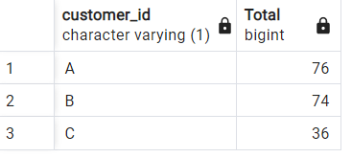

***-- 2. How many days has each customer visited the restaurant?***

select customer_id, count(distinct order_date) as "days" from sales

group by customer_id order by "days" desc;

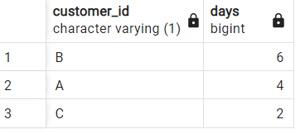

***-- 3. What was the first item from the menu purchased by each customer?***

select distinct t1.customer_id,

(with p1 as (select t2.product_id from sales t2 where t2.customer_id = t1.customer_id

 order by t2.order_date limit 1)

 select t2.product_name from p1 as t1

 join menu as t2

 on t1.product_id = t2.product_id)

from sales as t1;

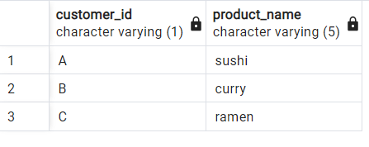

***-- 4. What is the most purchased item on the menu and how many times was it purchased by all customers?***

with purchased_items as (

Select t1.customer_id,t1.order_date,t2.product_name,t2.price

from sales as t1

join menu as t2 on t1.product_id = t2.product_id

  order by t1.customer_id),

***--4 a) Most purchased item***

temp1 as (select product_name,count(product_name) from purchased_items

  group by product_name order by count(product_name) desc limit 1)

***--4 b) How many times it was ordered***

select customer_id,count(product_name) from purchased_items where

product_name = (select product_name from temp1)

group by customer_id;

***--4 Combined***

with purchased_items as (

Select t1.customer_id,t1.order_date,t2.product_name,t2.price

from sales as t1

join menu as t2 on t1.product_id = t2.product_id

  order by t1.customer_id),

temp1 as (select product_name,count(product_name) from purchased_items

  group by product_name order by count(product_name) desc limit 1)

select customer_id,count(product_name) from purchased_items where

product_name = (select product_name from temp1)

group by customer_id;

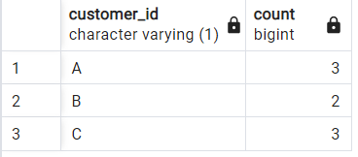

***-- 5. Which item was the most popular for each customer?***

with popular_item as

(select customer_id,product_name,

rank() over(Partition by customer_id order by count(*)) as rnk

from purchased_items group by customer_id,product_name)

select customer_id,product_name from popular_item where rnk = 1;

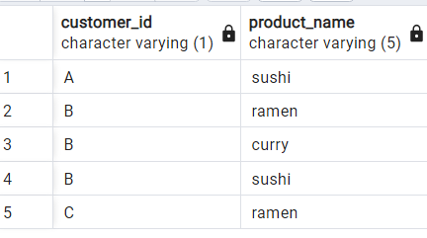

***-- 6. Which item was purchased first by the customer after they became a member?***

with first_table as (select t1.customer_id,(t1.order_date-t2.join_date) as diff,

t1.product_name

from purchased_items as t1

join members as t2

on

t1.customer_id = t2.customer_id where t1.order_date-t2.join_date >=0),

second_table as (select customer_id,min(diff) as diff from first_table group by customer_id)

select t1.customer_id,t2.product_name

from second_table as t1 join first_table as t2

on t1.customer_id = t2.customer_id and t1.diff = t2.diff;

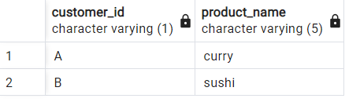

***-- 7. Which item was purchased just before the customer became a member?***

with table1 as (select t1.customer_id,min(abs(t1.order_date-t2.join_date)) as diff

from purchased_items as t1

join members as t2

on

t1.customer_id = t2.customer_id where t1.order_date-t2.join_date < 0

group by t1.customer_id),

table2 as (

select t1.customer_id,abs(t1.order_date-t2.join_date) as diff,

t1.product_name

from purchased_items as t1

join members as t2

on

t1.customer_id = t2.customer_id where t1.order_date-t2.join_date < 0)

select  t1.customer_id, t2.product_name

from table1 as t1 left join table2 as t2

on t1.customer_id = t2.customer_id and t1.diff = t2.diff;

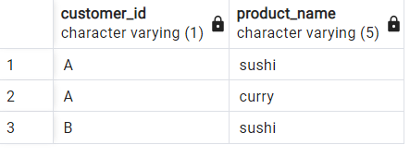

***-- 8. What is the total items and amount spent for each member before they became a member?***

select t1.customer_id,

count(t1.product_name) as Total_items,

sum(t1.price) as Total_amount

from purchased_items as t1

join members as t2

on

t1.customer_id = t2.customer_id where t1.order_date-t2.join_date < 0

group by t1.customer_id;

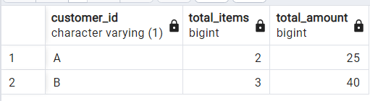

***-- 9.  If each $1 spent equates to 10 points and sushi has a 2x points multiplier - how many points would each customer have?***

with table1 as (select t1.customer_id,

case

when t1.product_name = 'sushi' then t1.price*20

else t1.price*10

end as Points

from purchased_items as t1)

select customer_id,sum(points) as points

from table1 group by customer_id

order by sum(points) desc;

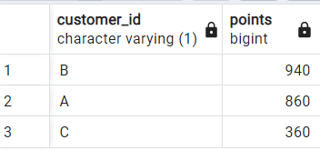

***/* 10. In the first week after a customer joins the program (including their join date) they***

***earn 2x points on all items, not just sushi - how many points do customer A and B have at the end***

***of January? */***

with table1 as (

select t1.customer_id,

case

when t1.product_name = 'sushi' then t1.price*20

when t1.product_name != 'sushi' and t1.order_date-t2.join_date >= 0

and t1.order_date-t2.join_date < 7 then t1.price*20

else t1.price*10

end as points

from purchased_items as t1

join members as t2

on

t1.customer_id = t2.customer_id)

select customer_id,sum(points) as points

from table1 group by customer_id

order by sum(points) desc;

