**Applied Materials**

**Global Information Services**

RIT

MDP Obsolescence Dashboard 1.1

Business Requirements Document (BRD)

**How to use this Template – Instructions:**

* This template contains instructions and examples in blue italics
* When creating a project deliverable from this template, replace the instructions or examples with your specific information. Also change the font style to Normal without italic
* This document is designed for multiple project types. If any section of this template is not applicable to your project, please delete
* Feel free to add additional sections if required to best meet the needs of your project objectives
* Change the header text to reflect the project name
* Do not change the footer information. These are pre-defined for copyright information, PMM template versioning purposes
* All the dates should be in mm/dd/yy format

**Project Document Version History**

|  |  |  |  |  |
| --- | --- | --- | --- | --- |
| **Version No.** | **Date** <mm/dd/yy> | **Prepared by/ Updated by** | **Changes Made** | **Status** |
|  | 2/12/21 | Priti Rastogi |  | DRAFT |
|  |  |  |  |  |
|  |  |  |  |  |

**Project Document Distribution List**

|  |  |  |
| --- | --- | --- |
| **Name** | **Role** | **Action/Information** |
| Andrew Moe  Jesse Garcia | *Customer / Process Owner* | *Responsible* |
|  |  |  |
| Priti Rastogi | *Project Manager* | *Accountable* |
| Yogendra Rajput | *Technical Lead* | *Responsible* |

**Cross-Reference Documents**

|  |  |  |  |
| --- | --- | --- | --- |
| **Document Name** | **Document Version** | **Document Section** | **Document Location** |
|  |  |  |  |
|  |  |  |  |
|  |  |  |  |

**TABLE OF CONTENTS**

**TABLE OF CONTENTS** 3

1 INTRODUCTION 3

1.1 Scope of this Document 3

1.2 Dashboard Data Changes 4

1.3 Dashboard Front-End Changes 4

1.4 Security Changes 4

# INTRODUCTION

## Scope of this Document

The purpose of this BRD document is to cover the scope of enhancements to the MDP Obsolescence Dashboard.

## Dashboard Data Changes

* The dashboard will be used by DDP BU. All queries where the data is being pulled today for MDP will include data for DDP as well. (H)
* Need to pull demand from MM360 Pegging where customer name is blank but BU = MDP or DDP and Actual Mfg Completion Date is blank.< Need more information>
* Pull column ‘Risk Mitigation’ from COMITT
* Pull Engineering Notes from COMITT

## Dashboard Front-End Changes

* Add BU drop down with MDP/DDP as filter. (H)
* Ability to add multiple part numbers, system number in the filter, currently it allows only single part number search. If multi parts are selected the part numbers will be displayed on top of the dashboard in the filter display area (H)
* Add PCN flag (H) and flag systems at risk for shipment based on PCN flag. If PCN flag = ‘Y’ then system is green , if PCN in ‘N’ then check risk mitigation . Flag the Impacted system column
* -Yes- no risk PCN approved-green
* -N -Looks at Risk Mitigation
* -N/A- green
* Add a text field ‘Analysis Outlook’ column for every project number on the OBS Items tab. It should track who edited the data with user name and timestamp (H)
* Show the user and timestamp of all fields that can be updated through Bulk Actions( M)

-Project Phase

-Copy Exact

-AMAT Buy Part #

-Functional Owner

The timestamp and user name should be shown on this pop-up:

* 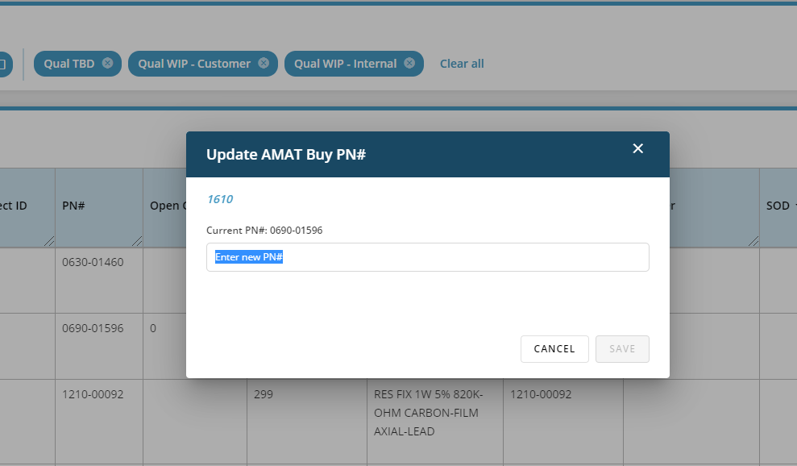
* Currently the OBS Dashboard pulls the ‘Engineering Notes’ from COMITT- it should pull the latest Engineering Notes for a project into the Comments field. (H)
* Pull the Engineering Actions into OBS Dashboard ( Low)
* 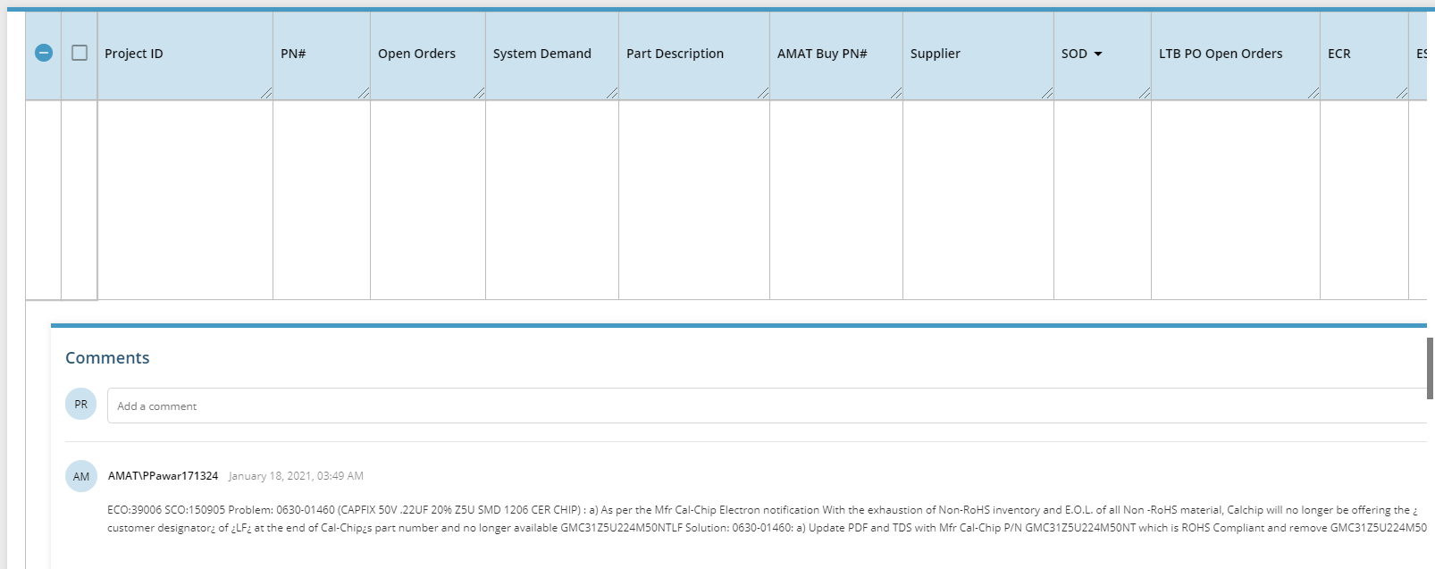
* 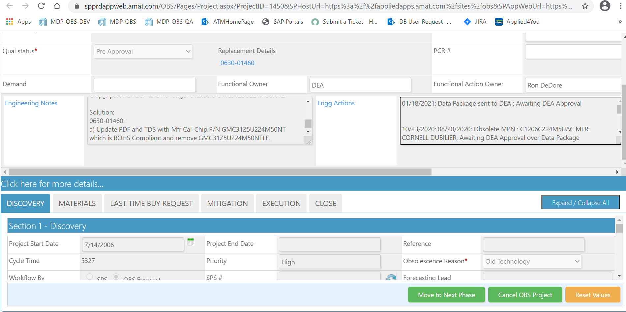
* Add hyperlink for every COMITT project. It should open the following COMITT project page (Medium)

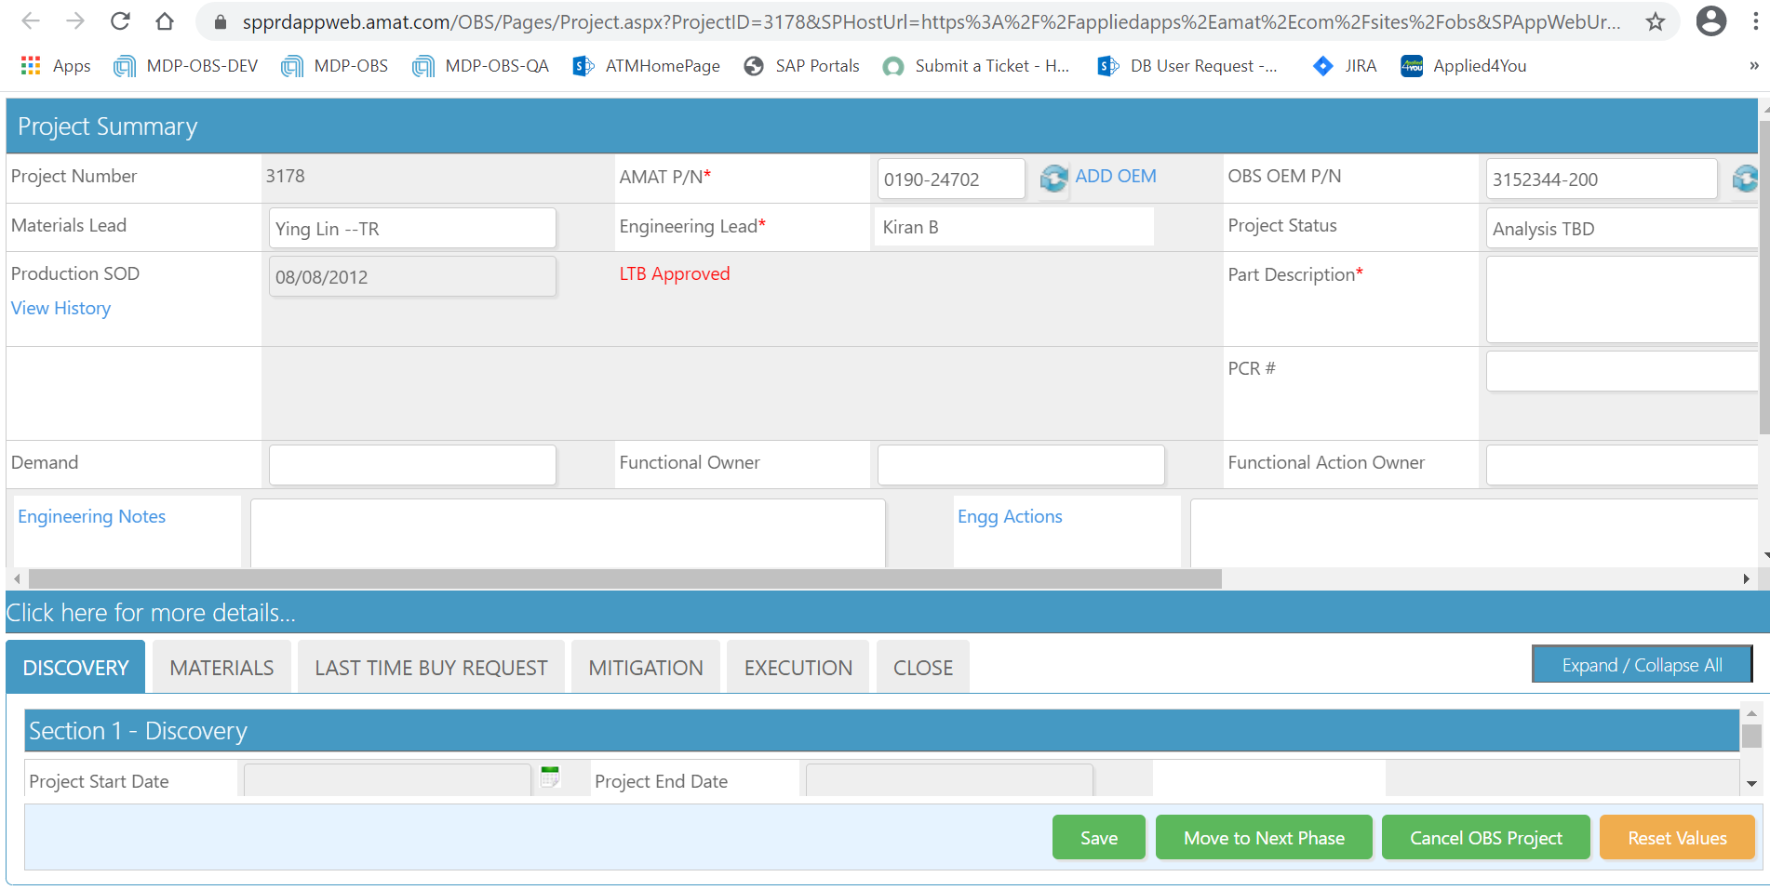

## 

## Security Changes

* A new read only role is needed where users with that role can only view data- they will not be able to edit comments, edit the new ‘Analysis Outlook’ column or use the bulk actions field (High)
* DDP users will be able to view MDP data and vice-versa.