Generic Cache Framework
Language neutral architecture with application owned source loading

1 Objective and scope
Provide a shared caching capability that any authorized application can use, regardless of its programming language or original data source. The capability must support interchangeable cache providers and database-configured policies, including enable and disable controls for individual cache operations.
Applications remain responsible for obtaining data from their own sources. The cache framework stores reusable results, determines whether they may be served, enforces freshness and access policies, and coordinates cache population. Redis and Couchbase are the initial providers under consideration.

What the design must achieve
Goal | Meaning
Language independence | Java, Python, and other applications use the same network contract.
Provider independence | A provider adapter isolates Redis or Couchbase behavior from clients and the service core.
Source independence | The application uses its existing API client, database access, or other business logic to load data.
Controlled freshness | Combine event-driven invalidation, soft and hard TTL, and application-executed refresh.
Runtime policy control | Enable or disable a cache operation centrally without changing application code.
Clear ownership | The service decides cache eligibility; the application loads and refreshes source data.

Decision established by this document
Select a shared cache service accessed over the network. Keep source loading in each application. Offer optional thin clients to simplify integration, while keeping policy enforcement and provider adapters inside the shared service.
The cache is a disposable copy, not the system of record. A cache outage must have a defined application fallback. The design supports bounded staleness; it does not promise instantaneous consistency with every source change.

Document sequence
First compare the two deployment options and explain the decision. Then describe the service, responsibilities, refresh strategies, cache keys, policies, and request/event workflows. Only after the design is established do we introduce API examples, a possible project structure, and a Java microservice example.
This is a proposed design for team review. Example durations, endpoints, and code are illustrative. It replaces the earlier assumption that the framework must be embedded as Java libraries in every consumer.

2 Deployment options and tradeoffs

Option 1 Libraries inside each application
Each application embeds a caching framework implemented in its own language. A Java library or Python package checks policy, invokes a provider adapter, and calls an application-supplied loader on a miss. The application connects directly to Redis or Couchbase.

Option 2 Shared cache service over the network
Applications call a common cache API. The shared service handles policy decisions, freshness, keys, coordination, and provider access. On a miss or bypass, the application calls its own source. When permitted, it sends the loaded result back to the service for caching.
Dimension | Option 1 Embedded libraries | Option 2 Shared service
Main advantage | No intermediate service hop; natural in-process loader callbacks. | One central implementation for all client languages.
Language support | A framework implementation is needed for each supported language. | Any language that can use the network API can integrate.
Provider changes | Adapters and client dependencies must be managed across language implementations. | Adapters change inside the service; the client contract can remain stable.
Policy ownership | Each application maintains its policy view and executes the rules. | The service maintains and enforces policies centrally.
Framework upgrades | Consumer applications adopt library releases and redeploy. | Service upgrades are centralized; breaking API changes still require client coordination.
Latency and throughput | Direct provider access usually has fewer network stages. | An extra network hop, serialization, and central capacity planning are required.
Operational cost | No shared service to run, but each app runs cache clients and policy logic. | Requires replicas, monitoring, scaling, authentication, and service ownership.
Failures | An application’s integration failures can be locally contained. | A service outage can affect many consumers; fallback and source protection matter.
Background refresh | The framework can invoke a local registered loader. | Applications must execute refresh; the service cannot run arbitrary client code.

Why we select option 2
The primary goal is one reusable caching capability across languages and sources, with centrally managed behavior. A shared service avoids rebuilding the policy engine and provider integrations in each language. It also provides one place to enforce enable/disable rules, observe cache behavior, and evolve refresh coordination.
We accept the additional hop and operational responsibility. The initial target should be source operations expensive enough to benefit. Measure hit, miss, bypass, and outage paths before expanding adoption; the shared service is not automatically faster for every operation.

3 Selected architecture
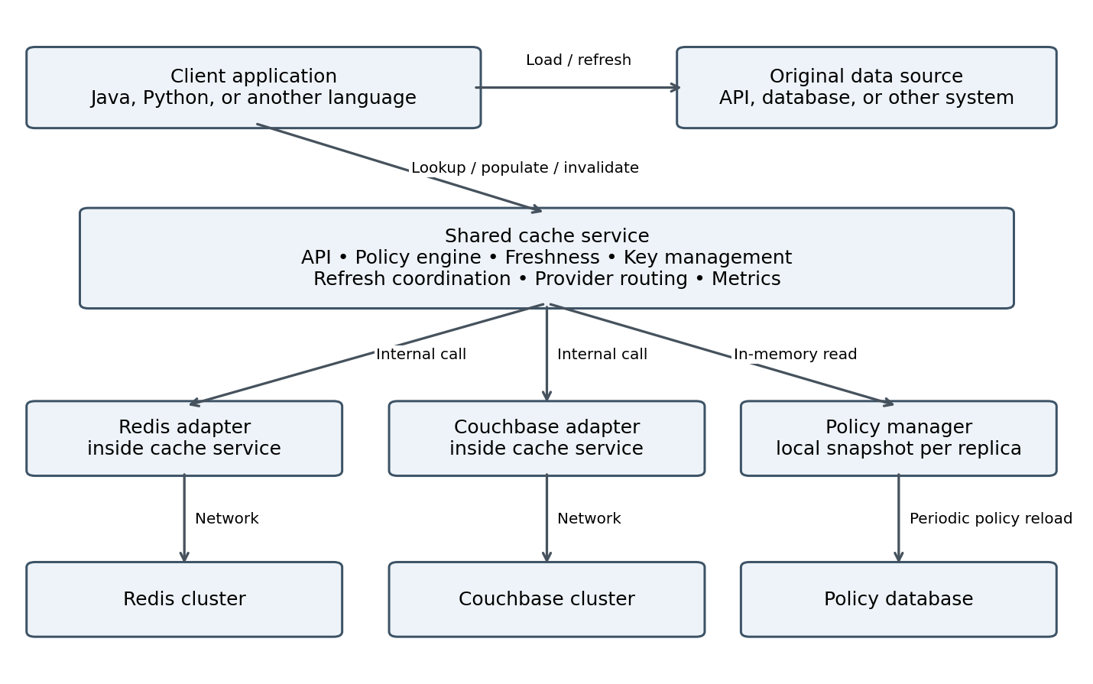
Figure 1. Applications access their sources directly. The cache service accesses the selected cache provider and the policy store. There is no source-loading connection from the cache service to the original source.

Service boundaries
The API is language-neutral. HTTP with JSON metadata is the proposed first transport; payloads use an agreed content type. Authentication and authorization identify the caller and allowed cache namespaces. A future gRPC interface can reuse the same semantics.
Provider routing maps a cache namespace to a configured backend. Redis and Couchbase adapters run inside the service, not inside client applications. Provider migration is a managed operation with namespace/version handling; it is separate from toggling caching on and off.

Optional thin clients
Java and Python clients may expose getOrLoad and handle outcomes, timeouts, and background task submission. They contain no provider SDK or authoritative policy engine. A loader callback executes only in the application process. Callers can also use the API directly if they implement the documented behavior.

4 Responsibilities and logical components
Responsibility | Cache service | Client application
Enable and disable | Own policies and enforce them on lookup, load permission, and population. | Honor BYPASS; may request stricter bypass but cannot override disable.
Key identity | Validate scope, canonicalize inputs, add namespace/schema/generation. | Supply complete business inputs and authorized tenant context.
Read and freshness | Read provider, classify fresh/stale/expired, decide permitted outcomes. | Return authorized usable values and honor expiry instructions.
Load on miss | Grant bounded permission to populate; coordinate competing loaders. | Call original source using existing business code and credentials.
Refresh stale data | Decide whether refresh is needed and which caller may populate. | Execute source reload in a bounded background worker.
Event invalidation | Apply generic invalidation commands, advance versions, reject obsolete writes. | Publish source-change events or map domain events to affected cache identities.
Policy persistence | Read policy DB; maintain snapshots and rollout visibility. | No configuration DB access is required for caching decisions.
Serialization | Enforce content type, size, and envelope contract. | Serialize business values and maintain their payload schema.
Failures | Return bounded outcomes; expose health, errors, and policy state. | Protect source capacity; handle source failures and cache-service outages.

How the service is organized
The Cache API accepts lookup, completion, cancellation, and invalidation requests. The orchestrator validates requests and invokes the policy engine, key manager, freshness evaluator, coordinator, and provider adapter. The policy manager refreshes the local configuration snapshot. The event integration accepts generic invalidation commands. Metrics record each outcome.
The refresh coordinator schedules or grants work; it does not fetch business data. On-demand stale refresh is executed by the requesting application. Future scheduled refresh can be driven by an application scheduler or an explicit refresh-request queue consumed by application workers.

Who owns event mapping
Business event mapping belongs to the domain/application owner. For example, CustomerChanged may affect both a customer detail entry and several search results. The generic service does not infer these dependencies from an arbitrary business event. It accepts resolved keys, namespaces, or supported tags through an authorized integration.

5 Refresh strategy catalogue
Refresh strategies can be combined. Expiry decides whether data may be used; invalidation removes its eligibility; refresh obtains a new source value. In this design, every actual source load or validation is performed by an application.
Strategy | Behavior and ownership | Use and limitation
Absolute hard TTL | Service stops serving after the maximum age; application reloads on demand. | Baseline safety net, including when a change event is delayed or lost.
Soft TTL | Service marks an entry stale before the hard deadline. | Triggers refresh without immediately discarding a usable value.
Cache-aside | Application loads a missing value and conditionally populates the service. | Chosen loading model; preserves source ownership.
Stale while revalidate | Service may return stale data and grant refresh; application reloads asynchronously. | For approved stale-tolerant operations only; bounded by hard TTL.
Event-driven invalidation | Domain integration sends affected identities; service invalidates and advances version. | Included from the start for event-capable sources; must handle retries and races.
Event-driven update | Application builds a complete value from a change event and submits a versioned update. | Useful later; payload completeness and event ordering are critical.
Change data capture | CDC detects DB changes; domain mapper issues invalidation or update. | Good for multiple DB writers; needs CDC and event mapping infrastructure.
Source polling | Application checks source changes and requests invalidation or refresh. | Alternative for sources without events; can create significant source load.
Conditional validation | Application uses ETag, modification time, or version to validate with source. | May avoid payload transfer; deadlines advance only after successful validation.
Explicit invalidation | Application invalidates after a successful source write or business action. | Initial feature; post-commit execution and delivery reliability matter.
Generation invalidation | Service changes namespace generation so prior entries are inaccessible. | Initial bulk-reset mechanism; older entries expire in storage later.

Event-driven invalidation reduces the stale window after a known change. TTL remains necessary because event delivery, coverage, and mappings can fail. Neither mechanism alone creates strong consistency with a separate source.

5 Refresh strategy catalogue continued
Strategy | Behavior and ownership | Use and limitation
Scheduled refresh | Application scheduler or worker reloads known keys on a schedule. | Reference datasets; stagger work across replicas and enforce central policy.
Refresh ahead | Application refreshes hot entries before their soft deadline. | Avoids stale reads; requires known keys and reload inputs.
Cache warming | Application preloads selected entries before expected traffic. | Reduce cold starts; restrict to useful keys and rate-limit source work.
Manual refresh | Authorized operator triggers an application-owned reload. | Operational recovery; the service alone cannot fetch the source.
Sliding expiration | Access renews idle lifetime, subject to an absolute maximum. | Useful for inactivity semantics; unsuitable as the sole freshness bound.
Tag or dependency invalidation | Application supplies relationships; service invalidates related entries. | Searches and aggregates; requires indexes and concurrency-safe semantics.
Write-through coordination | Application writes source then attempts cache update or invalidation. | Not atomic across systems; use post-commit delivery and retries.
Write-behind | Cache accepts business writes before asynchronous source persistence. | Excluded: would introduce durable-write responsibilities beyond this cache.
Read-through loading | A cache service invokes registered source loaders itself. | Not selected; source loading is explicitly application-owned.
TTL jitter | Service spreads early refresh or expiry times without exceeding maximum age. | Avoid synchronized traffic spikes; preserve soft ≤ hard ordering.
Probabilistic early refresh | Requests probabilistically trigger refresh near expiry. | Possible later optimization; still requires coordinated application workers.
Stale on source error | Application may keep using a previously permitted value within its deadline. | Optional and bounded; never serve beyond the hard maximum in this design.

Mechanisms that support refresh
Single-flight and load leases prevent avoidable duplicate work; they are coordination mechanisms, not freshness strategies. Retry backoff and circuit breakers protect source capacity. Policy polling updates cache rules, while source polling checks business data; these are different processes.
The catalogue describes options, not a commitment to implement them all initially. The next section identifies the starting combination and the behavior every supported client must implement.

6 Preferred starting combination
Start with cache-aside, hard TTL, optional soft TTL with stale-while-revalidate, event-driven invalidation, explicit invalidation, namespace generations, bounded load coordination, and jitter. Support event invalidation in the first release rather than treating it as an afterthought. Enable it per source when a reliable event path is available.
Initial capability | Recommended rule
Cache-aside | Application loads; service conditionally accepts population.
Hard TTL | Required for every entry. No cached response may be used after its deadline.
Soft TTL and stale reads | Supported initially but enabled only for operations that approve stale data.
Event invalidation | Invalidate affected keys on committed changes; block stale repopulation from older loads.
Single-flight and leases | One preferred loader per effective key across callers, with bounded wait and lease duration.
Jitter | Vary the soft refresh threshold downward; never extend the hard maximum.
Generation reset | Use for bulk invalidation, schema changes, or a clean re-enable.

Example with soft TTL 60 seconds and hard TTL 300 seconds
Entry age | Service decision | Application action
Below 60 seconds | HIT_FRESH if not invalidated. | Return the cached value.
60 to below 300 seconds | HIT_STALE only when policy and client permit it. One caller may receive a refresh permit. | Return stale within its remaining allowance; permit holder refreshes in background.
300 seconds or more | MISS or RETRY; no cached payload is eligible. | Load source if granted; otherwise retry briefly or use protected source fallback.
Change event at any time | Entry becomes ineligible immediately when invalidation is applied. | Next lookup reloads; soft/hard age does not override invalidation.

What TTL measures
TTL bounds reuse of the last successfully observed source result, not the age of the underlying source’s own data. Use a service-issued load-start timestamp as a conservative observation baseline; account for loading time when calculating remaining lifetime. Slow or expired loads are rejected for population rather than receiving a fresh full TTL after a long delay.
The service keeps the payload through the permitted stale window, normally until hard expiry. A cache provider may evict earlier. Clients honor a returned remaining-use duration using elapsed local time and network uncertainty; they must not retain a response indefinitely. Operations requiring strict freshness disable stale reads or bypass caching.

7 Cache key and value design

Logical identity supplied by the application
A key identifies a result, not merely a database row. The application supplies a cache name, schema version, and structured business inputs that fully determine the response. The service validates access, canonicalizes these inputs, and creates the physical key.
Logical identity:
cacheName: customer-details
schemaVersion: v1
inputs: {customerId: "123", locale: "en-CA"}
Service-owned key pattern:
environment:namespace:tenant:cacheName:schemaVersion:
generation:digest(canonicalInputs)
Namespace and tenant are derived from or checked against authenticated permissions. Default namespaces are application-owned. Cross-application sharing is opt-in and requires a common schema, identity contract, and compatible authorization scope.

Identity rules
Concern | Rule
Complete inputs | Include filters, pagination, locale, tenant, and permission scope when they affect the result.
Cross-language stability | Service canonicalization defines field ordering, types, number/date formats, nulls, and Unicode handling.
Payload compatibility | schemaVersion describes the value contract; change it when compatibility breaks.
Bulk changes | generation is service-owned and changes for namespace resets.
Privacy | Do not put credentials or raw sensitive data in physical keys or routine logs. A digest is not encryption.
Source reload | The application retains or reconstructs business inputs; a digest alone cannot recreate a request.

Stored entry envelope
Store payload bytes plus content type, schema version, observation time, soft deadline, hard deadline, and invalidation generation/version. Include sourceVersion when the source provides a meaningful version. Keep coordination ownership separate or atomically associated with the entry according to adapter capabilities.
JSON is a straightforward initial payload format for cross-language consumers. Binary formats can be supported through explicit content types and size limits. Avoid native Java serialization or Python-specific object formats as the shared contract.

Example distinction
customer-details with {customerId: "123", locale: "en-CA"} differs from the same customer with locale "fr-CA". A product search key must include its filters and page, not just the word products. Authorization remains an application responsibility before returning a result; cache access does not substitute for business authorization.

8 Central cache policies
The cache service is the authority for enable/disable and freshness decisions. It stores policy definitions in a configuration database and maintains a validated in-memory snapshot in each service replica. Client applications do not query that database or maintain authoritative copies of its flags.
Policy field | Purpose
namespace + cache_name | Identifies the operation and its authorized owning application/group.
enabled | Whether cache reads, population, and refresh grants are allowed.
provider_binding | Selects the configured Redis or Couchbase backend; credentials are stored separately.
soft_ttl_seconds | When a value becomes stale and refresh is appropriate.
hard_ttl_seconds | Absolute maximum reuse period; must be positive and ≥ soft TTL.
allow_stale | Whether stale responses may be returned before hard expiry.
event_invalidation_enabled | Enables a registered, authorized invalidation integration.
generation and revision | Generation changes key visibility; revision tracks policy updates.
load_lease_seconds | Bounded coordination ownership; matched to source timeout budget.
max_payload_bytes | Protects memory, network, and provider capacity.
updated_at and updated_by | Audit trail for policy changes.

Example policy
namespace: customer-service
cache_name: customer-details
enabled: true
provider_binding: redis-primary
soft_ttl_seconds: 60
hard_ttl_seconds: 300
allow_stale: true
event_invalidation_enabled: true
generation: 7
revision: 42
load_lease_seconds: 10
max_payload_bytes: 262144
Values are examples, not universal defaults. The ten-second load lease assumes a shorter source timeout and a bounded completion step. Different workloads may require different limits or carefully controlled lease renewal.

Checks on every cache operation
Lookup checks enable state, access, identity, and freshness. A refresh/load permit is granted only when allowed. Population checks policy again along with token scope, ownership, expiry, and invalidation version. Invalidation remains available when caching is disabled so obsolete data can still be removed.

8 Policy changes and enable disable behavior

Loading and propagating policy
Each cache-service replica loads its applicable policies at startup. A background poller, for example every 30 seconds with jitter, reads a consistent full snapshot of the relevant rows, validates it, and atomically swaps the local snapshot. A small full snapshot detects row deletion as well as updates. A larger configuration store can use a proper versioned change feed with deletion records.
Healthy replicas normally observe a change within one poll interval plus query time. Polling is not an instantaneous global switch. Expose the applied revision and snapshot age for every replica. Event notifications may accelerate reloading, but polling remains the recovery mechanism.

When an operation is disabled
Once a replica observes disabled, lookup returns BYPASS without reading business cache data, grants no new load/refresh permits, and rejects population. The application calls the original source and does not attempt to cache the result. The application may always request a stricter per-request bypass; it cannot force-enable an operation.
Requests already in flight and replicas that have not observed the update may complete under the prior policy. Rechecking policy at population reduces this window but does not eliminate propagation delay. If immediate revocation is required, it needs a separate synchronous control path rather than a promise based on polling.

Re-enabling and changing TTL
Disabling does not necessarily delete entries. By default, increment generation when re-enabling to avoid reviving old data. For initial simplicity, freshness-policy changes also increment generation so entries created under older TTL or stale rules are not silently reused. Provider migration uses a separate controlled rollout and generation change.

Configuration failures
Condition | Proposed behavior
Missing policy | Return BYPASS; do not invent an enabled policy.
Invalid new policy | Reject the snapshot/update, retain the last valid version, and alert.
Startup DB unavailable | Return BYPASS or mark cache service unavailable; clients follow source fallback.
Later polling failure | Use last valid snapshot for a configured maximum age; then bypass and alert.
Cache service unavailable | Application skips caching and calls source under its timeout and capacity controls.

Source capacity must be planned for bypass and outage traffic. A central policy store does not make client source-protection rules optional: source timeouts, concurrency limits, and load shedding remain application-owned.

9 Lookup and load workflow
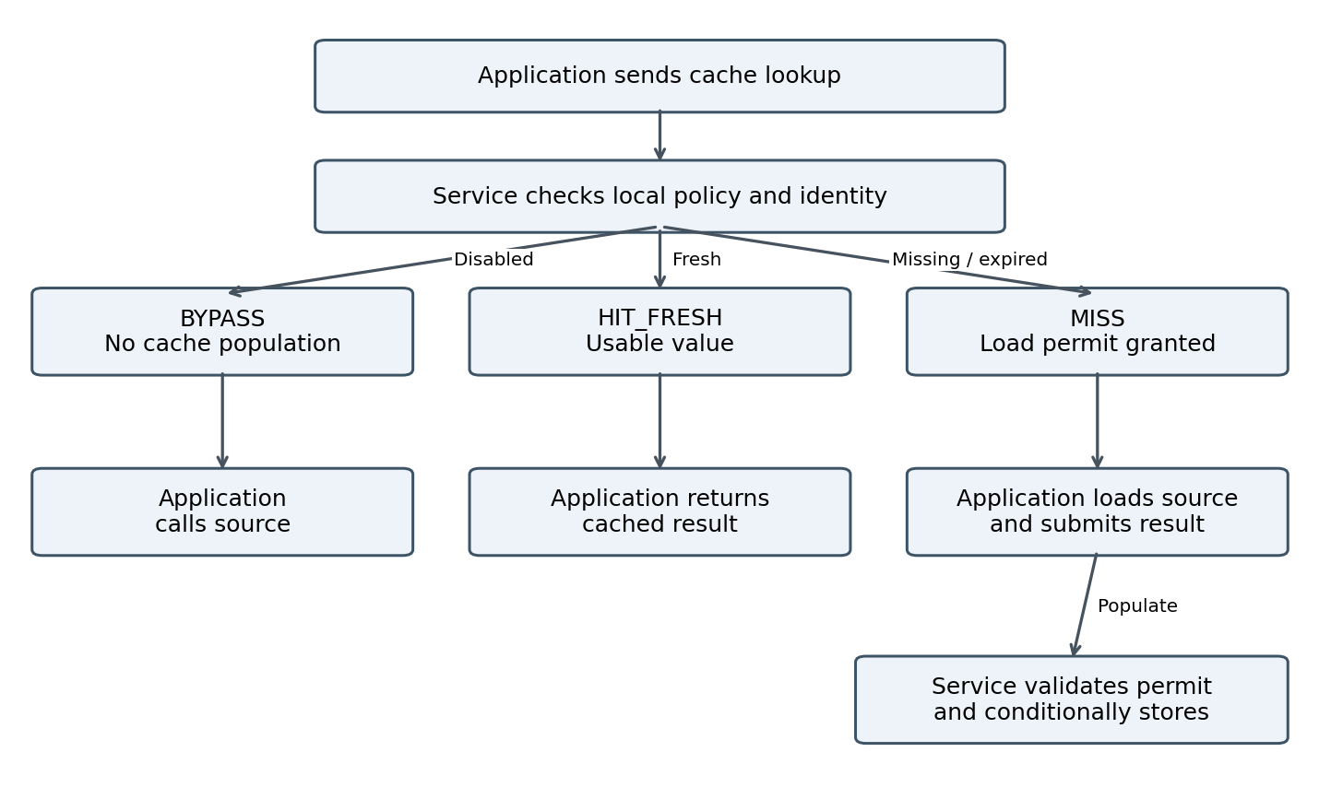
Figure 2. Main paths. HIT_STALE and RETRY are covered below. Cache population failure does not discard a successful source result; the application can still return it to the caller.
Service outcome | Required client behavior
HIT_FRESH | Use the payload within its returned validity allowance.
HIT_STALE | Use only when accepted by policy and this call. If a refresh permit is present, submit a bounded background reload.
MISS with load permit | Load synchronously from source; conditionally populate using that permit.
RETRY | Another loader owns this key. Retry lookup briefly with jitter and a total time budget.
BYPASS | Call source directly; do not populate or launch cache refresh.

If bounded waiting exhausts the request budget, a client may call the source directly under local protection, without population permission. This can create duplicate source calls but preserves a clear latency bound. Source failure follows the application’s existing error contract; it is not cached by default.

10 Stale refresh and event workflow

Stale while revalidate
The service finds an entry past soft TTL but before hard TTL. If both policy and caller allow stale reads, it returns the payload with its remaining-use allowance. It grants one eligible caller a short refresh permit. That application returns the stale response and schedules a source reload in its own bounded worker pool. Other callers may use the same stale entry without launching more refresh work.
After a successful reload, the worker submits a completion request. The service rechecks policy, token ownership, expiry, and invalidation version before accepting the new value. If the application crashes or cannot enqueue work, it releases the permit when possible; otherwise it expires. A later caller can refresh. With no traffic, demand-driven refresh does not run.

Event-driven invalidation
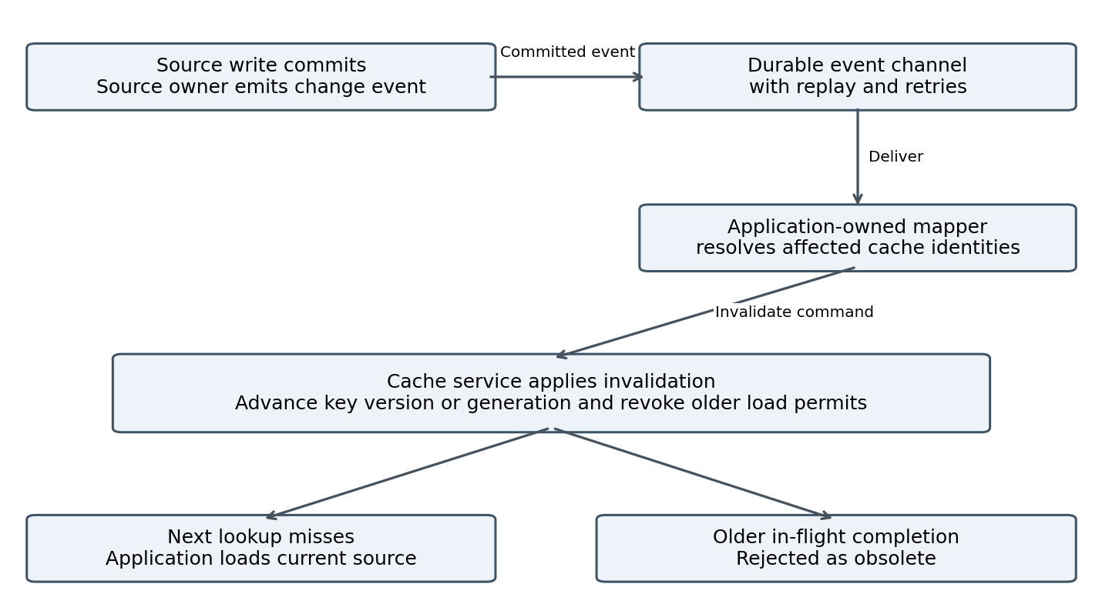
Figure 3. Default event action is invalidation, not centrally fetching a new value. Event mapping remains domain-owned.
Use stable event IDs for idempotency, acknowledge after invalidation is durably applied, retry failures, and retain replay/dead-letter handling. Publish from committed changes; an outbox or CDC can reduce the gap between a source commit and event publication. If an event is late, a cached result may remain visible until invalidation or hard expiry.
A simple delete is insufficient: an older source load could finish and repopulate the key. Versioned permits prevent that older completion from becoming a new cached entry. They do not retract responses already in flight or guarantee that a lagging source replica returns the latest data.

11 Coordination failure and service guarantees

Load permission and conditional population
A load permit is an opaque, short-lived token bound to caller scope, effective key, namespace generation, invalidation version, and lease ownership. Multiple service replicas must coordinate through shared authoritative state. In-memory locks in one replica are insufficient.
When a completion arrives, validate the permit and conditionally write against that state. Invalidation and completion must have a defined atomic ordering for the affected key. A separate read-check followed by an unconditional put is not sufficient. Provider adapters expose the needed compare-and-set/transaction capability or use a dedicated coordinator; an adapter cannot claim support without contract tests.
Coordination records must live at least as long as any relevant permits. Missing or evicted coordination state rejects a completion; it must not resurrect an old token. Expired leases can still permit overlapping source work, so the contract provides best-effort work suppression and conditional cache acceptance, not exactly-once source execution.

Failure behavior
Failure | Required behavior
Provider read timeout | Service fails quickly with a bypass/degraded outcome; application may call protected source.
Cache service unreachable | Client circuit breaker avoids repeated delay and uses source fallback.
Source load fails | Application returns its normal source error, or keeps using an already permitted stale result only before hard expiry.
Population fails or is rejected | Preserve successful source response; record failure and release permit when appropriate.
Refresh worker queue full | Do not create unbounded work. Release/expire permit; later traffic can retry.
Duplicate or old event | Idempotent invalidation; never roll version backward.
Event channel outage | Alert and replay on recovery; hard TTL remains the fallback bound.

Security and observability
Authenticate service callers, authorize namespaces and operations, encrypt transport, and separate provider credentials from policies. Only authorized applications may populate values. Limit payload size, request rate, load permits, and metrics label cardinality. Do not log payloads or secrets by default.
Measure fresh/stale hits, misses, bypasses, retries, cache-service latency, provider latency, population rejection, lease expiry, invalidation lag, and policy revision/age. Applications additionally measure source latency, refresh failures, and fallback volume. Plan capacity for cold caches and cache outages.
The selected consistency model is eventual consistency with explicit age bounds. Events can shorten stale windows but do not make separate source writes and cache operations one transaction. Applications requiring current authoritative values must bypass or perform source validation.

12 Adoption and review checkpoints

First release scope
Deliver the shared service with Redis and Couchbase adapters, central policy snapshots, cache-aside lookup/completion, mandatory hard TTL, opt-in soft TTL/stale refresh, event and explicit invalidation, generation resets, bounded load permits, and operational metrics. Demonstrate application-owned source loading and refresh with one service and a second-language API smoke test.
Include event invalidation in the initial design and testing. For each cache operation, enable it when its domain event mapping and delivery path are ready. A source without change events still works with TTL; add source polling or CDC according to its needs.

Acceptance tests
Area | Required evidence
Language neutrality | Java and Python requests resolve identical logical inputs to the same eligible entry under an approved shared namespace.
Enable and disable | Service enforces BYPASS and rejects completion after observing disable; propagation delay is measured.
Freshness | Fresh, stale, hard-expired, and invalidated cases follow their documented outcomes.
Load ownership | Only valid permits populate; expiry, application crash, replica changes, and token replay are covered.
Event races | An invalidation prevents acceptance of an older in-flight completion under concurrent service replicas.
Provider equivalence | Both adapters pass expiry, serialization, coordination, and failure contract tests.
Outage behavior | Cache outage and cold start do not create uncontrolled source load; time budgets are enforced.
Policy changes | Deleted rows, invalid updates, stale snapshots, generation changes, and clean re-enable are tested.

Later capabilities
Add application-owned scheduled refresh and warming, conditional source validation, tag invalidation, or event-driven updates only when a use case requires them. A refresh-request queue can coordinate future application workers. Provider migration, L1 client caching, and semantic AI caching are separate design decisions; none is implied by the basic cache API.

Decisions to finalize before coding
Confirm the service owner and implementation stack, policy DB, event transport and mappings, provider capability implementation for atomic invalidation/completion, and supported content types. Agree per-operation soft/hard TTL, allowed staleness, source timeout and capacity budgets, polling delay, lease duration, and tenant isolation. These details refine the agreed architecture rather than reopen application ownership of source loading.
The resulting platform has one language-neutral access contract and one central policy authority. Each application continues to own its business data access, while Redis and Couchbase remain replaceable storage implementations behind the service.

13 Network contract examples
Implementation details begin here. These proposed HTTP operations illustrate the design; they are not an existing deployed API. Every request is authenticated. Business payloads and provider credentials are never encoded in URLs.
Operation | Proposed endpoint | Purpose
Lookup | POST /v1/cache/lookup | Return outcome, payload when usable, and optional load/refresh permit.
Complete load | POST /v1/cache/complete | Submit loaded value using a permit; conditionally accept or reject.
Release load | POST /v1/cache/release | Best-effort release when a loader fails or cannot run.
Invalidate keys | POST /v1/cache/invalidate | Invalidate authorized logical identities using an idempotency/event ID.
Reset namespace | POST /v1/cache/generation | Authorized administrative generation change.

Lookup request
{
"namespace": "customer-service",
"cacheName": "customer-details",
"schemaVersion": "v1",
"inputs": {"customerId": "123", "locale": "en-CA"},
"allowStale": true,
"canRefresh": true,
"mode": "NORMAL"
}

Example stale response
{
"outcome": "HIT_STALE",
"value": {"customerId": "123", "displayName": "Example"},
"contentType": "application/json",
"remainingUseMs": 120000,
"policyRevision": 42,
"refreshPermit": "opaque-short-lived-token"
}
If canRefresh is false, the service must not grant a background refresh permit to that caller. If allowStale is false, a stale entry follows the load/retry path. These client hints can restrict behavior; they cannot override a disabled policy or permit forbidden stale reads.

Population request
{
"permit": "opaque-short-lived-token",
"contentType": "application/json",
"value": {"customerId": "123", "displayName": "Updated example"}
}
The service derives key scope and deadlines from the permit and current policy. Clients do not choose arbitrary TTLs. Completion returns accepted or a typed rejection such as disabled, expired, invalidated, or ownership lost. Thin clients treat these as cache outcomes, not as failure of an already successful source call.

14 Example implementation organization
The service implementation language remains a team choice. If Java is selected for the shared service, the following Maven layout is one possible organization. It does not make Java a requirement for its consumers.
Module or directory | Representative files | Packaging
cache-platform-parent/ | pom.xml; docs/architecture.md | Parent POM
cache-contract/ | openapi/cache-api.yaml  schemas/lookup.json; schemas/invalidate.json | Language-neutral API/schema artifacts
cache-service-app/ | CacheServiceApplication.java  LookupController.java; CompletionController.java  InvalidationController.java | One executable service JAR
cache-core/ | LookupOrchestrator.java; PolicyEngine.java  FreshnessEvaluator.java; CacheKeyFactory.java  CacheStore.java; LoadCoordinator.java  EntryEnvelope.java; InvalidationService.java | Internal library JAR
cache-policy-jdbc/ | JdbcPolicyRepository.java  PolicySnapshotManager.java; PolicyPoller.java  resources/db/cache_policy.sql | Internal library JAR
cache-adapter-redis/ | RedisCacheStore.java  RedisLoadCoordinator.java  RedisAdapterConfiguration.java | Internal library JAR
cache-adapter-couchbase/ | CouchbaseCacheStore.java  CouchbaseLoadCoordinator.java  CouchbaseAdapterConfiguration.java | Internal library JAR
cache-events/ | InvalidationConsumer.java  InvalidationCommand.java | Optional transport integration JAR
cache-contract-tests/ | CacheStoreContract.java  LoadInvalidationRaceContract.java | Test scope
clients/java/ and clients/python/ | CacheClient.java  cache_client/client.py | Optional thin JAR and Python package

Dependency and deployment boundaries
The service application assembles core, policy repository, selected provider adapters, and event integration into one deployment with multiple replicas. Internal modules are not separate microservices. Provider adapters implement core contracts; core does not depend on provider SDKs. Initial distributions may include both adapters, while each namespace binds to one configured backend.
Client applications use only the network contract or their thin client. They do not include service core, JDBC policy polling, Redis, or Couchbase libraries. A separate domain integration owns business-event mapping; the generic event module consumes already-resolved invalidation commands.

15 Example microservice integration
Take one Java customer microservice whose API calls an external customer API. It chooses a thin Java client for convenience. The same sequence applies to Python; no Java object or callback is sent across the network.

Application service code
public Customer getCustomer(String id, String locale) {
CacheIdentity identity = new CacheIdentity(
"customer-service", "customer-details", "v1",
Map.of("customerId", id, "locale", locale));
return cacheClient.getOrLoad(
identity,
Customer.class,
ReadOptions.allowStaleWithBackgroundRefresh(),
() -> externalCustomerApi.getCustomer(id, locale));
}
public Customer getAuthoritativeCustomer(String id, String locale) {
// Explicit bypass: source call, no cache lookup or population.
return externalCustomerApi.getCustomer(id, locale);
}
The caller authorizes access before returning customer data. The thin client performs HTTP lookup and completion; the lambda runs locally. Background refresh uses a dedicated bounded executor and a deliberate source authentication context, not a request-scoped credential that may disappear.

What the thin client does
lookup = callCacheService(identity, options)
switch lookup.outcome:
HIT_FRESH:
return decodeIfStillUsable(lookup)
HIT_STALE:
if lookup.refreshPermit exists:
enqueueBounded(() -> loadAndComplete(lookup.refreshPermit))
// If enqueue fails, release permit best-effort.
return decodeIfStillUsable(lookup)
MISS:
return loadAndComplete(lookup.loadPermit)
BYPASS:
return sourceLoader.load()
RETRY:
retryLookupWithinBudget()
// If exhausted: protected source call, without population.
loadAndComplete(permit):
try:
value = sourceLoader.load()
catch SourceError:
releasePermitBestEffort(permit)
throw sourceError
completeBestEffort(permit, value)
return value
Sample code shows control flow rather than a complete client implementation. An expired/unusable returned payload restarts the bounded lookup/load path. Cache transport failures trigger protected source fallback; they must not accidentally catch a source failure and invoke the source a second time. Background errors are recorded, while already-returned stale responses remain subject to their original hard deadline.

