|  |
| --- |
| Описание: Описание: для прик эмбл |
| МИНОБРНАУКИ РОССИИ |
| Федеральное государственное бюджетное образовательное учреждениевысшего профессионального образования"Российский технологический университет"МИРЭА |
| Институт «Комплексной безопасности и специального приборостроения» |
| Кафедра «Управление и моделирование систем» (КБ-3) |
|  |

|  |  |
| --- | --- |
| **Практика №3 по дисциплине** | |
|  | |
| **« Основы информационной безопасности »**  **«Метаданные»** | |
|  | |
| Выполнил студент группы БИСО-03-19 | *Ковалев П.А.* |

Москва 2020

Это моя фотография лимонов в стакане.

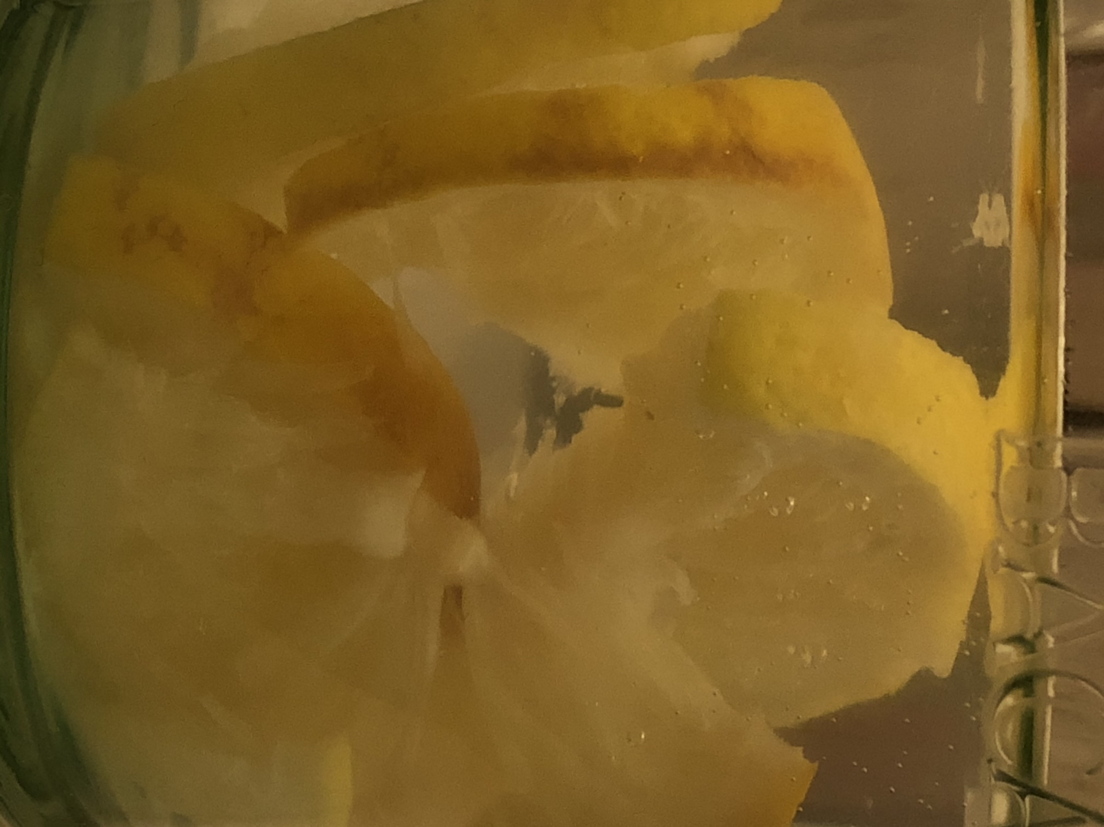

С помощью утилит ExifViewer были получены следующие данные:

|  |  |
| --- | --- |
| **create** | 2020-10-21T16:35:43+00:00 |
| ApertureValue | 54823/32325 |
| BrightnessValue | 2801/14722 |
| ColorSpace | 65535 |
| ComponentsConfiguration | 1, 2, 3, 0 |
| DateTime | 2020:10:21 19:27:46 |
| DateTimeDigitized | 2020:10:21 19:27:46 |
| DateTimeOriginal | 2020:10:21 19:27:46 |
| DigitalZoomRatio | 72/25 |
| ExifImageLength | 3024 |
| ExifImageWidth | 4032 |
| ExifOffset | 216 |
| ExifVersion | 48, 50, 51, 49 |
| ExposureBiasValue | 0/1 |
| ExposureMode | 0 |
| ExposureProgram | 2 |
| ExposureTime | 1/7 |
| Flash | 24 |
| FlashPixVersion | 48, 49, 48, 48 |
| FNumber | 9/5 |
| FocalLength | 4/1 |
| FocalLengthIn35mmFilm | 81 |
| ISOSpeedRatings | 100 |
| Make | Apple |
| MakerNote | 65, 112, 112, 108, 101, 32, 105, 79, 83, 0, 0, 1, 77, 77, 0, 32, 0, 1, 0, 9, 0, 0, 0, 1, 0, 0, 0, 12, 0, 2, 0, 7, 0, 0, 2, 46, 0, 0, 1, 148, 0, 3, 0, 7, 0, 0, 0, 104, 0, 0, 3, 194, 0, 4, 0, 9, 0, 0, 0, 1, 0, 0, 0, 1, 0, 5, 0, 9, 0, 0, 0, 1, 0, 0, 0, 188, 0, 6, 0, 9, 0, 0, 0, 1, 0, 0, 0, 183, 0, 7, 0, 9, 0, 0, 0, 1, 0, 0, 0, 1, 0, 8, 0, 10, 0, 0, 0, 3, 0, 0, 4, 42, 0, 12, 0, 10, 0, 0, 0, 2, 0, 0, 4, 66, 0, 13, 0, 9, 0, 0, 0, 1, 0, 0, 0, 12, 0, 14, 0, 9, 0, 0, 0, 1, 0, 0, 0, 4, 0, 15, 0, 9, 0, 0, 0, 1, 0, 0, 0, 2, 0, 16, 0, 9, 0, 0, 0, 1, 0, 0, 0, 1, 0, 17, 0, 2, 0, 0, 0, 37, 0, 0, 4, 82, 0, 20, 0, 9, 0, 0, 0, 1, 0, 0, 0, 5, 0, 22, 0, 2, 0, 0, 0, 29, 0, 0, 4, 120, 0, 23, 0, 9, 0, 0, 0, 1, 0, 0, 32, 0, 0, 25, 0, 9, 0, 0, 0, 1, 0, 0, 0, 0, 0, 26, 0, 2, 0, 0, 0, 6, 0, 0, 4, 150, 0, 31, 0, 9, 0, 0, 0, 1, 0, 0, 0, 0, 0, 32, 0, 2, 0, 0, 0, 37, 0, 0, 4, 156, 0, 33, 0, 10, 0, 0, 0, 1, 0, 0, 4, 194, 0, 35, 0, 9, 0, 0, 0, 2, 0, 0, 4, 202, 0, 37, 0, 9, 0, 0, 0, 1, 0, 0, 0, 0, 0, 38, 0, 9, 0, 0, 0, 1, 0, 0, 0, 0, 0, 39, 0, 10, 0, 0, 0, 1, 0, 0, 4, 210, 0, 43, 0, 2, 0, 0, 0, 37, 0, 0, 4, 218, 0, 45, 0, 9, 0, 0, 0, 1, 0, 0, 10, 208, 0, 46, 0, 9, 0, 0, 0, 1, 0, 0, 0, 2, 0, 47, 0, 9, 0, 0, 0, 1, 0, 0, 0, 110, 0, 54, 0, 9, 0, 0, 0, 1, 0, 0, 0, 89, 0, 55, 0, 9, 0, 0, 0, 1, 0, 0, 0, 1, 0, 0, 0, 0, 98, 112, 108, 105, 115, 116, 48, 48, 79, 17, 2, 0, 178, 0, 145, 0, 161, 0, 159, 0, 162, 0, 167, 0, 160, 0, 166, 0, 161, 0, 160, 0, 188, 0, 199, 0, 219, 0, 225, 0, 224, 0, 143, 0, 173, 0, 146, 0, 168, 0, 134, 0, 130, 0, 176, 0, 175, 0, 184, 0, 179, 0, 178, 0, 179, 0, 191, 0, 186, 0, 177, 0, 161, 0, 108, 0, 175, 0, 162, 0, 165, 0, 135, 0, 136, 0, 187, 0, 192, 0, 197, 0, 187, 0, 181, 0, 179, 0, 184, 0, 174, 0, 168, 0, 162, 0, 126, 0, 171, 0, 162, 0, 164, 0, 179, 0, 200, 0, 202, 0, 212, 0, 211, 0, 195, 0, 182, 0, 173, 0, 171, 0, 169, 0, 160, 0, 156, 0, 138, 0, 173, 0, 177, 0, 203, 0, 223, 0, 206, 0, 207, 0, 205, 0, 222, 0, 201, 0, 180, 0, 171, 0, 171, 0, 165, 0, 162, 0, 161, 0, 148, 0, 168, 0, 182, 0, 223, 0, 211, 0, 204, 0, 200, 0, 202, 0, 218, 0, 197, 0, 185, 0, 172, 0, 167, 0, 157, 0, 167, 0, 165, 0, 157, 0, 170, 0, 188, 0, 246, 0, 204, 0, 202, 0, 197, 0, 201, 0, 208, 0, 184, 0, 186, 0, 184, 0, 183, 0, 168, 0, 172, 0, 171, 0, 164, 0, 172, 0, 189, 0, 21, 1, 237, 0, 205, 0, 206, 0, 194, 0, 188, 0, 191, 0, 184, 0, 160, 0, 165, 0, 171, 0, 176, 0, 175, 0, 166, 0, 131, 0, 182, 0, 43, 1, 38, 1, 235, 0, 209, 0, 186, 0, 191, 0, 173, 0, 175, 0, 141, 0, 148, 0, 168, 0, 173, 0, 176, 0, 163, 0, 149, 0, 201, 0, 248, 0, 44, 1, 4, 1, 229, 0, 185, 0, 200, 0, 184, 0, 176, 0, 159, 0, 146, 0, 157, 0, 163, 0, 172, 0, 161, 0, 149, 0, 200, 0, 159, 0, 222, 0, 11, 1, 239, 0, 201, 0, 216, 0, 216, 0, 196, 0, 197, 0, 153, 0, 152, 0, 155, 0, 152, 0, 148, 0, 142, 0, 193, 0, 166, 0, 178, 0, 249, 0, 248, 0, 228, 0, 214, 0, 202, 0, 200, 0, 210, 0, 187, 0, 163, 0, 149, 0, 154, 0, 143, 0, 121, 0, 178, 0, 213, 0, 180, 0, 248, 0, 244, 0, 232, 0, 216, 0, 204, 0, 196, 0, 200, 0, 185, 0, 156, 0, 157, 0, 142, 0, 141, 0, 121, 0, 186, 0, 190, 0, 175, 0, 235, 0, 207, 0, 200, 0, 188, 0, 169, 0, 165, 0, 153, 0, 141, 0, 165, 0, 163, 0, 149, 0, 140, 0, 131, 0, 196, 0, 192, 0, 181, 0, 228, 0, 238, 0, 208, 0, 199, 0, 158, 0, 165, 0, 158, 0, 156, 0, 161, 0, 159, 0, 148, 0, 137, 0, 124, 0, 186, 0, 199, 0, 180, 0, 186, 0, 214, 0, 207, 0, 224, 0, 203, 0, 189, 0, 168, 0, 158, 0, 161, 0, 169, 0, 161, 0, 141, 0, 0, 8, 0, 0, 0, 0, 0, 0, 2, 1, 0, 0, 0, 0, 0, 0, 0, 1, 0, 0, 0, 0, 0, 0, 0, 0, 0, 0, 0, 0, 0, 0, 2, 12, 98, 112, 108, 105, 115, 116, 48, 48, 212, 1, 2, 3, 4, 5, 6, 7, 8, 85, 102, 108, 97, 103, 115, 85, 118, 97, 108, 117, 101, 89, 116, 105, 109, 101, 115, 99, 97, 108, 101, 85, 101, 112, 111, 99, 104, 16, 1, 19, 0, 2, 74, 117, 182, 50, 167, 226, 18, 59, 154, 202, 0, 16, 0, 8, 17, 23, 29, 39, 45, 47, 56, 61, 0, 0, 0, 0, 0, 0, 1, 1, 0, 0, 0, 0, 0, 0, 0, 9, 0, 0, 0, 0, 0, 0, 0, 0, 0, 0, 0, 0, 0, 0, 0, 63, 255, 255, 250, 164, 0, 1, 111, 105, 255, 255, 151, 158, 0, 0, 104, 147, 255, 255, 230, 87, 0, 0, 221, 186, 0, 0, 0, 51, 0, 0, 0, 128, 0, 0, 0, 111, 0, 0, 1, 0, 50, 68, 55, 70, 57, 65, 50, 65, 45, 70 |
| MeteringMode | 5 |
| Model | iPhone X |
| Orientation | 6 |
| ResolutionUnit | 2 |
| SceneCaptureType | 0 |
| SceneType | 1 |
| SensingMethod | 2 |
| ShutterSpeedValue | 21725/7659 |
| Software | 14.0 |
| SubjectArea | 2007, 1512, 2218, 1331 |
| SubSecTimeDigitized | 700 |
| SubSecTimeOriginal | 700 |
| TileLength | 512 |
| TileWidth | 512 |
| WhiteBalance | 0 |
| XResolution | 72/1 |
| YCbCrPositioning | 1 |
| YResolution | 72/1 |
| **modify** | 2020-10-21T16:35:43+00:00 |
| ApertureValue | 54823/32325 |
| BrightnessValue | 2801/14722 |
| ColorSpace | 65535 |
| ComponentsConfiguration | 1, 2, 3, 0 |
| DateTime | 2020:10:21 19:27:46 |
| DateTimeDigitized | 2020:10:21 19:27:46 |
| DateTimeOriginal | 2020:10:21 19:27:46 |
| DigitalZoomRatio | 72/25 |
| ExifImageLength | 3024 |
| ExifImageWidth | 4032 |
| ExifOffset | 216 |
| ExifVersion | 48, 50, 51, 49 |
| ExposureBiasValue | 0/1 |
| ExposureMode | 0 |
| ExposureProgram | 2 |
| ExposureTime | 1/7 |
| Flash | 24 |
| FlashPixVersion | 48, 49, 48, 48 |
| FNumber | 9/5 |
| FocalLength | 4/1 |
| FocalLengthIn35mmFilm | 81 |
| ISOSpeedRatings | 100 |
| Make | Apple |
| MakerNote | 65, 112, 112, 108, 101, 32, 105, 79, 83, 0, 0, 1, 77, 77, 0, 32, 0, 1, 0, 9, 0, 0, 0, 1, 0, 0, 0, 12, 0, 2, 0, 7, 0, 0, 2, 46, 0, 0, 1, 148, 0, 3, 0, 7, 0, 0, 0, 104, 0, 0, 3, 194, 0, 4, 0, 9, 0, 0, 0, 1, 0, 0, 0, 1, 0, 5, 0, 9, 0, 0, 0, 1, 0, 0, 0, 188, 0, 6, 0, 9, 0, 0, 0, 1, 0, 0, 0, 183, 0, 7, 0, 9, 0, 0, 0, 1, 0, 0, 0, 1, 0, 8, 0, 10, 0, 0, 0, 3, 0, 0, 4, 42, 0, 12, 0, 10, 0, 0, 0, 2, 0, 0, 4, 66, 0, 13, 0, 9, 0, 0, 0, 1, 0, 0, 0, 12, 0, 14, 0, 9, 0, 0, 0, 1, 0, 0, 0, 4, 0, 15, 0, 9, 0, 0, 0, 1, 0, 0, 0, 2, 0, 16, 0, 9, 0, 0, 0, 1, 0, 0, 0, 1, 0, 17, 0, 2, 0, 0, 0, 37, 0, 0, 4, 82, 0, 20, 0, 9, 0, 0, 0, 1, 0, 0, 0, 5, 0, 22, 0, 2, 0, 0, 0, 29, 0, 0, 4, 120, 0, 23, 0, 9, 0, 0, 0, 1, 0, 0, 32, 0, 0, 25, 0, 9, 0, 0, 0, 1, 0, 0, 0, 0, 0, 26, 0, 2, 0, 0, 0, 6, 0, 0, 4, 150, 0, 31, 0, 9, 0, 0, 0, 1, 0, 0, 0, 0, 0, 32, 0, 2, 0, 0, 0, 37, 0, 0, 4, 156, 0, 33, 0, 10, 0, 0, 0, 1, 0, 0, 4, 194, 0, 35, 0, 9, 0, 0, 0, 2, 0, 0, 4, 202, 0, 37, 0, 9, 0, 0, 0, 1, 0, 0, 0, 0, 0, 38, 0, 9, 0, 0, 0, 1, 0, 0, 0, 0, 0, 39, 0, 10, 0, 0, 0, 1, 0, 0, 4, 210, 0, 43, 0, 2, 0, 0, 0, 37, 0, 0, 4, 218, 0, 45, 0, 9, 0, 0, 0, 1, 0, 0, 10, 208, 0, 46, 0, 9, 0, 0, 0, 1, 0, 0, 0, 2, 0, 47, 0, 9, 0, 0, 0, 1, 0, 0, 0, 110, 0, 54, 0, 9, 0, 0, 0, 1, 0, 0, 0, 89, 0, 55, 0, 9, 0, 0, 0, 1, 0, 0, 0, 1, 0, 0, 0, 0, 98, 112, 108, 105, 115, 116, 48, 48, 79, 17, 2, 0, 178, 0, 145, 0, 161, 0, 159, 0, 162, 0, 167, 0, 160, 0, 166, 0, 161, 0, 160, 0, 188, 0, 199, 0, 219, 0, 225, 0, 224, 0, 143, 0, 173, 0, 146, 0, 168, 0, 134, 0, 130, 0, 176, 0, 175, 0, 184, 0, 179, 0, 178, 0, 179, 0, 191, 0, 186, 0, 177, 0, 161, 0, 108, 0, 175, 0, 162, 0, 165, 0, 135, 0, 136, 0, 187, 0, 192, 0, 197, 0, 187, 0, 181, 0, 179, 0, 184, 0, 174, 0, 168, 0, 162, 0, 126, 0, 171, 0, 162, 0, 164, 0, 179, 0, 200, 0, 202, 0, 212, 0, 211, 0, 195, 0, 182, 0, 173, 0, 171, 0, 169, 0, 160, 0, 156, 0, 138, 0, 173, 0, 177, 0, 203, 0, 223, 0, 206, 0, 207, 0, 205, 0, 222, 0, 201, 0, 180, 0, 171, 0, 171, 0, 165, 0, 162, 0, 161, 0, 148, 0, 168, 0, 182, 0, 223, 0, 211, 0, 204, 0, 200, 0, 202, 0, 218, 0, 197, 0, 185, 0, 172, 0, 167, 0, 157, 0, 167, 0, 165, 0, 157, 0, 170, 0, 188, 0, 246, 0, 204, 0, 202, 0, 197, 0, 201, 0, 208, 0, 184, 0, 186, 0, 184, 0, 183, 0, 168, 0, 172, 0, 171, 0, 164, 0, 172, 0, 189, 0, 21, 1, 237, 0, 205, 0, 206, 0, 194, 0, 188, 0, 191, 0, 184, 0, 160, 0, 165, 0, 171, 0, 176, 0, 175, 0, 166, 0, 131, 0, 182, 0, 43, 1, 38, 1, 235, 0, 209, 0, 186, 0, 191, 0, 173, 0, 175, 0, 141, 0, 148, 0, 168, 0, 173, 0, 176, 0, 163, 0, 149, 0, 201, 0, 248, 0, 44, 1, 4, 1, 229, 0, 185, 0, 200, 0, 184, 0, 176, 0, 159, 0, 146, 0, 157, 0, 163, 0, 172, 0, 161, 0, 149, 0, 200, 0, 159, 0, 222, 0, 11, 1, 239, 0, 201, 0, 216, 0, 216, 0, 196, 0, 197, 0, 153, 0, 152, 0, 155, 0, 152, 0, 148, 0, 142, 0, 193, 0, 166, 0, 178, 0, 249, 0, 248, 0, 228, 0, 214, 0, 202, 0, 200, 0, 210, 0, 187, 0, 163, 0, 149, 0, 154, 0, 143, 0, 121, 0, 178, 0, 213, 0, 180, 0, 248, 0, 244, 0, 232, 0, 216, 0, 204, 0, 196, 0, 200, 0, 185, 0, 156, 0, 157, 0, 142, 0, 141, 0, 121, 0, 186, 0, 190, 0, 175, 0, 235, 0, 207, 0, 200, 0, 188, 0, 169, 0, 165, 0, 153, 0, 141, 0, 165, 0, 163, 0, 149, 0, 140, 0, 131, 0, 196, 0, 192, 0, 181, 0, 228, 0, 238, 0, 208, 0, 199, 0, 158, 0, 165, 0, 158, 0, 156, 0, 161, 0, 159, 0, 148, 0, 137, 0, 124, 0, 186, 0, 199, 0, 180, 0, 186, 0, 214, 0, 207, 0, 224, 0, 203, 0, 189, 0, 168, 0, 158, 0, 161, 0, 169, 0, 161, 0, 141, 0, 0, 8, 0, 0, 0, 0, 0, 0, 2, 1, 0, 0, 0, 0, 0, 0, 0, 1, 0, 0, 0, 0, 0, 0, 0, 0, 0, 0, 0, 0, 0, 0, 2, 12, 98, 112, 108, 105, 115, 116, 48, 48, 212, 1, 2, 3, 4, 5, 6, 7, 8, 85, 102, 108, 97, 103, 115, 85, 118, 97, 108, 117, 101, 89, 116, 105, 109, 101, 115, 99, 97, 108, 101, 85, 101, 112, 111, 99, 104, 16, 1, 19, 0, 2, 74, 117, 182, 50, 167, 226, 18, 59, 154, 202, 0, 16, 0, 8, 17, 23, 29, 39, 45, 47, 56, 61, 0, 0, 0, 0, 0, 0, 1, 1, 0, 0, 0, 0, 0, 0, 0, 9, 0, 0, 0, 0, 0, 0, 0, 0, 0, 0, 0, 0, 0, 0, 0, 63, 255, 255, 250, 164, 0, 1, 111, 105, 255, 255, 151, 158, 0, 0, 104, 147, 255, 255, 230, 87, 0, 0, 221, 186, 0, 0, 0, 51, 0, 0, 0, 128, 0, 0, 0, 111, 0, 0, 1, 0, 50, 68, 55, 70, 57, 65, 50, 65, 45, 70 |
| MeteringMode | 5 |
| Model | iPhone X |
| Orientation | 6 |
| ResolutionUnit | 2 |
| SceneCaptureType | 0 |
| SceneType | 1 |
| SensingMethod | 2 |
| ShutterSpeedValue | 21725/7659 |
| Software | 14.0 |
| SubjectArea | 2007, 1512, 2218, 1331 |
| SubSecTimeDigitized | 700 |
| SubSecTimeOriginal | 700 |
| TileLength | 512 |
| TileWidth | 512 |
| WhiteBalance | 0 |
| XResolution | 72/1 |
| YCbCrPositioning | 1 |
| YResolution | 72/1 |
| **colorspace** | 2 |
| ApertureValue | 54823/32325 |
| BrightnessValue | 2801/14722 |
| ColorSpace | 65535 |
| ComponentsConfiguration | 1, 2, 3, 0 |
| DateTime | 2020:10:21 19:27:46 |
| DateTimeDigitized | 2020:10:21 19:27:46 |
| DateTimeOriginal | 2020:10:21 19:27:46 |
| DigitalZoomRatio | 72/25 |
| ExifImageLength | 3024 |
| ExifImageWidth | 4032 |
| ExifOffset | 216 |
| ExifVersion | 48, 50, 51, 49 |
| ExposureBiasValue | 0/1 |
| ExposureMode | 0 |
| ExposureProgram | 2 |
| ExposureTime | 1/7 |
| Flash | 24 |
| FlashPixVersion | 48, 49, 48, 48 |
| FNumber | 9/5 |
| FocalLength | 4/1 |
| FocalLengthIn35mmFilm | 81 |
| ISOSpeedRatings | 100 |
| Make | Apple |
| MakerNote | 65, 112, 112, 108, 101, 32, 105, 79, 83, 0, 0, 1, 77, 77, 0, 32, 0, 1, 0, 9, 0, 0, 0, 1, 0, 0, 0, 12, 0, 2, 0, 7, 0, 0, 2, 46, 0, 0, 1, 148, 0, 3, 0, 7, 0, 0, 0, 104, 0, 0, 3, 194, 0, 4, 0, 9, 0, 0, 0, 1, 0, 0, 0, 1, 0, 5, 0, 9, 0, 0, 0, 1, 0, 0, 0, 188, 0, 6, 0, 9, 0, 0, 0, 1, 0, 0, 0, 183, 0, 7, 0, 9, 0, 0, 0, 1, 0, 0, 0, 1, 0, 8, 0, 10, 0, 0, 0, 3, 0, 0, 4, 42, 0, 12, 0, 10, 0, 0, 0, 2, 0, 0, 4, 66, 0, 13, 0, 9, 0, 0, 0, 1, 0, 0, 0, 12, 0, 14, 0, 9, 0, 0, 0, 1, 0, 0, 0, 4, 0, 15, 0, 9, 0, 0, 0, 1, 0, 0, 0, 2, 0, 16, 0, 9, 0, 0, 0, 1, 0, 0, 0, 1, 0, 17, 0, 2, 0, 0, 0, 37, 0, 0, 4, 82, 0, 20, 0, 9, 0, 0, 0, 1, 0, 0, 0, 5, 0, 22, 0, 2, 0, 0, 0, 29, 0, 0, 4, 120, 0, 23, 0, 9, 0, 0, 0, 1, 0, 0, 32, 0, 0, 25, 0, 9, 0, 0, 0, 1, 0, 0, 0, 0, 0, 26, 0, 2, 0, 0, 0, 6, 0, 0, 4, 150, 0, 31, 0, 9, 0, 0, 0, 1, 0, 0, 0, 0, 0, 32, 0, 2, 0, 0, 0, 37, 0, 0, 4, 156, 0, 33, 0, 10, 0, 0, 0, 1, 0, 0, 4, 194, 0, 35, 0, 9, 0, 0, 0, 2, 0, 0, 4, 202, 0, 37, 0, 9, 0, 0, 0, 1, 0, 0, 0, 0, 0, 38, 0, 9, 0, 0, 0, 1, 0, 0, 0, 0, 0, 39, 0, 10, 0, 0, 0, 1, 0, 0, 4, 210, 0, 43, 0, 2, 0, 0, 0, 37, 0, 0, 4, 218, 0, 45, 0, 9, 0, 0, 0, 1, 0, 0, 10, 208, 0, 46, 0, 9, 0, 0, 0, 1, 0, 0, 0, 2, 0, 47, 0, 9, 0, 0, 0, 1, 0, 0, 0, 110, 0, 54, 0, 9, 0, 0, 0, 1, 0, 0, 0, 89, 0, 55, 0, 9, 0, 0, 0, 1, 0, 0, 0, 1, 0, 0, 0, 0, 98, 112, 108, 105, 115, 116, 48, 48, 79, 17, 2, 0, 178, 0, 145, 0, 161, 0, 159, 0, 162, 0, 167, 0, 160, 0, 166, 0, 161, 0, 160, 0, 188, 0, 199, 0, 219, 0, 225, 0, 224, 0, 143, 0, 173, 0, 146, 0, 168, 0, 134, 0, 130, 0, 176, 0, 175, 0, 184, 0, 179, 0, 178, 0, 179, 0, 191, 0, 186, 0, 177, 0, 161, 0, 108, 0, 175, 0, 162, 0, 165, 0, 135, 0, 136, 0, 187, 0, 192, 0, 197, 0, 187, 0, 181, 0, 179, 0, 184, 0, 174, 0, 168, 0, 162, 0, 126, 0, 171, 0, 162, 0, 164, 0, 179, 0, 200, 0, 202, 0, 212, 0, 211, 0, 195, 0, 182, 0, 173, 0, 171, 0, 169, 0, 160, 0, 156, 0, 138, 0, 173, 0, 177, 0, 203, 0, 223, 0, 206, 0, 207, 0, 205, 0, 222, 0, 201, 0, 180, 0, 171, 0, 171, 0, 165, 0, 162, 0, 161, 0, 148, 0, 168, 0, 182, 0, 223, 0, 211, 0, 204, 0, 200, 0, 202, 0, 218, 0, 197, 0, 185, 0, 172, 0, 167, 0, 157, 0, 167, 0, 165, 0, 157, 0, 170, 0, 188, 0, 246, 0, 204, 0, 202, 0, 197, 0, 201, 0, 208, 0, 184, 0, 186, 0, 184, 0, 183, 0, 168, 0, 172, 0, 171, 0, 164, 0, 172, 0, 189, 0, 21, 1, 237, 0, 205, 0, 206, 0, 194, 0, 188, 0, 191, 0, 184, 0, 160, 0, 165, 0, 171, 0, 176, 0, 175, 0, 166, 0, 131, 0, 182, 0, 43, 1, 38, 1, 235, 0, 209, 0, 186, 0, 191, 0, 173, 0, 175, 0, 141, 0, 148, 0, 168, 0, 173, 0, 176, 0, 163, 0, 149, 0, 201, 0, 248, 0, 44, 1, 4, 1, 229, 0, 185, 0, 200, 0, 184, 0, 176, 0, 159, 0, 146, 0, 157, 0, 163, 0, 172, 0, 161, 0, 149, 0, 200, 0, 159, 0, 222, 0, 11, 1, 239, 0, 201, 0, 216, 0, 216, 0, 196, 0, 197, 0, 153, 0, 152, 0, 155, 0, 152, 0, 148, 0, 142, 0, 193, 0, 166, 0, 178, 0, 249, 0, 248, 0, 228, 0, 214, 0, 202, 0, 200, 0, 210, 0, 187, 0, 163, 0, 149, 0, 154, 0, 143, 0, 121, 0, 178, 0, 213, 0, 180, 0, 248, 0, 244, 0, 232, 0, 216, 0, 204, 0, 196, 0, 200, 0, 185, 0, 156, 0, 157, 0, 142, 0, 141, 0, 121, 0, 186, 0, 190, 0, 175, 0, 235, 0, 207, 0, 200, 0, 188, 0, 169, 0, 165, 0, 153, 0, 141, 0, 165, 0, 163, 0, 149, 0, 140, 0, 131, 0, 196, 0, 192, 0, 181, 0, 228, 0, 238, 0, 208, 0, 199, 0, 158, 0, 165, 0, 158, 0, 156, 0, 161, 0, 159, 0, 148, 0, 137, 0, 124, 0, 186, 0, 199, 0, 180, 0, 186, 0, 214, 0, 207, 0, 224, 0, 203, 0, 189, 0, 168, 0, 158, 0, 161, 0, 169, 0, 161, 0, 141, 0, 0, 8, 0, 0, 0, 0, 0, 0, 2, 1, 0, 0, 0, 0, 0, 0, 0, 1, 0, 0, 0, 0, 0, 0, 0, 0, 0, 0, 0, 0, 0, 0, 2, 12, 98, 112, 108, 105, 115, 116, 48, 48, 212, 1, 2, 3, 4, 5, 6, 7, 8, 85, 102, 108, 97, 103, 115, 85, 118, 97, 108, 117, 101, 89, 116, 105, 109, 101, 115, 99, 97, 108, 101, 85, 101, 112, 111, 99, 104, 16, 1, 19, 0, 2, 74, 117, 182, 50, 167, 226, 18, 59, 154, 202, 0, 16, 0, 8, 17, 23, 29, 39, 45, 47, 56, 61, 0, 0, 0, 0, 0, 0, 1, 1, 0, 0, 0, 0, 0, 0, 0, 9, 0, 0, 0, 0, 0, 0, 0, 0, 0, 0, 0, 0, 0, 0, 0, 63, 255, 255, 250, 164, 0, 1, 111, 105, 255, 255, 151, 158, 0, 0, 104, 147, 255, 255, 230, 87, 0, 0, 221, 186, 0, 0, 0, 51, 0, 0, 0, 128, 0, 0, 0, 111, 0, 0, 1, 0, 50, 68, 55, 70, 57, 65, 50, 65, 45, 70 |
| MeteringMode | 5 |
| Model | iPhone X |
| Orientation | 6 |
| ResolutionUnit | 2 |
| SceneCaptureType | 0 |
| SceneType | 1 |
| SensingMethod | 2 |
| ShutterSpeedValue | 21725/7659 |
| Software | 14.0 |
| SubjectArea | 2007, 1512, 2218, 1331 |
| SubSecTimeDigitized | 700 |
| SubSecTimeOriginal | 700 |
| TileLength | 512 |
| TileWidth | 512 |
| WhiteBalance | 0 |
| XResolution | 72/1 |
| YCbCrPositioning | 1 |
| YResolution | 72/1 |
| **sampling-factor** | 2x2,1x1,1x1 |
| ApertureValue | 54823/32325 |
| BrightnessValue | 2801/14722 |
| ColorSpace | 65535 |
| ComponentsConfiguration | 1, 2, 3, 0 |
| DateTime | 2020:10:21 19:27:46 |
| DateTimeDigitized | 2020:10:21 19:27:46 |
| DateTimeOriginal | 2020:10:21 19:27:46 |
| DigitalZoomRatio | 72/25 |
| ExifImageLength | 3024 |
| ExifImageWidth | 4032 |
| ExifOffset | 216 |
| ExifVersion | 48, 50, 51, 49 |
| ExposureBiasValue | 0/1 |
| ExposureMode | 0 |
| ExposureProgram | 2 |
| ExposureTime | 1/7 |
| Flash | 24 |
| FlashPixVersion | 48, 49, 48, 48 |
| FNumber | 9/5 |
| FocalLength | 4/1 |
| FocalLengthIn35mmFilm | 81 |
| ISOSpeedRatings | 100 |
| Make | Apple |
| MakerNote | 65, 112, 112, 108, 101, 32, 105, 79, 83, 0, 0, 1, 77, 77, 0, 32, 0, 1, 0, 9, 0, 0, 0, 1, 0, 0, 0, 12, 0, 2, 0, 7, 0, 0, 2, 46, 0, 0, 1, 148, 0, 3, 0, 7, 0, 0, 0, 104, 0, 0, 3, 194, 0, 4, 0, 9, 0, 0, 0, 1, 0, 0, 0, 1, 0, 5, 0, 9, 0, 0, 0, 1, 0, 0, 0, 188, 0, 6, 0, 9, 0, 0, 0, 1, 0, 0, 0, 183, 0, 7, 0, 9, 0, 0, 0, 1, 0, 0, 0, 1, 0, 8, 0, 10, 0, 0, 0, 3, 0, 0, 4, 42, 0, 12, 0, 10, 0, 0, 0, 2, 0, 0, 4, 66, 0, 13, 0, 9, 0, 0, 0, 1, 0, 0, 0, 12, 0, 14, 0, 9, 0, 0, 0, 1, 0, 0, 0, 4, 0, 15, 0, 9, 0, 0, 0, 1, 0, 0, 0, 2, 0, 16, 0, 9, 0, 0, 0, 1, 0, 0, 0, 1, 0, 17, 0, 2, 0, 0, 0, 37, 0, 0, 4, 82, 0, 20, 0, 9, 0, 0, 0, 1, 0, 0, 0, 5, 0, 22, 0, 2, 0, 0, 0, 29, 0, 0, 4, 120, 0, 23, 0, 9, 0, 0, 0, 1, 0, 0, 32, 0, 0, 25, 0, 9, 0, 0, 0, 1, 0, 0, 0, 0, 0, 26, 0, 2, 0, 0, 0, 6, 0, 0, 4, 150, 0, 31, 0, 9, 0, 0, 0, 1, 0, 0, 0, 0, 0, 32, 0, 2, 0, 0, 0, 37, 0, 0, 4, 156, 0, 33, 0, 10, 0, 0, 0, 1, 0, 0, 4, 194, 0, 35, 0, 9, 0, 0, 0, 2, 0, 0, 4, 202, 0, 37, 0, 9, 0, 0, 0, 1, 0, 0, 0, 0, 0, 38, 0, 9, 0, 0, 0, 1, 0, 0, 0, 0, 0, 39, 0, 10, 0, 0, 0, 1, 0, 0, 4, 210, 0, 43, 0, 2, 0, 0, 0, 37, 0, 0, 4, 218, 0, 45, 0, 9, 0, 0, 0, 1, 0, 0, 10, 208, 0, 46, 0, 9, 0, 0, 0, 1, 0, 0, 0, 2, 0, 47, 0, 9, 0, 0, 0, 1, 0, 0, 0, 110, 0, 54, 0, 9, 0, 0, 0, 1, 0, 0, 0, 89, 0, 55, 0, 9, 0, 0, 0, 1, 0, 0, 0, 1, 0, 0, 0, 0, 98, 112, 108, 105, 115, 116, 48, 48, 79, 17, 2, 0, 178, 0, 145, 0, 161, 0, 159, 0, 162, 0, 167, 0, 160, 0, 166, 0, 161, 0, 160, 0, 188, 0, 199, 0, 219, 0, 225, 0, 224, 0, 143, 0, 173, 0, 146, 0, 168, 0, 134, 0, 130, 0, 176, 0, 175, 0, 184, 0, 179, 0, 178, 0, 179, 0, 191, 0, 186, 0, 177, 0, 161, 0, 108, 0, 175, 0, 162, 0, 165, 0, 135, 0, 136, 0, 187, 0, 192, 0, 197, 0, 187, 0, 181, 0, 179, 0, 184, 0, 174, 0, 168, 0, 162, 0, 126, 0, 171, 0, 162, 0, 164, 0, 179, 0, 200, 0, 202, 0, 212, 0, 211, 0, 195, 0, 182, 0, 173, 0, 171, 0, 169, 0, 160, 0, 156, 0, 138, 0, 173, 0, 177, 0, 203, 0, 223, 0, 206, 0, 207, 0, 205, 0, 222, 0, 201, 0, 180, 0, 171, 0, 171, 0, 165, 0, 162, 0, 161, 0, 148, 0, 168, 0, 182, 0, 223, 0, 211, 0, 204, 0, 200, 0, 202, 0, 218, 0, 197, 0, 185, 0, 172, 0, 167, 0, 157, 0, 167, 0, 165, 0, 157, 0, 170, 0, 188, 0, 246, 0, 204, 0, 202, 0, 197, 0, 201, 0, 208, 0, 184, 0, 186, 0, 184, 0, 183, 0, 168, 0, 172, 0, 171, 0, 164, 0, 172, 0, 189, 0, 21, 1, 237, 0, 205, 0, 206, 0, 194, 0, 188, 0, 191, 0, 184, 0, 160, 0, 165, 0, 171, 0, 176, 0, 175, 0, 166, 0, 131, 0, 182, 0, 43, 1, 38, 1, 235, 0, 209, 0, 186, 0, 191, 0, 173, 0, 175, 0, 141, 0, 148, 0, 168, 0, 173, 0, 176, 0, 163, 0, 149, 0, 201, 0, 248, 0, 44, 1, 4, 1, 229, 0, 185, 0, 200, 0, 184, 0, 176, 0, 159, 0, 146, 0, 157, 0, 163, 0, 172, 0, 161, 0, 149, 0, 200, 0, 159, 0, 222, 0, 11, 1, 239, 0, 201, 0, 216, 0, 216, 0, 196, 0, 197, 0, 153, 0, 152, 0, 155, 0, 152, 0, 148, 0, 142, 0, 193, 0, 166, 0, 178, 0, 249, 0, 248, 0, 228, 0, 214, 0, 202, 0, 200, 0, 210, 0, 187, 0, 163, 0, 149, 0, 154, 0, 143, 0, 121, 0, 178, 0, 213, 0, 180, 0, 248, 0, 244, 0, 232, 0, 216, 0, 204, 0, 196, 0, 200, 0, 185, 0, 156, 0, 157, 0, 142, 0, 141, 0, 121, 0, 186, 0, 190, 0, 175, 0, 235, 0, 207, 0, 200, 0, 188, 0, 169, 0, 165, 0, 153, 0, 141, 0, 165, 0, 163, 0, 149, 0, 140, 0, 131, 0, 196, 0, 192, 0, 181, 0, 228, 0, 238, 0, 208, 0, 199, 0, 158, 0, 165, 0, 158, 0, 156, 0, 161, 0, 159, 0, 148, 0, 137, 0, 124, 0, 186, 0, 199, 0, 180, 0, 186, 0, 214, 0, 207, 0, 224, 0, 203, 0, 189, 0, 168, 0, 158, 0, 161, 0, 169, 0, 161, 0, 141, 0, 0, 8, 0, 0, 0, 0, 0, 0, 2, 1, 0, 0, 0, 0, 0, 0, 0, 1, 0, 0, 0, 0, 0, 0, 0, 0, 0, 0, 0, 0, 0, 0, 2, 12, 98, 112, 108, 105, 115, 116, 48, 48, 212, 1, 2, 3, 4, 5, 6, 7, 8, 85, 102, 108, 97, 103, 115, 85, 118, 97, 108, 117, 101, 89, 116, 105, 109, 101, 115, 99, 97, 108, 101, 85, 101, 112, 111, 99, 104, 16, 1, 19, 0, 2, 74, 117, 182, 50, 167, 226, 18, 59, 154, 202, 0, 16, 0, 8, 17, 23, 29, 39, 45, 47, 56, 61, 0, 0, 0, 0, 0, 0, 1, 1, 0, 0, 0, 0, 0, 0, 0, 9, 0, 0, 0, 0, 0, 0, 0, 0, 0, 0, 0, 0, 0, 0, 0, 63, 255, 255, 250, 164, 0, 1, 111, 105, 255, 255, 151, 158, 0, 0, 104, 147, 255, 255, 230, 87, 0, 0, 221, 186, 0, 0, 0, 51, 0, 0, 0, 128, 0, 0, 0, 111, 0, 0, 1, 0, 50, 68, 55, 70, 57, 65, 50, 65, 45, 70 |
| MeteringMode | 5 |
| Model | iPhone X |
| Orientation | 6 |
| ResolutionUnit | 2 |
| SceneCaptureType | 0 |
| SceneType | 1 |
| SensingMethod | 2 |
| ShutterSpeedValue | 21725/7659 |
| Software | 14.0 |
| SubjectArea | 2007, 1512, 2218, 1331 |
| SubSecTimeDigitized | 700 |
| SubSecTimeOriginal | 700 |
| TileLength | 512 |
| TileWidth | 512 |
| WhiteBalance | 0 |
| XResolution | 72/1 |
| YCbCrPositioning | 1 |
| YResolution | 72/1 |

FOCA

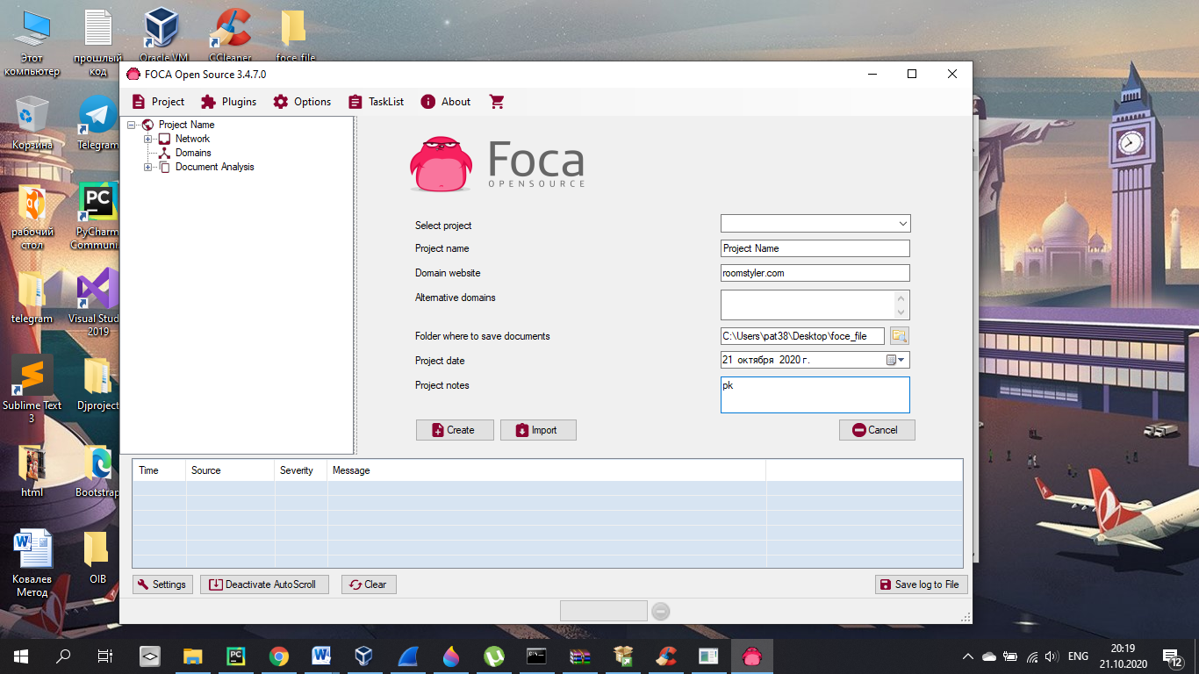

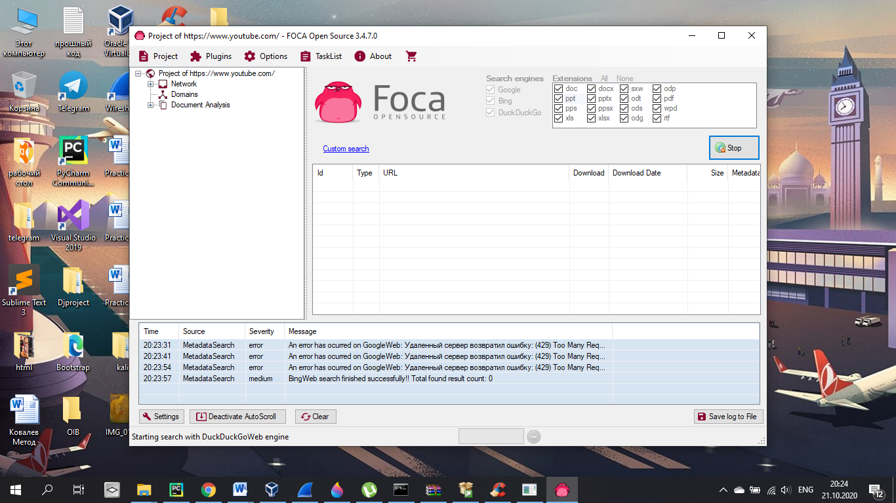

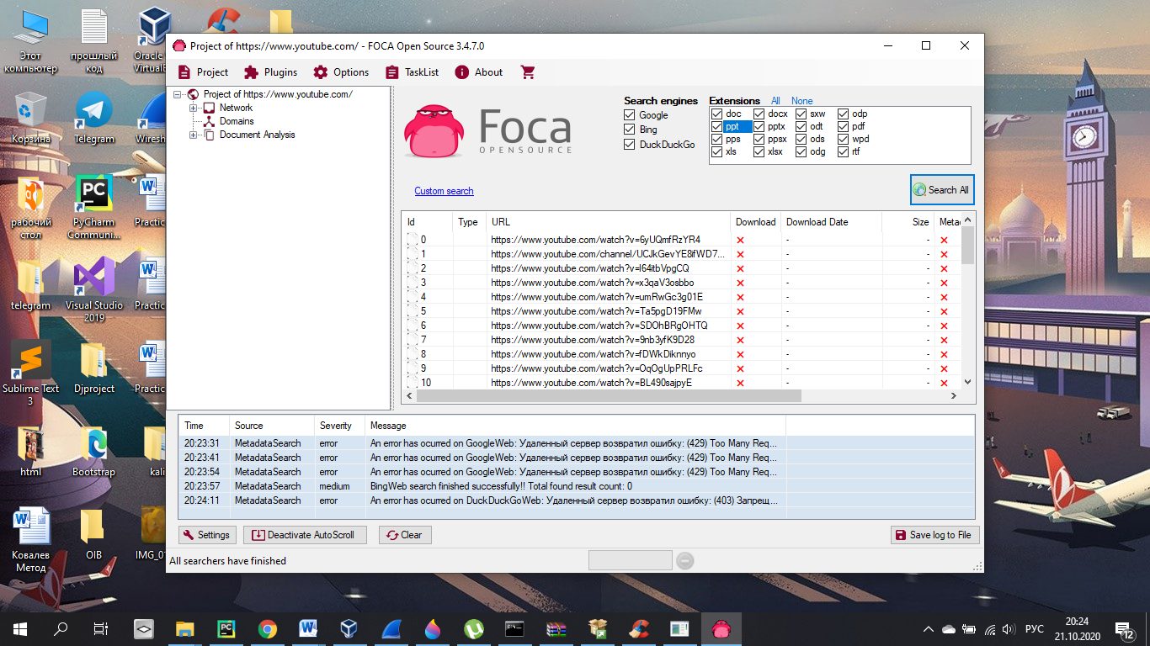

Произведя загрузку всех файлов с данного ресурса, производится автоматический анализ собранных файлов на наличие владельцев файлов, паролей и т.д.

CCLEANER

