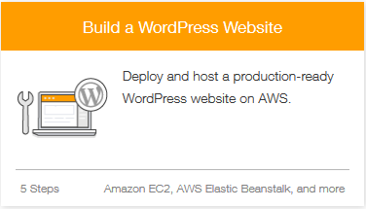

# Structure

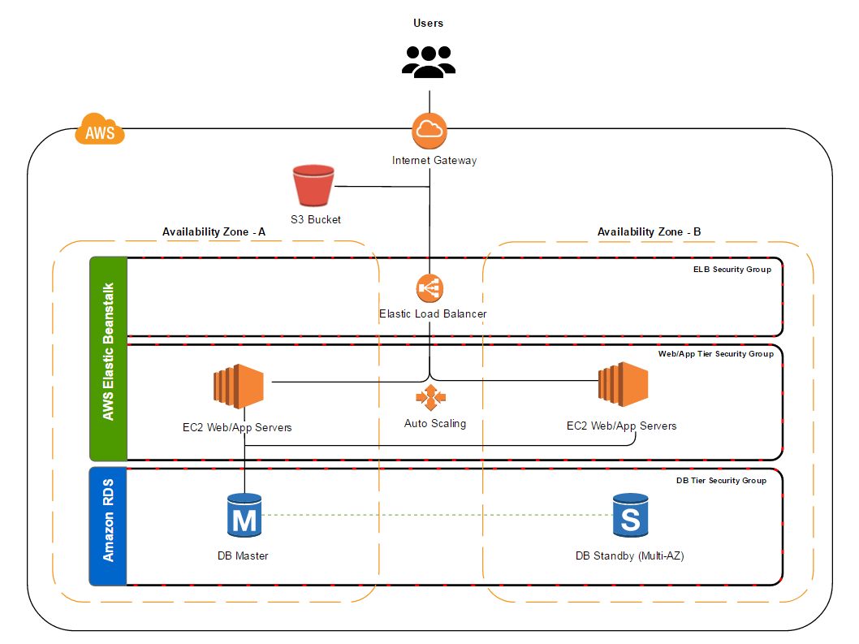

# Overview

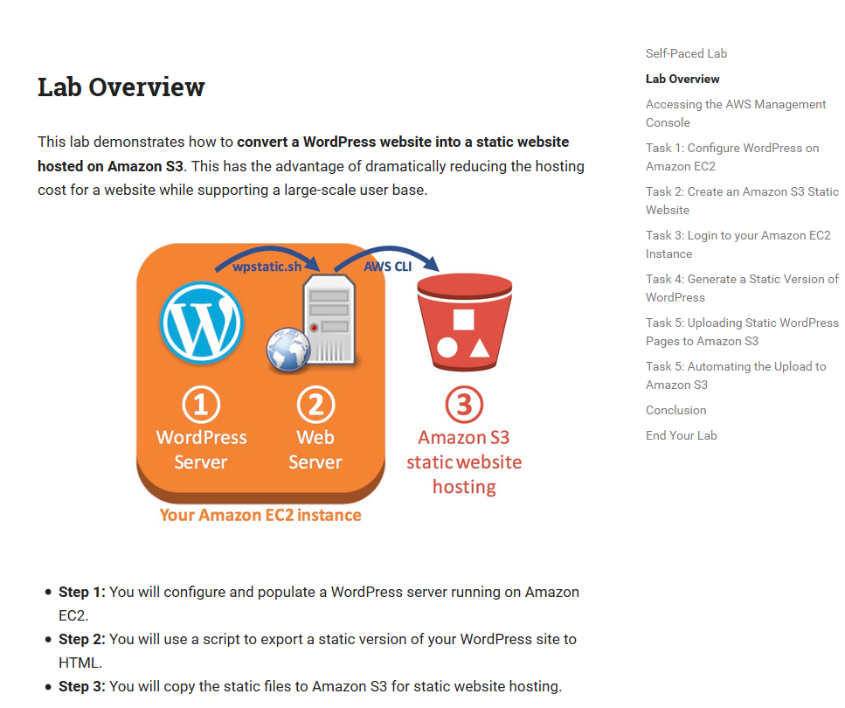

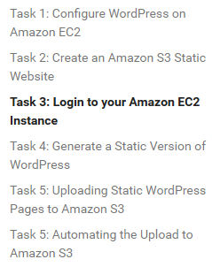

# WordPress on EC2

# S3 Static Website

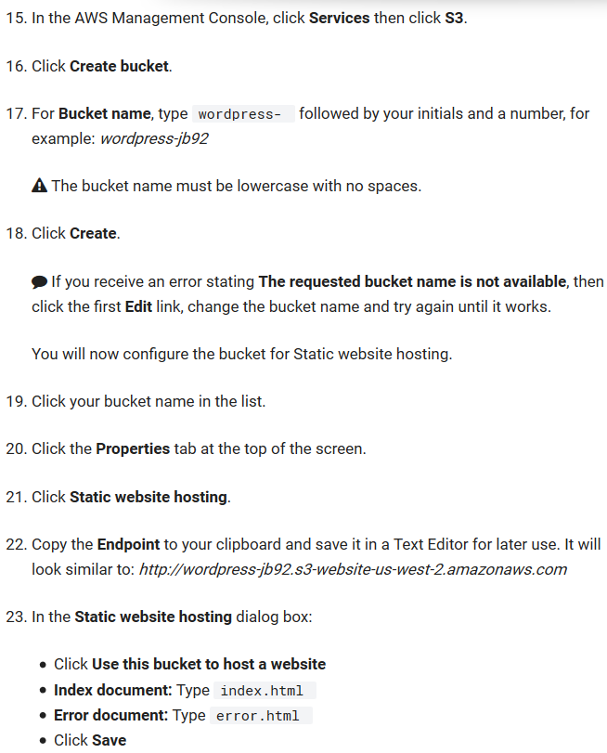

# Login to EC2

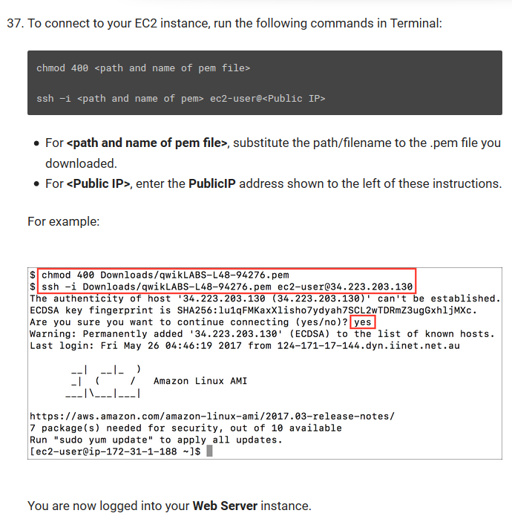

# Generate static version of WordPress

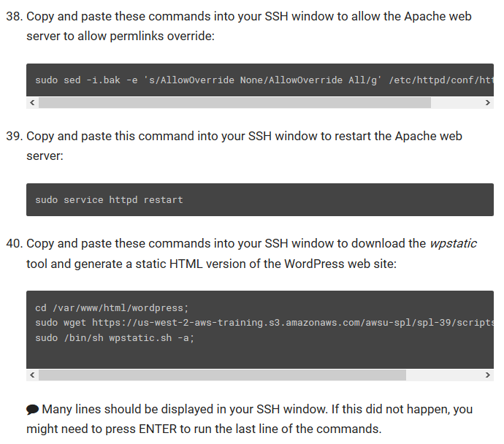

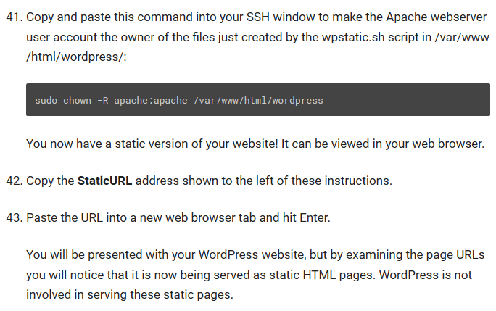

* 1. code

sudo sed -i.bak -e 's/AllowOverride None/AllowOverride All/g' /etc/httpd/conf/httpd.conf;

* 1. restart Apache

sudo service httpd restart

* 1. download wpstatic

cd /var/www/html/wordpress;

sudo wget https://us-west-2-aws-training.s3.amazonaws.com/awsu-spl/spl-39/scripts/wpstatic.sh;

sudo /bin/sh wpstatic.sh -a;

* 1. create a script

sudo chown -R apache:apache /var/www/html/wordpress

# Upload a static WordPress to S3

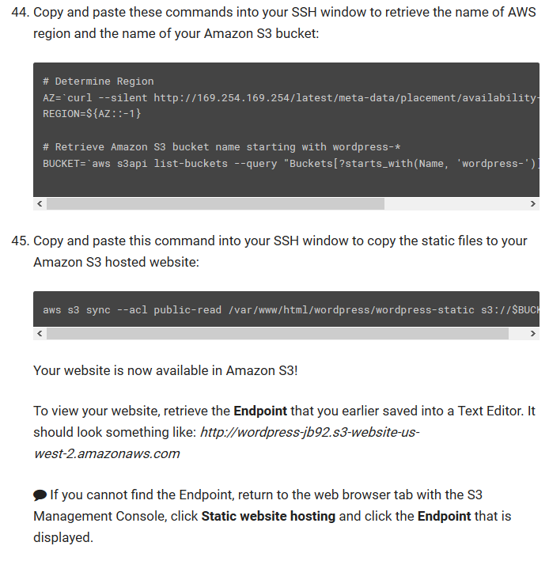

1. point to s3

# Determine Region

AZ=`curl --silent http://169.254.169.254/latest/meta-data/placement/availability-zone/`

REGION=${AZ::-1}

# Retrieve Amazon S3 bucket name starting with wordpress-*

BUCKET=`aws s3api list-buckets --query "Buckets[?starts_with(Name, 'wordpress-')].Name | [0]" --output text`

1. sync to the bucket

aws s3 sync --acl public-read /var/www/html/wordpress/wordpress-static s3://$BUCKET

## Automate upload to S3 with cronjob

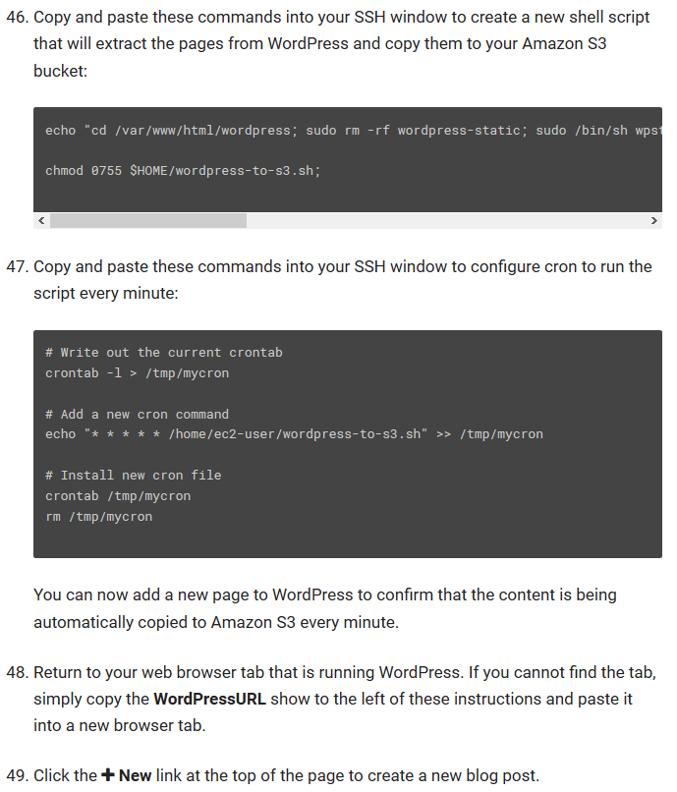

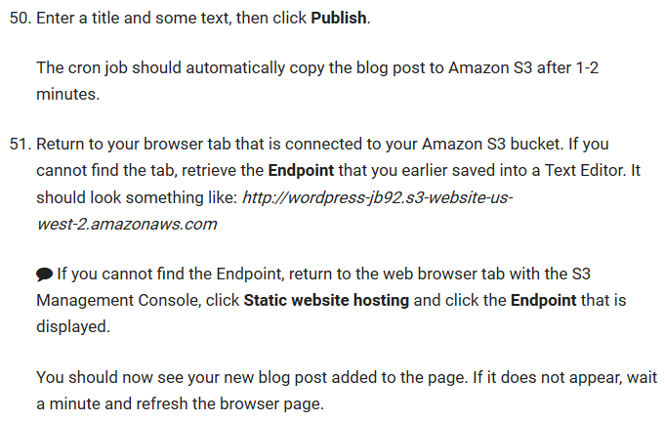

1. create a new script

echo "cd /var/www/html/wordpress; sudo rm -rf wordpress-static; sudo /bin/sh wpstatic.sh -a; aws s3 sync --acl public-read --delete /var/www/html/wordpress/wordpress-static s3://$BUCKET" > $HOME/wordpress-to-s3.sh;

chmod 0755 $HOME/wordpress-to-s3.sh;

1. configure a cronjob

# Write out the current crontab

crontab -l > /tmp/mycron

# Add a new cron command

echo "* * * * * /home/ec2-user/wordpress-to-s3.sh" >> /tmp/mycron

# Install new cron file

crontab /tmp/mycron

rm /tmp/mycron

# Useful links

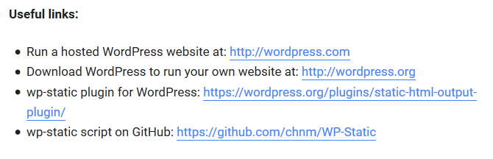

# Conclusion

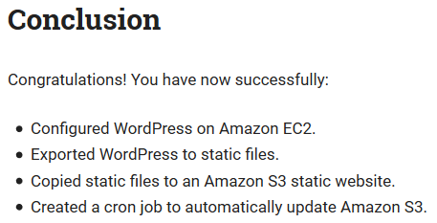

# Other Considerations

