GACD Programming Assignment

Autogenerated data summary from dataMaid

2019-07-17 16:05:42

# Data report overview

The dataset examined has the following dimensions:

|  |  |
| --- | --- |
| Feature | Result |
| Number of observations | 180 |
| Number of variables | 88 |

# Codebook summary table

|  |  |  |  |  |  |
| --- | --- | --- | --- | --- | --- |
| Label | Variable | Class | # unique values | Missing | Description |
|  | **Subject** | integer | 30 | 0.00 % |  |
|  | **Activity** | character | 6 | 0.00 % |  |
|  | **1 tBodyAcc-mean()-X** | numeric | 180 | 0.00 % |  |
|  | **2 tBodyAcc-mean()-Y** | numeric | 180 | 0.00 % |  |
|  | **3 tBodyAcc-mean()-Z** | numeric | 180 | 0.00 % |  |
|  | **41 tGravityAcc-mean()-X** | numeric | 180 | 0.00 % |  |
|  | **42 tGravityAcc-mean()-Y** | numeric | 180 | 0.00 % |  |
|  | **43 tGravityAcc-mean()-Z** | numeric | 180 | 0.00 % |  |
|  | **81 tBodyAccJerk-mean()-X** | numeric | 180 | 0.00 % |  |
|  | **82 tBodyAccJerk-mean()-Y** | numeric | 180 | 0.00 % |  |
|  | **83 tBodyAccJerk-mean()-Z** | numeric | 180 | 0.00 % |  |
|  | **121 tBodyGyro-mean()-X** | numeric | 180 | 0.00 % |  |
|  | **122 tBodyGyro-mean()-Y** | numeric | 180 | 0.00 % |  |
|  | **123 tBodyGyro-mean()-Z** | numeric | 180 | 0.00 % |  |
|  | **161 tBodyGyroJerk-mean()-X** | numeric | 180 | 0.00 % |  |
|  | **162 tBodyGyroJerk-mean()-Y** | numeric | 180 | 0.00 % |  |
|  | **163 tBodyGyroJerk-mean()-Z** | numeric | 180 | 0.00 % |  |
|  | **201 tBodyAccMag-mean()** | numeric | 180 | 0.00 % |  |
|  | **214 tGravityAccMag-mean()** | numeric | 180 | 0.00 % |  |
|  | **227 tBodyAccJerkMag-mean()** | numeric | 180 | 0.00 % |  |
|  | **240 tBodyGyroMag-mean()** | numeric | 180 | 0.00 % |  |
|  | **253 tBodyGyroJerkMag-mean()** | numeric | 180 | 0.00 % |  |
|  | **266 fBodyAcc-mean()-X** | numeric | 180 | 0.00 % |  |
|  | **267 fBodyAcc-mean()-Y** | numeric | 180 | 0.00 % |  |
|  | **268 fBodyAcc-mean()-Z** | numeric | 180 | 0.00 % |  |
|  | **294 fBodyAcc-meanFreq()-X** | numeric | 180 | 0.00 % |  |
|  | **295 fBodyAcc-meanFreq()-Y** | numeric | 180 | 0.00 % |  |
|  | **296 fBodyAcc-meanFreq()-Z** | numeric | 180 | 0.00 % |  |
|  | **345 fBodyAccJerk-mean()-X** | numeric | 180 | 0.00 % |  |
|  | **346 fBodyAccJerk-mean()-Y** | numeric | 180 | 0.00 % |  |
|  | **347 fBodyAccJerk-mean()-Z** | numeric | 180 | 0.00 % |  |
|  | **373 fBodyAccJerk-meanFreq()-X** | numeric | 180 | 0.00 % |  |
|  | **374 fBodyAccJerk-meanFreq()-Y** | numeric | 180 | 0.00 % |  |
|  | **375 fBodyAccJerk-meanFreq()-Z** | numeric | 180 | 0.00 % |  |
|  | **424 fBodyGyro-mean()-X** | numeric | 180 | 0.00 % |  |
|  | **425 fBodyGyro-mean()-Y** | numeric | 180 | 0.00 % |  |
|  | **426 fBodyGyro-mean()-Z** | numeric | 180 | 0.00 % |  |
|  | **452 fBodyGyro-meanFreq()-X** | numeric | 180 | 0.00 % |  |
|  | **453 fBodyGyro-meanFreq()-Y** | numeric | 180 | 0.00 % |  |
|  | **454 fBodyGyro-meanFreq()-Z** | numeric | 180 | 0.00 % |  |
|  | **503 fBodyAccMag-mean()** | numeric | 180 | 0.00 % |  |
|  | **513 fBodyAccMag-meanFreq()** | numeric | 180 | 0.00 % |  |
|  | **516 fBodyBodyAccJerkMag-mean()** | numeric | 180 | 0.00 % |  |
|  | **526 fBodyBodyAccJerkMag-meanFreq()** | numeric | 180 | 0.00 % |  |
|  | **529 fBodyBodyGyroMag-mean()** | numeric | 180 | 0.00 % |  |
|  | **539 fBodyBodyGyroMag-meanFreq()** | numeric | 180 | 0.00 % |  |
|  | **542 fBodyBodyGyroJerkMag-mean()** | numeric | 180 | 0.00 % |  |
|  | **552 fBodyBodyGyroJerkMag-meanFreq()** | numeric | 180 | 0.00 % |  |
|  | **555 angle(tBodyAccMean,gravity)** | numeric | 180 | 0.00 % |  |
|  | **556 angle(tBodyAccJerkMean),gravityMean)** | numeric | 180 | 0.00 % |  |
|  | **557 angle(tBodyGyroMean,gravityMean)** | numeric | 180 | 0.00 % |  |
|  | **558 angle(tBodyGyroJerkMean,gravityMean)** | numeric | 180 | 0.00 % |  |
|  | **559 angle(X,gravityMean)** | numeric | 180 | 0.00 % |  |
|  | **560 angle(Y,gravityMean)** | numeric | 180 | 0.00 % |  |
|  | **561 angle(Z,gravityMean)** | numeric | 180 | 0.00 % |  |
|  | **4 tBodyAcc-std()-X** | numeric | 180 | 0.00 % |  |
|  | **5 tBodyAcc-std()-Y** | numeric | 180 | 0.00 % |  |
|  | **6 tBodyAcc-std()-Z** | numeric | 180 | 0.00 % |  |
|  | **44 tGravityAcc-std()-X** | numeric | 180 | 0.00 % |  |
|  | **45 tGravityAcc-std()-Y** | numeric | 180 | 0.00 % |  |
|  | **46 tGravityAcc-std()-Z** | numeric | 180 | 0.00 % |  |
|  | **84 tBodyAccJerk-std()-X** | numeric | 180 | 0.00 % |  |
|  | **85 tBodyAccJerk-std()-Y** | numeric | 180 | 0.00 % |  |
|  | **86 tBodyAccJerk-std()-Z** | numeric | 180 | 0.00 % |  |
|  | **124 tBodyGyro-std()-X** | numeric | 180 | 0.00 % |  |
|  | **125 tBodyGyro-std()-Y** | numeric | 180 | 0.00 % |  |
|  | **126 tBodyGyro-std()-Z** | numeric | 180 | 0.00 % |  |
|  | **164 tBodyGyroJerk-std()-X** | numeric | 180 | 0.00 % |  |
|  | **165 tBodyGyroJerk-std()-Y** | numeric | 180 | 0.00 % |  |
|  | **166 tBodyGyroJerk-std()-Z** | numeric | 180 | 0.00 % |  |
|  | **202 tBodyAccMag-std()** | numeric | 180 | 0.00 % |  |
|  | **215 tGravityAccMag-std()** | numeric | 180 | 0.00 % |  |
|  | **228 tBodyAccJerkMag-std()** | numeric | 180 | 0.00 % |  |
|  | **241 tBodyGyroMag-std()** | numeric | 180 | 0.00 % |  |
|  | **254 tBodyGyroJerkMag-std()** | numeric | 180 | 0.00 % |  |
|  | **269 fBodyAcc-std()-X** | numeric | 180 | 0.00 % |  |
|  | **270 fBodyAcc-std()-Y** | numeric | 180 | 0.00 % |  |
|  | **271 fBodyAcc-std()-Z** | numeric | 180 | 0.00 % |  |
|  | **348 fBodyAccJerk-std()-X** | numeric | 180 | 0.00 % |  |
|  | **349 fBodyAccJerk-std()-Y** | numeric | 180 | 0.00 % |  |
|  | **350 fBodyAccJerk-std()-Z** | numeric | 180 | 0.00 % |  |
|  | **427 fBodyGyro-std()-X** | numeric | 180 | 0.00 % |  |
|  | **428 fBodyGyro-std()-Y** | numeric | 180 | 0.00 % |  |
|  | **429 fBodyGyro-std()-Z** | numeric | 180 | 0.00 % |  |
|  | **504 fBodyAccMag-std()** | numeric | 180 | 0.00 % |  |
|  | **517 fBodyBodyAccJerkMag-std()** | numeric | 180 | 0.00 % |  |
|  | **530 fBodyBodyGyroMag-std()** | numeric | 180 | 0.00 % |  |
|  | **543 fBodyBodyGyroJerkMag-std()** | numeric | 180 | 0.00 % |  |

# Variable list

## Subject

|  |  |
| --- | --- |
| Feature | Result |
| Variable type | integer |
| Number of missing obs. | 0 (0 %) |
| Number of unique values | 30 |
| Median | 15.5 |
| 1st and 3rd quartiles | 8; 23 |
| Min. and max. | 1; 30 |

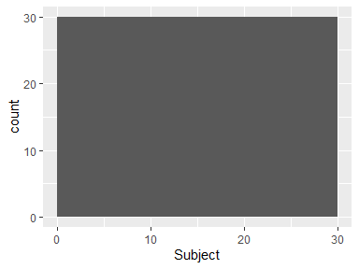

## Activity

|  |  |
| --- | --- |
| Feature | Result |
| Variable type | character |
| Number of missing obs. | 0 (0 %) |
| Number of unique values | 6 |
| Mode | “LAYING” |

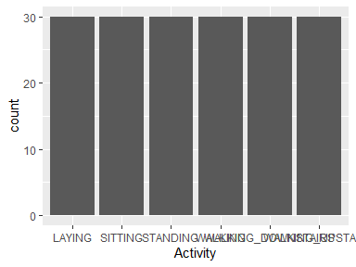

* Observed factor levels: "LAYING", "SITTING", "STANDING", "WALKING", "WALKING_DOWNSTAIRS", "WALKING_UPSTAIRS".

## 1 tBodyAcc-mean()-X

|  |  |
| --- | --- |
| Feature | Result |
| Variable type | numeric |
| Number of missing obs. | 0 (0 %) |
| Number of unique values | 180 |
| Median | 0.28 |
| 1st and 3rd quartiles | 0.27; 0.28 |
| Min. and max. | 0.22; 0.3 |

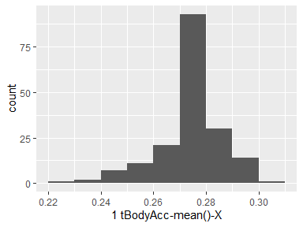

## 2 tBodyAcc-mean()-Y

|  |  |
| --- | --- |
| Feature | Result |
| Variable type | numeric |
| Number of missing obs. | 0 (0 %) |
| Number of unique values | 180 |
| Median | -0.02 |
| 1st and 3rd quartiles | -0.02; -0.01 |
| Min. and max. | -0.04; 0 |

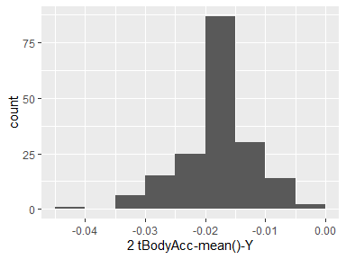

## 3 tBodyAcc-mean()-Z

|  |  |
| --- | --- |
| Feature | Result |
| Variable type | numeric |
| Number of missing obs. | 0 (0 %) |
| Number of unique values | 180 |
| Median | -0.11 |
| 1st and 3rd quartiles | -0.11; -0.1 |
| Min. and max. | -0.15; -0.08 |

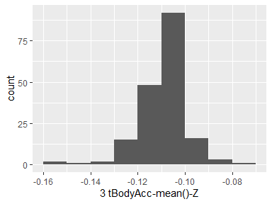

## 41 tGravityAcc-mean()-X

|  |  |
| --- | --- |
| Feature | Result |
| Variable type | numeric |
| Number of missing obs. | 0 (0 %) |
| Number of unique values | 180 |
| Median | 0.92 |
| 1st and 3rd quartiles | 0.84; 0.94 |
| Min. and max. | -0.68; 0.97 |

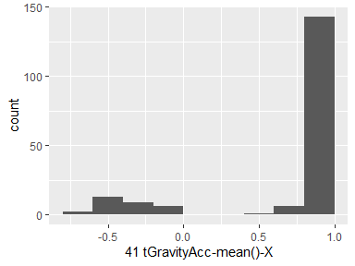

## 42 tGravityAcc-mean()-Y

|  |  |
| --- | --- |
| Feature | Result |
| Variable type | numeric |
| Number of missing obs. | 0 (0 %) |
| Number of unique values | 180 |
| Median | -0.13 |
| 1st and 3rd quartiles | -0.23; 0.09 |
| Min. and max. | -0.48; 0.96 |

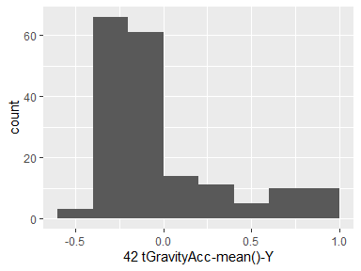

## 43 tGravityAcc-mean()-Z

|  |  |
| --- | --- |
| Feature | Result |
| Variable type | numeric |
| Number of missing obs. | 0 (0 %) |
| Number of unique values | 180 |
| Median | 0.02 |
| 1st and 3rd quartiles | -0.12; 0.15 |
| Min. and max. | -0.5; 0.96 |

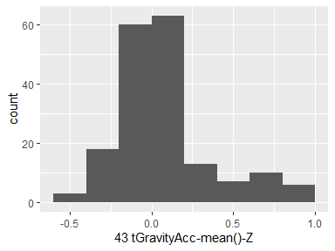

## 81 tBodyAccJerk-mean()-X

|  |  |
| --- | --- |
| Feature | Result |
| Variable type | numeric |
| Number of missing obs. | 0 (0 %) |
| Number of unique values | 180 |
| Median | 0.08 |
| 1st and 3rd quartiles | 0.07; 0.08 |
| Min. and max. | 0.04; 0.13 |

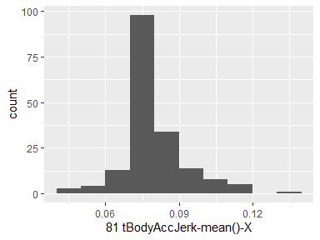

## 82 tBodyAccJerk-mean()-Y

|  |  |
| --- | --- |
| Feature | Result |
| Variable type | numeric |
| Number of missing obs. | 0 (0 %) |
| Number of unique values | 180 |
| Median | 0.01 |
| 1st and 3rd quartiles | 0; 0.01 |
| Min. and max. | -0.04; 0.06 |

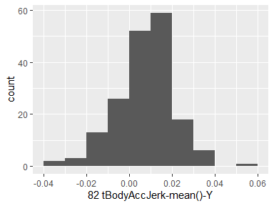

## 83 tBodyAccJerk-mean()-Z

|  |  |
| --- | --- |
| Feature | Result |
| Variable type | numeric |
| Number of missing obs. | 0 (0 %) |
| Number of unique values | 180 |
| Median | 0 |
| 1st and 3rd quartiles | -0.01; 0 |
| Min. and max. | -0.07; 0.04 |

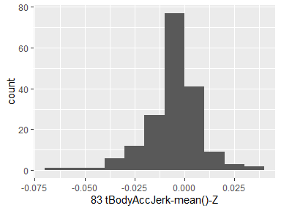

## 121 tBodyGyro-mean()-X

|  |  |
| --- | --- |
| Feature | Result |
| Variable type | numeric |
| Number of missing obs. | 0 (0 %) |
| Number of unique values | 180 |
| Median | -0.03 |
| 1st and 3rd quartiles | -0.05; -0.02 |
| Min. and max. | -0.21; 0.19 |

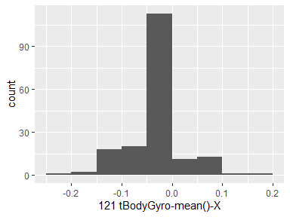

## 122 tBodyGyro-mean()-Y

|  |  |
| --- | --- |
| Feature | Result |
| Variable type | numeric |
| Number of missing obs. | 0 (0 %) |
| Number of unique values | 180 |
| Median | -0.07 |
| 1st and 3rd quartiles | -0.09; -0.06 |
| Min. and max. | -0.2; 0.03 |

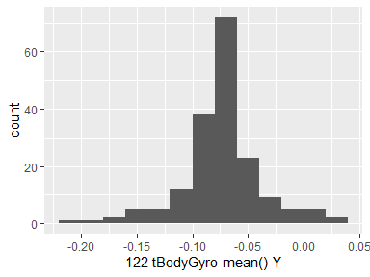

## 123 tBodyGyro-mean()-Z

|  |  |
| --- | --- |
| Feature | Result |
| Variable type | numeric |
| Number of missing obs. | 0 (0 %) |
| Number of unique values | 180 |
| Median | 0.09 |
| 1st and 3rd quartiles | 0.07; 0.1 |
| Min. and max. | -0.07; 0.18 |

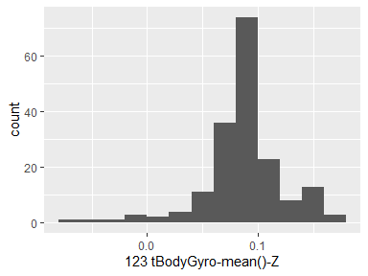

## 161 tBodyGyroJerk-mean()-X

|  |  |
| --- | --- |
| Feature | Result |
| Variable type | numeric |
| Number of missing obs. | 0 (0 %) |
| Number of unique values | 180 |
| Median | -0.1 |
| 1st and 3rd quartiles | -0.1; -0.09 |
| Min. and max. | -0.16; -0.02 |

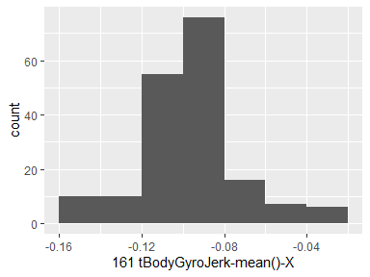

## 162 tBodyGyroJerk-mean()-Y

|  |  |
| --- | --- |
| Feature | Result |
| Variable type | numeric |
| Number of missing obs. | 0 (0 %) |
| Number of unique values | 180 |
| Median | -0.04 |
| 1st and 3rd quartiles | -0.05; -0.04 |
| Min. and max. | -0.08; -0.01 |

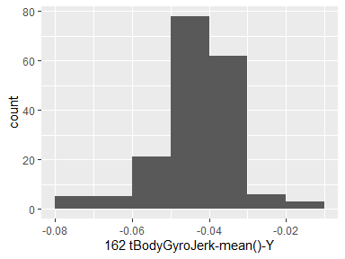

## 163 tBodyGyroJerk-mean()-Z

|  |  |
| --- | --- |
| Feature | Result |
| Variable type | numeric |
| Number of missing obs. | 0 (0 %) |
| Number of unique values | 180 |
| Median | -0.05 |
| 1st and 3rd quartiles | -0.06; -0.05 |
| Min. and max. | -0.09; -0.01 |

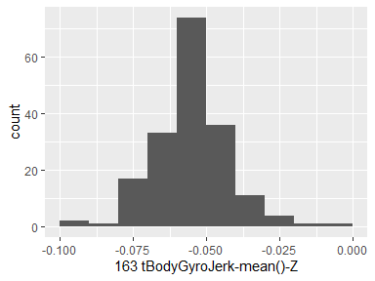

## 201 tBodyAccMag-mean()

|  |  |
| --- | --- |
| Feature | Result |
| Variable type | numeric |
| Number of missing obs. | 0 (0 %) |
| Number of unique values | 180 |
| Median | -0.48 |
| 1st and 3rd quartiles | -0.96; -0.09 |
| Min. and max. | -0.99; 0.64 |

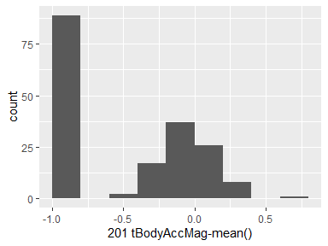

## 214 tGravityAccMag-mean()

|  |  |
| --- | --- |
| Feature | Result |
| Variable type | numeric |
| Number of missing obs. | 0 (0 %) |
| Number of unique values | 180 |
| Median | -0.48 |
| 1st and 3rd quartiles | -0.96; -0.09 |
| Min. and max. | -0.99; 0.64 |

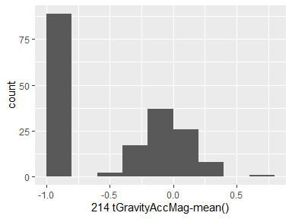

## 227 tBodyAccJerkMag-mean()

|  |  |
| --- | --- |
| Feature | Result |
| Variable type | numeric |
| Number of missing obs. | 0 (0 %) |
| Number of unique values | 180 |
| Median | -0.82 |
| 1st and 3rd quartiles | -0.98; -0.25 |
| Min. and max. | -0.99; 0.43 |

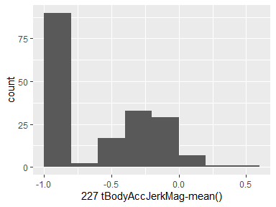

## 240 tBodyGyroMag-mean()

|  |  |
| --- | --- |
| Feature | Result |
| Variable type | numeric |
| Number of missing obs. | 0 (0 %) |
| Number of unique values | 180 |
| Median | -0.66 |
| 1st and 3rd quartiles | -0.95; -0.22 |
| Min. and max. | -0.98; 0.42 |

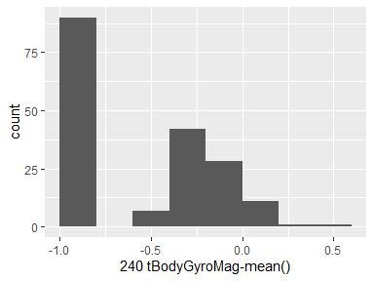

## 253 tBodyGyroJerkMag-mean()

|  |  |
| --- | --- |
| Feature | Result |
| Variable type | numeric |
| Number of missing obs. | 0 (0 %) |
| Number of unique values | 180 |
| Median | -0.86 |
| 1st and 3rd quartiles | -0.99; -0.51 |
| Min. and max. | -1; 0.09 |

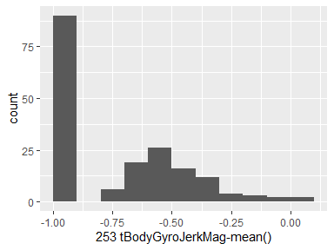

## 266 fBodyAcc-mean()-X

|  |  |
| --- | --- |
| Feature | Result |
| Variable type | numeric |
| Number of missing obs. | 0 (0 %) |
| Number of unique values | 180 |
| Median | -0.77 |
| 1st and 3rd quartiles | -0.98; -0.22 |
| Min. and max. | -1; 0.54 |

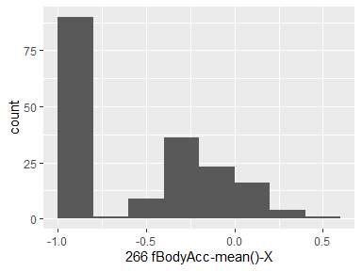

## 267 fBodyAcc-mean()-Y

|  |  |
| --- | --- |
| Feature | Result |
| Variable type | numeric |
| Number of missing obs. | 0 (0 %) |
| Number of unique values | 180 |
| Median | -0.59 |
| 1st and 3rd quartiles | -0.95; -0.06 |
| Min. and max. | -0.99; 0.52 |

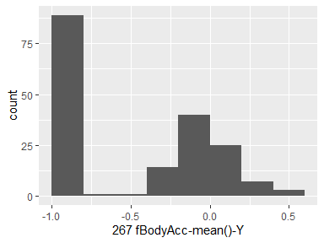

## 268 fBodyAcc-mean()-Z

|  |  |
| --- | --- |
| Feature | Result |
| Variable type | numeric |
| Number of missing obs. | 0 (0 %) |
| Number of unique values | 180 |
| Median | -0.72 |
| 1st and 3rd quartiles | -0.96; -0.32 |
| Min. and max. | -0.99; 0.28 |

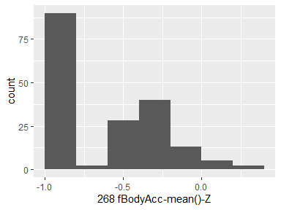

## 294 fBodyAcc-meanFreq()-X

|  |  |
| --- | --- |
| Feature | Result |
| Variable type | numeric |
| Number of missing obs. | 0 (0 %) |
| Number of unique values | 180 |
| Median | -0.26 |
| 1st and 3rd quartiles | -0.39; -0.06 |
| Min. and max. | -0.64; 0.16 |

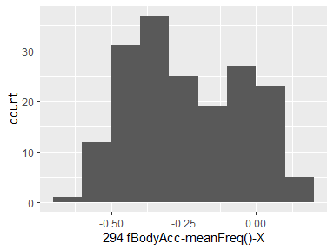

## 295 fBodyAcc-meanFreq()-Y

|  |  |
| --- | --- |
| Feature | Result |
| Variable type | numeric |
| Number of missing obs. | 0 (0 %) |
| Number of unique values | 180 |
| Median | 0.01 |
| 1st and 3rd quartiles | -0.08; 0.09 |
| Min. and max. | -0.38; 0.47 |

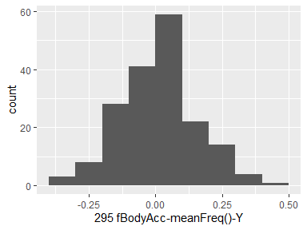

## 296 fBodyAcc-meanFreq()-Z

|  |  |
| --- | --- |
| Feature | Result |
| Variable type | numeric |
| Number of missing obs. | 0 (0 %) |
| Number of unique values | 180 |
| Median | 0.07 |
| 1st and 3rd quartiles | -0.04; 0.18 |
| Min. and max. | -0.52; 0.4 |

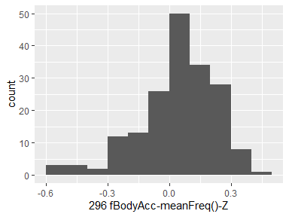

## 345 fBodyAccJerk-mean()-X

|  |  |
| --- | --- |
| Feature | Result |
| Variable type | numeric |
| Number of missing obs. | 0 (0 %) |
| Number of unique values | 180 |
| Median | -0.81 |
| 1st and 3rd quartiles | -0.98; -0.28 |
| Min. and max. | -0.99; 0.47 |

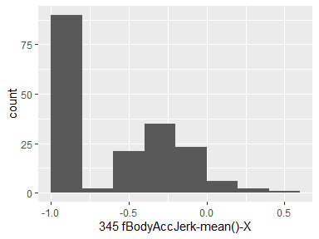

## 346 fBodyAccJerk-mean()-Y

|  |  |
| --- | --- |
| Feature | Result |
| Variable type | numeric |
| Number of missing obs. | 0 (0 %) |
| Number of unique values | 180 |
| Median | -0.78 |
| 1st and 3rd quartiles | -0.97; -0.2 |
| Min. and max. | -0.99; 0.28 |

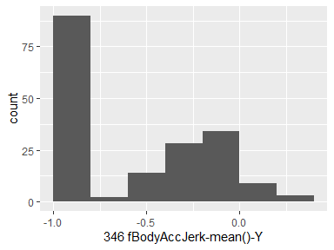

## 347 fBodyAccJerk-mean()-Z

|  |  |
| --- | --- |
| Feature | Result |
| Variable type | numeric |
| Number of missing obs. | 0 (0 %) |
| Number of unique values | 180 |
| Median | -0.87 |
| 1st and 3rd quartiles | -0.98; -0.47 |
| Min. and max. | -0.99; 0.16 |

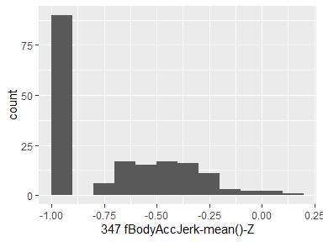

## 373 fBodyAccJerk-meanFreq()-X

|  |  |
| --- | --- |
| Feature | Result |
| Variable type | numeric |
| Number of missing obs. | 0 (0 %) |
| Number of unique values | 180 |
| Median | -0.06 |
| 1st and 3rd quartiles | -0.29; 0.18 |
| Min. and max. | -0.58; 0.33 |

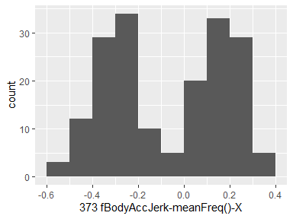

## 374 fBodyAccJerk-meanFreq()-Y

|  |  |
| --- | --- |
| Feature | Result |
| Variable type | numeric |
| Number of missing obs. | 0 (0 %) |
| Number of unique values | 180 |
| Median | -0.23 |
| 1st and 3rd quartiles | -0.4; -0.05 |
| Min. and max. | -0.6; 0.2 |

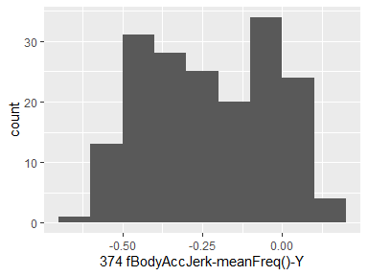

## 375 fBodyAccJerk-meanFreq()-Z

|  |  |
| --- | --- |
| Feature | Result |
| Variable type | numeric |
| Number of missing obs. | 0 (0 %) |
| Number of unique values | 180 |
| Median | -0.09 |
| 1st and 3rd quartiles | -0.31; 0.04 |
| Min. and max. | -0.63; 0.23 |

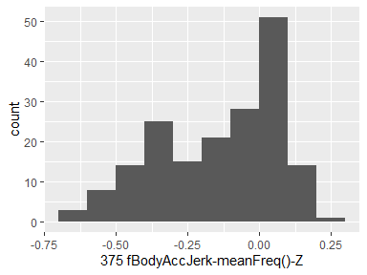

## 424 fBodyGyro-mean()-X

|  |  |
| --- | --- |
| Feature | Result |
| Variable type | numeric |
| Number of missing obs. | 0 (0 %) |
| Number of unique values | 180 |
| Median | -0.73 |
| 1st and 3rd quartiles | -0.97; -0.34 |
| Min. and max. | -0.99; 0.47 |

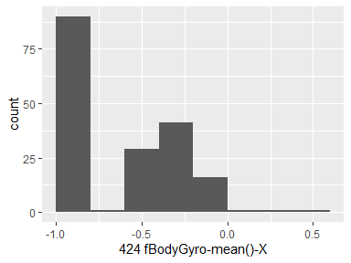

## 425 fBodyGyro-mean()-Y

|  |  |
| --- | --- |
| Feature | Result |
| Variable type | numeric |
| Number of missing obs. | 0 (0 %) |
| Number of unique values | 180 |
| Median | -0.81 |
| 1st and 3rd quartiles | -0.97; -0.45 |
| Min. and max. | -0.99; 0.33 |

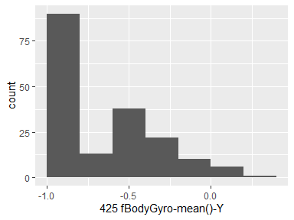

## 426 fBodyGyro-mean()-Z

|  |  |
| --- | --- |
| Feature | Result |
| Variable type | numeric |
| Number of missing obs. | 0 (0 %) |
| Number of unique values | 180 |
| Median | -0.79 |
| 1st and 3rd quartiles | -0.96; -0.26 |
| Min. and max. | -0.99; 0.49 |

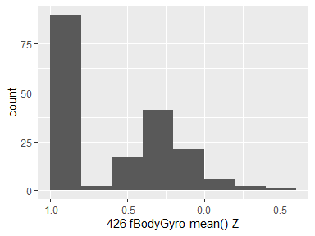

## 452 fBodyGyro-meanFreq()-X

|  |  |
| --- | --- |
| Feature | Result |
| Variable type | numeric |
| Number of missing obs. | 0 (0 %) |
| Number of unique values | 180 |
| Median | -0.12 |
| 1st and 3rd quartiles | -0.21; 0 |
| Min. and max. | -0.4; 0.25 |

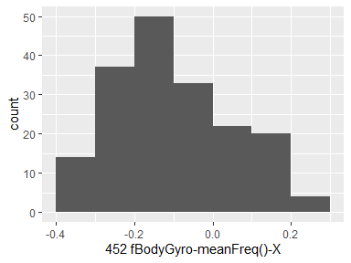

## 453 fBodyGyro-meanFreq()-Y

|  |  |
| --- | --- |
| Feature | Result |
| Variable type | numeric |
| Number of missing obs. | 0 (0 %) |
| Number of unique values | 180 |
| Median | -0.16 |
| 1st and 3rd quartiles | -0.29; -0.04 |
| Min. and max. | -0.67; 0.27 |

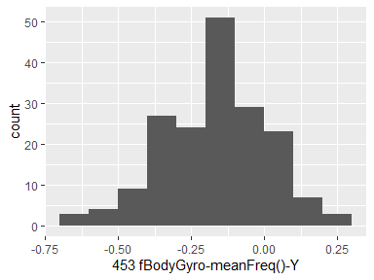

## 454 fBodyGyro-meanFreq()-Z

|  |  |
| --- | --- |
| Feature | Result |
| Variable type | numeric |
| Number of missing obs. | 0 (0 %) |
| Number of unique values | 180 |
| Median | -0.05 |
| 1st and 3rd quartiles | -0.15; 0.04 |
| Min. and max. | -0.51; 0.38 |

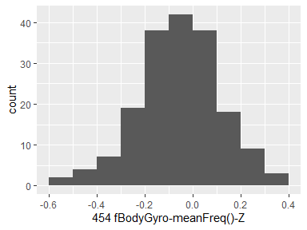

## 503 fBodyAccMag-mean()

|  |  |
| --- | --- |
| Feature | Result |
| Variable type | numeric |
| Number of missing obs. | 0 (0 %) |
| Number of unique values | 180 |
| Median | -0.67 |
| 1st and 3rd quartiles | -0.96; -0.16 |
| Min. and max. | -0.99; 0.59 |

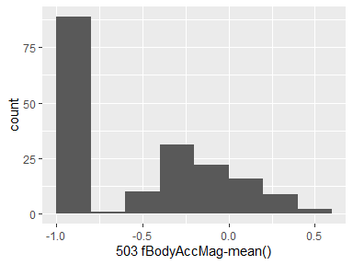

## 513 fBodyAccMag-meanFreq()

|  |  |
| --- | --- |
| Feature | Result |
| Variable type | numeric |
| Number of missing obs. | 0 (0 %) |
| Number of unique values | 180 |
| Median | 0.08 |
| 1st and 3rd quartiles | -0.01; 0.17 |
| Min. and max. | -0.31; 0.44 |

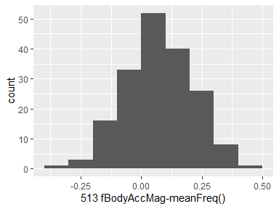

## 516 fBodyBodyAccJerkMag-mean()

|  |  |
| --- | --- |
| Feature | Result |
| Variable type | numeric |
| Number of missing obs. | 0 (0 %) |
| Number of unique values | 180 |
| Median | -0.79 |
| 1st and 3rd quartiles | -0.98; -0.19 |
| Min. and max. | -0.99; 0.54 |

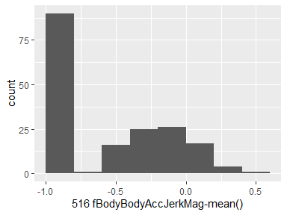

## 526 fBodyBodyAccJerkMag-meanFreq()

|  |  |
| --- | --- |
| Feature | Result |
| Variable type | numeric |
| Number of missing obs. | 0 (0 %) |
| Number of unique values | 180 |
| Median | 0.17 |
| 1st and 3rd quartiles | 0.05; 0.28 |
| Min. and max. | -0.13; 0.49 |

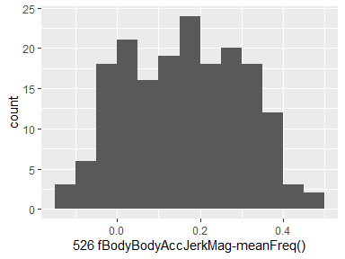

## 529 fBodyBodyGyroMag-mean()

|  |  |
| --- | --- |
| Feature | Result |
| Variable type | numeric |
| Number of missing obs. | 0 (0 %) |
| Number of unique values | 180 |
| Median | -0.77 |
| 1st and 3rd quartiles | -0.96; -0.41 |
| Min. and max. | -0.99; 0.2 |

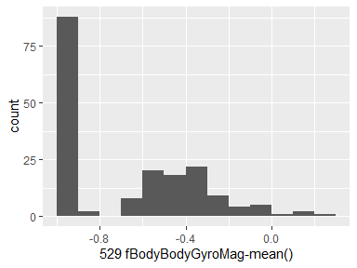

## 539 fBodyBodyGyroMag-meanFreq()

|  |  |
| --- | --- |
| Feature | Result |
| Variable type | numeric |
| Number of missing obs. | 0 (0 %) |
| Number of unique values | 180 |
| Median | -0.05 |
| 1st and 3rd quartiles | -0.17; 0.08 |
| Min. and max. | -0.46; 0.41 |

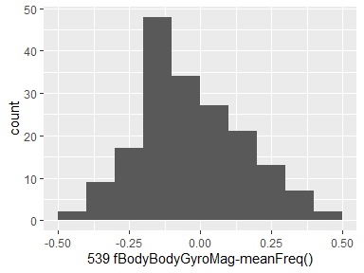

## 542 fBodyBodyGyroJerkMag-mean()

|  |  |
| --- | --- |
| Feature | Result |
| Variable type | numeric |
| Number of missing obs. | 0 (0 %) |
| Number of unique values | 180 |
| Median | -0.88 |
| 1st and 3rd quartiles | -0.98; -0.58 |
| Min. and max. | -1; 0.15 |

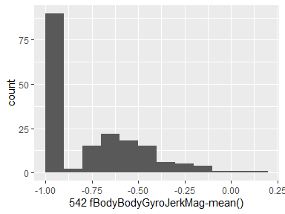

## 552 fBodyBodyGyroJerkMag-meanFreq()

|  |  |
| --- | --- |
| Feature | Result |
| Variable type | numeric |
| Number of missing obs. | 0 (0 %) |
| Number of unique values | 180 |
| Median | 0.11 |
| 1st and 3rd quartiles | 0.05; 0.21 |
| Min. and max. | -0.18; 0.43 |

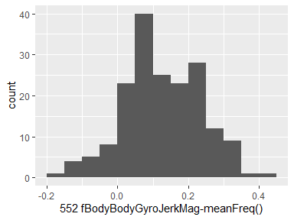

## 555 angle(tBodyAccMean,gravity)

|  |  |
| --- | --- |
| Feature | Result |
| Variable type | numeric |
| Number of missing obs. | 0 (0 %) |
| Number of unique values | 180 |
| Median | 0.01 |
| 1st and 3rd quartiles | -0.01; 0.02 |
| Min. and max. | -0.16; 0.13 |

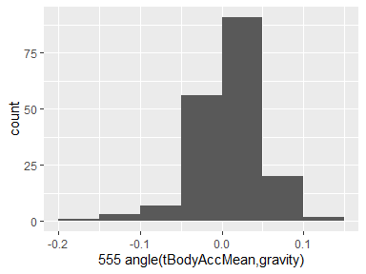

## 556 angle(tBodyAccJerkMean),gravityMean)

|  |  |
| --- | --- |
| Feature | Result |
| Variable type | numeric |
| Number of missing obs. | 0 (0 %) |
| Number of unique values | 180 |
| Median | 0 |
| 1st and 3rd quartiles | -0.02; 0.02 |
| Min. and max. | -0.12; 0.2 |

-1.png)

## 557 angle(tBodyGyroMean,gravityMean)

|  |  |
| --- | --- |
| Feature | Result |
| Variable type | numeric |
| Number of missing obs. | 0 (0 %) |
| Number of unique values | 180 |
| Median | 0.02 |
| 1st and 3rd quartiles | -0.02; 0.06 |
| Min. and max. | -0.39; 0.44 |

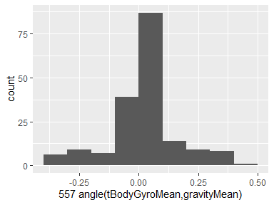

## 558 angle(tBodyGyroJerkMean,gravityMean)

|  |  |
| --- | --- |
| Feature | Result |
| Variable type | numeric |
| Number of missing obs. | 0 (0 %) |
| Number of unique values | 180 |
| Median | -0.02 |
| 1st and 3rd quartiles | -0.06; 0.03 |
| Min. and max. | -0.22; 0.18 |

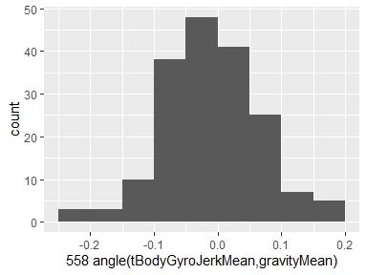

## 559 angle(X,gravityMean)

|  |  |
| --- | --- |
| Feature | Result |
| Variable type | numeric |
| Number of missing obs. | 0 (0 %) |
| Number of unique values | 180 |
| Median | -0.74 |
| 1st and 3rd quartiles | -0.79; -0.58 |
| Min. and max. | -0.95; 0.74 |

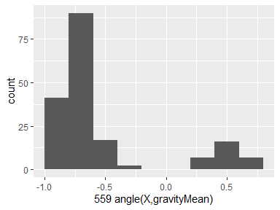

## 560 angle(Y,gravityMean)

|  |  |
| --- | --- |
| Feature | Result |
| Variable type | numeric |
| Number of missing obs. | 0 (0 %) |
| Number of unique values | 180 |
| Median | 0.17 |
| 1st and 3rd quartiles | 0.02; 0.24 |
| Min. and max. | -0.87; 0.42 |

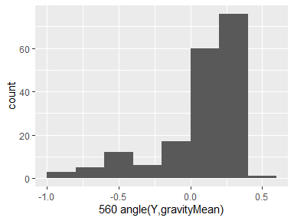

## 561 angle(Z,gravityMean)

|  |  |
| --- | --- |
| Feature | Result |
| Variable type | numeric |
| Number of missing obs. | 0 (0 %) |
| Number of unique values | 180 |
| Median | 0.01 |
| 1st and 3rd quartiles | -0.08; 0.11 |
| Min. and max. | -0.87; 0.39 |

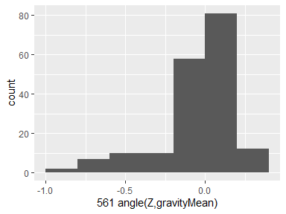

## 4 tBodyAcc-std()-X

|  |  |
| --- | --- |
| Feature | Result |
| Variable type | numeric |
| Number of missing obs. | 0 (0 %) |
| Number of unique values | 180 |
| Median | -0.75 |
| 1st and 3rd quartiles | -0.98; -0.2 |
| Min. and max. | -1; 0.63 |

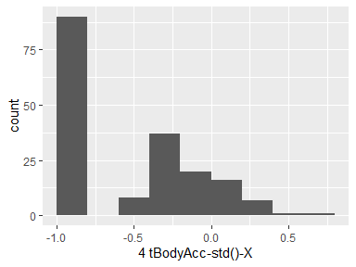

## 5 tBodyAcc-std()-Y

|  |  |
| --- | --- |
| Feature | Result |
| Variable type | numeric |
| Number of missing obs. | 0 (0 %) |
| Number of unique values | 180 |
| Median | -0.51 |
| 1st and 3rd quartiles | -0.94; -0.03 |
| Min. and max. | -0.99; 0.62 |

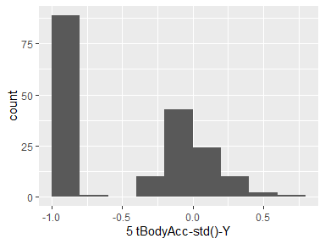

## 6 tBodyAcc-std()-Z

|  |  |
| --- | --- |
| Feature | Result |
| Variable type | numeric |
| Number of missing obs. | 0 (0 %) |
| Number of unique values | 180 |
| Median | -0.65 |
| 1st and 3rd quartiles | -0.95; -0.23 |
| Min. and max. | -0.99; 0.61 |

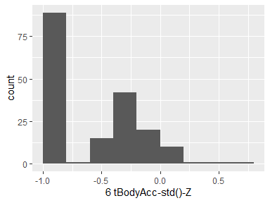

## 44 tGravityAcc-std()-X

|  |  |
| --- | --- |
| Feature | Result |
| Variable type | numeric |
| Number of missing obs. | 0 (0 %) |
| Number of unique values | 180 |
| Median | -0.97 |
| 1st and 3rd quartiles | -0.98; -0.95 |
| Min. and max. | -1; -0.83 |

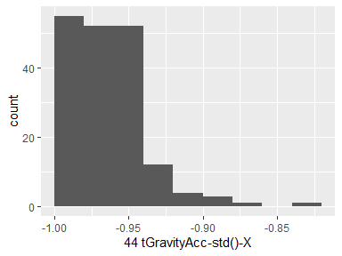

## 45 tGravityAcc-std()-Y

|  |  |
| --- | --- |
| Feature | Result |
| Variable type | numeric |
| Number of missing obs. | 0 (0 %) |
| Number of unique values | 180 |
| Median | -0.96 |
| 1st and 3rd quartiles | -0.97; -0.94 |
| Min. and max. | -0.99; -0.64 |

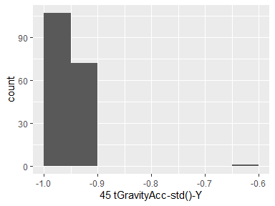

## 46 tGravityAcc-std()-Z

|  |  |
| --- | --- |
| Feature | Result |
| Variable type | numeric |
| Number of missing obs. | 0 (0 %) |
| Number of unique values | 180 |
| Median | -0.95 |
| 1st and 3rd quartiles | -0.96; -0.92 |
| Min. and max. | -0.99; -0.61 |

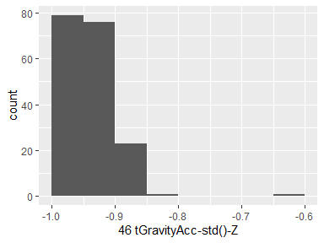

## 84 tBodyAccJerk-std()-X

|  |  |
| --- | --- |
| Feature | Result |
| Variable type | numeric |
| Number of missing obs. | 0 (0 %) |
| Number of unique values | 180 |
| Median | -0.81 |
| 1st and 3rd quartiles | -0.98; -0.22 |
| Min. and max. | -0.99; 0.54 |

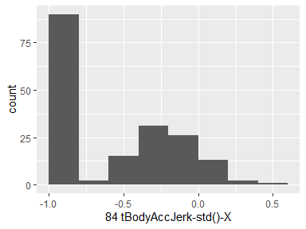

## 85 tBodyAccJerk-std()-Y

|  |  |
| --- | --- |
| Feature | Result |
| Variable type | numeric |
| Number of missing obs. | 0 (0 %) |
| Number of unique values | 180 |
| Median | -0.78 |
| 1st and 3rd quartiles | -0.97; -0.15 |
| Min. and max. | -0.99; 0.36 |

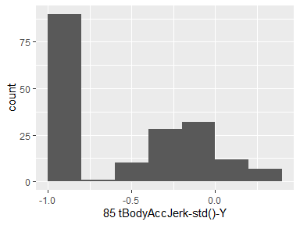

## 86 tBodyAccJerk-std()-Z

|  |  |
| --- | --- |
| Feature | Result |
| Variable type | numeric |
| Number of missing obs. | 0 (0 %) |
| Number of unique values | 180 |
| Median | -0.88 |
| 1st and 3rd quartiles | -0.98; -0.51 |
| Min. and max. | -0.99; 0.03 |

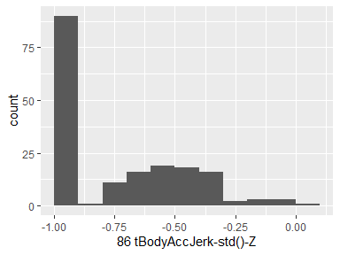

## 124 tBodyGyro-std()-X

|  |  |
| --- | --- |
| Feature | Result |
| Variable type | numeric |
| Number of missing obs. | 0 (0 %) |
| Number of unique values | 180 |
| Median | -0.79 |
| 1st and 3rd quartiles | -0.97; -0.44 |
| Min. and max. | -0.99; 0.27 |

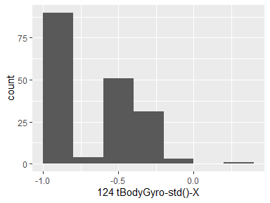

## 125 tBodyGyro-std()-Y

|  |  |
| --- | --- |
| Feature | Result |
| Variable type | numeric |
| Number of missing obs. | 0 (0 %) |
| Number of unique values | 180 |
| Median | -0.8 |
| 1st and 3rd quartiles | -0.96; -0.42 |
| Min. and max. | -0.99; 0.48 |

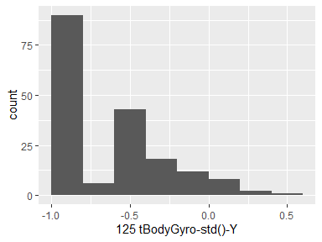

## 126 tBodyGyro-std()-Z

|  |  |
| --- | --- |
| Feature | Result |
| Variable type | numeric |
| Number of missing obs. | 0 (0 %) |
| Number of unique values | 180 |
| Median | -0.8 |
| 1st and 3rd quartiles | -0.96; -0.31 |
| Min. and max. | -0.99; 0.56 |

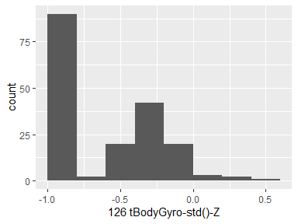

## 164 tBodyGyroJerk-std()-X

|  |  |
| --- | --- |
| Feature | Result |
| Variable type | numeric |
| Number of missing obs. | 0 (0 %) |
| Number of unique values | 180 |
| Median | -0.84 |
| 1st and 3rd quartiles | -0.98; -0.46 |
| Min. and max. | -1; 0.18 |

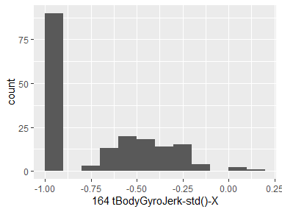

## 165 tBodyGyroJerk-std()-Y

|  |  |
| --- | --- |
| Feature | Result |
| Variable type | numeric |
| Number of missing obs. | 0 (0 %) |
| Number of unique values | 180 |
| Median | -0.89 |
| 1st and 3rd quartiles | -0.98; -0.59 |
| Min. and max. | -1; 0.3 |

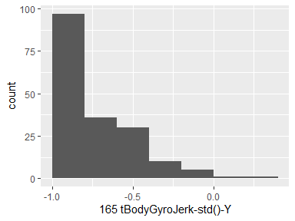

## 166 tBodyGyroJerk-std()-Z

|  |  |
| --- | --- |
| Feature | Result |
| Variable type | numeric |
| Number of missing obs. | 0 (0 %) |
| Number of unique values | 180 |
| Median | -0.86 |
| 1st and 3rd quartiles | -0.98; -0.47 |
| Min. and max. | -1; 0.19 |

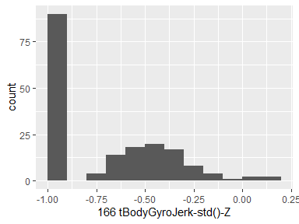

## 202 tBodyAccMag-std()

|  |  |
| --- | --- |
| Feature | Result |
| Variable type | numeric |
| Number of missing obs. | 0 (0 %) |
| Number of unique values | 180 |
| Median | -0.61 |
| 1st and 3rd quartiles | -0.94; -0.21 |
| Min. and max. | -0.99; 0.43 |

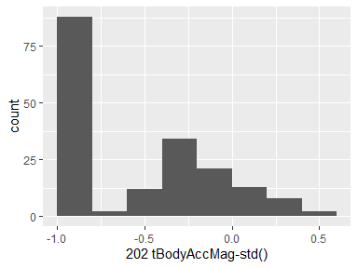

## 215 tGravityAccMag-std()

|  |  |
| --- | --- |
| Feature | Result |
| Variable type | numeric |
| Number of missing obs. | 0 (0 %) |
| Number of unique values | 180 |
| Median | -0.61 |
| 1st and 3rd quartiles | -0.94; -0.21 |
| Min. and max. | -0.99; 0.43 |

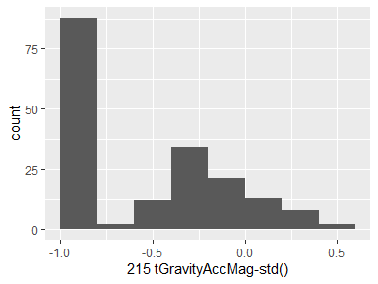

## 228 tBodyAccJerkMag-std()

|  |  |
| --- | --- |
| Feature | Result |
| Variable type | numeric |
| Number of missing obs. | 0 (0 %) |
| Number of unique values | 180 |
| Median | -0.8 |
| 1st and 3rd quartiles | -0.98; -0.22 |
| Min. and max. | -0.99; 0.45 |

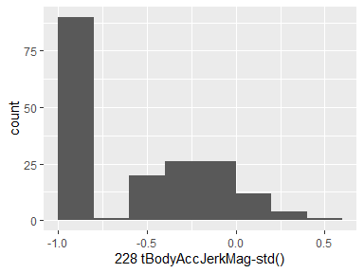

## 241 tBodyGyroMag-std()

|  |  |
| --- | --- |
| Feature | Result |
| Variable type | numeric |
| Number of missing obs. | 0 (0 %) |
| Number of unique values | 180 |
| Median | -0.74 |
| 1st and 3rd quartiles | -0.95; -0.36 |
| Min. and max. | -0.98; 0.3 |

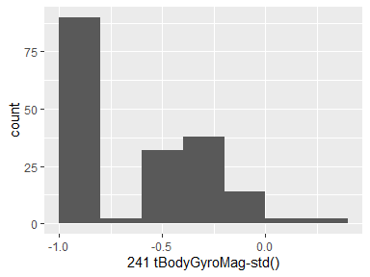

## 254 tBodyGyroJerkMag-std()

|  |  |
| --- | --- |
| Feature | Result |
| Variable type | numeric |
| Number of missing obs. | 0 (0 %) |
| Number of unique values | 180 |
| Median | -0.88 |
| 1st and 3rd quartiles | -0.98; -0.58 |
| Min. and max. | -1; 0.25 |

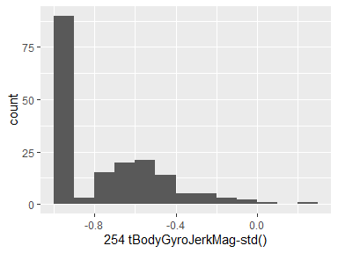

## 269 fBodyAcc-std()-X

|  |  |
| --- | --- |
| Feature | Result |
| Variable type | numeric |
| Number of missing obs. | 0 (0 %) |
| Number of unique values | 180 |
| Median | -0.75 |
| 1st and 3rd quartiles | -0.98; -0.2 |
| Min. and max. | -1; 0.66 |

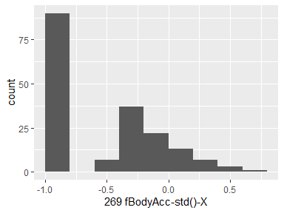

## 270 fBodyAcc-std()-Y

|  |  |
| --- | --- |
| Feature | Result |
| Variable type | numeric |
| Number of missing obs. | 0 (0 %) |
| Number of unique values | 180 |
| Median | -0.51 |
| 1st and 3rd quartiles | -0.94; -0.08 |
| Min. and max. | -0.99; 0.56 |

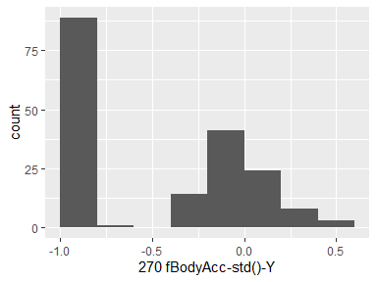

## 271 fBodyAcc-std()-Z

|  |  |
| --- | --- |
| Feature | Result |
| Variable type | numeric |
| Number of missing obs. | 0 (0 %) |
| Number of unique values | 180 |
| Median | -0.64 |
| 1st and 3rd quartiles | -0.95; -0.27 |
| Min. and max. | -0.99; 0.69 |

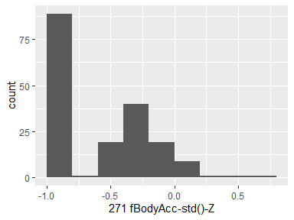

## 348 fBodyAccJerk-std()-X

|  |  |
| --- | --- |
| Feature | Result |
| Variable type | numeric |
| Number of missing obs. | 0 (0 %) |
| Number of unique values | 180 |
| Median | -0.83 |
| 1st and 3rd quartiles | -0.98; -0.25 |
| Min. and max. | -1; 0.48 |

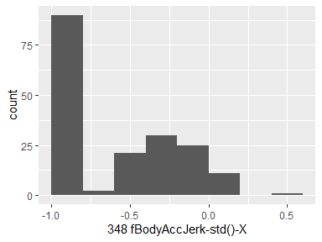

## 349 fBodyAccJerk-std()-Y

|  |  |
| --- | --- |
| Feature | Result |
| Variable type | numeric |
| Number of missing obs. | 0 (0 %) |
| Number of unique values | 180 |
| Median | -0.79 |
| 1st and 3rd quartiles | -0.97; -0.17 |
| Min. and max. | -0.99; 0.35 |

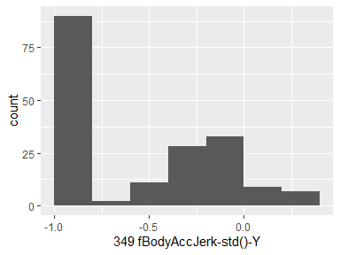

## 350 fBodyAccJerk-std()-Z

|  |  |
| --- | --- |
| Feature | Result |
| Variable type | numeric |
| Number of missing obs. | 0 (0 %) |
| Number of unique values | 180 |
| Median | -0.9 |
| 1st and 3rd quartiles | -0.98; -0.54 |
| Min. and max. | -0.99; -0.01 |

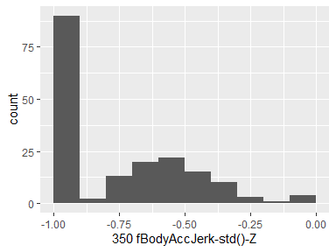

## 427 fBodyGyro-std()-X

|  |  |
| --- | --- |
| Feature | Result |
| Variable type | numeric |
| Number of missing obs. | 0 (0 %) |
| Number of unique values | 180 |
| Median | -0.81 |
| 1st and 3rd quartiles | -0.98; -0.48 |
| Min. and max. | -0.99; 0.2 |

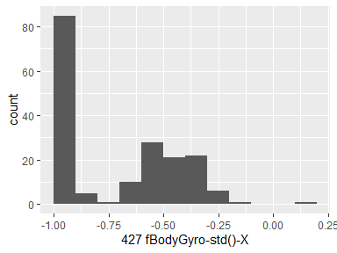

## 428 fBodyGyro-std()-Y

|  |  |
| --- | --- |
| Feature | Result |
| Variable type | numeric |
| Number of missing obs. | 0 (0 %) |
| Number of unique values | 180 |
| Median | -0.8 |
| 1st and 3rd quartiles | -0.96; -0.42 |
| Min. and max. | -0.99; 0.65 |

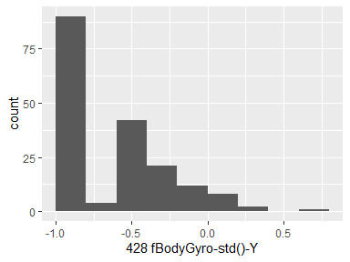

## 429 fBodyGyro-std()-Z

|  |  |
| --- | --- |
| Feature | Result |
| Variable type | numeric |
| Number of missing obs. | 0 (0 %) |
| Number of unique values | 180 |
| Median | -0.82 |
| 1st and 3rd quartiles | -0.96; -0.39 |
| Min. and max. | -0.99; 0.52 |

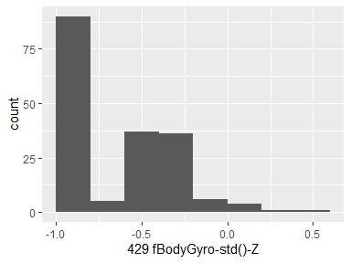

## 504 fBodyAccMag-std()

|  |  |
| --- | --- |
| Feature | Result |
| Variable type | numeric |
| Number of missing obs. | 0 (0 %) |
| Number of unique values | 180 |
| Median | -0.65 |
| 1st and 3rd quartiles | -0.95; -0.37 |
| Min. and max. | -0.99; 0.18 |

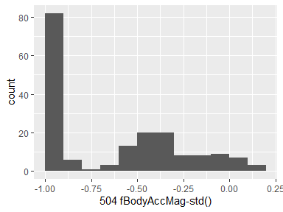

## 517 fBodyBodyAccJerkMag-std()

|  |  |
| --- | --- |
| Feature | Result |
| Variable type | numeric |
| Number of missing obs. | 0 (0 %) |
| Number of unique values | 180 |
| Median | -0.81 |
| 1st and 3rd quartiles | -0.98; -0.27 |
| Min. and max. | -0.99; 0.32 |

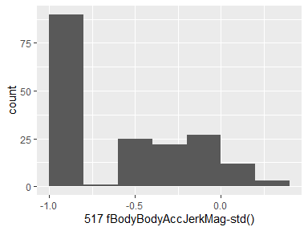

## 530 fBodyBodyGyroMag-std()

|  |  |
| --- | --- |
| Feature | Result |
| Variable type | numeric |
| Number of missing obs. | 0 (0 %) |
| Number of unique values | 180 |
| Median | -0.77 |
| 1st and 3rd quartiles | -0.95; -0.43 |
| Min. and max. | -0.98; 0.24 |

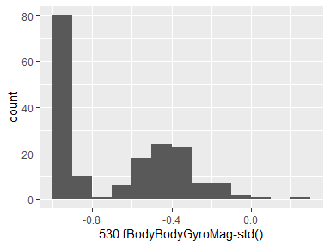

## 543 fBodyBodyGyroJerkMag-std()

|  |  |
| --- | --- |
| Feature | Result |
| Variable type | numeric |
| Number of missing obs. | 0 (0 %) |
| Number of unique values | 180 |
| Median | -0.89 |
| 1st and 3rd quartiles | -0.98; -0.61 |
| Min. and max. | -1; 0.29 |

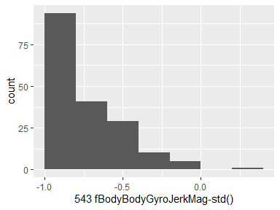

Report generation information:

* Created by kvmkaza (username: marut).
* Report creation time: Wed Jul 17 2019 16:05:44
* Report was run from directory: F:/JHU-DS/M3 - Getting and Cleaning Data/GACD-PA1
* dataMaid v1.3.1 [Pkg: 2019-07-10 from CRAN (R 3.6.1)]
* R version 3.6.0 (2019-04-26).
* Platform: x86_64-w64-mingw32/x64 (64-bit)(Windows 10 x64 (build 17763)).
* Function call: makeDataReport(data = tidyDF_Summ, mode = c("summarize", "visualize", "check"), smartNum = FALSE, file = "./Codebook.Rmd", checks = list( character = "showAllFactorLevels", factor = "showAllFactorLevels", labelled = "showAllFactorLevels", haven_labelled = "showAllFactorLevels", numeric = NULL, integer = NULL, logical = NULL, Date = NULL), listChecks = FALSE, maxProbVals = Inf, codebook = TRUE, reportTitle = "GACD Programming Assignment")