REPORT

Aim

To estimate the RSS and Virtual Memory occupied by a process. Also to display the physical addresses of pages which have been physically mapped.

Methodology

Software Walk
- We initialize page pointer to NULL
- Given page VA, we can perform a software page table walk doing the following in order,
- pgd_offset() - returns pgd offset given mm_struct of task and VA
- pud_offset() - returns pud offset given VA and pgd offset
- pmd_offset() - returns pmd offset given VA and pud offset
- pte_offset_map() - returns pte given VA and pmd offset
- If any of the above returns a none and bad value we exit page pointer as NULL
- If everything executes succesfully we obtain the struct page using pte_page() and return the same.

Module flow,
- Input PID as parameter to the module
- Extract the task_struct for entered PID using,
find_vpid() - Returns struct pid for given pid
pid_task() - Returns task_struct for given struct pid
- Using the task struct get the first virtual memory area (VMA),
task_struct -> mm_struct -> vma_struct
- This struct has the starting and ending virtual addresses (VA) of the current area in,
vm_start and vm_end
- Access each page in the area using the start and end by incrementing with PAGE_SIZE
- Increment page_size for each page reached
- For each page in VMA perform a software walk of the page table to obtain its page struct pointer
- If page struct pointer is not NULL and PA returned is not zero, if so we increment RSS and display the PA
- Display the RSS and size for current VMA
- Move to the next VMA using vma_next in the current VMA
- Repeat steps 4-7 until vma_next hits NULL which indicates end of Virtual memory assigned for the process.
- Display the total RSS and size

Experiments

1- Hello World C program

- A non-terminating hello world program was loaded
- The VMA tracker module was loaded with hello world's PID
- Output of log was compared the output of
/proc/<pid>/status
/proc/<pid>/smaps
- It was observed that VM size was equal in all three cases
- RSS in /proc/<pid>/status didn't match and this was caused due to sharing of pages
- But module output nearly matched with smaps difference of 2 pages (8kB) - 1212kB and 1204kB
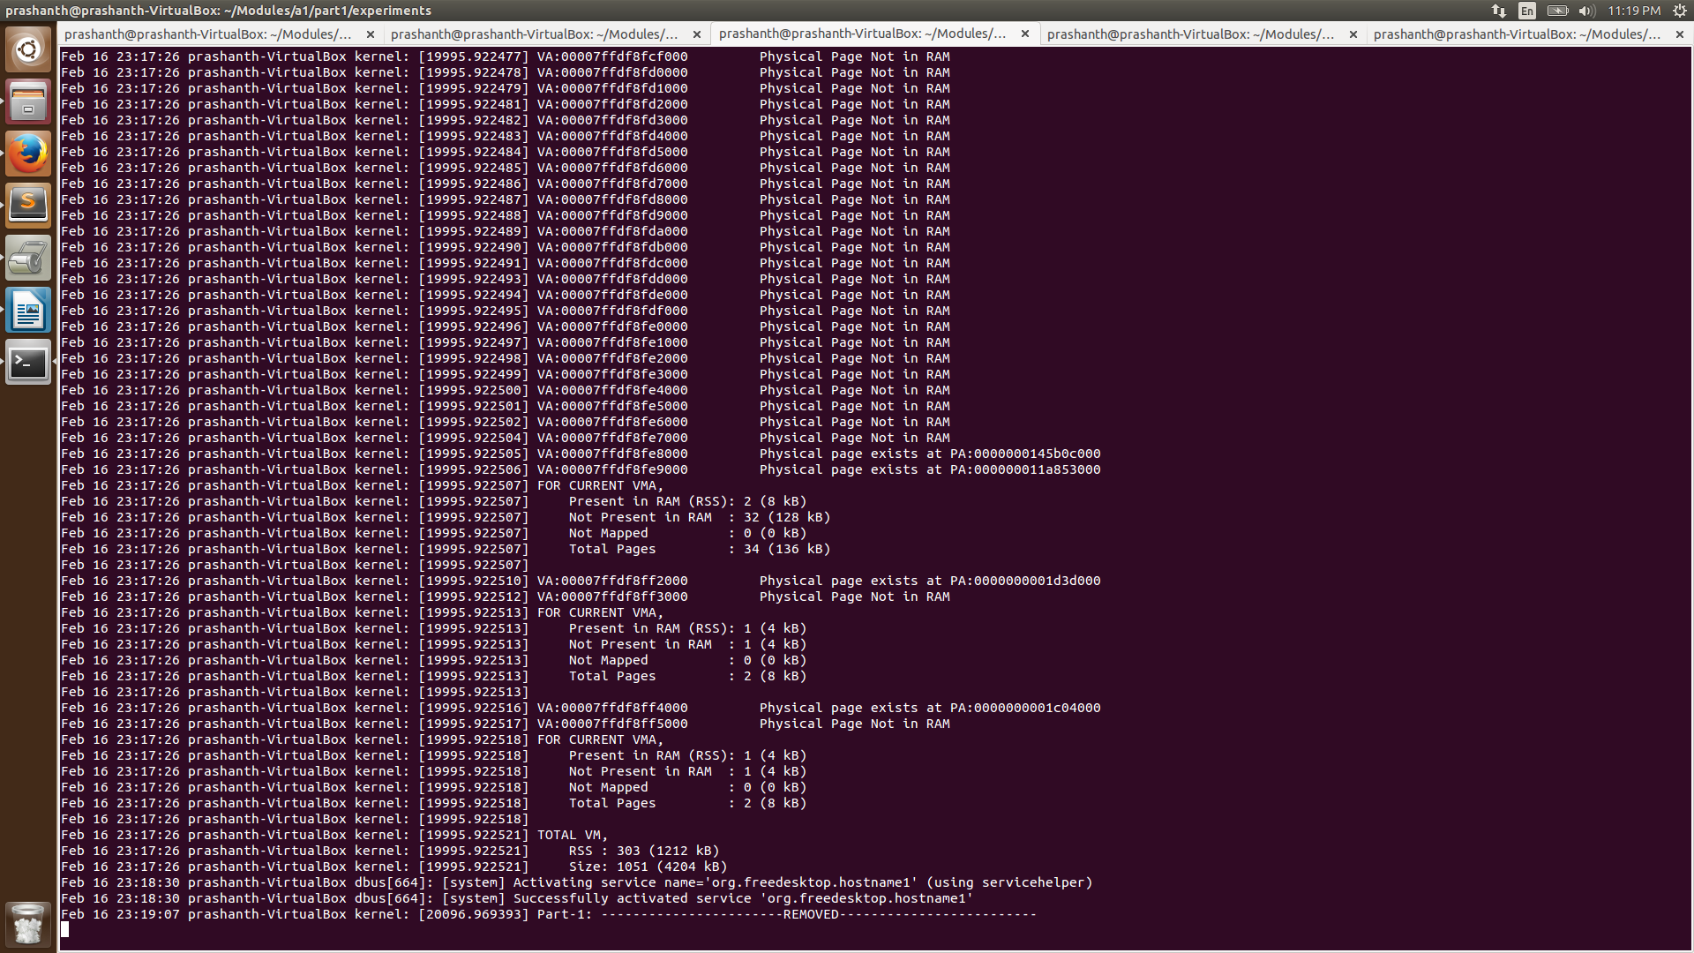

2- Top

- A top command was invoked
- The VMA tracker module was loaded with top's PID
- Output of log was compared the output of
/proc/<pid>/status
/proc/<pid>/smaps
- RSS in /proc/<pid>/status nearly matched with 1 page difference (4kB)
- The module output also nearly matched with smaps difference of 1 page (4kB)
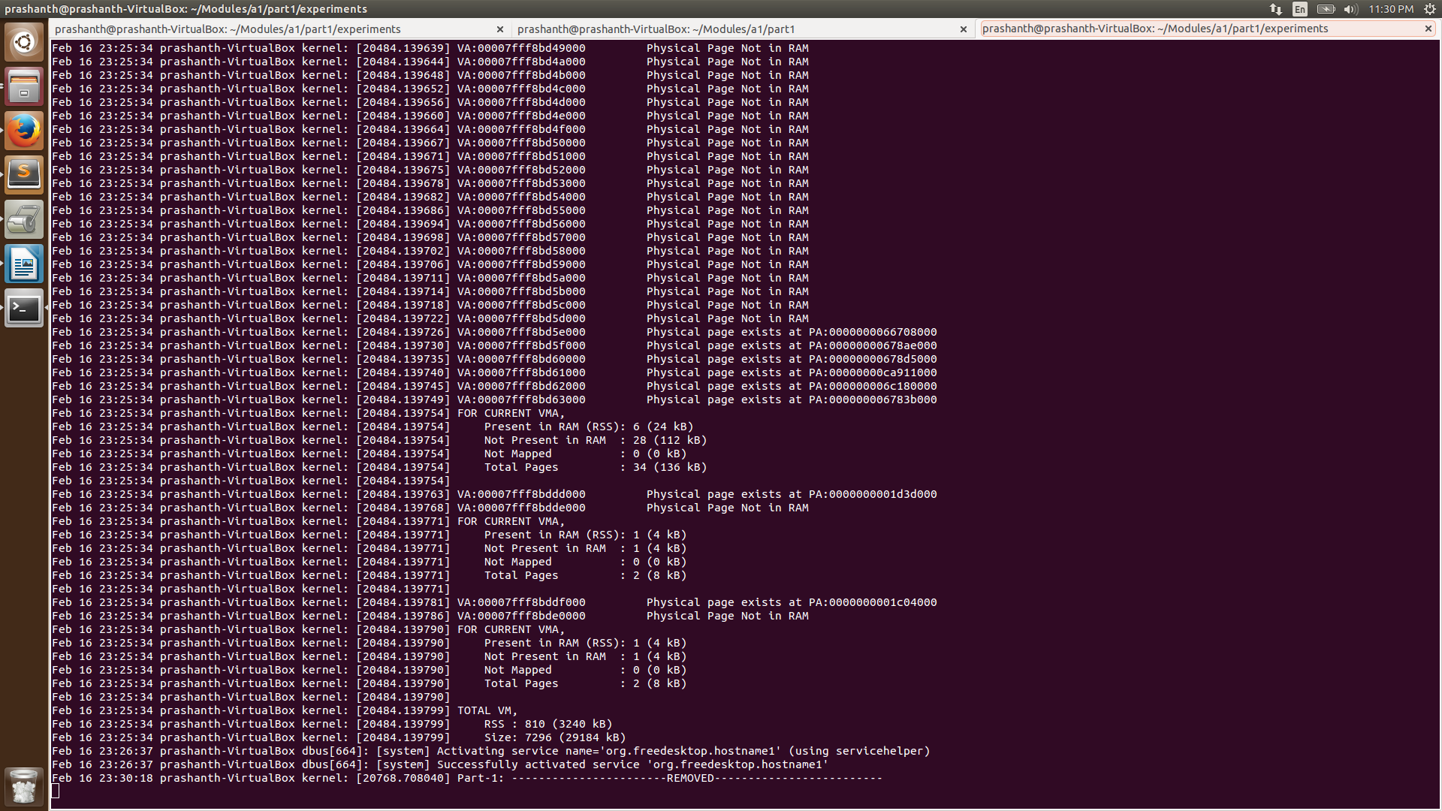
Observations

- It was observed that size of VMA output by the module always matched /status.
- The RSS of module and /status didn't match for some processes - the reason was sharing of pages between processes is accounted differently in /status.
- RSS nearly matched with /smaps with a minimal difference of 1-3 pages for small processes.
- Small processes didn't have many unmapped pages, but this number increased as the size of the process increased.
- Unmapped pages were observed in larger processes like firefox

