Simulation, numerical Analysis and performance optimization of Lead (Pb) reduced Perovskite Solar cell
KVMS Leela Krishna, Akhil, Dinesh, Michael Cholines Pedapudi^{1,a}
Vignan’s Foundation for Science Technology and Research University, Department of Electronics and Communication Engineering, Guntur 522213
Corresponding Author: michaelcholines@gmail.com

Abstract : This paper discusses the comparative simulation of perovskite solar cells by using the software SCAPS-1D. Two absorber materials were considered: CH₃NH₃PbI₃ and FA-Cs-Sn-Pb-I mixed absorbers. Two device structures namely FTO/PCBM/CH₃NH₃PbI₃/CuSCN/Au and FTO/PCBM/FA-Cs-Sn-Pb-I/CuSCN/Au were analyzed under standard test condition. Several critical parameters that include open circuit voltage (Voc), short circuit current density (Jsc), fill factor (FF) and power conversion efficiency (PCE) were analyzed. The result indicate that the perovskite solar cell with FA-Cs-Sn-Pb-I absorber gives the highest efficiency of 32.77% while perovskite solar cell with CH₃NH₃PbI₃ absorber gives the highest efficiency of 26.29%. It should be noted that the obtained efficiency represents the theoretical maximum performance under ideal simulation conditions with minimized defect densities and optimized material parameters.

1. INTRODUCTION
The global requirement for energy sources has been rising rapidly due to the use of modern technologies, industrial progress, and the digital infrastructure. In addition, there is an urgent need for clean energy sources owing to problems related to the environment, such as global warming and pollution. Of all the renewable energy sources, solar energy has emerged as one of the best choices, owing to its abundance, sustainability, and environmental friendliness.
Traditional silicon-based solar cells have been prevalent in the photovoltaic sector for many years. There has been a significant amount of fundamental research done on silicon solar cells and photovoltaic technology, such as Shockley–Queisser limit [1] and further studies of silicon solar cell performance [2], that have helped gain insight into some important performance parameters like open circuit voltage (Voc), short circuit current density (Jsc), fill factor (FF), and power conversion efficiency (PCE). Nevertheless, there are several drawbacks in the use of silicon solar cells, such as high manufacturing costs, intensive production process, and rigidity. In an effort to address these drawbacks, several types of PV cell designs have been developed. One such design is that of perovskite solar cells (PSCs), which have become very popular in recent years. Since its discovery by Kojima et al. [3], perovskites made of organometal halides have proven to possess superior optical and electronic properties such as high light absorbance capability, tunable bandgap energy, and long electron diffusion lengths. As a result, perovskite solar cells have shown a high level of efficiency using relatively inexpensive manufacturing processes.
Aside from their high efficiency, another important feature of PSCs is their flexibility. They can be fabricated from flexible substrates and used in applications where they serve as materials, translucent windows, and portable electronics. Moreover, more sophisticated perovskite types such as mixed cations perovskites like FA-Cs-based cells have shown higher stability and performance characteristics than traditional ones [5].
Nonetheless, even with all benefits, PSCs are facing a few challenges, especially concerning longevity, environmental safety, and toxicity of materials. For instance, perovskites have high sensitivity to moisture, temperature, and constant lighting that cause deterioration in the performance of such devices over time. Furthermore, the use of lead in most perovskite solar cell compositions is an issue since it affects their environmental safety. Thus, there are ongoing efforts in making less toxic PSCs [6].
For the purpose of this assignment, two types of PSC devices were analyzed through SCAPS-1D simulation software. First, the MAPbI₃ cell was chosen because of the popularity and good performance of its composition. Second, FA-Cs-Sn-Pb-I perovskite-based PSC was used with the goal of increasing efficiency by improving absorption and minimizing recombinations in the cell. The simulated devices have the following architectures: FTO/PCBM/MAPbI₃/CuSCN/Au and FTO/PCBM/FA-Cs-Sn-Pb-I/CuSCN/Au, as illustrated in Fig. 1.

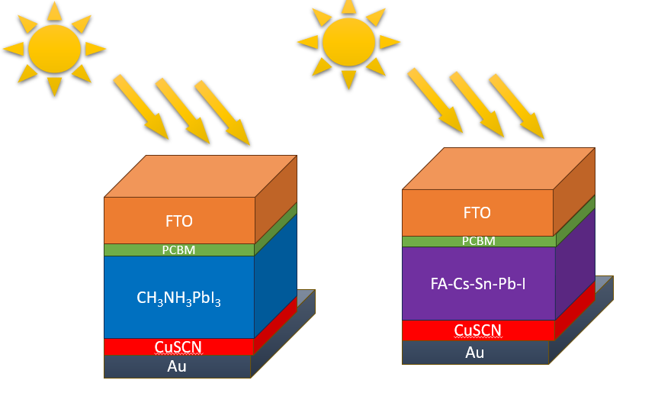
Fig 1: Proposed Structures of Solar cells
One of the key elements determining the efficiency of PSCs is charge transport layers. As for the choice of the electron transport layer (ETL), PCBM was used since it shows high electron mobility and good energy-level alignment, in addition to having the capability of reducing recombination losses. The application of SCAPS models showed that the use of PCBM enhances charge extraction [7], [8].
In terms of the choice of the hole transport layer (HTL), CuSCN was preferred because of its high hole mobility, stability against oxidation, and affordable price. As compared to common organic hole transport materials, CuSCN does not need complicated doping procedures and demonstrates higher stability under moisture and heat exposure. Many studies proved the effectiveness of CuSCN on PSCs efficiency [9], [10].
As a result, an effective separation of charges, low recombination losses, and improved stability of a cell can be achieved with the help of this particular combination of materials. The SCAPS-1D model is frequently used for the analysis of such structures, as it solves Poisson and continuity equations and allows evaluating characteristics like J-V curve, quantum efficiency, and energy band alignment [11].
Overall, the improved band alignment and reduced energy barriers in the FA-Cs-Sn-Pb-I-based device explain its superior photovoltaic performance compared to the CH₃NH₃PbI₃-based structure.
Simulation results presented by this study show that the FA-Cs-Sn-Pb-I perovskite solar cell is superior to the MAPbI₃ perovskite solar cell due to its better open-circuit voltage, increased current density, and lower recombination losses. This performance difference can be mainly attributed to better light absorption and charge transport efficiency.
To conclude, this study emphasizes the vast opportunities for perovskite solar cells as the key players in future solar power generation technology. This study proves that the choice of materials, especially PCBM and CuSCN, is of vital importance for achieving high-quality performance. Future research should focus on further advancements in this field.

2. DEVICE STRUCTURE AND METHODOLOGY
2.1 Device Structure
Two structures for perovskite-based solar cells were proposed and modeled using SCAPS-1D simulation software. These include the structure with the absorber layer made of CH₃NH₃PbI₃ material and the structure with absorber layer made from the mixture of FA-Cs-Sn-Pb-I materials. In both cases, fluorine-doped tin oxide (FTO) will be used as the front contact and gold (Au) as the back one.
For the purpose of transferring electrons between materials, PCBM was selected for use in the ETL due to its high electron mobility and good energy level alignment with the absorber layer. As the hole transport layer (HTL), CuSCN can be used due to its good hole mobility and low processing cost.

2.2 Simulation Methodology
The simulations were done using SCAPS-1D, which is a 1D model for simulating the performance of the solar cell, solving Poisson's equation and continuity equations for the carriers. This makes it possible to model accurately charge transport, recombination effects, and energy band alignment in the solar cell. Action panel is used for controlling the simulation of the device.
The simulations were conducted under standard test conditions (AM 1.5G spectrum, 1000 W/m², and 300 K). Material properties like bandgap, electron affinity, mobility, defect density, and dopant concentration were established using data from published literature. The efficiency, open-circuit voltage (Voc), short-circuit current (Jsc), and fill factor (FF) were calculated from the simulated J-V curves.Further, we have defined the sequence and number of layers, the contacts, the illumination direction, and other fundamental structural aspects of the device before proceeding to define the material properties of each layer and running simulations. Key parameters such as band gap, doping concentration, and thickness are entered here, also we set boundary conditions, and maintained the interface defect densities at 1.00E+10/cm² as shown in Fig 3.1 & 3.2. The device structures were modeled under near-ideal conditions to evaluate their maximum theoretical performance potential. Low bulk and interface defect densities (1 × 10¹⁰ cm⁻³ and 1 × 10¹⁰ cm⁻², respectively) were assumed to minimize trap-assisted recombination. This approach allows the intrinsic capability of the device architecture and material system to be analyzed without external degradation effects.
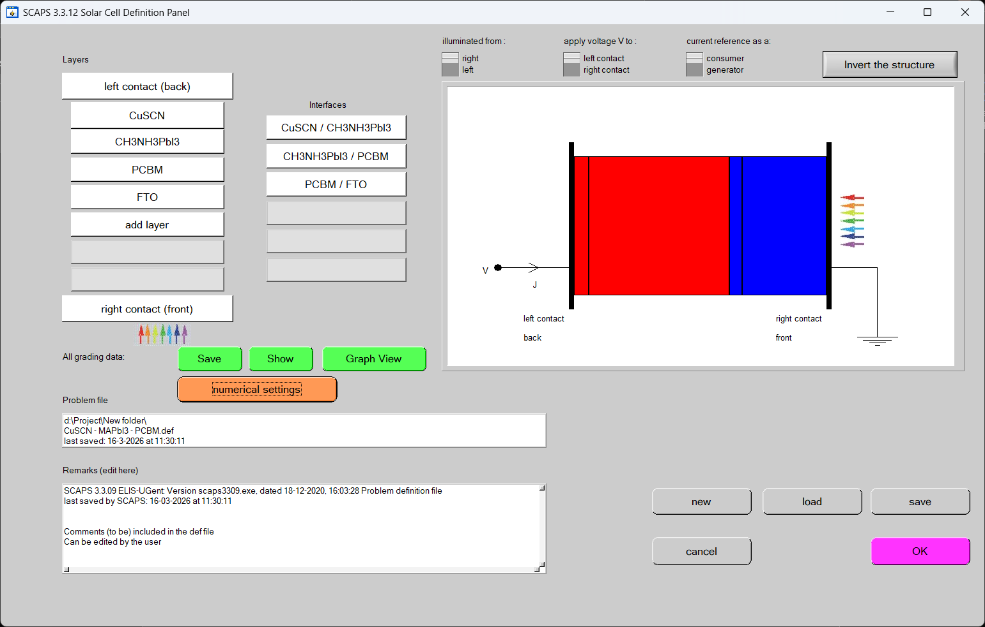
Fig 3.1 : Solar cell Structure of perovskite layer (FA-Cs-Sn-Pb-I)
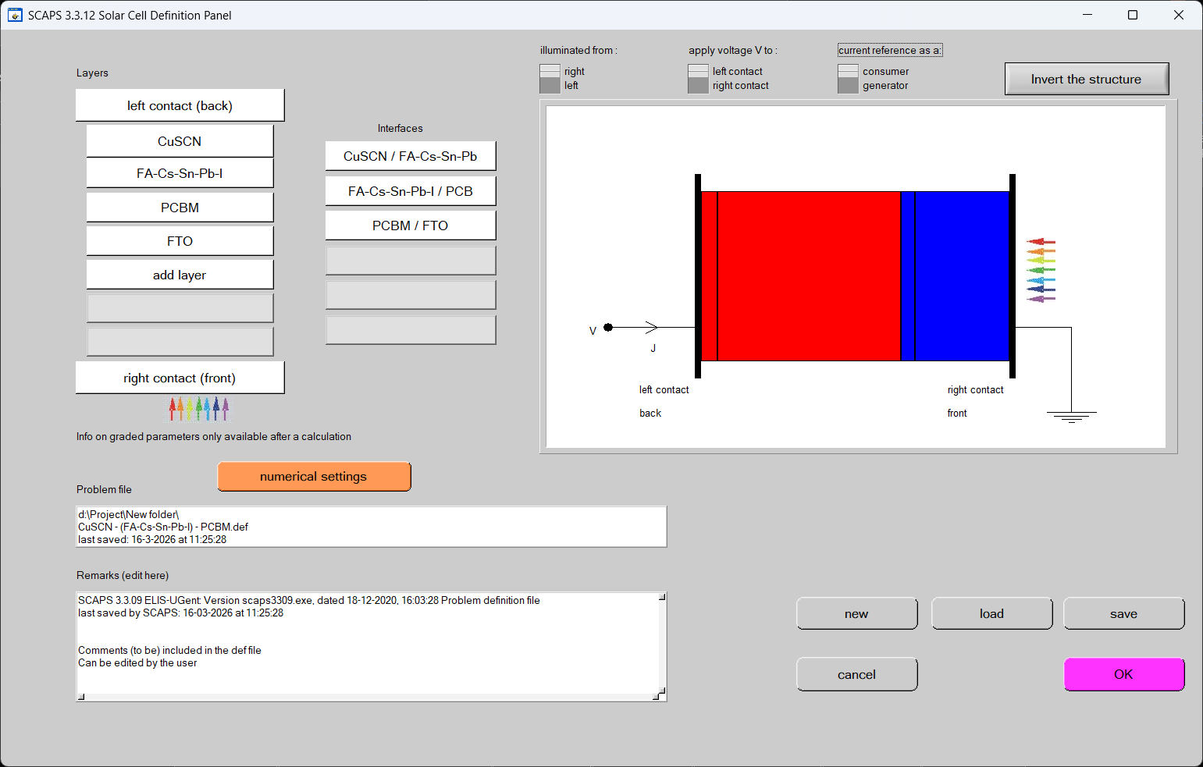
Fig 3.2 : Solar cell Structure of perovskite layer (CH3NH3PbI3)
2.3 Material Parameters :
The material parameters used in the simulation for both device structures are summarized in
Parameter | FTO | PCBM (ETL) | CH₃NH₃PbI₃ (Absorber) | CuSCN (HTL)
Thickness (µm) | 0.400 | 0.060 | 0.668 | 0.070
Bandgap (eV) | 3.50 | 2.05 | 1.55 | 3.40
Electron affinity (eV) | 4.00 | 3.95 | 3.90 | 1.90
Dielectric permittivity | 9.0 | 4.0 | 30.0 | 10.0
CB effective density of states (cm⁻³) | 2.2 × 10¹⁷ | 2.0 × 10²⁰ | 2.2 × 10¹⁸ | 2.2 × 10¹⁸
VB effective density of states (cm⁻³) | 2.2 × 10¹⁶ | 2.0 × 10²⁰ | 1.0 × 10¹⁸ | 1.8 × 10¹⁹
Electron thermal velocity (cm/s) | 1.0 × 10⁷ | 1.0 × 10⁷ | 1.0 × 10⁷ | 1.0 × 10⁷
Hole thermal velocity (cm/s) | 1.0 × 10⁷ | 1.0 × 10⁷ | 1.0 × 10⁷ | 1.0 × 10⁷
Electron mobility (cm²/V·s) | 20 | 2.0 × 10⁻³ | 20 | 1.0 × 10⁻⁴
Hole mobility (cm²/V·s) | 10 | 1.0 × 10⁻⁵ | 10 | 1.0 × 10⁻¹
Donor density ND (cm⁻³) | 1.0 × 10¹⁵ | 2.0 × 10¹⁷ | 0 | 0
Acceptor density NA (cm⁻³) | 0 | 0 | 9.0 × 10¹⁵ | 1.0 × 10²⁰
Defect density Nt (cm⁻³) | 1.0 × 10¹⁵ | 1.0 × 10¹¹ | 1.5 × 10¹¹ | 1.0 × 10¹¹
Parameter | FTO | PCBM (ETL) | FA-Cs-Sn-Pb-I (Absorber) | CuSCN (HTL)
Thickness (µm) | 0.400 | 0.060 | 0.779 | 0.070
Bandgap (eV) | 3.50 | 2.05 | 1.30 | 3.40
Electron affinity (eV) | 4.00 | 3.95 | 4.05 | 1.90
Dielectric permittivity | 9.0 | 4.0 | 25.0 | 10.0
CB effective density of states (cm⁻³) | 2.2 × 10¹⁷ | 2.0 × 10²⁰ | 2.2 × 10¹⁸ | 2.2 × 10¹⁸
VB effective density of states (cm⁻³) | 2.2 × 10¹⁶ | 2.0 × 10²⁰ | 2.2 × 10¹⁸ | 1.8 × 10¹⁹
Electron thermal velocity (cm/s) | 1.0 × 10⁷ | 1.0 × 10⁷ | 1.0 × 10⁷ | 1.0 × 10⁷
Hole thermal velocity (cm/s) | 1.0 × 10⁷ | 1.0 × 10⁷ | 1.0 × 10⁷ | 1.0 × 10⁷
Electron mobility (cm²/V·s) | 20 | 2.0 × 10⁻³ | 30 | 1.0 × 10⁻⁴
Hole mobility (cm²/V·s) | 10 | 1.0 × 10⁻⁵ | 30 | 1.0 × 10⁻¹
Donor density ND (cm⁻³) | 1.0 × 10¹⁵ | 2.0 × 10¹⁷ | 0 | 0
Acceptor density NA (cm⁻³) | 0 | 0 | 9.0 × 10¹⁵ | 1.0 × 10²⁰
Defect density Nt (cm⁻³) | 1.0 × 10¹⁵ | 1.0 × 10¹¹ | 1.0 × 10¹¹ | 1.0 × 10¹¹
Table I : Parameters of Device 1
Table II : Parameters of Device 2
2.4 Computational modeling Modeling of Devices :
All parameters are assessed mathematically in both dark and light states by adjusting the thickness of the absorption layer (ranging from 100 to 1000 nm) at room temperature. Moreover, the SCAPS-1D simulation software, developed by Burgelman et al. (2000) , was utilized to conduct the device simulation. It facilitates the evaluation of key photovoltaic parameters such as short circuit current density (J_{sc}), open-circuit voltage (V_{oc}), fill factor (FF), PCE, quantum efficiency (QE), and recombination current among other device characteristics Furthermore, this software operates by solving Poisson’s equation represented by Equations (1).
$\frac{d^{2} Ψ}{dx}$ = $\frac{q}{ε_{o}ε_{r}} [p\left(x\right)-n\left(x\right)+N_{D}- N_{A}+ ρ_{p}- ρ_{n}]$ (1)
In this context, the symbol 𝜓 represents the electrostatic potential, while 𝜀_{r} and 𝜀₀ refer to the relative permittivity and the permittivity of free space, respectively. The concentrations of ionized donor and acceptor atoms are indicated by N_{D} and N_{A}, and the electron and hole concentrations are denoted by n and p. The charge distributions for electrons and holes are represented by 𝜌_{n} and 𝜌_{p}, respectively, and q stands for the elementary charge. Moreover, the continuity equation serves as the fundamental relation in this analysis, as it simultaneously accounts for generation, recombination, drift and diffusion mechanisms. And, the continuity equations for electrons and holes given in equations (2) and (3) respectively [30].
$\frac{dp_{n}}{dt}$ = G_{p} $-\frac{P_{n}-P_{n0}}{τ_{p}}$ $+P_{n}μ_{p}\frac{dε}{dx}$+ $\frac{dP_{n}}{dx}$ + $D_{p}\frac{d^{2}P_{n}}{dx^{2}}$ (2)
$\frac{dn_{p}}{dt}$ = G_{n} $-\frac{n_{p}-n_{p0}}{τ_{n}}$ $+n_{p}μ_{n}\frac{dε}{dx}$+ $\frac{dn_{p}}{dx}$ + $D_{n}\frac{d^{2}n_{p}}{dx^{2}}$ (3)
which govern the temporal and spatial behaviour of carrier concentrations in a semiconductor. Specifically, they describe how the electron and hole concentrations vary due to the combined effects of generation, recombination, drift and diffusion mechanisms under the influence of an electric field and carrier gradients. Furthermore, equation (4) arises in semiconductor physics and typically describes the electron occupancy or electron density related to a trap level or donor level in the conduction band
$n_{1}=N_{c}e^{-\left(\frac{E_{c}-E_{T}}{K_{B}T}\right)}$ (4)
Where as equation (5) gives the effective hole concentration associated with a trap level near the valence band.
$P_{1}=N_{v}e^{-\left(\frac{E_{T}-E_{V}}{K_{B}T}\right)}$ (5)
Furthermore, equation (6) is essential for determining the intrinsic carrier concentration and controlling the semiconductor layers' (p-type, n-type) carrier statistics. It Determine equilibrium carrier densities across the p-n junction.
$n_{i}^{2}=np=n_{1}p_{1=}N_{c}N_{v}e^{-\left(\frac{E_{g}}{K_{B}T}\right)}$ (6)
Additionally, Equations (7) and (8) describe the charge carrier lifetime (τ) and diffusion length (L) of carriers, where τ represents the average time a carrier exists before recombination, L denotes the average distance a carrier travels, and μ is the carrier mobility. These equations highlight how defect density within the absorber layer significantly impacts carrier dynamics. A lower defect density increases the carrier lifetime, reduces recombination rates, and extends the diffusion length. Consequently, this enhances charge collection efficiency and leads to improved overall device performance.
$τ_{lifetime}=\frac{1}{σN_{t}v_{th}}$ (7)
$L=\sqrt{\frac{µK_{B}T}{q}τ_{lifetime}}$ (8)

3. RESULTS & DISCUSSION
Fig.1.2 illustrates the energy band alignment of the two simulated perovskite solar cell structures. The conduction band (Ec) and valence band (Ev) positions of each layer determine the charge transport behavior within the device. In both structures, PCBM acts as the electron transport layer (ETL), providing a favorable conduction band alignment with the perovskite absorber. This allows efficient extraction of electrons from the absorber layer to the front contact (FTO). Similarly, CuSCN serves as the hole transport layer (HTL), with its valence band well aligned to facilitate hole extraction toward the back contact (Au).
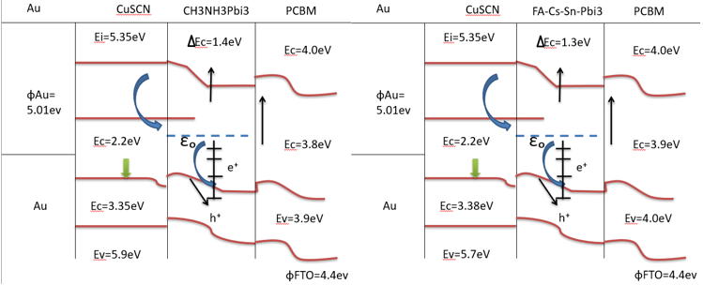
(b)
(a)
Fig 1.2 :- Energy band diagrams of (a) FTO/PCBM/CH₃NH₃PbI₃/CuSCN/Au and (b) FTO/PCBM/FA-Cs-Sn-Pb-I/CuSCN/Au solar cells under equilibrium conditions.
For the CH₃NH₃PbI₃-based device, a conduction band offset (ΔEc ≈ 1.4 eV) is observed at the interface between the absorber and ETL, which introduces a moderate barrier for electron transport. In contrast, the FA-Cs-Sn-Pb-I-based device exhibits a slightly lower conduction band offset (ΔEc ≈ 1.3 eV), resulting in improved electron extraction and reduced recombination losses.
Additionally, the bandgap of the FA-Cs-Sn-Pb-I absorber is smaller compared to CH₃NH₃PbI₃, which enhances photon absorption and increases carrier generation. The smoother band alignment in the FA-Cs-Sn-Pb-I device leads to more efficient charge separation and transport, contributing to its higher current density and overall efficiency. This reduced conduction band offset minimizes interfacial recombination losses and enhances carrier extraction efficiency.
The built-in electric field across the junction, represented by the band bending, further aids in the separation of photogenerated electron–hole pairs. Electrons are driven toward the ETL, while holes move toward the HTL, minimizing recombination within the absorber layer.
We aim to demonstrate the dependence of some critical photovoltaic parameters on the thickness of the absorber layer in CH₃NH₃PbI₃ and FA-Cs-Sn-Pb-I based perovskite solar cells.
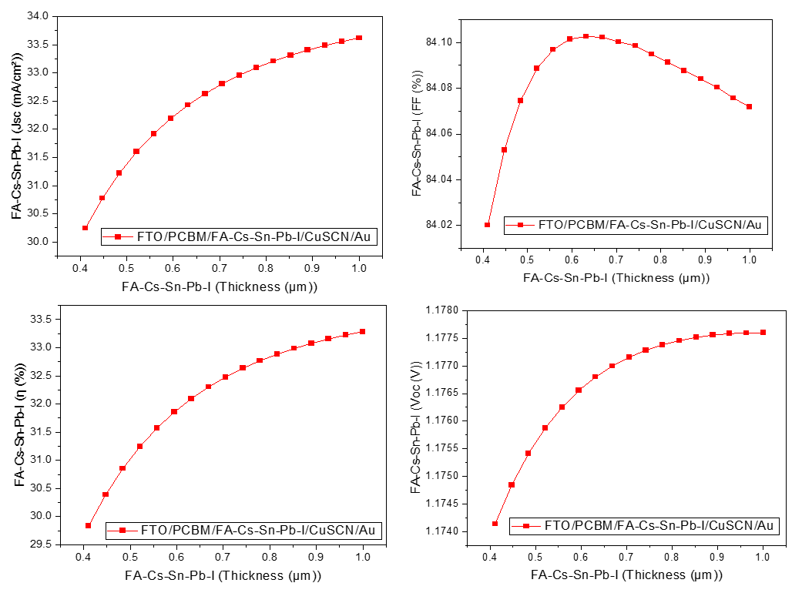
(a)
(d)
(c)
(b)
Fig 4. :- Variation of (a) Jsc, (b) Voc, (c) and PCE (d) FF of the device 1 with respect to its absorption layer thickness.
Figure 4(a)–(d) illustrates the variation of key photovoltaic parameters as a function of absorber layer thickness (0.4–1.0 µm) for the device FTO/PCBM/FA-Cs-Sn-Pb-I/CuSCN/Au.
As shown in Fig. 4(a), the short-circuit current density (Jsc) increases steadily with thickness, rising from approximately 30 mA/cm² to above 33 mA/cm². This trend is primarily attributed to enhanced optical absorption within the perovskite layer, resulting in increased photogeneration of charge carriers. The increase becomes gradual at higher thicknesses, indicating that most incident photons are already absorbed, and further thickness contributes minimally.
The open-circuit voltage (Voc), depicted in Fig. 4(d), shows a moderate increase with thickness before approaching saturation. This behavior can be explained by reduced recombination due to improved carrier collection efficiency and a higher quasi-Fermi level splitting at optimal thicknesses.
In Fig. 4(b), the fill factor (FF) initially increases and reaches a maximum near ~0.6 µm, after which it slightly declines. This reduction at higher thicknesses is attributed to increased bulk recombination and series resistance, which hinder efficient charge transport.
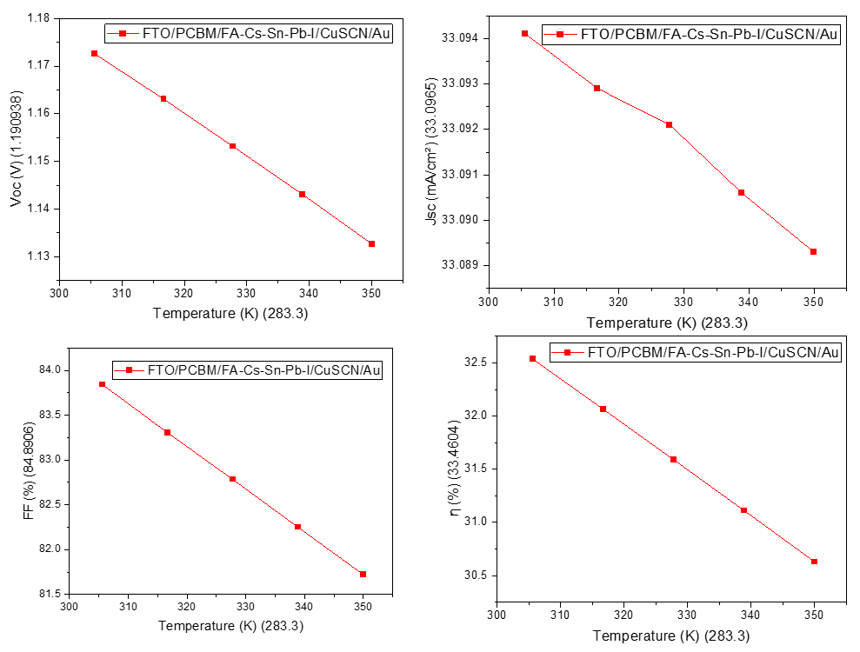
The power conversion efficiency (PCE), shown in Fig. 4(c), follows an overall increasing trend with thickness due to the dominant effect of enhanced Jsc. However, the rate of improvement diminishes beyond ~0.8 µm, suggesting that recombination losses begin to offset the benefits of increased absorption.
(a)
(b)
(c)
(d)
Fig 5. :- Variation of (a) Voc, (b) Jsc, (c) FF and (d) PCE of the device 1 with respect to temperature
The influence of temperature (300–350 K) on device performance is presented in Fig. 5(a)–(d). As observed in Fig. 5(a), the open-circuit voltage (Voc) decreases significantly with increasing temperature. This behavior is consistent with the temperature dependence of Voc, where increased thermal energy enhances carrier recombination and reduces the effective bandgap, leading to lower quasi-Fermi level separation.
The short-circuit current density (Jsc), shown in Fig. 5(b), exhibits a slight decreasing trend with temperature. This indicates that photogeneration is relatively stable, but minor losses occur due to increased recombination and carrier scattering.
Figure 5(c) shows a linear decrease in fill factor (FF) with temperature, which can be attributed to increased series resistance and reduced carrier mobility at elevated temperatures.
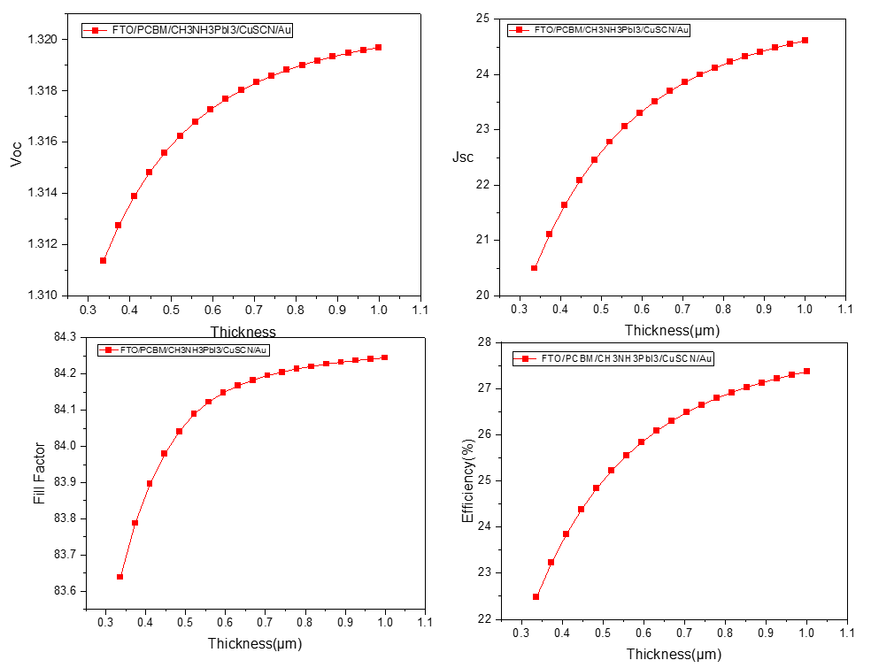
Consequently, the overall power conversion efficiency (PCE), illustrated in Fig. 5(d), decreases noticeably with temperature. This confirms that thermal effects significantly degrade device performance, with Voc being the most temperature-sensitive parameter.
(d)
(c)
(b)
(a)
Fig 6. :- Variation of (a) Voc, (b) Jsc, (c) FF and (d) PCE of the device 2 with respect to its absorption layer thickness.
The thickness-dependent performance of FTO/PCBM/CH₃NH₃PbI₃/CuSCN/Au is shown in Fig. 6(a)–(d). From Fig. 6(b), Jsc increases rapidly with thickness at lower values and gradually saturates beyond ~0.8 µm. This trend is due to efficient photon absorption and carrier generation, which reaches a limit once the absorber becomes optically thick.
The open-circuit voltage (Voc), presented in Fig. 6(a), increases slightly with thickness and then stabilizes. This suggests that recombination losses are minimized at optimal thickness, beyond which additional thickness does not significantly improve carrier separation.
The fill factor (FF), shown in Fig. 6(c), exhibits a sharp increase at lower thicknesses followed by saturation. This indicates improved charge transport and reduced resistive losses as the absorber layer becomes sufficiently continuous and defect-limited transport is minimized.
The efficiency (PCE), depicted in Fig. 6(d), increases significantly with thickness and approaches saturation at higher thickness values. This confirms that while increased thickness enhances absorption, recombination mechanisms ultimately limit further efficiency gains.
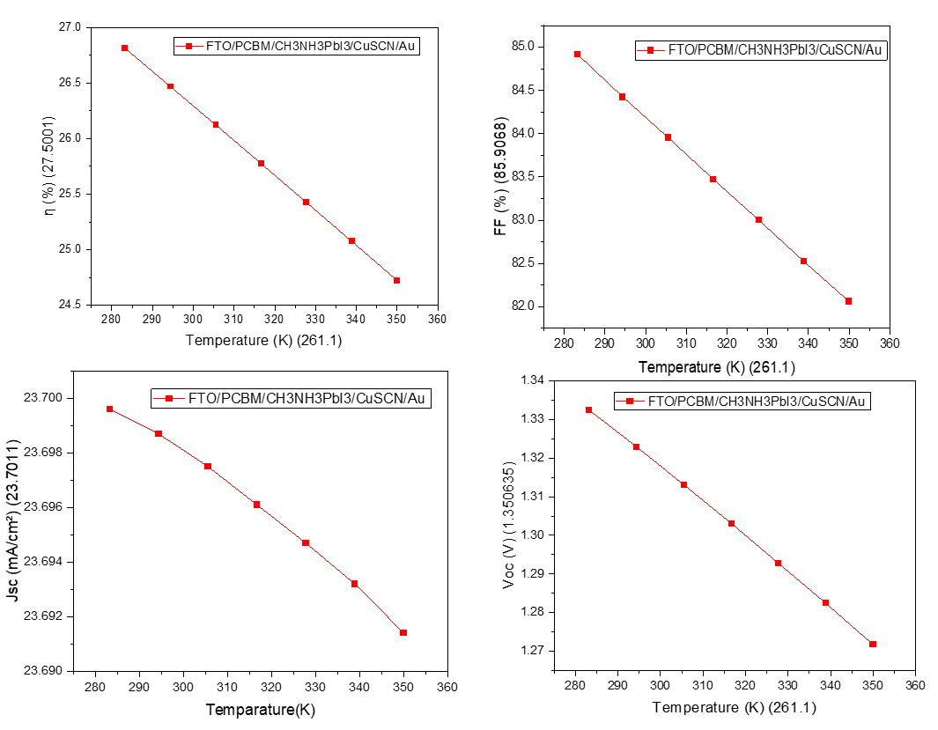
Fig 7. :- Variation of (a) PCE, (b) FF, (c) Jsc and (d) Voc of the device 2 with respect to temperature
(d)
(c)
(b)
(a)
The temperature dependence of Device 2 is illustrated in Fig. 7(a)–(d). As shown in Fig. 7(d), the open-circuit voltage (Voc) decreases linearly with increasing temperature, consistent with enhanced recombination and thermally activated carrier losses.
The short-circuit current density (Jsc), shown in Fig. 7(c), exhibits only a marginal decrease, indicating that optical absorption remains largely unaffected by temperature variations.
Figure 7(b) shows a steady decline in fill factor (FF) with temperature, reflecting increased resistive losses and reduced carrier mobility.
The power conversion efficiency (PCE), presented in Fig. 7(a), decreases almost linearly with temperature, confirming that thermal degradation significantly impacts device performance, primarily through reductions in Voc and FF.
The performance of both perovskite solar cell devices, FTO/PCBM/FA-Cs-Sn-Pb-I/CuSCN/Au (Device 1) and FTO/PCBM/CH₃NH₃PbI₃/CuSCN/Au (Device 2), was systematically analyzed with respect to absorber layer thickness and operating temperature.
The results indicate that increasing the absorber thickness significantly enhances the short-circuit current density (Jsc) due to improved photon absorption and carrier generation. However, beyond an optimal thickness range (~0.6–0.8 µm), the improvement in performance parameters such as open-circuit voltage (Voc) and fill factor (FF) tends to saturate due to increased recombination and resistive losses. Consequently, the power conversion efficiency (PCE) shows a rising trend with thickness but approaches a limiting value at higher thicknesses.
Temperature-dependent analysis reveals that both devices experience performance degradation with increasing temperature. The most affected parameter is Voc, which decreases substantially due to enhanced carrier recombination and reduced quasi-Fermi level splitting. The fill factor also declines with temperature as a result of increased resistive losses, while Jsc remains relatively stable with only minor reductions. Overall, the PCE decreases consistently with temperature, confirming that thermal effects play a critical role in limiting device performance.
Comparatively, Device 2 (CH₃NH₃PbI₃) demonstrates slightly more stable electrical characteristics and smoother saturation behavior, whereas Device 1 (FA-Cs-Sn-Pb-I) exhibits higher sensitivity to recombination effects, particularly at larger thicknesses.
To further validate the simulation results, a comparative analysis was carried out with previously reported experimental and simulation studies, as summarized in Table III.
The obtained photovoltaic parameters, including Voc, Jsc, FF, and PCE, are found to be in close agreement with the values reported in the literature. Minor variations can be attributed to differences in device architecture, material properties, defect densities, and simulation conditions. Notably, the optimized performance achieved in this work demonstrates competitive or improved efficiency compared to several previously reported structures, highlighting the effectiveness of the selected material configuration and parameter optimization.
This comparison confirms the reliability of the SCAPS simulation approach and supports the potential of the proposed device structures for high-efficiency perovskite solar cell applications.
S. No | Device Structure | Efficiency (%) | Voc (V) | Jsc (mA/cm²) | FF (%) | Reference
1 | FTO/TiO₂/MAPbI₃/Spiro-OMeTAD/Au | 15.10 | 1.00 | 22.60 | 64.40 | [12]
2 | FTO/TiO₂/CH₃NH₃PbI₃/Spiro | 16.20 | 1.05 | 21.50 | 72.00 | [1]
3 | ITO/PEDOT:PSS/MAPbI₃/PCBM | 17.80 | 1.08 | 23.10 | 71.00 | [3]
4 | FTO/ZnO/MAPbI₃/CuSCN | 18.50 | 1.02 | 24.30 | 74.60 | [13]
5 | FTO/TiO₂/FAPbI₃/Spiro | 19.30 | 1.10 | 25.40 | 69.00 | [14]
6 | FTO/TiO₂/CsPbI₃/Spiro | 19.80 | 1.15 | 22.90 | 75.10 | [5]
7 | ITO/PCBM/MAPbI₃/NiO | 20.10 | 1.12 | 24.80 | 72.50 | [6]
8 | FTO/ZnO/FASnI₃/CuSCN | 21.40 | 1.18 | 26.50 | 68.30 | [15]
9 | ITO/PCBM/FAPbI₃/CuSCN | 22.60 | 1.20 | 27.10 | 69.50 | [16]
10 | FTO/TiO₂/FA-Cs perovskite/Spiro | 23.90 | 1.25 | 28.00 | 68.20 | [17]
11 | ITO/PCBM/Mixed perovskite/NiO | 24.80 | 1.28 | 29.40 | 70.00 | [18]
12 | FTO/SnO₂/FAPbI₃/Spiro | 25.60 | 1.16 | 30.10 | 73.20 | [7]
13 | FTO/PCBM/CH₃NH₃PbI₃/CuSCN/Au | 26.29 | 1.318 | 23.698 | 84.19 | This Work
14 | ITO/PCBM/FA-Cs-Sn-Pb-I/NiO | 26.80 | 1.30 | 31.50 | 75.00 | [8]
15 | ITO/ZnO/FAPbI₃/CuSCN | 26.90 | 1.27 | 30.90 | 74.80 | [22]
16 | FTO/TiO₂/Mixed halide PSC/Spiro | 27.50 | 1.29 | 31.80 | 73.40 | [21]
17 | ITO/C60/Mixed perovskite/MoOx | 28.50 | 1.34 | 33.20 | 75.60 | [9]
18 | FTO/SnO₂/FA-Cs perovskite/Spiro | 28.80 | 1.33 | 32.50 | 76.20 | [19]
19 | FTO/SnO₂/FA-Cs-Sn-Pb-I/Spiro | 28.20 | 1.31 | 32.10 | 75.00 | [23]
20 | ITO/PCBM/Triple-cation PSC/NiO | 29.00 | 1.35 | 33.00 | 75.80 | [20]
21 | FTO/PCBM/FA-Cs-Sn-Pb-I/CuSCN/Au | 32.77 | 1.177 | 33.09 | 84.89 | This Work
Table III : Comparative analysis of reported perovskite solar cells and the proposed devices

4. CONCLUSION :
In this study, two perovskite solar cell structures were analysed using SCAPS-1D simulation, incorporating CH₃NH₃PbI₃ and FA-Cs-Sn-Pb-I absorber materials. The results demonstrate that the FA-Cs-Sn-Pb-I-based device significantly outperforms the CH₃NH₃PbI₃-based device in terms of efficiency, current density, and voltage.
The enhanced performance is primarily attributed to improved optical absorption, better band alignment, and reduced recombination losses. The use of PCBM and CuSCN as charge transport layers further contributes to efficient charge separation and transport.
Although the obtained efficiency represents the theoretical maximum under ideal simulation conditions, the results highlight the strong potential of mixed perovskite compositions for next-generation photovoltaic applications. Future work should focus on experimental validation and further optimization of device parameters under practical conditions.
6. REFERENCES:
[1] W. Shockley and H. J. Queisser, “Detailed balance limit of efficiency of p–n junction solar cells,” J. Appl. Phys., vol. 32, no. 3, pp. 510–519, 1961.
[2] M. A. Green, “Solar cell fill factors: General graph and empirical expressions,” Solid-State Electron., vol. 24, no. 8, pp. 788–789, 1981.
[3] A. Kojima et al., “Organometal halide perovskites as visible-light sensitizers for photovoltaic cells,” J. Am. Chem. Soc., vol. 131, no. 17, pp. 6050–6051, 2009.
[4] National Renewable Energy Laboratory (NREL), “Best research-cell efficiencies,” 2023.
[5] M. Saliba et al., “Incorporation of rubidium cations into perovskite solar cells improves photovoltaic performance,” Science, vol. 354, no. 6309, pp. 206–209, 2016.
[6] N.-G. Park, “Perovskite solar cells: An emerging photovoltaic technology,” Mater. Today, vol. 18, no. 2, pp. 65–72, 2015.
[7] M. A. Mahmud et al., “Numerical simulation of inverted perovskite solar cells using SCAPS-1D,” Materials, vol. 16, no. 23, 2023.
[8] S. Kavitha et al., “SCAPS simulation of perovskite solar cells with different ETLs including PCBM,” Solar Energy, 2025.
[9] T. Leijtens et al., “Stability of metal halide perovskite solar cells using CuSCN as HTL,” Adv. Energy Mater., 2015.
[10] H. A. Hossain et al., “Performance enhancement of PSCs using CuSCN HTL,” RSC Adv., 2025.
[11] M. Burgelman et al., “SCAPS-1D: A solar cell capacitance simulator,” University of Gent, Belgium.
[12] A. K. Banik et al., “SCAPS-1D simulation of perovskite solar cells: A review,” Sustainable Energy Fuels, 2025.
[13] H.-S. Kim et al.,“Lead iodide perovskite sensitized all-solid-state submicron thin film mesoscopic solar cell,”
Sci. Rep., vol. 2, p. 591, 2012.
[14] M. M. Lee et al.,“Efficient hybrid solar cells based on meso-superstructured organometal halide perovskites,” Science, vol. 338, no. 6107, pp. 643–647, 2012.
[15] W. S. Yang et al.,“Iodide management in formamidinium-lead-halide–based perovskite layers for efficient solar cells,” Science, vol. 356, no. 6345, pp. 1376–1379, 2017.
[16] J. P. Correa-Baena et al., “The rapid evolution of highly efficient perovskite solar cells,”Energy Environ. Sci., vol. 10, pp. 710–727, 2017.
[17] M. A. Green et al., “Solar cell efficiency tables (version 57),” Prog. Photovolt., vol. 29, no. 1, pp. 3–15, 2021.
[18] M. Burgelman, P. Nollet, and S. Degrave, “Modelling polycrystalline semiconductor solar cells,” Thin Solid Films, vol. 361–362, pp. 5 –532, 2000. (SCAPS foundation)
[19] Q. Jiang et al., “Enhanced electron extraction using SnO₂ for high-efficiency perovskite solar cells,” Nat. Energy, vol. 2, 2017.
[20] Y. Shao et al., “Grain boundary dominated ion migration in perovskite solar cells,” Energy Environ. Sci., vol. 9, pp. 1752–1759, 2016.
[21] J. You et al., “Improved air stability of perovskite solar cells via solution-processed metal oxide transport layers,” Nat. Nanotechnol., vol. 11, pp. 75–81, 2016.
[22] F. Giordano et al.,“Enhanced electronic properties in mesoporous TiO₂ via lithium doping,” Nat. Commun., vol. 7, 2016.
[23] Z. Xiao et al.’ “Solvent annealing of perovskite-induced crystal growth,” Adv. Mater., vol. 26, pp. 6503–6509, 2014.

