Situation 1 – Water flows through a 100 mm diameter pipe at a velocity of 4 $m/s$. Compute for the ff:
- Volume flow rate in $m^3/s$ and $L/s$
- Mass flow rate in $kg/s$
- Weight flow rate in $N/s$
Given:
Diameter (d) = 100 mm
Velocity (v) = 4 $m/s$

Required:
Volume flow rate (Q)
Mass flow rate (M)
Weight flow rate (W)

Solution:
- $Q\backslash =\backslash Av$
$$=\backslash \backslash frac\{\backslash pi\}\{4\}(0.1\backslash m)(4\backslash m/s)$$
$$Q\backslash =\backslash 0.031416\backslash m^3/s$$
$$\backslash mathbit\{Q\}\backslash =\backslash \backslash mathbf\{31\}.\backslash mathbf\{416\}\backslash \backslash mathbit\{L\}/\backslash mathbit\{s\}$$
$$\backslash mathbit\{Q\}\backslash =\backslash \backslash mathbf\{0\}.\backslash mathbf\{031\}\backslash \backslash mathbit\{m\}^\backslash mathbf\{3\}/\backslash mathbit\{s\}$$

- $M\backslash =\backslash \backslash rhoQ$
$$=1000\backslash left(0.031\backslash right)$$
$$\backslash mathbf\{M\}\backslash =\backslash \backslash mathbf\{31\}\backslash \backslash mathbf\{kg\}/\backslash mathbf\{s\}$$

- $W\backslash =\backslash \backslash deltaQ$
$$=9810\backslash left(0.031\backslash right)$$
$$\backslash mathbf\{W\}=\backslash mathbf\{304\}.\backslash mathbf\{11\}\backslash \backslash mathbf\{N\}/\backslash mathbf\{s\}$$

Situation 2 – Neglecting air resistance, determine to what height a vertical jet of water could rise if projected with a velocity of 32 $m/s$?
Given:
Velocity (v) = 32 $m/s$
Required:
Height (H)

Solution:
$$H\backslash =\backslash \backslash frac\{v^2\}\{2g\}$$
$$=\backslash \backslash frac\{\{(32\backslash m/s)\}^2\}\{2(9.81\backslash m/s^2)\}$$
$$\backslash mathbit\{H\}\backslash =\backslash \backslash mathbf\{52\}.\backslash mathbf\{192\}\backslash \backslash mathbit\{m\}$$

Situation 3 – If a jet is inclined upward 30° from the horizontal, what must be its velocity to reach over a 4 m wall at a horizontal distance of 25 m. Neglect friction.
Given:
Angle θ = 30°
Vertical distance (y) = 4 m
Horizontal distance (x) = 25 m

Required:
Velocity (v)

Solution:
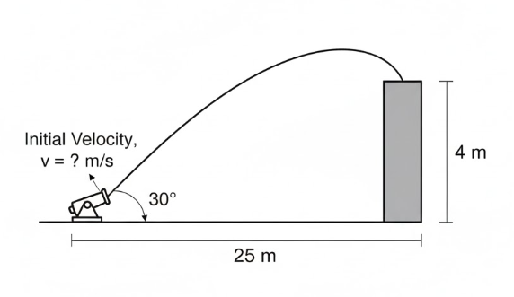
$$y\backslash =\backslash xtan\backslash theta-\backslash frac\{gx^2\}\{2v^2\{\backslash cos\{\backslash theta\}\}^2\}$$
$$4\backslash m\backslash =\backslash 25\backslash m[tan(30)]- \backslash frac\{9.81 \backslash m/s^2 (25 \backslash m)^2\}\{2v^2 [\backslash cos(30)^2]\}$$
$$\backslash mathbit\{v\}\backslash =\backslash \backslash mathbf\{19\}.\backslash mathbf\{793\}\backslash \backslash mathbit\{m\}/\backslash mathbit\{s\}$$

Situation 4 – Air is moving through a square 500 mm by 500 mm duct at 200 $m^3/min$. What is its mean velocity?
Given:
Base (b) & height (h) = 500 mm
Flow rate (Q) = 200 $m^3/min$
Required:
Velocity (v)

Solution:
$$Q\backslash =\backslash Av$$
$$200\backslash m^3/min\backslash (\backslash frac\{1\backslash min\}\{60\backslash s\})=(0.5\{\backslash m)\}^2(v)\backslash$$
$$\backslash mathbit\{v\}\backslash =\backslash \backslash mathbf\{13\}.\backslash mathbf\{333\}\backslash \backslash mathbit\{m\}/\backslash mathbit\{s\}$$

Situation 5 – The water tank in the figure is being filled through section 1 at 7 $m/s$ and through section 3 at 17 $L/s$. If water level h is constant, determine the exit velocity.
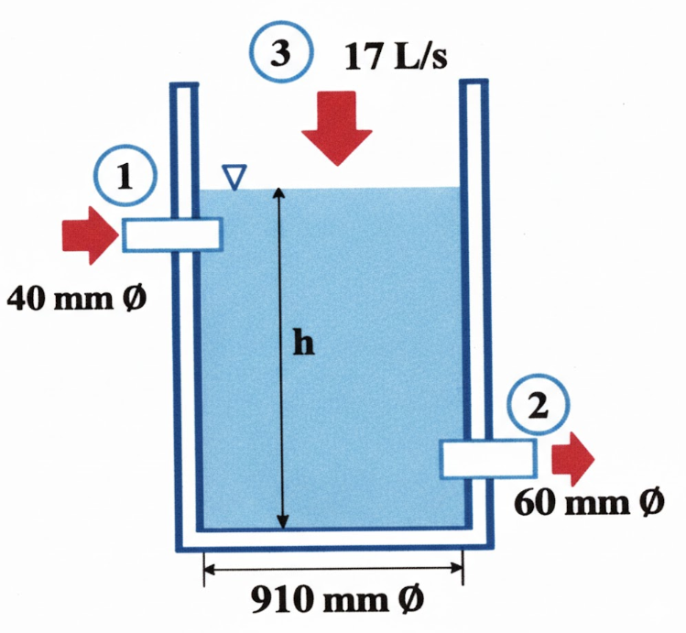
Given:
Section 1 velocity $(v_1)$ = 7 m/s
Section 3 flow rate $(Q_3)$ = 17 L/s
Required:
Section 2 velocity $(v_2)$

Solution:
$$Q_1+Q_3=Q_2$$
$$A_1v_1+Q_3=A_2v_2$$
$$\backslash frac\{\backslash pi\}\{4\}(0.04\backslash m)^2(7\backslash m/s)\backslash +\backslash 17\backslash L/s\backslash =\backslash \backslash frac\{\backslash pi\}\{4\}(0.06\backslash m)^2(v_2)$$
$$\backslash mathbit\{v\}_\backslash mathbf\{2\}=\backslash mathbf\{9\}.\backslash mathbf\{124\}\backslash \backslash mathbit\{m\}/\backslash mathbit\{s\}$$

Situation 6 – A diverging tube discharges water from a reservoir at a depth of h = 12 m below the water surface. The diameter of the tube gradually increases from 150 mm at the throat to 225 mm at the outlet. Neglecting friction, determine the ff:
- Maximum possible rate of discharge through this tube
- Corresponding possible pressure at the throat
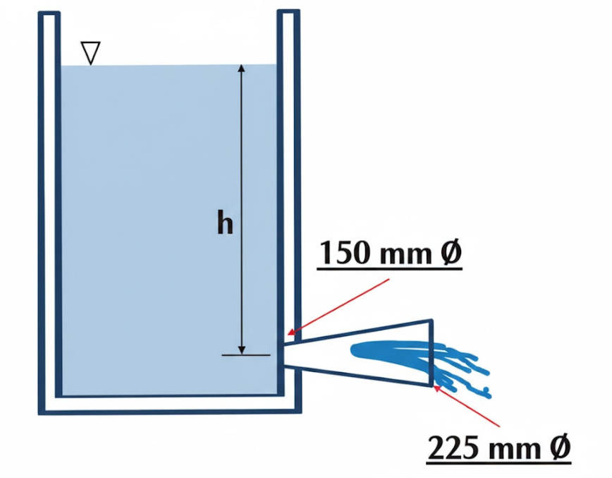
Given:
Depth (h) = 12 m
Diameter of throat $(D_2)$ = 150 mm
Diameter of outlet $(D_3)$ = 225 mm
Required:
Discharge through the tube $(Q)$
Pressure at the throat $(P_2)$

Solution:
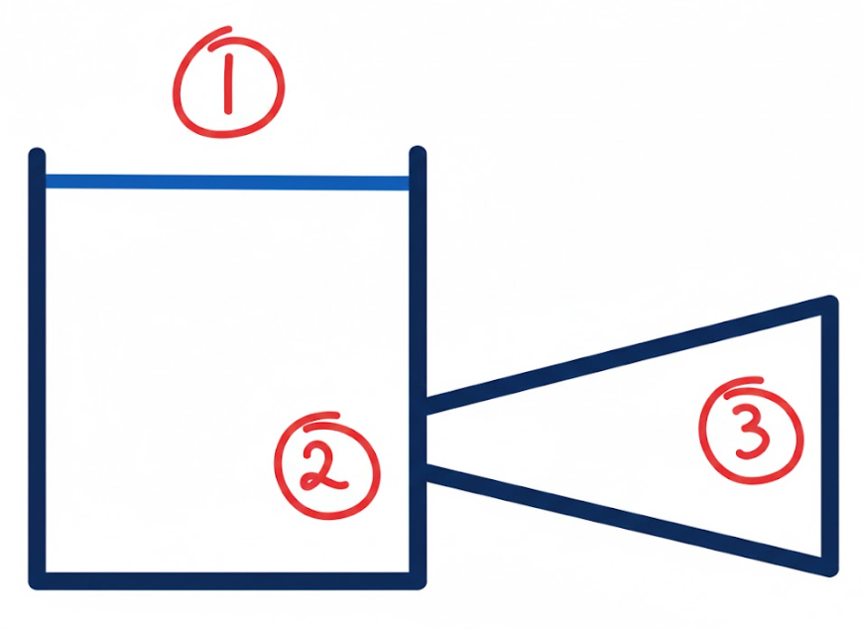
$$\backslash frac\{v^2\}\{2g\}\backslash rightarrow\backslash frac\{8Q^2\}\{\backslash pi^2gD^4\}$$
- $E_1=E_3$
$$(\backslash frac\{v^2\}\{2g\}+\backslash frac\{P\}\{\backslash delta\}+z)_1=(\backslash frac\{v^2\}\{2g\}+\backslash frac\{P\}\{\backslash delta\}+z)_3$$
$$0+0+12=\backslash frac\{8Q^2\}\{\backslash pi^2(9.81\backslash m/s^2)\{(0.225\backslash m)\}^4\}+0+0$$
$$\backslash mathbit\{Q\}=\backslash mathbf\{0\}.\backslash mathbf\{61\}\backslash mathbit\{m\}^\backslash mathbf\{3\}/\backslash mathbit\{s\}$$

- $E_2=E_3$
$$(\backslash frac\{v^2\}\{2g\}+\backslash frac\{P\}\{\backslash delta\}+z)_2=(\backslash frac\{v^2\}\{2g\}+\backslash frac\{P\}\{\backslash delta\}+z)_3$$
$$\backslash frac\{8\{(0.61m^3/s)\}^2\}\{\backslash pi^2(9.81m/s^2)\{(0.15\backslash m)\}^4\}+\backslash frac\{P\}\{9.81\backslash kN/m^3\}+0=\backslash frac\{[\backslash frac\{0.61 m^3 / s\}\{\backslash frac\{\backslash pi\}\{4\}(0.225\backslash \{ m\})^2\}]^2\}\{2(9.81 m / s^2)\}+0+0$$

$$\backslash mathbit\{P\}_\backslash mathbf\{2\}=\backslash mathbf\{478\}.\backslash mathbf\{09\}\backslash \backslash mathbit\{kPa\}$$

Given:
Situation 7 – A horizontal pipe gradually changes from 350 mm diameter section to 125 mm diameter section. The pressure at the 350 mm section is 120 kPa and at the 125 mm section is 80 kPa. If the flow rate is 18 $L/s$ of water, compute for the head lost between the two sections.
Diameter 1 $(D_{1})$ = 350 mm
Pressure 1 $(P_{1})$ = 120 kPa
Diameter 2 $(D_{2})$ = 125 mm
Pressure 2 $(P_{2})$ = 80 kPa
Flow rate (Q) = 18 L/s
Required:
Head loss (HL)

Solution:

$$\backslash frac\{v^2\}\{2g\}\backslash rightarrow\backslash frac\{8Q^2\}\{\backslash pi^2gD^4\}$$
$$E_1-HL=E_2$$
$$(\backslash frac\{v^2\}\{2g\}+\backslash frac\{P\}\{\backslash delta\}+z)_1-HL=(\backslash frac\{v^2\}\{2g\}+\backslash frac\{P\}\{\backslash delta\}+z)_2$$
$$\backslash frac\{8\{(0.018\backslash m^3/s)\}^2\}\{\backslash pi^2(9.81\backslash m/s^2)\{(0.35\backslash m)\}^4\}+\backslash frac\{120\backslash kPa\}\{9.81\backslash kN/m^3\}+0-HL=\backslash frac\{8\{(0.018\backslash m^3/s)\}^2\}\{\backslash pi^2(9.81\backslash m/s^2)\{(0.125\backslash m)\}^4\}+\backslash frac\{80\backslash kPa\}\{9.81\backslash kN/m^3\}+0$$
$$\backslash mathbit\{HL\}\backslash =\backslash \backslash mathbf\{3\}.\backslash mathbf\{97\}\backslash \backslash mathbit\{m\}$$

Situation 8 – A liquid having a specific gravity of 1.665 is flowing in a 75 mm diameter pipe. The total head at a given point was found to be 18 Joule per Newton. The elevation of the pipe above the datum is 3.2 m and the pressure in the pipe is 70.6 kPa. Compute for the velocity of flow and the horsepower in the stream at that point.
Given:
Specific gravity (sg) = 1.665
Diameter (D) = 75 mm
Total head (E) = 18 Joule per Newton
Datum (z) = 3.2 m
Pressure (P) = 70.6 kPa
Required:
Velocity (v)
Power (P)

Solution:
$$E=\backslash frac\{v^2\}\{2g\}+\backslash frac\{P\}\{\backslash delta\}+z$$
$$18\backslash m\backslash =\backslash \backslash frac\{v^2\}\{2\backslash left(9.81m/s^2\backslash right)\}+\backslash frac\{70.6\backslash kPa\}\{9.81\backslash kN/m^3\}+3.2\backslash m$$
$$\backslash mathbit\{v\}=\backslash mathbf\{14\}.\backslash mathbf\{338\}\backslash \backslash mathbit\{m\}/\backslash mathbit\{s\}$$

$$P=Q\backslash delta E$$
$$=\backslash \backslash frac\{\backslash pi\}\{4\}(0.075\backslash m)^2(14.338\backslash m/s)[9810\backslash N/m^3(1.665)](18 m)$$
$$=\backslash frac\{18623.304\backslash watts\}\{746\backslash hp\}$$
$$\backslash mathbit\{P\}=\backslash mathbf\{24\}.\backslash mathbf\{964\}\backslash \backslash mathbit\{hp\}$$

Situation 9 – High velocity water flows up an inclined plane as shown. What are the two possible depths of flow at section 2? Neglect losses. 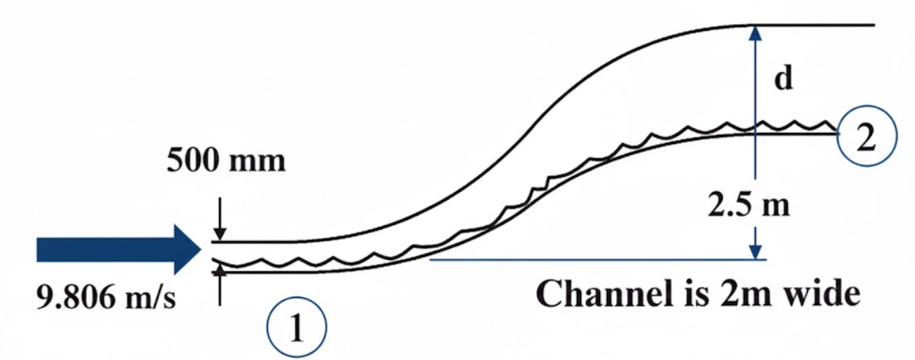
Given:
Velocity (v) = 9.806 m/s
Depth at section 1 $(d_{1})$ = 500 mm
Datum (z) = 2.5 m
Channel width (w) = 2 m

Required:
Two possible depths at section 2 $(d_{2})$

Solution:
$$Q=Av$$
$$=0.5\backslash m(2)(9.806\backslash m/s)\backslash$$
$$Q=9.806\backslash m^3/s$$

$$E_1=d_1+\backslash frac\{v^2\}\{2g\}$$
$$=0.5\backslash m+\backslash frac\{(9.806\backslash m/s)^2\}\{2(9.81\backslash m/s^2)\}$$
$$E_1=5.401\backslash m$$
$$E_2=E_1-z$$
$$=5.401\backslash m-2.5\backslash m$$
$$E_2=2.901\backslash m$$

$$E_2=d_2+\backslash frac\{v^2\}\{2g\}$$
$$2.901\backslash m\backslash =\backslash d_2+\backslash frac\{(\backslash frac\{9.806\backslash m^3/s\}\{2d_2\})\}\{2(9.81\backslash m/s^2)\}$$
$$\backslash mathbit\{d\}_\backslash mathbf\{2\}=\backslash mathbf\{2\}.\backslash mathbf\{738\}\backslash \backslash mathbit\{m\}\backslash \backslash mathbit\{or\}\backslash \backslash mathbf\{0\}.\backslash mathbf\{756\}\backslash \backslash mathbit\{m\}$$

Situation 10 – A turbine is rated 900 hp when the flow of water through is 780 $L/s$. Assuming efficiency of 85%, compute for the head acting on the turbine.
Given:
Power output = 900 hp
Flow rate = 780 L/s
Efficiency = 85%
Required:
Head extracted (HE)

Solution:
$$Efficiency=\backslash frac\{Output\}\{Input\}(100)$$
$$0.85=\backslash frac\{900\backslash hp\}\{Input\}$$
$$P_I=1058.824\backslash hp(764\backslash watts)$$
$$P_I=789882.353\backslash watts$$

$$P=Q\backslash deltaHE$$
$$789882.353\backslash watts=0.78\backslash m^3/s(9810\backslash N/m^3)(HE)$$
$$\backslash mathbit\{HE\}=\backslash mathbf\{103\}.\backslash mathbf\{228\}\backslash \backslash mathbit\{m\}$$

