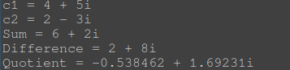
Assignment 1

Assignment 2
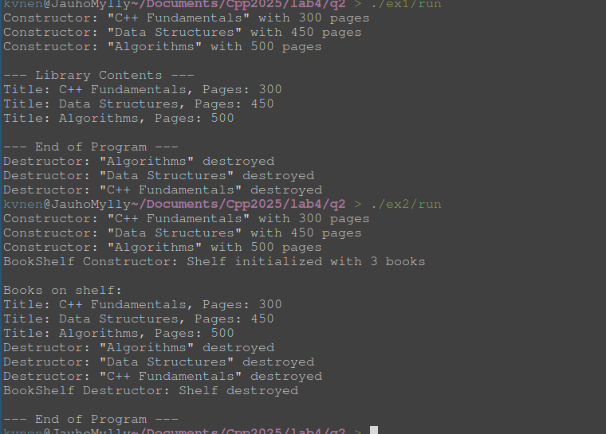
In the 1st example the destructor does basically nothing, it just prints out some text
In the 2nd example the destructor deletes the array that is created by the constructor inside the class

Assignment 3
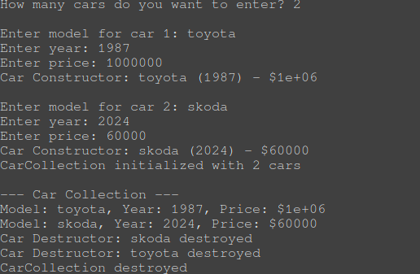

Assignment 4
