Relational Databases with MySQL Week 1 Coding Assignment
Points possible: 70
Category | Criteria | % of Grade
Functionality | Does the code work? | 25
Organization | Is the code clean and organized? Proper use of white space, syntax, and consistency are utilized. Names and comments are concise and clear. | 25
Creativity | Student solved the problems presented in the assignment using creativity and out of the box thinking. | 25
Completeness | All requirements of the assignment are complete. | 25

Instructions: Using a text editor of your choice, write the queries that accomplishes the objectives listed below. Take screenshots of the queries and results and paste them in this document where instructed below. Create a new repository on GitHub for this week’s assignments and push this document to the repository. Additionally, push an .sql file with all your queries to the same repository. Add the URL for this week’s repository to this document where instructed and submit this document to your instructor when complete.
Coding Steps:
Using the employees database you installed, write SQL queries that do the following (the SQL queries you write are what you will turn in for your homework):

1. Show all employees who were born before 1965-01-01
2. Show all employees who are female and were hired after 1990
3. Show the first and last name of the first 50 employees whose last name starts with F
4. Insert 3 new employees into the employees table. There emp_no should be 100, 101, and 102. You can choose the rest of the data.
5. Change the employee's first name to Bob for the employee with the emp_no of 10023.
6. Change all employees hire dates to 2002-01-01 whose first or last names start with P.

7. Delete all employees who have an emp_no less than 10000
8. Delete all employee who have an emp_no of 10048, 10099, 10234, and 20089.

Screenshots of Queries:

Screenshots of Query Results (only include the last 20 rows):

URL to GitHub Repository:
https://github.com/kvnftzsmmns/MySqlWeek1

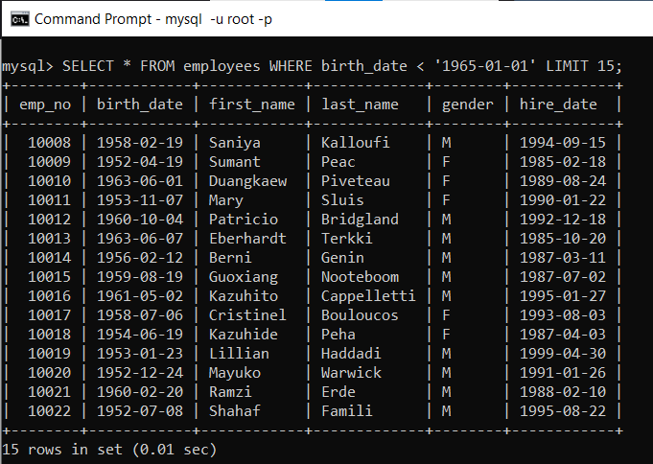
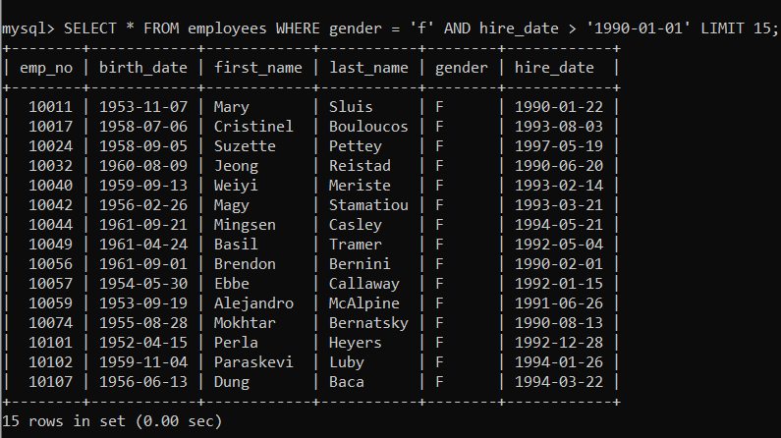
#1 – SELECT * FROM employees WHERE birth_date < '1965-01-01' LIMIT 20;
#2 - SELECT * FROM employees WHERE gender = 'f' AND hire_date > '1990-01-01' LIMIT 20;

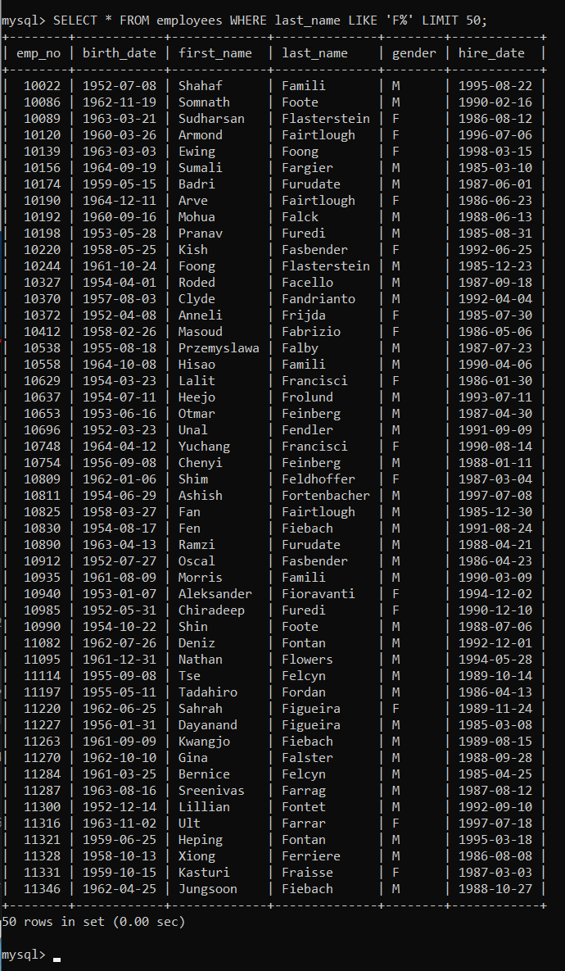
#3 SELECT * FROM employees WHERE last_name LIKE 'F%' LIMIT 50;

#4 – INSERT INTO employees VALUES (100, '1999-09-09', 'Douglas', 'Bubbletrouser', 'M', '2020-02-02'),
(101, '1969-06-09', 'Rusty', 'Shackleford', 'M', '2013-03-03'),
(102, '1945-12-122', 'Diane', 'Sawyer', 'F', '2011-01-11');

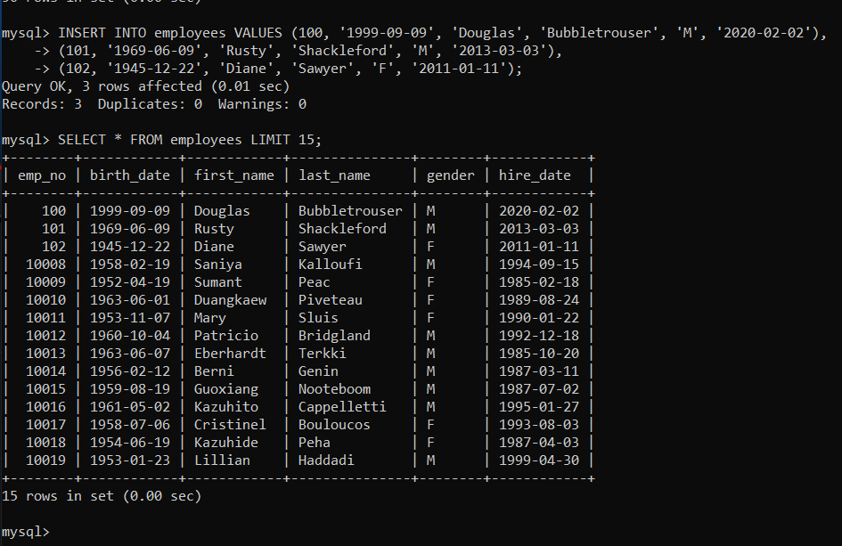
#5 – UPDATE employees SET first_name = 'Bob' WHERE emp_no = 10023;
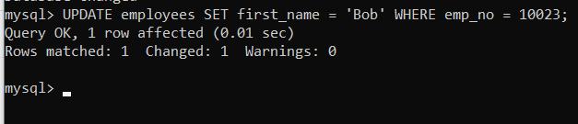

#6 UPDATE employees SET hire_date = '2002-01-01' WHERE first_name LIKE 'p%' AND last_name LIKE 'p%';
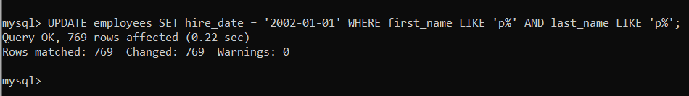

#7 – DELETE FROM employees WHERE emp_no < 10000;
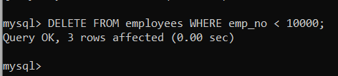
#8 – DELETE FROM employees WHERE emp_no = 10048;
DELETE FROM employees WHERE emp_no = 10099;
DELETE FROM employees WHERE emp_no = 10234;
DELETE FROM employees WHERE emp_no = 20089;

