The Impact of Phage Tail Architecture on Host Bacteria Adsorption
Tail size vs. adsorption dynamics
Colen J. Lawton¹*, Alyssa Q. Rivera¹, Miguel S. Santos¹
¹Seaside Polytechnic University, Dept. of Bioengineering, San Diego, CA, USA
Corresponding author: Colen J. Lawton, colen.lawton@spu.example.edu; ORCID: 1234-5678-9-1011

Abstract
Concise background, approach, results, and significance (150–250 words). Avoid citations and undefined abbreviations. State one or two key quantitative outcomes.
Keywords: Input three to five keywords that describe this study

Introduction
Context, motivation, and prior work. Summarize main contributions and outline the manuscript.

Methods
Describe how the study was done. Include the design, materials/data, participants or models, procedures, analytical or computational techniques, and any tools/software used.

Results
Present the findings from applying those methods. Include key data, tables, figures, statistical outcomes, trends, and any observations — without interpretation.

Discussion
Interpret results, limitations (weakly compressible LBM; current lack of walls), and opportunities for parameter sweeps and wall interactions.

References
1. Author AB, Author CD (Year) Title. Journal Volume(Issue):Pages. doi:…
2. Author EF (Year) Title. Preprint/server. doi:…

Figures

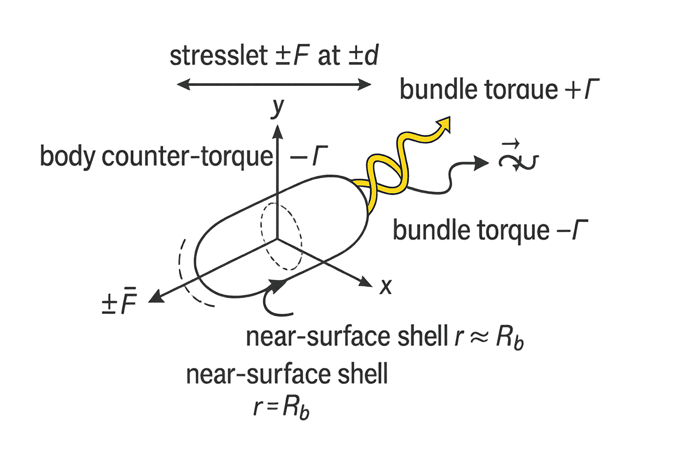
Figure 1. Cartoon of the hydrodynamic model. The stresslet applies +/- F at +/- d along $\hat{x}$ (yellow arrows). A rotating helical bundle (cyan) exerts torque $Γ$, while a body ring (magenta) applies $-Γ$ to enforce zero net torque. Optional tail thrust acts along the waveform with a small head counter-drag (gray). A dashed spherical shell at $r≈R_{b}$ indicates where near-surface tangential speed $u_{t}\left(ϑ,φ\right)$ is sampled and axes show $\hat{x},\hat{y},\hat{z}$.

