The Impact of Phage Tail Architecture on Host Bacteria Adsorption
Tail size vs. adsorption dynamics
Colen J. Lawton¹*, Alyssa Q. Rivera¹, Miguel S. Santos¹
¹Seaside Polytechnic University, Dept. of Bioengineering, San Diego, CA, USA
Corresponding author: Colen J. Lawton, colen.lawton@spu.example.edu; ORCID: 1234-5678-9-1011

Abstract
Tailed bacteriophage families exhibit wide variation in tail lengths and head sizes. This study examined if taxonomic family alone predicts host adsorption rate. Using data compiled from multiple sources, we found that only Podoviridae tail lengths were statistically different from both Siphoviridae ($p=8.23×{10}^{-5}$) and Myoviridae ($p=8.23×{10}^{-4}$), whereas phage–host adsorption rates were found to be on the same order of magnitude ($≈{10}^{-7}$) similarly distributed across the major tailed-virus families. By host, adsorption rates for Enterobacteriaceae were comparable across phage families and significantly higher than those for Synechococcus ($p ≈3.57×{10}^{-5}$ ), P. aeruginosa ($p ≈2.20×{10}^{-2}$), and Vibrio ($p ≈3.90×{10}^{-3}$).
Keywords: bacteriophage; adsorption rate; Phage morphology

Introduction
Context, motivation, and prior work. Summarize main contributions and outline the manuscript.

Methods

Surveyed adsorption rates of tailed phage with bacteria

For this study, bacteriophage adsorption data was compiled from 18 different literature sources to examine the association between microbial physical characteristics and phage adsorption rates. The literature review provided 66 individual data samples of adsorption rates spanning the Siphoviridae (Abedon et al., 2023, Moldovan et al., 2007; Shao and Wang, 2008; Puck et al., 1950; Storms et al., 2012; Mann, 2003; Suttle and Chan, 1993; Namonyo et al., 2023) (17 samples), Myoviridae (Stoddard et al., 2007; Mann, 2003; Jamal et al., 2014; Storms et al., 2010; Storms et al., 2012; Puck et al., 1950; Barr et al., 2015; Levisohn and Engelhard, 1987; Thammatinna et al., 2023, Kim et al., 2019; Namonyo et al., 2023) (36 samples) and Podoviridae (Niu et al., 2022; Sillankorva et al., 2008; Namonyo et al., 2023; Zhang et al., 2016; Yang et al., 2022; Puck et al., 1950; Storms et al., 2012; Koonjan et al., 2021; Xu et al., 2021; Namonyo et al., 2023) (14 samples) bacteriophage families. This survey provided a reasonable database to compare phage adsorption rates over four bacterial host families (Enterobacteriaceae, Pseudomonadaceae, Synechococcaceae and Vibrionaceae) and achieve insight into the variability of phage-host interactions across mammalian gut and marine habitats. Data on phage tail lengths and head sizes from the Siphoviridae, Myoviridae, and Podoviridae were also collected. Statistical correlations were performed with a Mann-Whitney U-test (Nadim, 2008). Reconstruction of distributions from data was accomplished using typical bootstrapping techniques.

Several studies (Moldovan et al., 2007; Barr et al. 2015; Sillankorva et al., 2008; Suttle and Chan, 1993; Yang et al., 2022), expressed phage adsorption rates in terms of percentage of adsorbed phages, $∆\hat{P}$ ($\%$) = $P_{0}$ - $P_{final}$ / $P_{0}$, in relation to the initial ($P_{0}$) and final ($P_{final}$) phage counts. In these cases, the percentage of adsorbed phages ($∆\hat{P}$ ($\%$)) was converted to proper adsorption rates $k$ (mL/hr) using the adsorption formula (Stergachis, 2010),
$$k=-\frac{1}{tB}\log\left(1-∆\hat{P}\right)$$where $t$ was the incubation time (hr), and $B$ was the concentration of bacterial hosts (per mL). The local concentration of phage and bacteria were taken as molecules per cubic centimeter. If input bacterial concentrations were given in terms of the multiplicity of infection, MOI, then $B=P_{0} / MOI$ was taken as the bacterial concentration for the observed adsorption rate.

Results
Statistical Analysis of Adsorption Rate Data
From the surveyed literature, phage family tail length distributions (Fig. 1A) were slightly skewed with medians; Siphoviridae: ${\tilde{L}}_{tail}$ =281 nm, Myoviridae: ${\tilde{L}}_{tail}$ = 134 nm and Podoviridae: ${\tilde{L}}_{tail}$ =18.9 nm (Table 1). Statistical analysis showed the tail lengths grouped by phage family (Fig. 1A) were statistically different between the Siphoviridae and Podoviridae families (Mann-Whitney U-test, $p=8.23×{10}^{-5}$) and Myoviridae and Podoviridae families (Mann-Whitney U-test, $p=8.23×{10}^{-4}$). Phage head data was similar across phage families (Fig. 1A). Distributions of phage adsorption rate constants grouped by phage family (Fig. 1B) were highly skewed, but with medians one the same order of magnitude $\left(≈{10}^{-7}\right)$ from one another; Siphoviridae: $\tilde{k}=2.34 ×{10}^{-7}$ (mL / hr), Myoviridae: $\tilde{k}=5.70 ×{10}^{-8}$ (mL / hr) and Podoviridae: $\tilde{k}=3.57 ×{10}^{-7}$ (mL / hr).
Statistical analysis showed that adsorption rates grouped by phage family (Fig. 1B) were non-normally distributed and highly skewed, so medians were compared using the Mann–Whitney U-test (5% significance). Adsorption rates for Siphoviridae and Podoviridae were not significantly different ($p ≈0.39$), whereas both differed significantly from Myoviridae ($p ≈0.006$ and $p ≈0.008$, respectively). Thus, the surveyed data indicates that Podoviridae share similar adsorption rates with Siphoviridae, while Myoviridae exhibit lower median rates. Consequently, tail-length variation does not appear to exert a strong family-scale influence on adsorption kinetics in this data.
Adsorption rates for Enterobacteriaceae were not significantly different across phage families (Mann–Whitney U-test, 5% significance). However, when compared across host species, Enterobacteriaceae exhibited adsorption rates roughly 4–5 times higher than Synechococcus and Vibrio (p < 0.01), while P. aeruginosa showed even greater rates overall ($p ≈0.02$). Thus, Enterobacteriaceae represents a relatively favorable host across phage families, with Synechococcus and Vibrio supporting lower adsorption efficiencies and P. aeruginosa supporting the highest.

Mann–Whitney U-tests (5 % significance) showed that adsorption rates for Enterobacteriaceae differed significantly from those for Synechococcus ($p ≈3.57×{10}^{-5}$), P. aeruginosa ($p ≈2.20×{10}^{-2}$), and Vibrio ($p ≈3.90×{10}^{-3}$). Enterobacteriaceae exhibited adsorption rates roughly 4–5 times higher than Synechococcus and Vibrio, but lower than P. aeruginosa. Among the remaining hosts, Synechococcus and Vibrio did not differ significantly ($p ≈0.67$), whereas P. aeruginosa showed consistently higher adsorption constants. Thus, Enterobacteriaceae and P. aeruginosa represent the most favorable hosts, while Synechococcus and Vibrio exhibit comparatively lower adsorption efficiencies.

Discussion

The violin plots highlight how bacteriophage adsorption dynamics depend more on host identity than on phage family morphology. Although Siphoviridae, Myoviridae, and Podoviridae differ markedly in tail length (panel A), their adsorption rate distributions largely overlap (panel B), suggesting tail length alone is not a dominant predictor of adsorption efficiency. Instead, host specificity emerges as a stronger determinant (panels C–D), with Enterobacteriaceae supporting consistently higher adsorption rates than Synechococcus, Vibrio, or Pseudomonas aeruginosa. Hidden variables may underlie these patterns, including differences in receptor abundance on host surfaces, variations in experimental conditions (e.g., temperature, ionic strength, and growth medium), and methodological differences in adsorption assays across studies. Moreover, ecological origin (marine vs. gut isolates), multiplicity of infection, and unreported host physiology at the time of infection could further confound comparisons. Together, the figure suggests that while phage morphology contributes to adsorption potential, biological and environmental host factors exert stronger control over observed rates.

References
1. Stoddard, Lauren I., Jennifer BH Martiny, and Marcia F. Marston. "Selection and characterization of cyanophage resistance in marine Synechococcus strains." Applied and Environmental Microbiology 73.17 (2007): 5516-5522.

2. Mann, Nicholas H. "Phages of the marine cyanobacterial picophytoplankton." FEMS microbiology reviews 27.1 (2003): 17-34.

3. Puck, Theodore T., Alan Garen, and Jewell Cline. "The mechanism of virus attachment to host cells: I. The role of ions in the primary reaction." The Journal of experimental medicine 93.1 (1951): 65-88.

4. Storms, Zachary J., et al. "Bacteriophage adsorption efficiency and its effect on amplification." Bioprocess and biosystems engineering 33.7 (2010): 823-831.

5. Storms, Zachary J., et al. "Modeling bacteriophage attachment using adsorption efficiency." Biochemical Engineering Journal 64 (2012): 22-29.

6. Barr, Jeremy J., et al. "Subdiffusive motion of bacteriophage in mucosal surfaces increases the frequency of bacterial encounters." Proceedings of the National Academy of Sciences 112.44 (2015): 13675-13680.

7. Levisohn, Reuben, Jay Moreland, and K. H. Nealson. "Isolation and characterization of a generalized transducing phage for the marine luminous bacterium Vibrio fischeri MJ-1." Journal of general microbiology 133.6 (1987): 1577-1582.

8. Zhang, Hui, et al. "Polar flagella rotation in Vibrio parahaemolyticus confers resistance to bacteriophage infection." Scientific Reports 6.1 (2016): 26147.

9. Koonjan, Shazeeda, Callum J. Cooper, and Anders S. Nilsson. "Complete genome sequence of vb_ecop_su7, a podoviridae coliphage with the rare c3 morphotype." Microorganisms 9.8 (2021): 1576.

10. Yuanyuan, Niu, et al. "Isolation and characterization of two homolog phages infecting Pseudomonas aeruginosa." Frontiers in Microbiology 13 (2022): 946251.

11. Xu, Jing, et al. "Molecular characteristics of novel phage vB_ShiP-A7 infecting multidrug-resistant Shigella flexneri and Escherichia coli, and its bactericidal effect in vitro and in vivo." Frontiers in Microbiology 12 (2021): 698962.

12. Sillankorva, Sanna, Peter Neubauer, and Joana Azeredo. "Isolation and characterization of a T7-like lytic phage for Pseudomonas fluorescens." BMC biotechnology 8.1 (2008): 80.

13. Moldovan, R., E. Chapman-McQuiston, and X. L. Wu. "On kinetics of phage adsorption." Biophysical journal 93.1 (2007): 303-315.

14. Shao, Yongping, and Ing-Nang Wang. "Bacteriophage adsorption rate and optimal lysis time." Genetics 180.1 (2008): 471-482.

15. Suttle, Curtis A., and Amy M. Chan. "Marine cyanophages infecting oceanic and coastal strains of Synechococcus: abundance, morphology, cross-infectivity and growth characteristics." Marine Ecology Progress Series 92 (1993): 99-109.

16. Nachar, Nadim. "The Mann–Whitney U: A test for assessing whether two independent samples come from the same distribution." Tutorials in Quantitative Methods for Psychology 4.1 (2008): 13–20.

17. Stergachis, Andy, Rebecca J. K. Bartlein, Alexander Dodoo, Jude Nwokike, and S. Patrick Kachur. "A situational analysis of pharmacovigilance plans in the Global Fund Malaria and U.S. President's Malaria Initiative proposals." Malaria Journal 9.1 (2010): 148.

Figures
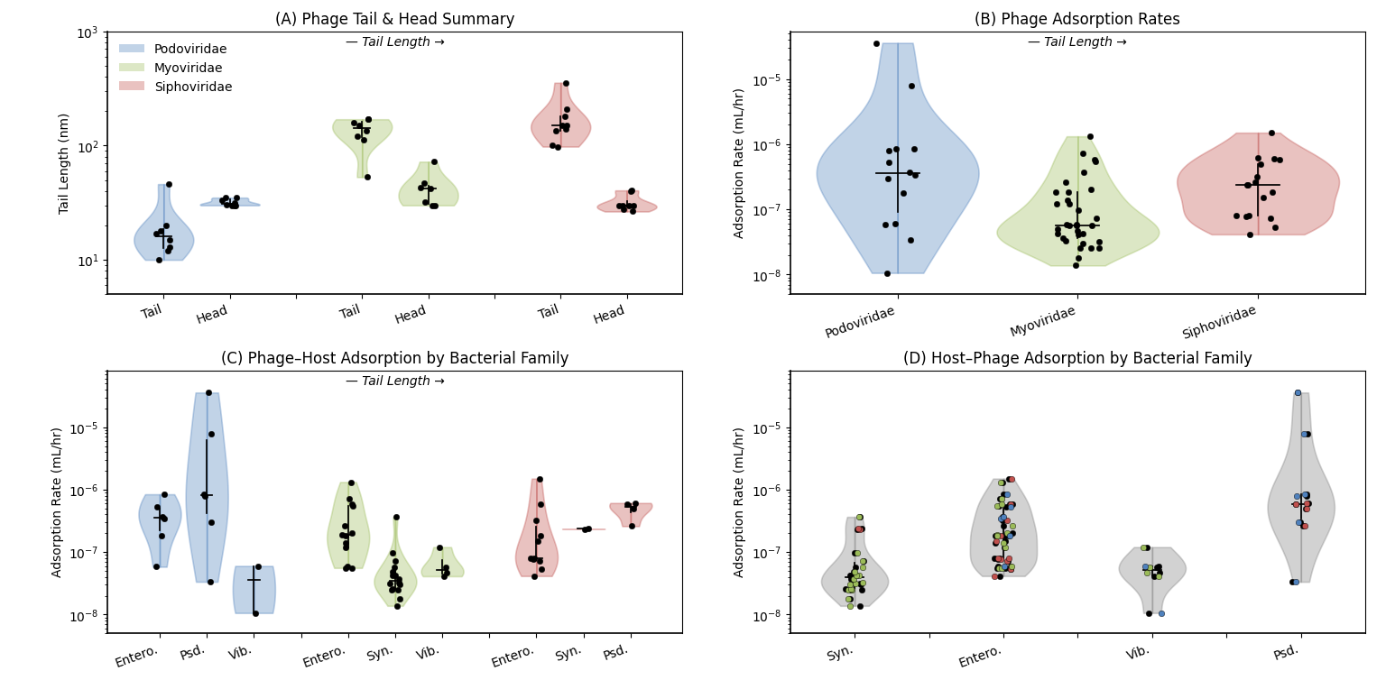
Figure 1. Adsorption rate and phage tail statistics.

