# Results

Table 1 presents summary statistics of exposure and covariates for the full study population and for those diagnosed with NHL between 1985 and 2004. The cohort is predominantly white (66%) and male (87%). Plant 2 employed the largest number of workers while Plant 1 employed the fewest. The median year of hire among those diagnosed with NHL was 1959 whereas the median year of hire in the full study population was 1967. Age at hire was approximately the same among those with NHL and the full study population. Median lagged cumulative exposure to all three MWF types was higher among NHL cases. Soluble MWFs were the most widely used MWF type, with approximately 90% of workers ever exposed. Median cumulative exposure among exposed was 6.5 times higher for soluble than for straight MWFs. Figure 1 shows median average annual exposure to the three MWF types among exposed workers over calendar time. Exposure to MWF generally followed a downward trend over time. Figure 2 shows the post-intervention distribution of the logarithm of cumulative exposure to soluble MWF at end of follow-up under hypothetical limits on average annual exposure were enforced since hire for all workers. The interventions we considered shifts in the distribution of cumulative exposure rather than deterministic enforcement of exposure at a particular value.

Table 1: Summary of population characteristics. Statistics shown above the horizontal line are count (%). Those shown below are median (quartile 1, quartile 3).

|  | Study population | |  | NHL cases | |
| --- | --- | --- | --- | --- | --- |
| N (person-years) | 34,734 | (596,698) |  | 231 | (2,777) |
| Race |  |  |  |  |  |
| White | 22,789 | (66%) |  | 173 | (75%) |
| Black | 6,304 | (18%) |  | 21 | (9%) |
| Unknown | 5,641 | (16%) |  | 37 | (16%) |
| Sex |  |  |  |  |  |
| Male | 30,235 | (87%) |  | 206 | (89%) |
| Female | 4,499 | (13%) |  | 25 | (11%) |
| Planta |  |  |  |  |  |
| Plant 1 | 8,721 | (25%) |  | 68 | (29%) |
| Plant 2 | 14,258 | (41%) |  | 90 | (39%) |
| Plant 3 | 11,755 | (34%) |  | 73 | (32%) |
| Ever exposed to MWFsb |  |  |  |  |  |
| Straight | 19,905 | (57%) |  | 133 | (58%) |
| Soluble | 31,044 | (89%) |  | 210 | (91%) |
| Synthetic | 12,262 | (35%) |  | 72 | (31%) |
| Deceased by end of follow-up | 10,384 | (30%) |  | 33 | (14%) |
| Year of birth | 1940 | (1925, 1950) |  | 1929 | (1919, 1940) |
| Year of hire | 1967 | (1953, 1976) |  | 1959 | (1951, 1969) |
| Age at hire (years) | 23.6 | (20.0, 30.1) |  | 25.4 | (21.1, 33.6) |
| Year of leaving workc | 1979 | (1968, 1989) |  | 1977 | (1964, 1987) |
| Age at leaving work (years)c | 45.0 | (31.9, 57.7) |  | 53.4 | (36.5, 61.2) |
| Years at workc | 15.3 | (7.3, 27.1) |  | 19.2 | (8.0, 29.9) |
| Year of death | 2000 | (1993, 2008) |  | 2001 | (1994, 2005) |
| Age at death (years) | 74.7 | (65.3, 82.5) |  | 73.8 | (66.2, 82.0) |
| Cumulative time off (years)b | 1.05 | (0.30, 1.80) |  | 0.71 | (0.14, 1.40) |
| Cumulative exposure to MWFs (mg/m3-years)d | | | | | |
| Straight | 0.70 | (0.22, 2.56) |  | 0.93 | (0.29, 3.30) |
| Soluble | 4.65 | (1.85, 12.13) |  | 7.16 | (2.86, 20.91) |
| Synthetic | 0.45 | (0.16, 1.64) |  | 0.89 | (0.29, 2.11) |
| NHL: non-Hodgkin lymphoma. | | | | | |
| a Plant of longest employment duration among those who worked at multiple plants; b Lagged 10 years; c Among those who left work by December 31, 1994; d Among ever-exposed individuals, lagged 10 years. | | | | | |

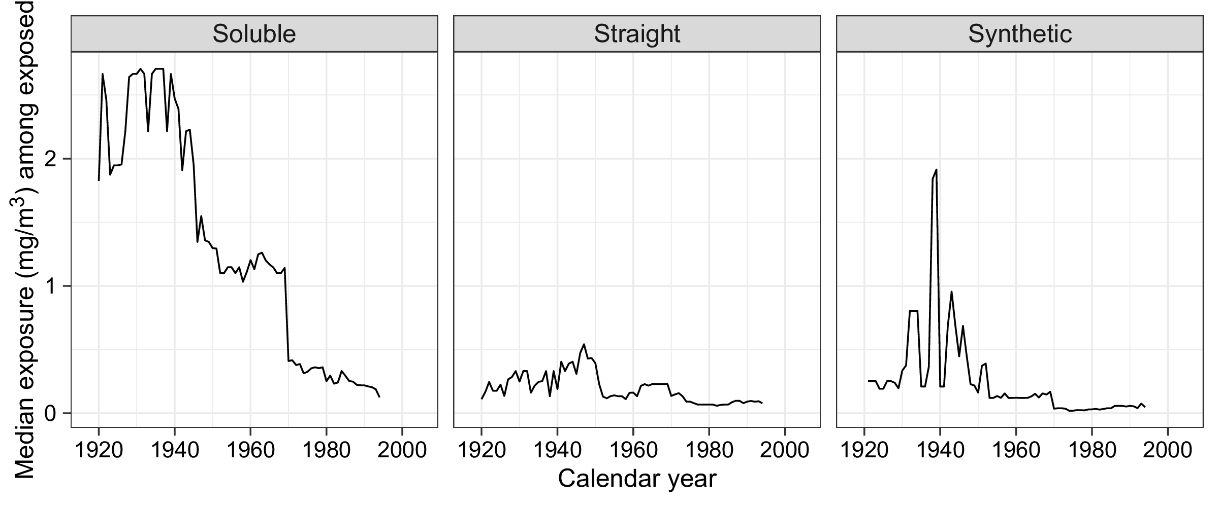

Figure 1. Median average annual exposure to straight, soluble, and synthetic metalworking fluids among exposed workers.

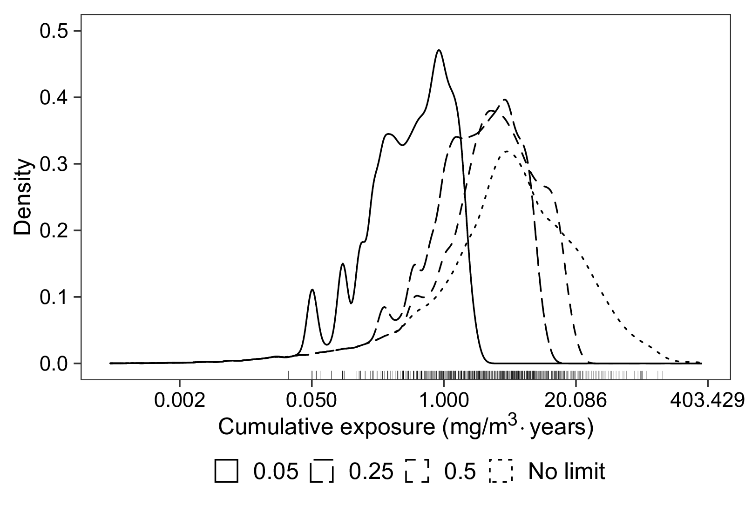

Figure 2. Post-intervention distribution of cumulative exposure to soluble metalworking fluids under hypothetical limits on average annual exposure (mg/m3) at end of follow-up. The rugplot shows maximum cumulative exposure accrued by non-Hodgkin lymphoma cases.

The observed cause-specific risk of NHL was 6.65 per 1000. Table 2 presents the hazard-extended ICE g-formula estimates of risk and risk ratios contrasting hypothetical limits on exposure to soluble MWF to no limit. The estimated risk under no limit on MWF exposure and elimination of competing risks was 9.56 (8.15, 10.89) per 1000. Results for interventions on straight and synthetic MWF are presented in Tables S1 and S2 in the Appendix. Since exposure to soluble MWF was greatest in prevalence and magnitude, limits on soluble MWF would result in interventions on a greater percentage of person-years than limits on straight or synthetic MWF. The intervention limiting average annual soluble MWF exposure at the REL affected 23.8% of the person-years in the follow-up period. Limiting straight and synthetic MWF exposure at the REL affected 3.2% and 1.1% of the person-years under follow-up, respectively.

Stronger limits on average annual exposure to soluble MWFs resulted in monotonic reductions in the risk of NHL. Capping average annual exposure to soluble MWFs at the NIOSH REL of 0.5 mg/m3 and a tenth of the REL resulted in a risk of 8.30 (6.52, 10.19) and 7.52 (5.73, 9.51) per 1000, respectively. The risk ratios contrasting these hypothetical limits to no limit were 0.87 (0.72, 1.02) and 0.79 (0.62, 0.97), respectively. Dynamic reductions in soluble exposure with the aim of limiting total MWF exposure to the REL and half the REL also yielded protective risk ratios: 0.84 (0.69, 0.99) and 0.80 (0.64, 0.98), respectively. These interventions attain risk reductions of similar magnitude as those when enforcing exposure limits at 0.25 and 0.05 mg/m3, but do so while intervening on a smaller proportion of person-years.

The relative risks contrasting interventions on straight and synthetic MWF exposure to the natural course were much smaller in magnitude than those for soluble; none were statistically significant.

Table 2: Counterfactual risks (per 1000) and risk ratios contrasting interventions on soluble MWF to the observed course.

| Exposure limit on soluble MWF (mg/m3) | Person-years intervened (%) | Risk per 1000 | (95% CI) | RR | (95% CI) |
| --- | --- | --- | --- | --- | --- |
| None | 0.0 | 9.56 | (8.15, 10.89) | 1.00 |  |
| 0.5 | 23.8 | 8.30 | (6.52, 10.19) | 0.87 | (0.72, 1.02) |
| 0.25 | 36.2 | 8.06 | (6.15, 10.15) | 0.84 | (0.68, 1.01) |
| 0.05 | 43.9 | 7.52 | (5.73, 9.51) | 0.79 | (0.62, 0.97) |
| max(0, 0.5 - str - syn) | 28.3 | 8.00 | (6.27, 9.87) | 0.84 | (0.69, 0.99) |
| max(0, 0.25 - str - syn) | 40.0 | 7.69 | (5.88, 9.64) | 0.80 | (0.64, 0.98) |
| MWF: metalworking fluid; str: exposure to straight metalworking fluids; syn: exposure to synthetic metalworking fluids. | | | | | |