
Università degli Studi di Messina
MIFT
Course: Machine Learning

FINAL PROJECT REPORT

Team Members:
Nurshirak Karimov

Dataset: final_project_dataset_complete.csv
Project Activities: Dataset Exploration, Preprocessing, EDA, Feature Engineering, Modeling, Tuning, and Interpretation

Submission date: 26.06.2026

Table of Contents
- Executive Summary
- Deliverables Checklist
- Project Activities and Deliverables:
- Dataset Exploration
- Data Preprocessing
- Exploratory Data Analysis
- Feature Engineering
- Modeling and Evaluation
- Hyperparameter Tuning
- Model Interpretation
- Presentation Summary and Recommendations
- Appendix A. Output Files
- Appendix B. Reproducibility Notes

Executive Summary
This report presents a complete machine learning workflow for the final project dataset. The dataset contains 9000 observations and 11 columns, including 8 numerical features, 2 categorical features, and a binary target variable. The target variable is relatively balanced, with class 0 representing 52.46% of observations and class 1 representing 47.54%. The workflow follows the requested project stages: dataset exploration, data preprocessing, in-depth exploratory data analysis, feature engineering, model training, model tuning, and model interpretation.
The most informative numerical features in the dataset were `feature_3`, `feature_4`, `feature_2`, and `feature_1`, based on their relationship with the target variable. Missing numerical values were detected in `feature_3` and `feature_6` and were handled through median imputation. Outliers were identified using the IQR rule and treated through clipping rather than row removal. Categorical variables were encoded through one-hot encoding during modeling, and numerical variables were scaled where required.
Six classification algorithms were trained and evaluated, including 4 ensemble learning models: Random Forest, Gradient Boosting, Extra Trees, and AdaBoost. The best tuned model was Random Forest Tuned, which achieved ROC-AUC = 0.962, Accuracy = 0.89, Precision = 0.9, Recall = 0.862, and F1-score = 0.881 on the test set. The final recommendation is to use the tuned Random Forest model as the main predictive model, supported by tuned Gradient Boosting as a robust alternative.

Deliverables Checklist
Deliverable | Requirement | Status
D0.0 | Passport pictures of team members | To be attached separately by team
D0.1 | Well documented Jupyter notebook or Python script | Completed separately; notebook/script reproduces the workflow
D1.1 | Section 1: Dataset exploration | Included in this report
D2.1 | Section 2: Data preprocessing | Included in this report
D2.2 | Cleaned dataset | Created as cleaned_dataset.csv
D3.1 | Section 3: Exploratory Data Analysis | Included with visualizations and statistical tests
D4.1 | Section 4: Feature engineering explanation | Included in this report
D4.2 | Dataset with new features | Created as feature_engineered_dataset.csv
D5.1 | Section 5: Model performance comparison | Included with metrics table
D5.2 | Trained models | Saved as model files
D6.1 | Section 6: Hyperparameter tuning | Included with default-vs-tuned comparison
D6.2 | Best tuned models | Saved as tuned model files
D7.1 | Section 7: Model interpretation | Included with feature importance
D8.1 | 15-minute PDF presentation, 20-25 slides max | Presentation structure provided in Section 8

1. Dataset Exploration
This section corresponds to deliverable D1.1. The purpose of dataset exploration is to understand the structure of the dataset, describe all available features, visualize distributions, and identify initial observations before preprocessing and modeling.
Table 1. Dataset structure
Item | Value
Number of entries | 9000
Number of columns | 11
Numerical features | feature_1, feature_2, feature_3, feature_4, feature_5, feature_6, feature_7, feature_8
Categorical features | category_1, category_2
Target variable | target
Target type | Binary classification target

Table 2. Feature description
Feature | Type | Possible values / meaning
feature_1 | Numerical | Continuous numeric values; distribution summarized below.
feature_2 | Numerical | Continuous numeric values; distribution summarized below.
feature_3 | Numerical | Continuous numeric values; distribution summarized below.
feature_4 | Numerical | Continuous numeric values; distribution summarized below.
feature_5 | Numerical | Continuous numeric values; distribution summarized below.
feature_6 | Numerical | Continuous numeric values; distribution summarized below.
feature_7 | Numerical | Continuous numeric values; distribution summarized below.
feature_8 | Numerical | Continuous numeric values; distribution summarized below.
category_1 | Categorical | Low, High, Above Average, Below Average
category_2 | Categorical | Region B, Region A, Region C
target | Binary target | 0 and 1; class to be predicted.

Table 3. Descriptive statistics for numerical features
feature | count | mean | std | min | 25% | 50% | 75% | max
feature_1 | 9000 | 0.0004 | 1.241 | -18.665 | -0.68 | -0.003 | 0.680 | 21.934
feature_2 | 9000 | 0.0033 | 2.508 | -37.852 | -1.382 | -0.016 | 1.38 | 47.603
feature_3 | 8600 | 0.0032 | 1.542 | -6.676 | -1.022 | 0.005 | 1.038 | 6.203
feature_4 | 9000 | -0.0084 | 2.061 | -8.19 | -1.399 | -0.019 | 1.394 | 8.189
feature_5 | 9000 | -0.0021 | 0.577 | -0.999 | -0.502 | 0.001 | 0.497 | 0.999
feature_6 | 8500 | -0.0064 | 1.981 | -8.59 | -1.329 | -0.003 | 1.324 | 6.803
feature_7 | 9000 | 0.0006 | 1.075 | -4.422 | -0.7 | -0.001 | 0.731 | 3.857
feature_8 | 9000 | 0.0033 | 2.043 | -9.474 | -1.356 | -0.007 | 1.402 | 7.572

1.1 Target Variable Distribution
The target variable is almost balanced: class 0 has 4721 observations (52.46%), while class 1 has 4279 observations (47.54%). This is a positive condition for classification because the models are not forced to learn from a severely imbalanced target distribution.
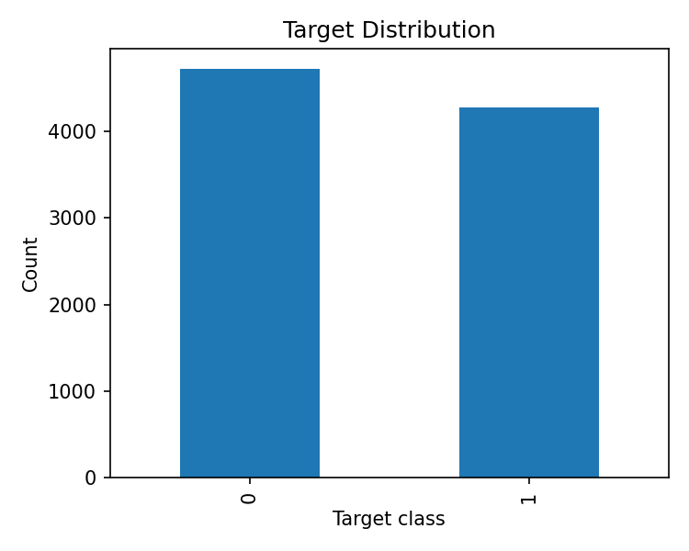
Figure 1. Target variable distribution.

1.2 Numerical Feature Distributions
The dataset contains 8 numerical variables. Histograms were used to examine the shape of each distribution. Several features appear approximately centered around zero, while some variables show wider spreads.
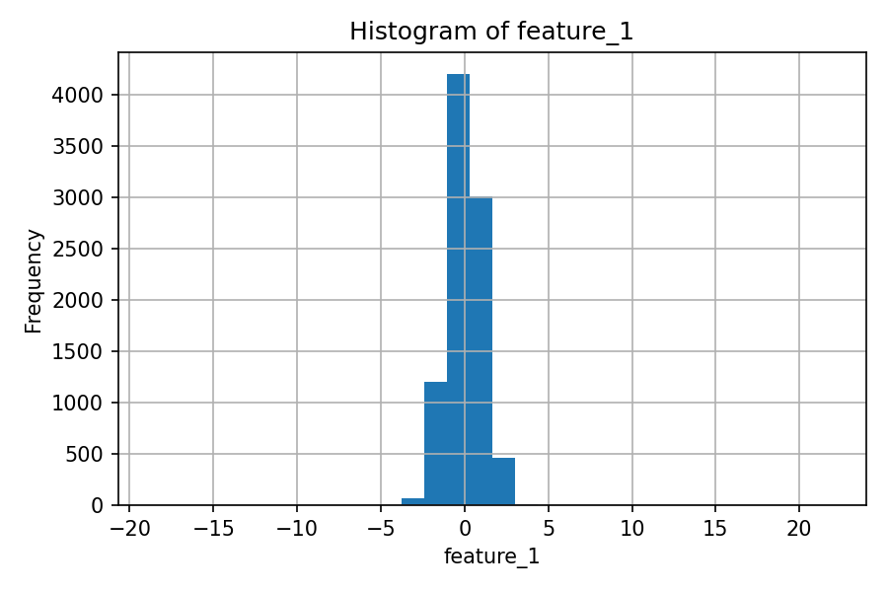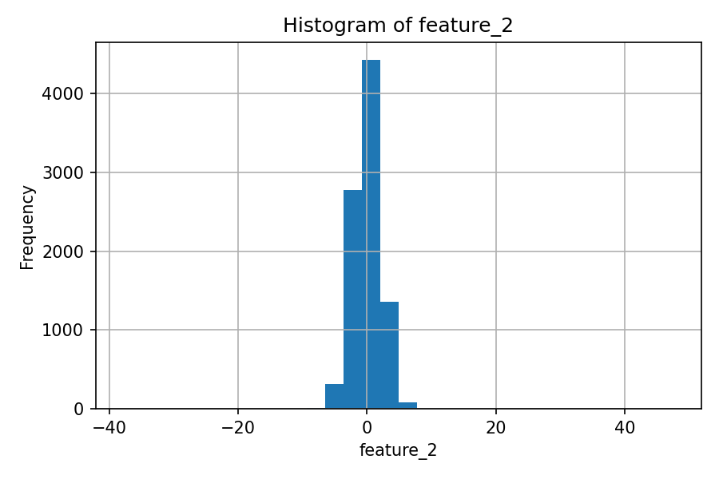
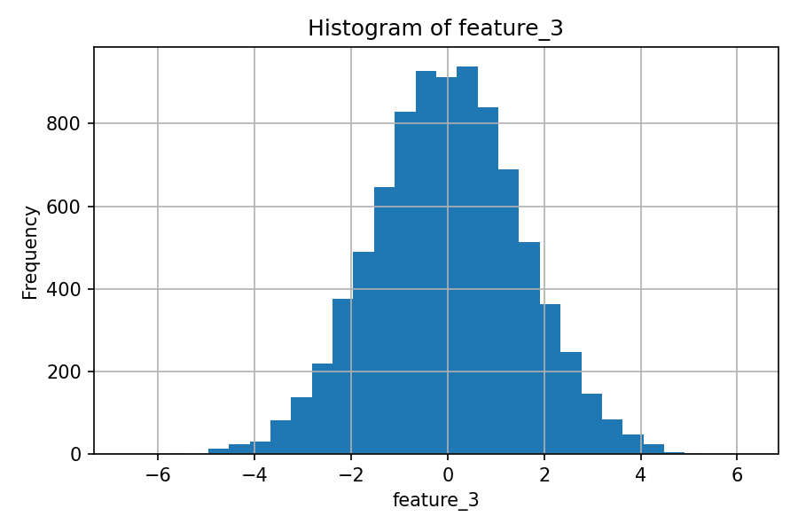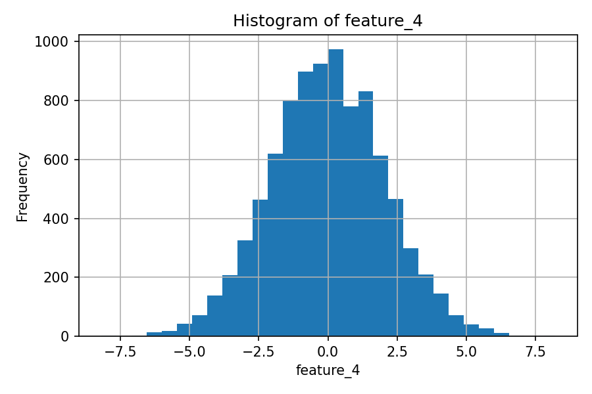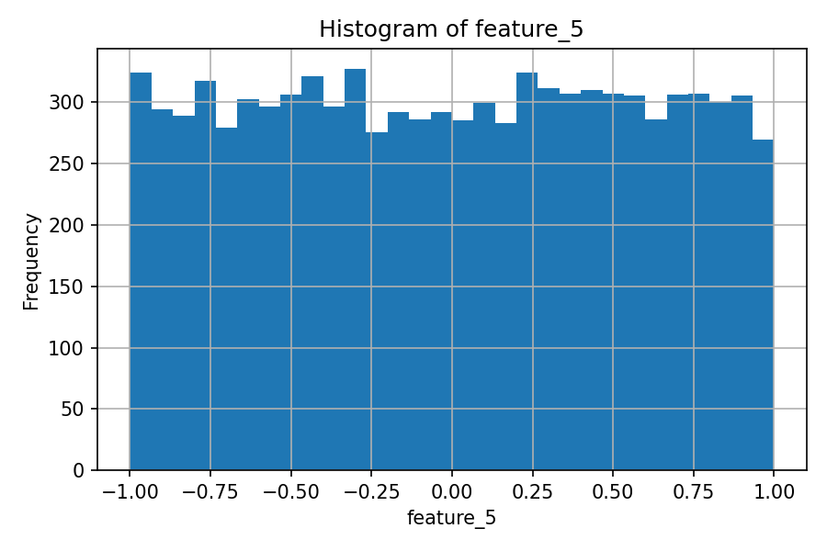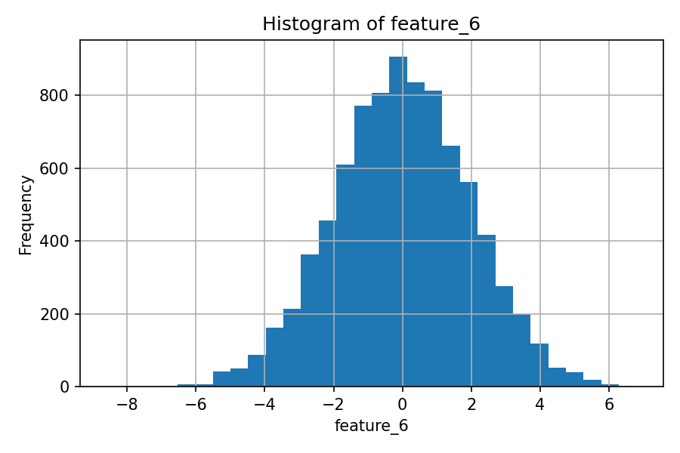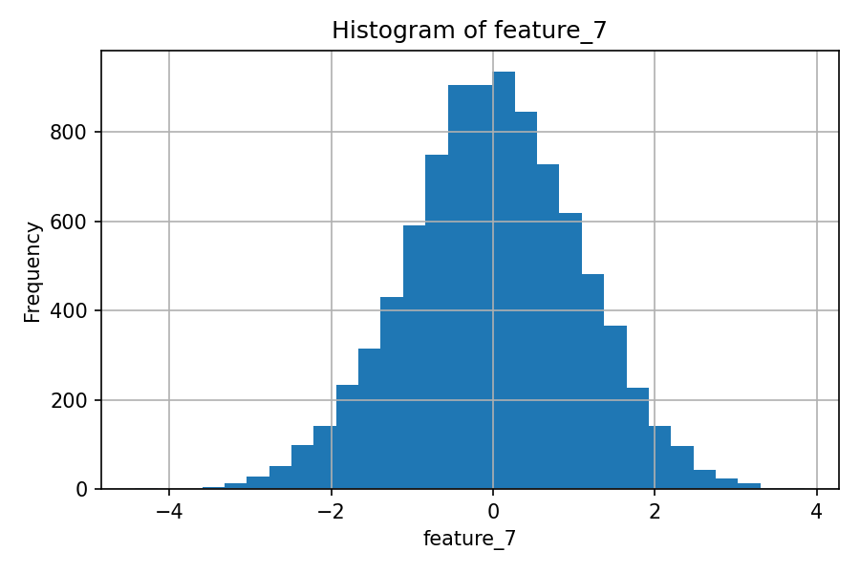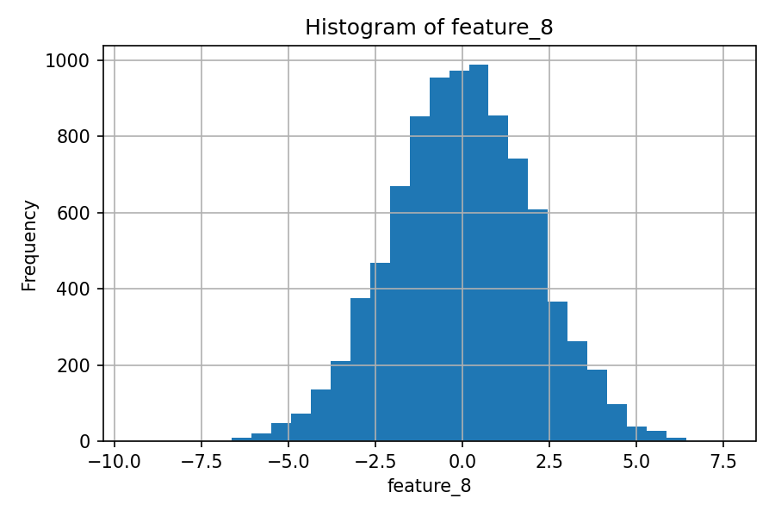
Figure 2.1 Histograms of numerical variables.
Boxplots were used to analyze the distribution of numerical features, identify potential outliers, examine the spread of values, and assess skewness. They helped us understand whether some numerical variables contained extreme values that could affect the preprocessing and modeling stages.
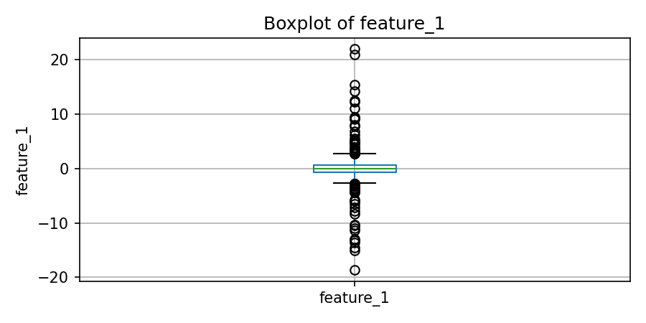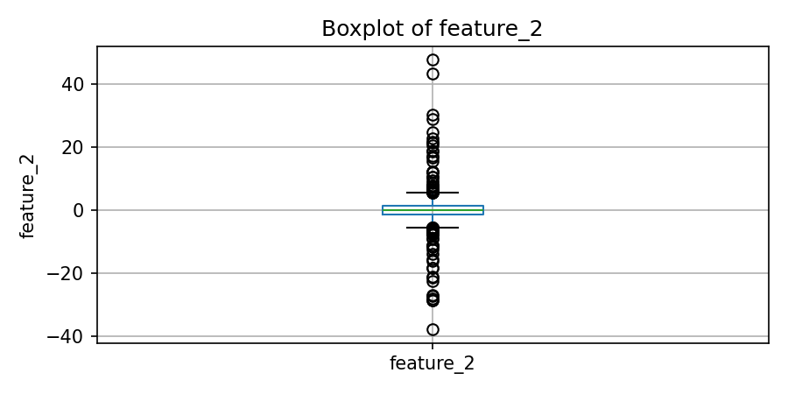
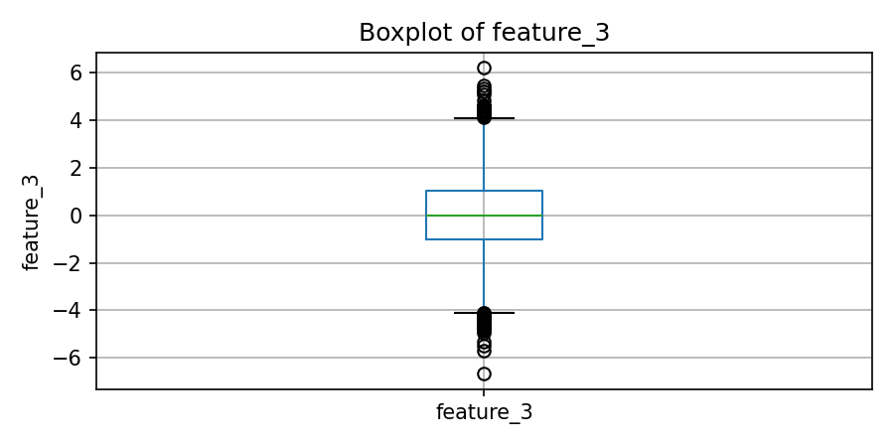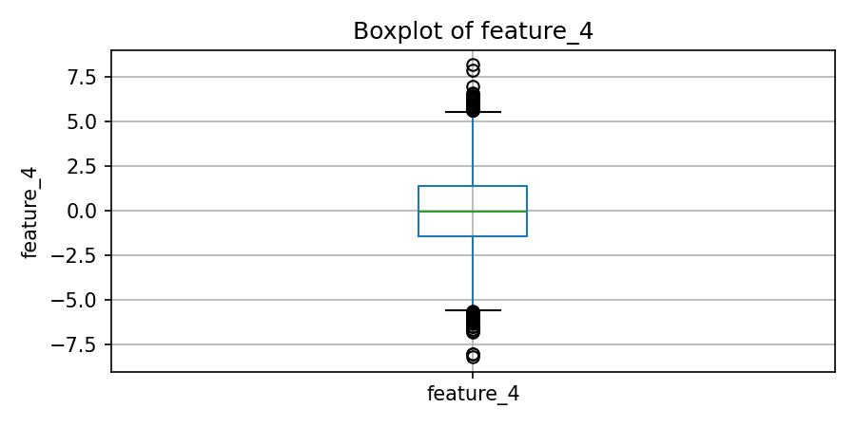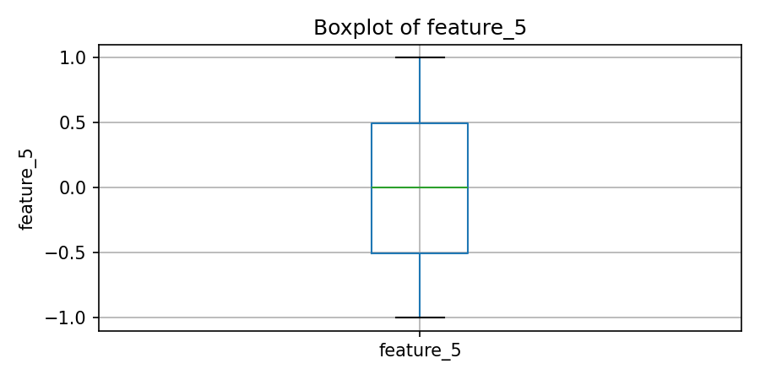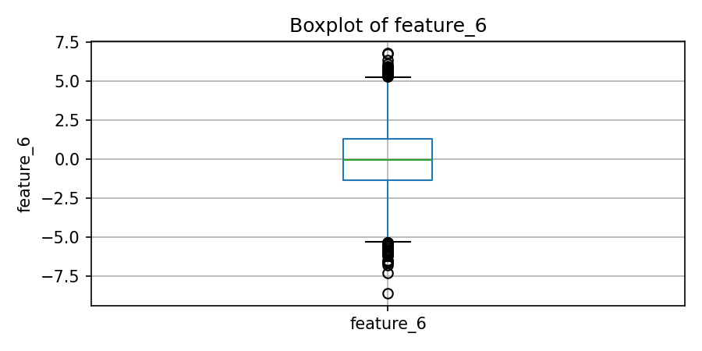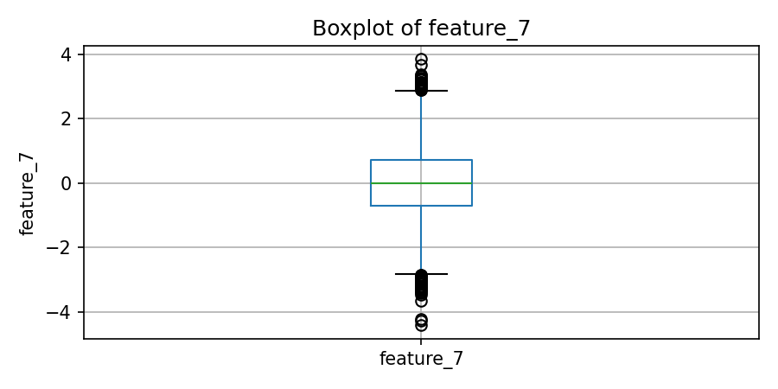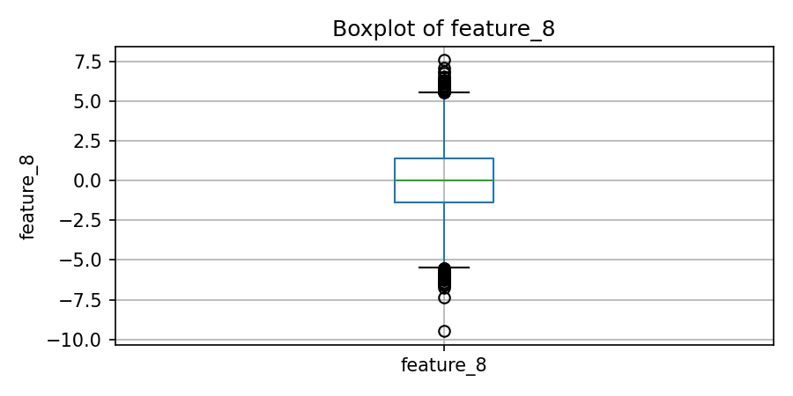
Figure 2.2 Boxplots of numerical variables.

1.3 Initial Correlation Analysis
To analyze relationships between numerical variables, we calculated a correlation matrix. This allowed us to identify whether some features were strongly positively or negatively related to each other and to the target variable. Initial correlation analysis suggests that `feature_1`, `feature_2`, and `feature_4` are positively associated with the target, whereas `feature_3` is negatively associated with it.

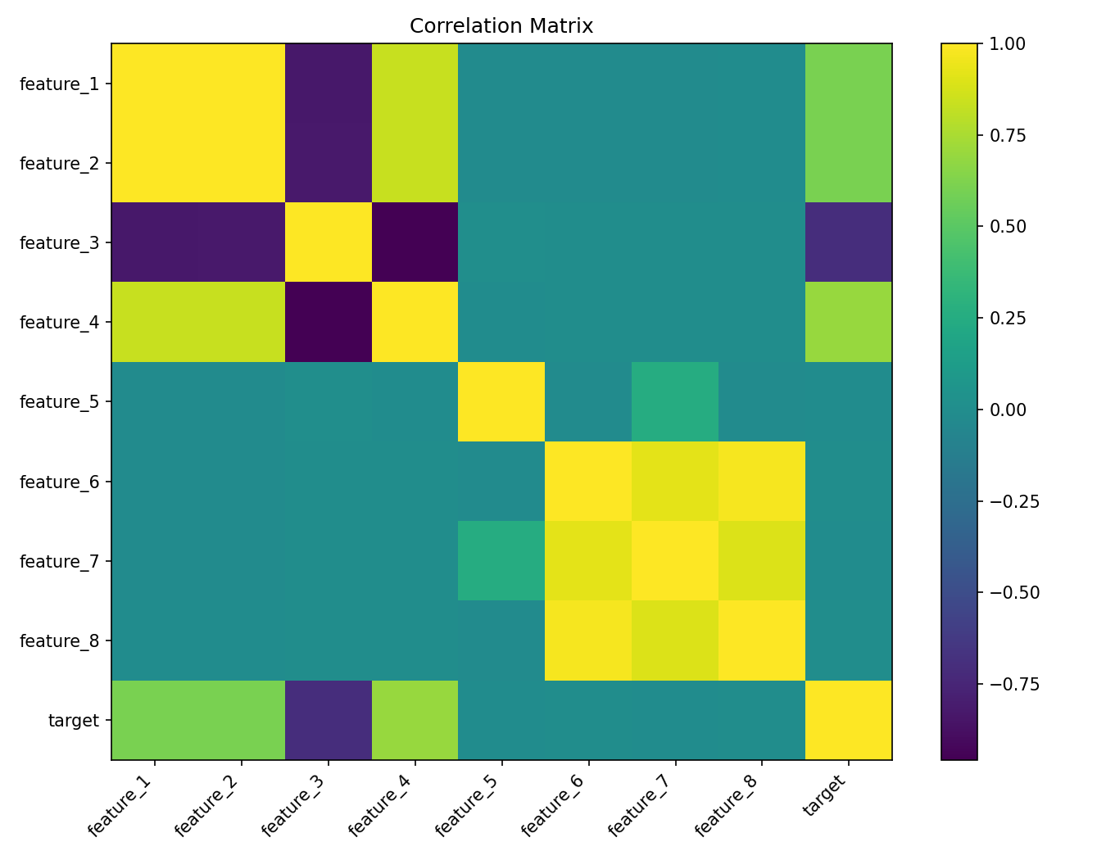
Figure 3. Correlation matrix.

1.5 Visual Analysis
Scatter plots were used to visually inspect the relationship between five numerical features with the strongest correlation to the target variable. For a binary target variable, the plots allow us to observe whether higher or lower values of a numerical feature are more frequently associated with one of the target classes. Although scatter plots do not provide a numerical measure of correlation, they help identify visible patterns, separation between classes, and possible non-linear relationships.
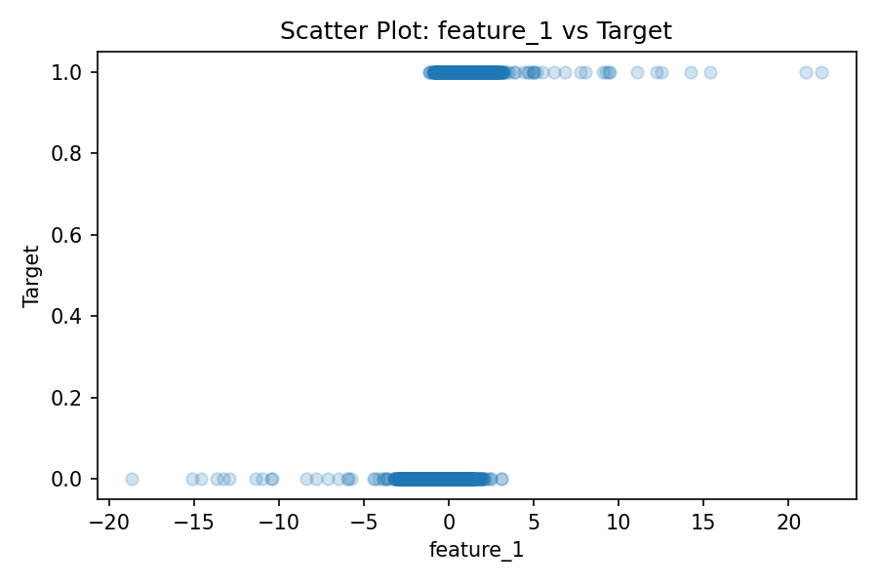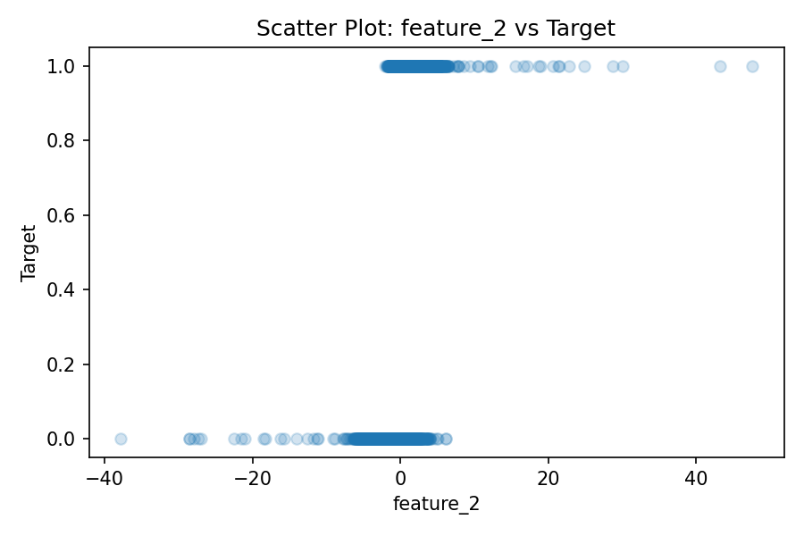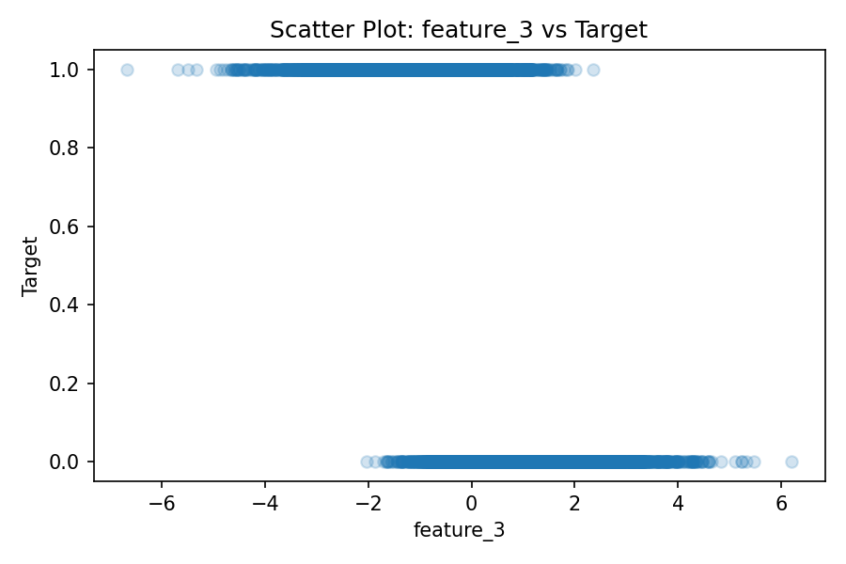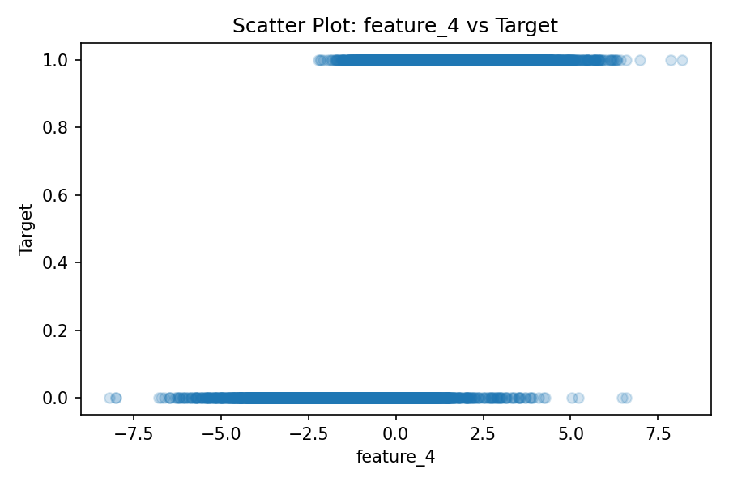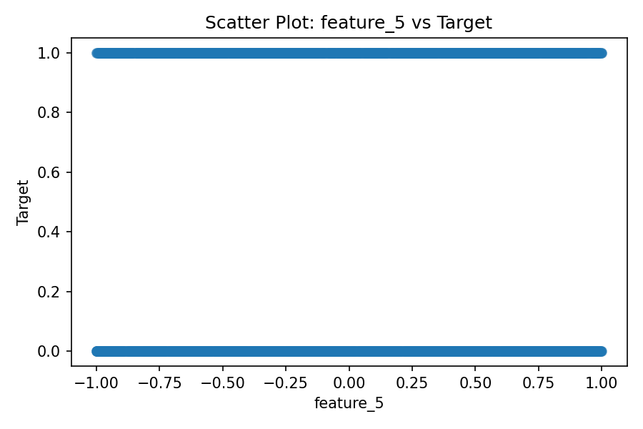
Figure 4. Scatter plots for numerical features against the target variable.

1.6 Initial Observations
- The dataset is large enough for supervised classification, with 9000 observations.
- Only two numerical features contain missing values: `feature_3` and `feature_6`.
- The target variable is relatively balanced, so accuracy can be used together with precision, recall, F1-score, and ROC-AUC.
- The strongest linear relationships with the target are observed for `feature_3`, `feature_4`, `feature_2`, and `feature_1`.

2. Data Preprocessing
This section corresponds to deliverables D2.1 and D2.2. The goal of preprocessing was to clean the dataset and prepare it for modeling while preserving as much information as possible. The main preprocessing steps were missing value treatment, outlier detection and clipping, categorical encoding, and numerical scaling.
Table 4. Missing values detected in the dataset
Feature | Missing count | Missing %
feature_3 | 400 | 4.44
feature_6 | 500 | 5.56

Missing numerical values were imputed using the median. Median imputation was selected because it is robust to skewed distributions and less sensitive to outliers than mean imputation. More complex methods such as KNN, MICE, or tree-based imputation were not used because they require additional assumptions, tuning, and computational complexity, while the amount of missing data was moderate and limited to two numerical features.

2.1 Outlier Detection and Treatment
Outliers were detected using the interquartile range (IQR) rule. For each numerical feature, the lower bound was calculated as Q1 - 1.5 x IQR and the upper bound as Q3 + 1.5 x IQR. Values outside these bounds were treated as outliers. Instead of removing observations, outliers were clipped to the nearest acceptable boundary. This preserved all rows while reducing the influence of extreme values on modeling and correlation analysis.
Table 5. IQR outlier summary
feature | lower_bound | upper_bound | outliers | outlier_pct
feature_1 | -2.721 | 2.721 | 113 | 1.26
feature_2 | -5.527 | 5.524 | 106 | 1.18
feature_3 | -4.113 | 4.13 | 75 | 0.87
feature_4 | -5.591 | 5.585 | 71 | 0.79
feature_5 | -2.002 | 1.996 | 0 | 0
feature_6 | -5.31 | 5.306 | 59 | 0.69
feature_7 | -2.848 | 2.88 | 69 | 0.77
feature_8 | -5.495 | 5.54 | 61 | 0.68

2.2 Encoding and Scaling
Categorical variables were encoded using one-hot encoding. This method was selected because both categorical variables have a limited number of discrete categories and do not have a strict ordinal structure. Numerical features were scaled using standardization for algorithms that are sensitive to scale, especially Logistic Regression. For tree-based ensemble models, scaling is not strictly necessary, but using a unified preprocessing pipeline makes the workflow consistent and reproducible.

2.3 Cleaned Dataset
The cleaned dataset was exported as `cleaned_dataset.csv`. It contains the original variables after missing value imputation and outlier clipping.

3. Exploratory Data Analysis
This section corresponds to deliverable D3.1. The goal of in-depth EDA was to understand the relationship between each feature and the target variable, identify important variables, visualize patterns, and test whether observed differences are statistically meaningful.

3.1 Correlation Matrix and Heatmap
A correlation matrix was calculated for all numerical variables and visualized using a heatmap. The heatmap helps identify the direction and strength of linear relationships. The target variable has the strongest absolute correlations with `feature_3`, `feature_4`, `feature_2`, and `feature_1`.
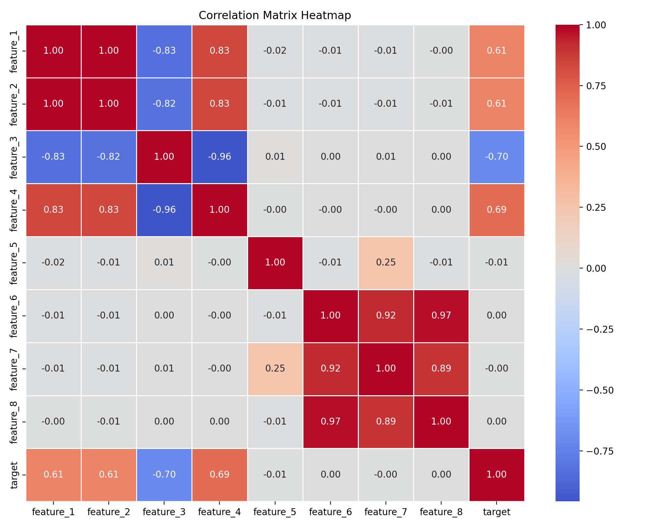
Figure 5. Correlation matrix heatmap for numerical variables.
Table 6. Numerical correlation with the target
Feature | Correlation with target | Absolute correlation
feature_2 | 0.707 | 0.707
feature_1 | 0.704 | 0.704
feature_4 | 0.698 | 0.698
feature_3 | -0.693 | 0.693
feature_5 | -0.008 | 0.008
feature_8 | 0.005 | 0.005
feature_7 | -0.002 | 0.002
feature_6 | 0.002 | 0.002
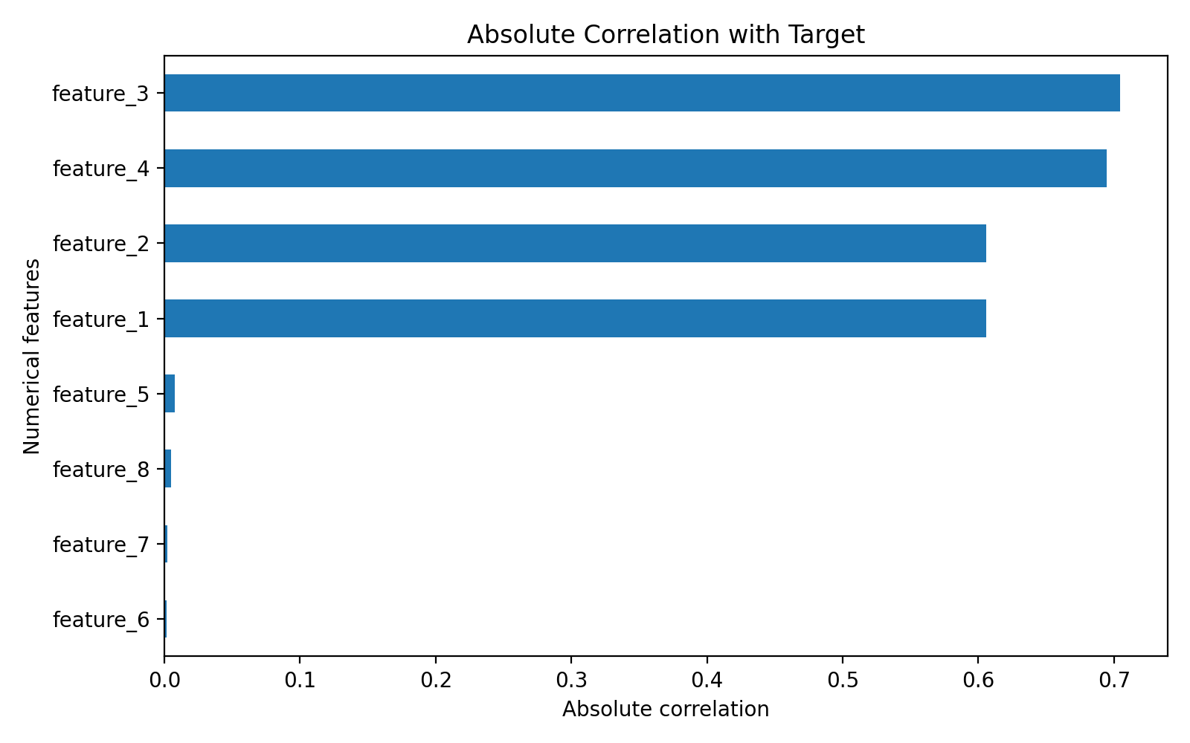
Figure 6. Absolute correlations between numerical features and the target.

3.2 Numerical Features versus Target
Boxplots were used to compare the distributions of the most important numerical features across target classes. These plots show whether the central tendency and spread of features differ between target = 0 and target = 1. The strongest differences were observed for `feature_1`, `feature_2`, `feature_3`, and `feature_4`.
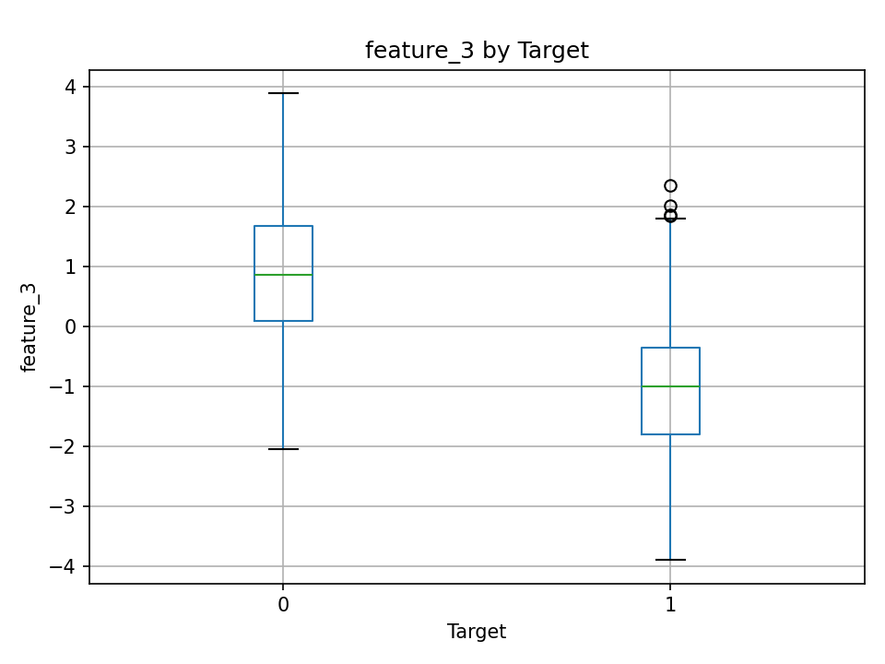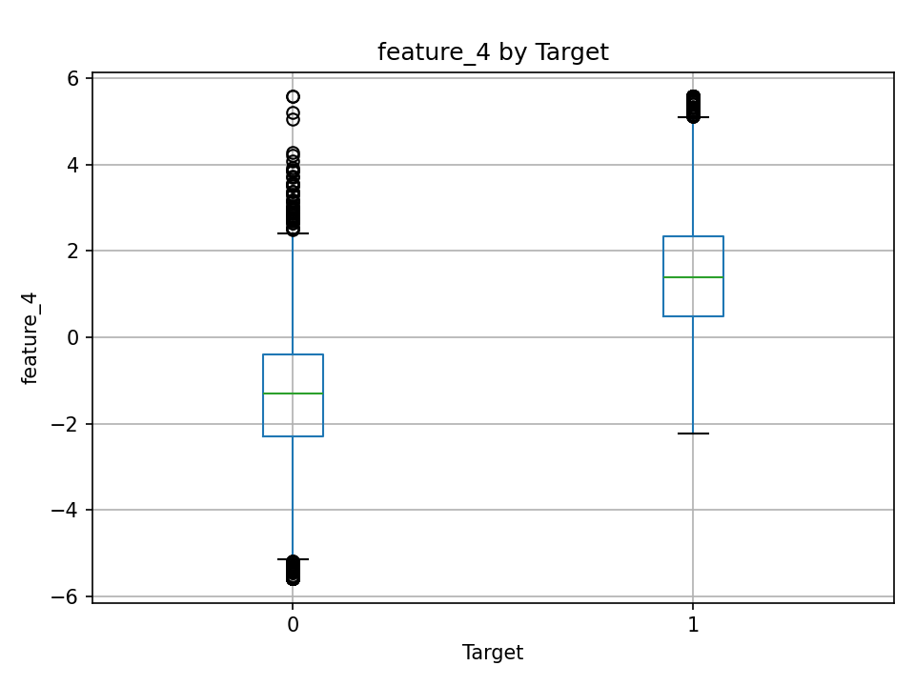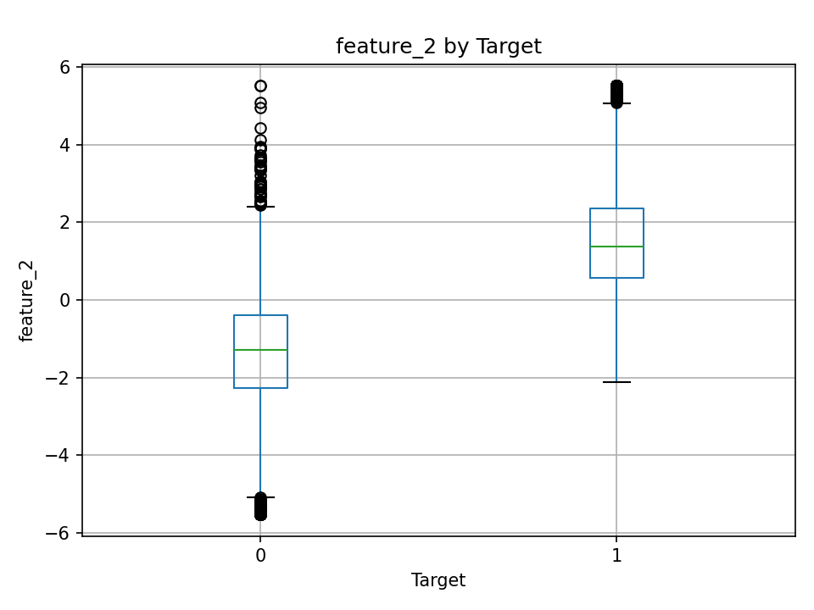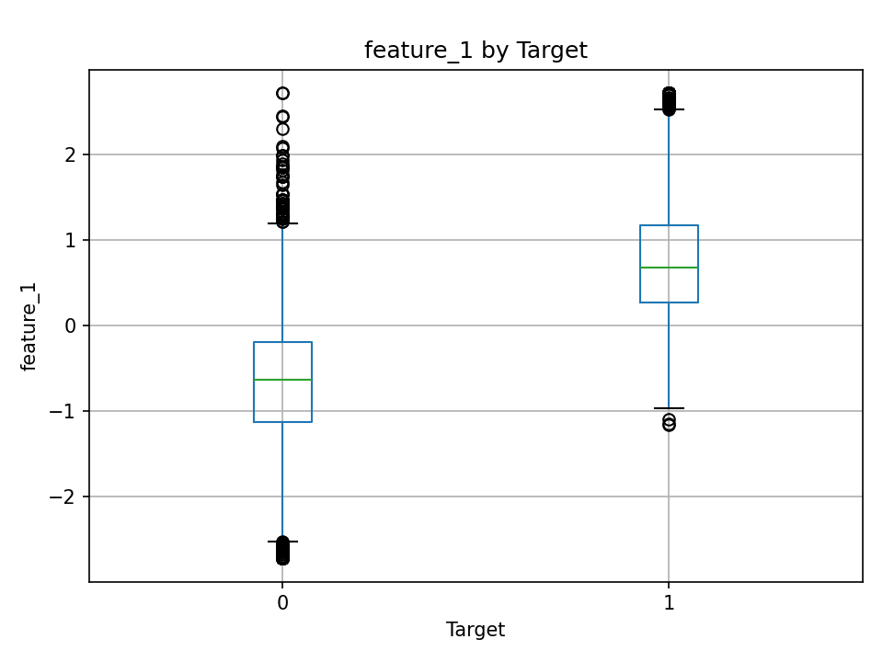
Figure 7. Top numerical features compared across target classes.

3.3 Categorical Features versus Target
Categorical variables were analyzed by calculating the target proportion by each category. The variable `category_1` shows clear differences in target rate between categories, suggesting that it contains meaningful predictive information. In contrast, `category_2` shows weaker separation.
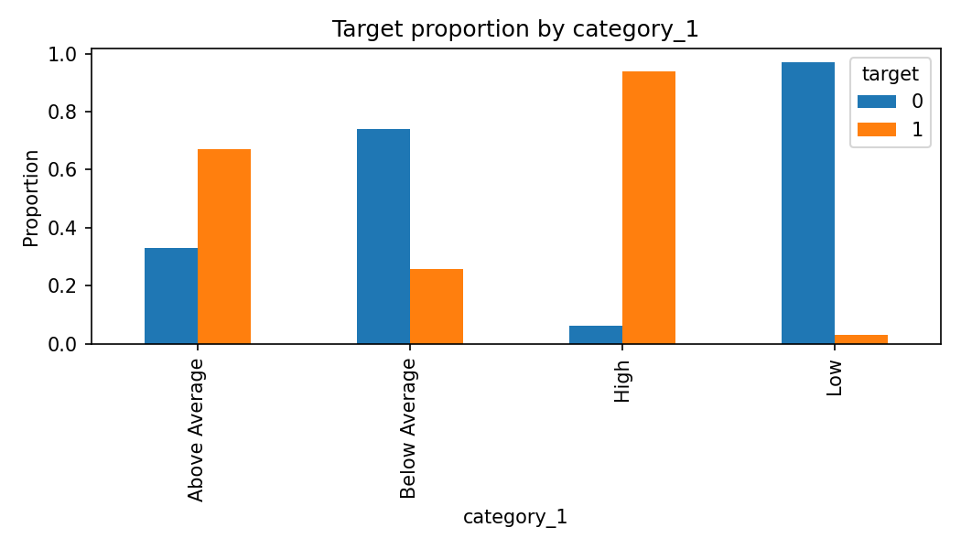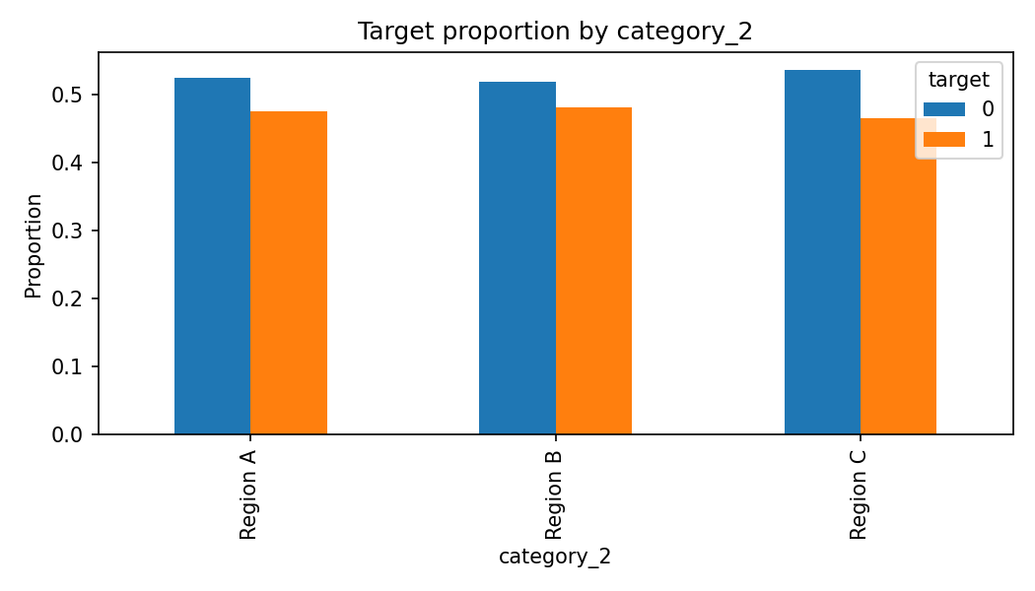
Figure 8. Target proportion by categorical variables.

3.4 Hypothesis Testing
Welch’s t-tests were applied to numerical features to compare mean values between target classes. Chi-square tests were applied to categorical variables to test whether category distributions were associated with the target. These tests were used as exploratory tools rather than as final proof of causality.
Table 7. Welch’s t-test results for numerical features
Feature | Mean target 0 | Mean target 1 | t-statistic | p-value
feature_1 | -0.684 | 0.753 | -94.486 | < 0.001
feature_2 | -1.38 | 1.522 | -95.302 | < 0.001
feature_3 | 0.988 | -1.082 | 91.226 | < 0.001
feature_4 | -1.368 | 1.492 | -92.662 | < 0.001
feature_5 | 0.002 | -0.007 | 0.747 | 0.455
feature_8 | -0.006 | 0.015 | -0.472 | 0.637
feature_7 | 0.003 | -0.001 | 0.199 | 0.842
feature_6 | -0.008 | -0.001 | -0.176 | 0.861

Table 8. Chi-square test results for categorical features
Feature | Chi-square | p-value
category_1 | 5175.32 | < 0.001
category_2 | 1.319 | 0.517

3.5 EDA Insights
- `feature_3` and `feature_4` show the strongest absolute correlations with the target, but in opposite directions.
- `feature_1` and `feature_2` are also strongly associated with the target and are likely to be important predictors.
- `category_1` is strongly associated with the target according to the chi-square test.
- `feature_5`, `feature_6`, `feature_7`, and `feature_8` show weak direct linear relationships with the target, but they may still contribute through non-linear patterns or interactions.
- The EDA results justify the use of non-linear ensemble models, because the target may depend on combinations of numerical and categorical patterns rather than one feature only.

4. Feature Engineering
This section corresponds to deliverables D4.1 and D4.2. Feature engineering was used to create additional variables that could capture combined effects, ratios, and overall numerical intensity. Since the original feature names are generic, the engineered variables were designed in a general but methodologically meaningful way.
Table 9. Engineered features
New feature | Formula | Purpose
feature_1_feature_2_interaction | feature_1 x feature_2 | Captures the joint effect of two strongly target-related variables.
feature_3_feature_4_interaction | feature_3 x feature_4 | Captures the joint effect of two opposing strongly target-related variables.
positive_signal_sum | feature_1 + feature_2 + feature_4 | Tests if all positive predictors can be linked into one common indicator.
abs_feature_3 | abs(feature_3) | Checks whether the absolute value of feature_3 will give a different meaning.
feature_2_to_feature_3_ratio | feature_2 / (abs(feature_3) + epsilon) | Captures relative signal between feature_2 and feature_3 while avoiding division by zero.
overall_numerical_intensity | Mean of standardized numerical variables per row | Summarizes the overall numerical activity/intensity of each observation.
overall_numerical_variability | Standard deviation of standardized numerical variables per row | Measures how uneven or variable the numerical profile of each observation is.
The feature-engineered dataset was exported as `dataset_with_engineered_features.csv`. The engineered features were later included in the modeling pipeline and evaluated through feature importance analysis.

5. Modeling and Evaluation
This section corresponds to deliverables D5.1 and D5.2. The objective was to train multiple classification models, compare their predictive performance, and save the trained models. The dataset was split into training and testing subsets using an 80/20 split with stratification to preserve the target class proportions.
- Training set: 80% of observations.
- Test set: 20% of observations.
- Stratification was used to preserve the target class distribution.
- Evaluation metrics: Accuracy, Precision, Recall, F1-score, and ROC-AUC.
- Cross-validation was used to estimate robustness on the full dataset.

5.1 Models Trained
Table 10. Models trained
Model | Type | Reason for inclusion
Logistic Regression | Linear baseline | Interpretable benchmark model.
Decision Tree | Single tree model | Non-linear baseline and interpretable structure.
Random Forest | Ensemble learning | Bagging ensemble that reduces variance and handles non-linearity.
Extra Trees | Ensemble learning | Highly randomized tree ensemble for robust comparison.
Gradient Boosting | Ensemble learning | Boosting ensemble that sequentially improves weak learners.
AdaBoost | Ensemble learning | Boosting method that focuses on hard-to-classify observations.

5.2 Test Set Performance
Table 11. Model performance on the test set
Model | Accuracy | Precision | Recall | F1 | ROC_AUC
Gradient Boosting | 0.8856 | 0.8916 | 0.8645 | 0.8778 | 0.9608
Random Forest | 0.8906 | 0.9004 | 0.8657 | 0.8827 | 0.9583
Logistic Regression | 0.8933 | 0.899 | 0.8738 | 0.8863 | 0.9574
Extra Trees | 0.8883 | 0.8979 | 0.8633 | 0.8803 | 0.9569
AdaBoost | 0.8894 | 0.9021 | 0.861 | 0.8811 | 0.9501
Decision Tree | 0.8406 | 0.8343 | 0.8294 | 0.8319 | 0.84

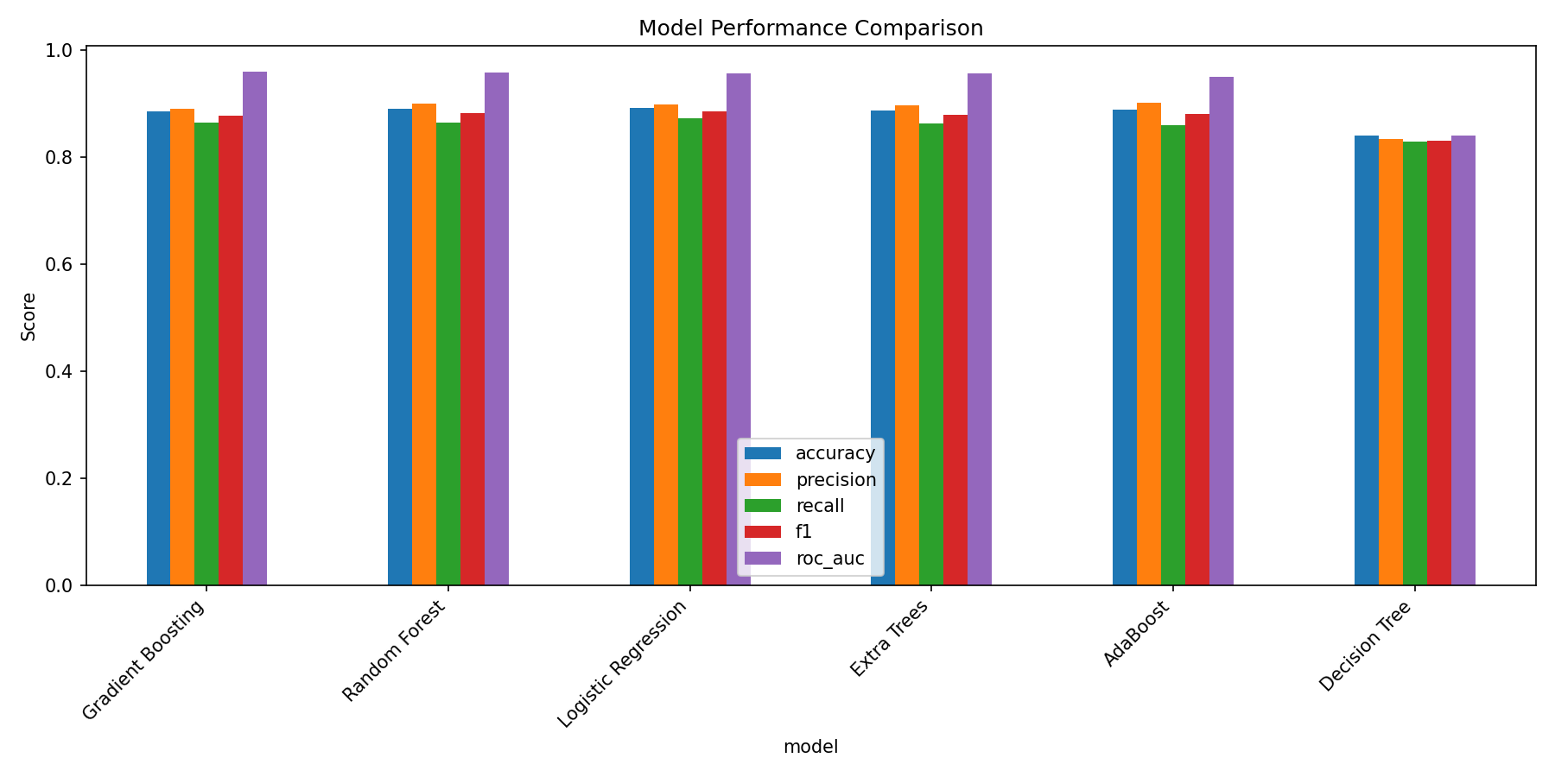
Figure 9. Model performance comparison across evaluation metrics.

5.3 Cross-Validation Results
Table 12. Cross-validation results
Model | CV_ROC_AUC_mean | CV_ROC_AUC_std | CV_F1_mean | CV_F1_std
Gradient Boosting | 0.9575 | 0.0025 | 0.8676 | 0.0042
Random Forest | 0.9558 | 0.0036 | 0.8715 | 0.0035
Logistic Regression | 0.9354 | 0.0039 | 0.8749 | 0.0093
Extra Trees | 0.9532 | 0.0026 | 0.8694 | 0.0045
AdaBoost | 0.9492 | 0.0056 | 0.8647 | 0.0081
Decision Tree | 0.8377 | 0.0091 | 0.83 | 0.0095

The cross-validation results confirm that ensemble models, especially Gradient Boosting and Random Forest, provide robust performance. Gradient Boosting achieved the strongest cross-validated ROC-AUC, while Random Forest and Extra Trees also performed strongly.

5.4 Modeling Insights
- Gradient Boosting achieved the highest test ROC-AUC among all trained models.
- Random Forest and Extra Trees also produced strong results and demonstrated the value of ensemble learning.
- Logistic Regression performed well, suggesting that several relationships in the data are also linearly separable.
- Decision Tree performed worse than ensemble models, which is expected because a single tree is more sensitive to variance and overfitting.
- All trained models were saved as serialized model files to satisfy deliverable D5.2.

6. Hyperparameter Tuning
This section corresponds to deliverables D6.1 and D6.2. Hyperparameter tuning was performed for three ensemble models: Random Forest, Gradient Boosting, and Extra Trees. The purpose was to test whether model performance could be improved by adjusting parameters such as the number of estimators, tree depth, and learning rate.
Table 13. Tuned model performance
Model | Accuracy | Precision | Recall | F1 | ROC_AUC
Random Forest Tuned | 0.8889 | 0.9 | 0.8622 | 0.8807 | 0.9617
Gradient Boosting Tuned | 0.8889 | 0.8933 | 0.8703 | 0.8817 | 0.9615
Extra Trees Tuned | 0.8906 | 0.9033 | 0.8622 | 0.8822 | 0.9603

Table 14. Selected hyperparameters
Model | Selected hyperparameters
Random Forest Tuned | n_estimators=500, min_samples_split=2, min_samples_leaf=2, max_features=None, max_depth=5
Extra Trees Tuned | n_estimators=200, min_samples_split=10, min_samples_leaf=1, max_features=None, max_depth=10
Gradient Boosting Tuned | subsample=0.7, n_estimators=50, max_depth=4, learning_rate=0.05

Table 15. Default versus tuned model comparison.
Model | Default_ROC_AUC | Tuned_ROC_AUC | Default_F1 | Tuned_F1
Extra Trees | 0.9569 | 0.9603 | 0.8803 | 0.8822
Gradient Boosting | 0.9608 | 0.9615 | 0.8778 | 0.8817
Random Forest | 0.9583 | 0.9617 | 0.8827 | 0.8807

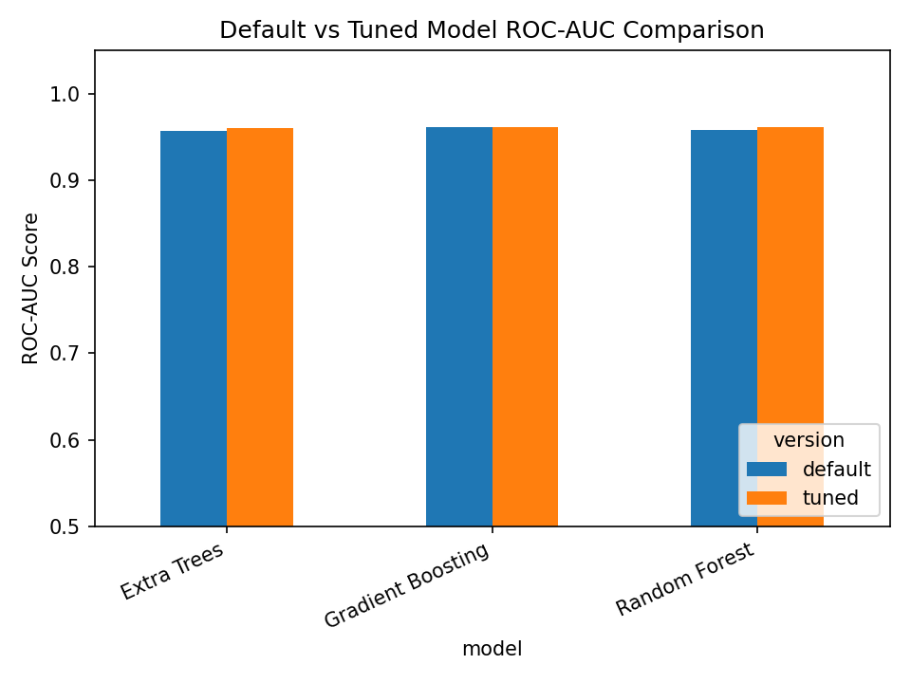
Figure 10. Default versus tuned ROC-AUC for ensemble models.
Hyperparameter tuning produced small improvements for Gradient Boosting and moderate improvements for Extra Trees. Random Forest stood out as the best-tuned model, with a slight improvement after tuning. The tuned Random Forest model was selected as the final recommended model because it achieved the highest ROC-AUC while maintaining strong precision, recall, and F1-score.

7. Model Interpretation
This section corresponds to deliverable D7.1. Model interpretation was performed using feature importance scores from the best tuned ensemble model. The best model was Random Forest Tuned.

7.1 Feature Importance
Model-based feature importance was used to identify the predictors that contributed most strongly to the model’s decisions. For tree-based models, feature importance scores are calculated based on how much each feature contributes to reducing impurity across the decision trees. Features with higher importance values were used more effectively by the model to separate the target classes. However, this method only indicates the relative importance of features and does not show the direction of their effect. Therefore, SHAP analysis was also used to provide a more detailed interpretation of how individual features push predictions toward or away from the positive class.
Table 16. Top feature importances from the best tuned model
feature | importance
feature_2 | 0.3546
feature_1 | 0.2256
positive_signal_sum | 0.2109
abs_feature_3 | 0.0897
feature_2_to_feature_3_ratio | 0.0655
feature_1_feature_2_interaction | 0.0272
feature_3 | 0.0111
feature_3_feature_4_interaction | 0.006
feature_4 | 0.0022
feature_5 | 0.0016
overall_numerical_variability | 0.0014
overall_numerical_intensity | 0.0011
feature_7 | 0.001
feature_6 | 0.0009
feature_8 | 0.0008

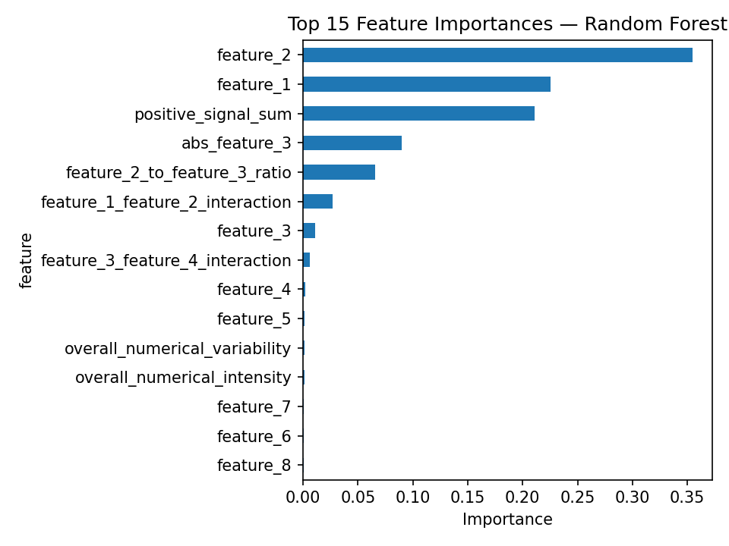
Figure 11. Top feature importances for the best tuned model.

7.2 SHAP Interpretation
SHAP was used to interpret the best-performing model by estimating the contribution of each feature to the model predictions. Before applying SHAP, the test data was transformed using the fitted preprocessing pipeline so that the explanation was based on the same feature space used by the model. The SHAP summary plot shows both the global importance of features and the direction of their effect. Positive SHAP values indicate that a feature increases the probability of the positive class, while negative SHAP values indicate that it decreases it.
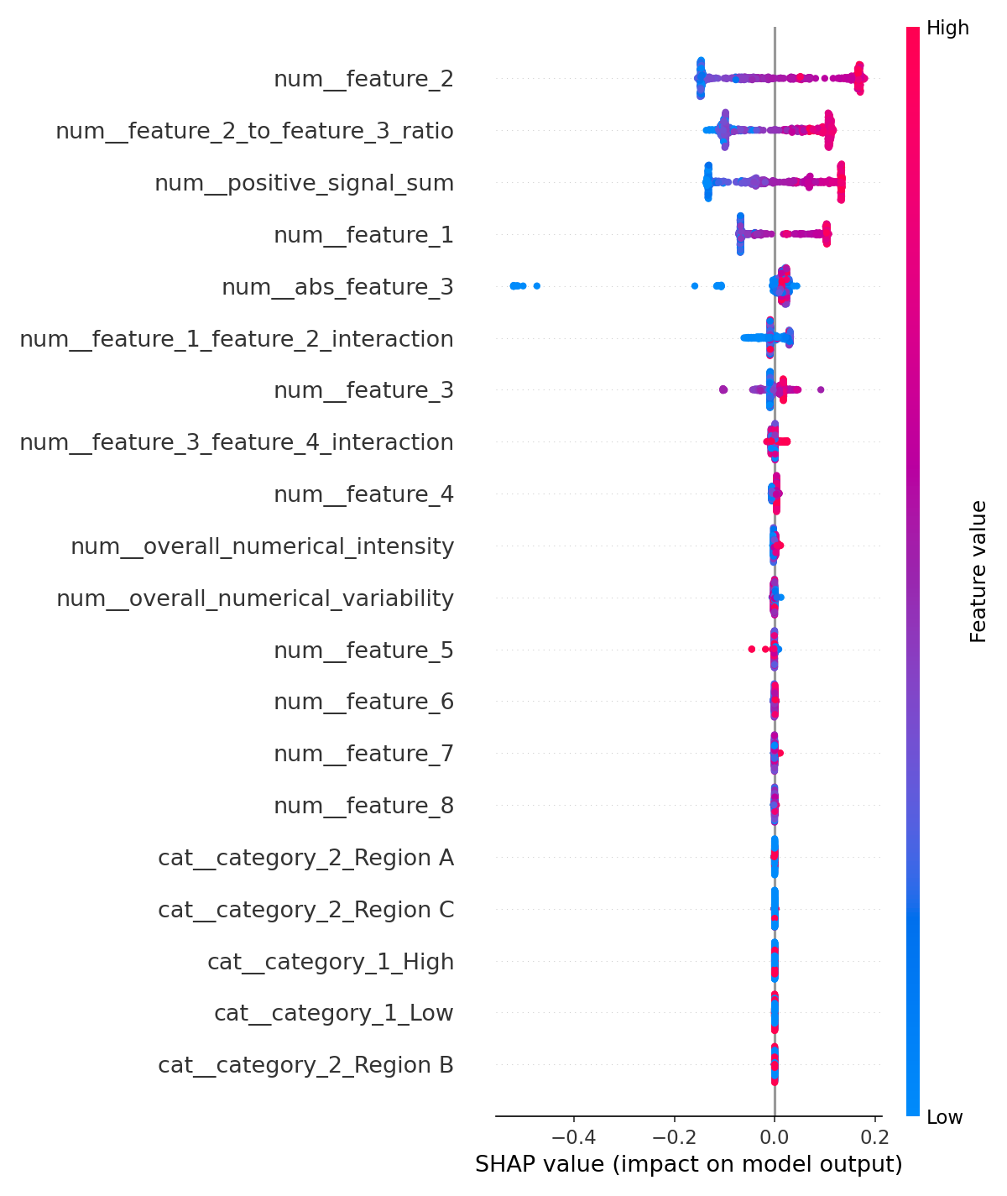
Figure 12. The SHAP summary plot.

7.3 Interpretation of Key Features
- `feature_2` and `feature_1` are the most important predictors in the final tuned model. This aligns with EDA, where both showed strong positive correlations with the target.
- As we can see, the engineered absolute feature `abs_feature_3` has a stronger contribution than `feature_3`, which showed a negative correlation with the target in EDA stage.
- `feature_4` contributed poorly to the final tuned model, contradicting the strong positive correlation with target found in EDA.
- The engineered ratio feature `feature_2_to_feature_3_ratio` and the combined signal feature `positive_signal_sum` were also useful. This suggests that combined effects between original features improved predictive power.
- Some variables with weak direct correlations, such as `feature_5` to `feature_8`, had lower final importance, meaning they contributed little to the final predictions.
- Although `category_1` showed a visible relationship with the target variable during the EDA stage, model-based feature importance and SHAP indicated that categorical variables had limited predictive contribution. This difference can be explained by the fact that EDA evaluates mostly bivariate relationships, while the model evaluates the marginal contribution of each feature in the presence of all other predictors. Therefore, `category_1` may be correlated with the target but may not add much new information beyond the numerical features. In addition, one-hot encoding can distribute the importance of a categorical variable across several dummy variables, making each encoded feature appear less important individually.

7.4 Business / Analytical Implications
Because the dataset uses generic feature names, the business interpretation must remain abstract. However, the analytical implication is clear: the prediction problem is mainly driven by a small group of strong numerical variables and one meaningful categorical structure. In a real business setting, these variables should be investigated further, mapped to operational meaning, and monitored as potential risk or decision indicators.

8. Presentation Summary and Observations

8.1 Final Observations and Recommendations
- Use the tuned Random Forest model as the final predictive model because it achieved the best ROC-AUC and balanced predictive performance.
- Use Gradient Boosting as a secondary robust model because tuning improved both ROC-AUC and F1-score.
- Focus interpretation on `feature_1`, `feature_2`, `feature_3`, `feature_4`, and the engineered interaction/ratio features.
- Before deployment in a real business context, map generic feature names to actual business variables and validate whether the model decisions are operationally meaningful.

8.2 Limitations
- The dataset uses generic feature names, which limits domain-specific interpretation.
- Correlation and hypothesis testing identify associations, not causality.
- Median imputation and IQR clipping are robust and transparent methods, but alternative preprocessing strategies could be tested in future work.
- Hyperparameter tuning was focused on selected ensemble models and a limited parameter grid to keep the workflow reproducible and computationally efficient.

Appendix A. Output Files
Table 18. Generated output files
Output | Deliverable | Description
cleaned_dataset.csv | D2.2 | Dataset after missing value imputation and outlier clipping.
dataset_with_engineered_features.csv | D4.2 | Dataset with engineered interaction, ratio, and aggregate features.
model_comparison.csv | D5.1 | Default models’ comparison metrics.
cross_validation_results.csv | D5.1 | Ensemble models’ cross-validation metrics.
tuned_model_results.csv | D6.1 | Tuned models’ performance metrics.
default_vs_tuned_comparison.csv | D6.1 | Tuned models against default versions performance comparison.
feature_importance.csv | D7.1 | Feature importance scores for the best tuned model.
models/*.joblib model files | D5.2 / D6.2 | Serialized trained and tuned models.
figures/*.png | D1.1 / D3.1 / D5.1 / D7.1 | Visualizations used in the report.

Appendix B. Reproducibility Notes
- The workflow should be executed from the top of the Jupyter notebook to the bottom without skipping cells.
- A fixed random_state = 42 was used for train-test splitting and model initialization where possible.
- The train-test split was stratified to preserve the target distribution.
- Preprocessing was implemented consistently before modeling: numerical scaling and categorical one-hot encoding were included in the modeling pipeline.

