Electricity Bill Payment

Introduction:
Project entitled “Electricity Bill Payment” is a very sophisticated application which aims to calculate and generate the monthly electricity bill with the actual base charges along with the usage and penalty.It will act as a substitute for the existing manual billing system which is extremely laborious and lots of paper work to do.The aim of this automated project is to develop a system that is meant to partially computerize the work performed in the Electricity Board by generating monthly bill.
The overall project document is divided into sub sections on the basis of project modules.

Phase1:
Here we are following the complete software development life cycle process and In this first module, we are going to deal with analysis and designing parts of the project followed by the codes.
Analysis and Designing consists of requirements,flow hierarchy with UML diagrams .

Use-Case Diagram:
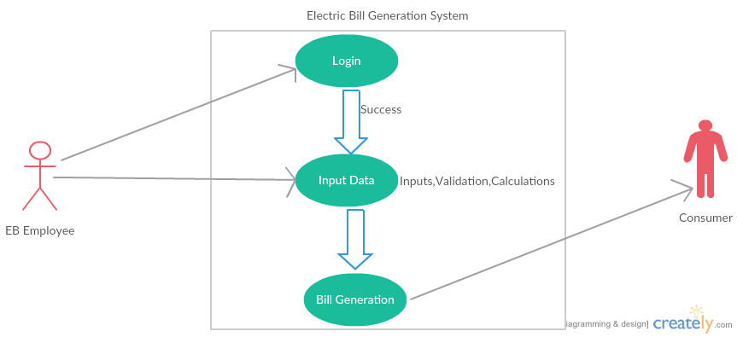
Activity Diagram:
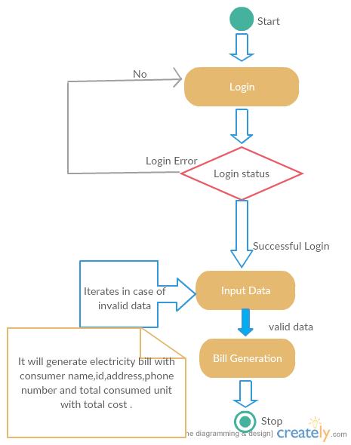
Class Diagram:
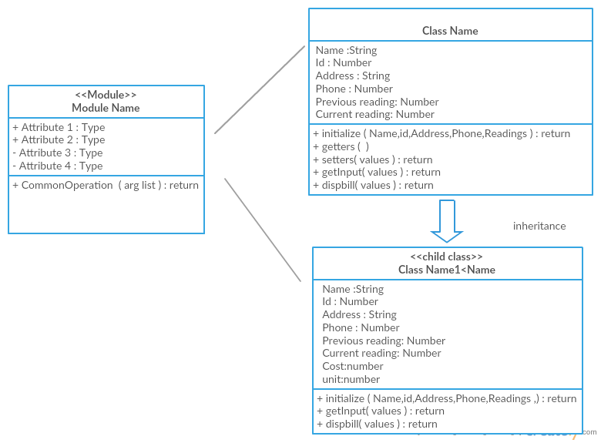
Working:
Application will ask user to provide input data such as consumer name,consumer Id,phone number,address and the meter reading of the current month as well as of the previous month .ie for calculating the consumed unit.
It has an automated calculation system which will calculate the Electricity Bill with base charges.Addition to base charges It calculates penalty in case of exceeding the usage limit. Base charges per unit will vary as per following table

Unit | Charge per unit
0-50 | 3 rupees
51-100 | 4 rupees
more than 100 | 6 rupees

Calculation Approach:
Base Charge: Rs. 80 per month(including meter charge).
here
unit consumed =(meter reading of previous month) - (meter reading of current month).

Total Electricity Bill = Base Charge+unit consumed*Charge per unit

------------------------------x------------------------------------x-------------------------------

