LumenEIOS OCR Implementation
As of 10 November 2026 · Code paths are relative to apps/lumeneios in the arena repo (branch sync/lumeneios-updates)
LumenEIOS OCR today only previews text. A teacher uploads JPG, PNG or PDF answer sheets, and the backend transcribes them with Qwen2.5-VL-3B-Instruct-AWQ. The model runs inside the FastAPI process on a local NVIDIA GPU. OCR does not grade, store results or publish marks. Every mark still needs a teacher's sign-off.

1. At a glance
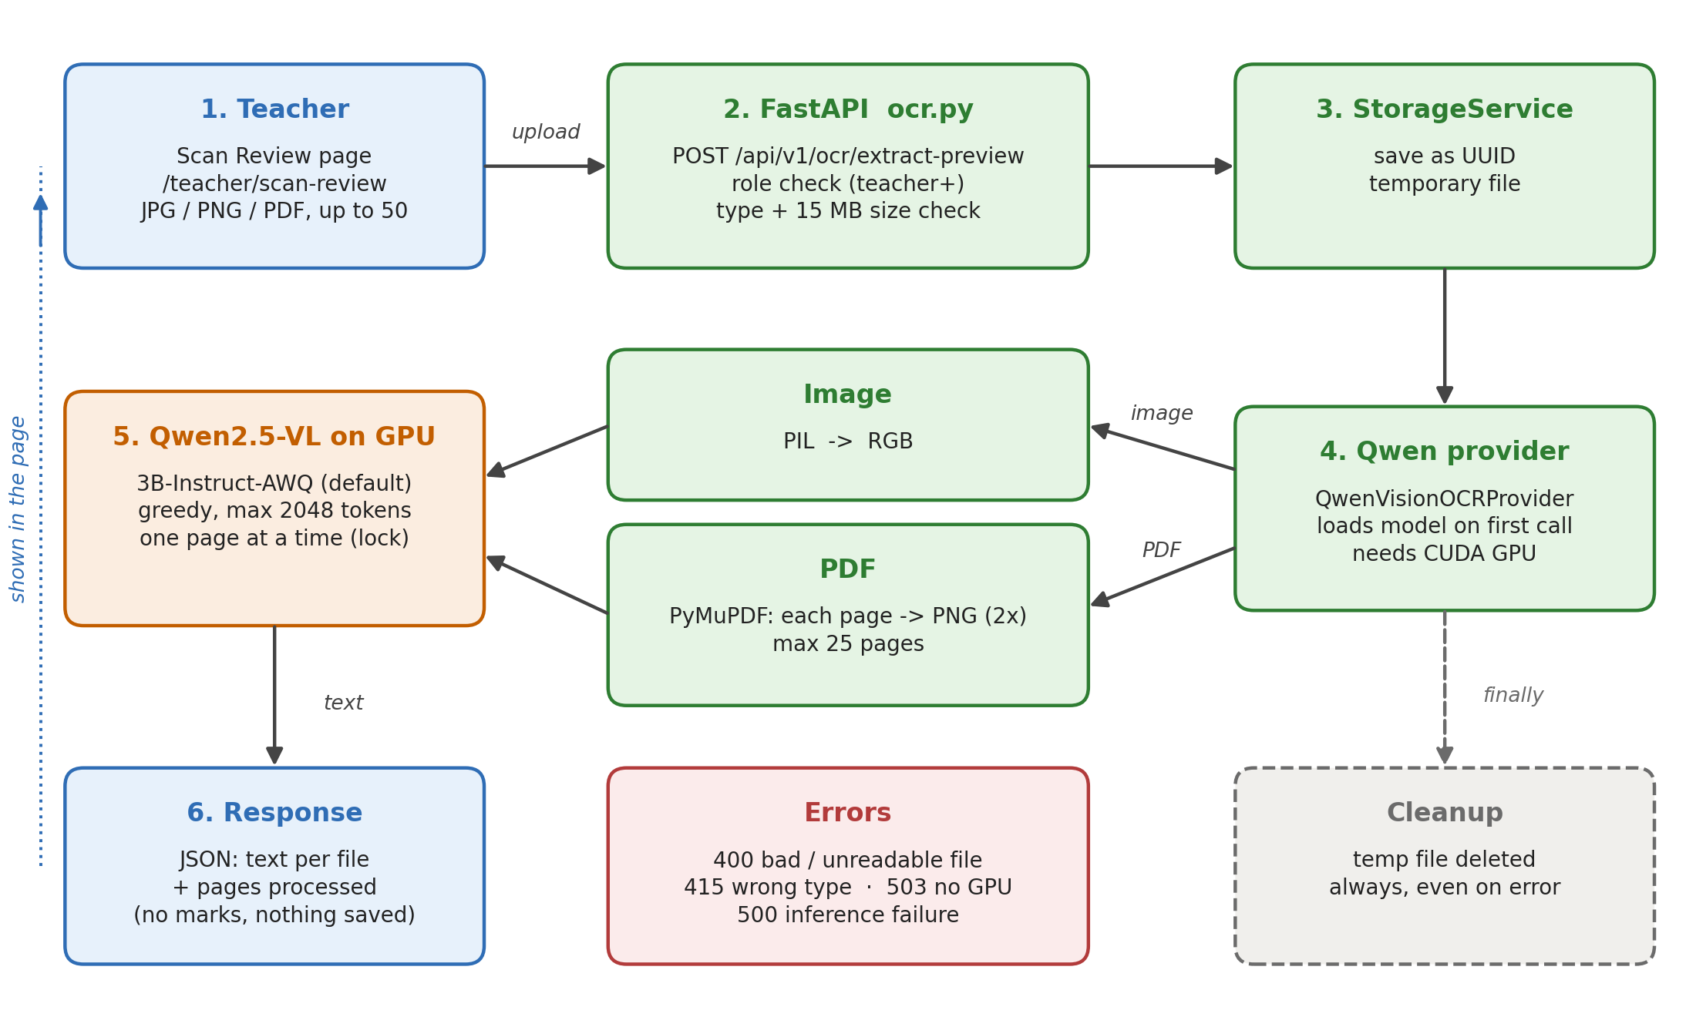
Figure 1. OCR preview request flow
Files are handled one after another. Each file is saved to a temporary path, transcribed and deleted, even if the transcription fails. Nothing is written to the database.

2. OCR providers
Every provider implements one interface, BaseOCRProvider.extract_document(path, options), in backend/app/services/ocr_service.py. get_ocr_provider(name) picks a provider by name.
Name | Class | Real or simulated | Output | Used by
qwen | QwenVisionOCRProvider | Real (Qwen2.5-VL on GPU) | Plain text per file, LaTeX for maths | /ocr/extract-preview
simulated (default) | SimulatedOCRProvider | Fixed demo data | 4 answer regions with boxes, confidence, suggested marks, competency | /ocr/process, batch grading
trocr | TrOCRHuggingFaceProvider | Stub. Returns simulated data relabelled | Same as simulated | /ocr/process
paddleocr | PaddleOCRProvider | Stub. Returns simulated data relabelled | Same as simulated | /ocr/process

Only Qwen actually reads the image. TrOCR and PaddleOCR are placeholders.

3. How the Qwen provider works
- Lazy load. The model loads on the first request, not at startup. A single shared instance is used (_qwen_provider).
- Checks. If torch, transformers or qwen_vl_utils is missing, or CUDA is not available, the provider raises QwenOCRUnavailableError and the API returns 503. It never quietly falls back to simulated output.
- Model setup. The model ID comes from settings.QWEN_VL_MODEL_ID (default Qwen/Qwen2.5-VL-3B-Instruct-AWQ). It loads in float16 with device_map="auto". The processor uses min_pixels = 512×28×28 and max_pixels = 2048×28×28.
- AWQ workaround. lm_head is added to modules_to_not_convert. Without this, Transformers swaps in randomly initialised AWQ weights and the output is garbage.
- Input. An image is opened with PIL and converted to RGB. A PDF is opened with PyMuPDF and each page is rendered to PNG at 2× zoom. PDFs are limited to 25 pages, and password-protected or empty PDFs are rejected.
- Prompt. The model is told to extract only visible text and formulas, keep the original language without translating, write [unclear] instead of guessing, format maths in LaTeX, and add no commentary.
- Generation. Greedy decoding (do_sample=False) with max_new_tokens=2048 per page, under torch.inference_mode().
- Serialisation. A global threading.Lock lets only one page use the GPU at a time. Inference runs in asyncio.to_thread so it doesn't block the event loop.
- Optional pause. If the teacher ticks "wait before each image", the provider sleeps 5 s before each image or page.
- Result. Page texts are joined with blank lines. The provider returns provider, model_version, extracted_text and pages_processed.

4. API endpoints
All routes are in backend/app/api/v1/ocr.py under /api/v1/ocr. Only admin, principal and teacher can call them. Students get 403.
Method + path | Purpose | Notes
POST /ocr/extract-preview | Qwen OCR text preview | Form fields files[] and wait_before_each_image. Returns provider, model_version and results (file_name, extracted_text, pages_processed). Saves nothing.
POST /ocr/process | Runs a provider on a stored Document and saves an OCRRun with regions | Rejects provider="qwen" with 400, because Qwen gives text only, not regions.
POST /ocr/review/verify | Teacher-verified marks for a document | Human-in-the-loop step. Not called by the Qwen preview.
/ocr/batches/... | Batch grading: create, start, cancel, retry, review, approve | Hard-coded to the simulated provider (batch_grading_service.py).

5. Frontend
The OCR Extraction Preview screen is at /teacher/scan-review (src/pages/teacher/ScanReview.tsx).
- Teachers drag and drop or pick up to 50 files: PDF, JPG, JPEG or PNG, 15 MB each.
- The page rejects bad types, oversize files and duplicates before sending anything.
- An optional checkbox adds the 5 s wait before each image.
- It calls apiClient.ocr.extractPreview(files, wait) in src/lib/apiClient.ts and shows one text panel per file, with its page count.
- It shows no marks and has no "publish" step.

6. Limits and errors
Case | Limit or behaviour | HTTP
No files | At least 1 file | 400
Too many files | Max 50 per request | 400
File too big or empty | Max 15 MB per file | 400
Wrong type | JPG, PNG or PDF only, by extension or MIME | 415
Unreadable or truncated image, corrupt PDF | Rejected | 400
PDF over 25 pages, password-protected or empty | Rejected | 400
No GPU, missing packages or model failed to load | QwenOCRUnavailableError | 503
Model crashed during generation | QwenOCRInferenceError | 500
Any other error | Returned as JSON so the browser doesn't just see "Failed to fetch" | 500
Long pages | Output stops at 2048 tokens per page; text may be cut off silently | —

7. Setup
- Install a CUDA-enabled PyTorch build that matches the GPU.
- Install backend/requirements-ocr.txt. The versions are pinned on purpose, because AutoAWQ is deprecated and only works with Transformers 4.51.3: transformers 4.51.3, accelerate 1.15.0, autoawq 0.2.9, triton 3.6.0, qwen-vl-utils 0.0.14, PyMuPDF 2.1. Tested on an RTX 5060 (8 GB) with PyTorch 2.11.0+cu128 and Python 3.14.
- Optional: set QWEN_VL_MODEL_ID in .env. Use HF_TOKEN if the model download needs it.
- Run FastAPI on the GPU machine. The weights download from Hugging Face on the first OCR request.
Measured speed: about 4 s per image and about 5 GB VRAM on the RTX 5060. On a Colab T4 it took 3–121 s per image.

About Qwen2.5-VL-7B
The app only loads models through Hugging Face Transformers. It does not talk to Ollama, so a qwen2.5vl:7b model in a local Ollama install is not used. To try 7B, set QWEN_VL_MODEL_ID to a Hugging Face 7B AWQ checkpoint (for example Qwen/Qwen2.5-VL-7B-Instruct-AWQ). It downloads on first use and needs more VRAM than the 3B model. 7B has not been tested on handwriting yet.

8. Tests
The tests are in backend/tests/. They use a fake model, so they need no GPU.
- test_qwen_ocr_preview.py covers:
  - the lm_head AWQ fix, and loading checkpoints that aren't quantised
  - text returned and the temp upload deleted
  - PDF page limit, corrupt PDF, and unreadable or truncated images
  - unsupported types (415), files over the size limit, and students blocked (403)
  - unexpected errors returned as JSON, and /ocr/process rejecting qwen
- test_qwen_gpu_smoke.py runs the real model. It is skipped unless RUN_QWEN_GPU_TEST=1 is set.
- test_ocr_and_review.py and test_api.py cover the simulated provider, human review and batch grading.
- The tests run against a throwaway database and upload folder, never lumeneios.db.
Current result: 398 passed and 3 skipped. One skipped test needs a GPU. The other two need PyMuPDF installed.

9. Known gaps
- Qwen output isn't connected to grading. It returns plain text only, with no answer regions, marks or competencies. Batch grading and /ocr/process still use simulated data.
- TrOCR and PaddleOCR are stubs.
- One page at a time. The global lock means one GPU and no batching. A worst-case request (50 PDFs × 25 pages) can take over an hour.
- Can't deploy yet. infrastructure/Dockerfile has no CUDA, so OCR only works where the backend runs on a GPU machine.
- Dependency risk. AutoAWQ is deprecated, and the pinned versions plus the lm_head workaround are fragile.
- Proposed next step (docs/ocr-gpu-deployment.md): move inference to a vLLM server on one NVIDIA L4 (GCP Mumbai, about $266/month on a school-hours schedule). The backend would call it over an OpenAI-compatible API. This allows batching, removes AutoAWQ, and leaves room to A/B test the 7B model.

