# Project Mimic Me!

## Display Feature Points

To display feature points:

* we have to extract x and y coordinates (featurePoint.x, featurePoint.y respectively),
* define their size and color. I use ‘navy’ color for stroke.
* I don’t fill them because in this case the picture seems to be cluttered.

The result of this work is below:

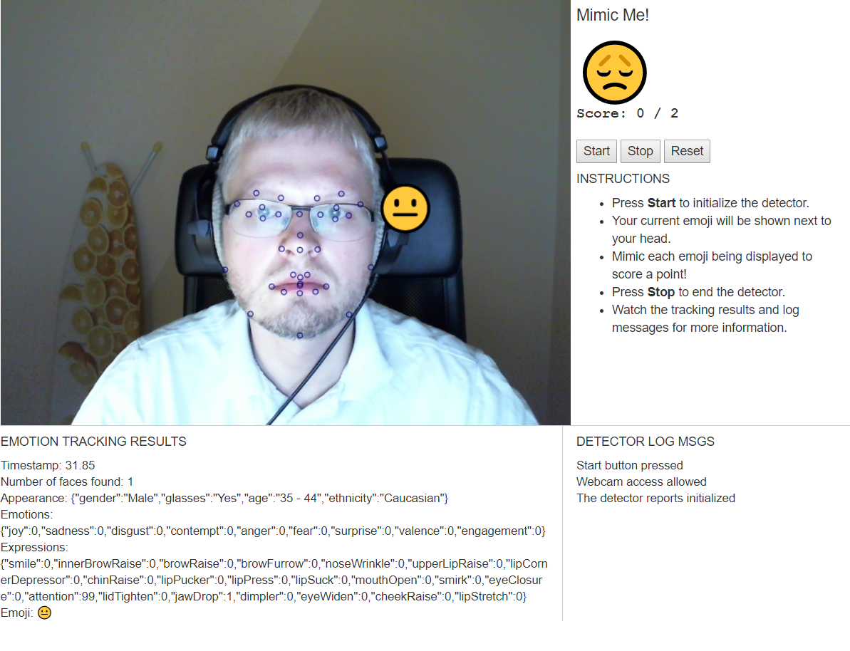

## Show Dominant Emoji

To show dominant emoji I realized the following steps:

* After some experiments I found optimal size for emoji – 50px (ctx.font = '50px Arial')
* To stick the emoji to my face I used particular feature points as an anchor.
  + I made a simple cycle to pass through all feature points and find points with max/min X and Y coordinates.
  + Then I take point in the right upper corned add small margin (to avoid face overlapping) and place to this coordinate the emoji
  + To find dominant emoji, I used *face.emojis.dominantEmoji* value
* You can find the result on the picture above

## 3. Implement Mimic Me!

First of all, I defined main variables:

|  |  |
| --- | --- |
| Variable name | Description |
| randomEmoji | Emoji we need to mimic (target) |
| correct | Total number of correct answers |
| total | Total number of played rounds |
| match | Boolean to check if we can mimic target emoji |
| maxTimeToGuess | Number of seconds to replicate an emotion |
| numbersOfRounds | Number of rounds to replicate an emotion |
| curDate | Date when round begins |
| stDate | Date after round began to check if we are within limit |

The logic of game is the following:

* When the system is initialized or we begin new game the function newGame() is activated. We have to confirm that we want to game:

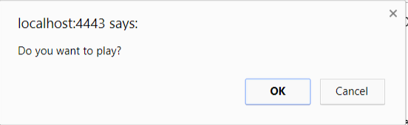

* If so, we have to initialize key parameters for game (max time play for each round and number of rounds:

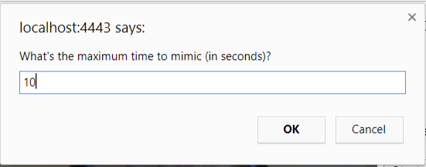

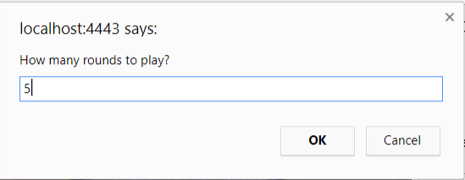

* After this, we begin to play. If we mimic target emotion (it is selected randomly from the list of possible emotions), the next round begins.
* If we cannot mimic target emotion, we get the warning and the next rounds begins:

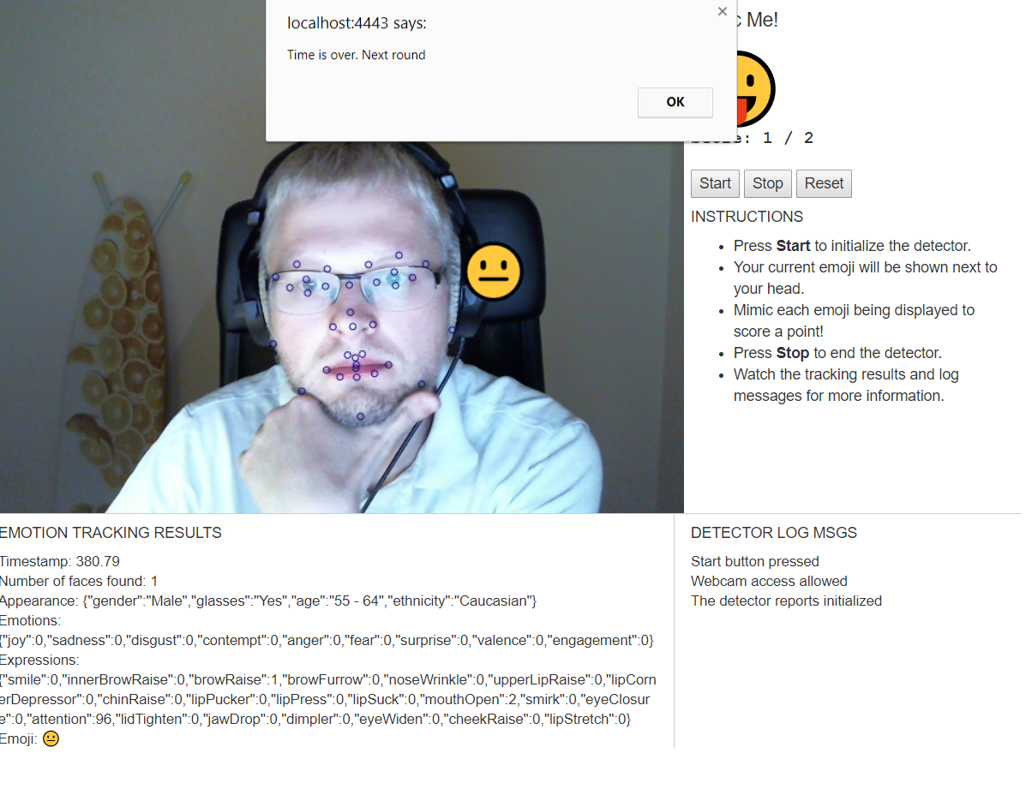

* At the end of game, we get summary:

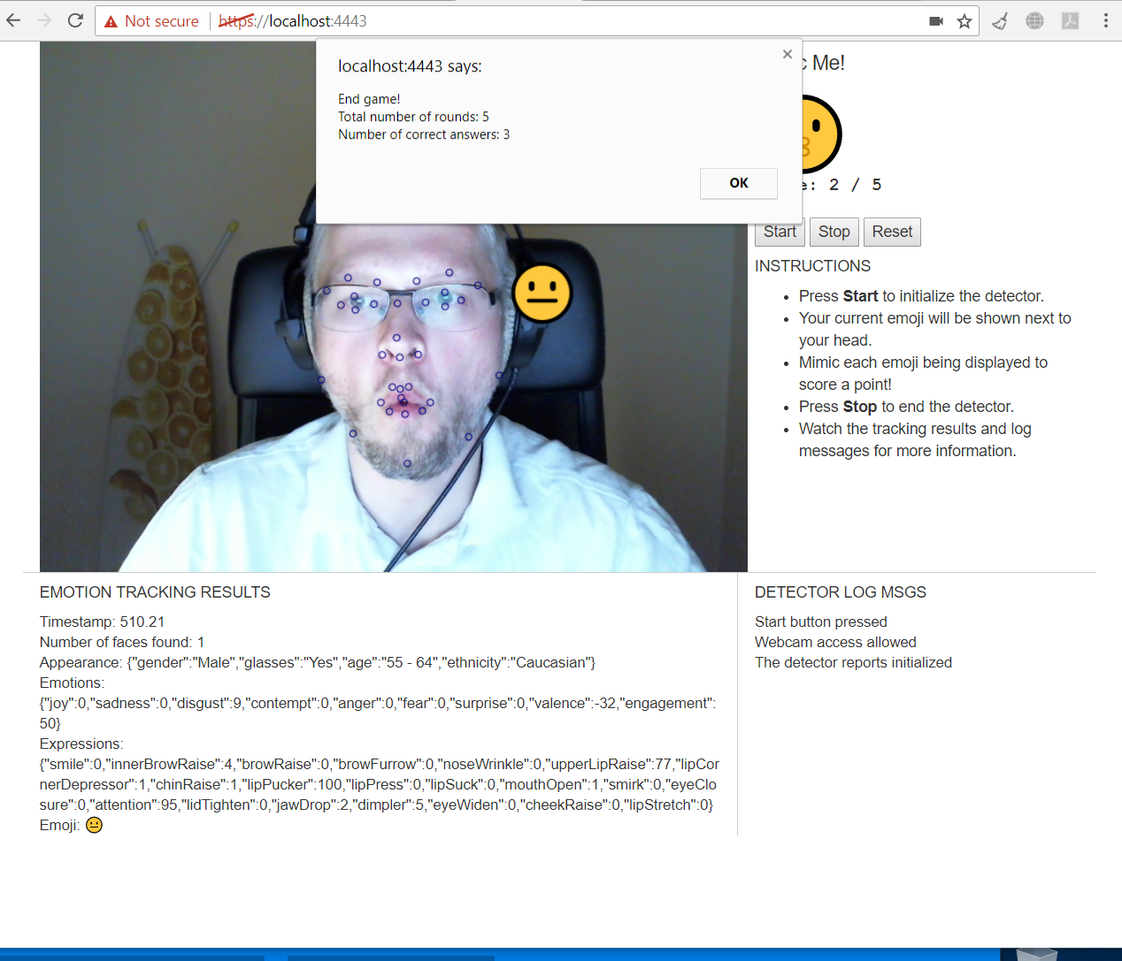

* After this game, we can begin new game (the system asks), or stop.