ENTERPRISE NETWORK DESIGN
& IMPLEMENTATION

Full Configuration, Screenshots & Troubleshooting Documentation
Cisco Packet Tracer Simulation | Enterprise Networking Project

Degree Programme | B.Tech – Computer Networks & Cloud Security
University | University of Vocational Technology (UoVT)
Simulation Tool | Cisco Packet Tracer 2025
Base Network | 172.16.1.0
Routing Protocol | OSPFv2 – Area 0
Year | 2026

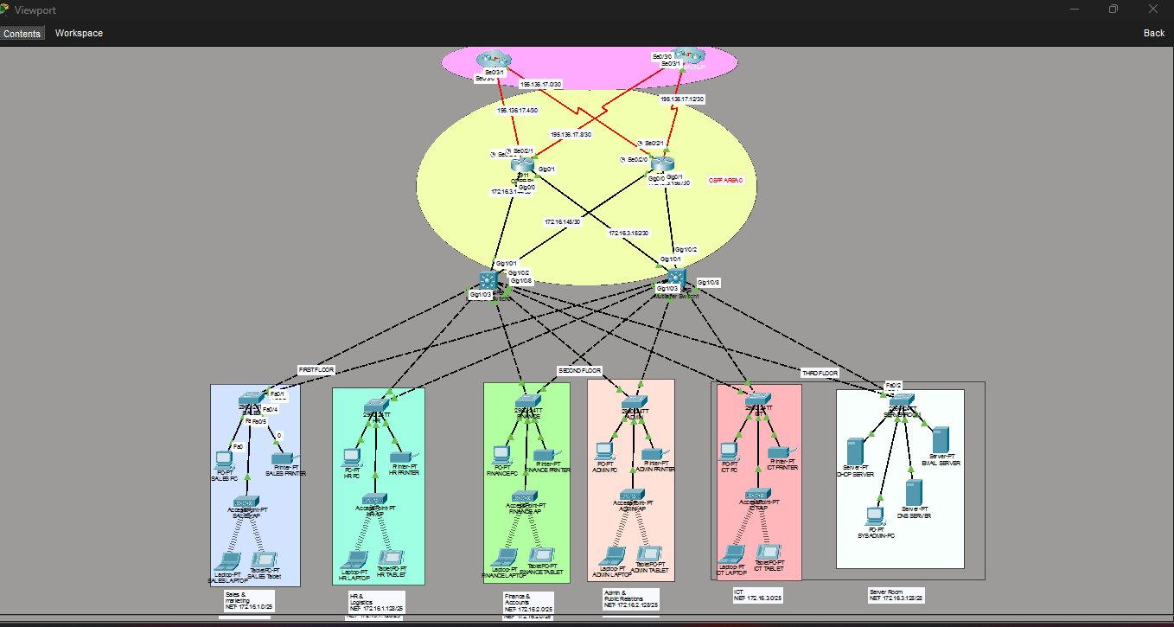
Figure 1 — Complete Enterprise Network Topology (Cisco Packet Tracer)

IP Addressing Reference

Department Subnets
Department | Network | Subnet Mask | Host Range | Broadcast
Sales & Marketing | 172.16.1.0 | 255.255.255.128/25 | .1 to .126 | 172.16.1.127
HR & Logistics | 172.16.1.128 | 255.255.255.128/25 | .129 to .254 | 172.16.1.255
Finance & Accounts | 172.16.2.0 | 255.255.255.128/25 | .1 to .126 | 172.16.2.127
Admin & PR | 172.16.2.128 | 255.255.255.128/25 | .129 to .254 | 172.16.2.255
ICT | 172.16.3.0 | 255.255.255.128/25 | .1 to .126 | 172.16.3.127
Server Room | 172.16.3.128 | 255.255.255.240/28 | .129 to .142 | 172.16.3.143

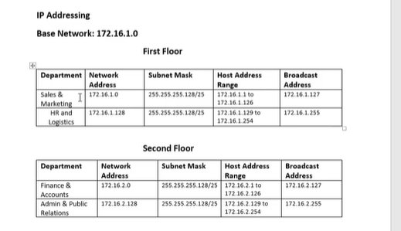
Figure 2 — IP Addressing Table: First & Second Floor Subnets

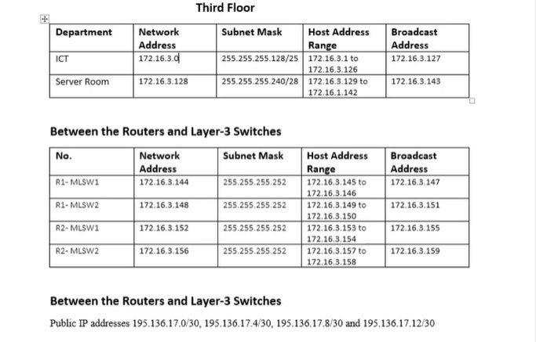
Figure 3 — IP Addressing Table: Third Floor, Router-Switch Links & ISP Links

Step 01 — Network Design Beautification & Hardware Initialization

To establish WAN serial connections between the core network and ISPs, physical hardware expansion was required. Standard Cisco routers do not include serial ports by default — the HWIC-2T module was installed on CORE-R1, CORE-R2, ISP1, and ISP2.

A. HWIC-2T Module Installation (All 4 Routers)
- Open the Physical tab of the router in Packet Tracer.
- Power OFF the router using the power button to prevent hardware damage.
- Drag and drop the HWIC-2T module into an available empty expansion slot.
- Power ON — IOS detects Serial0/2/0 and Serial0/2/1 interfaces automatically.
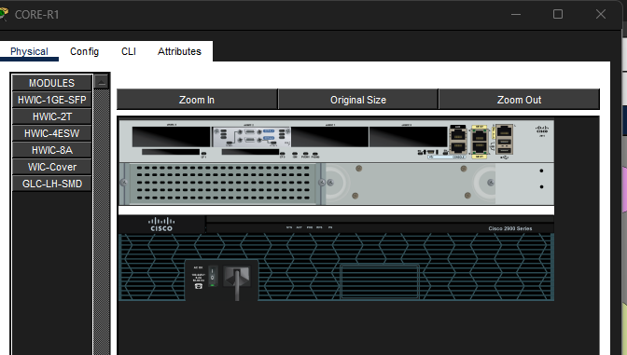
B. Multilayer Switch Power Supply
- Click MLT-SW1 → Physical tab → drag AC-POWER-SUPPLY into the power bay.
- Cisco IOS boot sequence initiates automatically.
- Repeat for MLT-SW2.
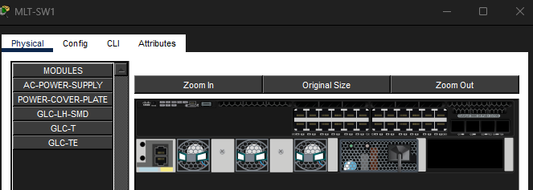
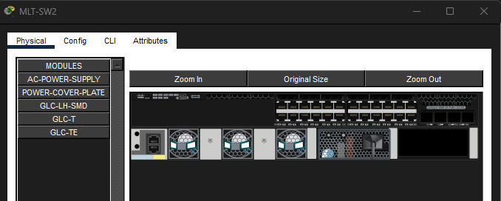
C. Activating Router Interfaces
- Click router → Config tab → select each interface.
- Toggle Port Status to ON — executes no shutdown implicitly.

Final Network Topology

Figure 4 — Final Enterprise Network Topology with all devices active

Command / Action | Technical Purpose & Why Used
HWIC-2T Module | Provides two high-speed serial WAN ports for DCE/DTE connections, enabling simulated ISP-to-enterprise WAN links.
AC-POWER-SUPPLY | Cisco 3650/3850 multilayer switches have modular power designs — explicit power supply insertion is required to boot.
Port Status → ON | All Cisco router interfaces are Administratively Down by default. Toggling ON brings the physical layer up.

Step 02 — Basic Settings to All Devices + SSH

Baseline security configurations were applied to all access layer switches. SSH v2 was configured on all Layer 3 devices (Routers + Multilayer Switches) to enable encrypted remote management.

SALES-SW — Basic Settings
Switch> enable
Switch# configure terminal
Switch(config)# hostname SALES-SW
SALES-SW(config)# banner motd #NO Unauthorised Access!!!#
SALES-SW(config)# no ip domain-lookup
SALES-SW(config)# line console 0
SALES-SW(config-line)# password cisco
SALES-SW(config-line)# login
SALES-SW(config-line)# exit
SALES-SW(config)# enable password cisco
SALES-SW(config)# service password-encryption
SALES-SW# write memory

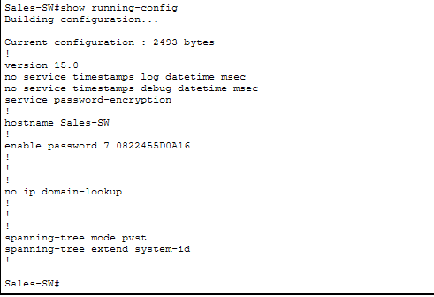
HR-SW — Basic Settings
Switch> enable
Switch# configure terminal
Switch(config)# hostname HR-SW
HR-SW(config)# banner motd #NO Unauthorised Access!!!#
HR-SW(config)# no ip domain-lookup
HR-SW(config)# line console 0
HR-SW(config-line)# password cisco
HR-SW(config-line)# login
HR-SW(config-line)# exit
HR-SW(config)# enable password cisco
HR-SW(config)# service password-encryption
HR-SW# write memory

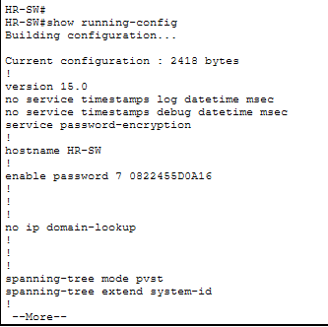
FINANCE-SW — Basic Settings
Switch> enable
Switch# configure terminal
Switch(config)# hostname FINANCE-SW
FINANCE-SW(config)# banner motd #NO Unauthorised Access!!!#
FINANCE-SW(config)# no ip domain-lookup
FINANCE-SW(config)# line console 0
FINANCE-SW(config-line)# password cisco
FINANCE-SW(config-line)# login
FINANCE-SW(config-line)# exit
FINANCE-SW(config)# enable password cisco
FINANCE-SW(config)# service password-encryption
FINANCE-SW# write memory

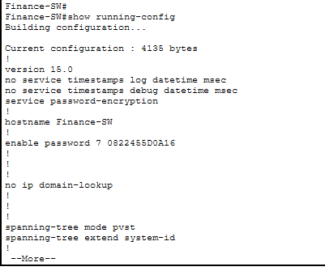
ADMIN-SW — Basic Settings
Switch> enable
Switch# configure terminal
Switch(config)# hostname ADMIN-SW
ADMIN-SW(config)# banner motd #NO Unauthorised Access!!!#
ADMIN-SW(config)# no ip domain-lookup
ADMIN-SW(config)# line console 0
ADMIN-SW(config-line)# password cisco
ADMIN-SW(config-line)# login
ADMIN-SW(config-line)# exit
ADMIN-SW(config)# enable password cisco
ADMIN-SW(config)# service password-encryption
ADMIN-SW# write memory

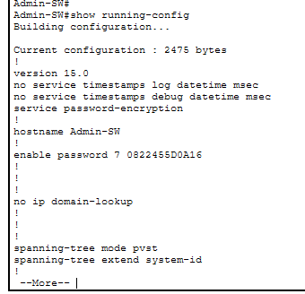
ICT-SW — Basic Settings
Switch> enable
Switch# configure terminal
Switch(config)# hostname ICT-SW
ICT-SW(config)# banner motd #NO Unauthorised Access!!!#
ICT-SW(config)# no ip domain-lookup
ICT-SW(config)# line console 0
ICT-SW(config-line)# password cisco
ICT-SW(config-line)# login
ICT-SW(config-line)# exit
ICT-SW(config)# enable password cisco
ICT-SW(config)# service password-encryption
ICT-SW# write memory

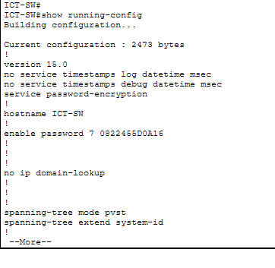
SERVERROOM-SW — Basic Settings
Switch> enable
Switch# configure terminal
Switch(config)# hostname SERVERROOM-SW
SERVERROOM-SW(config)# banner motd #NO Unauthorised Access!!!#
SERVERROOM-SW(config)# no ip domain-lookup
SERVERROOM-SW(config)# line console 0
SERVERROOM-SW(config-line)# password cisco
SERVERROOM-SW(config-line)# login
SERVERROOM-SW(config-line)# exit
SERVERROOM-SW(config)# enable password cisco
SERVERROOM-SW(config)# service password-encryption
SERVERROOM-SW# write memory

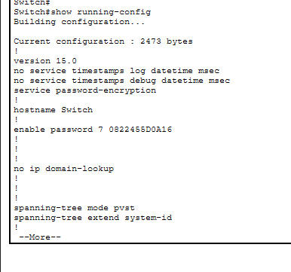
SSH v2 — Routers & Multilayer Switches
Applied to: CORE-R1, CORE-R2, MLT-SW1, MLT-SW2. ISP routers excluded — outside enterprise administrative control.
MLT-SW1 — SSH Configuration
MLT-SW1> enable
MLT-SW1# configure terminal
MLT-SW1(config)# hostname MLT-SW1
MLT-SW1(config)# line console 0
MLT-SW1(config-line)# password cisco
MLT-SW1(config-line)# login
MLT-SW1(config-line)# exit
MLT-SW1(config)# enable password cisco
MLT-SW1(config)# no ip domain-lookup
MLT-SW1(config)# banner motd #NO Unauthorised Access!!!#
MLT-SW1(config)# service password-encryption
MLT-SW1(config)# ip domain-name cisco.net
MLT-SW1(config)# username admin password cisco
MLT-SW1(config)# crypto key generate rsa
! When prompted: enter 1024
MLT-SW1(config)# ip ssh version 2
MLT-SW1(config)# line vty 0 15
MLT-SW1(config-line)# login local
MLT-SW1(config-line)# transport input ssh
MLT-SW1(config-line)# exit
MLT-SW1# write memory

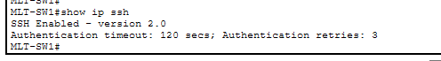
MLT-SW2 — SSH Configuration
MLT-SW2> enable
MLT-SW2# configure terminal
MLT-SW2(config)# hostname MLT-SW2
MLT-SW2(config)# line console 0
MLT-SW2(config-line)# password cisco
MLT-SW2(config-line)# login
MLT-SW2(config-line)# exit
MLT-SW2(config)# enable password cisco
MLT-SW2(config)# no ip domain-lookup
MLT-SW2(config)# banner motd #NO Unauthorised Access!!!#
MLT-SW2(config)# service password-encryption
MLT-SW2(config)# ip domain-name cisco.net
MLT-SW2(config)# username admin password cisco
MLT-SW2(config)# crypto key generate rsa
! When prompted: enter 1024
MLT-SW2(config)# ip ssh version 2
MLT-SW2(config)# line vty 0 15
MLT-SW2(config-line)# login local
MLT-SW2(config-line)# transport input ssh
MLT-SW2(config-line)# exit
MLT-SW2# write memory

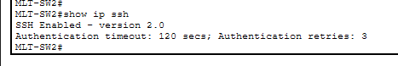
CORE-R1 — SSH Configuration
CORE-R1> enable
CORE-R1# configure terminal
CORE-R1(config)# hostname CORE-R1
CORE-R1(config)# line console 0
CORE-R1(config-line)# password cisco
CORE-R1(config-line)# login
CORE-R1(config-line)# exit
CORE-R1(config)# enable password cisco
CORE-R1(config)# no ip domain-lookup
CORE-R1(config)# banner motd #NO Unauthorised Access!!!#
CORE-R1(config)# service password-encryption
CORE-R1(config)# ip domain-name cisco.net
CORE-R1(config)# username admin password cisco
CORE-R1(config)# crypto key generate rsa
! When prompted: enter 1024
CORE-R1(config)# ip ssh version 2
CORE-R1(config)# line vty 0 15
CORE-R1(config-line)# login local
CORE-R1(config-line)# transport input ssh
CORE-R1(config-line)# exit
CORE-R1# write memory

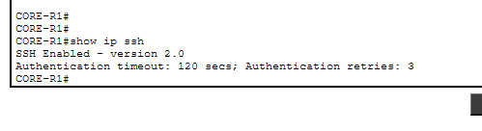
CORE-R2 — SSH Configuration
CORE-R2> enable
CORE-R2# configure terminal
CORE-R2(config)# hostname CORE-R2
CORE-R2(config)# line console 0
CORE-R2(config-line)# password cisco
CORE-R2(config-line)# login
CORE-R2(config-line)# exit
CORE-R2(config)# enable password cisco
CORE-R2(config)# no ip domain-lookup
CORE-R2(config)# banner motd #NO Unauthorised Access!!!#
CORE-R2(config)# service password-encryption
CORE-R2(config)# ip domain-name cisco.net
CORE-R2(config)# username admin password cisco
CORE-R2(config)# crypto key generate rsa
! When prompted: enter 1024
CORE-R2(config)# ip ssh version 2
CORE-R2(config)# line vty 0 15
CORE-R2(config-line)# login local
CORE-R2(config-line)# transport input ssh
CORE-R2(config-line)# exit
CORE-R2# write memory

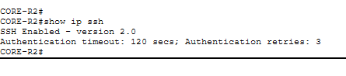
SSH Verification — Testing Remote Access
! From SysAdmin PC — SSH into CORE-R1
C:\> ssh -l admin 172.16.3.146
Password: cisco
! Expected: Banner appears + CORE-R1> prompt
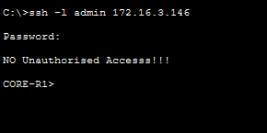

Command / Action | Technical Purpose & Why Used
hostname | Modifying the default hostname ensures precise device identification during SSH sessions and network monitoring.
banner motd | Provides legal standing in the event of a security breach by warning unauthorized access is prohibited.
no ip domain-lookup | Prevents the device from stalling and attempting a DNS broadcast when an admin mistypes a CLI command.
service password-encryption | Converts plain-text passwords to encrypted strings (Type-7) in the running-config.
crypto key generate rsa 1024 | Generates RSA key pairs required to encrypt SSH sessions. 1024-bit is the minimum for SSHv2.
ip ssh version 2 | Enforces SSHv2 only. SSHv1 contains known structural security vulnerabilities.
transport input ssh | Blocks Telnet completely on VTY lines — only encrypted SSH connections are permitted.

Step 03 & 04 — VLAN Assignment, Trunking & Port Security

VLANs logically segment broadcast domains by department. Trunk ports carry multi-VLAN traffic between switches. Port Security on Finance-SW restricts unauthorized physical connections.

VLAN ID | Department | Switch | Floor
VLAN 10 | Sales & Marketing | SALES-SW | 1st Floor
VLAN 20 | HR & Logistics | HR-SW | 1st Floor
VLAN 30 | Finance & Accounts | FINANCE-SW | 2nd Floor
VLAN 40 | Admin & PR | ADMIN-SW | 2nd Floor
VLAN 50 | ICT | ICT-SW | 3rd Floor
VLAN 60 | Server Room | SERVERROOM-SW | 3rd Floor
VLAN 99 | BlackHole (Unused Ports) | All Switches | All Floors

SALES-SW — VLAN 10 Configuration
SALES-SW> enable
SALES-SW# configure terminal
! Trunk ports to distribution switches
SALES-SW(config)# interface range fa0/1-2
SALES-SW(config-if-range)# switchport mode trunk
SALES-SW(config-if-range)# exit
! Create VLANs
SALES-SW(config)# vlan 10
SALES-SW(config-vlan)# name Sales_Marketing
SALES-SW(config-vlan)# vlan 99
SALES-SW(config-vlan)# name BlackHole
SALES-SW(config-vlan)# exit
! Assign access ports
SALES-SW(config)# interface range fa0/3-24
SALES-SW(config-if-range)# switchport mode access
SALES-SW(config-if-range)# switchport access vlan 10
SALES-SW(config-if-range)# exit
! Isolate unused gigabit ports
SALES-SW(config)# interface range gig0/1-2
SALES-SW(config-if-range)# switchport mode access
SALES-SW(config-if-range)# switchport access vlan 99
SALES-SW(config-if-range)# exit
SALES-SW# write memory

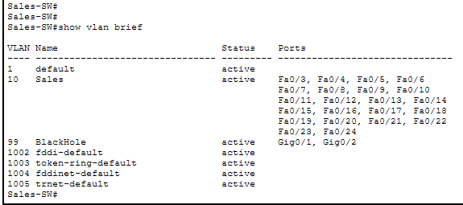
HR-SW — VLAN 20 Configuration
HR-SW> enable
HR-SW# configure terminal
! Trunk ports to distribution switches
HR-SW(config)# interface range fa0/1-2
HR-SW(config-if-range)# switchport mode trunk
HR-SW(config-if-range)# exit
! Create VLANs
HR-SW(config)# vlan 20
HR-SW(config-vlan)# name HR_Logistics
HR-SW(config-vlan)# vlan 99
HR-SW(config-vlan)# name BlackHole
HR-SW(config-vlan)# exit
! Assign access ports
HR-SW(config)# interface range fa0/3-24
HR-SW(config-if-range)# switchport mode access
HR-SW(config-if-range)# switchport access vlan 20
HR-SW(config-if-range)# exit
! Isolate unused gigabit ports
HR-SW(config)# interface range gig0/1-2
HR-SW(config-if-range)# switchport mode access
HR-SW(config-if-range)# switchport access vlan 99
HR-SW(config-if-range)# exit
HR-SW# write memory

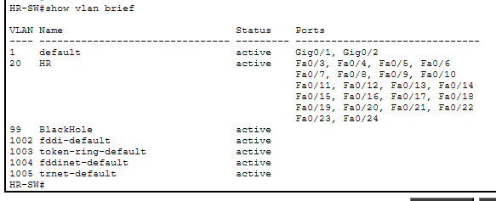
FINANCE-SW — VLAN 30 Configuration
FINANCE-SW> enable
FINANCE-SW# configure terminal
! Trunk ports to distribution switches
FINANCE-SW(config)# interface range fa0/1-2
FINANCE-SW(config-if-range)# switchport mode trunk
FINANCE-SW(config-if-range)# exit
! Create VLANs
FINANCE-SW(config)# vlan 30
FINANCE-SW(config-vlan)# name Finance_Accounts
FINANCE-SW(config-vlan)# vlan 99
FINANCE-SW(config-vlan)# name BlackHole
FINANCE-SW(config-vlan)# exit
! Assign access ports
FINANCE-SW(config)# interface range fa0/3-24
FINANCE-SW(config-if-range)# switchport mode access
FINANCE-SW(config-if-range)# switchport access vlan 30
FINANCE-SW(config-if-range)# exit
! Isolate unused gigabit ports
FINANCE-SW(config)# interface range gig0/1-2
FINANCE-SW(config-if-range)# switchport mode access
FINANCE-SW(config-if-range)# switchport access vlan 99
FINANCE-SW(config-if-range)# exit
FINANCE-SW# write memory

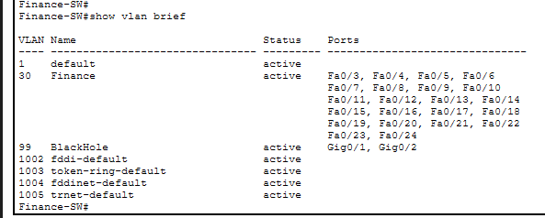
ADMIN-SW — VLAN 40 Configuration
ADMIN-SW> enable
ADMIN-SW# configure terminal
! Trunk ports to distribution switches
ADMIN-SW(config)# interface range fa0/1-2
ADMIN-SW(config-if-range)# switchport mode trunk
ADMIN-SW(config-if-range)# exit
! Create VLANs
ADMIN-SW(config)# vlan 40
ADMIN-SW(config-vlan)# name Admin_PR
ADMIN-SW(config-vlan)# vlan 99
ADMIN-SW(config-vlan)# name BlackHole
ADMIN-SW(config-vlan)# exit
! Assign access ports
ADMIN-SW(config)# interface range fa0/3-24
ADMIN-SW(config-if-range)# switchport mode access
ADMIN-SW(config-if-range)# switchport access vlan 40
ADMIN-SW(config-if-range)# exit
! Isolate unused gigabit ports
ADMIN-SW(config)# interface range gig0/1-2
ADMIN-SW(config-if-range)# switchport mode access
ADMIN-SW(config-if-range)# switchport access vlan 99
ADMIN-SW(config-if-range)# exit
ADMIN-SW# write memory

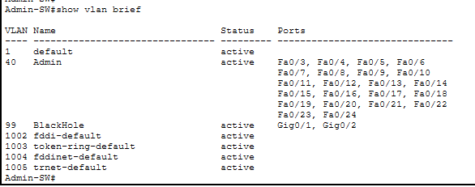
ICT-SW — VLAN 50 Configuration
ICT-SW> enable
ICT-SW# configure terminal
! Trunk ports to distribution switches
ICT-SW(config)# interface range fa0/1-2
ICT-SW(config-if-range)# switchport mode trunk
ICT-SW(config-if-range)# exit
! Create VLANs
ICT-SW(config)# vlan 50
ICT-SW(config-vlan)# name ICT_Dept
ICT-SW(config-vlan)# vlan 99
ICT-SW(config-vlan)# name BlackHole
ICT-SW(config-vlan)# exit
! Assign access ports
ICT-SW(config)# interface range fa0/3-24
ICT-SW(config-if-range)# switchport mode access
ICT-SW(config-if-range)# switchport access vlan 50
ICT-SW(config-if-range)# exit
! Isolate unused gigabit ports
ICT-SW(config)# interface range gig0/1-2
ICT-SW(config-if-range)# switchport mode access
ICT-SW(config-if-range)# switchport access vlan 99
ICT-SW(config-if-range)# exit
ICT-SW# write memory

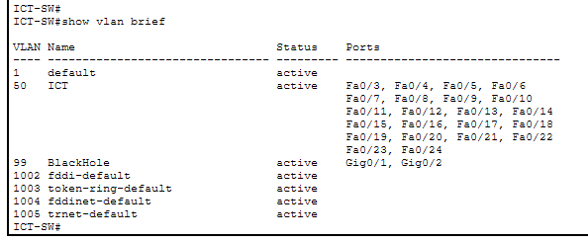
SERVERROOM-SW — VLAN 60 Configuration
SERVERROOM-SW> enable
SERVERROOM-SW# configure terminal
! Trunk ports to distribution switches
SERVERROOM-SW(config)# interface range fa0/1-2
SERVERROOM-SW(config-if-range)# switchport mode trunk
SERVERROOM-SW(config-if-range)# exit
! Create VLANs
SERVERROOM-SW(config)# vlan 60
SERVERROOM-SW(config-vlan)# name Server_Room
SERVERROOM-SW(config-vlan)# vlan 99
SERVERROOM-SW(config-vlan)# name BlackHole
SERVERROOM-SW(config-vlan)# exit
! Assign access ports
SERVERROOM-SW(config)# interface range fa0/3-24
SERVERROOM-SW(config-if-range)# switchport mode access
SERVERROOM-SW(config-if-range)# switchport access vlan 60
SERVERROOM-SW(config-if-range)# exit
! Isolate unused gigabit ports
SERVERROOM-SW(config)# interface range gig0/1-2
SERVERROOM-SW(config-if-range)# switchport mode access
SERVERROOM-SW(config-if-range)# switchport access vlan 99
SERVERROOM-SW(config-if-range)# exit
SERVERROOM-SW# write memory

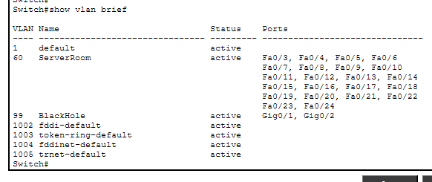

Distribution Layer Trunking — MLT-SW1 & MLT-SW2
MLT-SW1
MLT-SW1> enable
MLT-SW1# configure terminal
MLT-SW1(config)# interface range gig1/0/3-8
MLT-SW1(config-if-range)# switchport trunk encapsulation dot1q
MLT-SW1(config-if-range)# switchport mode trunk
MLT-SW1(config-if-range)# exit
MLT-SW1(config)# vlan 10
MLT-SW1(config-vlan)# name Sales
MLT-SW1(config-vlan)# vlan 20
MLT-SW1(config-vlan)# name HR
MLT-SW1(config-vlan)# vlan 30
MLT-SW1(config-vlan)# name Finance
MLT-SW1(config-vlan)# vlan 40
MLT-SW1(config-vlan)# name Admin
MLT-SW1(config-vlan)# vlan 50
MLT-SW1(config-vlan)# name ICT
MLT-SW1(config-vlan)# vlan 60
MLT-SW1(config-vlan)# name ServerRoom
MLT-SW1(config-vlan)# exit
MLT-SW1# write memory

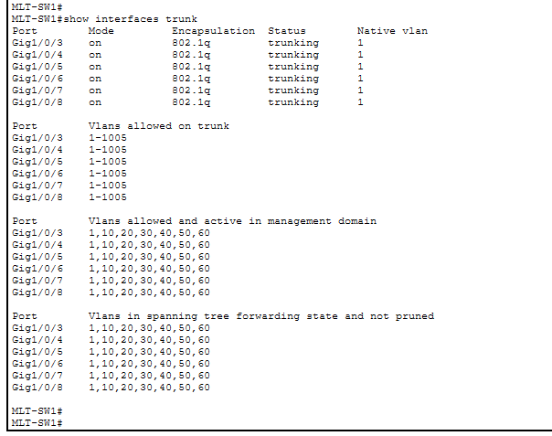
MLT-SW2
MLT-SW2> enable
MLT-SW2# configure terminal
MLT-SW2(config)# interface range gig1/0/3-8
MLT-SW2(config-if-range)# switchport trunk encapsulation dot1q
MLT-SW2(config-if-range)# switchport mode trunk
MLT-SW2(config-if-range)# exit
MLT-SW2(config)# vlan 10
MLT-SW2(config-vlan)# name Sales
MLT-SW2(config-vlan)# vlan 20
MLT-SW2(config-vlan)# name HR
MLT-SW2(config-vlan)# vlan 30
MLT-SW2(config-vlan)# name Finance
MLT-SW2(config-vlan)# vlan 40
MLT-SW2(config-vlan)# name Admin
MLT-SW2(config-vlan)# vlan 50
MLT-SW2(config-vlan)# name ICT
MLT-SW2(config-vlan)# vlan 60
MLT-SW2(config-vlan)# name ServerRoom
MLT-SW2(config-vlan)# exit
MLT-SW2# write memory

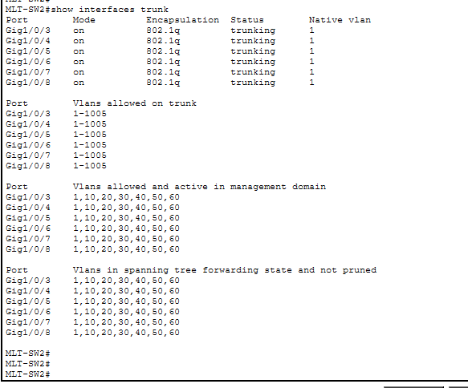

Port Security — FINANCE-SW
Finance handles sensitive records — restricting each port to one authorized MAC address prevents rogue device connections.
FINANCE-SW> enable
FINANCE-SW# configure terminal
FINANCE-SW(config)# interface range fa0/3-24
FINANCE-SW(config-if-range)# switchport mode access
FINANCE-SW(config-if-range)# switchport port-security
FINANCE-SW(config-if-range)# switchport port-security maximum 1
FINANCE-SW(config-if-range)# switchport port-security mac-address sticky
FINANCE-SW(config-if-range)# switchport port-security violation shutdown
FINANCE-SW(config-if-range)# exit
FINANCE-SW# write memory

! Verification
FINANCE-SW# show port-security
FINANCE-SW# show port-security interface fa0/3
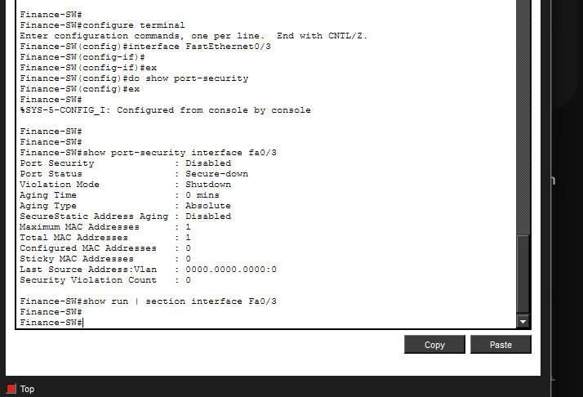

⚠️ Troubleshooting — Port Security 'Disabled' Status
⚠️ Issue: show port-security returned empty output. Interface showed 'Port Security: Disabled'.

FINANCE-SW# show port-security interface fa0/3

Port Security : Disabled
Port Status : Secure-down
Violation Mode : Shutdown
Maximum MAC Addresses : 1

Root Cause
- Port security requires dual-execution on large interface ranges in Packet Tracer firmware.
- Sticky MAC remains passive until an end-device sends an active Layer 2 frame.
Fix Applied
FINANCE-SW(config)# interface range fa0/3-24
FINANCE-SW(config-if-range)# switchport mode access
FINANCE-SW(config-if-range)# switchport port-security
FINANCE-SW(config-if-range)# exit
FINANCE-SW# write memory

! Send a ping from Finance PC to trigger MAC learning
! Then verify:
FINANCE-SW# show port-security interface fa0/3
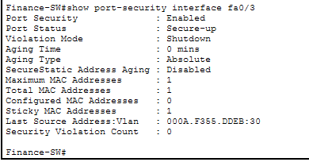

Command / Action | Technical Purpose & Why Used
switchport mode trunk | Carries frames for all VLANs over a single link using IEEE 802.1Q tagging.
switchport mode access | Binds a port to a single VLAN — suitable for PCs and printers.
vlan 99 BlackHole | Dead-ends all unused ports, preventing rogue hardware from bridging into the network.
switchport trunk encapsulation dot1q | Mandatory on Catalyst 3650/3850 before enabling trunk mode.
port-security maximum 1 | Allows only one MAC address per port — prevents unauthorized hubs.
mac-address sticky | Dynamically learns and permanently locks the first device MAC address.
violation shutdown | Moves the port to err-disabled state immediately when an unauthorized device is detected.

Step 05 — Subnetting & IP Addressing

Core interfaces on multilayer switches were converted to Layer 3 routed ports. Serial WAN interfaces on core routers received public IP addresses for ISP connectivity.

IP Addressing Reference Screenshots

Figure 5 — Subnetting Table: First & Second Floor


Figure 6 — Subnetting Table: Third Floor, Router-Switch Links & ISP Public IPs

MLT-SW1 — Layer 3 Routed Ports
MLT-SW1> enable
MLT-SW1# configure terminal
MLT-SW1(config)# interface range gig1/0/1-2
MLT-SW1(config-if-range)# no switchport
MLT-SW1(config-if-range)# exit
! Link toward CORE-R1
MLT-SW1(config)# interface gig1/0/1
MLT-SW1(config-if)# ip address 172.16.3.145 255.255.255.252
MLT-SW1(config-if)# no shutdown
MLT-SW1(config-if)# exit
! Link toward CORE-R2
MLT-SW1(config)# interface gig1/0/2
MLT-SW1(config-if)# ip address 172.16.3.153 255.255.255.252
MLT-SW1(config-if)# no shutdown
MLT-SW1(config-if)# exit
MLT-SW1# write memory

MLT-SW2 — Layer 3 Routed Ports
MLT-SW2> enable
MLT-SW2# configure terminal
MLT-SW2(config)# interface range gig1/0/1-2
MLT-SW2(config-if-range)# no switchport
MLT-SW2(config-if-range)# exit
! Link toward CORE-R1
MLT-SW2(config)# interface gig1/0/1
MLT-SW2(config-if)# ip address 172.16.3.149 255.255.255.252
MLT-SW2(config-if)# no shutdown
MLT-SW2(config-if)# exit
! Link toward CORE-R2
MLT-SW2(config)# interface gig1/0/2
MLT-SW2(config-if)# ip address 172.16.3.157 255.255.255.252
MLT-SW2(config-if)# no shutdown
MLT-SW2(config-if)# exit
MLT-SW2# write memory

CORE-R1 — Interface IP Addressing
CORE-R1> enable
CORE-R1# configure terminal
! LAN to MLT-SW1
CORE-R1(config)# interface gig0/0
CORE-R1(config-if)# ip address 172.16.3.146 255.255.255.252
CORE-R1(config-if)# no shutdown
CORE-R1(config-if)# exit
! LAN to MLT-SW2
CORE-R1(config)# interface gig0/1
CORE-R1(config-if)# ip address 172.16.3.154 255.255.255.252
CORE-R1(config-if)# no shutdown
CORE-R1(config-if)# exit
! WAN to ISP1 (DCE)
CORE-R1(config)# interface serial 0/2/0
CORE-R1(config-if)# clock rate 64000
CORE-R1(config-if)# ip address 195.136.17.1 255.255.255.252
CORE-R1(config-if)# no shutdown
CORE-R1(config-if)# exit
! WAN to ISP2 (DCE)
CORE-R1(config)# interface serial 0/2/1
CORE-R1(config-if)# clock rate 64000
CORE-R1(config-if)# ip address 195.136.17.5 255.255.255.252
CORE-R1(config-if)# no shutdown
CORE-R1(config-if)# exit
CORE-R1# write memory

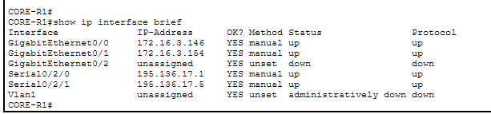
CORE-R2 — Interface IP Addressing
CORE-R2> enable
CORE-R2# configure terminal
! LAN to MLT-SW1
CORE-R2(config)# interface gig0/0
CORE-R2(config-if)# ip address 172.16.3.150 255.255.255.252
CORE-R2(config-if)# no shutdown
CORE-R2(config-if)# exit
! LAN to MLT-SW2
CORE-R2(config)# interface gig0/1
CORE-R2(config-if)# ip address 172.16.3.158 255.255.255.252
CORE-R2(config-if)# no shutdown
CORE-R2(config-if)# exit
! WAN to ISP1 (DCE)
CORE-R2(config)# interface serial 0/2/0
CORE-R2(config-if)# clock rate 64000
CORE-R2(config-if)# ip address 195.136.17.9 255.255.255.252
CORE-R2(config-if)# no shutdown
CORE-R2(config-if)# exit
! WAN to ISP2 (DCE)
CORE-R2(config)# interface serial 0/2/1
CORE-R2(config-if)# clock rate 64000
CORE-R2(config-if)# ip address 195.136.17.13 255.255.255.252
CORE-R2(config-if)# no shutdown
CORE-R2(config-if)# exit
CORE-R2# write memory

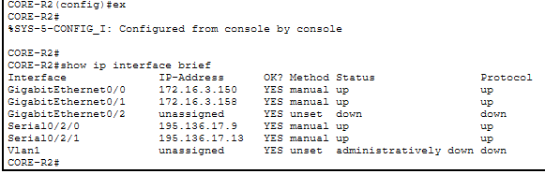
ISP1 & ISP2
ISP1(config)# interface serial 0/3/0
ISP1(config-if)# ip address 195.136.17.2 255.255.255.252
ISP1(config-if)# no shutdown
ISP1(config)# interface serial 0/3/1
ISP1(config-if)# ip address 195.136.17.10 255.255.255.252
ISP1(config-if)# no shutdown
ISP1# write memory

ISP2(config)# interface serial 0/3/0
ISP2(config-if)# ip address 195.136.17.6 255.255.255.252
ISP2(config-if)# no shutdown
ISP2(config)# interface serial 0/3/1
ISP2(config-if)# ip address 195.136.17.14 255.255.255.252
ISP2(config-if)# no shutdown
ISP2# write memory
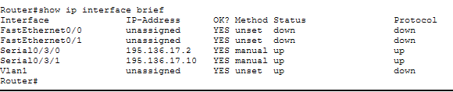
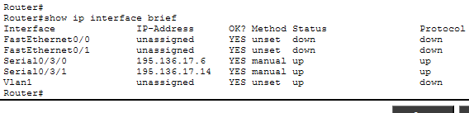
Command / Action | Technical Purpose & Why Used
no switchport | Converts a Layer 2 switch port to a Layer 3 routed interface capable of holding an IP address.
/30 Subnet | Point-to-point links only need 2 host IPs — /30 is the most efficient allocation.
clock rate 64000 | DCE serial interfaces must provide a clock signal. Without it the serial link stays down.

Step 06 — Dynamic Routing — OSPFv2

OSPFv2 was deployed as the IGP. All internal and WAN subnets are converged in Area 0 for automatic route discovery, load sharing and redundancy.

MLT-SW1 — OSPF (Router-ID: 2.2.2.2)
MLT-SW1> enable
MLT-SW1# configure terminal
MLT-SW1(config)# ip routing
MLT-SW1(config)# router ospf 10
MLT-SW1(config-router)# router-id 2.2.2.2
MLT-SW1(config-router)# network 172.16.1.0 0.0.0.127 area 0
MLT-SW1(config-router)# network 172.16.1.128 0.0.0.127 area 0
MLT-SW1(config-router)# network 172.16.2.0 0.0.0.127 area 0
MLT-SW1(config-router)# network 172.16.2.128 0.0.0.127 area 0
MLT-SW1(config-router)# network 172.16.3.0 0.0.0.127 area 0
MLT-SW1(config-router)# network 172.16.3.128 0.0.0.15 area 0
MLT-SW1(config-router)# network 172.16.3.144 0.0.0.3 area 0
MLT-SW1(config-router)# network 172.16.3.152 0.0.0.3 area 0
MLT-SW1(config-router)# exit
MLT-SW1(config)# ip route 0.0.0.0 0.0.0.0 GigabitEthernet1/0/1
MLT-SW1(config)# ip route 0.0.0.0 0.0.0.0 GigabitEthernet1/0/2 70
MLT-SW1# write memory

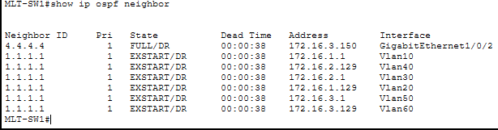
MLT-SW2 — OSPF (Router-ID: 1.1.1.1)
MLT-SW2> enable
MLT-SW2# configure terminal
MLT-SW2(config)# ip routing
MLT-SW2(config)# router ospf 10
MLT-SW2(config-router)# router-id 1.1.1.1
MLT-SW2(config-router)# network 172.16.1.0 0.0.0.127 area 0
MLT-SW2(config-router)# network 172.16.1.128 0.0.0.127 area 0
MLT-SW2(config-router)# network 172.16.2.0 0.0.0.127 area 0
MLT-SW2(config-router)# network 172.16.2.128 0.0.0.127 area 0
MLT-SW2(config-router)# network 172.16.3.0 0.0.0.127 area 0
MLT-SW2(config-router)# network 172.16.3.128 0.0.0.15 area 0
MLT-SW2(config-router)# network 172.16.3.148 0.0.0.3 area 0
MLT-SW2(config-router)# network 172.16.3.156 0.0.0.3 area 0
MLT-SW2(config-router)# exit
MLT-SW2(config)# ip route 0.0.0.0 0.0.0.0 GigabitEthernet1/0/1
MLT-SW2(config)# ip route 0.0.0.0 0.0.0.0 GigabitEthernet1/0/2 70
MLT-SW2# write memory

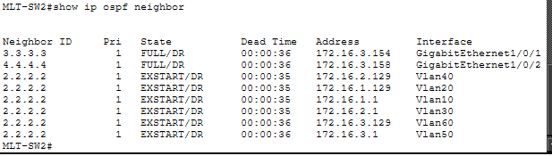
CORE-R1 — OSPF (Router-ID: 3.3.3.3)
CORE-R1> enable
CORE-R1# configure terminal
CORE-R1(config)# router ospf 10
CORE-R1(config-router)# router-id 3.3.3.3
CORE-R1(config-router)# network 172.16.3.144 0.0.0.3 area 0
CORE-R1(config-router)# network 172.16.3.152 0.0.0.3 area 0
CORE-R1(config-router)# network 195.136.17.0 0.0.0.127 area 0
CORE-R1(config-router)# exit
CORE-R1(config)# ip route 0.0.0.0 0.0.0.0 Serial0/2/0
CORE-R1(config)# ip route 0.0.0.0 0.0.0.0 Serial0/2/1 70
CORE-R1# write memory

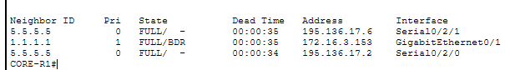

CORE-R2 — OSPF (Router-ID: 4.4.4.4)
CORE-R2> enable
CORE-R2# configure terminal
CORE-R2(config)# router ospf 10
CORE-R2(config-router)# router-id 4.4.4.4
CORE-R2(config-router)# network 172.16.3.148 0.0.0.3 area 0
CORE-R2(config-router)# network 172.16.3.156 0.0.0.3 area 0
CORE-R2(config-router)# network 195.136.17.0 0.0.0.127 area 0
CORE-R2(config-router)# exit
CORE-R2(config)# ip route 0.0.0.0 0.0.0.0 Serial0/2/0
CORE-R2(config)# ip route 0.0.0.0 0.0.0.0 Serial0/2/1 70
CORE-R2# write memory

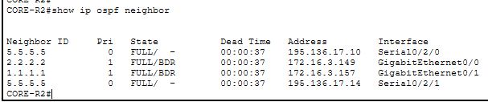
ISP1 & ISP2 — OSPF
ISP1(config)# router ospf 10
ISP1(config-router)# router-id 5.5.5.5
ISP1(config-router)# network 195.136.17.0 0.0.0.3 area 0
ISP1(config-router)# network 195.136.17.8 0.0.0.3 area 0
ISP1# write memory

ISP2(config)# router ospf 10
ISP2(config-router)# router-id 6.6.6.6
ISP2(config-router)# network 195.136.17.4 0.0.0.3 area 0
ISP2(config-router)# network 195.136.17.12 0.0.0.3 area 0
ISP2# write memory

⚠️ Troubleshooting — OSPF Router-ID Not Taking Effect
⚠️ Issue: OSPF neighbors failed to form FULL adjacency. Router-ID was already selected automatically before manual assignment.
! Fix — Force OSPF process to reload
CORE-R1# clear ip ospf process
Reset ALL OSPF processes? [no]: yes

! Verify
CORE-R1# show ip ospf neighbor

Command / Action | Technical Purpose & Why Used
ip routing | Activates the Layer 3 routing engine on the multilayer switch.
router-id X.X.X.X | Assigns a deterministic OSPF identifier, preventing ID changes during interface flapping.
network [IP] [wildcard] area 0 | Advertises the network and enables OSPF Hello packets on matching interfaces.
ip route 0.0.0.0 0.0.0.0 [iface] 70 | Backup default route with higher AD — used only when primary fails.
clear ip ospf process | Forces OSPF to reload router-id and rebuild adjacencies after configuration changes.

Step 07 — Static IP Addressing — Server Room

Core enterprise servers are assigned fixed static IPs. Static addressing prevents critical services from experiencing lease alterations associated with DHCP.

Device | IP Address | Subnet Mask | Default Gateway
DHCP Server | 172.16.3.130 | 255.255.255.240 | 172.16.3.129
DNS Server | 172.16.3.131 | 255.255.255.240 | 172.16.3.129
Email Server | 172.16.3.132 | 255.255.255.240 | 172.16.3.129
SysAdmin PC | 172.16.3.133 | 255.255.255.240 | 172.16.3.129

Packet Tracer GUI Steps
- Click on server/PC → Desktop tab → IP Configuration.
- Select Static → enter IP, Subnet Mask, Default Gateway, DNS.
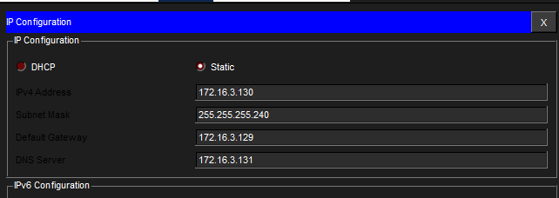
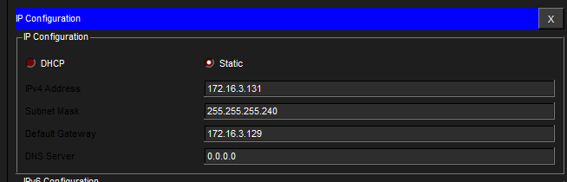

Command / Action | Technical Purpose & Why Used
Static IP (DHCP Server) | The DHCP server must have a fixed address — if it obtained one dynamically, all client lease requests would fail when that lease shifts.
Static IP (DNS Server) | All DHCP pools point to 172.16.3.131. Any change to this address would break name resolution across the entire enterprise.
Default Gateway 172.16.3.129 | This is the SVI gateway of VLAN 60 — the Layer 3 exit path for all server traffic.

Step 08 — DHCP Server Configuration

Five DHCP pools were provisioned — one per department. Server Room uses static addressing so no pool is required for VLAN 60.

Pool Name | Default GW | DNS Server | Start IP | Subnet Mask | Max Users
Sales_Pool | 172.16.1.1 | 172.16.3.131 | 172.16.1.6 | 255.255.255.128 | 120
HR_Pool | 172.16.1.129 | 172.16.3.131 | 172.16.1.134 | 255.255.255.128 | 120
Finance_Pool | 172.16.2.1 | 172.16.3.131 | 172.16.2.6 | 255.255.255.128 | 120
Admin_Pool | 172.16.2.129 | 172.16.3.131 | 172.16.2.134 | 255.255.255.128 | 120
ICT_Pool | 172.16.3.1 | 172.16.3.131 | 172.16.3.6 | 255.255.255.128 | 120

GUI Steps
- Click DHCP Server → Services → DHCP → toggle ON.
- Enter pool name, gateway, DNS, start IP, subnet mask, max users → click ADD.
- Repeat for all 5 pools.
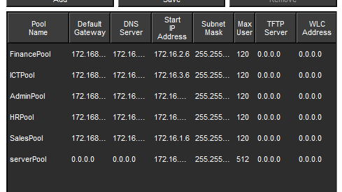

DNS Server Configuration
- DNS Server → Services → DNS → toggle ON.
- Add: Name = www.gtech.com | Type = A Record | Address = 172.16.3.131 → ADD.
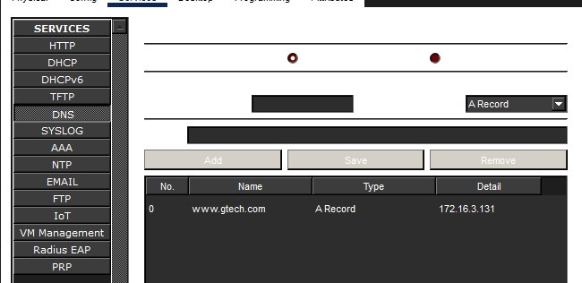

DHCP Verification — Department PCs Getting IP
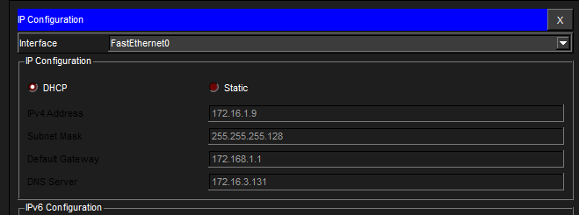
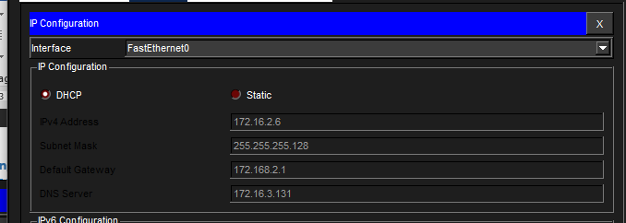
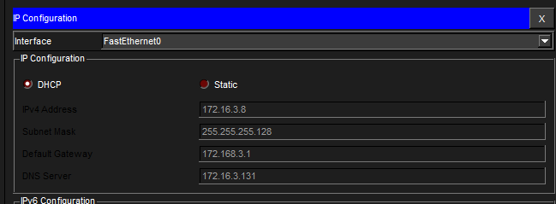

Command / Action | Technical Purpose & Why Used
Start IP at .6 / .134 | Lower addresses are reserved for network infrastructure. Offsetting prevents overlap with static switch/router assignments.
ip helper-address 172.16.3.130 | DHCP Discover messages are broadcasts that cannot cross VLANs. Helper converts them to unicast toward the DHCP server.
DNS A Record | Allows enterprise workstations to resolve www.gtech.com internally without querying external DNS servers.

Step 09 — Inter-VLAN Routing & DHCP Helper Addresses

SVIs were created on both MLT-SW1 and MLT-SW2 with identical gateway IPs forming an Active-Active redundant distribution matrix.

MLT-SW1 — SVI Configuration
MLT-SW1> enable
MLT-SW1# configure terminal
! ip routing already enabled from OSPF step
MLT-SW1(config)# interface vlan 10
MLT-SW1(config-if)# ip address 172.16.1.1 255.255.255.128
MLT-SW1(config-if)# ip helper-address 172.16.3.130
MLT-SW1(config-if)# no shutdown
MLT-SW1(config-if)# exit
MLT-SW1(config)# interface vlan 20
MLT-SW1(config-if)# ip address 172.16.1.129 255.255.255.128
MLT-SW1(config-if)# ip helper-address 172.16.3.130
MLT-SW1(config-if)# no shutdown
MLT-SW1(config-if)# exit
MLT-SW1(config)# interface vlan 30
MLT-SW1(config-if)# ip address 172.16.2.1 255.255.255.128
MLT-SW1(config-if)# ip helper-address 172.16.3.130
MLT-SW1(config-if)# no shutdown
MLT-SW1(config-if)# exit
MLT-SW1(config)# interface vlan 40
MLT-SW1(config-if)# ip address 172.16.2.129 255.255.255.128
MLT-SW1(config-if)# ip helper-address 172.16.3.130
MLT-SW1(config-if)# no shutdown
MLT-SW1(config-if)# exit
MLT-SW1(config)# interface vlan 50
MLT-SW1(config-if)# ip address 172.16.3.1 255.255.255.128
MLT-SW1(config-if)# ip helper-address 172.16.3.130
MLT-SW1(config-if)# no shutdown
MLT-SW1(config-if)# exit
MLT-SW1(config)# interface vlan 60
MLT-SW1(config-if)# ip address 172.16.3.129 255.255.255.240
MLT-SW1(config-if)# ip helper-address 172.16.3.130
MLT-SW1(config-if)# no shutdown
MLT-SW1(config-if)# exit
MLT-SW1# write memory

MLT-SW2 — SVI Configuration
MLT-SW2> enable
MLT-SW2# configure terminal
! ip routing already enabled from OSPF step
MLT-SW2(config)# interface vlan 10
MLT-SW2(config-if)# ip address 172.16.1.1 255.255.255.128
MLT-SW2(config-if)# ip helper-address 172.16.3.130
MLT-SW2(config-if)# no shutdown
MLT-SW2(config-if)# exit
MLT-SW2(config)# interface vlan 20
MLT-SW2(config-if)# ip address 172.16.1.129 255.255.255.128
MLT-SW2(config-if)# ip helper-address 172.16.3.130
MLT-SW2(config-if)# no shutdown
MLT-SW2(config-if)# exit
MLT-SW2(config)# interface vlan 30
MLT-SW2(config-if)# ip address 172.16.2.1 255.255.255.128
MLT-SW2(config-if)# ip helper-address 172.16.3.130
MLT-SW2(config-if)# no shutdown
MLT-SW2(config-if)# exit
MLT-SW2(config)# interface vlan 40
MLT-SW2(config-if)# ip address 172.16.2.129 255.255.255.128
MLT-SW2(config-if)# ip helper-address 172.16.3.130
MLT-SW2(config-if)# no shutdown
MLT-SW2(config-if)# exit
MLT-SW2(config)# interface vlan 50
MLT-SW2(config-if)# ip address 172.16.3.1 255.255.255.128
MLT-SW2(config-if)# ip helper-address 172.16.3.130
MLT-SW2(config-if)# no shutdown
MLT-SW2(config-if)# exit
MLT-SW2(config)# interface vlan 60
MLT-SW2(config-if)# ip address 172.16.3.129 255.255.255.240
MLT-SW2(config-if)# ip helper-address 172.16.3.130
MLT-SW2(config-if)# no shutdown
MLT-SW2(config-if)# exit
MLT-SW2# write memory

Inter-VLAN Ping Test
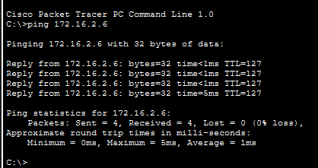
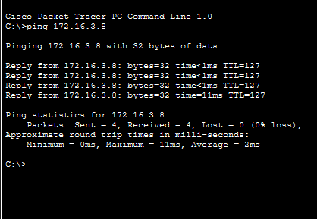

Command / Action | Technical Purpose & Why Used
interface vlan [ID] | Creates a Switched Virtual Interface — the logical Layer 3 gateway for all hosts in that VLAN.
ip helper-address 172.16.3.130 | Forwards DHCP broadcasts as unicast to the centralized server, enabling cross-VLAN DHCP.
Active-Active SVI Design | Identical gateway IPs on both switches allow simultaneous traffic processing and failover.

Step 10 — Wireless Network Configuration

Independent Access Points deployed per department with isolated SSIDs and WPA2-PSK encryption.

Department | AP Name | SSID | WPA2-PSK
Sales | Sales-AP | SALES-AP | Sales-AP123
HR | HR-AP | HR-AP | HR-AP123
Finance | Finance-AP | Finance-AP | Finance-AP123
Admin | Admin-AP | Admin-AP | Admin-AP123
ICT | ICT-AP | ICT-AP | ICT-AP123

Access Point Setup
- Click [Dept]-AP → Config tab → Port 1 → enter SSID → enable WPA2-PSK → enter password.
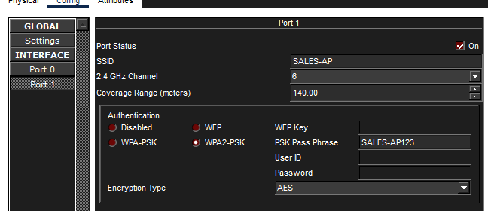

Laptop Wireless Setup
- Power off laptop → remove Ethernet NM-1CE module → insert WPC300N card → power on.
- Desktop → PC Wireless → Connect → select SSID → enter password → Connect.
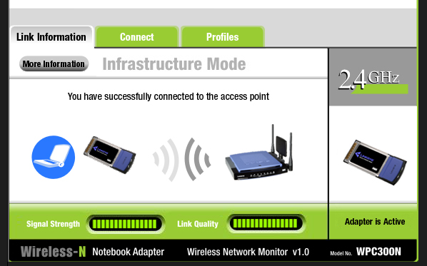

Wireless DHCP Verification
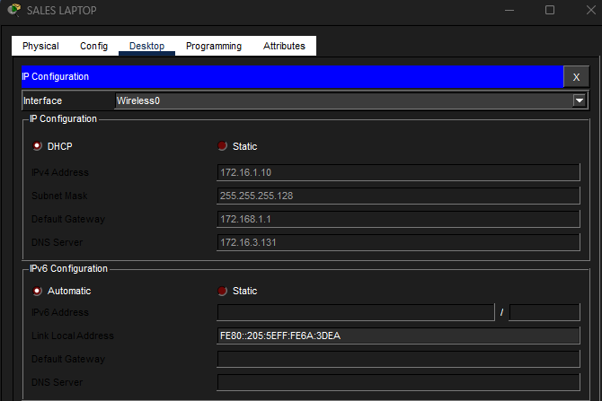
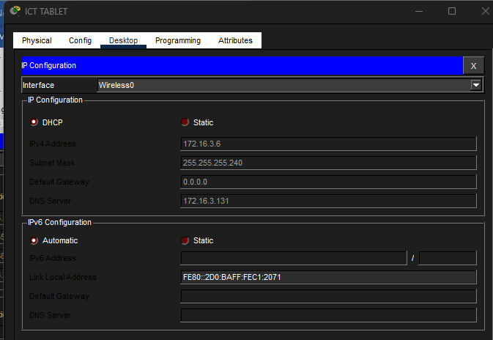

Command / Action | Technical Purpose & Why Used
WPC300N Module Swap | Default laptop modules are wired-only. WPC300N provides 2.4GHz wireless radio capability.
WPA2-PSK | Enforces AES block-cipher encryption on all wireless traffic, preventing packet sniffing.
Separate SSIDs | Each department discovers only its own network, preventing cross-departmental wireless bridging.

Step 11 — PAT + Access Control Lists

PAT allows all internal private addresses to share the public serial interface IP. ACLs define which networks are eligible for NAT translation.

CORE-R1 — NAT/PAT Configuration
CORE-R1> enable
CORE-R1# configure terminal
! Step 1: Define NAT-eligible networks
CORE-R1(config)# access-list 1 permit 172.16.1.0 0.0.0.127
CORE-R1(config)# access-list 1 permit 172.16.1.128 0.0.0.127
CORE-R1(config)# access-list 1 permit 172.16.2.0 0.0.0.127
CORE-R1(config)# access-list 1 permit 172.16.2.128 0.0.0.127
CORE-R1(config)# access-list 1 permit 172.16.3.0 0.0.0.127
CORE-R1(config)# access-list 1 permit 172.16.3.128 0.0.0.15
! Step 2: Bind ACL to WAN interfaces with PAT overload
CORE-R1(config)# ip nat inside source list 1 interface serial 0/2/0 overload
CORE-R1(config)# ip nat inside source list 1 interface serial 0/2/1 overload
! Step 3: Mark LAN interfaces
CORE-R1(config)# interface range gig0/0-1
CORE-R1(config-if-range)# ip nat inside
CORE-R1(config-if-range)# exit
! Step 4: Mark WAN interfaces
CORE-R1(config)# interface serial 0/2/0
CORE-R1(config-if)# ip nat outside
CORE-R1(config-if)# exit
CORE-R1(config)# interface serial 0/2/1
CORE-R1(config-if)# ip nat outside
CORE-R1(config-if)# exit
CORE-R1# write memory

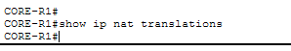
CORE-R2 — NAT/PAT Configuration
CORE-R2> enable
CORE-R2# configure terminal
! Step 1: Define NAT-eligible networks
CORE-R2(config)# access-list 1 permit 172.16.1.0 0.0.0.127
CORE-R2(config)# access-list 1 permit 172.16.1.128 0.0.0.127
CORE-R2(config)# access-list 1 permit 172.16.2.0 0.0.0.127
CORE-R2(config)# access-list 1 permit 172.16.2.128 0.0.0.127
CORE-R2(config)# access-list 1 permit 172.16.3.0 0.0.0.127
CORE-R2(config)# access-list 1 permit 172.16.3.128 0.0.0.15
! Step 2: Bind ACL to WAN interfaces with PAT overload
CORE-R2(config)# ip nat inside source list 1 interface serial 0/2/0 overload
CORE-R2(config)# ip nat inside source list 1 interface serial 0/2/1 overload
! Step 3: Mark LAN interfaces
CORE-R2(config)# interface range gig0/0-1
CORE-R2(config-if-range)# ip nat inside
CORE-R2(config-if-range)# exit
! Step 4: Mark WAN interfaces
CORE-R2(config)# interface serial 0/2/0
CORE-R2(config-if)# ip nat outside
CORE-R2(config-if)# exit
CORE-R2(config)# interface serial 0/2/1
CORE-R2(config-if)# ip nat outside
CORE-R2(config-if)# exit
CORE-R2# write memory

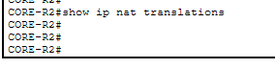

⚠️ Troubleshooting — Empty NAT Table & Ping Failures
⚠️ Issue: show ip nat translations returned empty. Pings to ISP returned 'Request timed out'.


Root Cause 1 — Missing NAT Boundary Tags
GigabitEthernet interfaces lacked 'ip nat inside'. Inbound corporate frames never triggered the NAT lookup engine.
Root Cause 2 — Wildcard Mask Mismatch
Overly restrictive ACL wildcards caused traffic from some floors to fall outside the matching boundary and get dropped without translation.
Root Cause 3 — Asymmetric Return Path
ISP routers lacked static reverse routes, causing return traffic to be dropped before reaching department PCs.
Fix Applied
! Fix 1: Re-declare interface boundaries
CORE-R2(config)# interface GigabitEthernet0/0
CORE-R2(config-if)# ip nat inside
CORE-R2(config-if)# interface Serial0/2/1
CORE-R2(config-if)# ip nat outside

! Fix 2: Widen ACL
CORE-R2(config)# no access-list 1
CORE-R2(config)# access-list 1 permit 172.16.0.0 0.0.255.255

! Fix 3: Add reverse route on ISP
ISP1(config)# ip route 172.16.0.0 255.255.0.0 195.136.17.9

! Verify
CORE-R2# show ip nat translations
CORE-R2# clear ip nat translation *
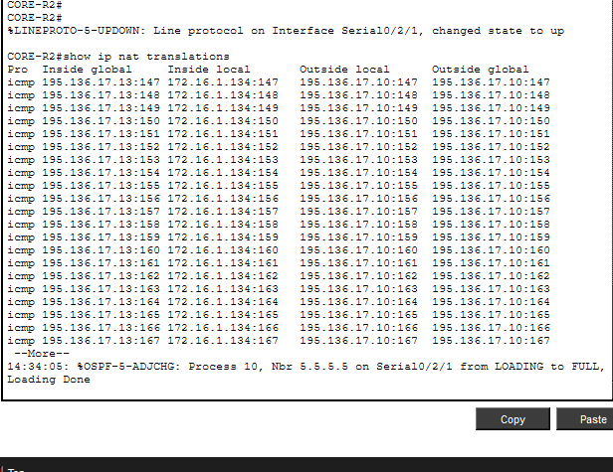

Command / Action | Technical Purpose & Why Used
access-list 1 permit [network] | Classifies which source IPs are eligible for NAT translation.
ip nat inside source list 1 interface [serial] overload | Enables PAT — all matching hosts share one public IP, tracked by unique port numbers.
ip nat inside / outside | Declares which interfaces are internal (LAN) and external (WAN) NAT boundaries.
overload | Enables PAT specifically. Without it, one-to-one static NAT would require a unique public IP per host.
clear ip nat translation * | Flushes the NAT cache — useful during troubleshooting to verify fresh translations populate correctly.

Step 12 — Verification & Testing

Comprehensive end-to-end testing was conducted after all configurations were applied to verify that every implemented technology functions as expected.

End-to-End Connectivity Test
C:\> ping 195.136.17.10 -n 4

Reply from 195.136.17.10: bytes=32 time=16ms TTL=253
Reply from 195.136.17.10: bytes=32 time=27ms TTL=253
Packets: Sent = 4, Received = 4, Lost = 0 (0% loss)
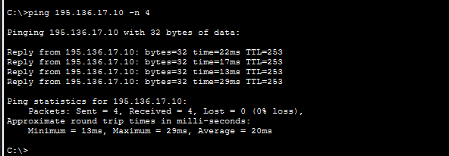

OSPF Neighbor Verification
CORE-R1# show ip ospf neighbor
! All neighbors in FULL state
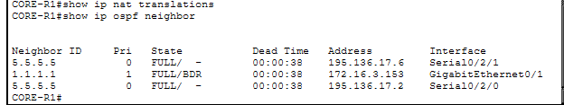

DHCP Verification
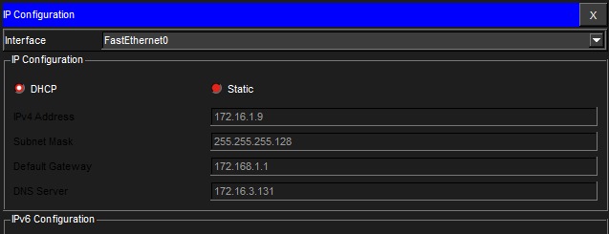

SSH Test
C:\> ssh -l admin 172.16.3.146
Password: cisco
! CORE-R1> prompt + banner shown
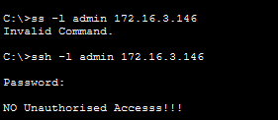
Port Security
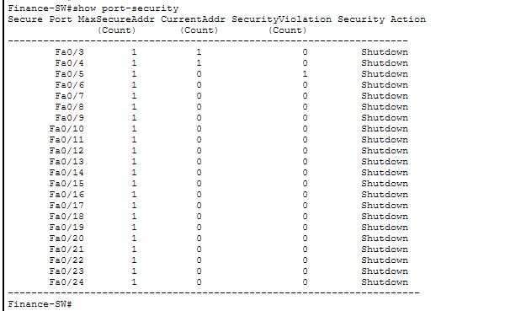

NAT/PAT Translation Table


Overall Test Summary
Test | Verification Method | Result
Inter-VLAN Connectivity | Ping across departments | Pass ✅
DHCP Auto-Assignment | IP auto-assigned to all PCs | Pass ✅
SSH Remote Access | SSH from SysAdmin PC | Pass ✅
OSPF Adjacency | show ip ospf neighbor | Pass ✅
NAT/PAT Translation | show ip nat translations | Pass ✅
Port Security (Finance) | show port-security | Pass ✅
Wireless Connectivity | Laptop/Tablet connect to AP | Pass ✅
Dual ISP Redundancy | Primary/backup route test | Pass ✅

Appendix — AI Assistance Disclosure

This project was independently designed and implemented by the student. Claude AI (Anthropic) was used strictly as a learning assistant to understand concepts — not to generate configurations.

AI Was Used For | Student Did Independently
Explaining networking concepts (OSPF, NAT, VLANs, SSH) | Full Packet Tracer topology design
Clarifying why each command is used | All CLI configurations typed manually
Documentation structure guidance | IP subnetting calculations
Reviewing logic for deeper understanding | All troubleshooting — identifying root causes & fixes
Answering 'what if' questions during learning | Final testing and verification

Every command in this document was typed manually and verified in Cisco Packet Tracer. All troubleshooting scenarios were real issues encountered and resolved during the project.

B.Tech in Computer Networks & Cloud Security | University of Vocational Technology (UoVT) | 2026

