**Guiding Principle Number 5:** *“Defy gravity. Innovate to overcome barriers.”*

Being that one of our key objectives is to defy gravity, we have a keen interest in reports of objects that do just that. However, the data collected by The National UFO Reporting Center (NUFORC) is minimally unorganized and difficult to navigate. Attached is the beginning of a project that reads the raw data collected by NUFORC from a CSV and displays it to the screen in an HTML table.

The project is an ASP NET Web Application, MVC 4. To access the project use Visual Studio Community Edition, or any version of Visual Studio you may already have – just so long as it can run MVC4. When you launch the project, you will see a page similar to the following:

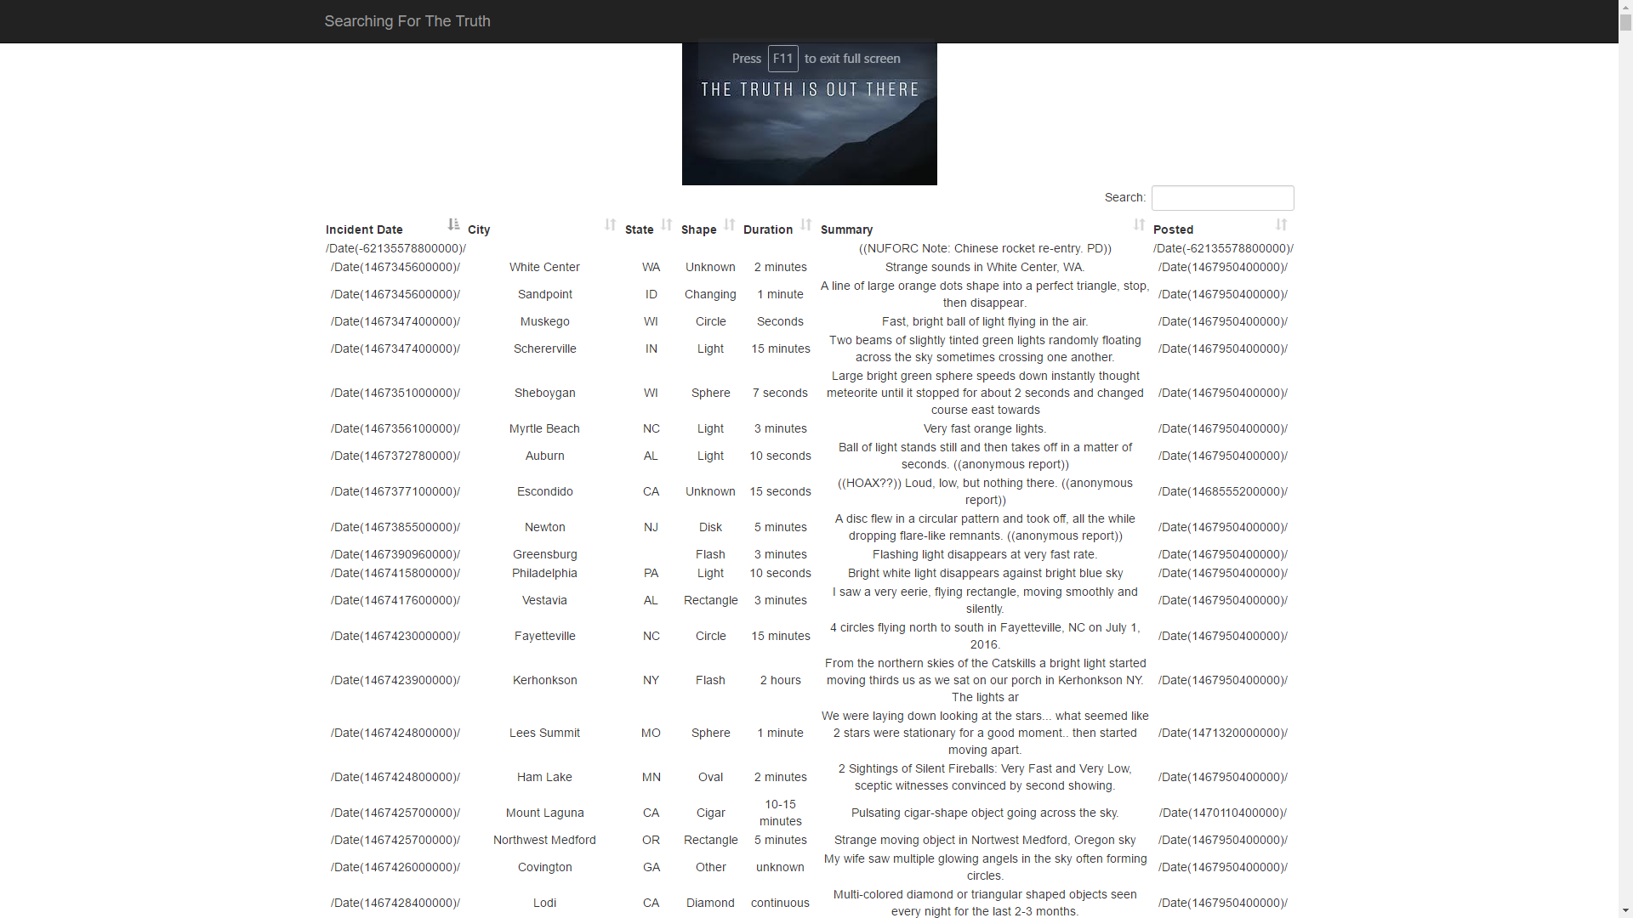

**We need the following functionality:**

1. Please style the table so that the rows alternate colors
2. The dates are gibberish, please format those so that we can read them
3. Please add paging to make the data more manageable
4. Please add the ability to filter by state and/or shape. Ideally, the possible options will be available in dropdowns above the table. *Note: The default search included with datatables.net is not sufficient.*
5. Add a button to the screen that will display a new modal dialogue when clicked. This modal dialogue will contain all the fields necessary to create a new sighting. The dialogue should have a “Save” option that when clicked will call the controller and return a message of success. *Note: The new sighting does not have to actually be saved anywhere for now.*
6. Write a Unit Test around each public method in the Home Controller

**Extra Credit:**

1. Save added sightings back to file.
2. When clicking on a city, open a new tab that shows the city on google maps
3. Add a bar graph chart that shows sightings per state
4. Whatever you think is useful

**A few call outs:**

1. Pay special attention to the UI, making sure everything is clean and intuitive.
2. Performance is critical.
3. Be creative.