

Resource Asset Registration Guide
V5.5 11/01/19

Revision History
Date | Version | Description | Author
10/10/2007 | 0.03 | Draft for Internal Review | D. Showalter
10/10/2007 | 0.04 | Second draft for Internal Review | D. Showalter
10/10/2007 | 0.05 | Draft for Posting | D. Showalter
10/11/2007 | 0.06 | Revised Draft for Posting | D. Showalter
10/16/2007 | 0.07 | Revised with Market Comments | D. Showalter
12/13/2007 | 0.08 | Revised for Planning Submittal | D. Showalter
4/01/2008 | 3.99 | Draft –Reorganized and reformatted for RARF Ver 4 | D. Showalter
4/08/2008 | 4.00 | Released with RARF Ver 4 (Official RARF) | D. Showalter
12/16/08 | 4.01 | Updated RARF Guide V4.01 | A. Moy
2/4/2009 | 4.02 | Updated and re-wrote transmission and load data tabs | S. Middleton
3/10/2009 | 4.03 | Corrected / Modified business rules for transformer tab | S. Middleton
6/5/2009 | 4.04 | Added Business Rules for Planning / Protection | S. Middleton
6/10/2009 | 4.05 | Added Business Rules for Planning / Protection | P. Nellutla
6/23/2009 | 4.06 | Added Business Rules for Planning / Protection | P. Nellutla
07/06/09 | 4.07 | Updated Business Rules for Planning, Line Data, Transformer tab and updated the definition of unit commercial date in section 4, Date effective field is included in section 12-18 | P. Nellutla
07/24/09 | 4.08 | Updated Business Rules for Line Data, Transformer, Breaker/Switch, Series Device, Load Data, Capacitor Reactor, Static Var Compensator, Planning, Protection. Updated Section 7.4 | P. Nellutla
09/01/09 | 4.09 | Updated Section 7.3 and updated Business Rules for Transformer/Line/Breaker-Switch/Series Device Data/Capacitor or Reactor/Load Data. | P. Nellutla
11/2/2009 | 4.10 | Updated Business Rules for Capacitor/Reactor and Transformer tabs. | P. Nellutla
11/18/2009 | 4.11 | Updated section 6.5 with Business Rules for Operational Parameters-GEN, CC, and Wind. Updated Business Rules for Capacitor- Reactor Tab | P. Nellutla
2/8/2010 | 4.12 | Updated Business Rules for Operational/Transmission tabs | P. Nellutla
12/10/10 | 4.13 | Added Protocol Disclaimer | - Deller
6/16/2011 | 4.14 | Removed TML and added MIS link | G.Schroeder
10/26/11 | 5.00 | Updated Guide for RARF v5.0 | - Deller
12/08/11 | 5.00 | Updated Guide for RARF v5.0 | - Moy
3/20/12 | 5.00 | Updated Guide for RARF v5.0 | - Moy
06/18/2012 | 5.1 | Updated Guide for RARF v5.1 | G. Schroeder
12/09/2013 | 5.2 | Updated Guide for RARF v5.2 Wind Form for NPRR425 | G. Schroeder
11/17/2014 | 5.3 | Updated Guide for RARF v5.3 NER Regional Standard BAL-TRE-001 | G.Schroeder
5/5/17 | 5.4 | Update Guide for RARF v5.4 | A.Deller
11/01/19 | 5.5 | Update Guide for v5.5 | G.Schroeder

Table of Contents
1.0 Summary of Resource Registration Guide 6
2.0 Summary of Resource Asset Registration Forms 8
2.1 Tabs 8
2.2 Glossary 10
3.0 Instructions 11
3.1 Process for Official Submittal 11
3.2 Process for Embedding documents in the RARF 12
4.0 General Information and ESIID Information RARF Workbook 13
4.1 Instructions 13
4.2 General and Site Information 13
4.3 Generation Load Split Information 15
4.4 Private Network - Site 15
5.0 Generation 16
5.1 Instructions 16
5.2 Unit Info - GEN 16
5.3 Unit Info – AGR 16
5.4 Ownership - GEN 17
5.5 Parameters - GEN 17
5.6 Operational Parameters - GEN 19
5.7 Operational Parameters - NRRC 19
5.8 Operational Parameters - ERRC 19
5.9 Private Network - Unit 20
5.10 Reactive Capability - GEN 20
5.11 Planning - GEN 20
5.12 Protection - GEN 21
5.13 Subsync - GEN 21
5.14 PSCAD Model 21
5.15 Dynamic Data 21
6.0 Combined Cycle RARF Workbook 21
6.1 Instructions 21
6.2 Unit Info - TRAIN 22
6.3 Unit Info - CC 22
6.4 Ownership - CC 23
6.5 Parameters - CC 23
6.6 CC Configuration 23
6.7 CC Transitions 24
6.8 Parameters - CFG 24
6.9 Operational Parameters - CFG 25
6.10 Operational Parameters - NRRC 25
6.11 Operational Parameters - ERRC 25
6.12 Private Network - Unit 26
6.13 Reactive Capability - CC 26
6.14 Planning - CC 26
6.15 Protection - CC 27
6.16 Subsync - CC 27
6.17 PSCAD Model 27
6.18 Dynamic Data 27
7.0 Renewable RARF Workbook 28
7.1 Instructions 28
7.2 Unit Info - RENEWABLE 28
7.3 Wind Turbine Details 28
7.4 Inverter Details – SOLAR 29
7.5 Panel Details - SOLAR 30
7.6 PVGR Connectivity 31
7.7 Ownership - RENEWABLE 31
7.8 Parameters - RENEWABLE 31
7.9 Operational Parameters - RENEWABLE 32
7.10 Operational Parameters - NRRC 32
7.11 Operational Parameters - ERRC 32
7.12 Private Network - Unit 33
7.13 Reactive Capability - RENEWABLE 33
7.14 Planning - RENEWABLE 34
7.15 Protection - RENEWABLE 34
7.16 Collector System - RENEWABLE 34
7.17 Collector System – Renew Segment data 35
7.18 PSCAD Model 35
7.19 Dynamic Data 35
8.0 LaaR RARF Workbook 35
8.1 Instructions 35
8.2 General Information - ALL 35
8.3 Load Resource Information 36
8.4 Load Resource Parameters 36
8.5 One Line 36
9.0 Transmission RARF Workbook 37
9.1 Instructions 37
9.2 Station 37
9.3 Line Data 37
9.4 Line Temperature 37
9.5 Breaker Switch Data 38
9.6 Capacitor and Reactor Data 38
9.7 Transformer Data 39
9.8 Transformer Tap settings 39
9.9 Static Var Compensator Data 39
9.10 Series Device Data 40
9.11 Load Data 40
9.12 PUN Load Data 41
9.13 One Line 41
9.14 Transformer Test Data 41
10.0 Settlement Only Distributed Generation (SODG) 42
10.1 Instructions 42
10.2 Unit Info – DG 42

PROTOCOL DISCLAIMER
This Guide describes ERCOT processes and is not intended to be a substitute for the ERCOT Nodal Protocols (available at http://www.ercot.com/mktrules/nprotocols/ ), as amended from time to time. If any conflict exists between this document and the ERCOT Nodal Protocols, the ERCOT Nodal Protocols shall control in all respects.

Summary of Resource Registration Guide
This document is a guide to completing Resource Asset Registration Form (RARF) with ERCOT in accordance with Section 16 of the ERCOT Nodal Protocols. Upon obtaining the forms from Resource Entities, ERCOT will keep the RARFs in a central repository hub so the files can be tracked and easily accessed by all ERCOT systems, as well as communicated back to the Resource Entity through audits (Figure 1 below illustrates the process flow of receiving and loading RARF data).
Data from the RARF package is used to provide input to the Network Model used by Operations in dispatch of Resources. RARF data also feeds the Planning group to support system studies. Data also flows to the Registration systems as well as the Settlement and Aggregation systems to ensure proper settlement of Resource dispatches and operation.
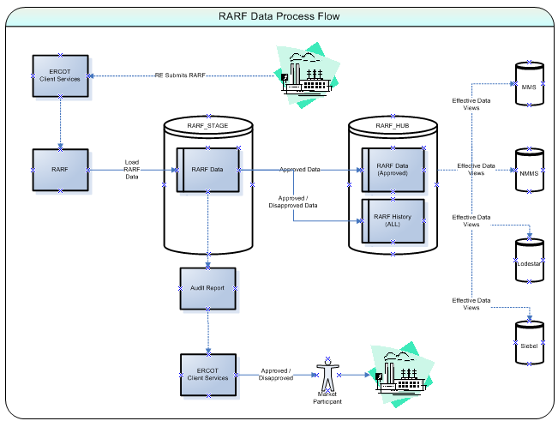
Figure 1

Summary of Resource Asset Registration Forms

Tabs
The RARF is a collection of workbooks that focus on specific Resource types. There are 7 major workbooks, as follows:
- General Site ESIID Information
- Generation
- Combined Cycle
- Renewable
- Load Resource
- Transmission
- Settlement Only Generation (SOG) Gen Form Pivoted

Each of the workbooks has multiple tabs for organizing and collecting data as follows:

- General Site ESIID Information
  - Instructions
  - General and Site Information
  - GEN Load Split – ESIID
  - Private Network - Site

- Generation
  - Instructions
  - Unit Info – GEN
  - Unit Info - AGR
  - Ownership – GEN
  - Parameters – GEN
  - Operational Parameters – Gen
  - Operational Parameters – NRRC
  - Operational Parameters – ERRC
  - Private Network – Unit
  - Reactive Capability – GEN
  - Planning – GEN
  - Protection – GEN
  - SubSync – GEN
  - PSCAD Model
  - Dynamic Data

- Renewable
  - Instructions
  - Unit Info – RENEWABLE
  - Wind Turbine details
  - Inverter Details – SOLAR
  - Panel Details – SOLAR
  - Ownership - RENEWABLE
  - Parameters – RENEWABLE
  - Operational Parameters – RENEWABLE
  - Operational Parameters – NRRC
  - Operational Parameters – ERRC
  - Private Network - Unit
  - Reactive Capability – RENEWABLE
  - Planning – RENEWABLE
  - Protection – RENEWABLE
  - Collector System - RENEWABLE
  - Collector System – Renew Segment Data
  - PSCAD Model
  - Dynamic Data

- Combined Cycle
  - Instructions
  - Unit Info – TRAIN
  - Unit Info - CC
  - Ownership – CC
  - Parameters – CC
  - CC Configurations
  - CC Transitions
  - Parameters – CFG
  - Operational Parameters – CFG
  - Operational Parameters – NRRC
  - Operational Parameters – ERRC
  - Private Network - Unit
  - Reactive Capability – CC
  - Planning – CC
  - Protection – C
  - Subsync - CC
  - PSCAD Model
  - Dynamic Data

- LaaR
  - RARF Form
  - General Information – LAAR
  - Load Resource Information
  - Load resource Parameters
  - CLR-NRRC
  - CLR-ERRC

- Transmission
  - Instructions
  - Station
  - Line Data
  - Line Temperature
  - Most Limiting Series Element
  - Breaker Switch Data
  - Capacitor and Reactor Data
  - Transformer Data
  - Transformer Tap Settings
  - Static Var Compensator Data
  - Series Device Data
  - Load Data
  - PUN Load
  - One Line
  - Transformer Test Data

- Settlement Only Generation (SOG)
  - Instructions
  - Unit Info - DG

Glossary
The RARF Glossary is posted on the ERCOT website (http://www.ercot.com/mktrules/guides/resourcereg/library) and is controlled by the Resource Data Working Group. This document controls what data elements are in the RARF and also defines what data is required at each stage of registration.

Instructions
A RARF package should be submitted for each generation resource site that contains data for all generation at the site. A separate RARF should also be submitted for each Resource Entity covering all load resources represented by that entity. A RARF is to be completed for all active and mothballed generation resources inside ERCOT. Organizations must submit a market participant application as a Resource Entity prior to submission of this form, if not eligible for Federal Hydro waiver (Section 16.5). If questions arise related to the completion of this form, please contact your designated ERCOT Account Manager or email Model Administration at resourcereg@ercot.com with the subject "Resource/Asset Registration Form".
- Please bear in mind the following for the completion of this form, A single, complete Generation RARF package, consists of:
  - the General Site ESIID Information workbook,
  - the Generation, Combined Cycle, Wind and/or Settlement Only Generation (SOG) workbook(s) as appropriate and
  - the workbook for Transmission assets, must be submitted for each resource site.
  - Note (In each form on the second tab in cell B5 is a cell that references the Site Code, this MUST be completed on all 5 of the (Gen, CC, Renewable, Settlement Only Generation (SOG) and Transmission) forms.)
- A single RARF must be submitted for each load resources represented by a common Resource Entity.

Process for Official Submittal
Each submittal must have all three workbooks (General Site ESIID Information the Resource workbook(s) (Generation, Combined Cycle, Renewable, Settlement Only Generation (SOG) ) and the Transmission workbook). Even if the submission is to alter a generator parameter, the General Site ESIID Information, the appropriate resource workbook (Generation, Combined Cycle, Renewable and/or Settlement Only Generation (SOG)) and Transmission book must be included. The LAAR will have a single workbook.
There are two methods of submitting the RARF, as follows:
PRIMARY: RARFs are to be submitted through the Market Information System (MIS) located at https://mis.ercot.com. Submission through the MIS link requires a valid Authorized Representative’s digital certificate.
ALTERNATE: An alternate email signature document is available upon request from your ERCOT Account Manager for those who have technical problems submitting via MIS. The RARF must be emailed in Microsoft Excel spreadsheet (xls) format, along with the signature document to: mpappl@ercot.com and resourcereg@ercot.com . (Please allow at least 2 additional days for processing)
The following are instructions for submitting the RARF through MIS:
- Access to ERCOT MIS requires a user digital certificate with a minimal role of “MP_ASSESTS’ this allows access to "Create Service Request" on the "Applications" page. The "user digital certificate" is authorized by the Market Participant's User Security Administrator.
- Upon accessing MIS, click on "Applications" then select "Service Request". Be advised that the Service Request will display in a new window as a pop-up, which may be restricted by browser settings.
- Complete the required fields on the "Service Request" screen annotated by red asterisks.

- The following Request Type and Sub-Type are essential to a proper submittal:
  - Request Type: Select "MP Registration" from the drop-down list
  - Request Sub-Type: Select "Resource/Asset Registration" from the drop-down list
Please note that if the Type and Sub-Type values above are not used, the RARF will not be received or processed by ERCOT Client Services.

- Short Description: Brief description of change and Sitecode.
  - Long Description: List of changes that are being made to the RARF.
Example: Parameters, Operational Parameters, Reactive Capabilities, Breaker Switch, etc.

- Click "Submit" (you will add the RARF file on the next screen)
- From the "Activities and Attachments" screen, under the Attachments heading of the Service Request click the ‘Add’ button. Please make sure that your Attachment is a .ZIP file and all RARF forms that are included are in .XLS format.
Please note that the RARF Forms must keep version 5.0 naming convention when being submitted (Wind_Form_Pivoted.xls, Gen_Form_Pivoted.xls, Combined_Cycle_Form_Pivoted.xls and Transmission_Form_Pivoted.xls).
The LAAR Form must keep the naming convention LAAR_Form_Pivoted.xls.

- Click "Submit" (you will add the RARF Zip file on the next screen)
- Click "Submit" (comments are optional)
ERCOT will verify the RARF is sent from the Authorized Representative of the registered Resource Entity via digital certificate. ERCOT may request additional authentication as deemed necessary.

Process for Embedding documents in the RARF
- While on the tab needing to embed a document within, click on INSERT, then click on OBJECT
- From the popup screen click on Adobe Acrobat Document in the list and also check the ‘display as icon’ button, then OK.
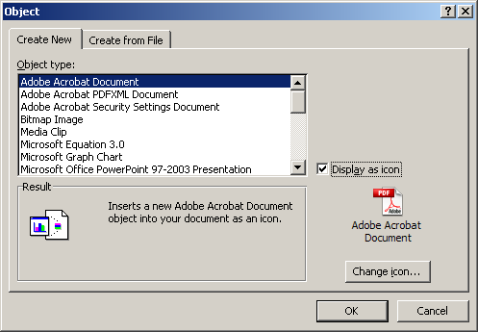
- A new popup screen will appear to select the file you want to embed, and then click the ‘Open’ button.
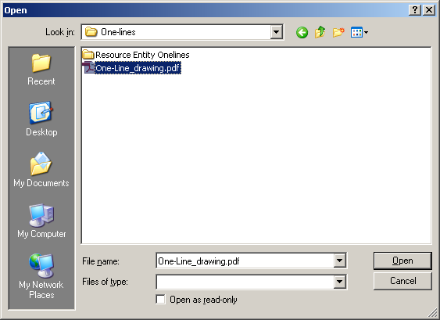
NOTE: the one-line pdf file will Open into a new screen. Just close it down and the file will be embedded in the One Line tab.

General Information and ESIID Information RARF Workbook

Instructions
Detailed instructions for the RARF submittal process through the Market Information System (MIS) are contained in section 3.1 of this document.

General and Site Information
The General and Site Information tab identifies information about the Resource Entity. The contact information is essential, as it provides ERCOT with additional contacts in case of questions regarding the RARF. The Resource Entity Name does not allow any special characters except spaces and dashes. The Data Universal Numbering System (DUNS) number is a nine digit identifier, some companies are given an additional 4 digits (total13 digits) by ERCOT to uniquely identify their entity. The Resource site name and site code are unique for each site and the code is jointly coordinated with ERCOT. The Site Name and Site Code should follow the name on the Interconnect Agreement signed with the Transmission Service Provider, with the Site Code being no more than 8 characters and all CAPs, no spaces or special characters (except underscores).
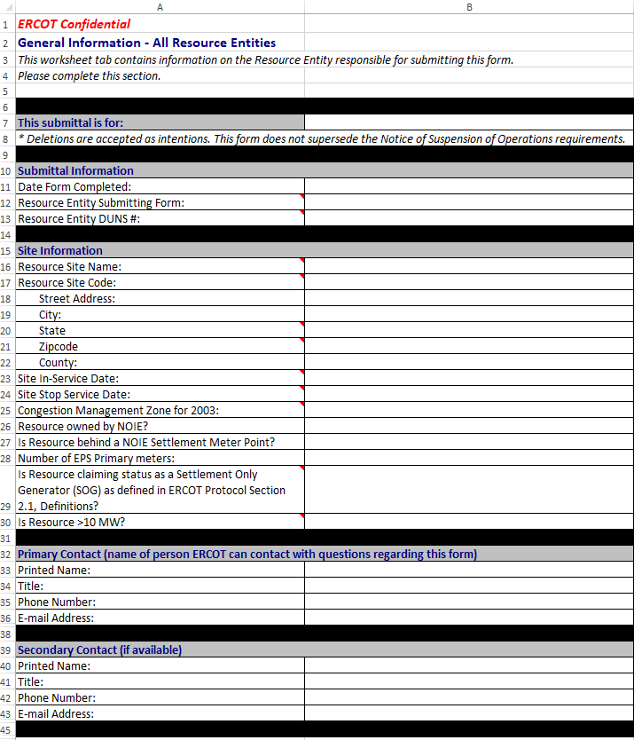

Generation Load Split Information
This section must be completed for the Electric Service Identifier assigned to a service delivery point. Or to note if the facility has or does not have a Gen Site Load split among multiple competitive retailers or among multiple TDSPs or has multiple Electric Service Identifiers.

With Split Load Resources
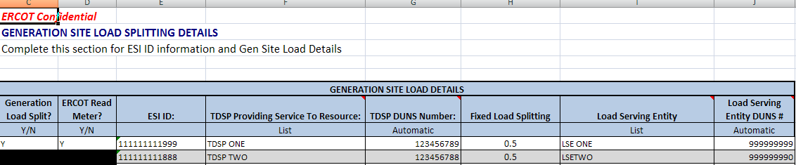
Without Split Load Resources
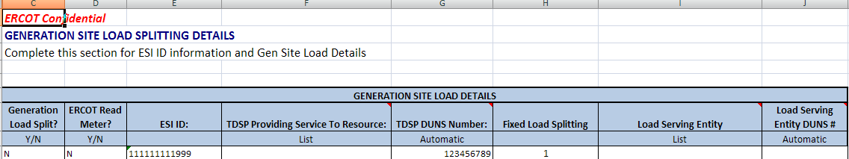

Private Network - Site
The Private Network Site tab identifies whether the site is part of a private use network (PUN) which typically contains load that is not directly metered by ERCOT. If the site is part of a PUN then the data is required for the site Load characteristics for the MW load and the MVAR load percentages. If the site is not part of a PUN, then no other data need be filled out on this tab and additional fields are blacked out.
With Private Network Site Info
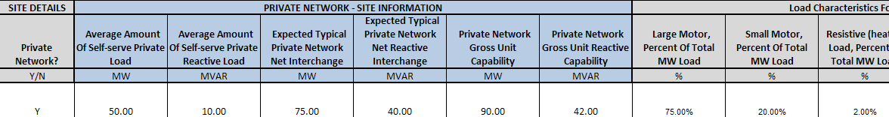
Without Private Network Site Info
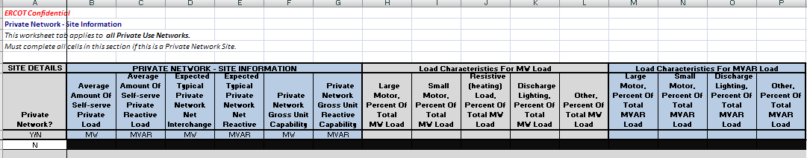

Generation

Instructions
Detailed instructions for the RARF submittal process through the Market Information System (MIS) are contained in section 3.1 of this document.

Unit Info - GEN
This section must be completed for each unit that is part of the generation resource site. It includes the Generator details, site and unit dates, point of interconnection information, fuel information, ratings and design information and geographic location data. (Fields include: Settlement Only Generation (SOG), Transmission POI date, SGIA date, Model Ready date, POI substation, POI voltage, POI bus number, Primary fuel, Secondary fuel, Resource category, Physical unit type, Governor droop, Governor dead-band, Design Max ambient temp, Design Min ambient temp, Latitude of plant & Longitude of plant). Note: Cell B5 (Resource Site Code) must be completed on all forms.
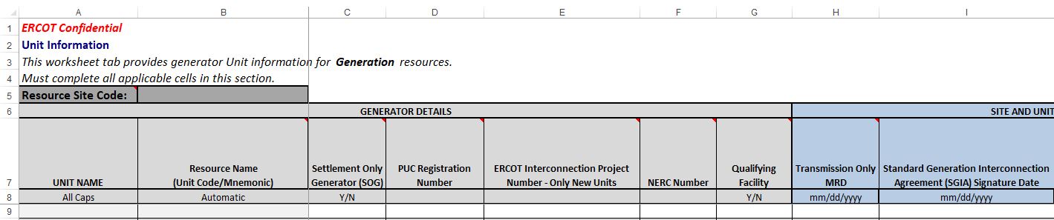
Note: Prior to your next RARF submission, remove all unit(s) that are no longer active and were stopped in a prior submission.

Unit Info – AGR
This section must be completed for each unit that is part of the generation with an Aggregated Unit . It includes the Resource Name Unit Code/Mnemonic, Aggregated Generation Resource Manufacturer Model, MW Rating for this Aggregated Generation Resource and Number of this type of Aggregated Generation Resource.
*Note – even if a site doesn’t have an AGR, the unit name still is required to be filled in.
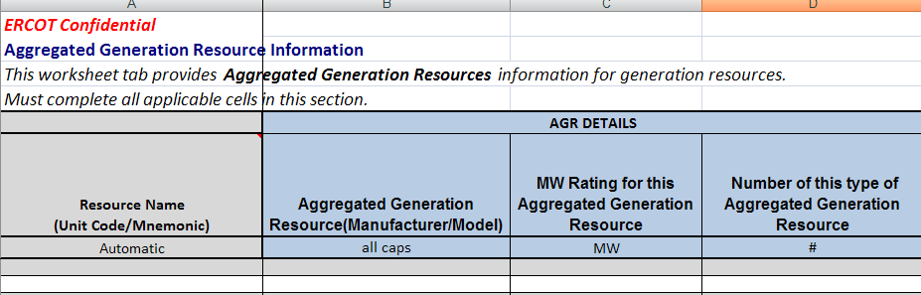

Ownership - GEN
The Ownership tab must be completed for each unit that is part of the generation resource site. It includes the Generator details, ownership information and percentages. (Fields include: Unit Name, Resource Name, Ownership start date & Ownership stop date)
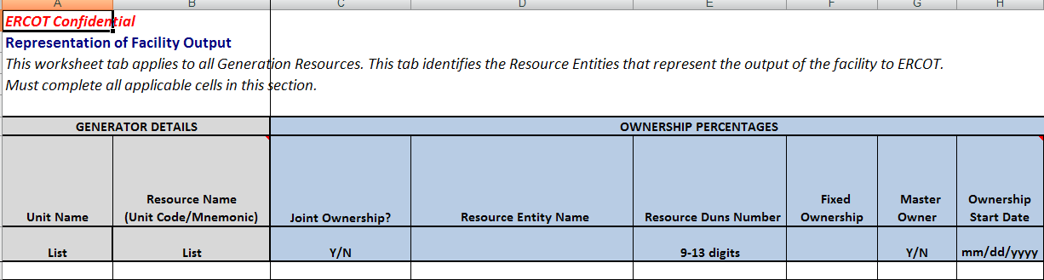

Parameters - GEN
The Parameters tab must be completed for each unit that is part of the generation resource site. It includes the Generator details, reasonability limits, seasonal ratings and unit de-rating values for temperature changes. (Fields include: Unit Name, Resource Name & Unit De-rating values)
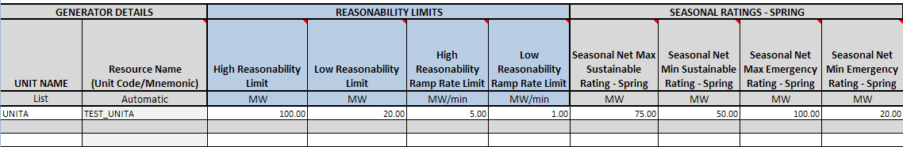
The Parameters tab has been updated to include Steam Turbine Pressure Curve data for Generation units with Physical Unit Type (ST) and Resource Category is 'Gas Steam - Non-reheat or Boiler without air-preheater, Gas Steam - Reheat Boiler, Gas Steam - Supercritical Boiler or Coal and Lignite'.

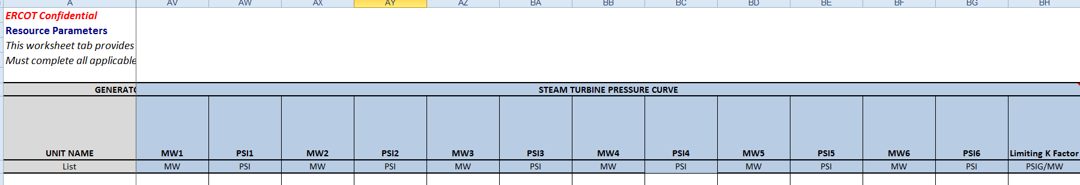

Field NAME | Definition / Detailed Description | Validations
MW1 | Maximum pressure. Net MW value where the steam generator typically reaches rated pressure. If pressure is constant for the normal operating range enter the same value as is entered as the Governor minimum operating level (required value for steam turbines). | 1. MW1 Must Not be Null if Physical Unit is 'ST' and Resource Category is 'Gas Steam - Non-reheat or Boiler without air-preheater, Gas Steam - Reheat Boiler, Gas Steam - Supercritical Boiler or Coal and Lignite' .  2. MW1 must be a floating point.  3. MWH => MW1 => MWL where,  MWH = HRL  MWL = Max(MW2*, MW3*, MW4*, MW5*, MW6, LRL) ( (* do not include in computation if null) )
PSI1 | Rated throttle pressure (required value for steam turbines) at MW1 | 1. PSI1 must be a floating point.  2. If MW1 is non-null then PSI1 must be non-null.
MW2 | Net unit output (breakpoint value used to define the pressure/MW curve). If not needed, enter same values as the Pressure PSI (1) or MW (1). | 1. MW2 must be a floating point.  2. If PSI2 is non-null then MW2 must be non-null.  3. If MW2 is non-null, MWH => MW2 => MWL where,  MWH = Min (HRL, MW1)  MWL = Max(MW3*, MW4*, MW5*, MW6, LRL) ( (* do not include in computation if null) )
PSI2 | Throttle steam pressure (PSI) at MW2 value (breakpoint value used to define the pressure/MW curve). If not needed, enter same values as the Pressure PSI (1) or MW (1). | 1. PSI2 must be a floating point.  2. If PSI2 is non-null then MW2 must be non-null.
MW3 | Net unit output (breakpoint value used to define the pressure/MW curve). If not needed, enter same values as the Pressure PSI (1) or MW (1). | 1. MW3 must be a floating point.  2. If PSI3 is non-null then MW3 must be non-null.  3. If MW3 is non-null, MWH => MW3 => MWL where,  MWH = Min (HRL, MW1, MW2*) ( (* do not include in computation if null) )  MWL = Max(MW4*, MW5*, MW6, LRL) ( (* do not include in computation if null) )
PSI3 | Throttle steam pressure (PSI) at MW3 value (breakpoint value used to define the pressure/MW curve). If not needed, enter same values as the Pressure PSI (1) or MW (1). | 1. PSI3 must be a floating point.  2. If MW3 is non-null then PSI3 must be non-null.
MW4 | Net unit output (breakpoint value used to define the pressure/MW curve). If not needed, enter same values as the Pressure PSI (1) or MW (1). | 1. MW4 must be a floating point.  2. If PSI4 is non-null then MW4 must be non-null.  3. If MW4 is non-null, MWH => MW4 => MWL where,  MWH = Min (HRL, MW1, MW2*, MW3*) ( (* do not include in computation if null) )  MWL = Max(MW5*, MW6, LRL) ( (* do not include in computation if null) )
PSI4 | Throttle steam pressure (PSI) at MW4 value (breakpoint value used to define the pressure/MW curve). If not needed, enter same values as the Pressure PSI (1) or MW (1). | 1. PSI4 must be a floating point.  2. If MW4 is non-null then PSI4 must be non-null.
MW5 | Net unit output (breakpoint value used to define the pressure/MW curve). In not needed, enter same values as the Pressure PSI (1) and MW (1). | 1. MW5 must be a floating point.  2. If PSI5 is non-null then MW5 must be non-null.  3. If MW5 is non-null, MWH => MW5 => MWL where,  MWH = Min (HRL, MW1, MW2*, MW3*, MW4*) ( (* do not include in computation if null) )  MWL = Max(MW6, LRL)
PSI5 | Throttle steam pressure (PSI) at MW5 value (breakpoint value used to define the pressure/MW curve). If not needed, enter same values as the Pressure PSI (1) or MW (1). | 1. PSI5 must be a floating point.  2. If MW5 is non-null then PSI5 must be non-null.
MW6 | Minimum pressure. Net unit MW output where the steam generator typically reaches minimum pressure (required value for steam turbines) | 1. MW6 Must Not Be Null if Physical Unit is 'ST' and Resource Category is 'Gas Steam - Non-reheat or Boiler without air-preheater, Gas Steam - Reheat Boiler, Gas Steam - Supercritical Boiler or Coal and Lignite' .  2. MW6 must be a floating point.  3. MWH => MW6 => MWL where,  MWH = Min (HRL, MW1, MW2*, MW3*, MW4*, MW5*) ( (* do not include in computation if null) )  MWL = LRL
PSI6 | Throttle steam pressure (PSI) at MW6 value (required value for steam turbines). | 1. PSI6 must be a floating point.  2. If MW6 is non-null then PSI6 must be non-null.
Limiting K Factor | The K factor is used to model the stored energy available to the resource. The value ranges between 0.0 and 0.6 PSIG per MW change when responding during a FME. The resource can measure the drop in throttle pressure when the resource is operating near 50% output of the steam turbine during a FME and provide this ratio of pressure change to the BA. The value is given as a PSI Change per MW change. The default value would be zero (required for steam turbines). | 1.K_FACTOR Must Not be Null if Physical Unit is 'ST' and Resource Category is 'Gas Steam - Non-reheat or Boiler without air-preheater, Gas Steam - Reheat Boiler, Gas Steam - Supercritical Boiler or Coal and Lignite' .  2. K Factor must be a floating point with default 0.0  3. 0.0 =< K =< 0.6

Operational Parameters - GEN
The Operational Parameters tab must be completed for each unit that is part of the generation resource site. It includes the Generator details and the resource parameters including minimum on-line and off-line times, hot, cold, intermediate, hot to intermediate and intermediate to cold start times and daily and weekly start data.
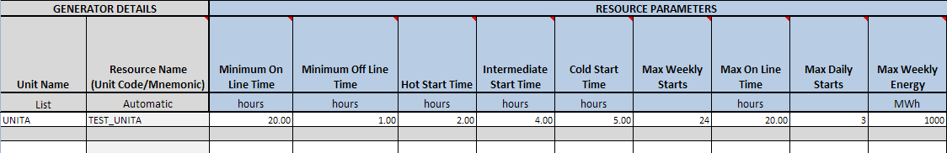

Operational Parameters - NRRC
The Operational Parameters Normal Ramp Rate Curve data must be completed for each unit that is part of the generation resource site. Note that only 1 MW value and the corresponding normal upward and normal downward ramp rate are required, additional MW’s are optional.
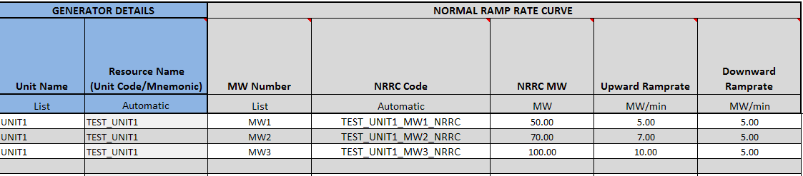

Operational Parameters - ERRC
The Operational Parameters Emergency Ramp Rate Curve data must be completed for each unit that is part of the generation resource site. Note that only 1 MW value and the corresponding normal upward and normal downward ramp rate are required, additional MW’s are optional.
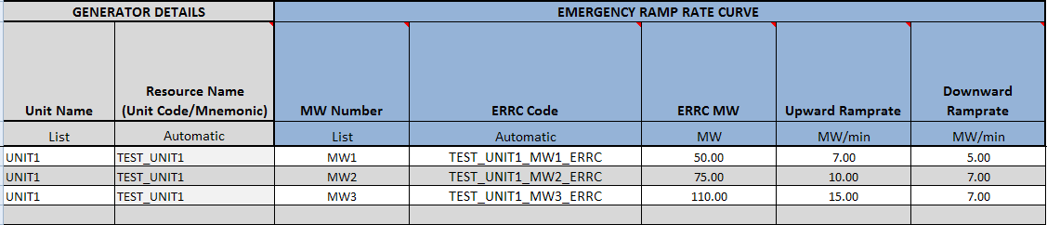

Private Network - Unit
The Private Network Unit tab is to be completed only if the site has completed the site information as a PUN site, then the data must be completed for each unit that is part of the private network resource site, Which includes the MW and MVAR load, net interchange and gross unit capabilities. If the site is not part of a PUN, then no unit data need be filled out on this tab and all fields will be blacked out. (Fields include: Unit Name, Site Code & Resource Name)
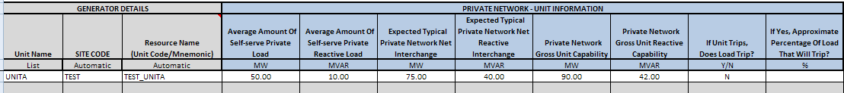

Reactive Capability - GEN
The Reactive Capability must be completed for each unit that is part of the generation resource site. It includes the generator details and the reactive capability curve data which are 5 increasing MW values of Operating Real Power and 9 points of MVAR reactive power information. The lagging MVAR amounts should be listed as positive numbers and the leading MVAR amounts should be listed as negative. MW5 is the unity power factor amount or maximum value of real power MW at 1.0 PF, the reactive power which crosses the x-axis on the curve is zero. (Fields include: Unit Name, Resource Name, Gross/Net values, NDCRC test & Test date)
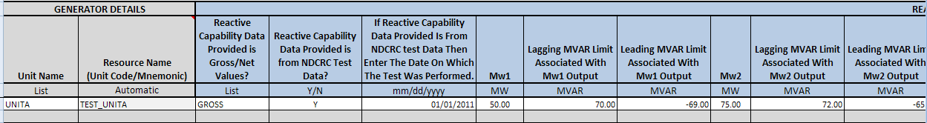

Planning - GEN
The Planning tab must be completed for each unit that is part of the generation resource site. It includes the generator details, planning details, generator auxiliary load information, generation auxiliary MW load characteristics and generation auxiliary MVAR load characteristics. (Fields include: Unit Name, Resource Name, Direct Axis Sub transient reactance unsaturated, Direct Axis Transient reactance unsaturated, Positive Sequence Z – R unsaturated, Positive Sequence Z – X unsaturated, Negative Sequence Z – R unsaturated, Negative Sequence Z – X unsaturated, Zero Sequence exist, Zero Sequence Z – R unsaturated, Zero Sequence Z – X unsaturated, Zero Sequence Grounding Resistance, Zero Sequence Grounding Reactance, Zero Sequence Resistance, Zero Sequence Reactance & Aux Load power factor)
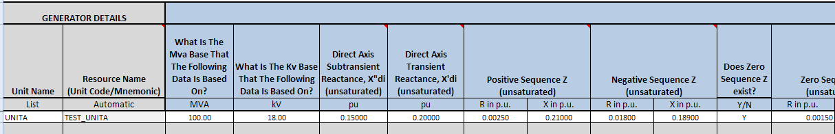

Protection - GEN
The Protection tab must be completed for each unit that is part of the generation resource site. It includes the generator details, plant under and over voltage protection and plant under and over frequency protection information. (Fields include: Unit Name & Resource Name)
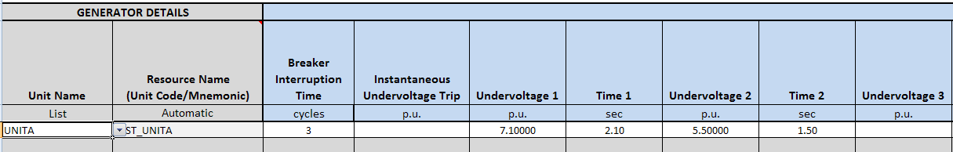

Subsync - GEN
The Subsync tab should be completed for each unit that may require subsynchronous resonance studies as part of the interconnection process or for additional planning studies to maintain the reliability of the ERCOT System by meeting all NERC Reliability Standards, ERCOT Protocols and Operating Guides that would be affected by the interconnection and operation of the generation site. (Fields include: Unit Name, Resource Name, Mass # & Mass Code)
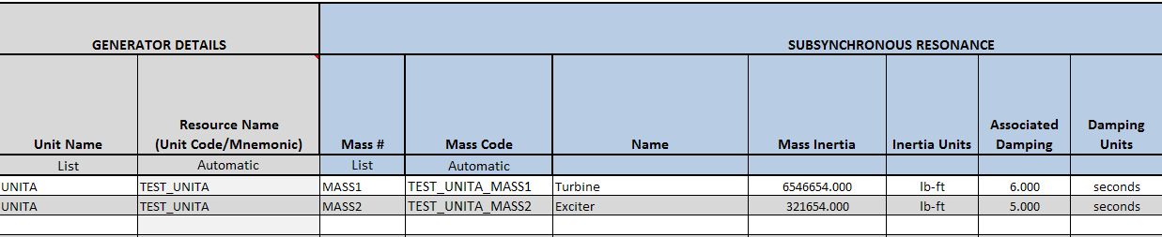

PSCAD Model
Embed PSCAD model to this tab. See section 3.2 for process.

Dynamic Data
Embed Dynamic Data model to this tab. See section 3.2 for process.

Combined Cycle RARF Workbook

Instructions
Detailed instructions for the RARF submittal process through the Market Information System (MIS) are contained in section 3.1 of this document.

Unit Info - TRAIN
This section must be completed for each combined cycle train that is part of the generation resource site. A Train is defined as: The combinations of gas turbines and steam turbines in an electric generation plant that employs more than one thermodynamic cycle. It includes the CC Train details, site and train unit dates, fuel information, power augmentation and geographic location data. (Fields include: Settlement Only Generation (SOG), Resource category, Latitude of plant & Longitude of plant). Each train code is made up of the Site Code appended with a train code (e.g. CC1, CC2 etc.). Note: Cell B5 (Resource Site Code) must be completed on all forms.
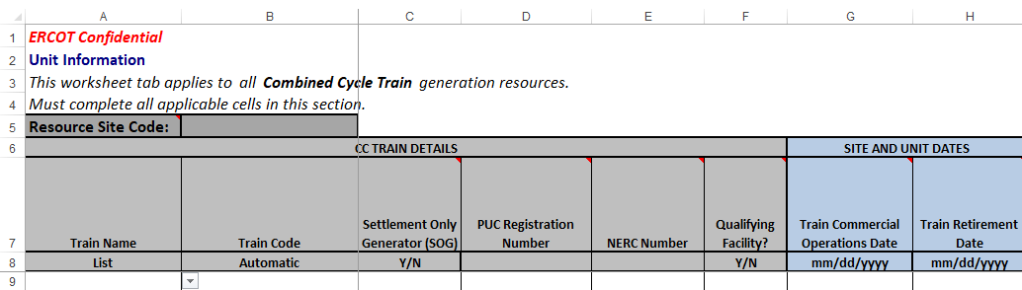
Note: Prior to your next RARF submission, remove all Train(s) that are no longer active and were stopped in a prior submission.

Unit Info - CC
This section must be completed for each unit that is part of the generation resource site. It includes the generator details, site and unit dates, point of interconnection information, fuel information and ratings and design information. (Fields include: Site Code, Train Code, Settlement Only Generation (SOG), Transmission POI date, SGIA date, Model Ready date, POI Substation, POI voltage, POI bus number, Primary fuel, Secondary fuel, Physical unit type, Governor droop, Governor dead-band, Design Max ambient temp & Design Min ambient temp)
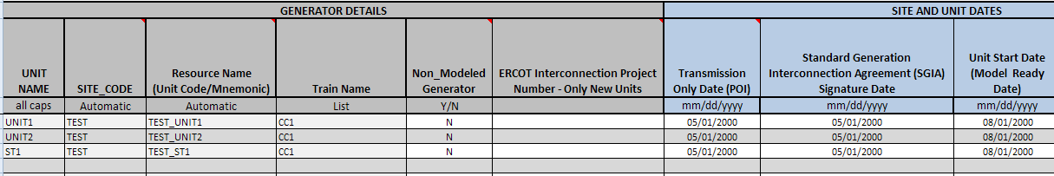
Note: Prior to your next RARF submission, remove all unit(s) that are no longer active and were stopped in a prior submission.

Ownership - CC
The Ownership tab must be completed for each train that is part of the generation resource site. It includes the train details and ownership details for each train. (Fields include: Train Name, Train Code, Ownership Start date & Ownership Stop date). Ownership for CC Trains is restricted to one owner each.


Parameters - CC
The Parameters CC tab must be completed for each unit that is part of the generation resource site. It includes the Generator details, reasonability limits, seasonal ratings and unit de-rating values for temperature changes. (Fields include: Unit Name, Resource Name & Unit de-rating values)
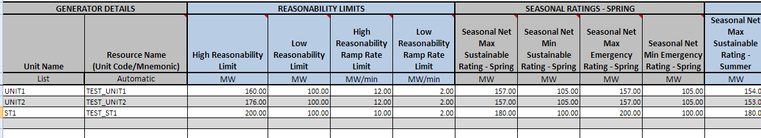

CC Configuration
The Combined Cycle Configurations tab must be completed for each train that is part of the generation resource site. It includes the Train and Generator details and the operational configurations for each operationally unique train. (Fields include: Train Code, Site Code Resource Name, Configuration # & Configuration Code). Configurations are identified by number. The configuration code is automatically generated by concatenating the Train Code and the Configuration Code. “x” indicates a primary units for the configuration, “A” indicates an alternate unit for a configuration.
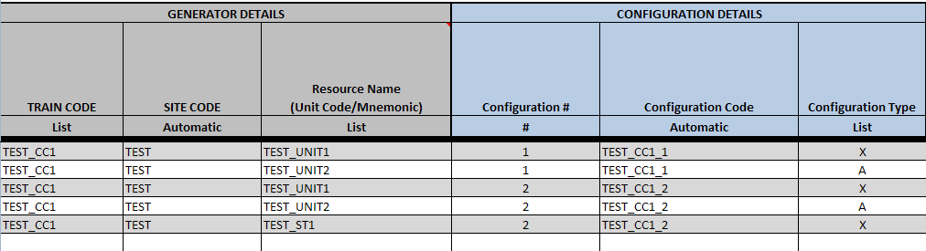
Note Regarding Alternate Units in CC Configurations:
If the units G1, G2, G3 all have the same unit characteristics such that the three configurations CC1_2, CC1_3, CC1_4 all have the same resource capabilities and would be offered exactly the same way, the ‘A’ CT can be the alternate for any of the 3 CTs, and there would not be a need to register CC1_3 or CC1_4 in the example below. That is to say, if CC1_2 was the only registered 2x1 configuration, it could be used to represent any combination of 2 CTs running with the CA unit. For example, if one of the G1, G2, or G3 units were in outage, you could use CC1_2 to run the remaining 2 non-outaged CTs running with the CA.

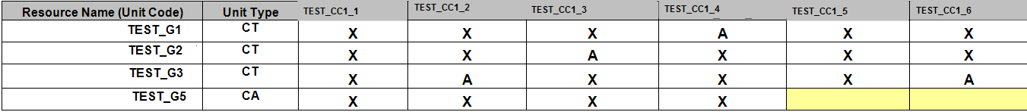

CC Transitions
The Combined Cycle Transitions tab must be completed for each train that is part of the generation resource site. It includes the Train details and transitions for each train. The transitions are a map that, for each operating state/configuration that you are in, it identifies what states/configurations you can go to next – whether it is adding a unit or removing a unit. Note you must complete the configurations tab before data can be entered on this tab. (Fields include: Site Code, Train Code, Configuration Code To & Configuration Code From). Each configuration must be able to transition from a configuration of “OFFLINE” to at least one valid configuration and from at least one valid configuration to “OFFLINE”.
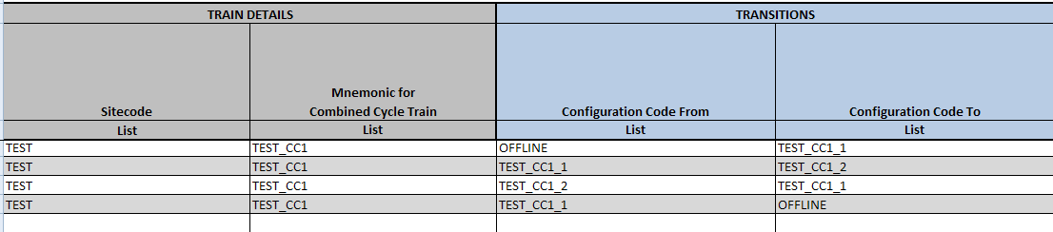

Parameters - CFG
The Parameters CFG tab must be completed for each configuration that is part of a train. It includes the Generator details, reasonability limits, seasonal ratings and unit de-rating values for temperature changes for each configuration. (Fields include: Site Code, Train Code, Configuration Code & Unit de-rating values)
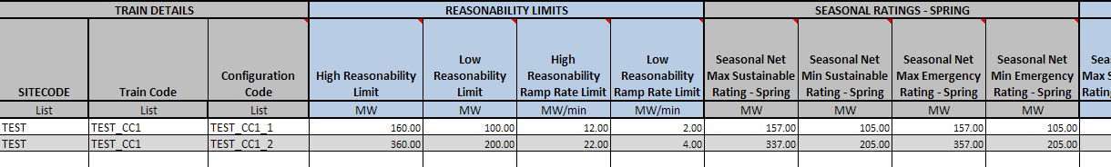

Operational Parameters - CFG
The Operational Parameters CFG tab must be completed for each configuration that is part of a train. It includes the Generator details and the resource parameters including minimum on-line and off-line times, hot, cold, intermediate, hot to intermediate and intermediate to cold start times and daily and weekly start data. Note you must complete the configurations tab before data can be entered on this tab. (Fields include: Site Code, Train Code & Configuration Code)
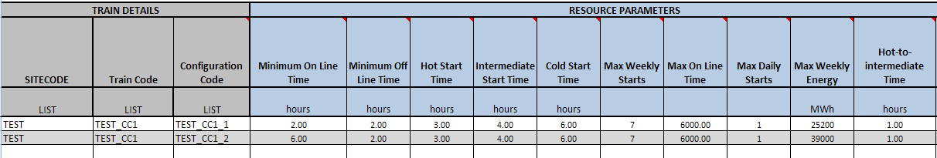

Operational Parameters - NRRC
The Operational Parameters Normal Ramp Rate Curve data must be completed for each configuration that is part of a train. Only 1 MW value and the corresponding normal upward and normal downward ramp rate are required, additional MW’s are optional. Note you must complete the configurations tab before data can be entered on this tab. (Fields include: Train Code, Configuration Code & MW number)
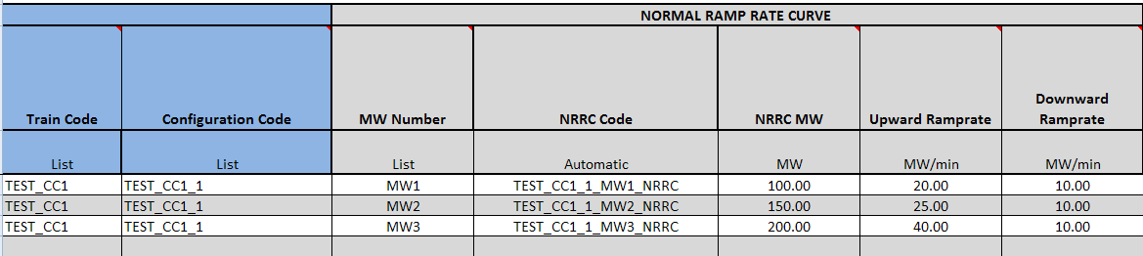

Operational Parameters - ERRC
The Operational Parameters Emergency Ramp Rate Curve data must be completed for each configuration that is part of a train. Only 1 MW value and the corresponding normal upward and normal downward ramp rate are required, additional MW’s are optional. Note you must complete the configurations tab before data can be entered on this tab. (Fields include: Train Code, Configuration Code & MW number)
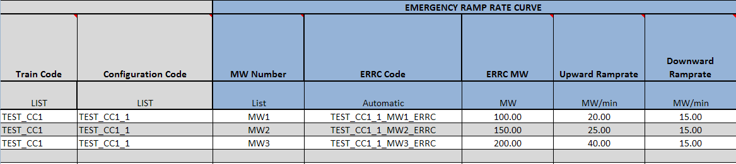

Private Network - Unit
The Private Network Unit tab is to be completed only if the site has completed the site information as a PUN site, then the data must be completed for each unit that is part of the private network resource site, Which includes the MW and MVAR load, net interchange and gross unit capabilities. If the site is not part of a PUN, then no unit data need be filled out on this tab and all fields will be blacked out. (Fields include: Unit Name, Site Code & Resource Name)
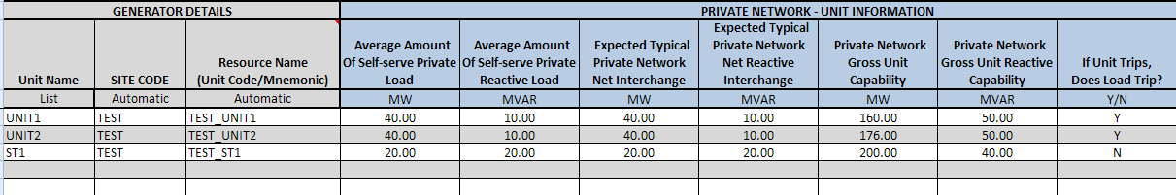

Reactive Capability - CC
The Reactive Capability must be completed for each unit that is part of the generation resource site. It includes the generator details and the reactive capability curve data which are 5 increasing MW values of Operating Real Power and 9 points of MVAR reactive power information. The lagging MVAR amounts should be listed as positive numbers and the leading MVAR amounts should be listed as negative. MW5 is the unity power factor amount or maximum value of real power MW at 1.0 PF, the reactive power which crosses the x-axis on the curve is zero. (Fields include: Unit Name, Resource Name, Gross/Net values, NDCRC test & Test date)
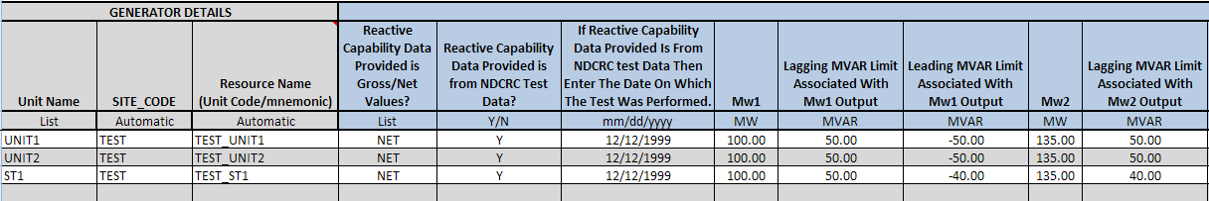

Planning - CC
The Planning tab must be completed for each unit that is part of the generation resource site. It includes the generator details, planning details, generator auxiliary load information, generation auxiliary MW load characteristics and generation auxiliary MVAR load characteristics. (Fields include: Unit Name, Site Code, Resource Name, Direct Axis Sub transient reactance unsaturated, Direct Axis Transient reactance unsaturated, Positive Sequence Z – R unsaturated, Positive Sequence Z – X unsaturated, Negative Sequence Z – R unsaturated, Negative Sequence Z – X unsaturated, Zero Sequence exist, Zero Sequence Z – R unsaturated, Zero Sequence Z – X unsaturated, Zero Sequence Grounding Resistance, Zero Sequence Grounding Reactance, Zero Sequence Resistance, Zero Sequence Reactance & Aux Load power factor)
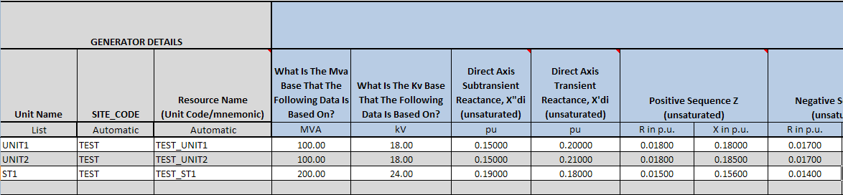

Protection - CC
The Protection tab must be completed for each unit that is part of the generation resource site. It includes the generator details, plant under and over voltage protection and plant under and over frequency protection information. (Fields include: Unit Name, Site Code & Resource Name)
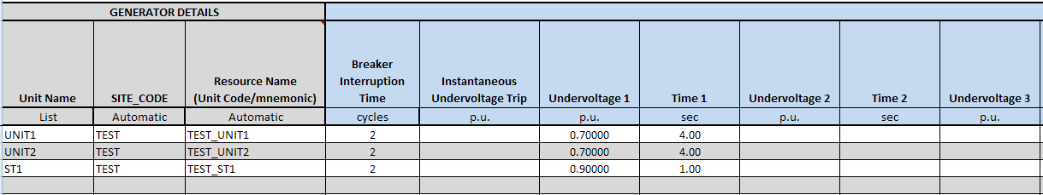

Subsync - CC
The Subsync tab should be completed for each unit that may require subsynchronous resonance studies as part of the interconnection process or for additional planning studies to maintain the reliability of the ERCOT System by meeting all NERC Reliability Standards, ERCOT Protocols and Operating Guides that would be affected by the interconnection and operation of the generation site. (Fields include: Unit Name, Resource Name, Mass # & Mass Code)
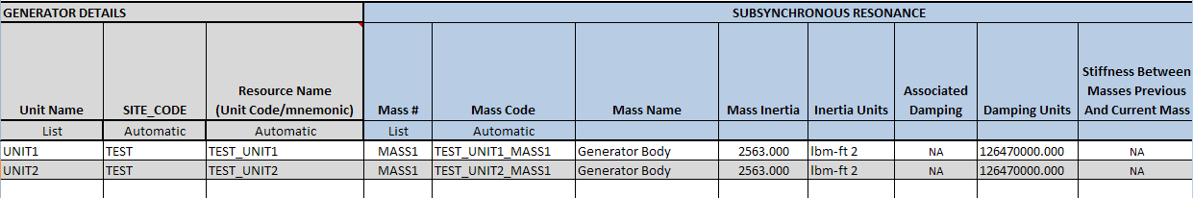

PSCAD Model
Embed PSCAD model to this tab. See section 3.2 for process.

Dynamic Data
Embed Dynamic Data model to this tab. See section 3.2 for process.

Renewable RARF Workbook

Instructions
Detailed instructions for the RARF submittal process through the Market Information System (MIS) are contained in section 3.1 of this document.

Unit Info - RENEWABLE
This section must be completed for each unit that is part of the renewable resource site. It includes the Generator details, site and unit dates, point of interconnection information, fuel information, ratings and design information and geographic location data. (Fields include: Settlement Only Generation (SOG), Transmission POI date, SGIA date, Model Ready date, POI substation, POI voltage, POI bus number, Primary fuel, Secondary fuel, Resource category, Physical unit type, Governor droop, Governor dead-band, Design Max ambient temp, Design Min ambient temp, Height of Instrumentation, Latitude of plant & Longitude of plant). Note: Cell B5 (Resource Site Code) must be completed on all forms.
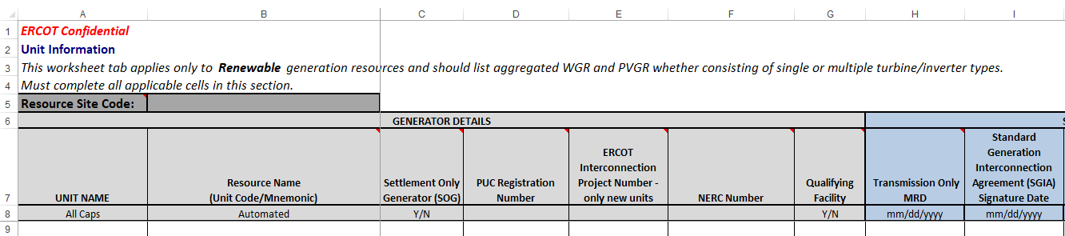

Note: Prior to your next RARF submission, remove all unit(s) that are no longer active and were stopped in a prior submission.

Wind Turbine Details
- This section must be completed for each unit and turbine type that makes up the wind resource site. It includes the Wind Generator Group details, Turbine Details, Planning Details and Turbine Step-Up Transformer Data. Fields include: WGR Group #, Turbine Type, Instantaneous Controlled Fault Current Magnitude (Multiple of full load current) for Turbine Types 3 & 4, Controlled Fault Current Magnitude at 2 to 3 cycles after fault (Multiple of full load current) for Turbine Types 3 & 4 and Controlled Fault Current Magnitude at 4 plus cycles after fault (Multiple of full load current) for Turbine Types 3 & 4)
- A Resource Entity may aggregate wind turbines together to form a WGR subject to provisions of Protocol Section 3.10.7.2 (9).
- A Resource Entity may also group WGRs into a WGR Group. The group is a collection of two or more WGRs whose performance in responding to SCED Dispatch Instructions will be assessed as an aggregate for Generation Resource Energy Deployment Performance (GREDP). A WGR Group cannot contain any WGRs that are Split Generation Resources. Additionally, only WGRs that have the same Resource Node can be mapped to a WGR Group.

Example: Non-Grouped WGRs
For Non_Grouped WGRs do not complete the WGR Group #.
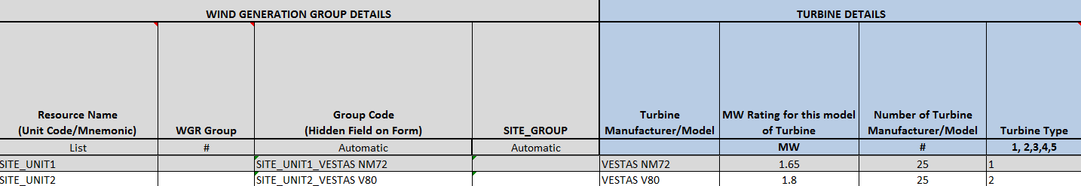
Example: Grouped WGRs
Grouped WGRs must complete the WGR Group #.
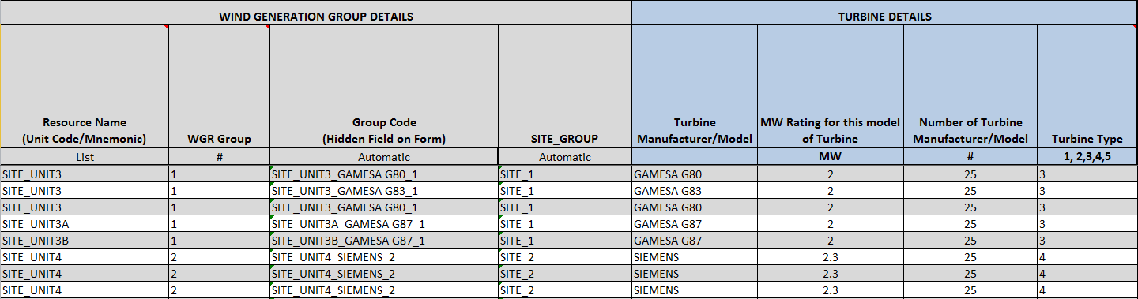

Inverter Details – SOLAR
- This section must be completed for each unit that is part of a solar unit and inverter type type that makes up the solar resource site. It includes the Solar Generator Group details, Inverter Details, Planning Details and Inverter Step-Up Transformer Data. Fields include: PVGR Group #, Inverter Type, Instantaneous Controlled Fault Current Magnitude (Multiple of full load current), Controlled Fault Current Magnitude at 2 to 3 cycles after fault (Multiple of full load current and Controlled Fault Current Magnitude at 4 plus cycles after fault (Multiple of full load current)
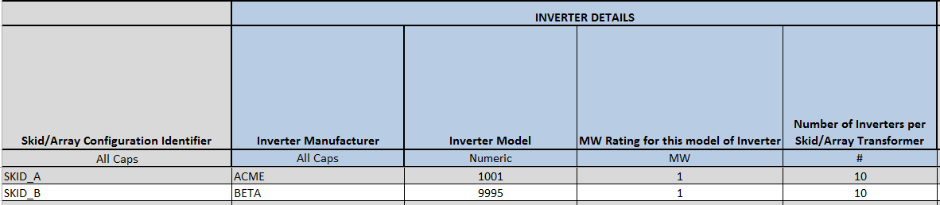

- A Resource Entity may aggregate photovoltaic generators together to form a PVGR subject to provisions of Protocol Section 3.10.7.2 (9).
- A Resource Entity may also group PVGRs into a PVGR Group. The group is a collection of two or more PVGRs whose performance in responding to SCED Dispatch Instructions will be assessed as an aggregate for Generation Resource Energy Deployment Performance (GREDP). A PVGR Group cannot contain any PVGRs that are Split Generation Resources. Additionally, only PVGRs that have the same Resource Node can be mapped to a PVGR Group.

Example: Non-Grouped PVGRs
For Non_Grouped PVGRs do not complete the PVGR Group #.
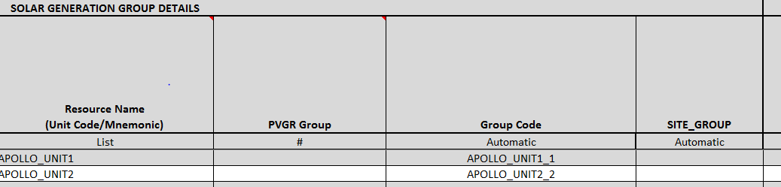ample: Grouped PVGRs
Grouped PVGRs must complete the PVGR Group #.

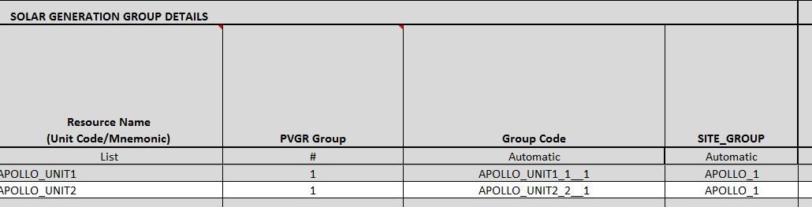

Panel Details - SOLAR

The Panel Details tab identifies the different configurations of panels use at a site. These will be attached to the inverters in the Connectivity tab.

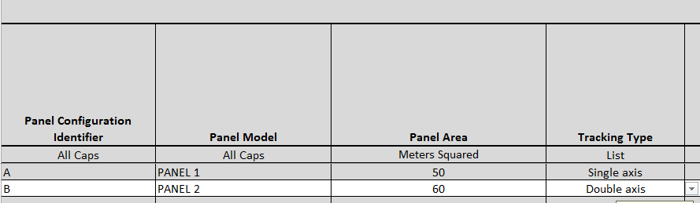

PVGR Connectivity
This tab allows the resource to connect the inverters and panels into units to fully describes the equipment comprising the generating untit
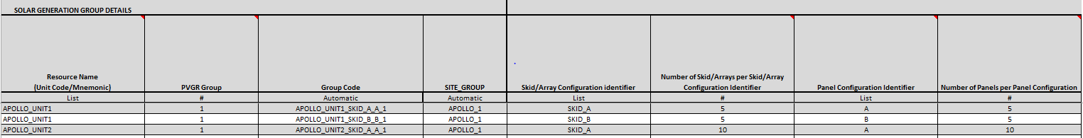

Ownership - RENEWABLE
The Ownership tab must be completed for each unit that is part of the Renewable resource site. It includes the Generator details, ownership information and percentages. (Fields include: Unit Name, Resource Name, Ownership start date & Ownership stop date)
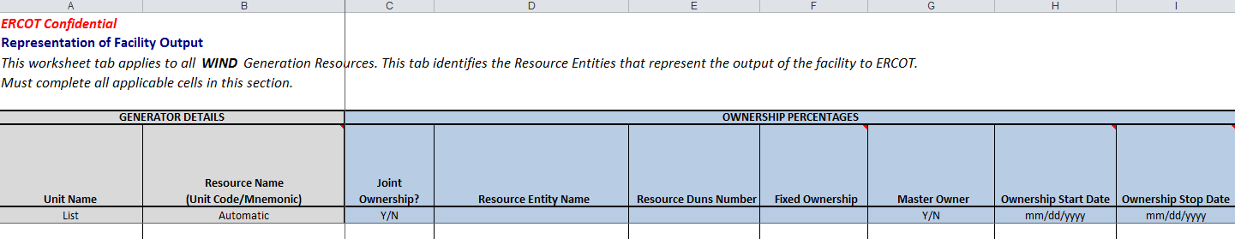

Parameters - RENEWABLE
The Parameters tab must be completed for each unit that is part of the Renewable resource site. It includes the Generator details, reasonability limits, seasonal ratings and unit de-rating values for temperature changes. (Fields include: Unit Name, Resource Name & Unit De-rating values). Unit De-Rating Values For Different Temperatures are the Net Max. MW rating at that temperature.
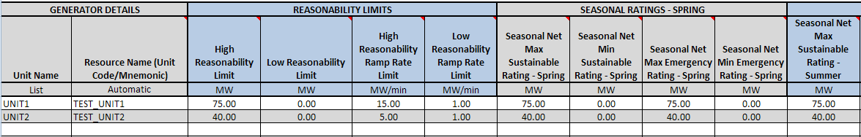

Operational Parameters - RENEWABLE
The Operational Parameters tab must be completed for each unit that is part of the Renewable resource site. It includes the Generator details and the resource parameters including minimum on-line and off-line times, hot, cold, intermediate, hot to intermediate and intermediate to cold start times and daily and weekly start data. (Fields include: Unit Name & Resource Name)
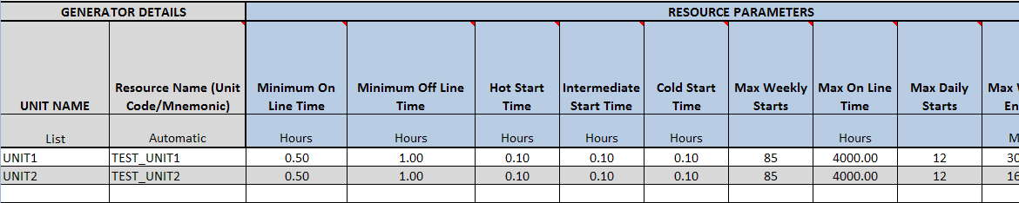

Operational Parameters - NRRC
The Operational Parameters Normal Ramp Rate Curve data must be completed for each unit that is part of the Renewable resource site. Note that only 1 MW value and the corresponding normal upward and normal downward ramp rate are required, additional MW’s are optional. (Fields include: Unit Name, Resource Name & MW number)
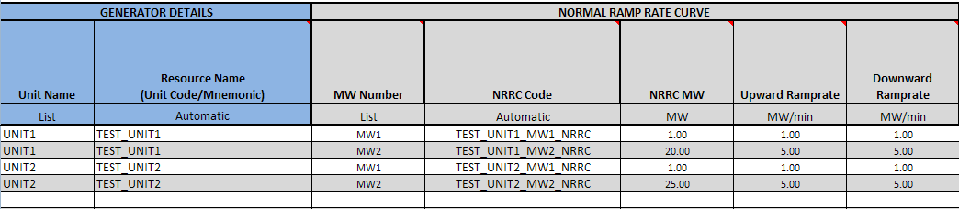

Operational Parameters - ERRC
The Operational Parameters Emergency Ramp Rate Curve data must be completed for each unit that is part of the Renewable resource site. Note that only 1 MW value and the corresponding normal upward and normal downward ramp rate are required, additional MW’s are optional. (Fields include: Unit Name, Resource Name & MW number)
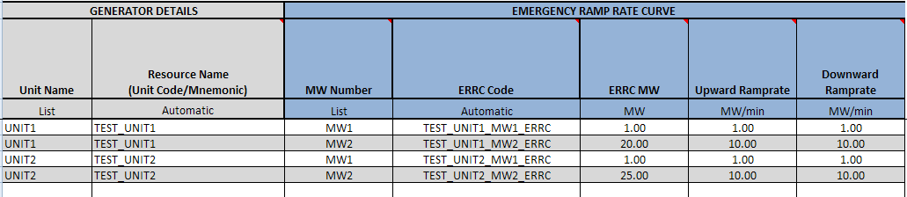

Private Network - Unit
The Private Network Unit tab is to be completed only if the site has completed the site information as a PUN site, then the data must be completed for each unit that is part of the private network resource site, Which includes the MW and MVAR load, net interchange and gross unit capabilities. If the site is not part of a PUN, then no unit data need be filled out on this tab and all fields will be blacked out. (Fields include: Unit Name, Site Code & Resource Name)
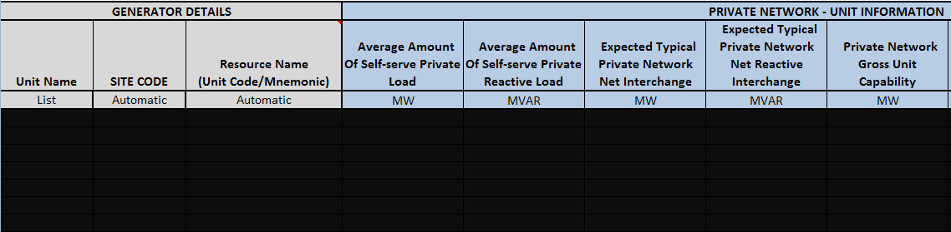

Reactive Capability - RENEWABLE
The Reactive Capability must be completed for each unit that is part of the Renewable resource site. It includes the generator details and the reactive capability curve data which are 5 increasing MW values of Operating Real Power and 9 points of MVAR reactive power information. The lagging MVAR amounts should be listed as positive numbers and the leading MVAR amounts should be listed as negative. MW5 is the unity power factor amount or maximum value of real power MW at 1.0 PF, the reactive power which crosses the x-axis on the curve is zero. (Fields include: Unit Name, Resource Name, Gross/Net values, NDCRC test & Test date)
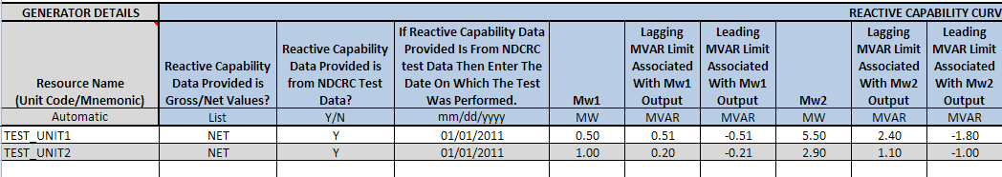

Planning - RENEWABLE
The Planning tab must be completed for each unit that is part of the Renewable resource site. It includes the generator auxiliary load information, generation auxiliary MW load characteristics and generation auxiliary MVAR load characteristics.
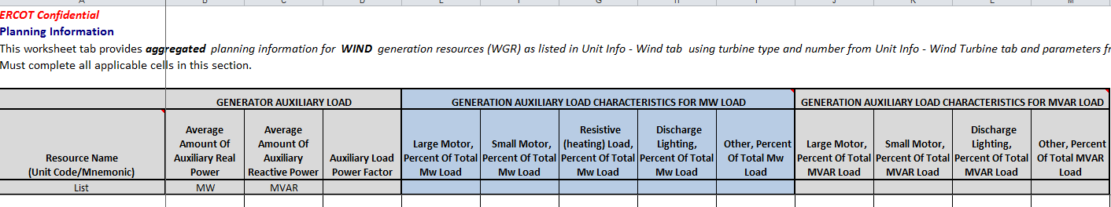

Protection - RENEWABLE
The Protection tab must be completed for each unit that is part of the Renewable resource site. It includes the generator details, plant under and over voltage protection and plant under and over frequency protection information. (Fields include: Unit Name, Site Code & Resource Name)
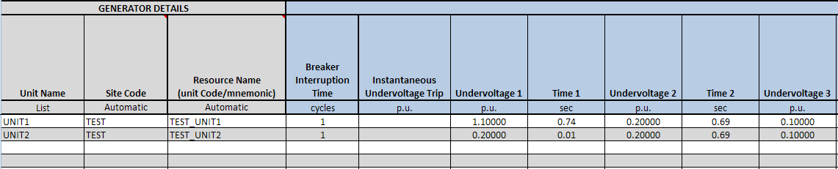

Collector System - RENEWABLE
The Collector System tab must be completed for each unit that is part of the Renewable resource site. It includes the system details for cable types, the positive sequence data and zero sequence data. Also attach either the collection system one-line or cable segment model data in fields provided. (all are new fields) See section 3.2 for process to embed files.
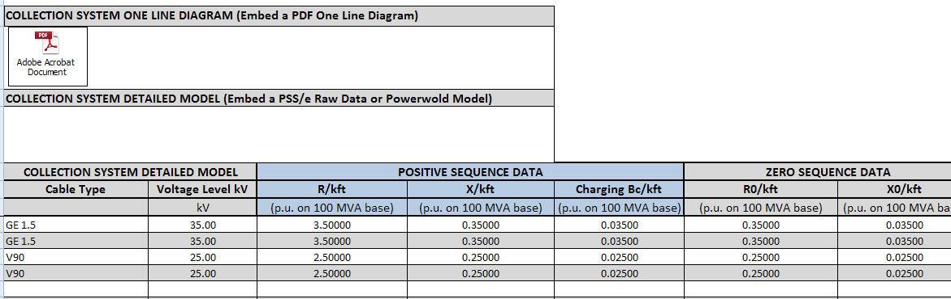

Collector System – Renew Segment data
The Collector System tab segment data must be completed for each cable type that is part of the Renewable resource site. It includes the cable type and the segment details. (all are new fields)
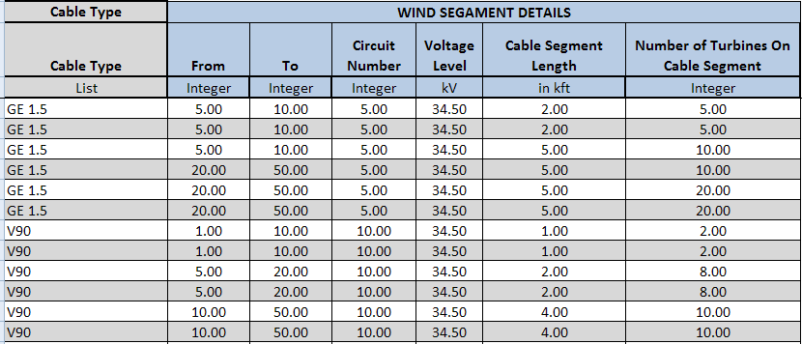
Embed the stability study model to this tab. See section 3.2 for process.

PSCAD Model
Embed PSCAD model to this tab. See section 3.2 for process.

Dynamic Data
Embed Dynamic Data model to this tab. See section 3.2 for process.

LaaR RARF Workbook

Instructions
Detailed instructions for the RARF submittal process through the Market Information System (MIS) are contained in section 3.1 of this document.

General Information - ALL
The General Information tab identifies information about the Resource Entity. The contact information is essential, as it provides ERCOT with additional contacts in case of questions regarding the RARF. Enter the Resource Entity Name that matches the name ERCOT has on record, note that it does not allow any special characters except spaces and dashes. The Data Universal Numbering System (DUNS) number is a 9 or 13 digit number listed with ERCOT to uniquely identify an entity.
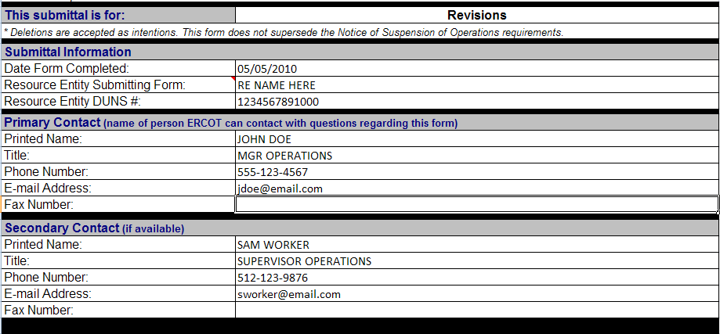

Load Resource Information
The Load Resource information tab includes the unit details for each of the loads acting as a resource. There are two types of load resources, controllable load resource and non-controllable load resource. Each load resource must be individually registered with ERCOT by ESI-ID and are subject to qualification testing.
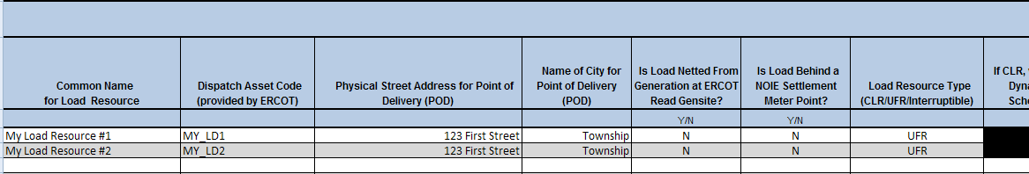

Load Resource Parameters
This section must be completed for each dispatch code that is part of a load resource. It includes the Non-CLR resource parameters, the CLR resource parameters, CLR normal ramp rate curve data and CLR emergency ramp rate curve data.
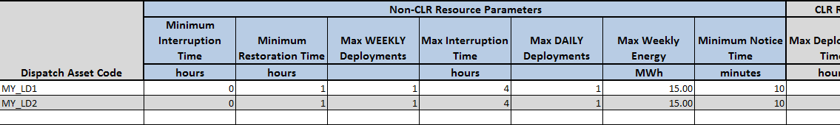

One Line
Embed the one line diagram(s) in pdf or cad to this tab. See section 3.2 for process.

Transmission RARF Workbook

Instructions
Detailed instructions for the RARF submittal process through the Market Information System (MIS) are contained in section 3.1 of this document.

Station
Thae Station data tab is to be completed for each station that the RE owns. There should be one line of data entered for each voltage contained in the station. The Station tab contains data describing the resource owned station.

Line Data
The Line data tab is to be completed for each line that is located at the resource site and consists of the Line details, the “to” connected station and devices and the “from” connected station and devices. (Fields include: Zero Sequence Line Resistance, Zero Sequence Line Reactance, Zero Sequence Charging Susceptance & Line Code). Note: Cell B5 (Resource Site Code) must be completed on all forms.
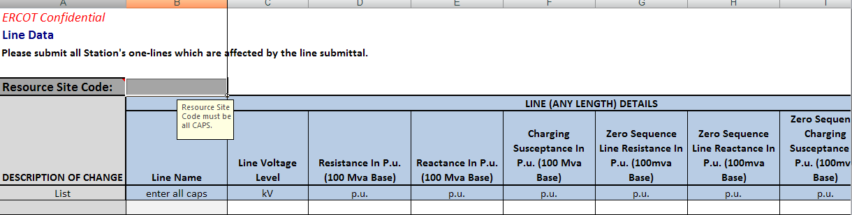
Note: Prior to your next RARF submission, remove “Add” or “Change” from the Description of Change column for all equipment that is not being updated on this submission. Only use “Add” or “Change” for new updates on this submission. If equipment was “Deleted” on prior submission, remove all data from that row before the next submission.

Line Temperature
The Line temperature tab is to be completed for each line that is located at the resource site and consists of the Line details, noting whether the line is static or dynamic in nature. If static then only the Nominal ratings would be completed, if dynamic then all the ratings including temperatures from 20 to 115 degrees need to be completed. (Fields include: Line Code & Planning Rate C ratings)
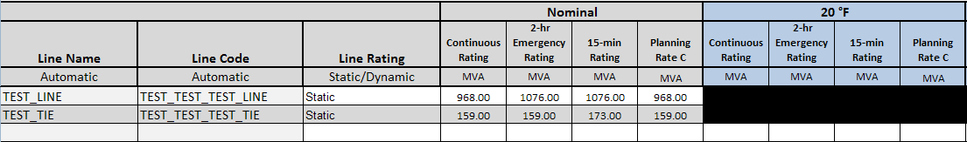

Breaker Switch Data
The Breaker Switch data tab is to be completed for each breaker or switch that is located at the resource site. It consists of the breaker or switch details, the static ratings and up to 10 connected devices for side 1 and 10 connected devices for side 2. (Fields include: Switch Code & Static ratings)

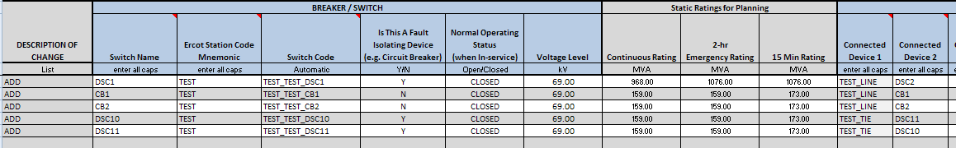

Note: Prior to your next RARF submission, remove “Add” or “Change” from the Description of Change column for all equipment that is not being updated on this submission. Only use “Add” or “Change” for new updates on this submission. If equipment was “Deleted” on prior submission, remove all data from that row before the next submission.

Capacitor and Reactor Data
The Capacitor and Reactor data tab is to be completed for each capacitor and reactor that is located at the resource site. It consists of the capacitor and reactor details and up to 10 connected devices. (Fields include: Device Code & Zero Sequence Reactance)
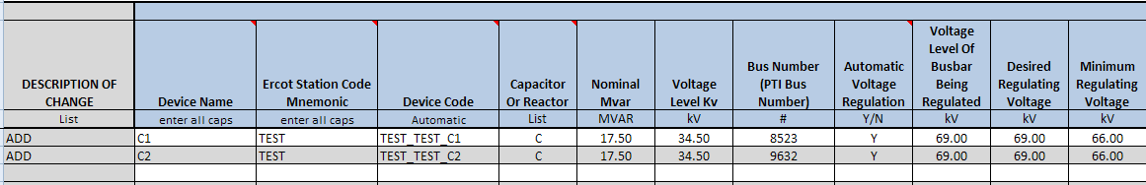
Note: Prior to your next RARF submission, remove “Add” or “Change” from the Description of Change column for all equipment that is not being updated on this submission. Only use “Add” or “Change” for new updates on this submission. If equipment was “Deleted” on prior submission, remove all data from that row before the next submission.

Transformer Data
The Transformer data tab is to be completed for each transformer that is located at the resource site. It consists of the transformer details, units associated if it is a generator step up transformer, high side voltage information, low side voltage information, voltage regulation, low tap settings and high tap settings. (Fields include: Transformer Code, Zero Sequence Data, Zero Sequence Grounding Resistance, Zero Sequence Grounding Reactance, Zero Sequence Resistance, Zero Sequence Reactance, Positive Sequence Resistance & Positive Sequence Reactance)
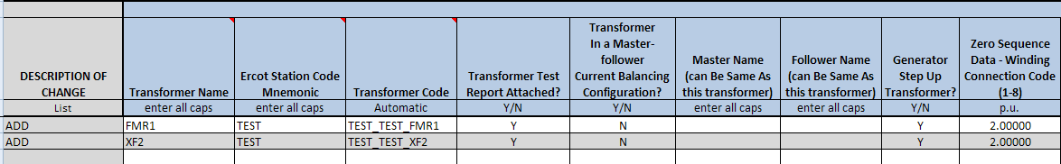
Note: Prior to your next RARF submission, remove “Add” or “Change” from the Description of Change column for all equipment that is not being updated on this submission. Only use “Add” or “Change” for new updates on this submission. If equipment was “Deleted” on prior submission, remove all data from that row before the next submission.

Transformer Tap settings
The Transformer Tap Settings tab is to be completed for each transformer that is located at the resource site. It consists of the Description of Change Transformer Name, ERCOT Station Code Mnemonic, Transformer Code High or Low side connection flag and the Tap Setting positions and voltage levels.
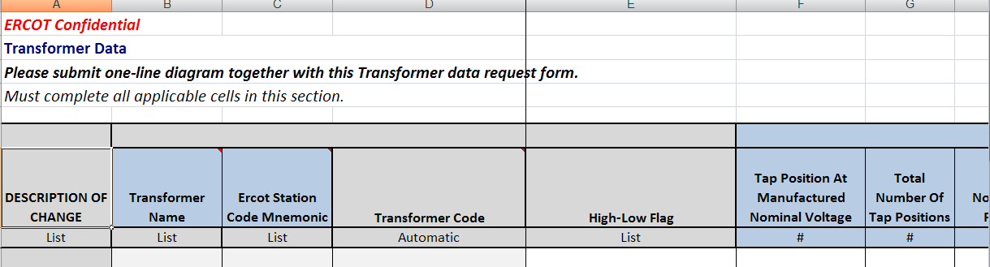
Note: Prior to your next RARF submission, remove “Add” or “Change” from the Description of Change column for all equipment that is not being updated on this submission. Only use “Add” or “Change” for new updates on this submission. If equipment was “Deleted” on prior submission, remove all data from that row before the next submission.

Static Var Compensator Data
The Static Var Compensator data tab is to be completed for each svc that is located at the resource site. It consists of the svc details and up to 10 connected devices. (Fields include: SVC Code, Fixed MVAR, Minimum Admittance Limits, Maximum Admittance Limits, Minimum Threshold, Maximum Threshold, Minimum Voltage Threshold & Maximum Voltage Threshold)
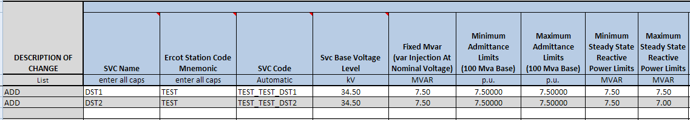
Note: Prior to your next RARF submission, remove “Add” or “Change” from the Description of Change column for all equipment that is not being updated on this submission. Only use “Add” or “Change” for new updates on this submission. If equipment was “Deleted” on prior submission, remove all data from that row before the next submission.

Series Device Data
The Series Device data tab is to be completed for each series device that is located at the resource site. It consists of the series device details and up to 10 connected devices for side 1 and 10 connected devices for side 2. Series devices are impedance element which may be series reactors and capacitors or may be short lines within a station. (Fields include: SD Code)
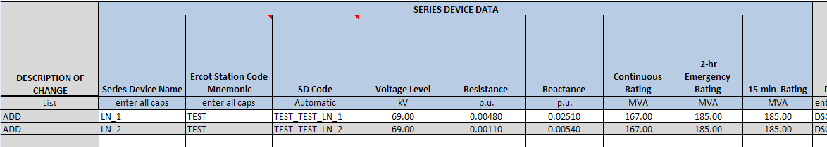
Note: Prior to your next RARF submission, remove “Add” or “Change” from the Description of Change column for all equipment that is not being updated on this submission. Only use “Add” or “Change” for new updates on this submission. If equipment was “Deleted” on prior submission, remove all data from that row before the next submission.

Load Data
The Load data tab is to be completed for each load that is located at the resource site. It consists of the load details and up to 10 connected devices. For the transmission grid (greater than 60kV) and for the kV grids modeled for output paths of generators (less than 60kV), all auxillary, station service and/or power transformers are modeled in ERCOT as a load point at the high side of these types of transformers. (FieldsFields include: Load Code)
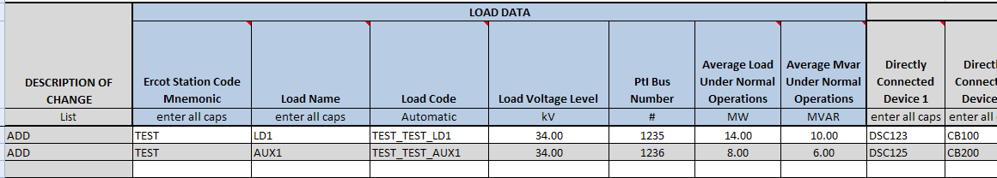
Note: Prior to your next RARF submission, remove “Add” or “Change” from the Description of Change column for all equipment that is not being updated on this submission. Only use “Add” or “Change” for new updates on this submission. If equipment was “Deleted” on prior submission, remove all data from that row before the next submission.

PUN Load Data
The PUN Load data tab is to be completed for each load that is located at Private Use Network (PUN) resource site. It consists of the station details for each load and the 168 hour (24 hours and 7 days) MW data for each load. This tab must be manually populated for the 5.1 version
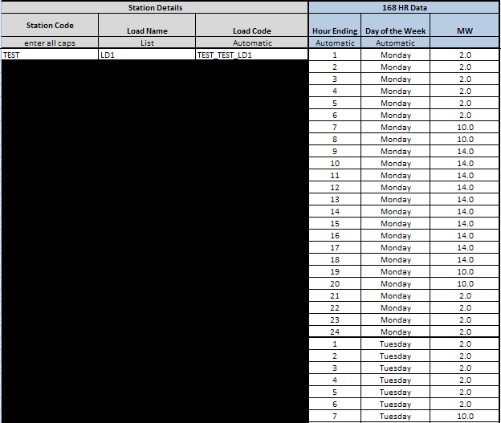

One Line
Embed the one line diagram(s) in pdf or cad to this tab. See section 3.2 for process.

Transformer Test Data
All One Lines will have to be Reembeded
Embed the transformer test data to this tab. See section 3.2 for process.

Settlement Only Distributed Generation (SODG)

Instructions
Detailed instructions for the RARF submittal process through the Market Information System (MIS) are contained in section 3.1 of this document.

Unit Info – DG
This section must be completed for each Settlement Only Distributed Generation (SODG) unit. It includes the Generator Details, Unit Dates, Fuel Information, Private Network Info, Generic Info, Mapping Instructions and Resource Owner Data. Cell B5 (Resource Site Code) must be completed on all forms.
