Online Library NLQ Agent Architecture
Proof of Concept architecture document for modules/online_library_agent
Document | online_library_agent_architecture.docx
Module | modules/online_library_agent
Status | POC / local development module
Date | June 20, 2026
Primary Runtime | Python 3.13, FastAPI, Uvicorn
LLM Runtime | Local Ollama using mistral:latest
MCP Dependency | modules/online_library_mcp over Streamable HTTP on port 8004
Purpose | Answer online-library natural-language questions by discovering and calling MCP tools.

1. Executive Summary
The Online Library NLQ Agent is a FastAPI proof of concept that accepts natural-language questions, discovers available MCP tools from the Online Library MCP server, uses local Ollama with mistral:latest to select or summarize tool results, and returns a browser-friendly answer with developer diagnostics.
- The agent does not connect directly to PostgreSQL.
- The agent does not call the Online Library REST API on port 8003 directly.
- The agent calls only the MCP server on port 8004 for data access.
- The MCP server calls the REST API on port 8003, which then reads PostgreSQL.
- The /ask UI contains guided forms plus an open-ended NLQ field for reliable POC demos.

2. Tech Stack
Layer | Technology | Usage
API/UI framework | FastAPI | Provides /health, /tools, /ask browser UI, and POST /ask JSON/form flow.
Server | Uvicorn | Runs the ASGI app locally on port 8005.
MCP client | Official MCP Python SDK | Connects to Streamable HTTP MCP endpoint at http://127.0.0.1:8004/mcp.
LLM client | httpx to Ollama /api/generate | Calls local mistral:latest for tool selection and answer formatting.
Model runtime | Ollama | Local model host on http://127.0.0.1:11434.
Configuration | python-dotenv | Loads module-local .env values.
Validation | FastAPI TestClient / PowerShell | Manual and in-process endpoint validation.

3. Scope
In scope for this POC:
- Guided NLQ browser page.
- JSON POST /ask API.
- MCP tools/list discovery.
- MCP tools/call execution.
- Ollama-based tool selection and result summarization.
- Keyword fallback when LLM tool-selection JSON is invalid.
- Domain guardrail for unrelated questions.
- Developer diagnostics in the output.
Out of scope for this POC:
- Authentication and authorization.
- Conversation memory.
- Multi-turn planning.
- Direct database access.
- Production observability and rate limiting.
- CLI command, deferred for later.

4. Component Overview
File | Responsibility
api.py | FastAPI app, guided /ask page, JSON/form handling, result rendering.
planner.py | Coordinates MCP discovery, LLM tool selection, fallback, MCP tool call, and final response.
mcp_client.py | MCP Streamable HTTP client using ClientSession and streamablehttp_client.
llm.py | Minimal Ollama /api/generate client and JSON extraction helper.
models.py | Pydantic request/response models.
config.py | Module-local .env configuration.
Readme.md | Run and usage instructions.
docs/online_library_agent_plan.md | Planning and implementation notes.

5. Runtime Architecture

Runtime Flow Summary (collapsed by default)
User / Browser / API Client
|
| HTTP /ask
v
Online Library NLQ Agent :8005
|
| MCP tools/list + tools/call
v
Online Library MCP Server :8004
|
| HTTP JSON REST calls
v
Online Library FastAPI API :8003
|
| psycopg SELECT
v
PostgreSQL online_library :5432
The NLQ Agent also calls local Ollama :11434 for tool selection and answer formatting.

6. Request Control Flow
- User opens GET /ask or sends POST /ask.
- Agent validates the NLQ request.
- Agent calls MCP tools/list to get tool names, descriptions, and schemas.
- Agent asks mistral:latest to select the best tool, using strict JSON instructions.
- If LLM JSON fails, keyword fallback chooses the tool when possible.
- If the request is unrelated, domain guardrail returns a helpful unsupported-question message.
- Agent calls the selected MCP tool with limit and offset.
- MCP server calls the Online Library REST API and returns JSON rows.
- Agent sends the tool result to Ollama for a concise summary.
- UI displays table data, then the summary, then developer diagnostics.

7. PlantUML-Style Sequence Diagram
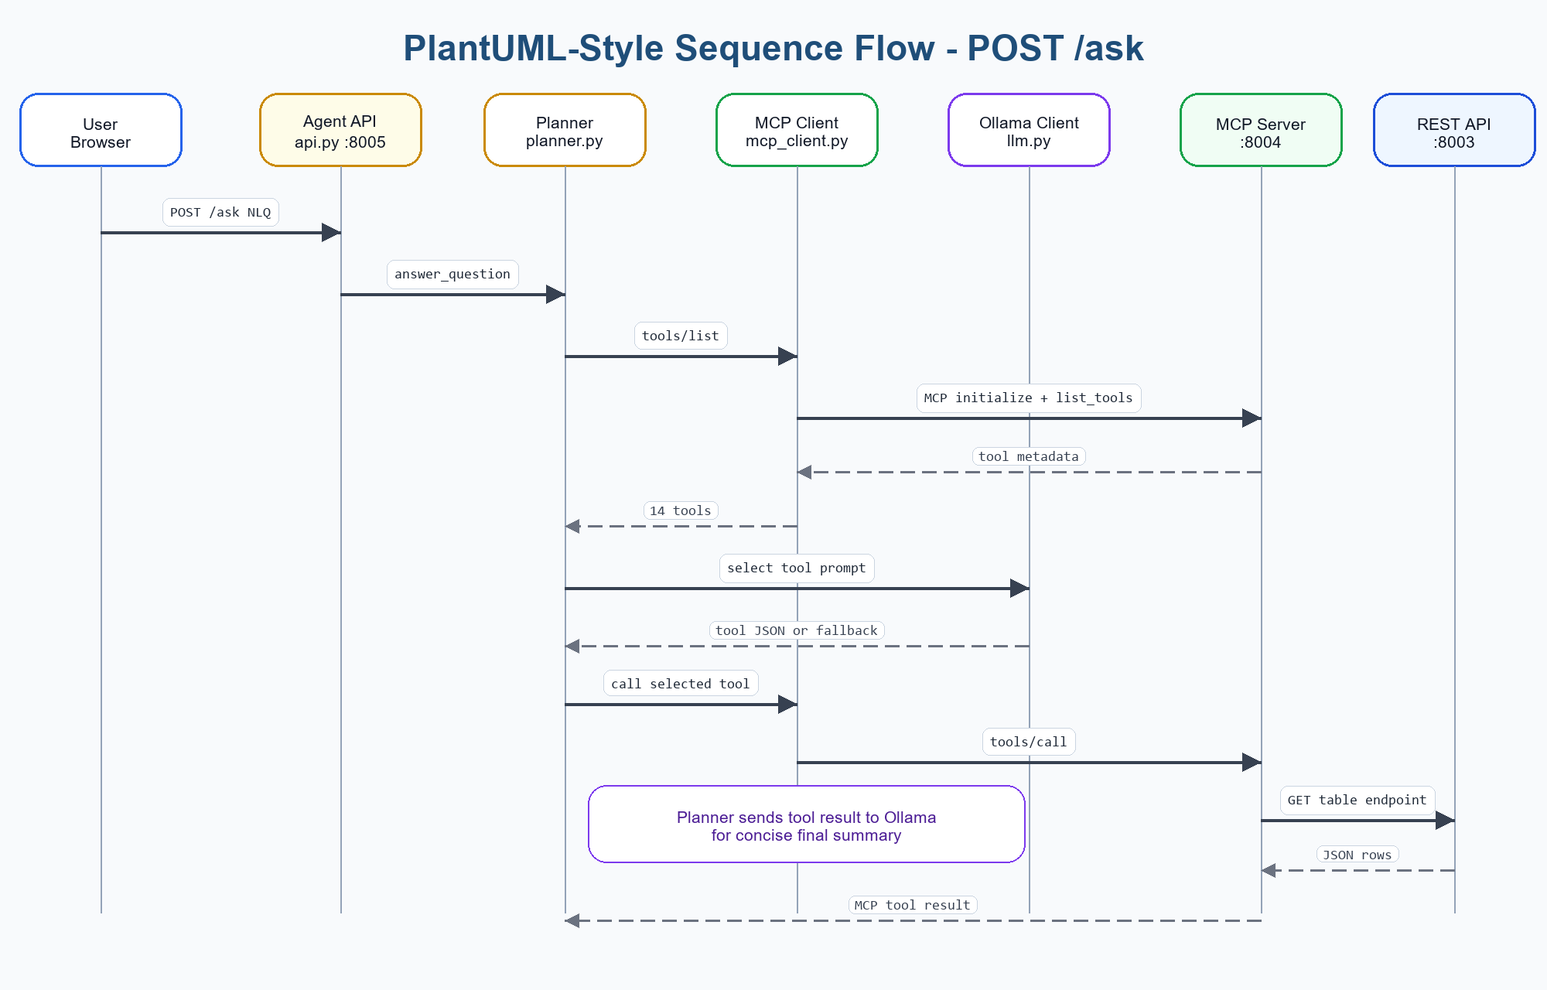
Figure: PlantUML-style sequence flow for POST /ask

PlantUML Source Code - NLQ /ask flow (collapsed by default)
@startuml
actor User
participant "Online Library Agent
FastAPI :8005" as Agent
participant "Planner
planner.py" as Planner
participant "MCP Client
mcp_client.py" as MCPClient
participant "Ollama Client
llm.py" as LLM
participant "MCP Server
:8004" as MCP
participant "Online Library API
:8003" as API
autonumber
User -> Agent: POST /ask {question, limit, offset}
Agent -> Planner: answer_question()
Planner -> MCPClient: list_tools()
MCPClient -> MCP: initialize + tools/list
MCP --> MCPClient: tool metadata
MCPClient --> Planner: tools
Planner -> LLM: select tool prompt
LLM --> Planner: strict JSON tool choice or invalid text
alt invalid LLM JSON
Planner -> Planner: keyword fallback / domain guardrail
end
Planner -> MCPClient: call_tool(selected_tool, args)
MCPClient -> MCP: tools/call
MCP -> API: GET table endpoint
API --> MCP: JSON rows
MCP --> MCPClient: tool result
MCPClient --> Planner: parsed JSON
Planner -> LLM: summarize tool result
LLM --> Planner: concise final answer
Planner --> Agent: AskResponse with debug
Agent --> User: HTML or JSON result
@enduml

8. C4-Style Architecture View

C4 Context View
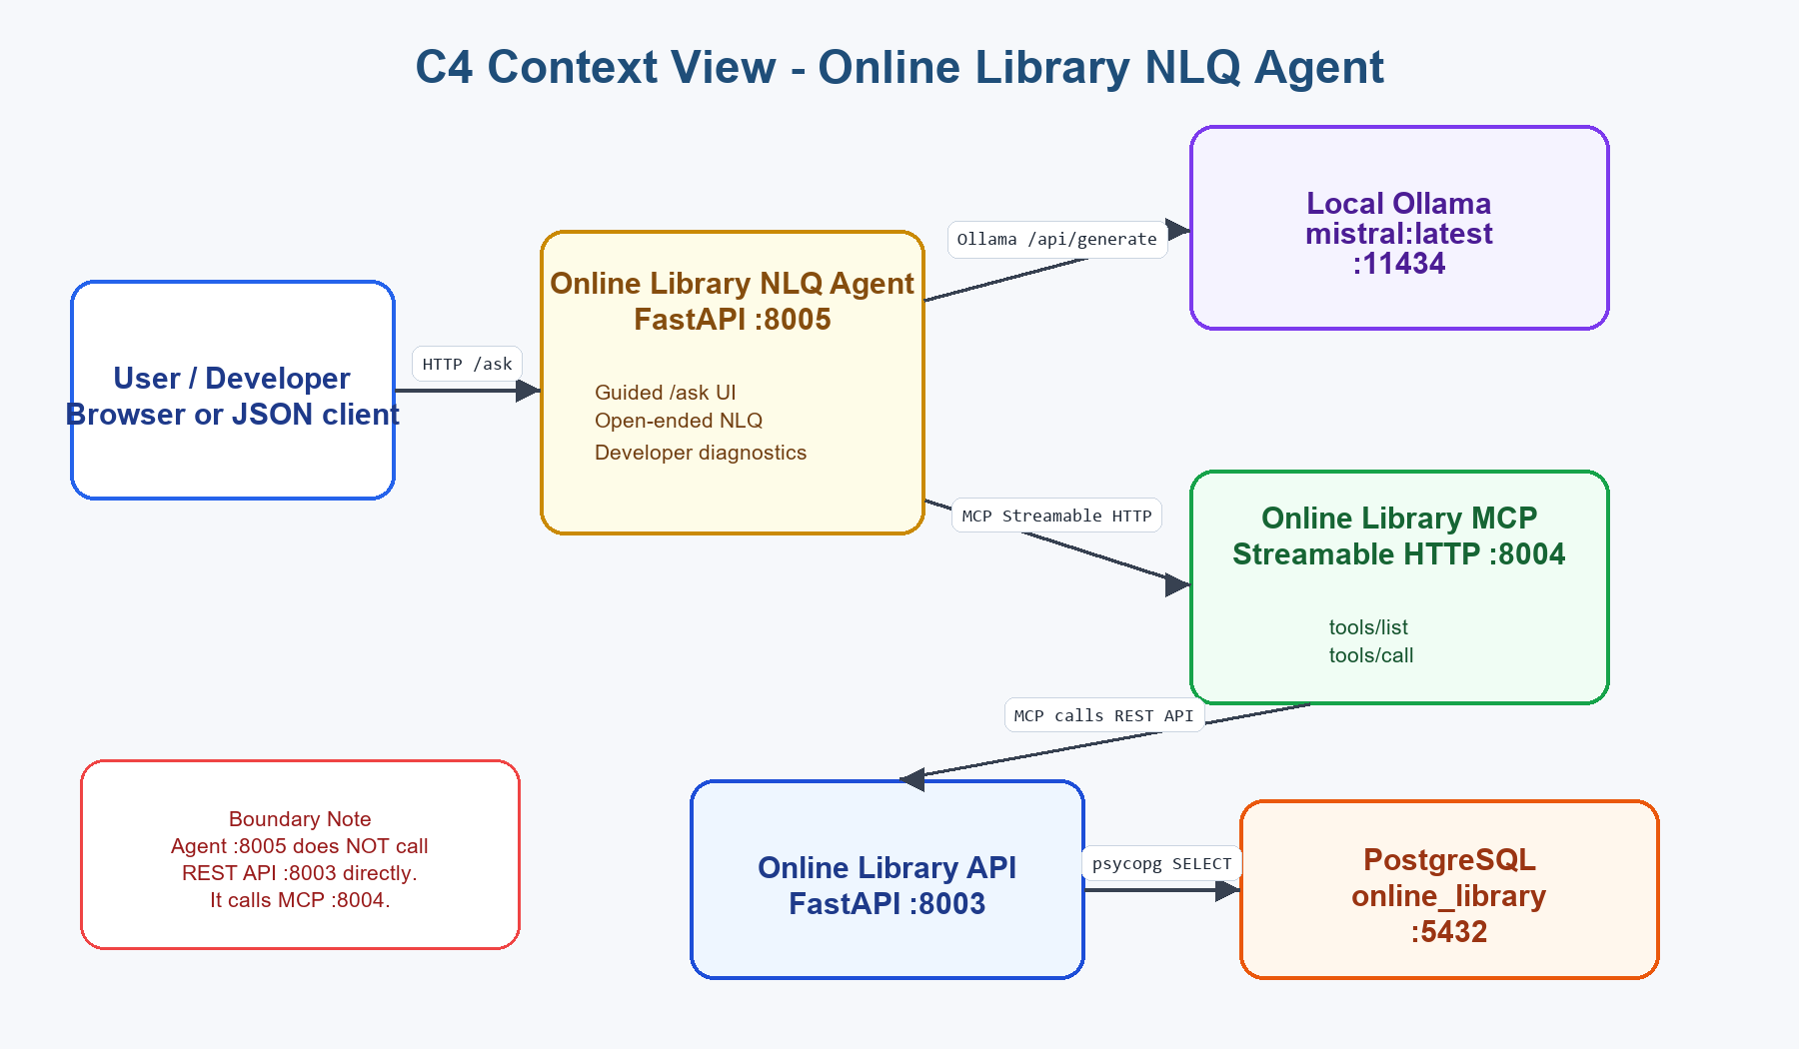
Figure: C4 Context View - Online Library NLQ Agent

C4 Context Source Code (collapsed by default)
System Context
[User / Developer]
|
| HTTP /ask
v
[Online Library NLQ Agent :8005]
|
| MCP Streamable HTTP | Ollama /api/generate
v v
[Online Library MCP :8004] [Local Ollama mistral:latest :11434]
|
| HTTP JSON REST
v
[Online Library API :8003]
|
| psycopg SELECT
v
[PostgreSQL online_library :5432]
Important: the NLQ Agent does not call the REST API :8003 directly.

C4 Container View
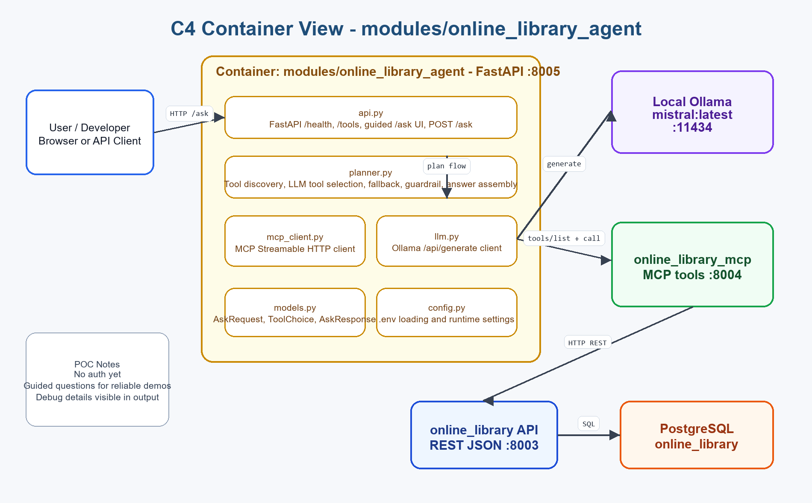
Figure: C4 Container View - modules/online_library_agent

C4 Container Source Code (collapsed by default)
Container: modules/online_library_agent
api.py
- FastAPI /health, /tools, /ask
- guided browser UI
- JSON/form handling
planner.py
- calls tools/list
- sends tool-selection prompt to Ollama
- validates selected tool
- calls MCP tool
- sends result to Ollama for summary
- builds debug details
mcp_client.py
- MCP Streamable HTTP ClientSession
- list_tools()
- call_tool()
llm.py
- httpx client to Ollama /api/generate
- JSON extraction helper
config.py
- module-local .env values
- Ollama, MCP, timeout, temperature, token settings
External containers:
- online_library_mcp :8004
- online_library API :8003
- PostgreSQL :5432
- Ollama :11434

9. API Endpoints
Endpoint | Purpose
GET /health | Returns agent status, MCP URL, Ollama URL, and model.
GET /tools | Discovers MCP tools and returns tool metadata.
GET /ask | Guided browser UI with dropdowns and open-ended NLQ field.
POST /ask | Processes JSON or form NLQ request and returns answer/debug/raw result.

10. Configuration

Module .env Values (collapsed by default)
OLLAMA_BASE_URL=http://127.0.0.1:11434
OLLAMA_MODEL=mistral:latest
ONLINE_LIBRARY_MCP_URL=http://127.0.0.1:8004/mcp
ONLINE_LIBRARY_AGENT_HOST=127.0.0.1
ONLINE_LIBRARY_AGENT_PORT=8005
ONLINE_LIBRARY_AGENT_TIMEOUT_SECONDS=120
ONLINE_LIBRARY_AGENT_DEFAULT_LIMIT=10
ONLINE_LIBRARY_TOOL_SELECTION_TEMPERATURE=0.1
ONLINE_LIBRARY_ANSWER_TEMPERATURE=0.2
ONLINE_LIBRARY_TOOL_SELECTION_NUM_PREDICT=160
ONLINE_LIBRARY_ANSWER_NUM_PREDICT=220

11. Developer Diagnostics
The POC intentionally shows internal execution details in the response so developers can verify behavior.
- Tool used.
- Original NLQ.
- Tool arguments.
- LLM provider and model.
- Ollama and MCP URLs.
- Temperature and max-token settings.
- Fallback and guardrail status.
- Timing values for selection, MCP call, answer generation, and total flow.

12. Local Run And Test

Run Commands (collapsed by default)
.\.venv\Scripts\python.exe -m uvicorn modules.online_library.api:app --reload --port 8003
.\.venv\Scripts\python.exe -m modules.online_library_mcp.server
ollama pull mistral:latest
.\.venv\Scripts\python.exe -m uvicorn modules.online_library_agent.api:app --reload --port 8005
- Open http://127.0.0.1:8005/ask.
- Use a guided question such as List library users.
- Try an unsupported question such as How many cars are there in the showroom? to verify the guardrail.
- Use GET /tools to verify 14 MCP tools are visible.

13. POC Limitations
- No authentication on agent, MCP, or REST API.
- Local Mistral can be slow; observed calls may take tens of seconds.
- Tool selection depends on LLM JSON quality, with keyword fallback for resilience.
- No conversation memory or multi-step reasoning beyond one selected tool.
- User-related data is visible because this is a local POC.
- No production logging, monitoring, rate limiting, or audit trail.

14. Recommended Upgrades
- Add authentication before exposing user/member data.
- Add a smaller/faster local model option for tool selection.
- Add richer semantic tools instead of table-shaped tools only.
- Add tool result filtering and field masking.
- Add conversation memory if needed.
- Add automated tests for planner fallback and guardrails.
- Add telemetry for LLM latency and MCP calls.
- Add deployment diagrams for Docker/Kubernetes if this moves beyond local POC.

15. Related Modules
Module | Relationship
modules/online_library | REST API over PostgreSQL tables on port 8003.
modules/online_library_mcp | MCP Streamable HTTP tools on port 8004. This is the agent data-access layer.
modules/weather_ai_agent | Reference pattern for local LLM configuration and Ollama/Gemini support.

16. Open Details / Questions
- Should future versions hide developer diagnostics behind a debug flag?
- Should user/member email fields be masked before returning to the agent UI?
- Should the agent include screenshots of the /ask UI in the next architecture document revision?
End of Online Library NLQ Agent Architecture POC Document

